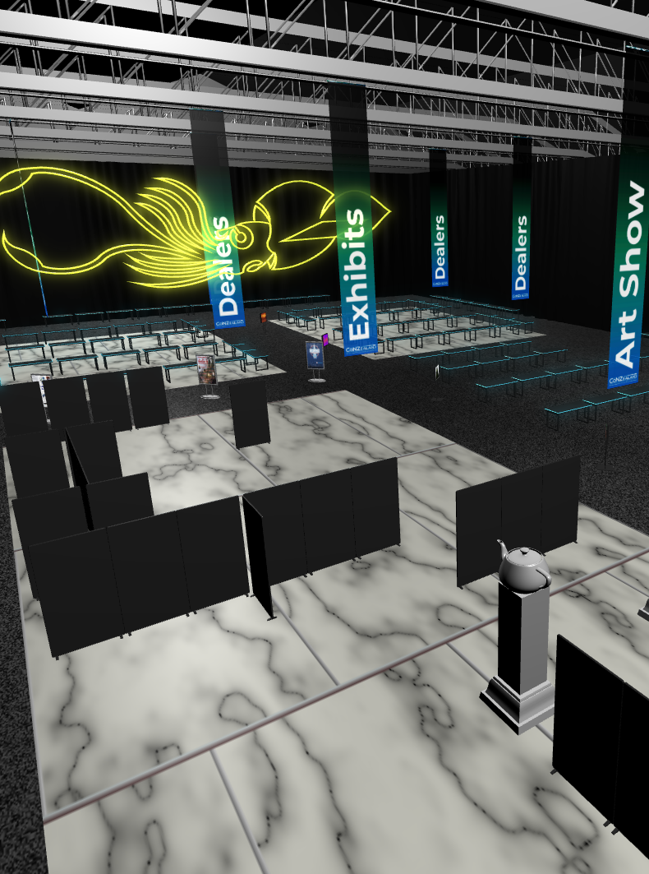

Chief Propeller Head: Tom Becker,

Cyberspace Architect: Jack William Bell

Virtual Arena Designer: Taiyo Fujii,

Vertex Herders: Ryan Casal, Dan Campbell

# AVirtual Exhibits Space

### [Conzealand Virtual Exhibits Team]

SQUID HALL

So, this pandemic happened. We had a few months at best…