Julie Sweany

Lab 1

February 12, 2018

IT1150, CRN13094

# Table of Contents

Table of Contents 2

Executive Summary 3

Chapter 1 Material 4

HTML vs CSS 4

The W3C 4

Text Editors vs IDEs 4

Components of an HTTP URL 4

ADA and Web Development 5

Search Engine Optimization 5

Responsive Web Design 6

Chapter 2 Material 7

Exercise 2-2 7

Exercise 2-3 10

Conclusion 12

Resources 13

# Executive Summary

This lab provides an overview for some important web development concepts. HTML and CSS are explained, and a discussion of some hands-on experience working with each of them is included. The lab also takes a look at the W3C and its role within web development, explains the difference between text editors and development tools, outlines the main components of an HTTP URL, and looks at the ADA’s relationship to web accessibility issues. Brief introductions to search engine optimization and responsive web design are also included.

# Chapter 1 Material

## HTML vs CSS

HTML (HyperText Markup Language) and CSS (Cascading Style Sheets) each play an important role in the coding behind today’s websites. HTML defines the content and structure of the site. The HTML code consists of a head, which provides information about the document, and a body, which contains the elements that will be displayed within the web browser. Tags are used to identify elements. For example, the <h1> tag can be used to identify specific text as an important headline, while a <p> tag is used categorize another block of text as a paragraph. Tags also provide a means for establishing links to other pages and for using image files that will display on the web page. CSS handles the formatting for the website. Rule sets in the CSS establish the attributes associated with the elements used on the webpage, determining things such as the choice of font, font-size, color, borders or rules. CSS can also be used for arranging the elements into a grid-based layout to control where each of the elements will appear within the space of the browser window.

## The W3C

The W3C (World Wide Web Consortium) develops standards for a wide variety of web-related products. This improves the functionality of the Web and helps to ensure compatibility between browsers, hardware, scripting languages, and all of the other components used on the Web. In addition to making sure the Web operates as it should, the W3C is committed to improving accessibility and for expanding the reach of the Web. The W3C also assists web developers by making available a variety of open source software, including a various validators, link checkers, server software, and other utilities.

## Text Editors vs IDEs

Text editors allow a user to write and save HTML and CSS files. Some text editors are very basic, while others offer a few features, such as auto-completion and syntax highlighting. Notepad++ for Windows is an example of a basic text editor. IDEs (Integrated Development Environments) offer more than just the basics of a text editor, adding features such as preview panels, drag-and-drop capabilities for assembling the code, file and folder management, and built-in FTP (File Transfer Protocol) capabilities. IDEs may also integrate JavaScript or server-side languages, such as PHP or Python, or they may include additional tools, such as Photoshop or Illustrator for working with graphics. Dreamweaver is a popular IDE that many developers use to improve their productivity.

## Components of an HTTP URL

The URL (Uniform Resource Locator) has four parts. The first part is the protocol, which is typically “http://” or, for secure sites, “https://”. Next, the domain name allows the browser to determine the correct server to which it needs to send its HTTP request. Domain names typically begin with “www”, followed by a period and name, followed by another period and “com”, “org”, “edu”, “gov”, etc. The domain name is followed by the path, which indicates where the file is stored on the server. The folder names are included within forward slashes, for example: “/the_folder_name/”. The URL ends with the filename, which for a default home page would appear as, “index.html”.

## ADA and Web Development

The ADA (Americans with Disabilities Act) establishes regulations to ensure that people with disabilities have accessibility to programs, services, and activities. WebAIM, an organization dedicated to improving web accessibility, notes on its website that the ADA, when passed in 1990, did not directly address accessibility to the Internet. However, a WebAIM blog post, “DOJ Withdraws ADA Rulemaking Process”, goes on to explain that in 2010, the Department of Justice made clear that the web is covered by the ADA, and it began work on providing technical guidance for making websites compliant with the ADA. In December of 2017, the Department of Justice withdrew their process for establishing website guidance under the ADA. So, it seems web developers will need to do their best to comply with the ADA without the benefit of clear legal guidelines for the foreseeable future. That said, there are abundant resources, such as those provided by organizations like WebAIM and the W3C, to help developers improve the accessibility of their sites.

## Search Engine Optimization

Search Engine Optimization (SEO) aims to improve a website’s rankings by search engines, such as Google, Yahoo or Bing. SEO is an extremely complex subject and involves many aspects, but reliablesoft.net, a company offering SEO services, identifies four major categories within SEO: On-Page SEO, Technical SEO, Advanced On-Page SEO, and Off-Page SEO.

On-Page SEO most closely aligns with the coding behind websites, and many specific actions can be addressed. The most important goal in this area is to make it easy for search engines to search the website’s content easily and thoroughly. This can be achieved through using adequate numbers of carefully chosen keywords, giving each page of the site a unique, accurate title, and including a page description in the code for each page. Since search engines don’t gather information directly from image files, it’s important to include text descriptions for photos used on the site. The structure of the site can also affect page rankings. It’s important to keep the site structure simple, so that the search engine can easily access all the content, and the site’s content should be well organized.

Technical SEO aims to make it easy for search engines to locate and scan a website, and involves things like providing a site map and robots.txt for the site and using the webmaster tools provided by the search engines themselves. Each search engine company offers a great deal of specific advice to developers seeking to improve SEO.

Advanced Page SEO techniques may include multi-lingual websites, internal linking, and accelerated mobile pages.

Off-Page SEO mainly involves improving the quality of outside links to the website, stressing the importance of natural links with high-quality websites.

## Responsive Web Design

People access the Web using a wide variety of devices, with very different screen sizes. This presents a challenge to web designers and developers attempting to create websites that will look good and function well at a variety of sizes. Responsive web design (RWD) is increasingly being chosen as the solution. RWD involves coding a website so that the content automatically adapts to screens of different sizes. Many considerations factor into RWD, but a common starting point for responsive sites is that the size of the viewport needs to be discovered so that the browser will have the information necessary for adjusting the page elements to the appropriate sizes. This is accomplished through the use of a viewport meta tag. Next, images and text may be set to scale automatically to fit within the page’s layout on the screen. Another option for dealing with images in RWD, is to use different image files for different screen sizes. The layout of the website can also automatically change according to screen size. For example, when displayed on a large computer monitor, a site may have two columns of text and a column with images and ads, but that same site, when viewed on a smart phone, may display in a single column, with text and then, scrolling down, an image, an ad, then scrolling further, some more text.

# Chapter 2 Material

## Exercise 2-2

I started this exercise by opening the HTML and CSS files in TextEdit. (I am working on a Mac, and TextEdit is similar to Notepad on Windows.)

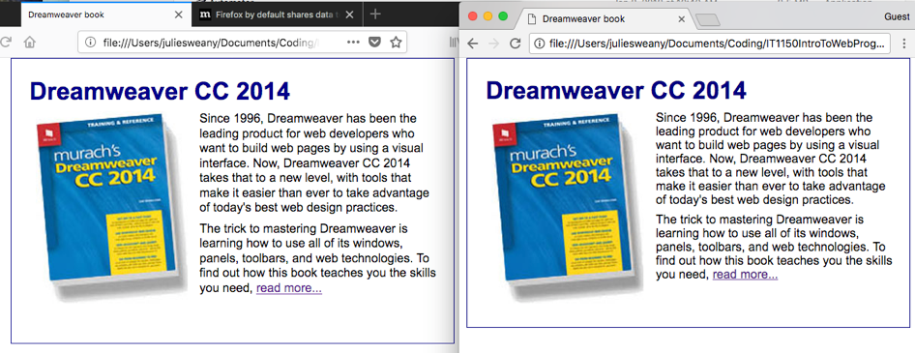Next, I opened the HTML file in Firefox and Chrome. I found that these two browsers displayed the test book page slightly differently. The rectangular border was taller when viewed in Chrome, with a little extra space included within the bottom area of the rectangle. Also, the lines of text within the paragraph were spaced a little more closely in the Chrome version, so that the final line was pretty much even with the bottom of the book image, whereas the text in the Firefox version continued below the bottom of the book image.

Continuing on, I made the directed changes to the HTML and CSS files. These changes made the headline red, moved the image to the right of the paragraph, and added an additional line of text at the bottom, appearing in red.

The process for working with the W3C’s online validators for HTML and CSS went exactly as the textbook explained that it would. I made the two intentional mistakes outlined in the exercise, and the validators identified them. Then I fixed the files and retested them in the browsers to complete the exercise.

A screenshot showing the final result appears below, followed by the code.

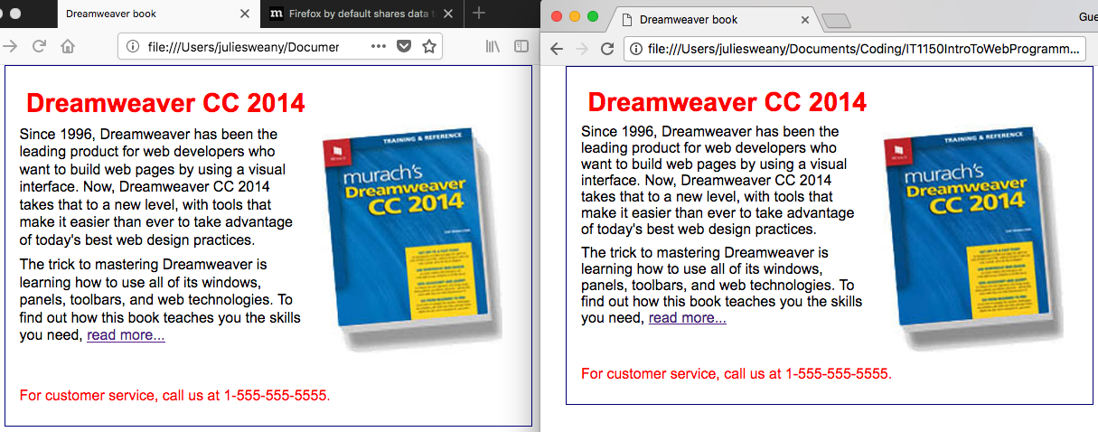

**The HTML:**

<!doctype html>

<html lang="en-us">

<head>

<meta charset="utf-8">

<title>Dreamweaver book</title>

<link rel="stylesheet" href="book.css">

</head>

<body>

<h1>Dreamweaver CC 2014</h1>

<img src="dreamweaverbook2.jpg" alt="Dreamweaver Book">

<p>Since 1996, Dreamweaver has been the leading product for web

developers who want to build web pages by using a visual interface.

Now, Dreamweaver CC 2014 takes that to a new level, with tools that

make it easier than ever to take advantage of today's best web design

practices.</p>

<p>The trick to mastering Dreamweaver is learning how to use all of its

windows, panels, toolbars, and web technologies. To find

out how this book teaches you the skills you need, <a href="">

read more...</a></p><br><br>

<p id = "service">For customer service, call us at 1-555-555-5555.</p>

</body>

</html>

**The CSS:**

body {

font-family: Arial, Helvetica, sans-serif;

font-size: 100%;

width: 550px;

margin: 0 auto;

padding: 1em;

border: 1px solid navy;

}

h1 {

margin: 0;

padding: .25em;

color: red;

font-size: 180%;

}

img {

float: right;

margin: 0 1em;

}

p {

margin: 0;

padding-bottom: .5em;

}

#service {

color: red;

clear: both;

}

## Exercise 2-3

This exercise provided an example of how to start a new web page from HTML and CSS template files. Following the directions led to the creation of a simple web page with a headline with a border around it. As part of the encouraged experimenting, I added a paragraph, changed the background color within the border, and centered the headline. The screenshot, below, shows the result, followed by the HTML and CSS.

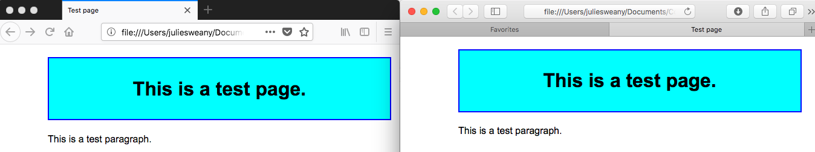

**The HTML:**

<!DOCTYPE html>

<html lang="en">

<head>

<meta charset="utf-8">

<title>Test page</title>

<link rel="stylesheet" href="testpage.css">

</head>

<body>

<h1>This is a test page.</h1>

<p>This is a test paragraph.</p>

</body>

</html>

The CSS:

body {

margin: 0 auto;

font-family: Arial, Helvetica, sans-serif;

font-size: 100%;

width: 500px;

text-align: left;

}

h1 {width: 500px;

background-color: cyan;

border: 2px solid blue;

padding: 1em;

text-align: center;

}

# Conclusion

Because I had the benefit of taking IT1025 IT Concepts for Programmers last semester, much of the content for this lab was not new to me, but it did serve as a helpful refresher. I look forward to learning much more about web development as the semester progresses. It is a very complex discipline, and I am sure there is a lot to master. I’m especially looking forward to learning about audio and video files and about javascript because those areas will be completely new to me.

# Resources

Boehm, Anne and Ruvalcaba, Zak. *Murach’s HTML5 and CSS3* 3rd ed. Mike Murach &   
 Associates, Inc. 2015

Google website. “Responsive Web Design Basics” Retrieved from: https://developers.  
 google.com/web/fundamentals/design-and-ux/responsive/

Google website. *“Seach Engine Optimization (SEO) Starter Guide”* Retrieved from:   
 <https://support.google.com/webmasters/answer/7451184?hl=en>

Moz website. *“The Beginner’s Guide to SEO”* Retrieved from: [https://moz.com/beginners-guide-  
 to-seo](https://moz.com/beginners-guide-to-seo)

Reliablesoft.net website. Retrieved from: https://www.reliablesoft.net/diy-seo-tutorial-for-  
 beginners/

Smith, Jared. WebAIM website. *“DOJ Withdraws ADA Rulemaking Process”* Dec. 22, 1017.   
 Retrieved from: https://webaim.org/blog/dojhaltswebguidance/

W3Schools website. *“HTML Responsive Web Design”* Retrieved from:   
 https://www.w3schools.com/html/html_responsive.asp