Julie Sweany

Lab 2

February 26, 2018

IT1150, CRN13094

# Table of Contents

Table of Contents 2

Executive Summary 3

Chapter 3, Exercise 3-1 4

Halloween Exercise, Part 1 8

Chapter 4, Exercise 4-1 11

Halloween Exercise, Part 2 17

Conclusion 22

Resources 23

# Executive Summary

This lab explains the work involved for completing four exercises. The exercises provided experience using HTML to structure two simple web pages and creating CSS files for the styling of those pages.

# Chapter 3, Exercise 3-1

Exercise 3-1 demonstrates using HTML to construct a simple web page.

Using the supplied text, <h1>, <h2>, and <h3> tags were applied to create headlines, and <p> tags were used to create paragraph elements. An unordered list was created using the <ul> and <li> tags. The <br> tag was used to move the speakers’ names down to new lines underneath the months. Additionally, a blockquote was indicated via the <blockquote> tag.

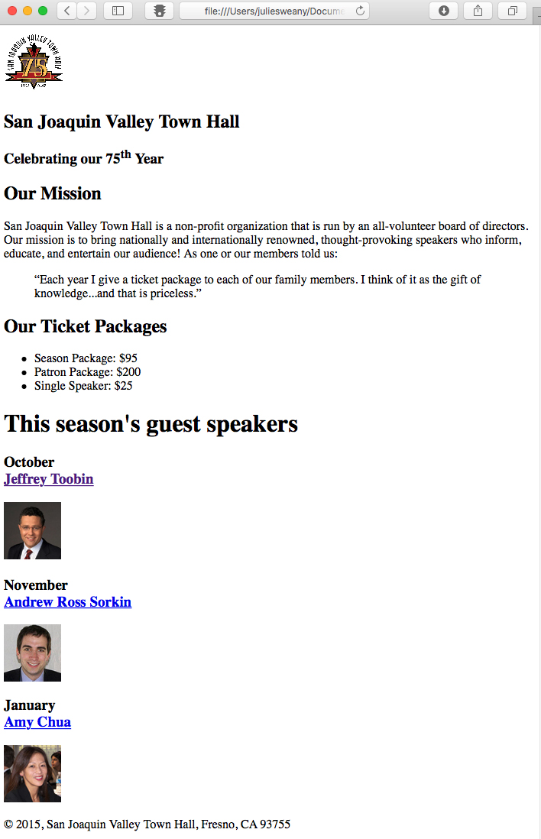The exercise also provided some experience with special characters and text formatting. A copyright symbol and double quotes were added using &copy;, &ldquo;, and &rdquo;, and the letters “th” following “75” were superscripted using the <sup> tag.

Several images were included on the page, providing practice using the <img> element, the source attribute, and the alt attribute. The images also provided some practice using relative file paths, since the images are stored in a folder separate from the HTML file for the home page.

The <a> tag and href attribute provided links to the speaker pages, and a link back to the home page was added to the toobin.html file.

The exercise concluded with validating the code and testing in different browsers.

The screenshot included to the right shows the completed page for Exercise 3-1 in the Safari browser.

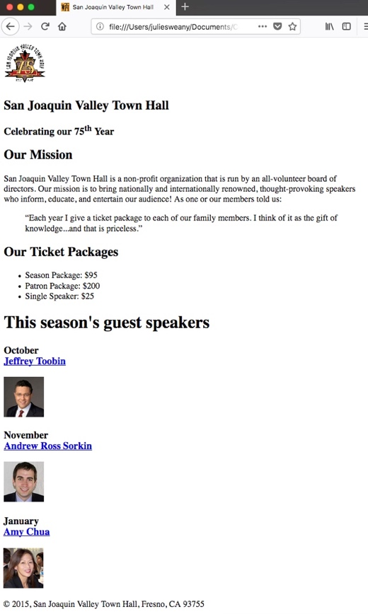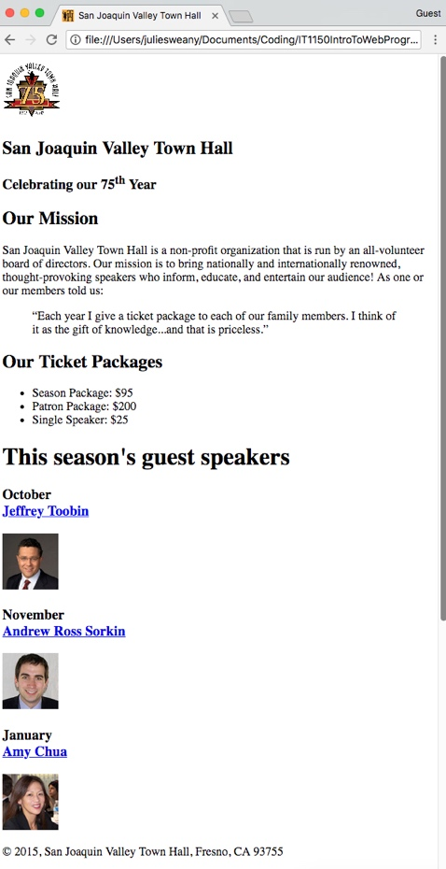Below are screenshots showing the completed page for Exercise 3-1 in the Chrome browser (to the left) and the Firefox browser (to the right). It displayed similarly in all three browsers tested.

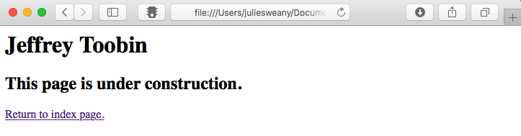

To the right is a screenshot showing the speaker page, with its link back to the home page. (It is shown displayed in Chrome only, since there was no significant difference between browsers.)

HTML for Exercise 3-1

Index.html

<!DOCTYPE html>

<html lang="en">

<head>

<meta charset="utf-8">

<title>San Joaquin Valley Town Hall</title>

<link rel="shortcut icon" href="images/favicon.ico">

</head>

<body>

<header>

<img src="images/town_hall_logo.gif" alt="Town Hall Logo" height="80">

<h2>San Joaquin Valley Town Hall</h2>

<h3>Celebrating our 75<sup>th</sup> Year</h3>

</header>

<main>

<h2>Our Mission</h2>

<p>San Joaquin Valley Town Hall is a non-profit organization that is run by an all-volunteer board of directors. Our mission is to bring nationally and internationally renowned, thought-provoking speakers who inform, educate, and entertain our audience! As one or our members told us:</p>

<blockquote>&ldquo;Each year I give a ticket package to each of our family members. I think of it as the gift of knowledge...and that is priceless.&rdquo;</blockquote>

<h2>Our Ticket Packages</h2>

<ul>

<li>Season Package: $95</li>

<li>Patron Package: $200</li>

<li>Single Speaker: $25</li>

</ul>

<h1>This season's guest speakers</h1>

<h3>October<br><a href="speakers/toobin.html">Jeffrey Toobin</a></h3>

<img src="images/toobin75.jpg" alt="Toobin Photo">

<h3>November<br><a href="speakers/sorkin.html">Andrew Ross Sorkin</a></h3>

<img src="images/sorkin75.jpg" alt="Sorkin Photo">

<h3>January<br><a href="speakers/chua.html">Amy Chua</a></h3>

<img src="images/chua75.jpg" alt="Chua Photo">

</main>

<footer>

<p>&copy; 2015, San Joaquin Valley Town Hall, Fresno, CA 93755</p>

</footer>

</body>

</html>

HTML for Exercise 3-1

toobin.html

<html lang="en">

<head>

<meta charset="utf-8">

<title>San Joaquin Valley Town Hall</title>

<link rel="shortcut icon" href="images/favicon.ico">

</head>

<body>

<h1>Jeffrey Toobin</h1>

<h2>This page is under construction.</h2>

<p><a href="../index.html">Return to index page.</a></p>

</body>

</html>

# Halloween Exercise, Part 1

This exercise reinforced many of the concepts dealt with in Exercise 3-1.

Again, <H1>, <H2>, <H3>, and <P> elements were assigned for text, and an unordered list was included using the <ul> and <li> tags. This exercise also included a link to an image and links to other web pages within the site. Additionally, some inline text formatting was achieved through the use of the <b> tag, and a special symbol, the copyright, was included by using &copy;.

Validation produces no errors, so I completed the exercise by testing the page in my three browsers. It displayed very similarly in each of them. Looking very closely, there is an extremely small difference between the browsers in the amount of line spacing for the text. It is so slight, though, that no casual viewer would even notice.

The finished page, displayed in the Chrome browser, appears below.

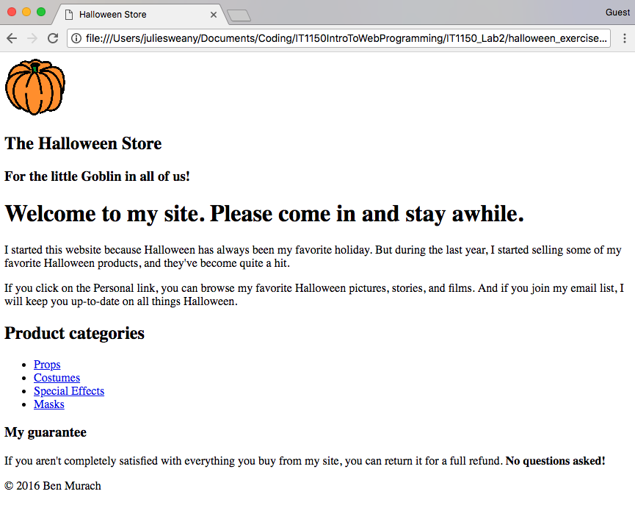

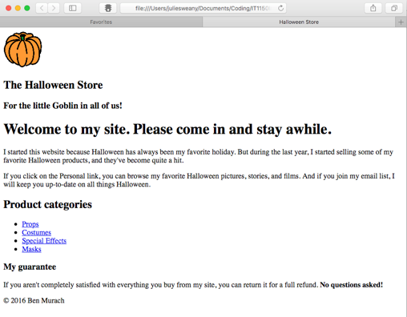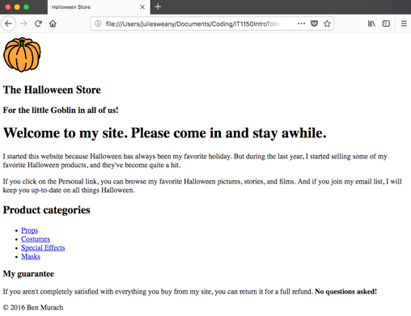Halloween Exercise, Part 1, displayed in Safari (left) and Firefox (right).

HTML for Halloween Exercise, Part 1

<!DOCTYPE html>

<html lang="en">

<head>

<meta charset="utf-8" />

<title>Halloween Store</title>

</head>

<body>

<header>

<img src="images/pumpkin.gif" alt="pumpkin">

<h2>The Halloween Store</h2>

<h3>For the little Goblin in all of us!</h3>

</header>

<main>

<h1>Welcome to my site. Please come in and stay awhile.</h1>

<p>I started this website because Halloween has always been my favorite holiday. But during the last year, I started selling some of my favorite Halloween products, and they've become quite a hit.</p>

<p>If you click on the Personal link, you can browse my favorite Halloween pictures, stories, and films. And if you join my email list, I will keep you up-to-date on all things Halloween.</p>

<h2>Product categories</h2>

<ul>

<li><a href="slides/products/props.html">Props</a>

<li><a href="slides/products/costumes.html">Costumes</a>

<li><a href="slides/products/effects.html">Special Effects</a>

<li><a href="slides/products/masks.html">Masks</a>

</ul>

<h3>My guarantee</h3>

<p>If you aren't completely satisfied with everything you buy from my site, you can return it for a full refund.

<b>No questions asked!</b></p>

</main>

<footer>

<p>&copy; 2016 Ben Murach</p>

</footer>

</body>

</html>

# Chapter 4, Exercise 4-1

This exercise provided experience using CSS. Using the HTML file from Chapter 3,   
Exercise 3-1 and some provided CSS files, further styling was achieved by adding additional rule sets to the main.css file.

Directions indicated changes to the font size, which were made using the font-size: property, to the color using the color: property, and to the alignment through the   
text-align: property. There was also a direction to indent some of the text. This was achieved with the text-indent: property.

In most cases, the directions requested that changes be made to elements within specific semantic elements within the HTML. So, the selectors usually included both the semantic element (such as, header, for example) plus another HTML element (like p, h1, or h2, for example).

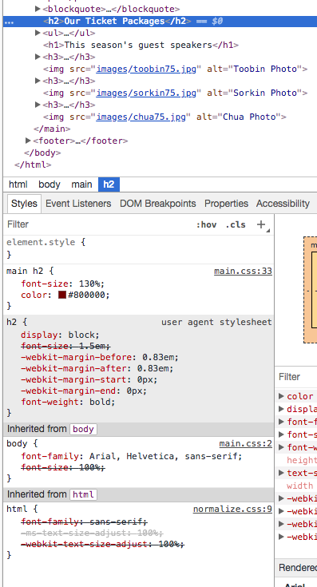Two of the more interesting changes were to make links with focus or with the mouse hovering over them to display as italic text and to add a shadow effect to some text. There are two pre-defined classes, or pseudo-classes, that take care of the first charge—:hover and :focus. The text-shadow: property, along with several parameters, will produce a shadow effect on text. Since, in this example, we wanted to shadow only on a very small, specific portion of the text, a <span> element was used in the HTML and a class was established for applying the shadow effect.

The exercise also pointed out the help that can be accessed through Chrome’s developer tools. The developer window within Chrome documents all the styling instructions in the code, clearly outlining all the instructions coming from all of the code files involved. This makes it very clear which instructions are being overridden by others, and I think it could be a valuable tool when troubleshooting a page that isn’t displaying as intended.

A portion of Chrome’s developer window is shown in the screenshot to the right.

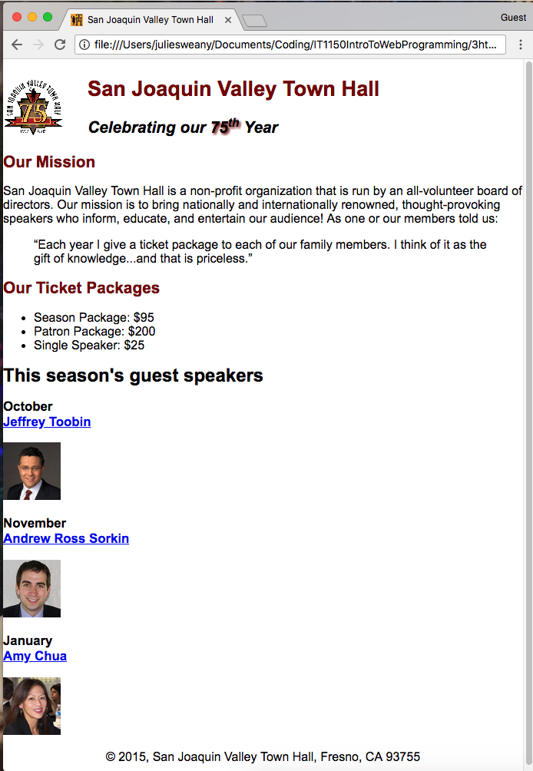**Screenshot of the final page** for Chapter 4, Exercise 4-1, as displayed in the Chrome browser.

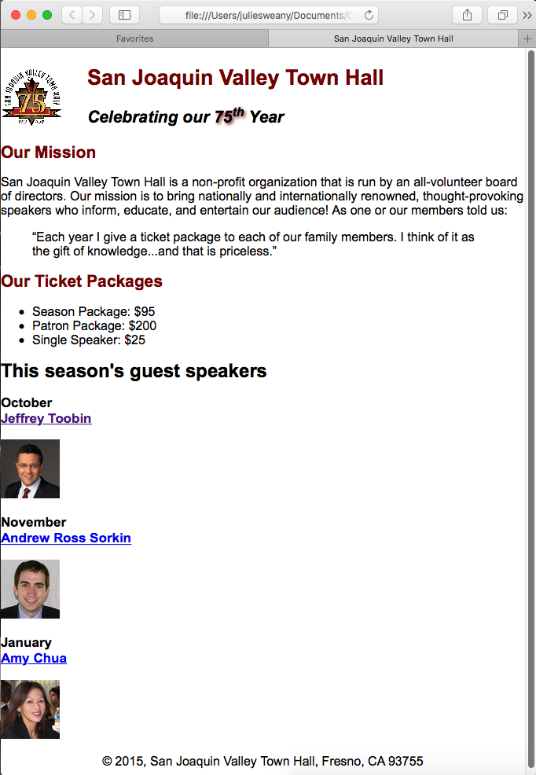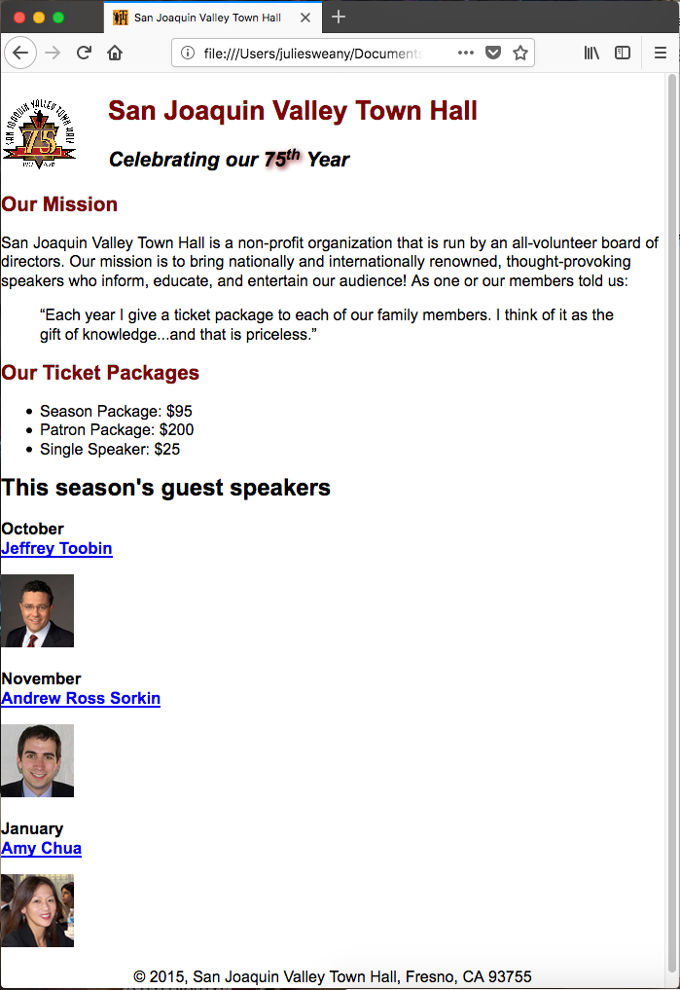Chapter 4, Exercise 4-1 screenshots of the final page displayed in Firefox (left) and Safari (right).

The HTML for Chapter 4, Exercise 4-1

<!DOCTYPE html>

<html lang="en">

<head>

<meta charset="utf-8">

<title>San Joaquin Valley Town Hall</title>

<link rel="shortcut icon" href="images/favicon.ico">

<link rel="stylesheet" href="styles/normalize.css">

<link rel="stylesheet" href="styles/main.css">

</head>

<body>

<header>

<img src="images/town_hall_logo.gif" alt="Town Hall Logo" height="80">

<h2>San Joaquin Valley Town Hall</h2>

<h3>Celebrating our <span class="shadow">75<sup>th</sup></span> Year</h3>

</header>

<main>

<h2>Our Mission</h2>

<p>San Joaquin Valley Town Hall is a non-profit organization that is run by an all-volunteer board of directors. Our mission is to bring nationally and internationally renowned, thought-provoking speakers who inform, educate, and entertain our audience! As one or our members told us:</p>

<blockquote>&ldquo;Each year I give a ticket package to each of our family members. I think of it as the gift of knowledge...and that is priceless.&rdquo;</blockquote>

<h2>Our Ticket Packages</h2>

<ul>

<li>Season Package: $95</li>

<li>Patron Package: $200</li>

<li>Single Speaker: $25</li>

</ul>

<h1>This season's guest speakers</h1>

<h3>October<br><a href="speakers/toobin.html">Jeffrey Toobin</a></h3>

<img src="images/toobin75.jpg" alt="Toobin Photo">

<h3>November<br><a href="speakers/sorkin.html">Andrew Ross Sorkin</a></h3>

<img src="images/sorkin75.jpg" alt="Sorkin Photo">

<h3>January<br><a href="speakers/chua.html">Amy Chua</a></h3>

<img src="images/chua75.jpg" alt="Chua Photo">

</main>

<footer>

<p>&copy; 2015, San Joaquin Valley Town Hall, Fresno, CA 93755</p>

</footer>

</body>

</html>

The CSS for Chapter 4, Exercise 4-1

/* the styles for the elements */

body {

font-family: Arial, Helvetica, sans-serif;

font-size: 100%;

}

/* the styles for the header */

header img {

float: left;

}

header h2 {

font-size: 170%;

color: #800000;

text-indent: 30px;

}

header h3 {

font-size: 130%;

font-style: italic;

text-indent: 30px;

}

.shadow {

text-shadow: 2px 2px 4px #800000;

}

/* the styles for the section */

main {

clear: left;

}

main h1 {

font-size: 150%;

}

main h2 {

font-size: 130%;

color: #800000;

}

main h3 {

font-size: 105%;

}

/* the styles for links */

a:hover, a:focus {

font-style: italic;

}

/* the styles for the footer */

footer p {

text-align: center;

}

# Halloween Exercise, Part 2

This exercise reinforced the CSS skills developed in the previous exercise. In fact, virtually all of the directions for this exercise were also included within the work for Chapter 4, Exercise 4-1. One new addition was to add extra line spacing within the unordered list. This was achieved through the use of the line-height: property within the CSS file. This exercise also involved added styling to links that were not being hovered over, through the use of the a:link selector.

The final page, as displayed in the Chrome browser.

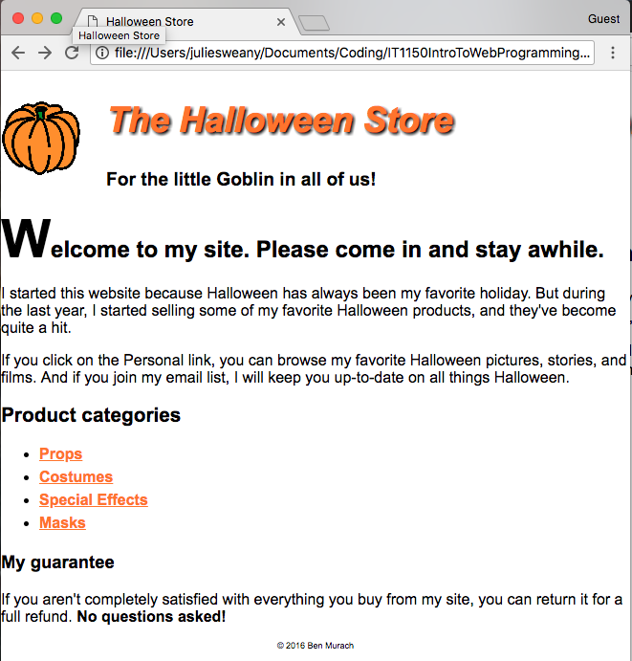

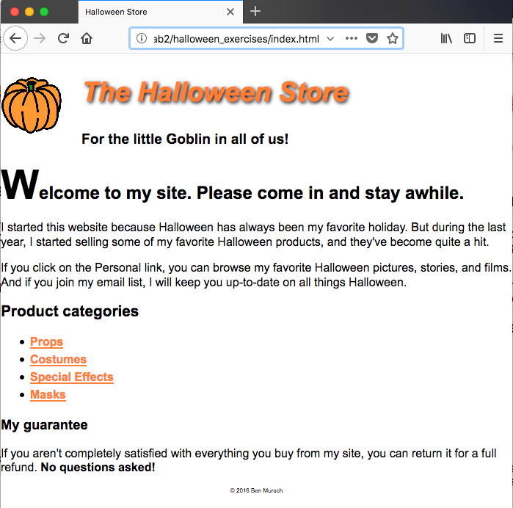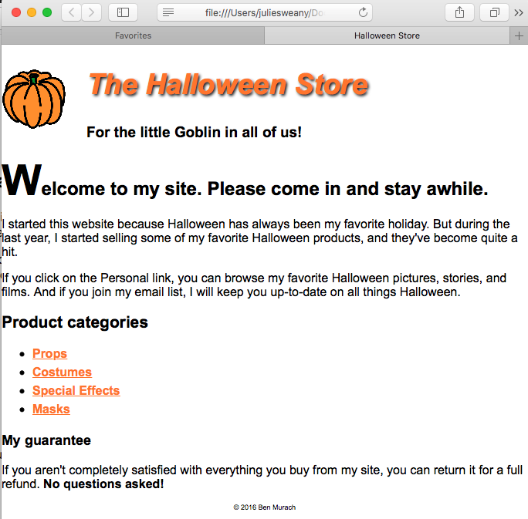The final page for Halloween Exercise, Part 2, displayed in Firefox (on the left) and Safari (on the right).

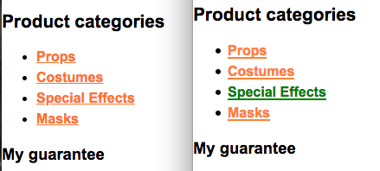

A screenshot (above) showing the effect of hovering over a link. It also shows a difference between browsers. In the bold font, there is a heavier look to the type and the underlines when viewed in Firefox (on the right) vs Chrome (on the left).

The HTML code for Halloween Exercise, Part 2

<!DOCTYPE html>

<html lang="en">

<head>

<meta charset="utf-8" />

<title>Halloween Store</title>

<link rel="stylesheet" href="styles/normalize.css">

<link rel="stylesheet" href="styles/main.css">

</head>

<body>

<header>

<img src="images/pumpkin.gif" alt="pumpkin">

<h2>The Halloween Store</h2>

<h3>For the little Goblin in all of us!</h3>

</header>

<main>

<h1><span class="large">W</span>elcome to my site. Please come in and stay awhile.</h1>

<p>I started this website because Halloween has always been my favorite holiday. But during the last year, I started selling some of my favorite Halloween products, and they've become quite a hit.</p>

<p>If you click on the Personal link, you can browse my favorite Halloween pictures, stories, and films. And if you join my email list, I will keep you up-to-date on all things Halloween.</p>

<h2>Product categories</h2>

<ul>

<li><a href="slides/products/props.html">Props</a>

<li><a href="slides/products/costumes.html">Costumes</a>

<li><a href="slides/products/effects.html">Special Effects</a>

<li><a href="slides/products/masks.html">Masks</a>

</ul>

<h3>My guarantee</h3>

<p>If you aren't completely satisfied with everything you buy from my site, you can return it for a full refund.

<b>No questions asked!</b></p>

</main>

<footer>

<p>&copy; 2016 Ben Murach</p>

</footer>

</body>

</html>

The CSS for Halloween Exercise, Part 2

/* the styles for the elements */

body {

font-family: Arial, Helvetica, sans-serif;

font-size: 100%;

}

/* the styles for the header */

header img {

float: left;

}

header h2 {

font-size: 230%;

font-style: italic;

color: #FF8033;

text-shadow: 2px 2px 4px #000000;

text-indent: 25px;

}

header h3 {

font-size: 120%;

text-indent: 25px;

}

/* the styles for the section */

main {

clear: left;

}

main h1 {

font-size: 150%;

}

main h2 {

font-size: 130%;

}

main h3 {

font-size: 115%;

}

main ul {

line-height: 1.5;

}

/* style for a class */

.large {

font-size: 230%;

}

/* the styles for links */

a:link, a:focus, a:visited {

font-weight: bold;

color: #FF8033;

}

a:hover {

color: green;

}

/* the styles for the footer */

footer p {

text-align: center;

font-size: 50%;

}

# Conclusion

I enjoyed working on these exercises. So far, the directions have been logical and easy-to-follow. I expect that as the complexity of the web pages being worked upon increases, it will become more difficult to ensure that everything displays as intended and to troubleshoot the problems when things don’t go as intended. But, for the time being, I’m achieving the intended results without problems, and I’ve begun trying to do things from memory, instead of repeatedly referring back to the text book. I will need to commit more of these skills to memory and to speed up the pace of my work before I can expect to use these skills professionally, so I’m looking forward to gaining much more experience with HTML and CSS through the remainder of the course.

# Resources

Boehm, Anne and Ruvalcaba, Zak. *Murach’s HTML5 and CSS3* 3rd ed. Mike Murach &   
 Associates, Inc. 2015