Julie Sweany

Lab 4

April 2, 2018

IT1150, CRN13094

# Table of Contents

Table of Contents 2

Executive Summary 3

Chapter 7, Exercise 7-1 4

Halloween Exercise, Part 7 15

Chapter 8, Exercise 8-1 28

Halloween 8 42

Conclusion 52

Resources 53

# Executive Summary

Lab 4 deals with lists, links, and responsive design. The exercises provided ample experience working with various types of links, and also introduced the concepts behind creating navigations menus of varying complexity. The lab also provided experience creating responsive designs that reflowed automatically into differently sized browser windows, as well as using media queries to adapt the design to different breakpoints.

# Chapter 7, Exercise 7-1

Exercise 7-1 added to the previously created sample web page by adding a two-tier navigation menu.

The first step was establishing a nav element within the HTML document, and adding an id, “nav_menu”, to that element. Next, an unordered list was added within the nav element, and within the <ul> tags, <li> tags were added for each of the links that would appear in the menu.

Then it was time to take care of some styling issues within the CSS. Many of these changes had been dealt with in previous exercises, but some were new. For example, the display: property was used to set the <a> elements within the <li> elements to block. With this change, the entire li element became a clickable link, not just the text.

The horizontal structure of the menu was also established within the CSS, through the use of a left float for all of the list item elements.

By this point in the exercise, the first-tier of the menu was established and it was time to add the second tier. Going back to the HTML file, an unordered list was added within the last set of <li> tags in the original unordered list. To this, the four li elements with <a> elements that would become the second-tier menu were added.

Once the HTML for the second-tier menu was established, it was time to return to the CSS to add styling and functionality. This part of the exercise introduced many new concepts. The unordered list that was nested inside of the unordered list for the first-tier menu was given the property display: which was set to none. This prevented the nested list from being displayed initially. To make them appear when the cursor is over the associated first-tier menu item, a pseudo class, :hover., was used in the selector for the child unordered list nested within the list item, with the property display: set to block. Additions to the CSS were also needed to ensure the proper placement of the second-tier menu. The nested unordered list was set to position: absolute and top: 100%. That lined up the top of the first list item for that unordered list with the top of the line item in which it was nested. Then an empty block needed to be created to push that line item down, so that it appeared underneath its parent list item. That was accomplished through this code: #nav_menu > ul::after { content: ""; display: block; clear: both; } The greater than sign acts as a child selector, so the rule only applies to the first unordered list in the nav_menu. An empty element is created with the content: “” and display: block, which pushes the first nested list item down. Then, by clearing both, the remaining list items do not float, but rather they appear to be stacked vertically.

The exercise concluded with two small additional directions. A link to a video file was added to one of the <a> tags in the HTML. A Shock Wave Flash file (.swf) was used in the href and a type attribute, type=”application/x-shockwave-flash”, was included to help browsers use the appropriate media player. Lastly, some bullets were changed to open circle shapes using the list-style-type: circle.

The screenshot included below shows the completed page for Exercise 7-1 in the Safari browser.

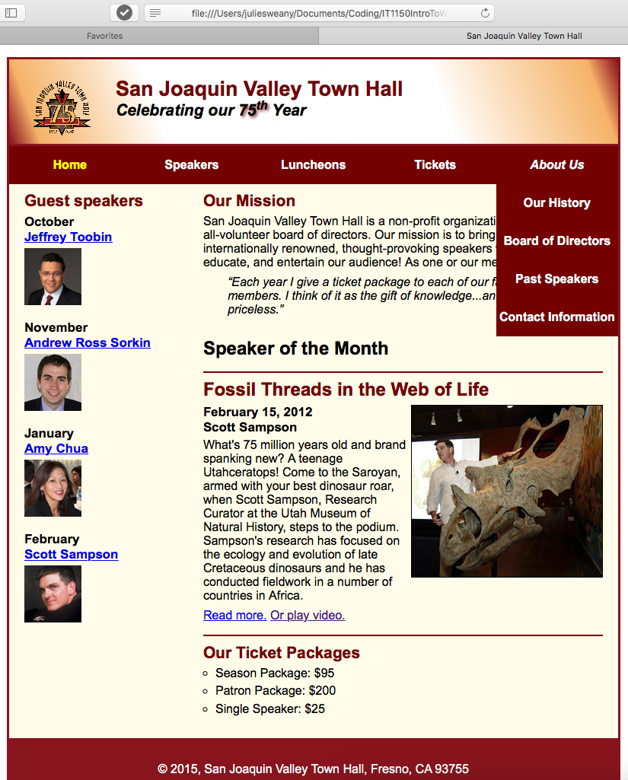

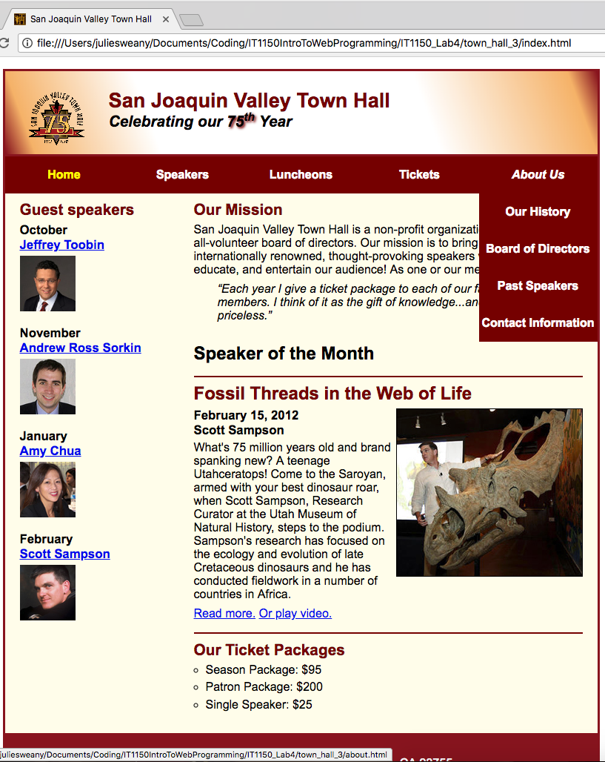Screenshots showing the completed page for Exercise 7-1 in the Chrome browser (to the left) and the Firefox browser (below). The page displayed similarly in all three browsers tested.

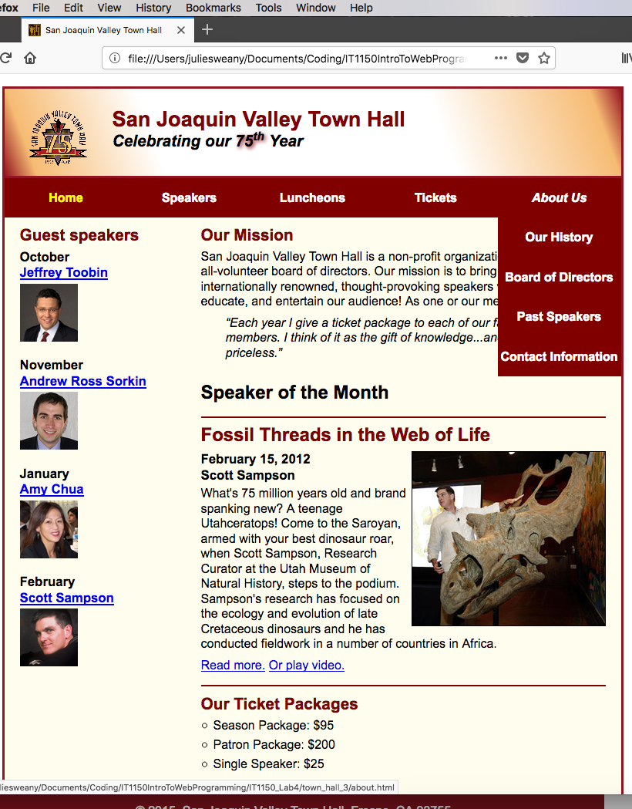

HTML for Exercise 7-1

<!DOCTYPE html>

<html lang="en">

<head>

<meta charset="utf-8">

<title>San Joaquin Valley Town Hall</title>

<link rel="shortcut icon" href="images/favicon.ico">

<link rel="stylesheet" href="styles/normalize.css">

<link rel="stylesheet" href="styles/main.css">

</head>

<body>

<header>

<img src="images/town_hall_logo.gif" alt="Town Hall Logo" height="80">

<h2>San Joaquin Valley Town Hall</h2>

<h3>Celebrating our <span class="shadow">75<sup>th</sup></span> Year</h3>

</header>

<nav id="nav_menu">

<ul>

<li><a href="index.html" class="current">Home</a></li>

<li><a href="speakers.html">Speakers</a></li>

<li><a href="luncheons.html">Luncheons</a></li>

<li><a href="tickets.html">Tickets</a></li>

<li><a href="about.html">About Us</a>

<ul>

<li><a>Our History</a></li>

<li><a>Board of Directors</a></li>

<li><a>Past Speakers</a></li>

<li><a>Contact Information</a></li>

</ul>

</li>

</ul>

</nav>

<main>

<section>

<h2>Our Mission</h2>

<p>San Joaquin Valley Town Hall is a non-profit organization that is run by an all-volunteer board of directors. Our mission is to bring nationally and internationally renowned, thought-provoking speakers who inform, educate, and entertain our audience! As one or our members told us:</p>

<blockquote>&ldquo;Each year I give a ticket package to each of our family members. I think of it as the gift of knowledge...and that is priceless.&rdquo;</blockquote>

<h1>Speaker of the Month</h1>

<article>

<h2>Fossil Threads in the Web of Life</h2>

<img src="images/sampson_dinosaur.jpg" alt="Sampson and dinosaur">

<h3>February 15, 2012<br>

Scott Sampson</h3>

<p>What's 75 million years old and brand spanking new? A teenage Utahceratops! Come to the Saroyan, armed with your best dinosaur roar, when Scott Sampson, Research Curator at the Utah Museum of Natural History, steps to the podium. Sampson's research has focused on the ecology and evolution of late Cretaceous dinosaurs and he has conducted fieldwork in a number of countries in Africa.</p>

<p><a href="speakers/sampson.html">Read more.</a>&nbsp;<a href="media/sampson.swf" type="application/x-shockwave-flash" target="_blank">Or play video.</a></p>

</article>

<h2>Our Ticket Packages</h2>

<ul>

<li>Season Package: $95</li>

<li>Patron Package: $200</li>

<li>Single Speaker: $25</li>

</ul>

</section>

<aside>

<h2>Guest speakers</h2>

<h3>October<br><a href="speakers/toobin.html">Jeffrey Toobin</a></h3>

<img src="images/toobin75.jpg" alt="Toobin Photo">

<h3>November<br><a href="speakers/sorkin.html">Andrew Ross Sorkin</a></h3>

<img src="images/sorkin75.jpg" alt="Sorkin Photo">

<h3>January<br><a href="speakers/chua.html">Amy Chua</a></h3>

<img src="images/chua75.jpg" alt="Chua Photo">

<h3>February<br><a href="speakers/sampson.html">Scott Sampson</a></h3>

<img src="images/sampson75.jpg" alt="Sampson Photo">

</aside>

</main>

<footer>

<p>&copy; 2015, San Joaquin Valley Town Hall, Fresno, CA 93755</p>

</footer>

</body>

</html>

CSS for Exercise 3-1

/* reset selector */

* {

margin: 0;

padding: 0;

}

/* the styles for the elements */

html {

background-color: #ffffff;

}

body {

background-color: #fffded;

width: 800px;

margin: 1em auto 1em;

border: 3px solid #931420;

font-family: Arial, Helvetica, sans-serif;

font-size: 100%;

}

section {

width: 525px;

float: right;

}

aside {

width: 215px;

float: right;

padding: 0 0 20px 20px;

}

footer {

background-color: #931420;

padding: 1em;

clear: both;

}

/* the styles for the header */

header {

background-image: linear-gradient(20deg, #931420 0%, #f6bb73 5%, #ffffff 25%,

#ffffff 70%, #f6bb73 95%, #931420 100%);

background-image: -webkit-linear-gradient(20deg, #931420 0%, #f6bb73 5%, #ffffff 25%, #ffffff 70%, #f6bb73 95%, #931420 100%);

background-image: -moz-linear-gradient(20deg, #931420 0%, #f6bb73 5%, #ffffff 25%, #ffffff 70%, #f6bb73 95%, #931420 100%);

background-image: -o-linear-gradient(20deg, #931420 0%, #f6bb73 5%, #ffffff 25%, #ffffff 70%, #f6bb73 95%, #931420 100%);

border-bottom: 3px solid #931420;

padding: 1.5em 0 2em;

}

header img {

float: left;

padding: 0 30px 0;

}

header h2 {

font-size: 170%;

color: #800000;

}

header h3 {

font-size: 130%;

font-style: italic;

}

.shadow {

text-shadow: 2px 2px 4px #800000;

}

/* the styles for the nav_menu class */

#nav_menu ul {

margin: 0;

padding: 0;

list-style-type: none;

position: relative;

}

#nav_menu ul li {

float: left;

}

#nav_menu ul li a {

width: 160px;

text-align: center;

display: block;

padding: 1em 0;

text-decoration: none;

background-color: #800000;

color: white;

font-weight: bold;

}

#nav_menu ul li a.current {

color: yellow;

}

#nav_menu ul ul {

display: none;

position: absolute;

top: 100%;

}

/* makes 2nd tier menu appear vertically*/

#nav_menu ul ul li {

float: none;

}

/* makes 2nd tier menu appear when hovering over li of main menu*/

#nav_menu ul li:hover > ul {

display: block;

}

/* creates an empty block to push 2nd tier menu down*/

#nav_menu > ul::after {

content: "";

display: block;

clear: both;

}

/* the styles for the section */

section {

clear: left;

padding: 0 20px 20px;

}

section h1 {

font-size: 150%;

padding: .5em 0 .0;

}

section h2 {

font-size: 130%;

color: #800000;

padding: .5em 0 .25em;

}

section p {

padding-bottom: .5em;

}

section blockquote {

padding: 0 2em 0;

font-style: italic;

}

aside h3 {

font-size: 105%;

padding-bottom: .25em;

}

aside img {

padding-bottom: 1em;

}

aside h2 {

font-size: 130%;

color: #800000;

padding: .5em 0 .25em;

}

section ul {

padding: 0 0 .25em 1em;

list-style-type: circle;

}

section li {

padding-bottom: .35em;

}

/* the styles for links */

a:hover, a:focus {

font-style: italic;

}

article {

padding: .5em 0 .5em;

border-top: 2px solid #800000;

border-bottom: 2px solid #800000;

}

article img {

float: right;

border: 1px solid #000000;

}

article h1 {

font-size: 150%;

padding: .5em 0 .25em;

}

article h2 {

font-size: 150%;

padding: 0 0 .25em;

}

article h3 {

font-size: 105%;

padding: 0 0 .25em;

}

/* the styles for the footer */

footer p {

text-align: center;

color: white;

padding: 1em 0;

}

# Halloween Exercise, Part 7

The process for adding a navigation menu to the Halloween web site was very similar to that of the previous exercise. One variation in this exercise was to change the background color when the cursor hovers over the second-tier menu. This was accomplished with this code: #nav_menu ul li ul li a:hover { background-color: gray; }

This exercise also involved setting up a vertical navigation menu for the links on the left-hand side of the page. This was an easier task, since lists normally flow vertically. The process was fairly similar to setting up a horizontal navigation menu, but without the need to incorporate floats.

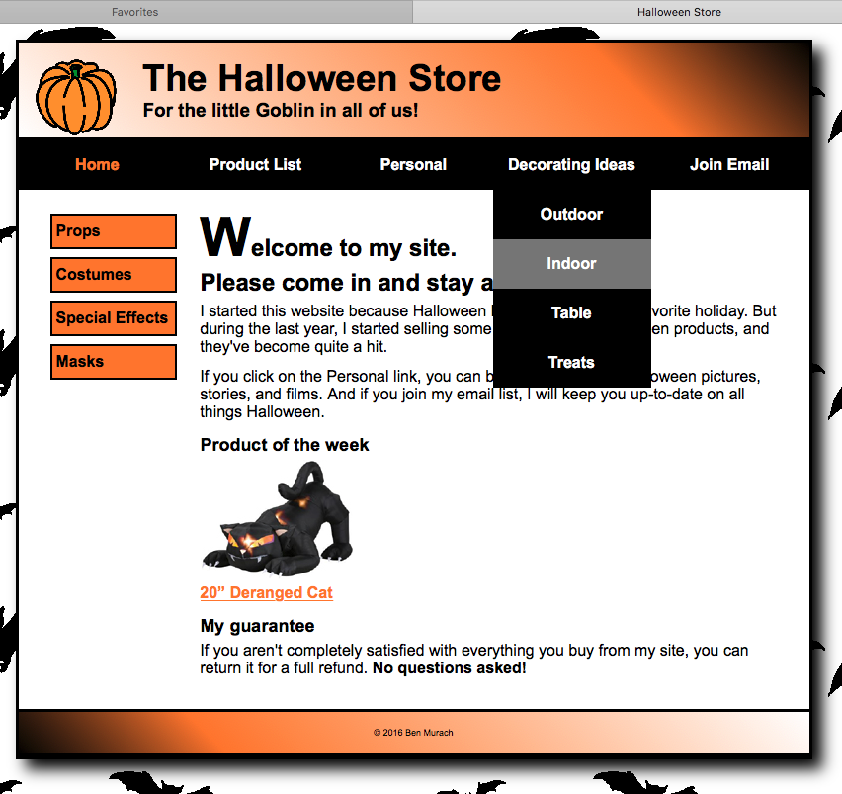

The finished page, displayed in the Safari browser.

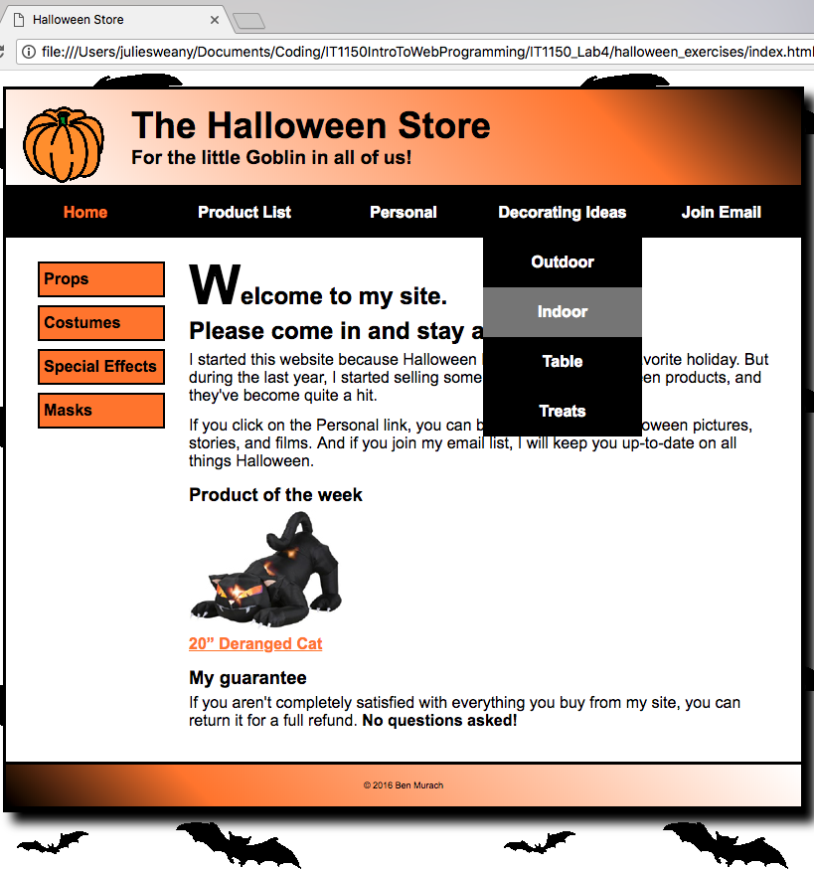Halloween Exercise, Part 7, displayed in Chrome (left) and Firefox (below).

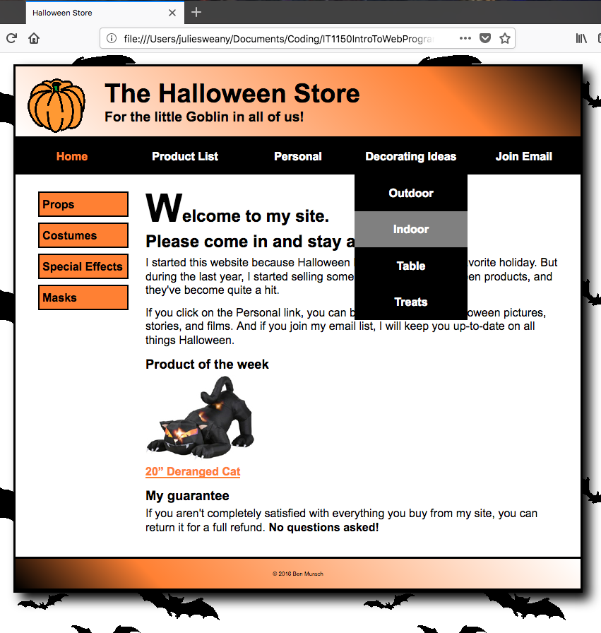

HTML for Halloween Exercise, Part 7

<!DOCTYPE html>

<html lang="en">

<head>

<meta charset="utf-8" />

<title>Halloween Store</title>

<link rel="stylesheet" href="styles/normalize.css">

<link rel="stylesheet" href="styles/main.css">

</head>

<body>

<header>

<img src="images/pumpkin.gif" alt="pumpkin">

<h2>The Halloween Store</h2>

<h3>For the little Goblin in all of us!</h3>

</header>

<nav id="nav_menu">

<ul>

<li><a href="index.html" class="current">Home</a></li>

<li><a href="products.html">Product List</a></li>

<li><a href="personal.html">Personal</a></li>

<li><a href="decorating.html">Decorating Ideas</a>

<ul>

<li><a>Outdoor</a></li>

<li><a>Indoor</a></li>

<li><a>Table</a></li>

<li><a>Treats</a></li>

</ul></li>

<li><a href="email.html">Join Email</a></li>

</ul>

</nav>

<aside id="sidebar">

<ul>

<li><a href="slides/products/props.html">Props</a>

<li><a href="slides/products/costumes.html">Costumes</a>

<li><a href="slides/products/effects.html">Special Effects</a>

<li><a href="slides/products/masks.html">Masks</a>

</ul>

</aside>

<section>

<h1><span class="large">W</span>elcome to my site.<br>Please come in and stay awhile.</h1>

<p>I started this website because Halloween has always been my favorite holiday. But during the last year, I started selling some of my favorite Halloween products, and they've become quite a hit.</p>

<p>If you click on the Personal link, you can browse my favorite Halloween pictures, stories, and films. And if you join my email list, I will keep you up-to-date on all things Halloween.</p>

<h3>Product of the week</h3>

<a href="slides/products/cat.html"><img src="images/cat1.jpg" alt="cat"></a><br>

<a href="slides/products/cat.html">20&rdquo; Deranged Cat</a>

<h3>My guarantee</h3>

<p>If you aren't completely satisfied with everything you buy from my site, you can return it for a full refund.

<b>No questions asked!</b></p>

</section>

<footer>

<p>&copy; 2016 Ben Murach</p>

</footer>

</body>

</html>

CSS for Halloween Exercise, Part 7

/* reset selector */

* {

margin: 0;

padding: 0;

}

/* style for background behind body */

html {

background-image: url("../images/bats.gif")

}

/* the styles for the elements */

body {

font-family: Arial, Helvetica, sans-serif;

font-size: 100%;

width: 800px;

background-color: white;

margin: 1em auto;

border: 3px solid black;

box-shadow: 10px 10px 15px black;

}

/* the styles for the header */

header img {

float: left;

}

header h2 {

font-size: 230%;

text-indent: 25px;

}

header h3 {

font-size: 120%;

text-indent: 25px;

}

header {padding: 1em;

border-bottom: 3px solid black;

background-image: linear-gradient(45deg, #ffffff 0%, #FF8033 75%, #000000 100%);

background-image: -webkit-linear-gradient(45deg, #ffffff 0%, #FF8033 75%, #000000 100%);

background-image: -moz-linear-gradient(45deg, #ffffff 0%, #FF8033 75%, #000000 100%);

background-image: -o-linear-gradient(45deg, #ffffff 0%, #FF8033 75%, #000000 100%);

}

/* Styles for the navigation menus */

/* the styles for the nav_menu class */

#nav_menu ul {

margin: 0;

padding: 0;

list-style-type: none;

position: relative;

}

#nav_menu ul li {

float: left;

}

#nav_menu ul li a {

width: 160px;

text-align: center;

display: block;

padding: 1em 0;

text-decoration: none;

background-color: #000000;

color: white;

font-weight: bold;

}

#nav_menu ul li a.current {

color: #FF8033;

}

#nav_menu ul ul {

display: none;

position: absolute;

top: 100%;

}

/* makes 2nd tier menu appear vertically*/

#nav_menu ul ul li {

float: none;

}

/* makes 2nd tier menu appear when hovering over li of main menu*/

#nav_menu ul li:hover > ul {

display: block;

}

/* creates an empty block to push 2nd tier menu down*/

#nav_menu > ul::after {

content: "";

display: block;

clear: both;

}

/* makes 2nd tier menu li blocks display in gray when hovered over*/

#nav_menu ul li ul li a:hover {

background-color: gray;

}

/* the styles for the sidebar */

#sidebar {

float: left;

margin: 1.5em 1.5em 0 0;

width: 160px;

height: 500px;

}

#sidebar ul {

line-height: 1.5;

}

#sidebar li {

margin-left: 2em;

margin-bottom: .5em;

display: block;

}

#sidebar ul li a {

color: black;

text-decoration: none;

padding: .25em;

display: block;

background-color: #FF8033;

border: 2px solid black;

}

/* the styles for the section */

section {

margin: 0 1.5em 2em;

}

section h1 {

font-size: 150%;

margin-bottom: .25em;

}

section h2 {

font-size: 130%;

}

section h3 {

margin: .75em 0 .25em;

font-size: 115%;

}

section p {

margin-bottom: .75em;

}

/* style for a class */

.large {

font-size: 230%;

}

/* the styles for links */

a:link, a:focus, a:visited {

font-weight: bold;

color: #FF8033;

}

a:hover {

color: green;

}

/* the styles for the footer */

footer {

clear: both;

border-top: 3px solid black;

padding: 1em;

border-bottom: 3px solid black;

background-image: linear-gradient(45deg, #000000 0%, #FF8033 25%, #FFFFFF 100%);

background-image: -webkit-linear-gradient(45deg, #000000 0%, #FF8033 25%, #FFFFFF 100%);

background-image: -moz-linear-gradient(45deg, #000000 0%, #FF8033 25%, #FFFFFF 100%);

background-image: -o-linear-gradient(45deg, #000000 0%, #FF8033 25%, #FFFFFF 100%);

}

footer p {

text-align: center;

font-size: 50%;

}

# Chapter 8, Exercise 8-1

Exercise 8-1 dealt with creating a responsive web page with media queries to allow for special rule sets to be applied when the page reaches certain sizes. Aside from the media queries, most of the properties and attributes were previously introduced. However, in order to make the page resize well, it was necessary to pay close attention to many details and make many changes, even within this relatively simple layout.

In order to use the media queries, <meta name="viewport" content="width=device-width, initial-scale=1"> was added within the head of the HTML document. Then, in the CSS the code for the query began with something like, @media only screen and (max-width: 767px), followed by the rules at that size, enclosed in curly braces.

The exercise also involved adding a slick_nav menu to the page, when displayed at smaller sizes. This involved adding links to additional style sheets and jQuery resources and some lines of javascript to the HTML. It was also necessary to add rules to the CSS to either hide or the display the regular navigations menu or the slick nav menu, depending on the screen size.

The page displayed in Chrome at its largest size.

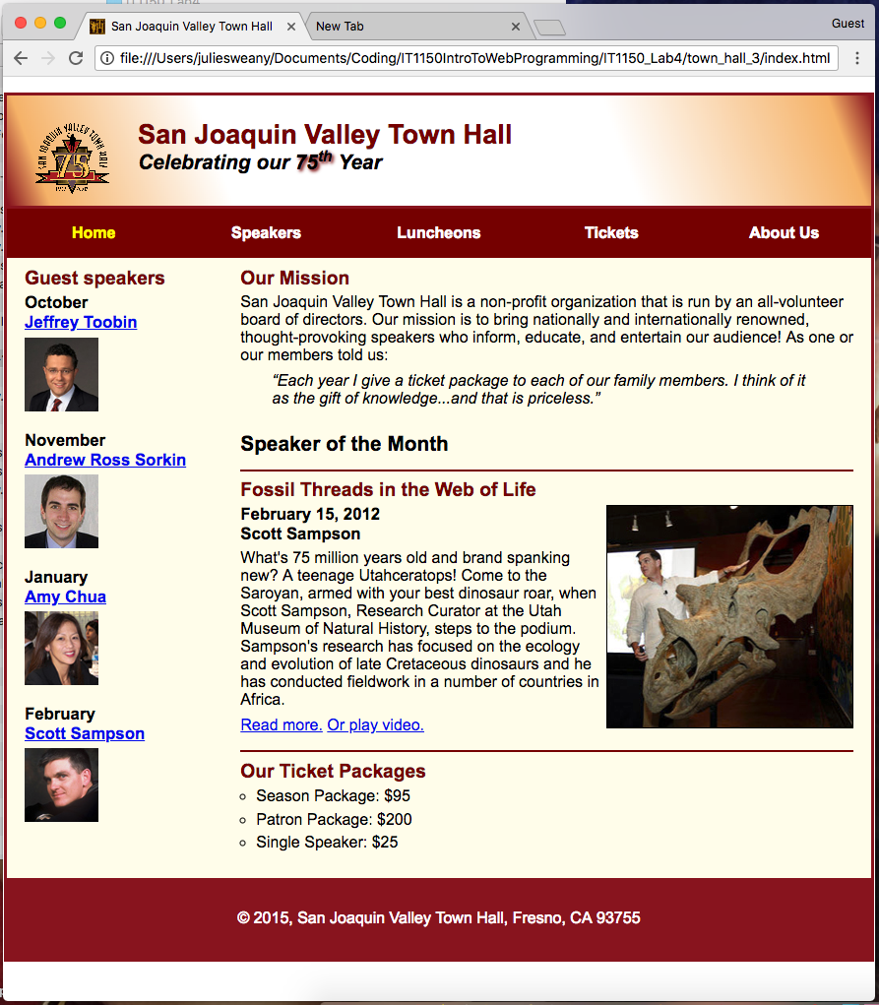

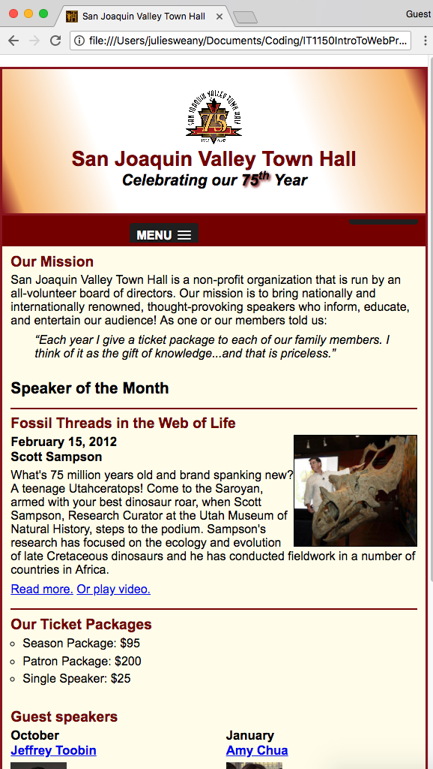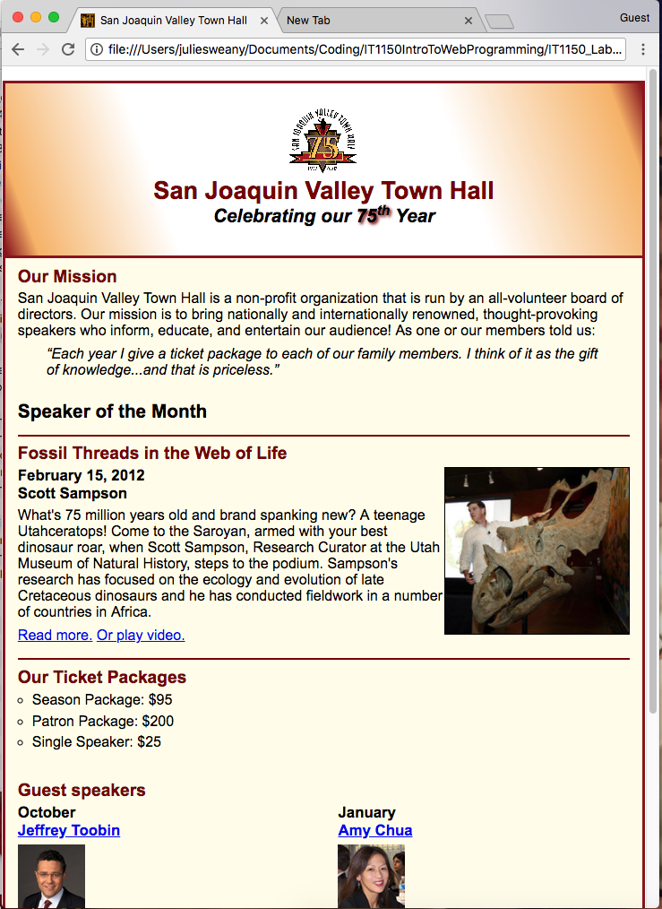**The page as it appears in Chrome when sized between 767 and479 pixels.**



**The page as it appears in Chrome when sized smaller than 479 pixels.**

The HTML for Chapter 8, Exercise 8-1

<!DOCTYPE html>

<html lang="en">

<head>

<meta charset="utf-8">

<meta name="viewport" content="width=device-width, initial-scale=1">

<title>San Joaquin Valley Town Hall</title>

<link rel="shortcut icon" href="images/favicon.ico">

<link rel="stylesheet" href="styles/normalize.css">

<link rel="stylesheet" href="styles/main.css">

<link rel="stylesheet" href="styles/slicknav.css">

<script src="https://code.jquery.com/jquery-2.1.3.min.js"></script>

<script src="js/jquery.slicknav.min.js"></script>

<script type="text/javascript">

$(document).ready(function(){

$('#nav_menu').slicknav({prependTo:"#mobile_menu"});

});

</script>

</head>

<body>

<header>

<img src="images/town_hall_logo.gif" alt="Town Hall Logo" height="80">

<h2>San Joaquin Valley Town Hall</h2>

<h3>Celebrating our <span class="shadow">75<sup>th</sup></span> Year</h3>

</header>

<nav id="mobile_menu"></nav>

<nav id="nav_menu">

<ul>

<li><a href="index.html" class="current">Home</a></li>

<li><a href="speakers.html">Speakers</a></li>

<li><a href="luncheons.html">Luncheons</a></li>

<li><a href="tickets.html">Tickets</a></li>

<li><a href="about.html">About Us</a>

<ul>

<li><a>Our History</a></li>

<li><a>Board of Directors</a></li>

<li><a>Past Speakers</a></li>

<li><a>Contact Information</a></li>

</ul>

</li>

</ul>

</nav>

<main>

<section>

<h2>Our Mission</h2>

<p>San Joaquin Valley Town Hall is a non-profit organization that is run by an all-volunteer board of directors. Our mission is to bring nationally and internationally renowned, thought-provoking speakers who inform, educate, and entertain our audience! As one or our members told us:</p>

<blockquote>&ldquo;Each year I give a ticket package to each of our family members. I think of it as the gift of knowledge...and that is priceless.&rdquo;</blockquote>

<h1>Speaker of the Month</h1>

<article>

<h2>Fossil Threads in the Web of Life</h2>

<img src="images/sampson_dinosaur.jpg" alt="Sampson and dinosaur">

<h3>February 15, 2012<br>

Scott Sampson</h3>

<p>What's 75 million years old and brand spanking new? A teenage Utahceratops! Come to the Saroyan, armed with your best dinosaur roar, when Scott Sampson, Research Curator at the Utah Museum of Natural History, steps to the podium. Sampson's research has focused on the ecology and evolution of late Cretaceous dinosaurs and he has conducted fieldwork in a number of countries in Africa.</p>

<p><a href="speakers/sampson.html">Read more.</a>&nbsp;<a href="media/sampson.swf" type="application/x-shockwave-flash" target="_blank">Or play video.</a></p>

</article>

<h2>Our Ticket Packages</h2>

<ul>

<li>Season Package: $95</li>

<li>Patron Package: $200</li>

<li>Single Speaker: $25</li>

</ul>

</section>

<aside>

<h2>Guest speakers</h2>

<div>

<h3>October<br><a href="speakers/toobin.html">Jeffrey Toobin</a></h3>

<img src="images/toobin75.jpg" alt="Toobin Photo">

<h3>November<br><a href="speakers/sorkin.html">Andrew Ross Sorkin</a></h3>

<img src="images/sorkin75.jpg" alt="Sorkin Photo">

<h3>January<br><a href="speakers/chua.html">Amy Chua</a></h3>

<img src="images/chua75.jpg" alt="Chua Photo">

<h3>February<br><a href="speakers/sampson.html">Scott Sampson</a></h3>

<img src="images/sampson75.jpg" alt="Sampson Photo">

</div>

</aside>

</main>

<footer>

<p>&copy; 2015, San Joaquin Valley Town Hall, Fresno, CA 93755</p>

</footer>

</body>

</html>

The CSS for Chapter 8, Exercise 8-1

/* reset selector */

* {

margin: 0;

padding: 0;

}

/* the styles for the elements */

html {

background-color: #ffffff;

}

body {

background-color: #fffded;

width: 99%;

max-width: 960px;

margin: 1em auto 1em;

border: 3px solid #931420;

font-family: Arial, Helvetica, sans-serif;

font-size: 100%;

}

aside {

width: 20%;

float: left;

padding: 0 0 2% 2%;

}

footer {

background-color: #931420;

padding: 1em;

clear: both;

}

/* hide mobile navigation initially */

#mobile_menu {

display: none;

}

/* the styles for the header */

header {

background-image: linear-gradient(20deg, #931420 0%, #f6bb73 5%, #ffffff 25%,

#ffffff 70%, #f6bb73 95%, #931420 100%);

background-image: -webkit-linear-gradient(20deg, #931420 0%, #f6bb73 5%, #ffffff 25%, #ffffff 70%, #f6bb73 95%, #931420 100%);

background-image: -moz-linear-gradient(20deg, #931420 0%, #f6bb73 5%, #ffffff 25%, #ffffff 70%, #f6bb73 95%, #931420 100%);

background-image: -o-linear-gradient(20deg, #931420 0%, #f6bb73 5%, #ffffff 25%, #ffffff 70%, #f6bb73 95%, #931420 100%);

border-bottom: 3px solid #931420;

padding: 1.5em 0 2em;

}

header img {

float: left;

padding: 0 3% 0;

}

header h2 {

font-size: 170%;

color: #800000;

}

header h3 {

font-size: 130%;

font-style: italic;

}

.shadow {

text-shadow: 2px 2px 4px #800000;

}

/* the styles for the nav_menu class */

#nav_menu ul {

margin: 0;

padding: 0;

list-style-type: none;

position: relative;

}

#nav_menu ul li {

float: left;

width: 20%;

}

#nav_menu ul li a {

text-align: center;

display: block;

padding: 1em 0;

text-decoration: none;

background-color: #800000;

color: white;

font-weight: bold;

}

#nav_menu ul li a.current {

color: yellow;

}

#nav_menu ul ul {

display: none;

position: absolute;

top: 100%;

}

/* makes 2nd tier menu appear vertically*/

#nav_menu ul ul li {

float: none;

}

/* makes 2nd tier menu appear when hovering over li of main menu*/

#nav_menu ul li:hover > ul {

display: block;

}

/* creates an empty block to push 2nd tier menu down*/

#nav_menu > ul::after {

content: "";

display: block;

clear: both;

}

/* the styles for the section */

section {

float: right;

width: 71%;

padding: 0 2% 2%;

}

section h1 {

font-size: 150%;

padding: .5em 0 .0;

}

section h2 {

font-size: 130%;

color: #800000;

padding: .5em 0 .25em;

}

section p {

padding-bottom: .5em;

}

section blockquote {

padding: 0 2em 0;

font-style: italic;

}

aside h3 {

font-size: 105%;

padding-bottom: .25em;

}

aside img {

padding-bottom: 1em;

}

aside h2 {

font-size: 130%;

color: #800000;

padding: .5em 0 .25em;

}

section ul {

padding: 0 0 .25em 1em;

list-style-type: circle;

}

section li {

padding-bottom: .35em;

}

/* the styles for links */

a:hover, a:focus {

font-style: italic;

}

article {

padding: .5em 0 .5em;

border-top: 2px solid #800000;

border-bottom: 2px solid #800000;

}

article img {

float: right;

max-width: 40%;

min-width: 150px;

border: 1px solid #000000;

}

article h1 {

font-size: 150%;

padding: .5em 0 .25em;

}

article h2 {

font-size: 150%;

padding: 0 0 .25em;

}

article h3 {

font-size: 105%;

padding: 0 0 .25em;

}

/* the styles for the footer paragraphs */

footer p {

text-align: center;

color: white;

padding: 1em 0;

}

/* media query to check that viewport is 959px or less wide */

@media only screen and (max-width: 959px) {

section h1 {

font-size: 130%;

}

section h2 {

font-size: 120%;

}

aside h2 {

font-size: 120%;

}

}

/* media query to check that viewport is 767px or less wide */

@media only screen and (max-width: 767px) {

#nav_menu {

display: none;

}

/* display mobile menu */

#mobile_menu {

display: block;

}

.slicknav_menu {

background-color: #800000 !important;

}

header img {

float: none;

padding: 0;

display: block;

margin-left: auto;

margin-right: auto;

}

header h2 {

clear: both;

text-align: center;

}

header h3 {

clear: both;

text-align: center;

}

section {

width: 96%;

float: none;

}

aside {

width: 96%;

margin-right: auto;

margin-left: auto;

float: none;

clear: both;

padding: 0 2% 2% 2%;

}

article img {

max-width: 30%;

}

div {

clear: both;

-moz-column-count: 2;

-webkit-column-count: 2;

column-count: 2;

column-gap: 2em;

}

}

/* media query to check that viewport is 479px or less wide */

@media only screen and (max-width: 479px) {

body {

font-size: 90%;

}

}

# Halloween 8

Again, this exercise reinforced the concepts introduced in the previous exercise. This exercise also provided a little extra practice rearranging the elements on the page using floats, since the vertical navigation on the left was supposed to be displayed underneath the main section on smaller screens.

The page, displayed at a larger size.

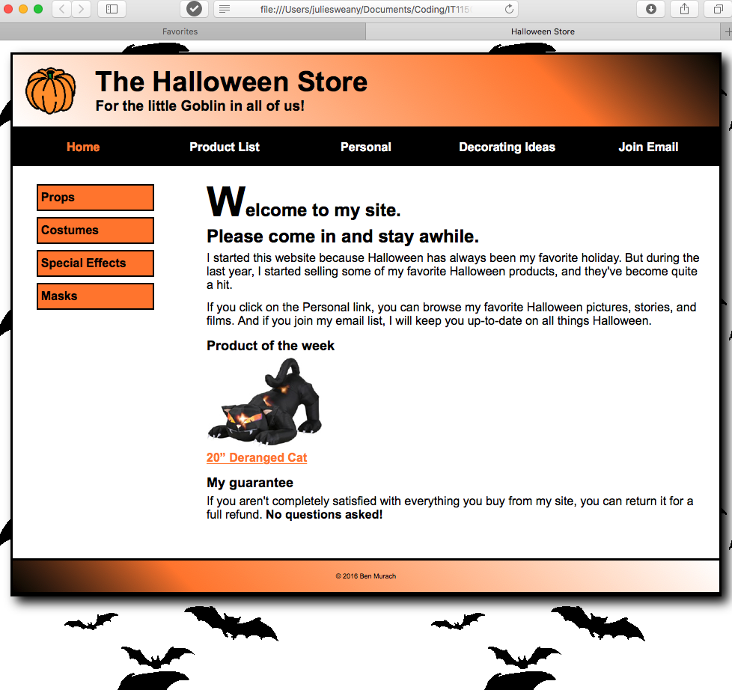

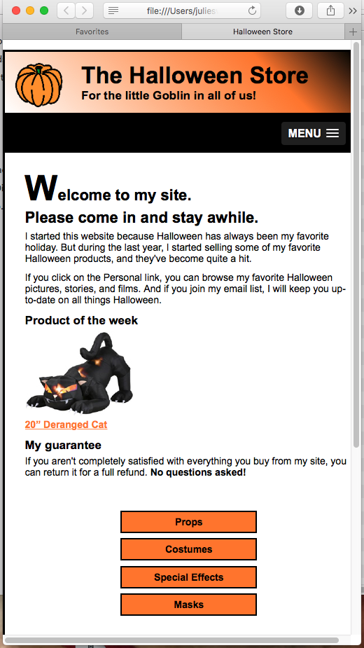

The HTML for Halloween 8

<!DOCTYPE html>

<html lang="en">

<head>

<meta charset="utf-8" />

<meta name="viewport" content="width=device-width, initial-scale=1">

<title>Halloween Store</title>

<link rel="stylesheet" href="styles/normalize.css">

<link rel="stylesheet" href="styles/main_rwd.css">

<link rel="stylesheet" href="styles/slicknav.css">

<script src="https://code.jquery.com/jquery-2.1.3.min.js"></script>

<script src="js/jquery.slicknav.min.js"></script>

<script type="text/javascript">

$(document).ready(function(){

$('#nav_menu').slicknav({prependTo:"#mobile_menu"});

});

</script>

</head>

<body>

<header>

<img src="images/pumpkin.gif" alt="pumpkin">

<h2>The Halloween Store</h2>

<h3>For the little Goblin in all of us!</h3>

</header>

<nav id="mobile_menu"></nav>

<nav id="nav_menu">

<ul>

<li><a href="index.html" class="current">Home</a></li>

<li><a href="products.html">Product List</a></li>

<li><a href="personal.html">Personal</a></li>

<li><a href="decorating.html">Decorating Ideas</a>

<ul>

<li><a>Outdoor</a></li>

<li><a>Indoor</a></li>

<li><a>Table</a></li>

<li><a>Treats</a></li>

</ul></li>

<li><a href="email.html">Join Email</a></li>

</ul>

</nav>

<section>

<h1><span class="large">W</span>elcome to my site.<br>Please come in and stay awhile.</h1>

<p>I started this website because Halloween has always been my favorite holiday. But during the last year, I started selling some of my favorite Halloween products, and they've become quite a hit.</p>

<p>If you click on the Personal link, you can browse my favorite Halloween pictures, stories, and films. And if you join my email list, I will keep you up-to-date on all things Halloween.</p>

<h3>Product of the week</h3>

<a href="slides/products/cat.html"><img src="images/cat1.jpg" alt="cat"></a><br>

<a href="slides/products/cat.html">20&rdquo; Deranged Cat</a>

<h3>My guarantee</h3>

<p>If you aren't completely satisfied with everything you buy from my site, you can return it for a full refund.

<b>No questions asked!</b></p>

</section>

<aside id="sidebar">

<ul>

<li><a href="slides/products/props.html">Props</a>

<li><a href="slides/products/costumes.html">Costumes</a>

<li><a href="slides/products/effects.html">Special Effects</a>

<li><a href="slides/products/masks.html">Masks</a>

</ul>

</aside>

<footer>

<p>&copy; 2016 Ben Murach</p>

</footer>

</body>

</html>

The CSS for Halloween 8

/* reset selector */

* {

margin: 0;

padding: 0;

}

/* style for background behind body */

html {

background-image: url("../images/bats.gif")

}

/* the styles for the elements */

body {

font-family: Arial, Helvetica, sans-serif;

font-size: 100%;

width: 95%;

max-width: 960px;

background-color: white;

margin: 1em auto;

border: 3px solid black;

box-shadow: .5em .5em .9em black;

}

/* the styles for the header */

header img {

float: left;

width: 100%;

max-width: 70px;

min-width: 40px;

}

header h2 {

font-size: 230%;

text-indent: 25px;

}

header h3 {

font-size: 120%;

text-indent: 25px;

}

header {padding: 1em;

border-bottom: 3px solid black;

background-image: linear-gradient(45deg, #ffffff 0%, #FF8033 75%, #000000 100%);

background-image: -webkit-linear-gradient(45deg, #ffffff 0%, #FF8033 75%, #000000 100%);

background-image: -moz-linear-gradient(45deg, #ffffff 0%, #FF8033 75%, #000000 100%);

background-image: -o-linear-gradient(45deg, #ffffff 0%, #FF8033 75%, #000000 100%);

}

/* hide mobile menu initially */

#mobile_menu {

display: none;

}

/* Styles for the navigation menus */

/* the styles for the nav_menu class */

#nav_menu ul {

margin: 0;

padding: 0;

list-style-type: none;

position: relative;

}

#nav_menu ul li {

display: block;

width: 20%;

float: left;

}

#nav_menu ul li a {

text-align: center;

display: block;

padding: 1em 0;

text-decoration: none;

background-color: #000000;

color: white;

font-weight: bold;

}

#nav_menu ul li a.current {

color: #FF8033;

}

#nav_menu ul ul {

display: none;

position: absolute;

top: 100%;

}

/* makes 2nd tier menu appear vertically*/

#nav_menu ul ul li {

display: block;

width: 20%;

}

#nav_menu ul ul li {

display: block;

width: 20%;

float: none;

}

/* makes 2nd tier menu appear when hovering over li of main menu*/

#nav_menu ul li:hover > ul {

display: block;

}

/* creates an empty block to push 2nd tier menu down*/

#nav_menu > ul::after {

content: "";

display: block;

clear: both;

}

/* makes 2nd tier menu li blocks display in gray when hovered over*/

#nav_menu ul li ul li a:hover {

background-color: gray;

}

/* the styles for the sidebar */

#sidebar {

float: left;

margin: 1.5em 1.5em 0 0;

width: 20%;

height: 500px;

}

#sidebar ul {

line-height: 1.5;

}

#sidebar li {

margin-left: 2em;

margin-bottom: .5em;

display: block;

}

#sidebar ul li a {

color: black;

text-decoration: none;

padding: .25em;

display: block;

background-color: #FF8033;

border: 2px solid black;

}

/* the styles for the section */

section {

width: 70%;

float: right;

margin: 0 1.5em 2em;

}

section h1 {

font-size: 150%;

margin-bottom: .25em;

}

section h2 {

font-size: 130%;

}

section h3 {

margin: .75em 0 .25em;

font-size: 115%;

}

section p {

margin-bottom: .75em;

}

section img {

width: 100%;

max-width: 154px;

min-width: 40px;

}

/* style for a class */

.large {

font-size: 230%;

}

/* the styles for links */

a:link, a:focus, a:visited {

font-weight: bold;

color: #FF8033;

}

a:hover {

color: green;

}

/* the styles for the footer */

footer {

clear: both;

border-top: 3px solid black;

padding: 1em;

border-bottom: 3px solid black;

background-image: linear-gradient(45deg, #000000 0%, #FF8033 25%, #FFFFFF 100%);

background-image: -webkit-linear-gradient(45deg, #000000 0%, #FF8033 25%, #FFFFFF 100%);

background-image: -moz-linear-gradient(45deg, #000000 0%, #FF8033 25%, #FFFFFF 100%);

background-image: -o-linear-gradient(45deg, #000000 0%, #FF8033 25%, #FFFFFF 100%);

}

footer p {

text-align: center;

font-size: 50%;

}

/* media query to check that viewport is 800px or less wide */

@media only screen and (max-width: 800px) {

html {

background-image: none;

}

body {

font-size: 90%;

width: 100%;

box-shadow: none;

}

}

/* media query to check that viewport is 767px or less wide */

@media only screen and (max-width: 767px) {

#nav_menu {

display: none;

}

#mobile_menu {

display: block;

}

.slicknav_menu {

background-color: black !important;

}

section {

float: left;

width: 95%;

margin-right: 1em;

padding: .5em;

}

#sidebar {

clear: both;

float: none;

width: 45%;

margin: auto;

}

#sidebar ul li {

text-align: center;}

/* media query to check that viewport is 479px or less wide */

@media only screen and (max-width: 479px) {

section h1 {

font-size: 70%;

}

header {

font-size: 70%;

}

}

# Conclusion

As the saying goes, “the devil is in the details”. Most of the rules behind creating a responsive design aren’t that hard to master, but there are so many individual rule sets and interactions and combinations that it can (and did!) become confusing. These exercises took me far longer to complete than I had thought they would.

I also struggled with the slick nav menus. I suspect that learning more about javascript will help me gain a better understanding of these in the future.

# Resources

Boehm, Anne and Ruvalcaba, Zak. *Murach’s HTML5 and CSS3* 3rd ed. Mike Murach &   
 Associates, Inc. 2015