Julie Sweany

Lab 5

April 16, 2018

IT1150, CRN13094

# Table of Contents

Table of Contents 2

Executive Summary 3

Chapter 10, Exercise 10-1 4

Halloween Exercise, Part 10 14

Chapter 11, Exercise 11-1 27

Halloween Exercise, Part 11 39

Conclusion 49

Resources 50

# Executive Summary

Lab 5 introduces the concepts behind creating tables and forms. In both cases, most of the new material involves creating these elements within the HTML.

For tables, data cells and rows need to be established. It is often helpful to also include a header and footer, and possibly a caption, in addition to the main body of the table.

For forms, there are attributes to master for the form itself, as well as for a variety of input fields, such as text fields, radio buttons, checkboxes, and dropdown lists.

Many of the changes to the CSS in this exercise involve previously covered information. However, properties and attributes specific to tables and forms are also introduced, such as border collapse in tables or pseudo-classes for validation in forms.

Extremely complex tables and forms can be created using HTML and CSS, and Lab 5 explains the essential concepts that make their creation possible.

# Chapter 10, Exercise 10-1

Exercise 10-1 focused on adding a table to a page of the Town Hall website. As usual, the basic structure was established in the HTML and the styling was indicated in the CSS.

To begin, <table> tags were added within the section element of the HTML. Then, within the table, rows were added with <tr> tags, and within those, the <td> tag was placed around the content to be displayed within the fields in that row. Additionally, the <th> tag was used to indicate the header for the table, which applied some default styling and would later provide an easy method for applying specialized styles to that information through the CSS. Finally, at certain places within the HTML, colspan and rowspan were used to create cells that would span multiple columns or rows.

Many standard changes were made to the table through the CSS, including font-weight, color, font-size, and text-align. Three more familiar properties, border-top:, border-bottom: and padding:, controlled the sizing of the cells of the table and created rules between specific rows within the table.

Some of the styling was more specific to tables, as well. The border-collapse: property was set to collapse, which eliminated extra spacing between the table’s cells. As mentioned previously, the <th> tags are helpful within the CSS, essentially serving the same function as a class. Classes are obviously not limited to being used in tables, but they are used extensively for this purpose because they are very useful for applying different styles to different fields of the table. Conveniently, there are also pseudo-classes that are very helpful for styling tables. For instance, I used td: last-child as a selector to align the text in the last column to the right.

The exercise concluded with the addition of a figure caption for the table. In the HTML, the table was enclosed within <figure> tags, and within those, the <figcaption> tags were used. The new caption essentially replaced what had been a heading, so the styles for that heading were then applied to the figcaption within the CSS.

This screenshot shows the completed page for Exercise 10-1 in the Safari browser. Since there weren’t significant differences in the appearance when viewed in different browsers, I’ve included just one example per exercise throughout this lab.

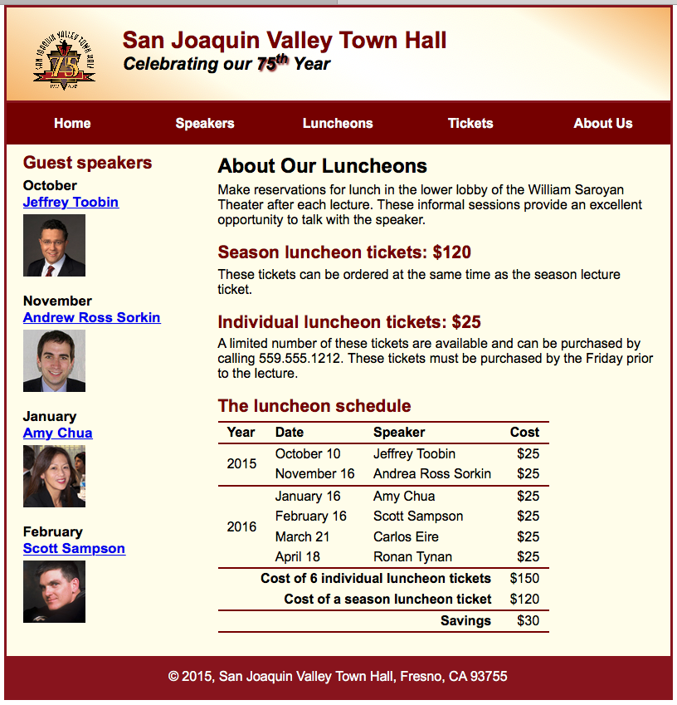

HTML for Exercise 10-1

<!DOCTYPE html>

<html lang="en">

<head>

<meta charset="utf-8">

<title>San Joaquin Valley Town Hall</title>

<link rel="shortcut icon" href="images/favicon.ico">

<link rel="stylesheet" href="styles/normalize.css">

<link rel="stylesheet" href="styles/main.css">

</head>

<body>

<header>

<img src="images/town_hall_logo.gif" alt="Town Hall logo" height="80">

<h2>San Joaquin Valley Town Hall</h2>

<h3>Celebrating our <span class="shadow">75<sup>th</sup></span> Year</h3>

</header>

<nav id="nav_menu">

<ul>

<li><a href="index.html">Home</a></li>

<li><a href="speakers.html">Speakers</a></li>

<li><a href="luncheons.html">Luncheons</a></li>

<li><a href="tickets.html">Tickets</a></li>

<li><a href="aboutus.html"> About Us</a>

<ul>

<li><a href="#">Our History</a></li>

<li><a href="#">Board of Directors</a></li>

<li><a href="#">Past Speakers</a></li>

<li><a href="#">Contact Information</a></li>

</ul>

</li>

</ul>

</nav>

<main>

<section>

<h1>About Our Luncheons</h1>

<p>Make reservations for lunch in the lower lobby of the William Saroyan Theater after each lecture.

These informal sessions provide an excellent opportunity to talk with the speaker.</p>

<h2>Season luncheon tickets: $120</h2>

<p>These tickets can be ordered at the same time as the season lecture ticket.</p>

<h2>Individual luncheon tickets: $25</h2>

<p>A limited number of these tickets are available and can be purchased by calling

559.555.1212. These tickets must be purchased by the Friday prior to the lecture.</p>

<figure>

<figcaption>The luncheon schedule</figcaption>

<table>

<tr><th>Year</th>

<th>Date</th>

<th>Speaker</th>

<th>Cost</th></tr>

<tbody>

<tr><td rowspan="2">2015</td><td>October 10</td><td>Jeffrey Toobin</td><td>$25</td></tr>

<tr><td>November 16</td><td>Andrea Ross Sorkin</td><td>$25</td></tr>

<tr class="topborder"><td rowspan="4">2016</td><td>January 16</td><td>Amy Chua</td><td>$25</td></tr>

<tr><td>February 16</td><td>Scott Sampson</td><td>$25</td></tr>

<tr><td>March 21</td><td>Carlos Eire</td><td>$25</td></tr>

<tr><td>April 18</td><td>Ronan Tynan</td><td>$25</td></tr>

<tr class="topborder"><td colspan="3" class="boldright">Cost of 6 individual luncheon tickets</td><td>$150</td></tr>

<tr><td colspan="3" class="boldright">Cost of a season luncheon ticket</td><td>$120</td></tr>

<tr class="topbottomborder"><td colspan="3" class="boldright">Savings</td><td>$30</td></tr>

</tbody>

</table>

</figure>

</section>

<aside>

<h2>Guest speakers</h2>

<h3>October<br><a href="speakers/toobin.html">Jeffrey Toobin</a></h3>

<img src="images/toobin75.jpg" alt="Jeffrey Toobin photo">

<h3>November<br><a href="../speakers/sorkin.html">Andrew Ross Sorkin</a></h3>

<img src="images/sorkin75.jpg" alt="Andrew Ross Sorkin photo">

<h3>January<br><a href="../speakers/chua.html">Amy Chua</a></h3>

<img src="images/chua75.jpg" alt="Amy Chua photo">

<h3>February<br><a href="../speakers/sampson.html">Scott Sampson</a></h3>

<img src="images/sampson75.jpg" alt="Scott Sampson photo">

</aside>

</main>

<footer>

<p>&copy; 2015, San Joaquin Valley Town Hall, Fresno, CA 93755</p>

</footer>

</body>

</html>

CSS for Exercise 10-1

/* the styles for the elements */

* {

margin: 0;

padding: 0;

}

html {

background-color: white;

}

body {

font-family: Arial, Helvetica, sans-serif;

font-size: 100%;

width: 800px;

margin: 0 auto;

border: 3px solid #931420;

background-color: #fffded;

}

a:focus, a:hover {

font-style: italic;

}

/* the styles for the header */

header {

padding: 1.5em 0 2em 0;

border-bottom: 3px solid #931420;

background-image: -moz-linear-gradient(

30deg, #f6bb73 0%, #f6bb73 30%, white 50%, #f6bb73 80%, #f6bb73 100%);

background-image: -webkit-linear-gradient(

30deg, #f6bb73 0%, #fffded 30%, white 50%, #fffded 80%, #f6bb73 100%);

background-image: -o-linear-gradient(

30deg, #f6bb73 0%, #fffded 30%, white 50%, #fffded 80%, #f6bb73 100%);

background-image: linear-gradient(

30deg, #f6bb73 0%, #fffded 30%, white 50%, #fffded 80%, #f6bb73 100%);

}

header h2 {

font-size: 175%;

color: #800000;

}

header h3 {

font-size: 130%;

font-style: italic;

}

header img {

float: left;

padding: 0 30px;

}

.shadow {

text-shadow: 2px 2px 2px #800000;

}

/* the styles for the navigation menu */

#nav_menu ul {

list-style-type: none;

margin: 0;

padding: 0;

position: relative;

}

#nav_menu ul li {

float: left;

}

#nav_menu ul li a {

display: block;

width: 160px;

text-align: center;

padding: 1em 0;

text-decoration: none;

background-color: #800000;

color: white;

font-weight: bold;

}

#nav_menu a.current {

color: yellow;

}

#nav_menu ul ul {

display: none;

position: absolute;

top: 100%;

}

#nav_menu ul ul li {

float: none;

}

#nav_menu ul li:hover > ul {

display: block;

}

#nav_menu > ul::after {

content: "";

clear: both;

display: block;

}

/* the styles for the main content */

main {

clear: left;

}

/* the styles for the section */

section {

width: 525px;

float: right;

padding: 0 20px 20px 20px;

}

section h1 {

font-size: 150%;

padding: .5em 0 .25em 0;

margin: 0;

}

section h2 {

color: #800000;

font-size: 130%;

padding: .5em 0 .25em 0;

}

section p {

padding-bottom: .5em;

}

section blockquote {

padding: 0 2em;

font-style: italic;

}

section ul {

padding: 0 0 .25em 1.25em;

list-style-type: circle;

}

section li {

padding-bottom: .35em;

}

/* the styles for the table */

table {

border-collapse: collapse;

}

figure, figcaption {

margin: 0;

padding: 0;

}

figcaption {

display: block;

font-weight: bold;

color: #800000;

font-size: 130%;

padding: .5em 0 .25em 0;

}

th, td {

padding: .2em .7em;

text-align: left;

}

td:last-child {

text-align: right;

}

th {

border-top: .15em solid #800000;

border-bottom: .15em solid #800000;

}

tr.bottomborder {

border-bottom: .15em solid #800000;

}

tr.topborder {

border-top: .15em solid #800000;

}

tr.topbottomborder {

border-top: .15em solid #800000;

border-bottom: .15em solid #800000;

}

td.boldright {

text-align: right;

font-weight: bold;

}

/* the styles for the article */

article {

padding: .5em 0;

border-top: 2px solid #800000;

border-bottom: 2px solid #800000;

}

article h2 {

padding-top: 0;

}

article h3 {

font-size: 105%;

padding-bottom: .25em;

}

article img {

float: right;

margin: .5em 0 1em 1em;

border: 1px solid black;

}

/* the styles for the aside */

aside {

width: 215px;

float: right;

padding: 0 0 20px 20px;

}

aside h2 {

color: #800000;

font-size: 130%;

padding: .5em 0 .25em 0;

}

aside h3 {

font-size: 105%;

padding-bottom: .25em;

}

aside img {

padding-bottom: 1em;

}

/* the styles for the footer */

footer {

background-color: #931420;

clear: both;

}

footer p {

text-align: center;

color: white;

padding: 1em 0;

}

# Halloween Exercise, Part 10

As is usually the case, this Halloween exercise reinforced concepts introduced in the previous example. The <table>, <tr>, <td>, and <th> tags are again used in the HTML to establish the structure of the table, followed up with styling of the table within the CSS.

New to this exercise are the links in the “Description” column and the background color of the “Price” column. To use links within a table, the <a> tags simply get nested within the <td> tags. The background color was added in the CSS. Using the selector td: last-child made it possible to easily add the background-color property to only the last column.

The finished page for Halloween Exercise, Part 10.

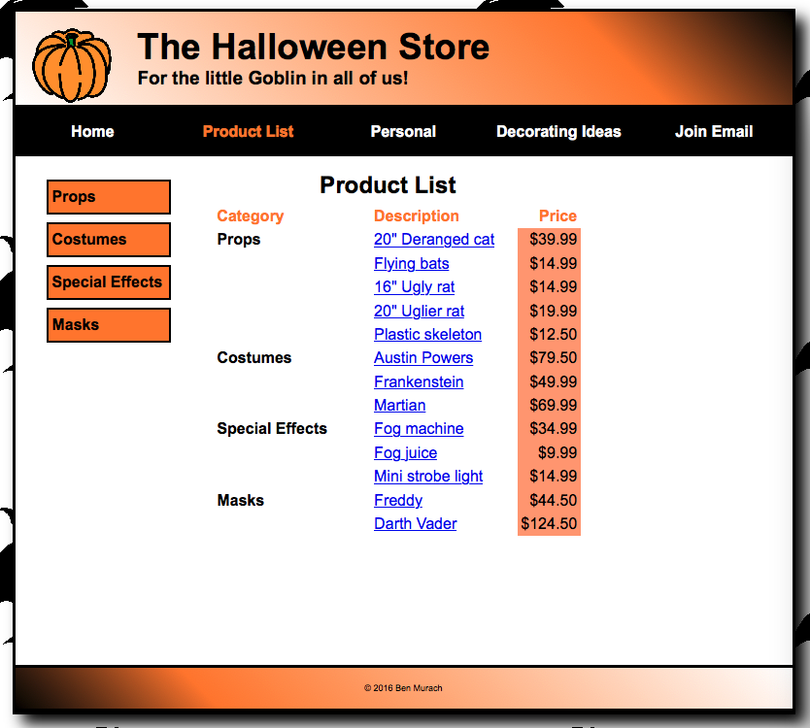

HTML for Halloween Exercise, Part 10

<!DOCTYPE html>

<html lang="en">

<head>

<meta charset="utf-8" />

<meta name="viewport" content="width=device-width, initial-scale=1">

<title>Halloween Store</title>

<link rel="stylesheet" href="styles/normalize.css">

<link rel="stylesheet" href="styles/main.css">

</head>

<body>

<header>

<img src="images/pumpkin.gif" alt="pumpkin">

<h2>The Halloween Store</h2>

<h3>For the little Goblin in all of us!</h3>

</header>

<nav id="nav_menu">

<ul>

<li><a href="index.html">Home</a></li>

<li><a href="products.html" class="current">Product List</a></li>

<li><a href="personal.html">Personal</a></li>

<li><a href="decorating.html">Decorating Ideas</a>

<ul>

<li><a>Outdoor</a></li>

<li><a>Indoor</a></li>

<li><a>Table</a></li>

<li><a>Treats</a></li>

</ul></li>

<li><a href="email.html">Join Email</a></li>

</ul>

</nav>

<aside id="sidebar">

<ul>

<li><a href="slides/products/props.html">Props</a>

<li><a href="slides/products/costumes.html">Costumes</a>

<li><a href="slides/products/effects.html">Special Effects</a>

<li><a href="slides/products/masks.html">Masks</a>

</ul>

</aside>

<section>

<figure>

<figcaption>Product List</figcaption>

<table>

<tr>

<th>Category</th><th>Description</th><th>Price</th></tr>

<tbody>

<tr><td>Props</td><td><a href="products/cat.html">20&quot; Deranged cat</a></td><td>$39.99</td></tr>

<tr><td></td><td><a href="products/bats.html">Flying bats</a></td><td>$14.99</td></tr>

<tr><td></td><td><a href="products/uglyrat.html">16&quot; Ugly rat</a></td><td>$14.99</td></tr>

<tr><td></td><td><a href="products/uglierrat.html">20&quot; Uglier rat</a></td><td>$19.99</td></tr>

<tr><td></td><td><a href="products/skeleton.html">Plastic skeleton</a></td><td>$12.50</td></tr>

<tr><td>Costumes</td><td><a href="products/austinpowers.html">Austin Powers</a></td><td>$79.50</td></tr>

<tr><td></td><td><a href="products/frankenstein.html">Frankenstein</a></td><td>$49.99</td></tr>

<tr><td></td><td><a href="products/martian.html">Martian</a></td><td>$69.99</td></tr>

<tr><td>Special Effects</td><td><a href="products/fogmachine.html">Fog machine</a></td><td>$34.99</td></tr>

<tr><td></td><td><a href="products/fogjuice.html">Fog juice</a></td><td>$9.99</td></tr>

<tr><td></td><td><a href="products/strobe.html">Mini strobe light</a></td><td>$14.99</td></tr>

<tr><td>Masks</td><td><a href="products/freddy.html">Freddy</a></td><td>$44.50</td></tr>

<tr><td></td><td><a href="products/darth.html">Darth Vader</a></td><td>$124.50</td></tr>

</tbody>

</table>

</figure>

</section>

<footer>

<p>&copy; 2016 Ben Murach</p>

</footer>

</body>

</html>

CSS for Halloween Exercise, Part 10

/* reset selector */

* {

margin: 0;

padding: 0;

}

/* style for background behind body */

html {

background-image: url("../images/bats.gif")

}

/* the styles for the elements */

body {

font-family: Arial, Helvetica, sans-serif;

font-size: 100%;

width: 800px;

background-color: white;

margin: 1em auto;

border: 3px solid black;

box-shadow: 10px 10px 15px black;

}

/* the styles for the header */

header img {

float: left;

}

header h2 {

font-size: 230%;

text-indent: 25px;

}

header h3 {

font-size: 120%;

text-indent: 25px;

}

header {padding: 1em;

border-bottom: 3px solid black;

background-image: linear-gradient(45deg, #ffffff 0%, #FF8033 75%, #000000 100%);

background-image: -webkit-linear-gradient(45deg, #ffffff 0%, #FF8033 75%, #000000 100%);

background-image: -moz-linear-gradient(45deg, #ffffff 0%, #FF8033 75%, #000000 100%);

background-image: -o-linear-gradient(45deg, #ffffff 0%, #FF8033 75%, #000000 100%);

}

/* Styles for the navigation menus */

/* the styles for the nav_menu class */

#nav_menu ul {

margin: 0;

padding: 0;

list-style-type: none;

position: relative;

}

#nav_menu ul li {

float: left;

}

#nav_menu ul li a {

width: 160px;

text-align: center;

display: block;

padding: 1em 0;

text-decoration: none;

background-color: #000000;

color: white;

font-weight: bold;

}

#nav_menu ul li a.current {

color: #FF8033;

}

#nav_menu ul ul {

display: none;

position: absolute;

top: 100%;

}

/* makes 2nd tier menu appear vertically*/

#nav_menu ul ul li {

float: none;

}

/* makes 2nd tier menu appear when hovering over li of main menu*/

#nav_menu ul li:hover > ul {

display: block;

}

/* creates an empty block to push 2nd tier menu down*/

#nav_menu > ul::after {

content: "";

display: block;

clear: both;

}

/* makes 2nd tier menu li blocks display in gray when hovered over*/

#nav_menu ul li ul li a:hover {

background-color: gray;

}

/* the styles for the sidebar */

#sidebar {

float: left;

margin: 1.5em 1.5em 0 0;

width: 160px;

height: 500px;

}

#sidebar ul {

line-height: 1.5;

}

#sidebar li {

margin-left: 2em;

margin-bottom: .5em;

display: block;

}

#sidebar ul li a {

color: black;

text-decoration: none;

font-weight: bold;

padding: .25em;

display: block;

background-color: #FF8033;

border: 2px solid black;

}

/* the styles for the section */

section {

margin: 1em 1.5em 2em;

}

section h1 {

font-size: 150%;

margin-bottom: .25em;

}

section h2 {

font-size: 130%;

}

section h3 {

margin: .75em 0 .25em;

font-size: 115%;

}

section p {

margin-bottom: .75em;

}

/* the styles for the table */

td {

padding: .2em 1.5em;

text-align: left;

}

th {

padding: .2em 1.5em;

text-align: left;

color: #FF8033;

}

figcaption {

font-size: 150%;

font-weight: bold;

text-align: center;

margin-bottom: .25em;

}

figure {

width: 35em;

}

th:last-child {

padding: .2em .2em;

text-align: right;

}

td:first-child {

font-weight: bold;

}

td:last-child {

text-align: right;

background-color: #FFA07A;

padding: .2em .2em;

}

/* style for a class */

.large {

font-size: 230%;

}

/* the styles for the footer */

footer {

clear: both;

border-top: 3px solid black;

padding: 1em;

border-bottom: 3px solid black;

background-image: linear-gradient(45deg, #000000 0%, #FF8033 25%, #FFFFFF 100%);

background-image: -webkit-linear-gradient(45deg, #000000 0%, #FF8033 25%, #FFFFFF 100%);

background-image: -moz-linear-gradient(45deg, #000000 0%, #FF8033 25%, #FFFFFF 100%);

background-image: -o-linear-gradient(45deg, #000000 0%, #FF8033 25%, #FFFFFF 100%);

}

footer p {

text-align: center;

font-size: 50%;

}

# Chapter 11, Exercise 11-1

Exercise 11-1 centered on adding a form to a page of the Town Hall sample website. The provided tickets.html page included a significant start toward the finished form. The <form> tags, along with the appropriate attributes, such as action, method, and name were included from the start. Also, several fieldsets grouped similar controls together, and examples of different kinds of input fields, labels, and buttons had been included.

The first few steps of the exercise dealt with some familiar properties, such as margins, padding, borders, and colors. New this time, were the selectors used within the CSS — fieldset for the groupings of like content within the form and legend, which is a way of displaying text that identifies or describes that grouping.

Next, the directions asked for some changes to the HTML. Combining two fieldsets was fairly straightforward, since it only involved removing a closing and opening <fieldset> tag. Changing the legend was as simple as finding the correct <legend> tags and making a change to the text enclosed within them.

Changes became more involved with the instruction to add a “Payment Method” fieldset with two radio buttons. Using input type=”radio” and using the same name attribute created two radio buttons. (For radio buttons, only one can be selected at a time. This is as opposed to check boxes, where more than one can be selected at a given time.) A label for each of the buttons was also added within the HTML, and then it was time to use the CSS to adjust the placement. Since the labels usually appear to the left of their associated input elements, it was necessary to use a float and adjust the widths for the radio buttons and for the labels in order to get the placement right.

Next, a dropdown list was added. An <option> tag that included a different value attribute for each of the choices was written for each of the choices within the “Card Type” list. Dropdown lists for expiration date years and months were also created.

Finally, validation was added for the “Card Number” field by adding pattern=”\d{16}” within the field’s input tag.

The final page for Exercise 11-1 displayed in the Firefox browser.

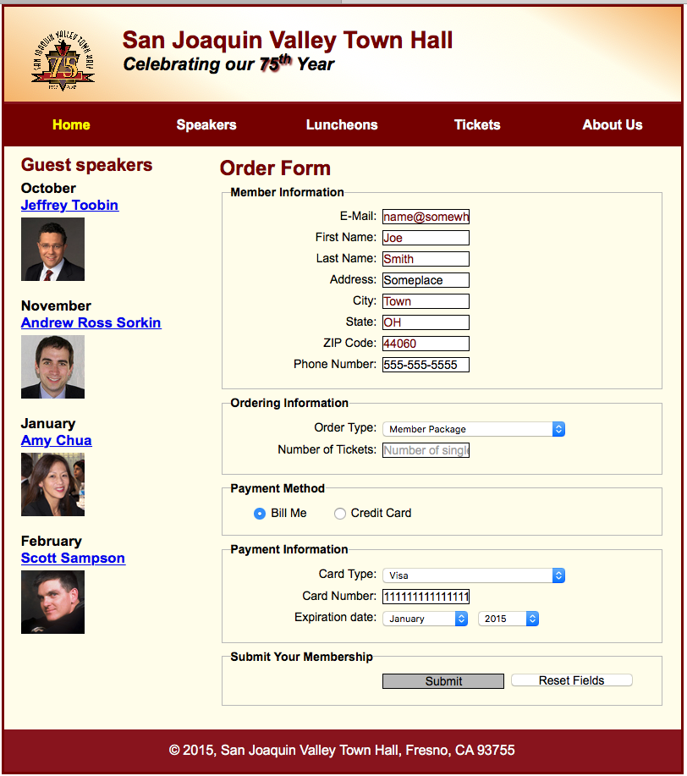

The result of clicking the Submit button on the page for Exercise 11-1.

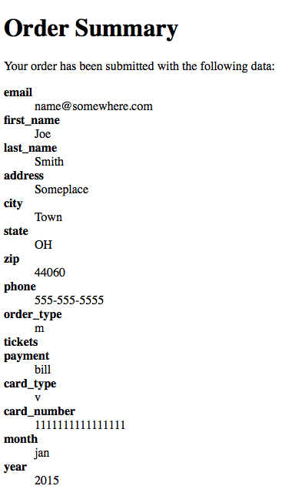

The HTML for Chapter 11, Exercise 11-1

<!DOCTYPE html>

<html lang="en">

<head>

<meta charset="utf-8">

<title>San Joaquin Valley Town Hall</title>

<link rel="shortcut icon" href="images/favicon.ico">

<link rel="stylesheet" href="styles/normalize.css">

<link rel="stylesheet" href="styles/tickets.css">

</head>

<body>

<header>

<img src="images/town_hall_logo.gif" alt="Town Hall logo" height="80">

<h2>San Joaquin Valley Town Hall</h2>

<h3>Celebrating our <span class="shadow">75<sup>th</sup></span> Year</h3>

</header>

<nav id="nav_menu">

<ul>

<li><a href="index.html" class="current">Home</a></li>

<li><a href="speakers.html">Speakers</a></li>

<li><a href="luncheons.html">Luncheons</a></li>

<li><a href="tickets.html">Tickets</a></li>

<li><a href="aboutus.html"> About Us</a>

<ul>

<li><a href="#">Our History</a></li>

<li><a href="#">Board of Directors</a></li>

<li><a href="#">Past Speakers</a></li>

<li><a href="#">Contact Information</a></li>

</ul>

</li>

</ul>

</nav>

<main>

<section>

<h1>Order Form</h1>

<form action="register_account.html" method="get"

name="registration_form" id="registration_form">

<fieldset>

<legend>Member Information</legend>

<label for="email">E-Mail:</label>

<input type="email" name="email" id="email" autofocus required><br>

<label for="first_name">First Name:</label>

<input type="text" name="first_name" id="first_name" required><br>

<label for="last_name">Last Name:</label>

<input type="text" name="last_name" id="last_name" required><br>

<label for="address">Address:</label>

<input type="text" name="address" id="address"><br>

<label for="city">City:</label>

<input type="text" name="city" id="city" required><br>

<label for="state">State:</label>

<input type="text" name="state" id="state" required maxlength="2" placeholder="2-character code"><br>

<label for="zip">ZIP Code:</label>

<input type="text" name="zip" id="zip" required placeholder="5 or 9 digits"

pattern="^\d{5}(-\d{4})?$" title="Either 5 or 9 digits"><br>

<label for="phone">Phone Number:</label>

<input type="tel" name="phone" id="phone" placeholder="999-999-9999"

pattern="\d{3}[\-]\d{3}[\-]\d{4}" title="Must be 999-999-999 format"><br>

</fieldset>

<fieldset>

<legend>Ordering Information</legend>

<label for="order_type">Order Type:</label>

<select name="order_type" id="order_type">

<option value="m">Member Package</option>

<option value="d">Donor Package</option>

<option value="s">Single Tickets</option>

</select><br>

<label for="tickets">Number of Tickets:</label>

<input type="text" name="tickets" id="tickets" placeholder="Number of single tickets"><br>

</fieldset>

<fieldset id="payment_method">

<legend>Payment Method</legend>

<input type="radio" name="payment" id="payment1" value="bill"><label for="payment1">Bill Me</label>

<input type="radio" name="payment" id="payment2" value="credit"><label for="payment2">Credit Card</label>

</fieldset>

<fieldset>

<legend>Payment Information</legend>

<label for="card_type">Card Type:</label>

<select name="card_type" id="card_type">

<option value="v">Visa</option>

<option value="m">MasterCard</option>

<option value="d">Discover</option>

</select><br>

<label for="card_number">Card Number:</label>

<input type="text" name="card_number" id="card_number" pattern="\d{16}" placeholder="16 digits"><br>

<label>Expiration date:</label>

<select name="month" id="month">

<option value="jan">January</option>

<option value="feb">February</option>

<option value="mar">March</option>

<option value="apr">April</option>

<option value="may">May</option>

<option value="june">June</option>

<option value="july">July</option>

<option value="aug">August</option>

<option value="sept">September</option>

<option value="oct">October</option>

<option value="nov">November</option>

<option value="dec">December</option>

</select>

<select name="year" id="year">

<option value="2015">2015</option>

<option value="2016">2016</option>

<option value="2017">2017</option>

<option value="2018">2018</option>

<option value="2019">2019</option>

</select>

</fieldset>

<fieldset id="buttons">

<legend>Submit Your Membership</legend>

<label>&nbsp;</label>

<input type="submit" id="submit" value="Submit">

<input type="reset" id="reset" value="Reset Fields">

</fieldset>

</form>

</section>

<aside>

<h2>Guest speakers</h2>

<h3>October<br><a href="speakers/toobin.html">Jeffrey Toobin</a></h3>

<img src="images/toobin75.jpg" alt="Jeffrey Toobin photo">

<h3>November<br><a href="speakers/sorkin.html">Andrew Ross Sorkin</a></h3>

<img src="images/sorkin75.jpg" alt="Andrew Ross Sorkin photo">

<h3>January<br><a href="speakers/chua.html">Amy Chua</a></h3>

<img src="images/chua75.jpg" alt="Amy Chua photo">

<h3>February<br><a href="speakers/c7_sampson.html">Scott Sampson</a></h3>

<img src="images/sampson75.jpg" alt="Scott Sampson photo">

</aside>

</main>

<footer>

<p>&copy; 2015, San Joaquin Valley Town Hall, Fresno, CA 93755</p>

</footer>

</body>

</html>

The CSS for Chapter 11, Exercise 11-1

/* the styles for the elements */

* {

margin: 0;

padding: 0;

}

html {

background-color: white;

}

body {

font-family: Arial, Helvetica, sans-serif;

font-size: 100%;

width: 800px;

margin: 0 auto;

border: 3px solid #800000;

background-color: #fffded;

}

a:focus, a:hover {

font-style: italic;

}

/* the styles for the header */

header {

padding: 1.5em 0 2em 0;

border-bottom: 3px solid #931420;

background-image: -moz-linear-gradient(

30deg, #f6bb73 0%, #f6bb73 30%, white 50%, #f6bb73 80%, #f6bb73 100%);

background-image: -webkit-linear-gradient(

30deg, #f6bb73 0%, #fffded 30%, white 50%, #fffded 80%, #f6bb73 100%);

background-image: -o-linear-gradient(

30deg, #f6bb73 0%, #fffded 30%, white 50%, #fffded 80%, #f6bb73 100%);

background-image: linear-gradient(

30deg, #f6bb73 0%, #fffded 30%, white 50%, #fffded 80%, #f6bb73 100%);

}

header h2 {

font-size: 175%;

color: #800000;

}

header h3 {

font-size: 130%;

font-style: italic;

}

header img {

float: left;

padding: 0 30px;

}

.shadow {

text-shadow: 2px 2px 2px #800000;

}

/* the styles for the form */

fieldset {

margin-top: 0;

margin-bottom: .5em;

padding: .5em 1em;

}

legend {

color: #000000;

font-weight: bold;

font-size: 85%;

margin-bottom: .5em;

}

label {

float: left;

width: 12em;

text-align: right;

}

label, input, select {

font-size: 90%;

}

input, select {

width: 15em;

margin-left: .5em;

margin-bottom: .5em;

}

input:required, input[required] {

border: 2px solid #800000;

color: #800000;

}

input:valid {

border: 1px solid black;

}

input:invalid {

border: 2px solid #800000;

box-shadow: none;

}

br {

clear: both;

}

#order_type, input, select {

width: 15em;

margin-left: .5em;

}

#card_type, input, select {

width: 15em;

margin-left: .5em;

}

#year, input, select {

width: 5em;

margin-left: .5em;

}

#month, input, select {

width: 7em;

margin-left: .5em;

}

#payment_method label {

float: none;

text-align: left;

width: 9em;

margin-left: .5em;

}

#payment_method input, select {

float: none;

width: auto;

margin-right: .5em;

margin-left: 2em;

margin-bottom: .5em;

}

#buttons input {

float: left;

width: 10em;

}

/* the styles for the navigation menu */

#nav_menu ul {

list-style-type: none;

margin: 0;

padding: 0;

position: relative;

}

#nav_menu ul li {

float: left;

}

#nav_menu ul li a {

display: block;

width: 160px;

text-align: center;

padding: 1em 0;

text-decoration: none;

background-color: #800000;

color: white;

font-weight: bold;

}

#nav_menu a.current {

color: yellow;

}

#nav_menu ul ul {

display: none;

position: absolute;

top: 100%;

}

#nav_menu ul ul li {

float: none;

}

#nav_menu ul li:hover > ul {

display: block;

}

#nav_menu > ul::after {

content: "";

clear: both;

display: block;

}

/* the styles for the main content */

main {

clear: left;

}

/* the styles for the section */

section {

width: 525px;

float: right;

padding: 0 20px 20px 20px;

}

section h1 {

font-size: 150%;

color: #800000;

padding: .5em 0 .25em 0;

margin: 0;

}

/* the styles for the aside */

aside {

width: 215px;

float: right;

padding: 0 0 20px 20px;

}

aside h2 {

color: #800000;

font-size: 130%;

padding: .5em 0 .25em 0;

}

aside h3 {

font-size: 105%;

padding-bottom: .25em;

}

aside img {

padding-bottom: 1em;

}

/* the styles for the footer */

footer {

background-color: #931420;

clear: both;

}

footer p {

text-align: center;

color: white;

padding: 1em 0;

}

# Halloween Exercise, Part 11

This exercise provided additional practice developing forms. New for this part of the lab were formatting the Subscribe button and including a message to help the user correctly input information. Another new concept was using the Subscribe button to link to another page of the website.

Adding an id within the <input> tags for the button allowed me to make changes specific to only that button within the CSS. Using many familiar properties, such as margin-top, background-color, font-weight, width, and height, I was able to match the button’s appearance with the desired effect.

To help users understand that 5 digits should be entered for the zip code, a pop-up message was added. The message appears when the mouse hovers over the input field or after information in the wrong format has been entered. This was achieved by adding to the <input> tag for that button a pattern attribute for validation and a title attribute to display the message, when appropriate.

The Subscribe button’s link to the subscribe.html page was achieved by indicating the relative URL for the page as the action within the opening <form> tag.

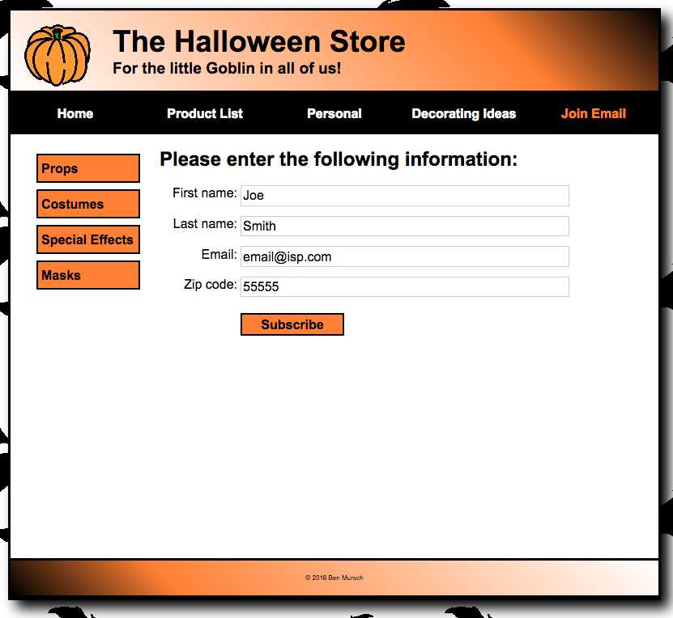

The completed page for the Halloween Exercise, Part 11.

The error message that appears if the entered zip code does not conform to the expected format.

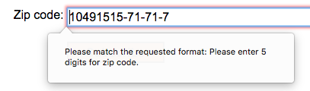

The linked page that displays when the Subscribe button is clicked.

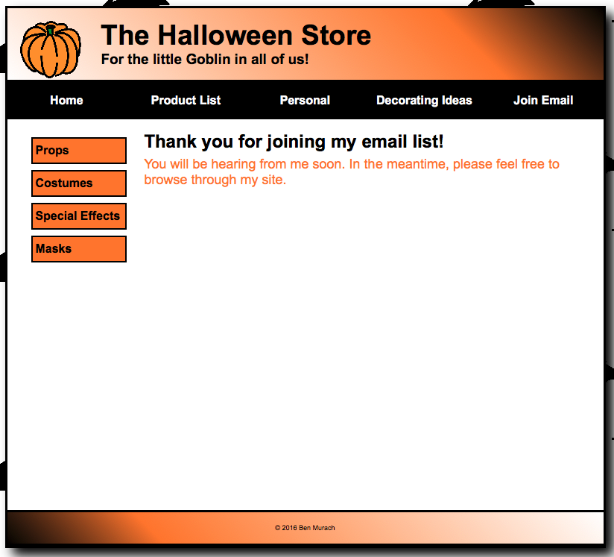

The HTML for Halloween 11

email.html

<!DOCTYPE html>

<html lang="en">

<head>

<meta charset="utf-8" />

<meta name="viewport" content="width=device-width, initial-scale=1">

<title>Halloween Store</title>

<link rel="stylesheet" href="styles/normalize.css">

<link rel="stylesheet" href="styles/email.css">

</head>

<body>

<header>

<img src="images/pumpkin.gif" alt="pumpkin">

<h2>The Halloween Store</h2>

<h3>For the little Goblin in all of us!</h3>

</header>

<nav id="nav_menu">

<ul>

<li><a href="index.html">Home</a></li>

<li><a href="products.html">Product List</a></li>

<li><a href="personal.html">Personal</a></li>

<li><a href="decorating.html">Decorating Ideas</a>

<ul>

<li><a>Outdoor</a></li>

<li><a>Indoor</a></li>

<li><a>Table</a></li>

<li><a>Treats</a></li>

</ul></li>

<li><a href="email.html" class="current">Join Email</a></li>

</ul>

</nav>

<aside id="sidebar">

<ul>

<li><a href="slides/products/props.html">Props</a>

<li><a href="slides/products/costumes.html">Costumes</a>

<li><a href="slides/products/effects.html">Special Effects</a>

<li><a href="slides/products/masks.html">Masks</a>

</ul>

</aside>

<section>

<h1>Please enter the following information:</h1>

<form name="email_form" action="subscribe.html">

<label for="firstname">First name:</label>

<input type="text" name="firstname" id="firstname" autofocus required><br>

<label for="lastname">Last name:</label>

<input type="text" name="lastname" id="lastname" required><br>

<label for="email">Email:</label>

<input type="text" name="email" id="email" required><br>

<label for="zip">Zip code:</label>

<input type="text" name="zip" id="zip" placeholder="Optional, but appreciated: 99999" pattern="\d{5}" title="Please enter 5 digits for zip code"><br>

<label></label>

<input type="submit" name="Subscribe" value="Subscribe" id="button">

</form>

</section>

<footer>

<p>&copy; 2016 Ben Murach</p>

</footer>

</body>

</html>

The CSS for Halloween 11

email.css

/* reset selector */

* {

margin: 0;

padding: 0;

}

/* style for background behind body */

html {

background-image: url("../images/bats.gif")

}

/* the styles for the elements */

body {

font-family: Arial, Helvetica, sans-serif;

font-size: 100%;

width: 800px;

background-color: white;

margin: 1em auto;

border: 3px solid black;

box-shadow: 10px 10px 15px black;

}

/* the styles for the header */

header img {

float: left;

}

header h2 {

font-size: 230%;

text-indent: 25px;

}

header h3 {

font-size: 120%;

text-indent: 25px;

}

header {padding: 1em;

border-bottom: 3px solid black;

background-image: linear-gradient(45deg, #ffffff 0%, #FF8033 75%, #000000 100%);

background-image: -webkit-linear-gradient(45deg, #ffffff 0%, #FF8033 75%, #000000 100%);

background-image: -moz-linear-gradient(45deg, #ffffff 0%, #FF8033 75%, #000000 100%);

background-image: -o-linear-gradient(45deg, #ffffff 0%, #FF8033 75%, #000000 100%);

}

/* Styles for the navigation menus */

/* the styles for the nav_menu class */

#nav_menu ul {

margin: 0;

padding: 0;

list-style-type: none;

position: relative;

}

#nav_menu ul li {

float: left;

}

#nav_menu ul li a {

width: 160px;

text-align: center;

display: block;

padding: 1em 0;

text-decoration: none;

background-color: #000000;

color: white;

font-weight: bold;

}

#nav_menu ul li a.current {

color: #FF8033;

}

#nav_menu ul ul {

display: none;

position: absolute;

top: 100%;

}

/* makes 2nd tier menu appear vertically*/

#nav_menu ul ul li {

float: none;

}

/* makes 2nd tier menu appear when hovering over li of main menu*/

#nav_menu ul li:hover > ul {

display: block;

}

/* creates an empty block to push 2nd tier menu down*/

#nav_menu > ul::after {

content: "";

display: block;

clear: both;

}

/* makes 2nd tier menu li blocks display in gray when hovered over*/

#nav_menu ul li ul li a:hover {

background-color: gray;

}

/* the styles for the sidebar */

#sidebar {

float: left;

margin: 1.5em 1.5em 0 0;

width: 160px;

height: 500px;

}

#sidebar ul {

line-height: 1.5;

}

#sidebar li {

margin-left: 2em;

margin-bottom: .5em;

display: block;

}

#sidebar ul li a {

color: black;

text-decoration: none;

font-weight: bold;

padding: .25em;

display: block;

background-color: #FF8033;

border: 2px solid black;

}

/* the styles for the section */

section {

margin: 1em 1.5em 2em;

}

section h1 {

font-size: 150%;

margin-bottom: .25em;

}

section h2 {

font-size: 130%;

}

section h3 {

margin: .75em 0 .25em;

font-size: 115%;

}

section p {

margin-bottom: .75em;

}

/* the styles for the form within the section */

section input{

width: 25em;

margin-top: .75em;

}

section label{

float: left;

width: 6em;

margin-top: .75em;

margin-right: .25em;

text-align: right;

}

section #button{

margin-top:1.25em;

background-color:#FF8033;

border: 2px solid black;

margin-top:1.25em;

font-weight: bold;

width: 8em;

height: 1.75em;

}

/* style for a class */

.large {

font-size: 230%;

}

#thanks {

font-size: 110%;

color: #FF8033

}

/* the styles for the footer */

footer {

clear: both;

border-top: 3px solid black;

padding: 1em;

border-bottom: 3px solid black;

background-image: linear-gradient(45deg, #000000 0%, #FF8033 25%, #FFFFFF 100%);

background-image: -webkit-linear-gradient(45deg, #000000 0%, #FF8033 25%, #FFFFFF 100%);

background-image: -moz-linear-gradient(45deg, #000000 0%, #FF8033 25%, #FFFFFF 100%);

background-image: -o-linear-gradient(45deg, #000000 0%, #FF8033 25%, #FFFFFF 100%);

}

footer p {

text-align: center;

font-size: 50%;

}

The HTML for Halloween 11

subscribe.html

<!DOCTYPE html>

<html lang="en">

<head>

<meta charset="utf-8" />

<meta name="viewport" content="width=device-width, initial-scale=1">

<title>Halloween Store</title>

<link rel="stylesheet" href="styles/normalize.css">

<link rel="stylesheet" href="styles/email.css">

</head>

<body>

<header>

<img src="images/pumpkin.gif" alt="pumpkin">

<h2>The Halloween Store</h2>

<h3>For the little Goblin in all of us!</h3>

</header>

<nav id="nav_menu">

<ul>

<li><a href="index.html">Home</a></li>

<li><a href="products.html">Product List</a></li>

<li><a href="personal.html">Personal</a></li>

<li><a href="decorating.html">Decorating Ideas</a>

<ul>

<li><a>Outdoor</a></li>

<li><a>Indoor</a></li>

<li><a>Table</a></li>

<li><a>Treats</a></li>

</ul></li>

<li><a href="email.html">Join Email</a></li>

</ul>

</nav>

<aside id="sidebar">

<ul>

<li><a href="slides/products/props.html">Props</a>

<li><a href="slides/products/costumes.html">Costumes</a>

<li><a href="slides/products/effects.html">Special Effects</a>

<li><a href="slides/products/masks.html">Masks</a>

</ul>

</aside>

<section>

<h1>Thank you for joining my email list!</h1>

<p id="thanks"> You will be hearing from me soon. In the meantime, please feel free to browse through my site.

</p>

</section>

<footer>

<p>&copy; 2016 Ben Murach</p>

</footer>

</body>

</html>

# Conclusion

I enjoyed working through this introduction to tables and forms. I feel the exercises in the book gave me a solid foundation for creating more tables in future projects. I’m also happy with the experience working with forms, but in that area, I feel like there is a lot more to learn. HTML5 includes more form capabilities than I had previously realized, and it will be interesting going forward to learn more about them.

# Resources

Boehm, Anne and Ruvalcaba, Zak. *Murach’s HTML5 and CSS3* 3rd ed. Mike Murach &   
 Associates, Inc. 2015