Julie Sweany

Lab 6

April 30, 2018

IT1150, CRN13094

# Table of Contents

Table of Contents 2

Executive Summary 3

Adding Audio and Video 4

Print Formatting 13

Chapter 14, Exercise 14-1 16

Semester Project 21

Topic 21

The wireframe for the homepage of the Dancing Through the Decades website 21

Target audience 21

Usability 21

Groups of Information 21

Principles of graphic design 21

Lifecycle of the website 22

Sitemap 22

The wireframe for the Dancing Through the Decades website. 22

Conclusion 23

Resources 24

# Executive Summary

Lab 6 covered several more web development concepts and also introduced plans for the semester project.

The lab introduced adding audio and video to websites and formatting webpages for printing. The lab also covered transitions, such as changing the size of an element when it is hovered over, and transforms, such as rotating images. Simple animations, allowing the elements to move to new positions on the page, were also explained.

The lab concluded with a discussion of plans for the semester project. This covered the essential ideas to consider while designing a website, such as understanding the target audience, ensuring usability, and adhering to basic principles of graphic design. This portion of the lab included developing a site map and creating a wireframe, and it cleared the way to begin on the development stage of the project.

# Adding Audio and Video

Audio and video can be added to webpages by including <audio> and <video> tags within the HTML. I added examples of each to the Halloween web page created earlier. In each case, the controls attribute was included to make the media player’s controls appear on the page, giving the user the ability to turn the audio and video on or off. The video tag also contained a poster attribute with a path to an image file. This displayed the image within the video player before the video was played.

This screenshot shows the addition of audio and video elements to one of the previously completed Halloween exercises.

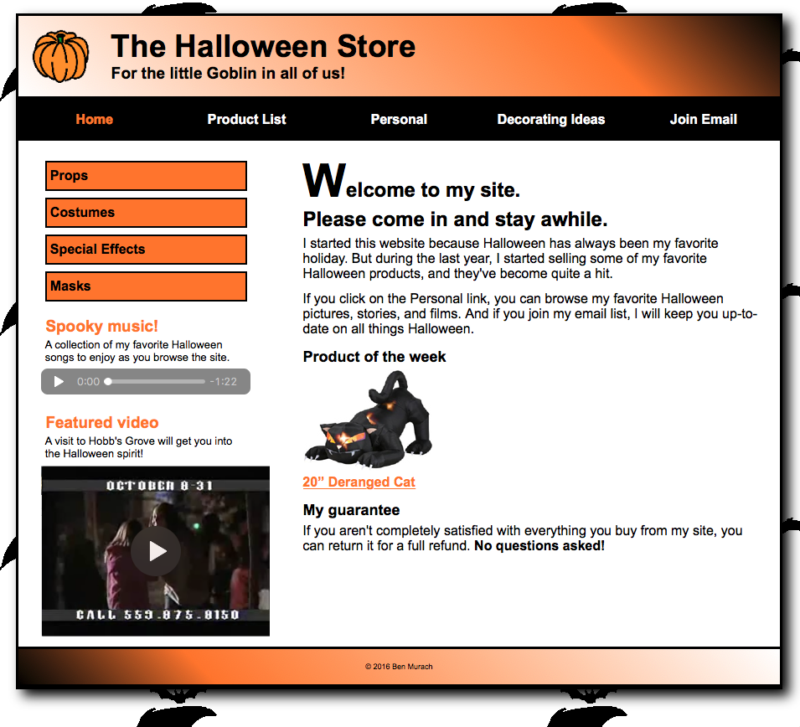

HTML for Exercise 12-1

<!DOCTYPE html>

<html lang="en">

<head>

<meta charset="utf-8" />

<meta name="viewport" content="width=device-width, initial-scale=1">

<title>Halloween Store</title>

<link rel="stylesheet" href="styles/normalize.css">

<link rel="stylesheet" href="styles/main_rwd.css">

<link rel="stylesheet" href="styles/slicknav.css">

<script src="https://code.jquery.com/jquery-2.1.3.min.js"></script>

<script src="js/jquery.slicknav.min.js"></script>

<script type="text/javascript">

$(document).ready(function(){

$('#nav_menu').slicknav({prependTo:"#mobile_menu"});

});

</script>

</head>

<body>

<header>

<img src="images/pumpkin.gif" alt="pumpkin">

<h2>The Halloween Store</h2>

<h3>For the little Goblin in all of us!</h3>

</header>

<nav id="mobile_menu"></nav>

<nav id="nav_menu">

<ul>

<li><a href="index.html" class="current">Home</a></li>

<li><a href="products.html">Product List</a></li>

<li><a href="personal.html">Personal</a></li>

<li><a href="decorating.html">Decorating Ideas</a></li>

<li><a href="email.html">Join Email</a></li>

</ul>

</nav>

<section>

<h1><span class="large">W</span>elcome to my site.<br>Please come in and stay awhile.</h1>

<p>I started this website because Halloween has always been my favorite holiday. But during the last year, I started selling some of my favorite Halloween products, and they've become quite a hit.</p>

<p>If you click on the Personal link, you can browse my favorite Halloween pictures, stories, and films. And if you join my email list, I will keep you up-to-date on all things Halloween.</p>

<h3>Product of the week</h3>

<a href="slides/products/cat.html"><img src="images/cat1.jpg" alt="cat"></a><br>

<a href="slides/products/cat.html">20&rdquo; Deranged Cat</a>

<h3>My guarantee</h3>

<p>If you aren't completely satisfied with everything you buy from my site, you can return it for a full refund.

<b>No questions asked!</b></p>

</section>

<aside id="sidebar">

<ul>

<li><a href="slides/products/props.html">Props</a>

<li><a href="slides/products/costumes.html">Costumes</a>

<li><a href="slides/products/effects.html">Special Effects</a>

<li><a href="slides/products/masks.html">Masks</a>

</ul>

<h3>Spooky music!</h3>

<p>A collection of my favorite Halloween songs to enjoy as you browse the site.</p>

<audio id="music" src="media/HalloweenMusic.m4a" controls></audio>

<h3>Featured video</h3>

<p>A visit to Hobb's Grove will get you into the Halloween spirit!</p>

<video id="video" src="media/hobbsgrove.mp4" controls width="100%" poster="media/video_frame.png"></video>

</aside>

<footer>

<p>&copy; 2016 Ben Murach</p>

</footer>

</body>

</html>

CSS for Exercise 12-1

/* reset selector */

* {

margin: 0;

padding: 0;

}

/* style for background behind body */

html {

background-image: url("../images/bats.gif")

}

/* the styles for the elements */

body {

font-family: Arial, Helvetica, sans-serif;

font-size: 100%;

width: 95%;

max-width: 960px;

background-color: white;

margin: 1em auto;

border: 3px solid black;

box-shadow: .5em .5em .9em black;

}

/* the styles for the header */

header img {

float: left;

width: 100%;

max-width: 70px;

min-width: 40px;

}

header h2 {

font-size: 230%;

text-indent: 25px;

}

header h3 {

font-size: 120%;

text-indent: 25px;

}

header {padding: 1em;

border-bottom: 3px solid black;

background-image: linear-gradient(45deg, #ffffff 0%, #FF8033 75%, #000000 100%);

background-image: -webkit-linear-gradient(45deg, #ffffff 0%, #FF8033 75%, #000000 100%);

background-image: -moz-linear-gradient(45deg, #ffffff 0%, #FF8033 75%, #000000 100%);

background-image: -o-linear-gradient(45deg, #ffffff 0%, #FF8033 75%, #000000 100%);

}

/* hide mobile menu initially */

#mobile_menu {

display: none;

}

/* Styles for the navigation menus */

/* the styles for the nav_menu class */

#nav_menu ul {

margin: 0;

padding: 0;

list-style-type: none;

position: relative;

}

#nav_menu ul li {

display: block;

width: 20%;

float: left;

}

#nav_menu ul li a {

text-align: center;

display: block;

padding: 1em 0;

text-decoration: none;

background-color: #000000;

color: white;

font-weight: bold;

}

#nav_menu ul li a.current {

color: #FF8033;

}

#nav_menu ul ul {

display: none;

position: absolute;

top: 100%;

}

/* makes 2nd tier menu appear vertically*/

#nav_menu ul ul li {

display: block;

width: 20%;

}

#nav_menu ul ul li {

display: block;

width: 20%;

float: none;

}

/* makes 2nd tier menu appear when hovering over li of main menu*/

#nav_menu ul li:hover > ul {

display: block;

}

/* creates an empty block to push 2nd tier menu down*/

#nav_menu > ul::after {

content: "";

display: block;

clear: both;

}

/* makes 2nd tier menu li blocks display in gray when hovered over*/

#nav_menu ul li ul li a:hover {

background-color: gray;

}

/* the styles for the sidebar */

#sidebar {

float: left;

margin: 1.5em .5em 0 0;

width: 30%;

height: 580px;

}

#sidebar ul {

line-height: 1.5;

}

#sidebar li {

margin-left: 2em;

margin-bottom: .5em;

display: block;

}

#sidebar ul li a {

color: black;

text-decoration: none;

padding: .25em;

display: block;

background-color: #FF8033;

border: 2px solid black;

}

#sidebar h3 {

color: #FF8033;

margin-left: 1.75em;

margin-top: 1em;

}

#sidebar p {

margin-left: 2.5em;

margin-top: .25em;

margin-bottom: .5em;

font-size: 80%;

}

#music {

margin-left: 10%;

margin-right: 10%;

}

#video {

margin-left: 10%;

margin-right: 10%;

}

/* the styles for the section */

section {

width: 60%;

float: right;

margin: 0 1.5em 2em;

}

section h1 {

font-size: 150%;

margin-bottom: .25em;

}

section h2 {

font-size: 130%;

}

section h3 {

margin: .75em 0 .25em;

font-size: 115%;

}

section p {

margin-bottom: .75em;

}

section img {

width: 100%;

max-width: 154px;

min-width: 40px;

}

/* style for a class */

.large {

font-size: 230%;

}

/* the styles for links */

a:link, a:focus, a:visited {

font-weight: bold;

color: #FF8033;

}

a:hover {

color: green;

}

/* the styles for the footer */

footer {

clear: both;

border-top: 3px solid black;

padding: 1em;

border-bottom: 3px solid black;

background-image: linear-gradient(45deg, #000000 0%, #FF8033 25%, #FFFFFF 100%);

background-image: -webkit-linear-gradient(45deg, #000000 0%, #FF8033 25%, #FFFFFF 100%);

background-image: -moz-linear-gradient(45deg, #000000 0%, #FF8033 25%, #FFFFFF 100%);

background-image: -o-linear-gradient(45deg, #000000 0%, #FF8033 25%, #FFFFFF 100%);

}

footer p {

text-align: center;

font-size: 50%;

}

/* media query to check that viewport is 800px or less wide */

@media only screen and (max-width: 800px) {

html {

background-image: none;

}

body {

font-size: 90%;

width: 100%;

box-shadow: none;

}

/* media query to check that viewport is 767px or less wide */

@media only screen and (max-width: 767px) {

#nav_menu {

display: none;

}

#mobile_menu {

display: block;

}

.slicknav_menu {

background-color: black !important;

}

section {

float: left;

width: 95%;

margin-right: 1em;

padding: .5em;

}

#sidebar {

clear: both;

float: none;

width: 45%;

margin: auto;

}

#sidebar ul li {

text-align: center;}

/* media query to check that viewport is 479px or less wide */

@media only screen and (max-width: 479px) {

section h1 {

font-size: 70%;

}

header {

font-size: 70%;

}

}

# Print Formatting

Web pages typically contain many elements that users do not want to include when printing, so web developers often add print formatting to their websites.

This was easily done for the Halloween web page by creating a new CSS file to override some of the screen styles when the page is printed. The only change needed within the HTML was the inclusion of the link to the print.css file, <link rel="stylesheet" href="styles/print.css" media="print">.

In the CSS file, the display property was set to none for the navigation menu and the sidebar. This prevented printing of the main navigation menu, along the top of the page, as well as the entire sidebar, including the recently added audio and video elements. It was then necessary to make some adjustments to the section. The width was set to 75%, margin was set to auto to center the element, and the float was changed to none.

Besides removing unneeded elements, it’s also good practice to use black type with serifs on a white background when printing. This page already had black type on a white background, but the font-family needed to be changed to serif within the CSS. By default, all the browsers I tested removed background colors, but if they hadn’t, that would have been another appropriate change to make in the styling for printed pages.

The print preview as viewed in Safari.

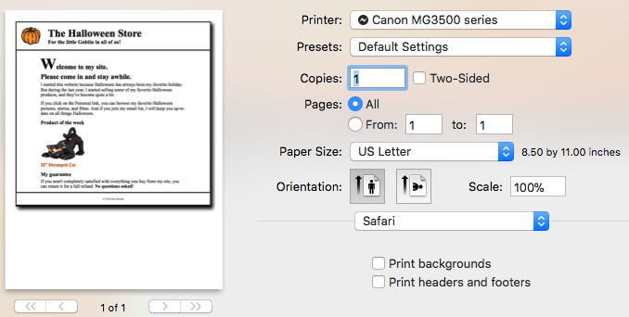

The print preview as viewed in Chrome.

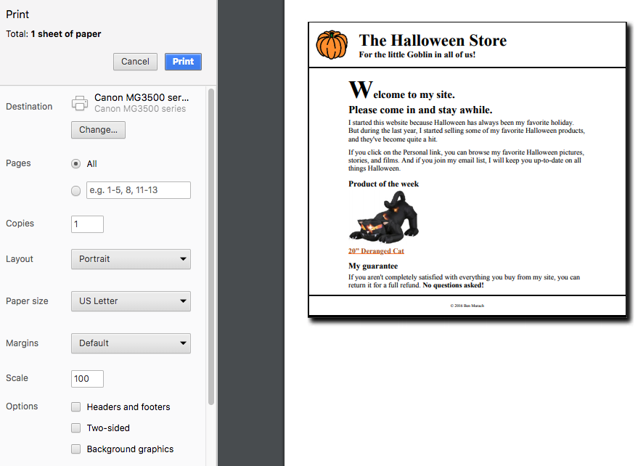

The print preview as viewed in Firefox.

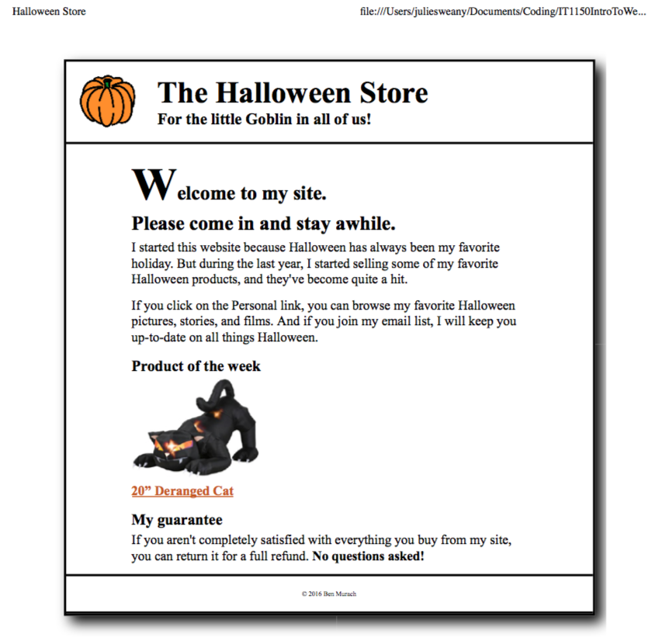

CSS for the Print Formatting Exercise

body {

font-family: "Times New Roman", Times, serif;

}

#nav_menu {

display: none;

}

#sidebar {

display: none;

}

section {

width: 75%;

float: none;

margin: auto;

}

# Chapter 14, Exercise 14-1

Exercise 14-1 covered transitions, transforms, and animations using the Townhall sample website.

First, transitions were added to the speaker images to make them move when the user hovers the mouse over them. This was accomplished by adding a transition property within the appropriate rule set in the CSS. In the transition property, margin-left and margin-top were indicated as properties that would go through the transition and 2 seconds was indicated as the time the transition would take to complete. Additionally, for the transition property it was necessary to also include a –webkit-transition property to ensure compatibility with the Safari and Chrome browsers.

Next, the image in the article section was changed to rotate when hovered over. This was achieved with the transform property, with an attribute of rotate, with the amount of rotation included in parentheses. A transform-origin was also added to control the center of the rotation.

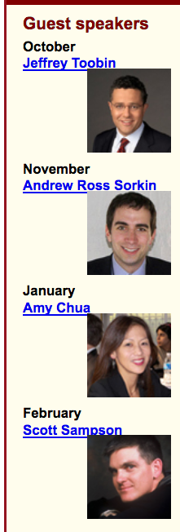The following step animated the four images in the aside so that they moved when the page loads. The action begins two seconds after the page loads and lasts for three seconds, repeating four times. This was accomplished using animation: moveright 3s 4 2s alternate; and @keyframes moveright. That was followed by from, with the starting property values in curly braces and to, with the ending property values in curly braces.

The exercise concluded with a direction to increase the size of the images in the aside 1.4 times. This was done with a transform property, with an attribute of scale, with the amount of horizontal and vertical scale in parentheses.

A screenshot showing   
that the speaker images   
move and enlarge when   
the page is first loaded.

The CSS for Chapter 14, Exercise 14-1

/* the styles for the elements */

* {

margin: 0;

padding: 0;

}

html {

background-color: white;

}

body {

font-family: Arial, Helvetica, sans-serif;

font-size: 100%;

width: 800px;

margin: 0 auto;

border: 3px solid #931420;

background-color: #fffded;

}

a:focus, a:hover {

font-style: italic;

}

/* the styles for the header */

header {

padding: 1.5em 0 2em 0;

border-bottom: 3px solid #931420;

background-image: -moz-linear-gradient(

30deg, #f6bb73 0%, #f6bb73 30%, white 50%, #f6bb73 80%, #f6bb73 100%);

background-image: -webkit-linear-gradient(

30deg, #f6bb73 0%, #fffded 30%, white 50%, #fffded 80%, #f6bb73 100%);

background-image: -o-linear-gradient(

30deg, #f6bb73 0%, #fffded 30%, white 50%, #fffded 80%, #f6bb73 100%);

background-image: linear-gradient(

30deg, #f6bb73 0%, #fffded 30%, white 50%, #fffded 80%, #f6bb73 100%);

}

header h2 {

font-size: 175%;

color: #800000;

}

header h3 {

font-size: 130%;

font-style: italic;

}

header img {

float: left;

padding: 0 30px;

}

.shadow {

text-shadow: 2px 2px 2px #800000;

}

/* the styles for the navigation menu */

#nav_menu ul {

list-style-type: none;

margin: 0;

padding: 0;

position: relative;

}

#nav_menu ul li {

float: left;

}

#nav_menu ul li a {

display: block;

width: 160px;

text-align: center;

padding: 1em 0;

text-decoration: none;

background-color: #800000;

color: white;

font-weight: bold;

}

#nav_menu a.current {

color: yellow;

}

#nav_menu ul ul {

display: none;

position: absolute;

top: 100%;

}

#nav_menu ul ul li {

float: none;

}

#nav_menu ul li:hover > ul {

display: block;

}

#nav_menu > ul::after {

content: "";

clear: both;

display: block;

}

/* the styles for the main content */

main {

clear: left;

}

/* the styles for the section */

section {

width: 525px;

float: right;

padding: 0 20px 20px 20px;

}

section h1 {

font-size: 150%;

padding: .5em 0 .25em 0;

margin: 0;

}

section h2 {

color: #800000;

font-size: 130%;

padding: .5em 0 .25em 0;

}

section p {

padding-bottom: .5em;

}

section blockquote {

padding: 0 2em;

font-style: italic;

}

section ul {

padding: 0 0 .25em 1.25em;

list-style-type: circle;

}

section li {

padding-bottom: .35em;

}

/* the styles for the article */

article {

padding: .5em 0;

border-top: 2px solid #800000;

border-bottom: 2px solid #800000;

}

article h2 {

padding-top: 0;

}

article h3 {

font-size: 105%;

padding-bottom: .25em;

}

article img {

float: right;

margin: .5em 0 1em 1em;

border: 1px solid black;

transition: 3s;

-webkit-transition: 3s;

}

article img:hover {

transform: rotate(720deg);

transform-origin: left top;

}

/* the styles for the aside */

aside {

width: 215px;

float: right;

padding: 0 0 20px 20px;

}

aside h2 {

color: #800000;

font-size: 130%;

padding: .5em 0 .25em 0;

}

aside h3 {

font-size: 105%;

padding-bottom: .25em;

}

aside img {

padding-bottom: 1em;

margin-left: 0px;

margin-top: 0px;

transition: margin-left 2s, margin-top 2s;

-webkit-transition: margin-left 2s, margin-top 2s;

}

aside img {

animation: moveright 3s 4 2s alternate;}

{ -webkit-animation: moveright 3s 4 2s alternate;}

@keyframes moveright {

from { margin-left: 0px;

margin-top: 0px; }

to { margin-left: 100px;

margin-top: 10px;

transform: scale(1.4, 1.4);

}

}

aside img:hover {

margin-left: 100px;

margin-top: 20px;

}

/* the styles for the footer */

footer {

background-color: #931420;

clear: both;

}

footer p {

text-align: center;

color: white;

padding: 1em 0;

}

# Semester Project

## Topic

For my semester project, I plan to create a website to promote an event called “Dancing Through the Decades”. This event is a dance featuring music from the 1950s through the 1990s that was planned for Cleveland-area Girl Scouts in middle school and high school. The website would be used to promote the event and to provide a means for buying tickets or signing up as a volunteer for the event.

## The wireframe for the homepage of the Dancing Through the Decades website

## Target audience

The website will target two groups. The website’s primary audience is Girl Scouts who may want to attend the dance. Secondarily, the website will need to address troop volunteers who may be willing to help with the dance and to help spread word about the dance to their troops.

## Usability

The website’s design will conform to current conventions for usability. Because the scope of this website is rather small and manageable, I don’t foresee any problem organizing the information logically and making it easy for the user to find the information they are seeking. Efforts will be made to make sure navigation of the site, links, and order forms all conform to users’ expectations in those areas in order to avoid confusion.

## Groups of Information

I will most likely be able to organize the “chunks” of information by page. The homepage will convey all relevant information about the dance. The second-tier pages will include one for the order form, one with information for adults who are interested in volunteering, and one that gives information about the group that has organized the event.

## Principles of graphic design

To create a website that is well organized and easy to use, it’s best to adhere to the four principles of graphic design. Alignment means that related items line up with each other and proximity means that related items are located close to one another. I’ve already started to take these approaches on the wireframe, above. For instance, the main activities of the event are all in the right-hand column, with the text aligning on the left. Repetition will also play a role. The footer will appear on all the pages. I think the header will likely be simplified a bit for the second-tier pages, but it will match from page to page within that level. Contrast will also be used to help draw attention to more important elements. The logo and name of the dance will be high-contrast, as will the button for buying tickets.

## Lifecycle of the website

Designed to promote a one-time event, this website would not have a very long lifecycle. The design of the site would likely only need to be approved by a few key volunteers involved in the planning of the event. Implementation and testing would follow, and the maintenance stage would be relatively short, since the website would not need to remain active after the event. However, it would probably be wise to take note of how the site performed, so that any lessons learned could be taken into account when the group planned similar events requiring new websites.

## Sitemap

Two levels contain all of the pages needed for the Dancing Through the Decades website. The home page focuses on the main goal of the website, which is promoting the event. Then, the second-tier pages provide an order form, information on the event organizers, and volunteer opportunities.

## The wireframe for the Dancing Through the Decades website.



# Conclusion

I found this lab quite interesting because it cleared up some things I had wondered about. One of these things was formatting pages for printing. I’ve come across quite a few web pages that have caused me significant frustration when I tried to print them, but I had no idea what determined how they would print. I’m actually glad to learn how it easy it is to modify webpages for printing.

Animations and transforms also interest me because, when used properly, they can make websites feel much more polished and professional. I found creating these effects a little tricky, and I had to try several times to get some of the lab exercises to work properly. However, it’s only difficult at first because there are many properties to master, and once they are learned, they will offer a lot of control.

# Resources

Boehm, Anne and Ruvalcaba, Zak. *Murach’s HTML5 and CSS3* 3rd ed. Mike Murach &   
 Associates, Inc. 2015

W3Schools website. *CSS Animations.* Retrieved from: https://www.w3schools.com/  
 css/css3_animations.asp