Julie Sweany

Lab 7

May 6, 2018

IT1150, CRN13094

# Table of Contents

Table of Contents 2

Executive Summary 3

Chapter 15, Exercise 15-1 4

Chapter 15, Exercise 15-2 13

Chapter 16, Exercise 16-1 18

Chapter 16, Exercise 16-2 26

Chapter 17, Exercise 17-1 33

Conclusion 43

Resources 44

# Executive Summary

Lab 7 offered information and experience using JavaScript, jQuery, and jQuery Mobile.

JavaScript, a scripting language that is run client-side by the web browser, enables developers to modify elements and to provide additional interactivity and functionality in their websites. jQuery and jQuery Mobile supply open-source and well tested JavaScript files for developers to incorporate into their sites.

The lab involved exercises adding some popular JavaScript features to websites, such as print buttons. It also introduced popular jQuery plugins, such as image swaps, accordions, and Cycle 2 slideshows, and provided experience working with a jQuery Mobile website.

# Chapter 15, Exercise 15-1

Exercise 15-1 demonstrated how JavaScript can be used to add a print button to a webpage and to create text that will automatically display the current year.

The exercise made use of a provided JavaScript file, so most of the changes were made within the HTML file. A <script> tag linking to the correct JavaScript file was added to the <head> of the HTML. In the <aside>, the button was added with this code: <input type="button" id="printButton" value="Print Page">. The id name needed to match the id used within the JavaScript code. After the functionality of the button was established, some formatting changes were made within the CSS for the page to conclude that part of the exercise.

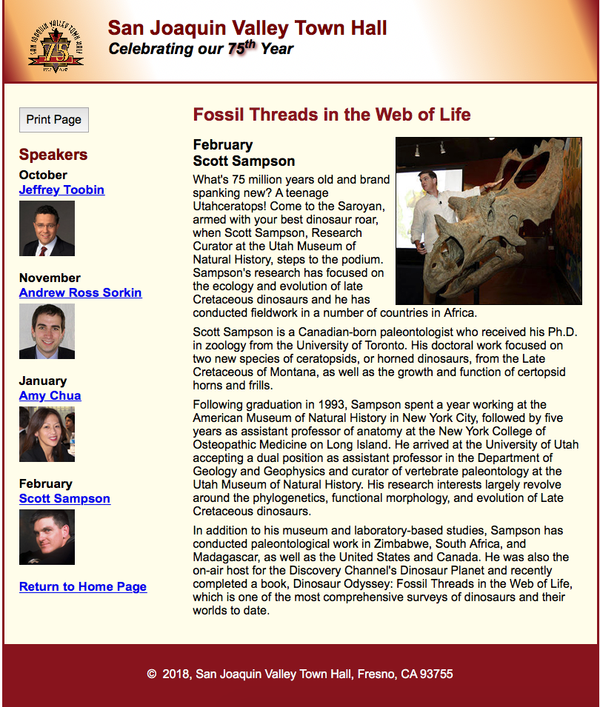Next, some inline JavaScript was added to the footer section of the HTML. Again, the basic JavaScript was provided, so this only involved copying and pasting the code into the correct portion of the HTML and making some minor adjustments to the text.

The screenshot to the left shows the completed page for Exercise 15-1.

Below, the screenshot shows the print dialogue box that opens when the Print Page button is clicked.

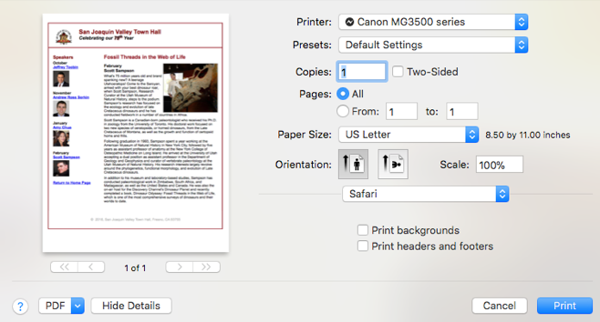

HTML for Exercise 15-1

<!DOCTYPE html>

<html lang="en">

<head>

<meta charset="utf-8">

<title>San Joaquin Valley Town Hall</title>

<link rel="shortcut icon" href="../images/favicon.ico">

<link rel="stylesheet" href="../styles/normalize.css">

<link rel="stylesheet" href="../styles/sampson.css">

<link rel="stylesheet" href="../styles/sampson_print.css" media="print">

<script src="../javascript/printPage.js"></script>

</head>

<body>

<header>

<img src="../images/town_hall_logo.gif" alt="Town Hall Logo" height="80">

<h2>San Joaquin Valley Town Hall</h2>

<h3>Celebrating our <span class="shadow">75<sup>th</sup></span> Year</h3>

</header>

<main>

<section>

<h1>Fossil Threads in the Web of Life</h1>

<article>

<img src="../images/sampson_dinosaur.jpg" alt="Sampson with dinosaur">

<h2>February<br>

Scott Sampson</h2>

<p>What's 75 million years old and brand spanking new? A teenage Utahceratops! Come to the

Saroyan, armed with your best dinosaur roar, when Scott Sampson, Research Curator at the

Utah Museum of Natural History, steps to the podium. Sampson's research has focused on the

ecology and evolution of late Cretaceous dinosaurs and he has conducted fieldwork in a number

of countries in Africa.</p>

<p>Scott Sampson is a Canadian-born paleontologist who received his Ph.D. in zoology from the

University of Toronto. His doctoral work focused on two new species of ceratopsids, or horned

dinosaurs, from the Late Cretaceous of Montana, as well as the growth and function of certopsid

horns and frills.</p>

<p>Following graduation in 1993, Sampson spent a year working at the American Museum of Natural

History in New York City, followed by five years as assistant professor of anatomy at the New

York College of Osteopathic Medicine on Long Island. He arrived at the University of Utah

accepting a dual position as assistant professor in the Department of Geology and Geophysics

and curator of vertebrate paleontology at the Utah Museum of Natural History. His research

interests largely revolve around the phylogenetics, functional morphology, and evolution of

Late Cretaceous dinosaurs.</p>

<p>In addition to his museum and laboratory-based studies, Sampson has conducted paleontological

work in Zimbabwe, South Africa, and Madagascar, as well as the United States and Canada. He was

also the on-air host for the Discovery Channel's Dinosaur Planet and recently completed a book,

Dinosaur Odyssey: Fossil Threads in the Web of Life, which is one of the most

comprehensive surveys of dinosaurs and their worlds to date.</p>

</article>

</section>

<aside>

<input type="button" id="printButton" value="Print Page">

<h2>Speakers</h2>

<h3>October<br><a href="speakers/toobin.html">Jeffrey Toobin</a></h3>

<img src="../images/toobin75.jpg" alt="Toobin Photo">

<h3>November<br><a href="speakers/sorkin.html">Andrew Ross Sorkin</a></h3>

<img src="../images/sorkin75.jpg" alt="Sorkin Photo">

<h3>January<br><a href="speakers/chua.html">Amy Chua</a></h3>

<img src="../images/chua75.jpg" alt="Chua Photo">

<h3>February<br><a href="speakers/sampson.html">Scott Sampson</a></h3>

<img src="../images/sampson75.jpg" alt="Sampson Photo">

<h3><a href="../index.html">Return to Home Page</a></h3>

</aside>

</main>

<footer>

<p>

<script>

var today = new Date();

document.write("&copy; &nbsp;");

document.write(today.getFullYear());

document.write(", San Joaquin Valley Town Hall, Fresno, CA 93755");

</script></p>

</footer>

</body>

</html>

CSS for Exercise 15-1

/* reset selector */

* {

margin: 0;

padding: 0;

}

/* the styles for the elements */

html {

background-color: #ffffff;

}

body {

background-color: #fffded;

width: 800px;

margin: 1em auto 1em;

border: 3px solid #931420;

font-family: Arial, Helvetica, sans-serif;

font-size: 100%;

}

section {

width: 525px;

float: right;

}

aside {

width: 215px;

float: right;

padding: 0 0 20px 20px;

}

footer {

background-color: #931420;

padding: 1em;

clear: both;

}

/* the styles for the header */

header {

background-image: linear-gradient(20deg, #931420 0%, #f6bb73 5%, #ffffff 25%,

#ffffff 70%, #f6bb73 95%, #931420 100%);

background-image: -webkit-linear-gradient(20deg, #931420 0%, #f6bb73 5%, #ffffff 25%, #ffffff 70%, #f6bb73 95%, #931420 100%);

background-image: -moz-linear-gradient(20deg, #931420 0%, #f6bb73 5%, #ffffff 25%, #ffffff 70%, #f6bb73 95%, #931420 100%);

background-image: -o-linear-gradient(20deg, #931420 0%, #f6bb73 5%, #ffffff 25%, #ffffff 70%, #f6bb73 95%, #931420 100%);

border-bottom: 3px solid #931420;

padding: 1.5em 0 2em;

}

header img {

float: left;

padding: 0 30px 0;

}

header h2 {

font-size: 170%;

color: #800000;

}

header h3 {

font-size: 130%;

font-style: italic;

}

.shadow {

text-shadow: 2px 2px 4px #800000;

}

/* the styles for the section */

section {

clear: left;

padding: 0 20px 20px;

}

section h1 {

font-size: 150%;

padding: .5em 0 .0;

color: #931420;

}

section h2 {

font-size: 130%;

color: #800000;

padding: .5em 0 .25em;

}

section p {

padding-bottom: .5em;

}

section blockquote {

padding: 0 2em 0;

font-style: italic;

}

aside h3 {

font-size: 105%;

padding-bottom: .25em;

}

aside img {

padding-bottom: 1em;

}

aside h2 {

font-size: 130%;

color: #800000;

padding: .5em 0 .25em;

}

aside #printButton {

padding: .5em;

margin-top: 2em;

margin-bottom: .5em;

}

section ul {

padding: 0 0 .25em 1em;

}

section li {

padding-bottom: .35em;

}

/* the styles for links */

a:hover, a:focus {

font-style: italic;

}

article {

padding: 0 0 .5em;

}

article img {

float: right;

border: 1px solid #000000;

}

article h1 {

font-size: 150%;

padding: .5em 0 0;

}

article h2 {

font-size: 120%;

padding: 0 0 .25em;

color: #000000;

}

article h3 {

font-size: 105%;

padding: 0 0 .25em;

}

/* the styles for the footer */

footer p {

text-align: center;

color: white;

padding: 1em 0;

}

External JavaScript for Exercise 15-1

var $ = function(id) {

return document.getElementById(id);

}

var printPage = function() {

window.print();

}

window.onload = function() {

$("printButton").onclick = printPage;

}

# Chapter 15, Exercise 15-2

Exercise 15-2 added a jQuery image swap function to one of the Town Hall examples.

The provided HTML file included links in the <head> to the JavaScript library and to the JavaScript file for image swaps. The link to the JavaScript CSS file had not been included and was added with: <link rel="stylesheet" href="styles/jquery-ui.min.css">.

The provided unordered list was correct, other than the omission of one of the title attributes, which was easily added. However, to make the image swap function as intended, it was necessary to add two additional lines to establish the IDs for “caption” and “class”:   
<h2 id="caption">Jeffrey Toobin</h2>  
<p><img src="images/toobin_court.jpg" alt="" id="image"></p>

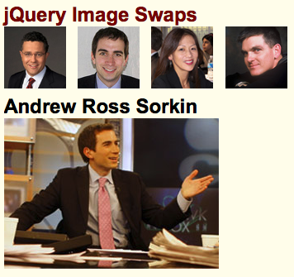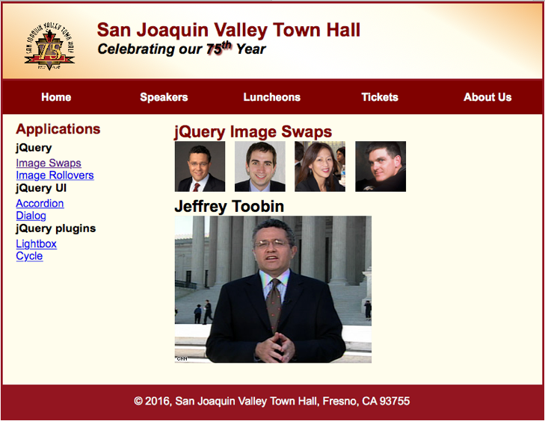Screenshots of the functioning image swap feature.

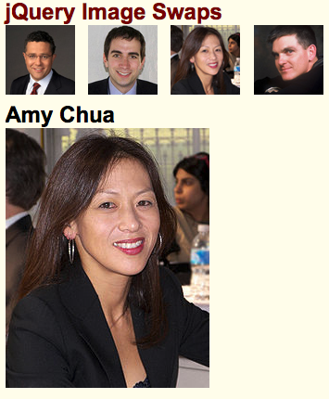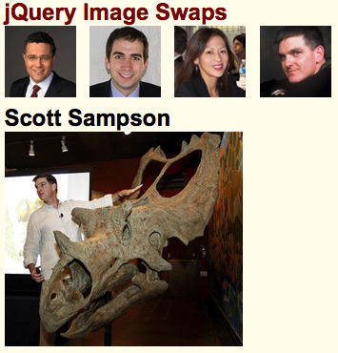HTML for Exercise 15-2

<!DOCTYPE html>

<html lang="en">

<head>

<meta charset="utf-8">

<title>San Joaquin Valley Town Hall</title>

<link rel="shortcut icon" href="images/favicon.ico">

<link rel="stylesheet" type="text/css" href="styles/normalize.css">

<link rel="stylesheet" href="styles/jquery-ui.min.css">

<link rel="stylesheet" href="styles/speaker.css">

<link rel="stylesheet" href="styles/jquery-ui.min.css">

<script src="https://code.jquery.com/jquery-2.1.3.min.js"></script>

<script src="javascript/image_swaps.js"></script>

</head>

<body>

<header> <img src="images/town_hall_logo.gif" alt="Town Hall logo" height="80">

<h2>San Joaquin Valley Town Hall</h2>

<h3>Celebrating our <span class="shadow">75<sup>th</sup></span> Year</h3>

</header>

<nav id="nav_menu">

<ul>

<li><a href="../index.html">Home</a></li>

<li><a href="speakers.html">Speakers</a></li>

<li><a href="luncheons.html">Luncheons</a></li>

<li><a href="tickets.html">Tickets</a></li>

<li><a href="aboutus.html"> About Us</a>

<ul>

<li><a href="#">Our History</a></li>

<li><a href="#">Board of Directors</a></li>

<li><a href="#">Past Speakers</a></li>

<li><a href="#">Contact Information</a></li>

</ul>

</li>

</ul>

</nav>

<main>

<section>

<h1>jQuery Image Swaps</h1>

<ul id="image_list">

<li><a href="images/toobin_court.jpg" title="Jeffrey Toobin">

<img src="images/toobin75.jpg" alt=""></a></li>

<li><a href="images/sorkin_desk260.jpg" title="Andrew Ross Sorkin">

<img src="images/sorkin75.jpg" alt=""></a></li>

<li><a href="images/chua_220.jpg" title="Amy Chua">

<img src="images/chua75.jpg" alt=""></a></li>

<li><a href="images/sampson_dinosaur.jpg" title="Scott Sampson">

<img src="images/sampson75.jpg" alt=""></a></li>

</ul>

<h2 id="caption">Jeffrey Toobin</h2>

<p><img src="images/toobin_court.jpg" alt="" id="image"></p>

</section>

<aside>

<h2>Applications</h2>

<h3>jQuery</h3>

<p><a href="image_swaps.html">Image Swaps</a></p>

<p><a href="image_rollovers.html">Image Rollovers</a></p>

<h3>jQuery UI</h3>

<p><a href="accordion_dialog.html">Accordion</a></p>

<p><a href="accordion_dialog.html">Dialog</a></p>

<h3>jQuery plugins</h3>

<p><a href="lightbox.html">Lightbox</a></p>

<p><a href="slideshow.html">Cycle</a> </p>

</aside>

</main>

<footer>

<p>&copy; 2016, San Joaquin Valley Town Hall, Fresno, CA 93755</p>

</footer>

</body>

</html>

JavaScript for Exercise 15-2

$(document).ready(function() {

// preload images

$("#image_list a").each(function() {

var swappedImage = new Image();

swappedImage.src = $(this).attr("href");

});

// set up event handlers for links

$("#image_list a" ).click(function(evt) {

// swap image

var imageURL = $(this).attr("href");

$("#image").attr("src", imageURL);

//swap caption

var caption = $(this).attr("title");

$("#caption").text(caption);

// cancel the default action of the link

evt.preventDefault(); // jQuery method that's cross-browser compatible

}); // end click

// move focus to first thumbnail

$("li:first-child a:first-child").focus();

}); // end ready

# Chapter 16, Exercise 16-1

Exercise 16-1 introduced the jQuery Accordion Widget. The essential functioning of the accordion was already established in the provided HTML file, with the appropriate links to JavaScript and CSS files already present.

First, the directions indicated that all images within the accordion should be floated left. This was accomplished by adding a rule to the speaker.css file. This illustrated the fact that even though the jQuery widgets have their own CSS files, it’s possible to make formatting adjustments in the CSS files that you’ve created for your website.

Next came some changes to the script for the accordion. Adding collapsible: true makes it possible to collapse all sections of the accordion. (By default, a section is always open.) To have the accordion open to varying heights to accommodate the size of the content, heightStyle: content was also added.

A screenshot showing all of the accordion sections collapsed.

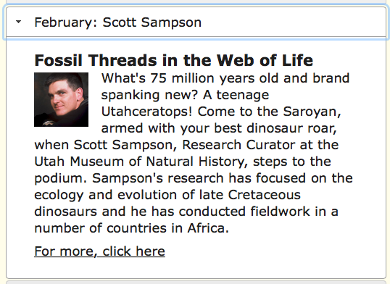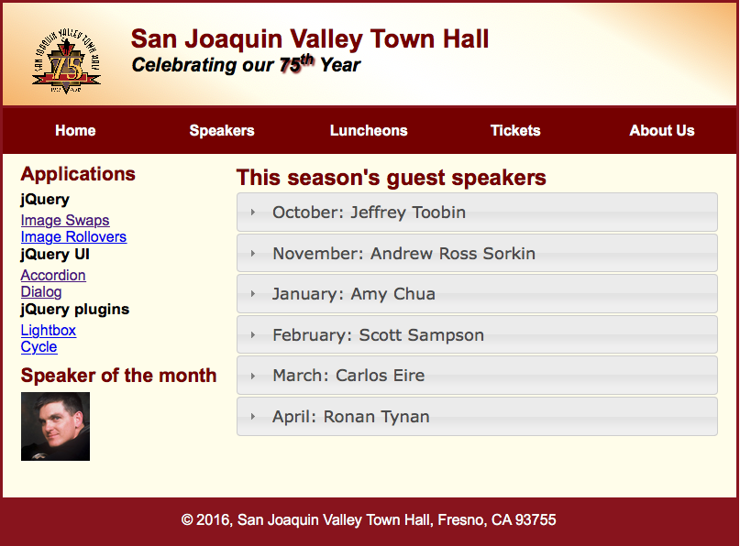

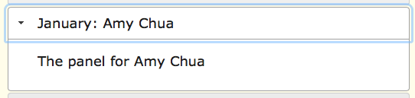**Screenshots** showing the accordion sections open to different sizes, depending on content.

HTML for Chapter 16, Exercise 16-1

<!doctype html>

<html lang="en">

<head>

<meta charset="utf-8">

<title>San Joaquin Valley Town Hall</title>

<link rel="shortcut icon" href="images/favicon.ico">

<link rel="stylesheet" href="styles/normalize.css">

<link rel="stylesheet" href="jquery-ui-1.11.2.custom/jquery-ui.min.css">

<!-- JavaScript HTML requirements -->

<script src="https://code.jquery.com/jquery-2.1.3.min.js"></script>

<script src="jquery-ui-1.11.2.custom/jquery-ui.min.js"></script>

<link rel="stylesheet" href="styles/speaker.css">

<script>

$(document).ready(function() {

$("#accordion").accordion({

heightStyle: "content",

collapsible: true});

});

</script>

</head>

<body>

<header> <img src="images/town_hall_logo.gif" alt="Town Hall logo" height="80">

<h2>San Joaquin Valley Town Hall</h2>

<h3>Celebrating our <span class="shadow">75<sup>th</sup></span> Year</h3>

</header>

<nav id="nav_menu">

<ul>

<li><a href="../index.html">Home</a></li>

<li><a href="speakers.html">Speakers</a></li>

<li><a href="luncheons.html">Luncheons</a></li>

<li><a href="tickets.html">Tickets</a></li>

<li><a href="aboutus.html"> About Us</a>

<ul>

<li><a href="#">Our History</a></li>

<li><a href="#">Board of Directors</a></li>

<li><a href="#">Past Speakers</a></li>

<li><a href="#">Contact Information</a></li>

</ul>

</li>

</ul>

</nav>

<main>

<section>

<h1 class="spaceafter">This season's guest speakers</h1>

<div id="accordion">

<h3><a href="#">October: Jeffrey Toobin</a></h3>

<div>

<p>The panel for Jeffrey Toobin</p>

</div>

<h3><a href="#">November: Andrew Ross Sorkin</a></h3>

<div>

<p>The panel for Andrew Ross Sorkin</p>

</div>

<h3><a href="#">January: Amy Chua</a></h3>

<div>

<p>The panel for Amy Chua</p>

</div>

<h3><a href="#">February: Scott Sampson</a></h3>

<div>

<h3>Fossil Threads in the Web of Life</h3>

<a href="speakers/sampson.html"><img src="images/sampson75.jpg" alt="Scott Sampson"></a>

<p>What's 75 million years old and brand spanking new? A teenage

Utahceratops! Come to the Saroyan, armed with your best dinosaur roar, when Scott Sampson,

Research Curator at the Utah Museum of Natural History, steps to the podium. Sampson's

research has focused on the ecology and evolution of late Cretaceous dinosaurs and he has

conducted fieldwork in a number of countries in Africa.</p>

<p><a href="speakers/sampson.html">For more, click here</a></p>

</div>

<h3><a href="#">March: Carlos Eire</a></h3>

<div>

<p>The panel for Carlos Eire</p>

</div>

<h3><a href="#">April: Ronan Tynan</a></h3>

<div>

<p>The panel for Ronan Tynan</p>

</div>

</div>

</section>

<aside>

<h2>Applications</h2>

<h3>jQuery</h3>

<p><a href="image_swaps.html">Image Swaps</a></p>

<p><a href="image_rollovers.html">Image Rollovers</a></p>

<h3>jQuery UI</h3>

<p><a href="accordion_dialog.html">Accordion</a></p>

<p><a href="accordion_dialog.html">Dialog</a></p>

<h3>jQuery plugins</h3>

<p><a href="lightbox.html">Lightbox</a></p>

<p><a href="slideshow.html">Cycle</a> </p>

<h2>Speaker of the month</h2>

<img id="speaker" src="images/sampson75.jpg" width="75" height="75" alt=""/>

<div id="dialog" title="February: Scott Sampson" style="display:none">

<h3>Fossil Threads in the Web of Life</h3>

<img src="images/sampson75.jpg" alt="Scott Sampson" width="75" height="75">

<p>

What's 75 million years old and brand spanking new? Find out this month

by attending Scott Sampson's fascinating presentation.

</p>

</div>

</aside>

</main>

<footer>

<p>&copy; 2016, San Joaquin Valley Town Hall, Fresno, CA 93755</p>

</footer>

</body>

</html>

CSS for Chapter 16, Exercise 16-1

/* the styles for the elements */

* {

margin: 0;

padding: 0;

}

html {

background-color: white;

}

body {

font-family: Arial, Helvetica, sans-serif;

font-size: 100%;

width: 800px;

margin: 0 auto;

border: 3px solid #931420;

background-color: #fffded;

}

a:focus, a:hover {

font-style: italic;

}

/* the styles for the header */

header {

padding: 1.5em 0 2em 0;

border-bottom: 3px solid #931420;

background-image: -moz-linear-gradient(

30deg, #f6bb73 0%, #f6bb73 30%, white 50%, #f6bb73 80%, #f6bb73 100%);

background-image: -webkit-linear-gradient(

30deg, #f6bb73 0%, #fffded 30%, white 50%, #fffded 80%, #f6bb73 100%);

background-image: -o-linear-gradient(

30deg, #f6bb73 0%, #fffded 30%, white 50%, #fffded 80%, #f6bb73 100%);

background-image: linear-gradient(

30deg, #f6bb73 0%, #fffded 30%, white 50%, #fffded 80%, #f6bb73 100%);

}

header h2 {

font-size: 175%;

color: #800000;

}

header h3 {

font-size: 130%;

font-style: italic;

}

header img {

float: left;

padding: 0 30px;

}

.shadow {

text-shadow: 2px 2px 2px #800000;

}

/* the styles for the navigation menu */

#nav_menu ul {

list-style-type: none;

margin: 0;

padding: 0;

position: relative;

}

#nav_menu ul li {

float: left;

}

#nav_menu ul li a {

display: block;

width: 160px;

text-align: center;

padding: 1em 0;

text-decoration: none;

background-color: #800000;

color: white;

font-weight: bold;

}

#nav_menu ul ul {

display: none;

position: absolute;

top: 100%;

}

#nav_menu ul ul li {

float: none;

}

#nav_menu ul li:hover > ul {

display: block;

}

#nav_menu > ul::after {

content: "";

clear: both;

display: block;

}

/* the styles for the main content */

main {

clear: left;

}

/* the styles for the section */

section {

width: 525px;

float: right;

padding: 0 20px 20px 20px;

}

section h1 {

color: #800000;

font-size: 150%;

padding-top: .5em;

margin: 0;

}

section p {

padding-bottom: .5em;

}

section blockquote {

padding: 0 2em;

font-style: italic;

}

section ul {

padding: 0 0 .25em 0;

}

section li {

padding-right: 10px;

display: inline;

}

section img {

float: left;

margin-right: 1em;

margin-top: .25em;

}

/* the styles for the article */

article {

padding: .5em 0;

}

article h2 {

font-size: 115%;

padding: 0 0 .25em 0;

}

article img {

float: right;

margin: .5em 0 1em 1em;

border: 1px solid black;

}

/* the styles for the aside */

aside {

width: 215px;

float: right;

padding: 0 0 20px 20px;

}

aside h2 {

color: #800000;

font-size: 130%;

padding: .5em 0 .25em 0;

}

aside h3 {

font-size: 105%;

padding-bottom: .25em;

}

aside img {

padding-bottom: 1em;

}

/* the styles for the footer */

footer {

background-color: #931420;

clear: both;

}

footer p {

text-align: center;

color: white;

padding: 1em 0;

}

# Chapter 16, Exercise 16-2

Exercise 16-2 used the jQuery plugin, Cycle 2, to create a slideshow. A functional HTML file, complete with all the appropriate links to JavaScript and CSS files was provided. Then, changes were made in the HTML to adjust some of the plugin’s attributes. First, a data-cycle-timeout=”2000” was added to the opening <div> tag of the slideshow. This set the time for each slide to be shown at 2000 milliseconds. Then, data-cycle-fx="scrollHorz" made the images move into place by moving horizontally across the screen. Finally, data-cycle-pause-on-hover="true" was added to allow the user to hover over the image in order to keep it in view for as long as the mouse continues to hover.

The exercise also involved adding captions underneath the images. This was achieved by adding data-cycle-caption="#alt-caption" data-cycle-caption-template="{{alt}} to the opening <div> tag and <div id="alt-caption" class="center"></div>, following the <div> containing all the <img> tags for the slideshow.

Screenshots showing the images and captions included in the slideshow.

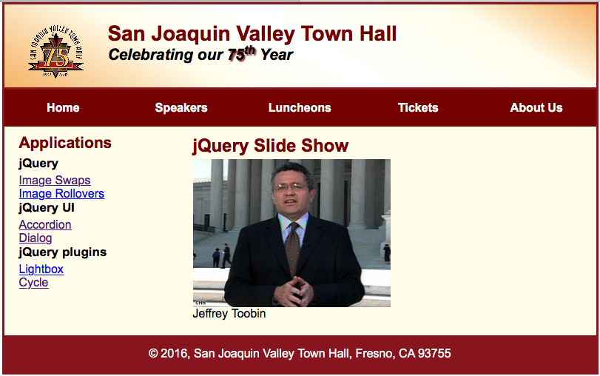

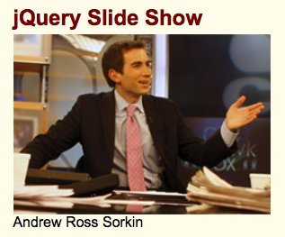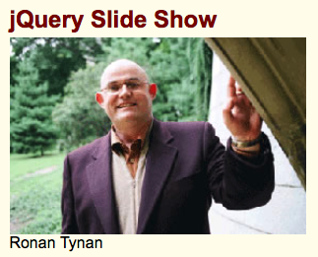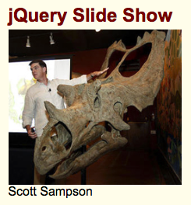

HTML for Chapter 16, Exercise 16-2

<!DOCTYPE html>

<html lang="en">

<head>

<meta charset="utf-8">

<title>San Joaquin Valley Town Hall</title>

<link rel="shortcut icon" href="images/favicon.ico">

<link rel="stylesheet" type="text/css" href="styles/normalize.css">

<link rel="stylesheet" href="styles/speaker.css">

<script src="http://code.jquery.com/jquery-2.1.3.min.js"></script>

<script src="http://malsup.github.com/jquery.cycle2.js"></script>

<script src="http://malsup.github.io/jquery.cycle2.shuffle.js"></script>

</head>

<body>

<header> <img src="images/town_hall_logo.gif" alt="Town Hall logo" height="80">

<h2>San Joaquin Valley Town Hall</h2>

<h3>Celebrating our <span class="shadow">75<sup>th</sup></span> Year</h3>

</header>

<nav id="nav_menu">

<ul>

<li><a href="../index.html">Home</a></li>

<li><a href="speakers.html">Speakers</a></li>

<li><a href="luncheons.html">Luncheons</a></li>

<li><a href="tickets.html">Tickets</a></li>

<li><a href="aboutus.html"> About Us</a>

<ul>

<li><a href="#">Our History</a></li>

<li><a href="#">Board of Directors</a></li>

<li><a href="#">Past Speakers</a></li>

<li><a href="#">Contact Information</a></li>

</ul>

</li>

</ul>

</nav>

<main>

<section>

<h1 class="spaceafter">jQuery Slide Show</h1>

<div class="cycle-slideshow"

data-cycle-timeout="2000"

data-cycle-fx="scrollHorz"

data-cycle-pause-on-hover="true"

data-cycle-caption="#alt-caption"

data-cycle-caption-template="{{alt}}"

>

<img src="images/toobin_court.jpg" alt="Jeffrey Toobin" height="200">

<img src="images/sorkin_desk260.jpg" alt="Andrew Ross Sorkin" height="200">

<img src="images/tynan_wave.jpg" alt="Ronan Tynan" height="200">

<img src="images/sampson_dinosaur.jpg" alt="Scott Sampson" height="200">

</div>

<div id="alt-caption" class="center"></div>

</section>

<aside>

<h2>Applications</h2>

<h3>jQuery</h3>

<p><a href="image_swaps.html">Image Swaps</a></p>

<p><a href="image_rollovers.html">Image Rollovers</a></p>

<h3>jQuery UI</h3>

<p><a href="accordion_dialog.html">Accordion</a></p>

<p><a href="accordion_dialog.html">Dialog</a></p>

<h3>jQuery plugins</h3>

<p><a href="lightbox.html">Lightbox</a></p>

<p><a href="slideshow.html">Cycle</a> </p>

</aside>

</main>

<footer>

<p>&copy; 2016, San Joaquin Valley Town Hall, Fresno, CA 93755</p>

</footer>

</body>

</html>

CSS for Chapter 16, Exercise 16-2

/* the styles for the elements */

* {

margin: 0;

padding: 0;

}

html {

background-color: white;

}

body {

font-family: Arial, Helvetica, sans-serif;

font-size: 100%;

width: 800px;

margin: 0 auto;

border: 3px solid #931420;

background-color: #fffded;

}

a:focus, a:hover {

font-style: italic;

}

/* the styles for the header */

header {

padding: 1.5em 0 2em 0;

border-bottom: 3px solid #931420;

background-image: -moz-linear-gradient(

30deg, #f6bb73 0%, #f6bb73 30%, white 50%, #f6bb73 80%, #f6bb73 100%);

background-image: -webkit-linear-gradient(

30deg, #f6bb73 0%, #fffded 30%, white 50%, #fffded 80%, #f6bb73 100%);

background-image: -o-linear-gradient(

30deg, #f6bb73 0%, #fffded 30%, white 50%, #fffded 80%, #f6bb73 100%);

background-image: linear-gradient(

30deg, #f6bb73 0%, #fffded 30%, white 50%, #fffded 80%, #f6bb73 100%);

}

header h2 {

font-size: 175%;

color: #800000;

}

header h3 {

font-size: 130%;

font-style: italic;

}

header img {

float: left;

padding: 0 30px;

}

.shadow {

text-shadow: 2px 2px 2px #800000;

}

/* the styles for the navigation menu */

#nav_menu ul {

list-style-type: none;

margin: 0;

padding: 0;

position: relative;

}

#nav_menu ul li {

float: left;

}

#nav_menu ul li a {

display: block;

width: 160px;

text-align: center;

padding: 1em 0;

text-decoration: none;

background-color: #800000;

color: white;

font-weight: bold;

}

#nav_menu ul ul {

display: none;

position: absolute;

top: 100%;

}

#nav_menu ul ul li {

float: none;

}

#nav_menu ul li:hover > ul {

display: block;

}

#nav_menu > ul::after {

content: "";

clear: both;

display: block;

}

/* the styles for the main content */

main {

clear: left;

}

/* the styles for the section */

section {

width: 525px;

float: right;

padding: 0 20px 20px 20px;

}

section h1 {

color: #800000;

font-size: 150%;

padding-top: .5em;

margin: 0;

}

section p {

padding-bottom: .5em;

}

section blockquote {

padding: 0 2em;

font-style: italic;

}

section ul {

padding: 0 0 .25em 0;

}

section li {

padding-right: 10px;

display: inline;

}

section img {

float: left;

margin-right: 1em;

margin-top: .25em;

}

/* the styles for the article */

article {

padding: .5em 0;

}

article h2 {

font-size: 115%;

padding: 0 0 .25em 0;

}

article img {

float: right;

margin: .5em 0 1em 1em;

border: 1px solid black;

}

/* the styles for the aside */

aside {

width: 215px;

float: right;

padding: 0 0 20px 20px;

}

aside h2 {

color: #800000;

font-size: 130%;

padding: .5em 0 .25em 0;

}

aside h3 {

font-size: 105%;

padding-bottom: .25em;

}

aside img {

padding-bottom: 1em;

}

/* the styles for the footer */

footer {

background-color: #931420;

clear: both;

}

footer p {

text-align: center;

color: white;

padding: 1em 0;

}

# Chapter 17, Exercise 17-1

Exercise 17-1 involved making changes to a website built using jQuery Mobile. The first change was to make the button at the bottom of Scott Sampson’s page go to the Speakers page, rather than back to the previous page visited. The provided Back Button had used the dat-rel=”back” attribute. To make the change, this was replaced with an anchor to the Speakers page, <a href="#speakers" data-theme="b">Back to Speakers</a>, which was enclosed in a <div> tag for the class, “ui-bar”.

Images were added to the Speakers page by adding an <img> tag with the appropriate path after the anchor to the individual speaker’s page and before the <p> tags for that speaker. All of this information was contained within <li> tags in an unordered list.

Following the model of the other speakers’ pages, a new page was created for Andrew Ross Sorkin. Completing this task illustrated the concept of creating multiple pages within a single HTML file using jQuery Mobile. A <div> tag with the attribute data-role="page" established a new page, and the page was given an id to allow for creating customized content for that page.

Experimentation was then encouraged, and I chose to add a Column-Toggle Table Widget from jQuery Mobile. The links to jQuery were already present in the HTML, so adding the widget only involved copying and pasting some example code from the jQuery Mobile site and changing the content to information appropriate for my site.

The newly added widget for the table was styled according to the default jQuery Mobile CSS, so some additional formatting was required to make things look right. Creating an additional external CSS file and linking to it after the links to the jQuery Mobile CSS file allowed styling changes. Margins were adjusted and the font size was decreased for the <td> and <th> content.

Additionally, some changes were made to theme settings. Changing the colors in the navigations buttons can be done by changing the value of the data-theme attribute. In this case, they were changed from a to b, jQuery Mobile offers additional default choices and also allows developers to create custom themes for use if their projects.

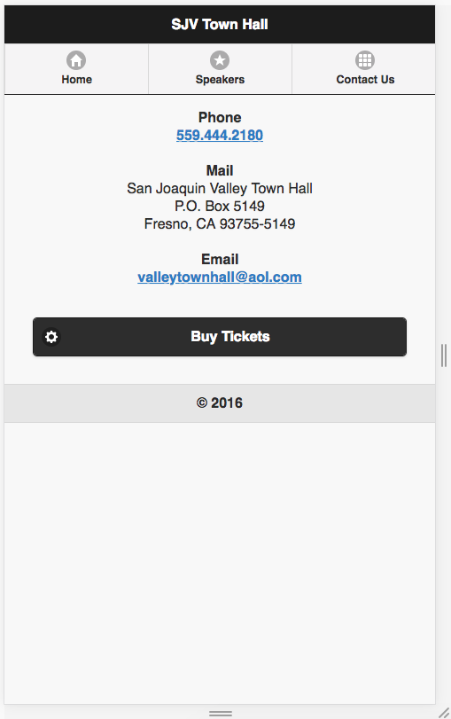

Screenshots showing default theme choices “A” and “B” for the navigation buttons.

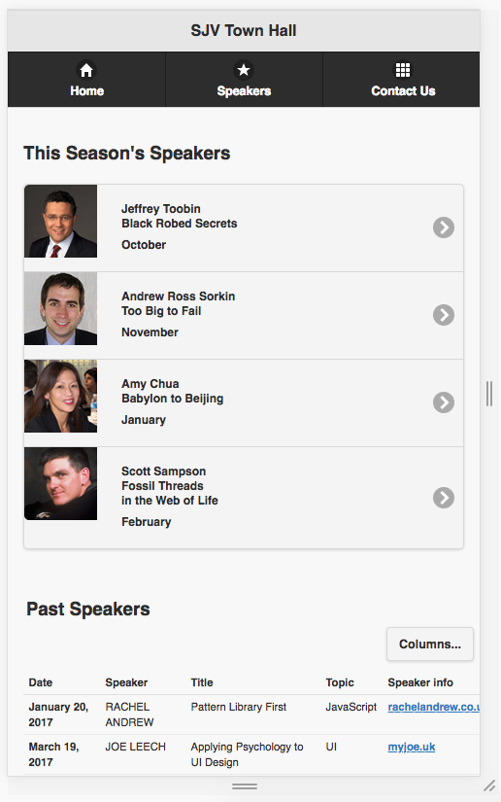

HTML for Chapter 17, Exercise 17-1

<!DOCTYPE HTML>

<html lang="en">

<head>

<meta charset="utf-8">

<meta name="viewport" content="width=device-width, initial-scale=1">

<title>San Joaquin Valley Town Hall</title>

<!-- include the jQuery Mobile stylesheet -->

<link rel="stylesheet" href="http://code.jquery.com/mobile/1.4.5/jquery.mobile-1.4.5.min.css">

<!-- include the jQuery and jQuery Mobile JavaScript files -->

<script src=" https://code.jquery.com/jquery-2.1.3.min.js"></script>

<script src="https://code.jquery.com/mobile/1.4.5/jquery.mobile-1.4.5.min.js"></script>

<link rel="stylesheet" href="mobile.css">

</head>

<body>

<div data-role="page" id="home">

<header data-role="header">

<h1>SJV Town Hall</h1>

<div data-role="navbar">

<ul>

<li><a href="#home" data-icon="home" data-theme="b" class="ui-btn-active">Home</a></li>

<li><a href="#speakers" data-icon="star" data-theme="b">Speakers</a></li>

<li><a href="#contact" data-icon="grid" data-theme="b">Contact Us</a></li>

</ul>

</div>

</header>

<section class="ui-content" role="main">

<h3>Speaker of the month<br>February</h3>

<a href="#sampson">

<img src="images/sampson75.jpg" alt="Scott Sampson">

<h4>Fossil Threads in the Web of Life<br>

Scott Sampson</h4>

</a>

<h3>Cutting-edge speakers <br>for 75 years</h3>

<p>Since 1936, San Joaqin Valley Town Hall has showcased nationally and internationally renowned,

thought-provoking, speakers who inform, educate, and entertain our audience.</p>

<h3>Our History</h3>

<p>1937: In the town of Hanford, California, Clio Lee Aydelott—a woman of letters—hoped to

make an addition to the Central Valley's intellectual and cultural life by providing a

venue for "thinking adults to become better informed." A Town Hall series, already established

in twenty other U.S. cities, thus debuted in Fresno with a program in 1938; it consisted of

seven morning and six evening lectures. The lectures were so well received that a second series

was scheduled for the fall of the same year.</p>

<p>The lecture series continued under the direction of Dr. Rappaport for eight seasons. At that

time, the San Joaquin Valley Town Hall of Fresno was formed to produce the lecture series

independently. The first series of six morning lectures began in October of 1946, and that

format continues to this day.</p>

<p>Over the years, Town Hall has hosted almost 500 speakers who have provided stimulating, intellectual

entertainment. Some speakers of note include Margaret Mead, Bennett Cerf, Agnes DeMille,

James Michener, Gore Vidal, Maya Angelou, Ray Bradbury, Condoleezza Rice, Henry Kissinger,

and Chet Huntley. In the future, Town Hall will continue to work hard to bring you speakers who

will enlighten and entertain.</p>

</section>

<footer data-role="footer">

<h4>&copy; 2016</h4>

</footer>

</div>

<div data-role="page" id="speakers">

<header data-role="header">

<h1>SJV Town Hall</h1>

<div data-role="navbar">

<ul>

<li><a href="#home" data-icon="home" data-theme="b">Home</a></li>

<li><a href="#speakers" data-icon="star" data-theme="b" class="ui-btn-active">Speakers</a></li>

<li><a href="#contact" data-icon="grid" data-theme="b">Contact Us</a></li>

</ul>

</div>

</header>

<section class="ui-content" role="main">

<h3>This Season's Speakers</h3>

<ul data-role="listview" data-split-icon="gear" data-inset="true">

<li>

<a href="#toobin">

<img src="images/toobin75.jpg">

<p><strong>Jeffrey Toobin<br>Black Robed Secrets</strong></p>

<p><strong>October</strong></p>

</a>

</li>

<li>

<a href="#sorkin">

<img src="images/sorkin75.jpg">

<p><strong>Andrew Ross Sorkin<br>Too Big to Fail</strong></p>

<p><strong>November</strong></p>

</a>

</li>

<li>

<a href="#">

<img src="images/chua75.jpg">

<p><strong>Amy Chua<br>Babylon to Beijing</strong></p>

<p><strong>January</strong></p>

</a>

</li>

<li>

<a href="#sampson">

<img src="images/sampson75.jpg">

<p><strong>Scott Sampson<br>Fossil Threads <br>in the Web of Life</strong></p>

<p><strong>February</strong></p>

</a>

</li>

</ul>

</section>

<h3 id=past_speakers>Past Speakers</h3>

<table data-role="table" id="table-column-toggle" data-mode="columntoggle" class="ui-responsive table-stroke">

<thead>

<tr>

<th data-priority="2">Date</th>

<th>Speaker</th>

<th data-priority="3">Title</th>

<th data-priority="1">Topic</abbr></th>

<th data-priority="5">Speaker info</th>

</tr>

</thead>

<tbody>

<tr>

<th>January 20, 2017</th>

<td>RACHEL ANDREW</td>

<td>Pattern Library First</td>

<td>JavaScript</td>

<td><a href="http://rachelandrew.co.uk" data-rel="external">rachelandrew.co.uk</a></td>

</tr>

<tr>

<th>March 19, 2017</th>

<td>JOE LEECH</td>

<td>Applying Psychology to UI Design</td>

<td>UI</td>

<td><a href="http://myjoe.uk" data-rel="external">myjoe.uk</a></td>

</tr>

<tr>

<th>April 26, 2017</th>

<td>LEA VEROU</td>

<td>CSS Secrets</td>

<td>CSS</td>

<td><a href="http://lea.verour.me" data-rel="external">lea.verour.me</a></td>

</tr>

<tr>

<th>October 3, 2017</th>

<td>MARCY SUTTON</td>

<td>Accesibility Audit</td>

<td>UI</td>

<td><a href="http://marcysutton.com">marcysutton.com</a></td>

</tr>

</tbody>

</table>

<footer data-role="footer">

<h4>&copy; 2016</h4>

</footer>

</div>

<div data-role="page" id="contact">

<header data-role="header" data-theme="b">

<h1>SJV Town Hall</h1>

<div data-role="navbar">

<ul>

<li><a href="#home" data-icon="home" data-theme="a">Home</a></li>

<li><a href="#speakers" data-icon="star" data-theme="a">Speakers</a></li>

<li><a href="#contact" data-icon="grid" data-theme="a" class="ui-btn-active">Contact Us</a></li>

</ul>

</div>

</header>

<section class="ui-content" role="main" style="text-align:center;">

<strong>Phone</strong><br>

<a href="tel:15594442180">559.444.2180</a><br><br>

<strong>Mail</strong><br>

San Joaquin Valley Town Hall<br>

P.O. Box 5149<br>

Fresno, CA 93755-5149<br><br>

<strong>Email</strong><br>

<a href="mailto:valleytownhall@aol.com">valleytownhall@aol.com</a><br><br>

<div class="ui-bar">

<a href="#buytix" data-icon="gear" data-theme="b">Buy Tickets</a>

</div>

</section>

<footer data-role="footer">

<h4>&copy; 2016</h4>

</footer>

</div>

<div data-role="page" id="buytix" data-dialog="true">

<header data-role="header">

<h1>Buy Tickets</h1>

</header>

<section data-role="content">

<h3>Ticket packages and prices</h3>

<p><strong>Season ticket: $95</strong></p>

<p>Admission to all six lectures, plus one single-lecture guest ticket good for any one lecture</p>

<p><strong>Patron ticket: $200</strong></p>

<p>Admission to all six lectures, plus three single-lecture guest tickets and recognition in annual brochure</p>

<p><strong>Single lecture: $25</strong></p>

<p>Must be purchased at the box office on the day of the lecture</p>

<a href="#" data-role="button" data-rel="back">Cancel</a>

<a href="#" data-role="button" data-rel="back" data-theme="b" >Buy Ticket</a>

</section>

<footer data-role="footer">

<h4>&copy; 2016</h4>

</footer>

</div>

<div data-role="page" id="toobin">

<header data-role="header">

<h1>SJV Town Hall</h1>

<div data-role="navbar">

<ul>

<li><a href="#home" data-icon="home" data-theme="b">Home</a></li>

<li><a href="#speakers" data-icon="star" data-theme="b">Speakers</a></li>

<li><a href="#contact" data-icon="grid" data-theme="b">Contact Us</a></li>

</ul>

</div>

</header>

<section class="ui-content" role="main">

<h3>The Supreme Nine:<br>Black Robed Secrets</h3>

<img src="images/toobin_court.cnn.jpg" alt="Jeffrey Toobin" width="260" />

<p>Author of the critically acclaimed best seller, <i>The Nine: Inside the Secret World

of the Supreme Court</i>, Jeffrey Toobin brings the inside story of one of America's

most mysterious and powerful institutions to the Saroyan stage. At the podium,

Toobin is an unbiased, deeply analytic expert on American law, politics and procedure

and he provides a unique look into the inner workings of the Supreme Court

and its influence.</p>

<p>Inside the Secret World of the Supreme Court was published by Doubleday and spent

more than four months on the NY Times best-seller list, earning Toobin the 2008

J. Anthony Lukas Prize for Nonfiction from the Columbia Graduate School of Journalism. Toobin

has also written several other best-selling books, including <i>A Vast Conspiracy:

The Real Story of the Sex Scandal that Nearly Brought Down a President</i>; <i>The Run of His Life:

The People vs. O.J. Simpson</i>; and <i>Too Close to Call: The 36-Day Battle to Decide the

2000 Election.</i></p>

<p><a href="#" data-role="button" data-rel="back" data-theme="b">Back to previous page</a></p>

</section>

<footer data-role="footer">

<h4>&copy; 2016</h4>

</footer>

</div>

<div data-role="page" id="sorkin">

<header data-role="header">

<h1>SJV Town Hall</h1>

<div data-role="navbar">

<ul>

<li><a href="#home" data-icon="home" data-theme="b">Home</a></li>

<li><a href="#speakers" data-icon="star" data-theme="b">Speakers</a></li>

<li><a href="#contact" data-icon="grid" data-theme="b">Contact Us</a></li>

</ul>

</div>

</header>

<section class="ui-content" role="main">

<h3>Too Big to Fail</h3>

<img src="images/sorkin_desk260.jpg" alt="Andrew Ross Sorkin" width="260" />

<p>Text would appear here.</p>

<p>And more here.</p>

<p><a href="#" data-role="button" data-rel="back" data-theme="b">Back to previous page</a></p>

</section>

<footer data-role="footer">

<h4>&copy; 2016</h4>

</footer>

</div>

<div data-role="page" id="sampson">

<header data-role="header">

<h1>SJV Town Hall</h1>

<div data-role="navbar">

<ul>

<li><a href="#home" data-icon="home" data-theme="b">Home</a></li>

<li><a href="#speakers" data-icon="star" data-theme="b">Speakers</a></li>

<li><a href="#contact" data-icon="grid" data-theme="b">Contact Us</a></li>

</ul>

</div>

</header>

<section class="ui-content" role="main">

<h3>Fossil Threads<br>in the Web of Life</h3>

<img src="images/sampson_dinosaur.jpg" alt="Scott Sampson" width="260" />

<p>What's 75 million years old and brand spanking new? A teenage

Utahceratops! Come to the Saroyan, armed with your best dinosaur roar, when Scott Sampson,

Research Curator at the Utah Museum of Natural History, steps to the podium. Sampson's

research has focused on the ecology and evolution of late Cretaceous dinosaurs and he has

conducted fieldwork in a number of countries in Africa.</p>

<p>Scott Sampson is a Canadian-born paleontologist who received his Ph.D. in zoology from

the University of Toronto. His doctoral work focused on two new species of ceratopsids, or

horned dinosaurs, from the Late Cretaceous of Montana, as well as the

growth and function of certopsid horns and frills.</p>

<p>Following graduation in 1993, Sampson spent a year working at the American

Museum of Natual History in New York City, followed by five years as assistant professor of

anatomy at the New York College of Osteopathic Medicine on Long Island. He arrived at the

University of Utah accepting a dual position as assistant professor in the Department of

Geology and Geophysics and curator of vertebrate paleontology at the Utah Museum of Natural

History. His research interests largely revolve around the phylogenetics, functional

morphology, and evolution of Late Cretaceous dinosaurs.</p>

<p>In addition to his museum and laboratory-based studies, Sampson has conducted paleontological

work in Zimbabwe, South Africa, and Madagascar, as well as the United States and Canada. He was

also the on-the-air host for the Discovery Channel's Dinosaur Planet and recently completed a

book, <em>Dinosaur Odyssey: Fossil Threads in the Web of Life</em>, which is one of the most

comprehensive surveys of dinosaurs and their worlds to date.</p>

<div class="ui-bar">

<a href="#speakers" data-theme="b">Back to Speakers</a>

</div>

</section>

<footer data-role="footer">

<h4>&copy; 2016</h4>

</footer>

</div>

</body>

</html>

CSS for Chapter 17, Exercise 17-1

table {

margin-left: 1em;

}

#past_speakers {

margin-left: 1em;

margin-right: 1em;

margin-bottom: 0;

}

td, th {

font-size: 70%}

# Conclusion

Although using JavaScript can seem difficult at first, the effort pays off in the features it can provide for a developer’s websites. Going into this lab, I felt some apprehension because I had found using the SlickNav plugin in a previous lab a little confusing. And, indeed, some of the first exercises in this lab were a little challenging, too. However, as I went through the lab, things became easier. Like anything else, JavaScript takes practice, so I’m glad this lab offered additional experience.

# Resources

Boehm, Anne and Ruvalcaba, Zak. *Murach’s HTML5 and CSS3* 3rd ed. Mike Murach &   
 Associates, Inc. 2015

Cycle2 website. Retrieved from: https://jquery.malsup.com/cycle2

jQuery User Interface website. Retrieved from: https://jqueryui.com

TutorialsPoint website. *JQueryUI Tutorial.* Retrieved from:   
 https://www.tutorialspoint.com/jqueryui/index.htm