Julie Sakai

CSD 310

Module 2.3 Assignment

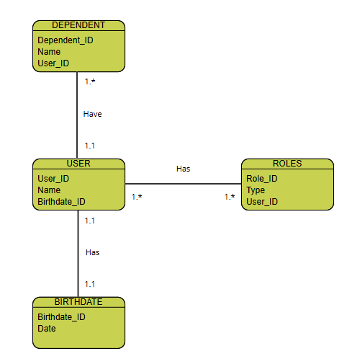ERD Diagram

NoSQL Data Structure

