Julie Sakai

CSD 310

Module 5.2 Assignment

MySQL UPPER() Function converts all the characters in a string to uppercase. This function can be used to locate all the students last names Sakai whether it was input as Sakai, sakai, or SAKAI. This ensures consistency in the data by converting all the values to uppercase.

Alias: StringInUppercase, UpperCaseString, or UppercaseValue

In my example, I used “i love cats!” which converted to “I LOVE CATS!”.

MySQL REVERSE() Function converts the characters in a string in a reverse order. This function is not used as often but can be useful when creating a palindrome check or reversing word order. The REVERSE() function can determine if a string is the same when it is read forward and backward.

Alias: ReversedString, StringReversed, or ReversedValue

In my example, my string was Desserts and in reverse it is stressed.

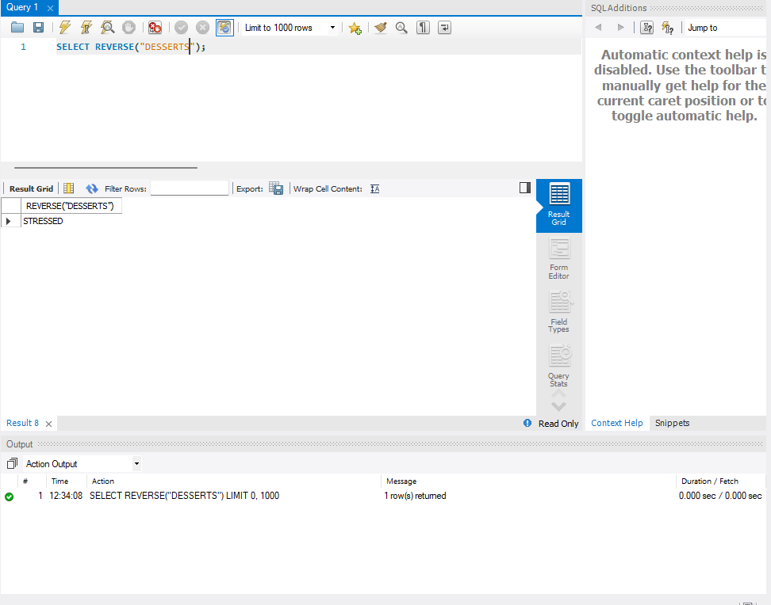

MySQL LENGTH() Function counts the number of characters in a string. It is used to ensure that strings meet certain length requirements. An example could be validating a password to check to meet the minimum requirements of 12 characters.

Alias: StringLength, StringCharacterCount, or Length

In my example, I used “supercalifragilisticexpialidocious” to find out the number of characters in that string.

