

MODPATH Version 7: Example Problems

MODPATH Version 7.2.001  
December 2017

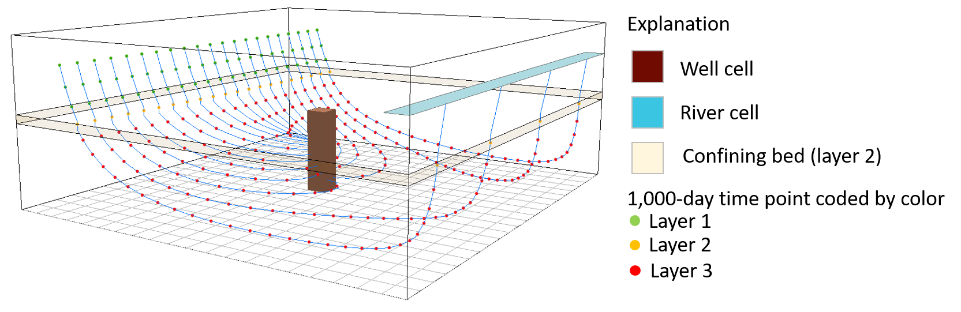

Contents

Overview 3

Example 1 (EX01) – Structured Grid, Steady-State Flow 4

Simulation 1A – Forward Tracking Pathlines with Time-Series Simulation 7

Simulation 1B – Forward-Tracking Endpoint Simulation 9

Example 2 (EX02) – Unstructured Grid, Steady-State Flow 12

Simulation 2A – Backward-Tracking Pathline and Time-Series Simulation 14

Simulation 2B – Backward-Tracking Endpoint Simulation 16

Example 3 (EX03) – Structured Grid, Transient Flow 18

Simulation 3A – Forward-Tracking Time-series Simulation with Multiple Release Times 19

Example 4 (EX04) – Unstructured Grid, Specified Lateral Flow Boundaries 20

Simulation 4A – Backward-Tracking Pathline Simulation 21

# 

# Overview

This software distribution includes four example problems that are designed to illustrate the major features of MODPATH and provide a starting point for users to experiment and build new datasets. MODPATH-7 supports three versions of MODFLOW (MODFLOW-2005, MODFLOW-USG, and MODFLOW-6). All the example problems can be setup to work with more than one version of MODFLOW. Multiple versions of MODPATH datasets are provided for examples 1 and 2 to illustrate the differences in MODPATH-7 datasets that are required to link MODPATH to the different versions of MODFLOW.

Each example problem directory contains subdirectories named “original” and “work.” The directory “original” contains a completed version of the example problem. The “work” directory is initially empty. To run the example problem, copy all of the files from directory “original” into directory “work.” Run the example problems from the “work” directory. To preserve the original files, do not make any changes to the contents of directory “original.”

The example problems in this software distribution are setup to run on computers using Microsoft Windows. There is no need to run MODFLOW because all the MODFLOW output needed for the MODPATH simulations is contained in the original set of files. A batch file is provided to run the MODPATH executable. To run the batch file, type:

run-mpath7.bat

MODPATH will prompt for the name of a MODPATH simulation file. Enter the name of one of the example problem simulation files to run a MODPATH simulation. Files with extension “.mpsim” denote MODPATH simulation data files. The batch files are setup to run the MODPATH executable file located in the “bin” directory of the software distribution. There is no need to put the MODPATH executable file in the user search path in order to run the examples.

# Example 1 (EX01) – Structured Grid, Steady-State Flow

Example 1 is based on the groundwater flow system shown in figure 1. The flow system consists of two aquifers separated by a thin low conductivity confining layer.

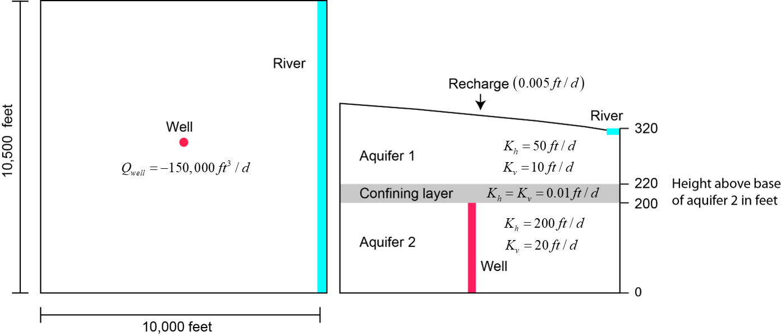

Figure 1. Conceptual model (ft, foot; ft3, cubic foot, ft/d, foot per day).

The system is simulated with a traditional structured model grid consisting of 3 model layers, 21 rows, and 20 columns (figure 2). Areal grid cells are uniform square cells, 500 feet per side. The model layers correspond to the hydrogeologic units shown in figure 1.

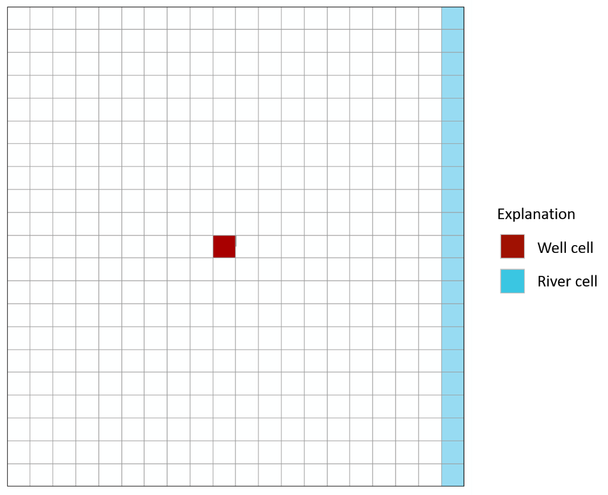

The well is located in row 11, column 10, and layer 3. The river is located in layer 1, column 20, rows 1 - 21.

MODPATH simulations require several data files that are referred to throughout the MODPATH documentation as “flow system files.” Flow system files provide the basic information needed to define groundwater flow velocity and grid structure. Many flow system files are either MODFLOW input files or output files generated by MODFLOW. Flow system files are specified in the MODPATH name file. The specific type and content of the flow system files depends on the version of MODFLOW used to generate the groundwater flow simulation. For flow simulations based on structured grids, flow system files can be either (1) MODFLOW-2005/MODFLOW-USG data files, or (2) MODFLOW-6 data files. Both types of datasets are provided for example 1.

Figure 3 shows the MODPATH name file for the MODFLOW-2005 version of example 1.

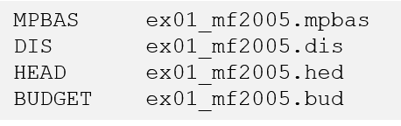

Figure 3. MODPATH name file for MODFLOW-2005 and MODFLOW-USG structured grids.

Each line in the name file designates a specific flow-system file with a key word indicating the file type and the name of the file. For a MODFLOW-2005 structured grid the flow-system files are:

* MPBAS – the MODPATH basic data file
* DIS – the MODFLOW-2005 discretization file
* HEAD – the MODFLOW binary head output file
* BUDGET – the MODFLOW budget output file

The DIS file contains both spatial and time discretization data. The MODPATH basic data file contains additional data such as IBOUND, layer types, and porosity that are needed to fully describe the grid and to compute groundwater flow velocity.

Figure 4 shows the MODPATH name file for the MODFLOW-6 version of example 1.

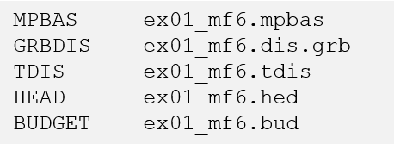

Figure 4. MODPATH name file for MODFLOW-6 structured grids

For a MODFLOW-6 structured grid, the flow-system files are:

* MPBAS – the MODPATH basic data file
* GRBDIS – the MODFLOW-6 binary grid file
* TDIS – the MODFLOW-6 time discretization file
* HEAD – the MODFLOW binary head output file
* BUDGET – the MODFLOW budget output file

Spatial grid data is provided by the binary grid file (GRBDIS). The binary grid file is generated by MODFLOW-6. Time discretization data is provided by the MODFLOW-6 time discretization file (TDIS).

The contents of the MODPATH basic data file are different for the MODFLOW-2005 and MODFLOW-6 simulations. Figure 5 shows the MODPATH basic data files for the two versions of MODFLOW.

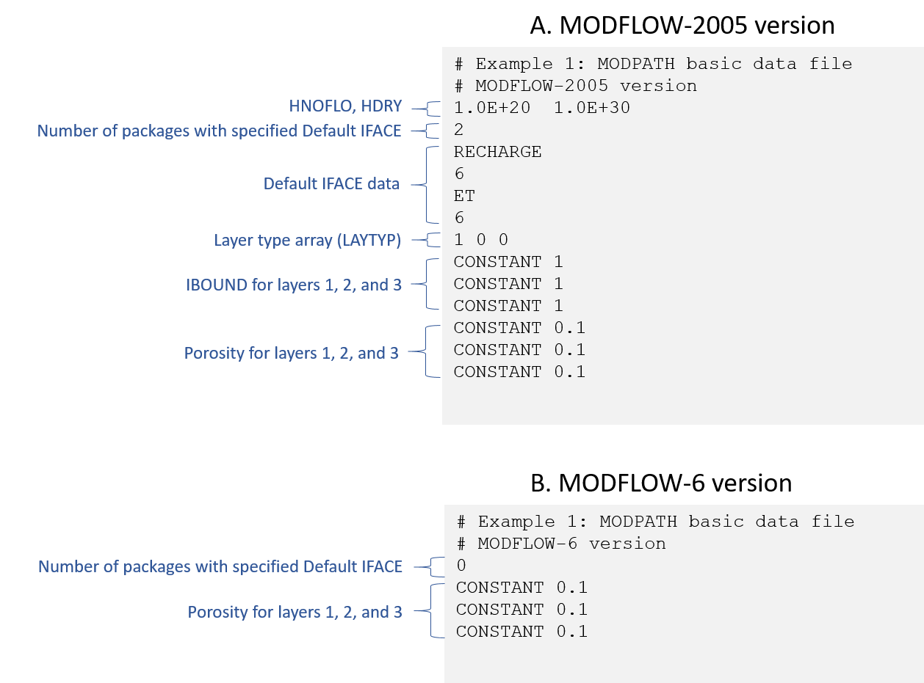

Figure 5. MODPATH basic data file

The MODPATH basic data file for MODFLOW-6 simulations contains fewer data items because data items related to properties such as IBOUND and layer types are included in the MODFLOW-6 binary grid file. HNOFLO and HDRY values are not included for the MODFLOW-6 simulations because MODFLOW-6 automatically sets HNOFLO equal to 1.0E+30 and HDRY equal to -1.0E+30. Finally, the default IFACE values were removed from the basic data file because MODFLOW-6 allows all stress packages to specify IFACE data in their package data files. In previous versions of MODFLOW, packages such as the recharge package could not specify IFACE. A default IFACE value still can be specified for any stress package, but it is no longer required for packages such as recharge and evapotranspiration.

## Simulation 1A – Forward Tracking Pathlines with Time-Series Simulation

In simulation 1A, a line of 21 particles is placed at the water table in layer 1 for column 3, rows 1 through 21. A combined pathline and time-series simulation is run that tracks the particles forward to their discharge locations. The particle stop option is set to extend the final time step to assure that all of the particles reach their discharge locations, regardless of travel time. The simulation file and starting locations file for simulation 1A are shown in figure 6 and figure 7, respectively.

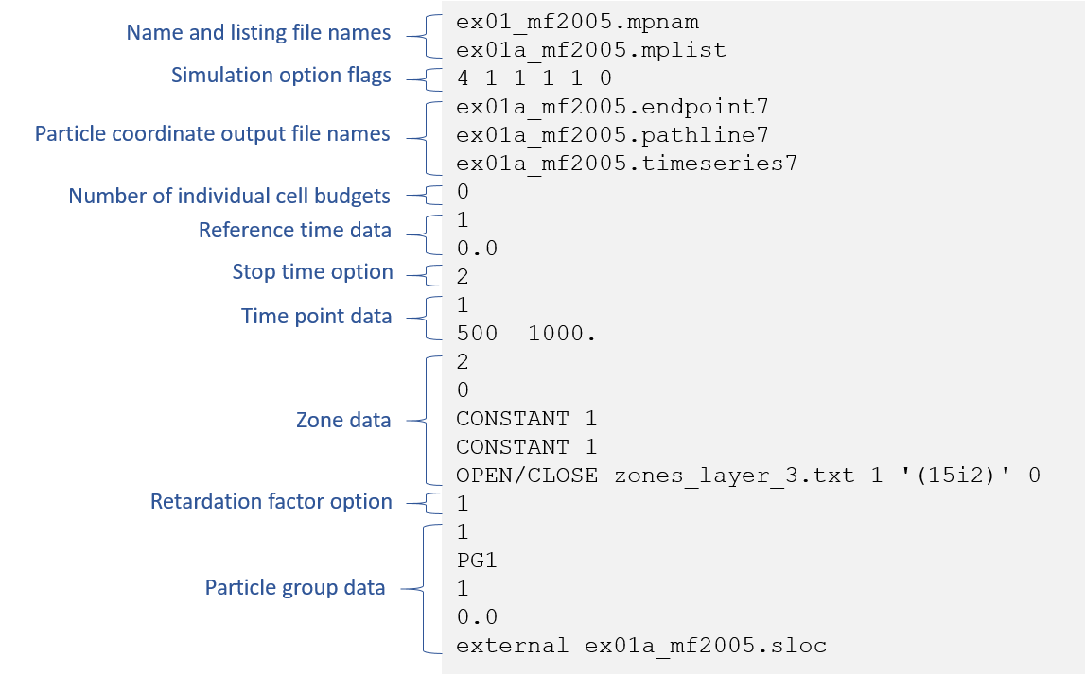

Figure 6. Simulation file for example 1A.

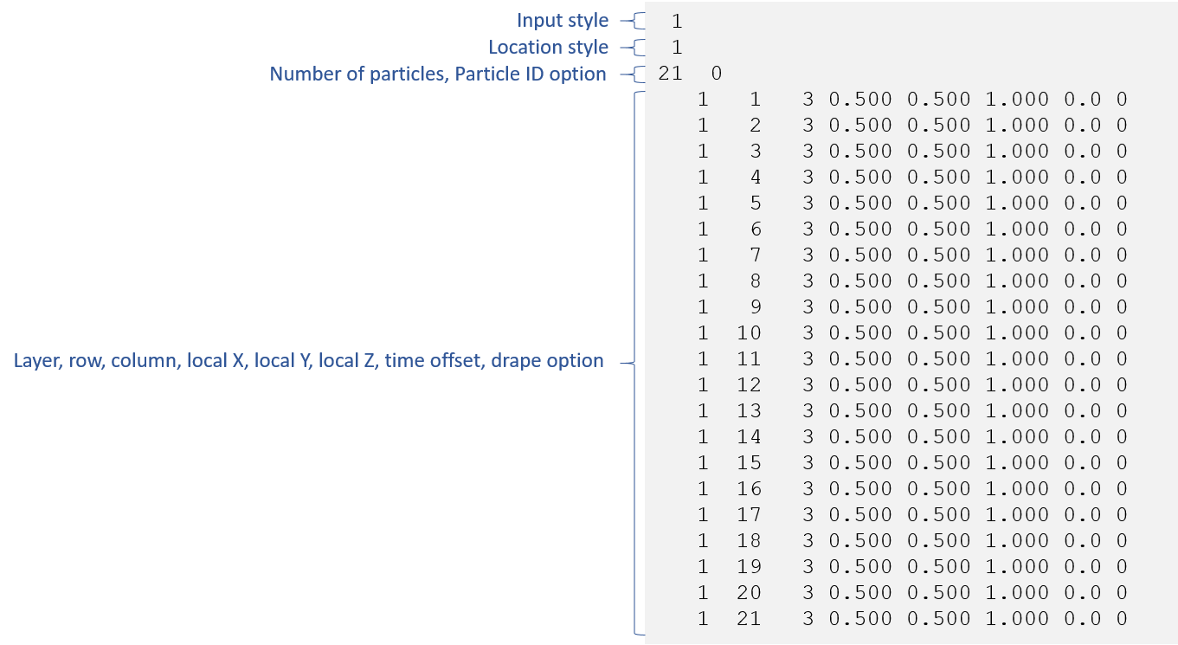

Figure 7. Starting locations file for example 1A.

All of the data are now ready to run MODPATH for simulation 1A. When the simulation is complete, summary information is printed to the command window. In the case of simulation 1A, the following output files are generated:

* Listing file
* Endpoint file
* Pathline file
* Timeseries file
* Log file

The particle coordinate output files are simple text files that contain spatial and time coordinates that define the particle paths. The data provided in those files often are used to create standardized graphics files that can be displayed in a variety of two- and three-dimensional viewers. Figure 8 shows a map view of the pathlines generated by simulation 1A. The points represent 1,000-day time points. The point colr signifies the model layer. The same data are displayed in a three-dimensional perspective view in figure 9.

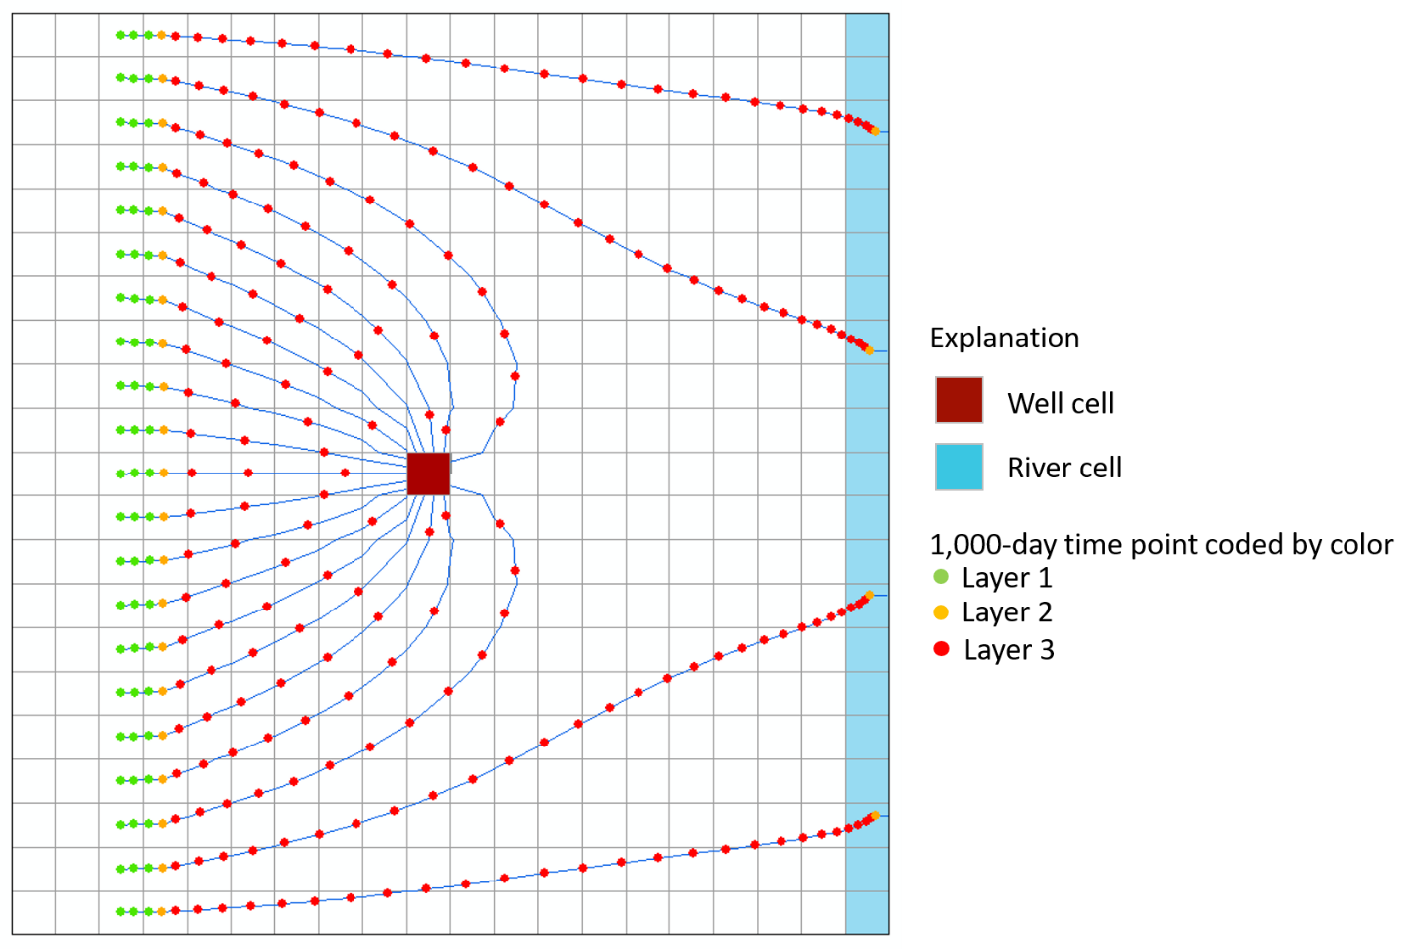

Figure 8. Map view of pathlines and time points for simulation 1SA.



Figure 9. Three-dimensional perspective view of pathlines and time pointws for simulation 1A.

## Simulation 1B – Forward-Tracking Endpoint Simulation

MODPATH often is used to compute recharge capture areas for wells and other hydrologic features. Forward-tracking endpoint simulations are an efficient way to use MODPATH to compute capture areas for wells. In simulation 1B, a capture area for the well is determined by placing a 3 x 3 array of particles on the top face of layer 1 and then tracking the particles forward to their discharge points using a forward endpoint simulation. The endpoint file generated by MODPATH contains information about the starting location and the final location of each particle. The capture area for the well can be displayed for a forward-tracking endpoint simulation by plotting the starting locations of all the particles color-coded according to the zone value of the final cells in which they terminate. Figure 10 and figure 11 show the simulation file and starting locations file for simulation 1B, respectively.

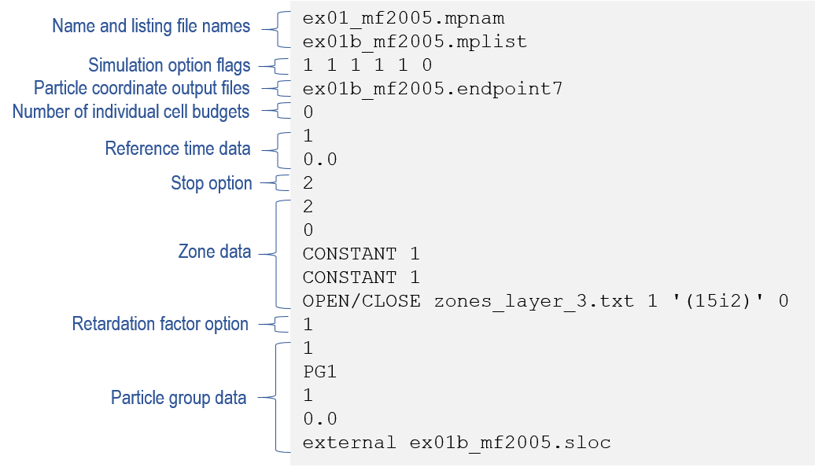

Figure 10. Simulation file for example 1B

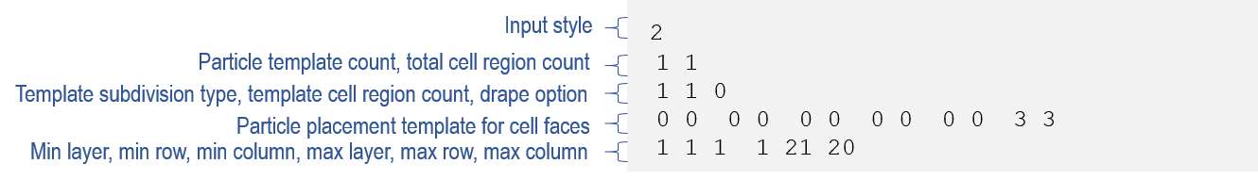

Figure 11. Starting locations file for simulation 1B

The starting locations file used for simulation 1B has a different, more compact structure than that used for simulation 1A. In simulation 1B, the starting locations are specified using a template and a specified range of cells. The template defines how particles are placed in each cell within the range. That approach allows thousands of particles to be generated automatically with only a few lines of data in the starting locations file. The other data files used in simulation 1A also can be used in simulation 1B. The starting locations of particles that discharge to the cell containing the well are shown in red. Starting locations that discharge to the river are shown with open circles.

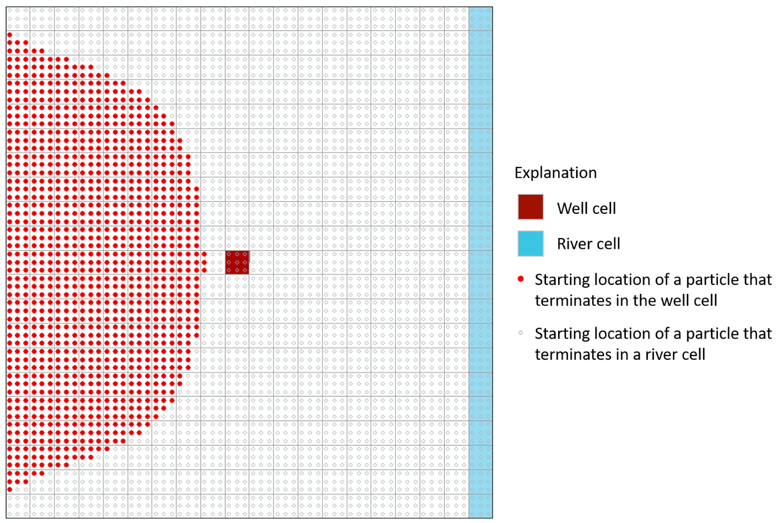

Figure 12.Map view of starting locations color-coded to show discharge locations for   
simulation 1B

# Example 2 (EX02) – Unstructured Grid, Steady-State Flow

Example 2 simulates the same groundwater flow system as example 1 using MODFLOW-USG and MODFLOW-6 with an unstructured grid to refine the area near the well. Figure 13 shows the unstructured grid, which is based on the structured grid used in example 1 (referred to as the base grid). The areal grid is refined around the base-grid location that contains the well in example 1 (row 11, column 10). The base-grid cell containing the well is refined three levels, which means that the unstructured grid contains an 8 x 8 array of 64 cells in place of the original base-grid cell. The grid is smoothed so that it will meet the requirements of MODPATH for unstructured grids. The same areal grid is used for all model layers. The three-layer unstructured grid contains a total of 1,953 cells. The well is located in cell 1,623 in layer 3.

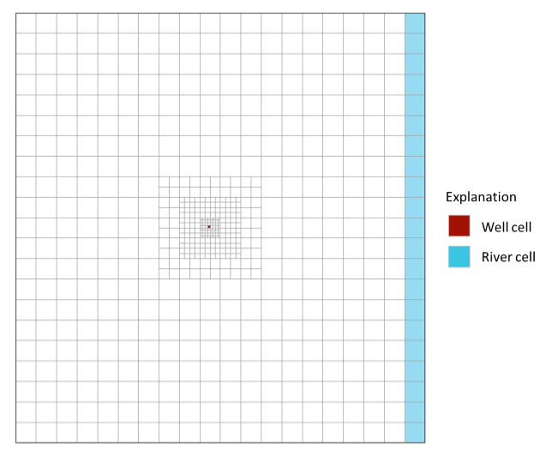

Figure 13. Unstructured grid in example 2.

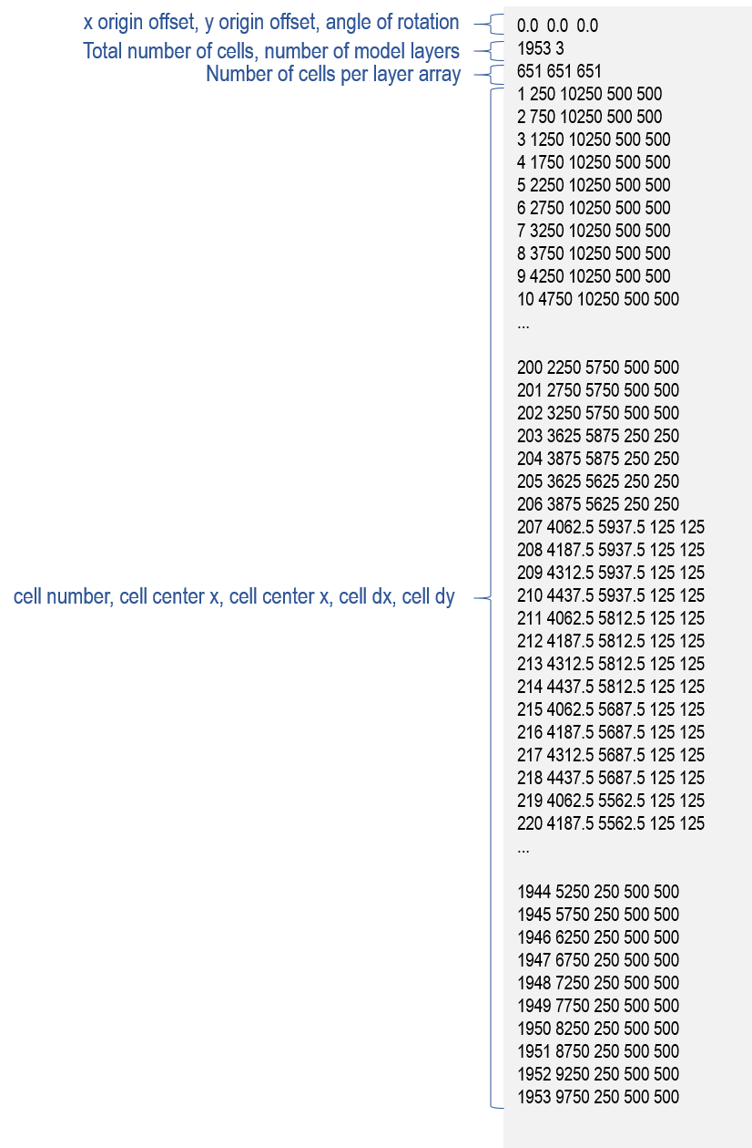

Figure 14. GRIDMETA file for example 2 (MODFLOW-USG)

The MODPATH name file for the MODFLOW-USG version of example 2 is shown in figjre 15.

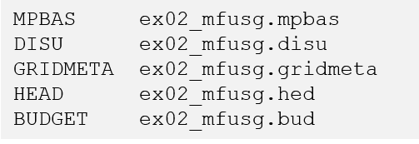

Figure 15. MODPATH name file (MODFLOW-USG)

For a MODFLOW-USG unstructured grid, the flow-system files are:

* MPBAS – the MODPATH basic data file
* DISU – the MODFLOW-USG unstructured grid discretization file
* GRIDMETA – supplemental grid data file for MODFLOW-USG an unstructured grid
* HEAD – the MODFLOW binary head output file
* BUDGET – the MODFLOW budget output file

An edited version of the GRIDMETA file for example 2 is shown in figure 14. The MODPATH basic data file is not shown because it is similar to that shown previously for example 1.

## Simulation 2A – Backward-Tracking Pathline and Time-Series Simulation

In simulation 2A a ring of 16 particles is placed around faces 1 through 4 at the mid-depth of layer 3 and then tracked backward to their recharge locations at the water table. Figure 16 and figure 17 show the simulation file and starting location file, respectively.

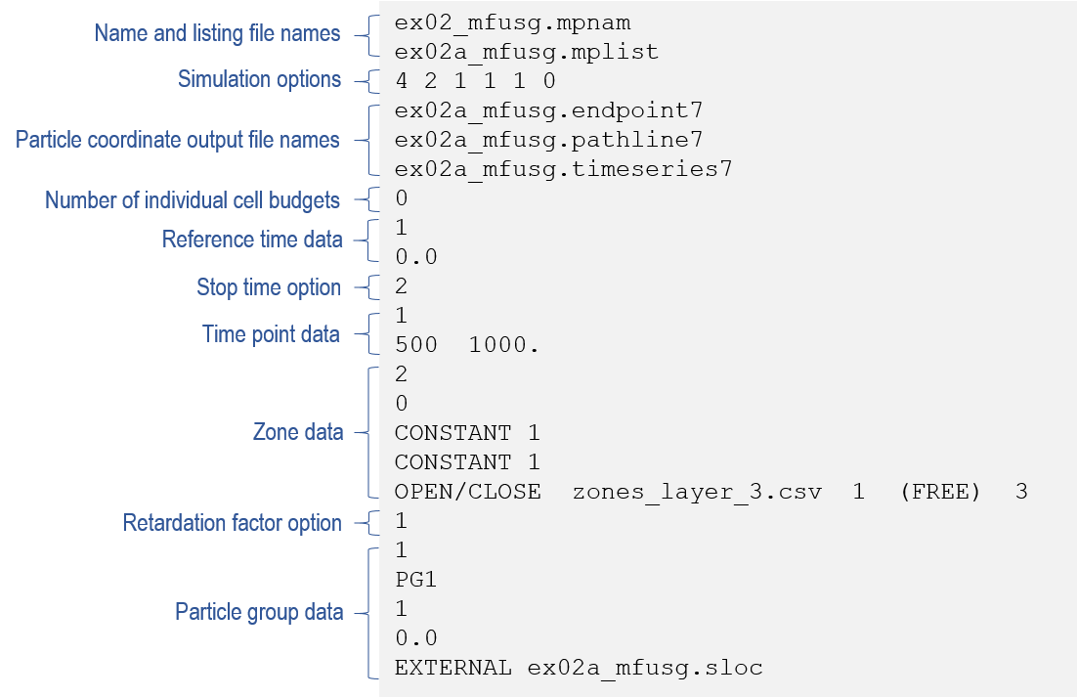

Figure 16. Simulation file for simulation 2A

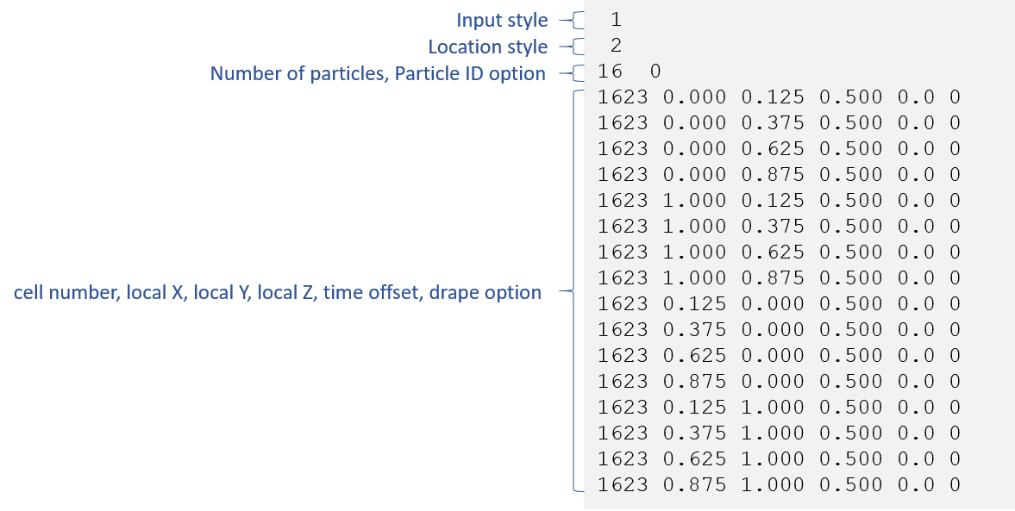

Figure 17. Starting locations file for simulation 2A.

For unstructured grid simulations, particle starting locations are specified by cell number rather than by layer, row, column. The pathlines generated by backward tracking are shown in figures 18 and 19.

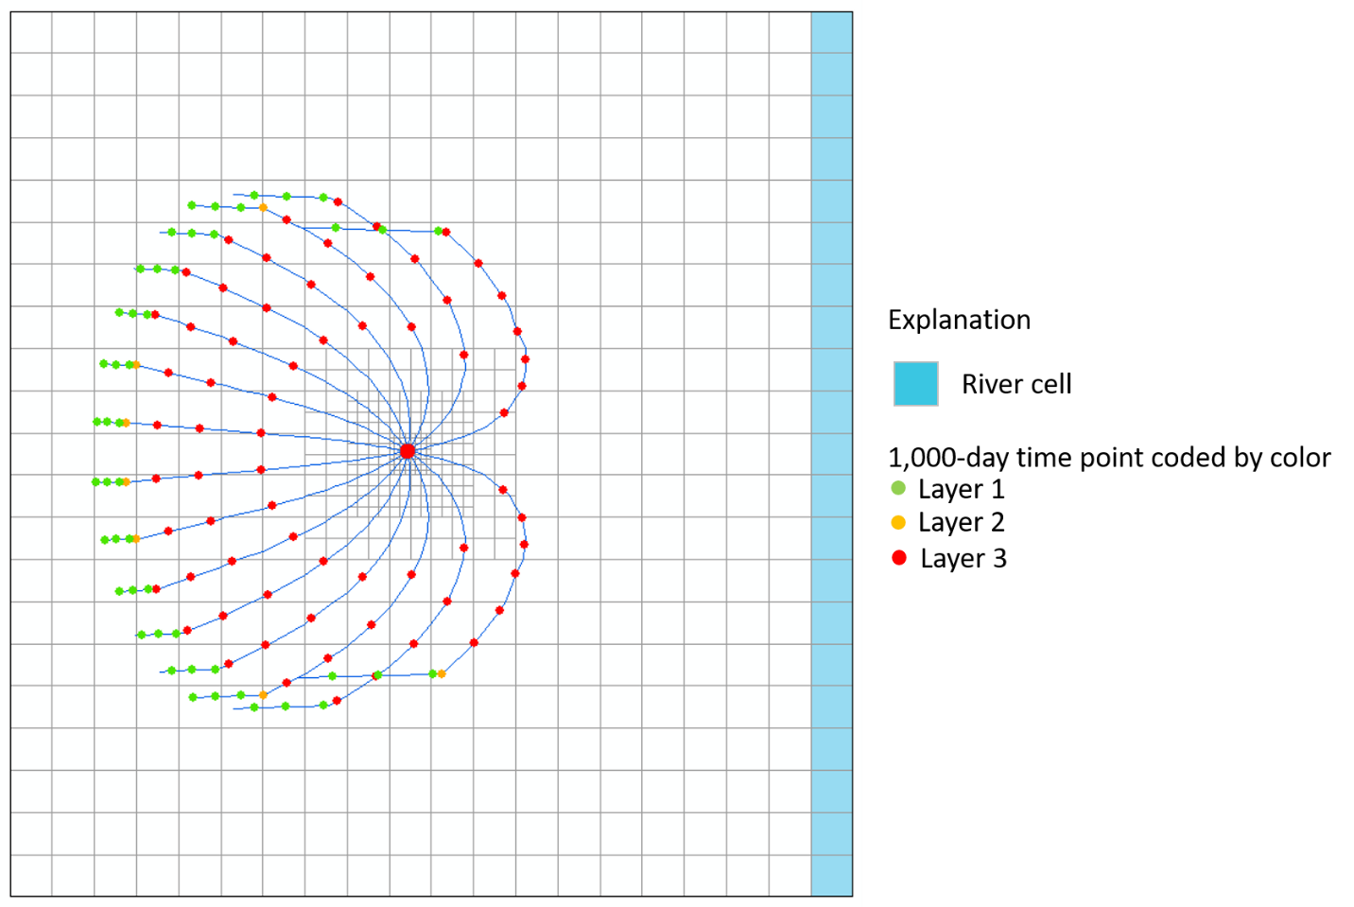

Figure 18. Pathlines generated by backward tracking from the well in simulation 2A.

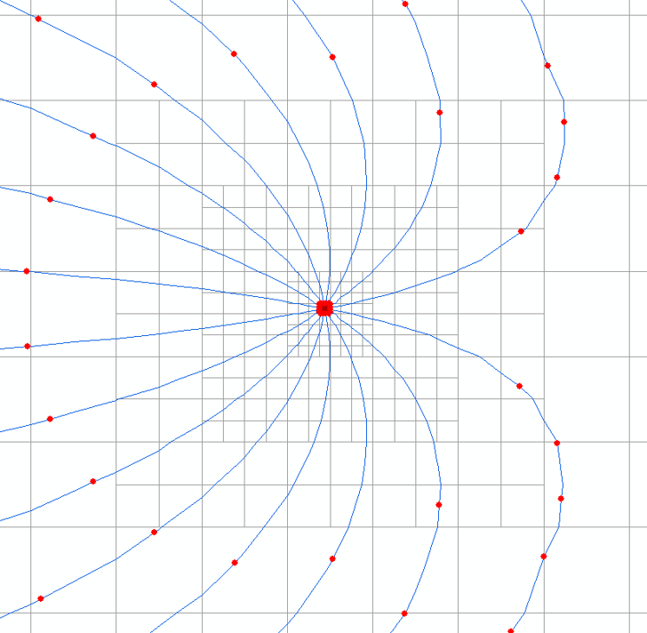

Figure 19. Enlarged view of pathlines for simulation 2A.

## Simulation 2B – Backward-Tracking Endpoint Simulation

Simulation 2B uses backward particle tracking to generate a capture area for the well. A 10 x 10 array of 100 particles is placed on faces 1 through 4 of cell 1,623, which contains the well. An additional 4 x 4 array of 16 particles is placed on the top of the cell. Particles are trackied backward using an endpoint analysis. Figure 20 shows the final location of the particles that originated at the well. Figure 21 shows a three-dimensional view of the particles together with the pathlines generated in simulation 2A.

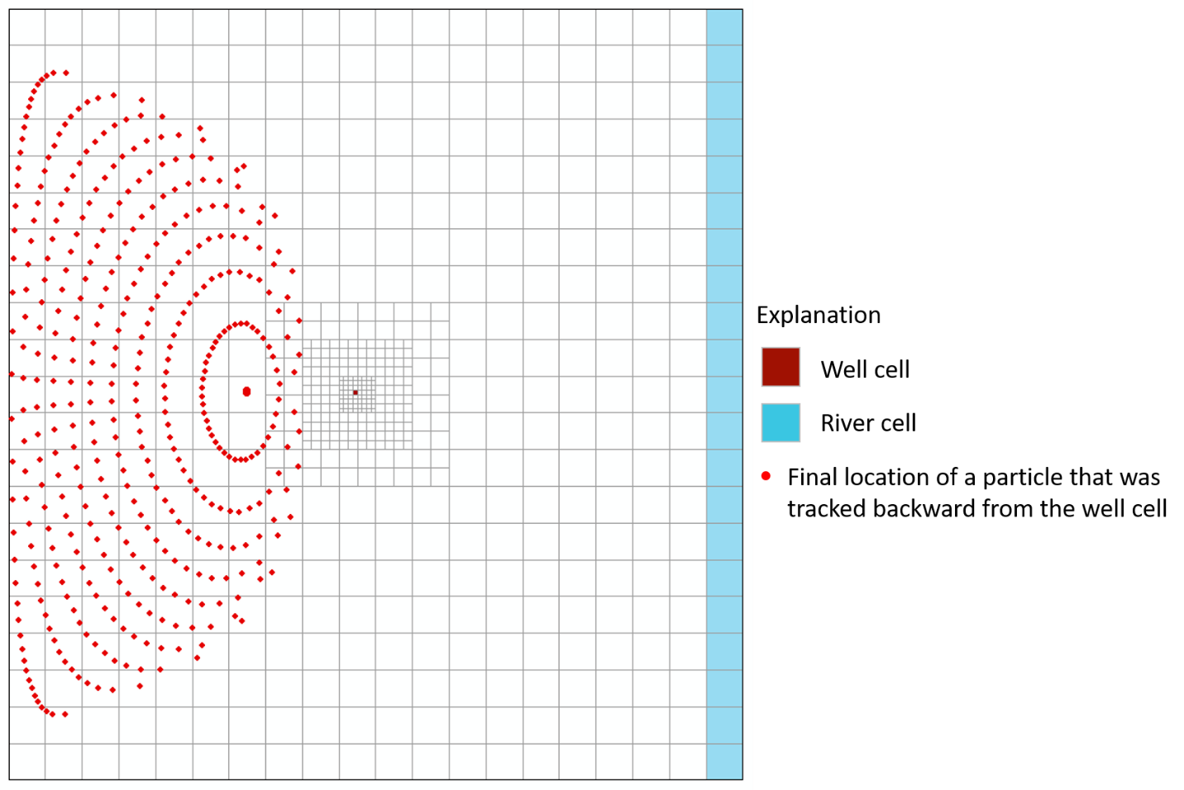

Figure 20. Backward-tracking endpoints for simulation 2B.

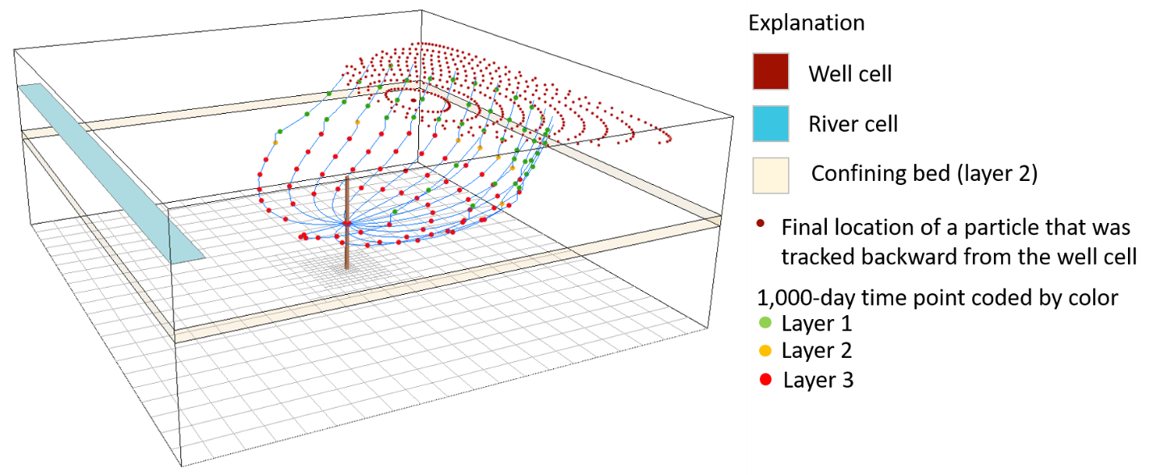

Figure 21. Three-dimensional view of particle-tracking results for simulations 2A and 2B.

# Example 3 (EX03) – Structured Grid, Transient Flow

Example 3 is a transient flow example based on the same conceptual hydrogeologic flow system as examples 1 and 2. Example 3 is based on a MODFLOW-6 simulation that consists of three stress periods:

* Stress period 1 – steady-state, 1 time step, period length = 100,000 days
* Stress period 2 – transient, 10 time steps, period length = 36,500 days
* Stress period 3 – steady-state, 1 time step, period lengtrh = 100,000 days

Stress period 1 is steady-state with no well discharge. Two discharge wells are added at the beginning of stress period 2 (100,000 days into the simulation). The wells continue to discharge at a constant rate for stress periods 2 and 3.

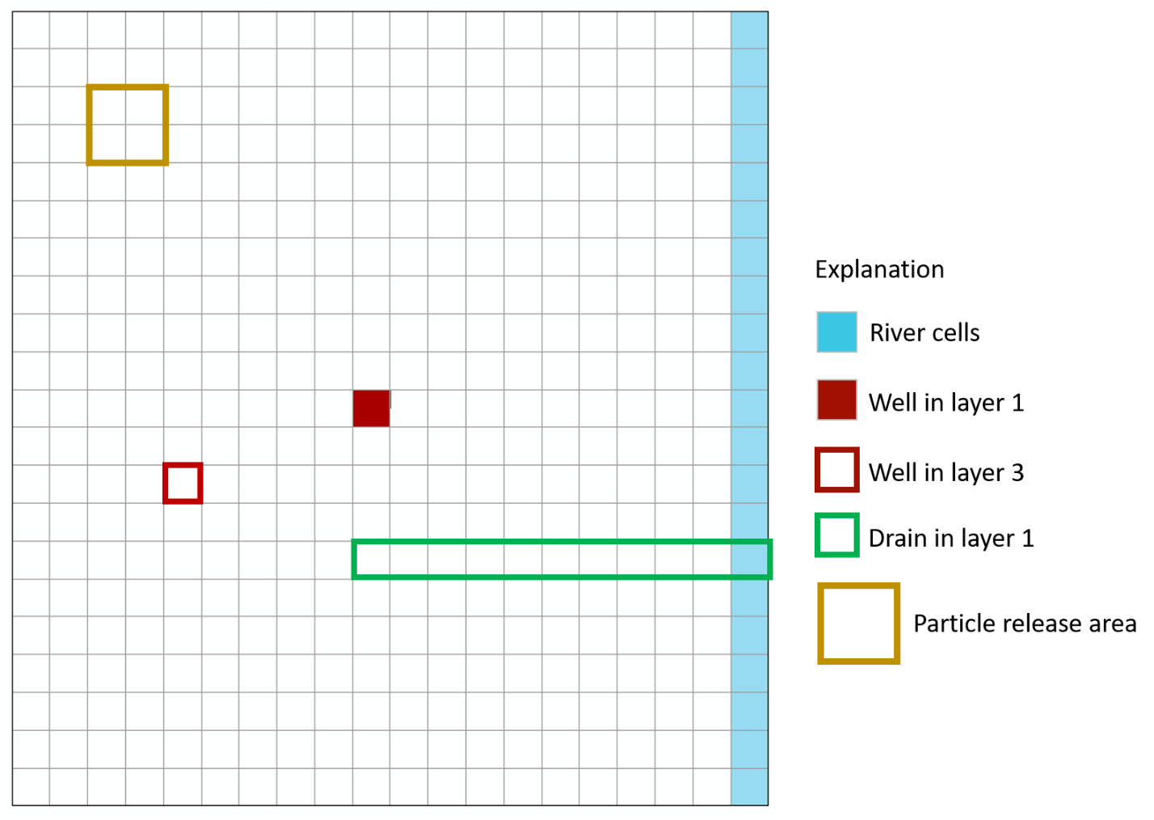

Figure 22. Areal grid and hydrologic features for example 3.

## Simulation 3A – Forward-Tracking Time-series Simulation with Multiple Release Times

Particles are added at the top of layer 1 for 4 cells shown in figure 22. The particles are released at regular 20-day intervals for a period of 200 days starting at tracking time 0.0. Reference time option 2 is used to compute the reference time using a relative time position of 0.9 in time step 1 of stress period 1. That approach results in a reference time of 90,000 days. Figure 23 shows time-series plots of particles at 2000-day intervals color-coded according to their discharge location.

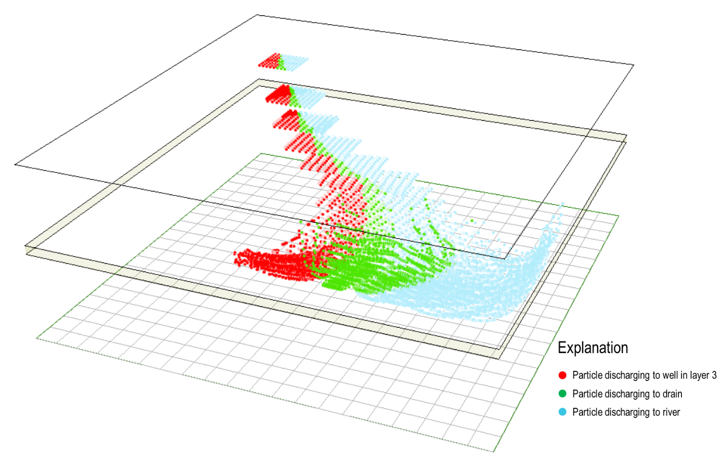

Figure 23. Time points at 2000-day intervals for example 3A.

# Example 4 (EX04) – Unstructured Grid, Specified Lateral Flow Boundaries

Example 4 is a simple, one-layer, confined aquifer flow system based on a steady-state MODFLOW-6 simulation using an unstructured quadpatch grid. The model domain is irregular in shape and contains large areas of inactive cells. The IDOMAIN array in MODFLOW-6 is used to eliminate the inactive cells from the MODFLOW solution. The grid and flow-system boundary conditions are shown in figure 24. The flow system consists of inflow boundaries on the left side of the grid (shown in red), constant head boundaries on the right (shown as yellow dots), and 2 discharge wells located near the center of the refined grid region in the upper left region of the active grid. Boundary flows are represented using injection wells in the cells adjacent to the flow boundary. The well flows for the boundary wells are assigned to the boundary faces of the cells using the auxiliary variable IFACE in the well package data file. The wells are too small to be shown on figure 24.

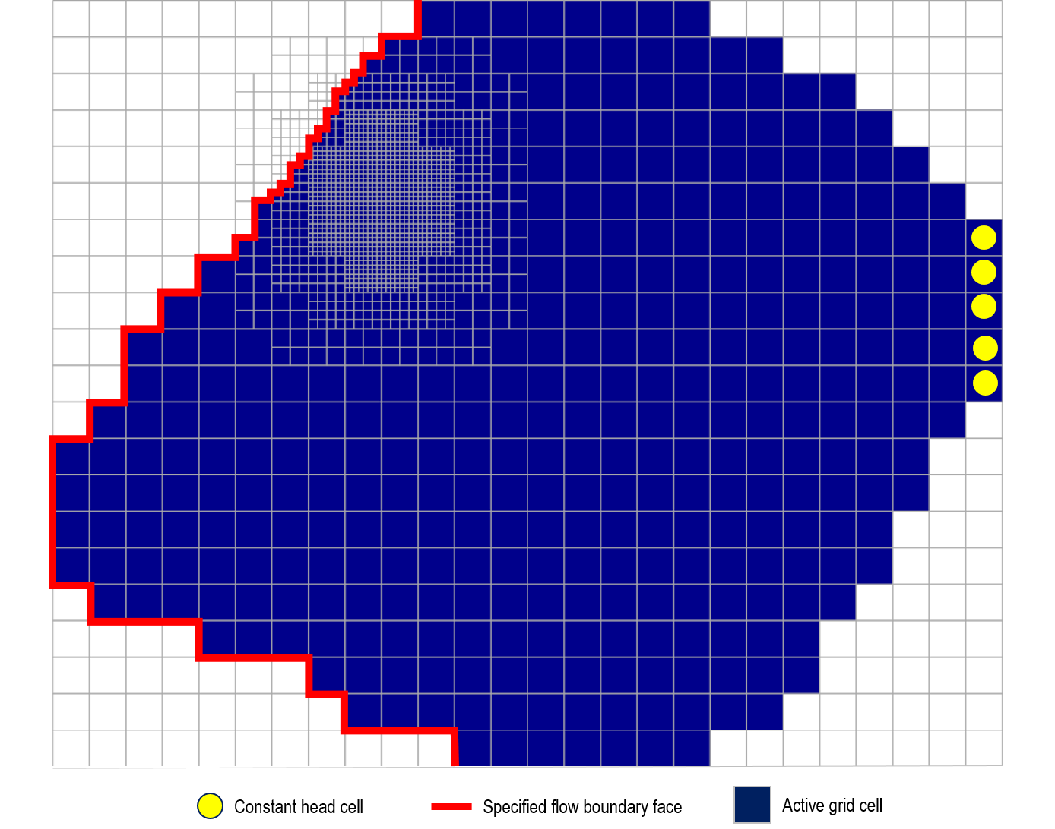

Figure 24. Grid and boundary conditions for example 4.

## Simulation 4A – Backward-Tracking Pathline Simulation

Pathlines were generated by backward tracking. A total of 20 particles were started at the constant head boundary and 16 particles were distributed around faces 1 through 4 in each of the two discharge wells. Results are shown in figure 25. Color shading in figure 25 represents head which is highest on the left and lowest at the constant head cells on the right.

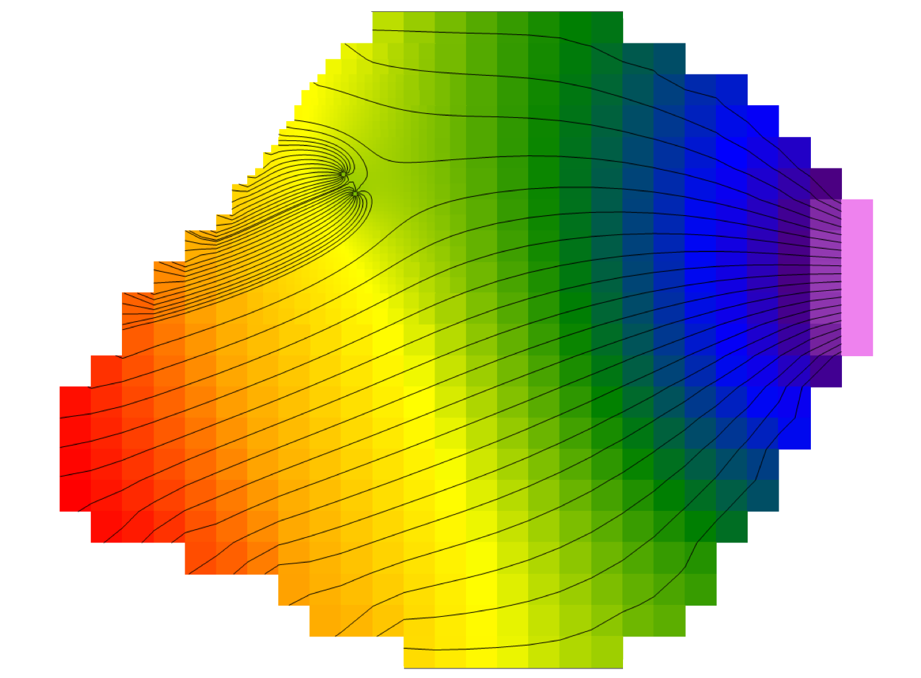

Figure 25. Pathlines from backward tracking simulation in example 4A.