Genetic basis of between- and within-individual variance of docility

MARTIN Julien G.A.^{1*}, PIROTTA Enrico²⁻, PETELLE Matthew^{3x} & BLUMSTEIN Daniel T.⁴⁵⁺
¹ Institute of Biological and Environmental Sciences, University of Aberdeen, Aberdeen, UK
² Enrico affiliation
³ Matt's affiliation
⁴ Department of Ecology & Evolutionary Biology, University of California, Los Angeles, CA, USA
⁵ The Rocky Mountain Biological Laboratory, Crested Butte, CO, USA
Enric
*Correspondence author: Julien Martin
Institute of Biological and Environmental Sciences, University of Aberdeen, Zoology Building, Tillydrone avenue, Aberdeen, AB24 2TZ, UK. Email: julienmartin@abdn.ac.uk Tel: +44 1224 272399
⁻ Email: enrico's email
^{x} Email: matt's email
⁺ Email: marmots@ucla.edu

Running title:
Keywords :
type of article : Letter
Number of words : abstract (), manuscript () and main text ()
?? references, 2 tables and 1 figures
Summary
Within a population, phenotypes vary between individuals and within individuals for labile traits expressed repeatedly. However, evolutionary and behavioural ecologists have mainly focused on estimating between-individual mean trait variance and neglected within-individual variance. The development of a new statistical tool, the double hierarchical model, now allows concurrent estimation of between-individual differences in both the mean of a trait and within-individual variance of that trait at the same time, while correcting for environmental effects. We used 11,389 measures of docility behaviour from 1,576 yellow-bellied marmots (Marmota flaviventris) to estimate between-individual variation in both mean docility and within-individual variance in docility. Using a quantitative genetic approach, we then decomposed the mean trait and the within-individual variances into their environmental and genetic components. We found that individuals differed not only in their mean docility, but also in their within-individual variance. In addition, we found an additive genetic basis and a positive genetic covariance between the mean and within-individual variation.

In addition, we demonstrate the evolutionary importance of considering variation in within-individual variance in traits, because the positive genetic covariance between the mean trait and within-individual variance can influence the evolutionary trajectory of docility.
Introduction
Within a population, phenotypes vary between individuals and within individuals for labile traits expressed repeatedly. However, evolutionary and behavioural ecologists have mainly focused on estimating between-individual mean trait variance and neglected within-individual variance. In fact, the main assumption of a mixed-effects models used to estimated between-individual variance in mean traits is that within-individual residual variance is identical across individuals. Individual heterogeneity of within-individual variance is a well-known problem but rarely accounted for. The development of a new statistical tool, the double hierarchical model, now allows concurrent estimation of between-individual differences in the mean of a trait and within-individual variance of that trait at the same time, while correcting for environmental effects. This type of model is an extension of a mixed-effects model fitting fixed and random effects on both the mean and the residual variance of a trait.

Material and Methods
We used 11,389 measures of docility behaviour from 1,576 yellow-bellied marmots (Marmota flaviventris) to estimate between-individual variation in both mean docility and within-individual variance in docility. Using a quantitative genetic approach, we then implemented a “double hierarchical animal model” to decompose the mean trait and the within-individual variances into their environmental and genetic components.
Study species and site: We used behavioral data collected as part of a long-term demographic study on yellow-bellied marmots (Marmota flaviventris- hereafter marmots) at the Rocky Mountain Biological Laboratory in Gothic, Colorado, USA (38 77’N, 106 59’W). Marmots are large, facultatively social, subalpine squirrels that live in colonies consisting of one or more matrilineal groups . These colonies usually consist of one adult male, multiple adult females, and their offspring. We regularly trap individuals using tomahawk traps set at the entrance of burrows. Once trapped, individuals are weighed, sexed, their ano-genital distance and left hind foot measured, permanent ear tags administered, and given an unique dye mark so they can be identified from afar .

Quantifying docility: We quantified docility over X trapping events for X individuals from 2002-2014. Docility was assessed by an individual’s reaction to being trapped and handled . Docility is a commonly used metric in personality studies, and has been found to be repeatable, heritable , and influence reproduction . Upon arriving at a trap, individuals were placed inside a cloth-handling bag, and we dichotomously scored (0/1) whether individuals- bit the trap, emitted an alarm called, struggled in the trap or bag, tooth chattered, and whether they hesitated moving into the handling bag. We summed these scores and subtracted them from a maximum of five . Thus, a docile individual would have a score of five while an individual with a score of 0 would be non-docile or pugnacious.

Pedigree: Parentage was assigned from DNA samples collected from individuals during their first trapping event. We extracted DNA using a QiaGen QIAamp DNA minikit and genotyped individuals using 12 microsatellites. Alleles were visualized and assigned using GENEMAPPER, and parentage was assigned using CERVUS 3.0 . CERVUS was used to confirm maternity and assign paternity using a maximum likelihood method at 95% confidence (for full pedigree methods see , however, we trapped juveniles almost immediately after they emerged from their natal burrow and assigned dams behaviourally. Behavioural assignments were only used when genetic assignments were ambiguous. See Table S1.1 in supplementary material for pedigree information.
y = X_{m}b_{m}+ Z_{m}a_{m} + Q_{m}p_{m} + e where a_{m}~N(0, σ_{am}²), p_{m}~N(0, σ_{pm}²) and e ~N(0, σ_{e}²)
y is the docility record; bm, am and pm are the vectors of fixed, random additive genetic and permanent environment effects associated with the corresponding incidence matrix Xm, Zm and Qm; e is the vector of residuals.

Y = X_{m}b_{m} + Z_{m}a_{m} + Q_{m}p_{m} + e
ε ~N(0,Diag{σ_{ε}²})
log(σ_{e}²) = X_{v}b_{v} + Z_{v}a_{v,} + Q_{v} p_{v}
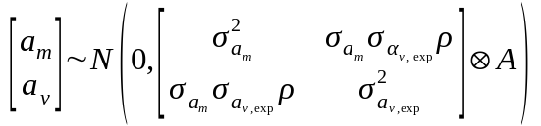
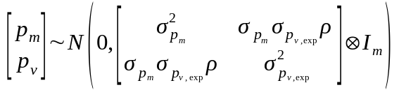

Y = µ_{m} + β_{m}X_{m} + Z_{m}u_{m} + Q_{m}pe_{m} + χ exp[1/2(µ_{v, exp} + X_{v}b_{v, exp} + Z_{v}u_{v, exp} + Q_{v}pe_{v, exp})]
Statistical analysis
The aim of our analysis was to concurrently estimate the between-individual differences in mean docility and its residual within-individual variance. Moreover, we wanted to decompose the variability of the mean trait and of its variance into environmental and genetic components using a quantitative genetic approach. We developed four models that progressively built towards such goal, while allowing us to monitor any change in the estimates as increasing complexity was introduced:
1. Model 1 was a traditional mixed-effects model, where the mean docility was modelled as a combination of fixed and random effects and variance was assumed to be homogeneous across individuals. Following previous results from this population , the fixed effects we included were: trial number, to account for potential habituation to human handling; Julian day, as a proxy for any seasonal changes in docility; time of day, coded as 0 for AM sampling and 1 for PM sampling; and age, which was a categorical factor with three levels (juveniles, yearlings and adults). Year and individual ID were fitted as random effects on mean docility. The reader should refer to for a detailed description of these variables and justification for their inclusion in the model. Model 1 can be therefore written as:
P = Xb+ Qp + My + e
with p~N(0, σ_{p}²), y~N(0, σ_{p}²) and e ~N(0, σ_{e}²).
P is the docility record; b, p and y are the vectors of fixed, random permanent environment (identity) and random year effects associated with the corresponding incidence matrix X, Z and Q and M; e is the vector of residuals.
σ_{α}² and σ_{δ}² are the between-individual and between-year random effect variances, respectively. ε_{ijk} is the Gaussian deviation from the linear predictor η_{ijk}, with variance σ_{ε}². Random effects and residuals are independently and identically distributed.
2. Similarly to model 1, model 2 only considered changes in mean docility. However, this model also included an additive genetics component, fitted as a random effect on the mean . Model 2 is therefore equivalent to a classic animal model , and can be written as:
y_{ijk} = η_{ijk} + ε_{ijk},
η_{ijk} = β₀ + β₁x_{1ijk} + β₂x_{2ijk} + β₃x_{3ijk} + β₄x_{4ijk} + β₅x_{5ijk} + α_{i} + δ_{j} + φ_{ijk},
α_{i} ~ N(0, σ_{α}²),
δ_{j} ~ N(0, σ_{δ}²),
φ_{ijk∈F} ~ N(0, σ_{φ}²),
φ_{ijk∈D} ~ N((φ_{ijk,m} + φ_{ijk,f})/2, σ_{φ}²/2),
ε_{ijk} ~ N(0, σ_{ε}²)
where, building on model 1, φ_{ijk} is the random effect for the additive genetics component. For founders F, φ_{ijk} is normally distributed with mean 0 and variance σ_{φ}², while for descendants D it has mean (φ_{ijk,m} + φ_{ijk,f})/2 and variance σ_{φ}²/2 (REFXXX). φ_{ijk,m} and φ_{ijk,f} are, respectively, the additive genetic contribution of mother m and father f for observation ijk. When the mother's or the father's identity was unknown, the missing value φ_{ijk} was assumed to have a Normal prior N(0, σ_{φ}²).
3. Model 3 was a double hierarchical generalised linear model (DHGLM) . This included a model for the mean docility (as in model 1), as well as a dispersion part for the residual variance. The residual variance was modelled on the log-normal scale as a function of the fixed effect of age (a categorical variable with three levels, as in the mean part), with year and individual ID as random effects. We also estimated the correlation between the individual random effect on the mean and the individual random effect on the variance, using a multivariate Normal distribution. Model 3 can be written as:
y_{ijk} = η_{ijk} + ε_{ijk},
η_{ijk} = β₀ + β₁x_{1ijk} + β₂x_{2ijk} + β₃x_{3ijk} + β₄x_{4ijk} + β₅x_{5ijk} + α_{1i} + δ_{j},
δ_{j} ~ N(0, σ_{δ}²),
ε_{ijk} ~ N(0, σ_{εijk}²),
log(σ_{εijk}²) = γ₀ + γ₁x_{4ijk} + γ₂x_{5ijk} + α_{2i} + δ_{dj},
δ_{dj} ~ N(0, ω_{δd}²),
α_{i} ~ MVN(0, Σ_{α}²),
Σ_{α}² = 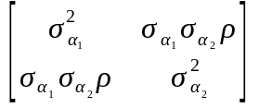
where γ₀ is the intercept of the residual variance and γ_{1,2} are the fixed effects for the yearling and adult age classes, on the log-scale. δ_{dj} is the jth random effect of year for the dispersion part, with variance ω_{δd}². Σ_{α}² is the variance-covariance matrix for the correlated random effect of additive genetics on the mean and dispersion part, and ρ is the correlation between α₁ and α₂.
4. Finally, model 4 was a double hierarchical generalised linear animal model (DHGLAM), with a mean and a dispersion part as in model 3, but including an additive genetic component (as in model 2) fitted as a correlated random effect on both the mean and the residual variance . Starting from model 3, model 4 can therefore be written as:
y_{ijk} = η_{ijk} + ε_{ijk},
η_{ijk} = β₀ + β₁x_{1ijk} + β₂x_{2ijk} + β₃x_{3ijk} + β₄x_{4ijk} + β₅x_{5ijk} + α_{1i} + δ_{j} + φ_{1ijk},
δ_{j} ~ N(0, σ_{δ}²),
ε_{ijk} ~ N(0, σ_{εijk}²),
log(σ_{εijk}²) = γ₀ + γ₁x_{4ijk} + γ₂x_{5ijk} + α_{2i} + δ_{dj} + φ_{2ijk},
δ_{dj} ~ N(0, ω_{δd}²)
α_{i} ~ MVN(0, Σ_{α}²),
Σ_{α}² = ,
φ_{ijk∈F} ~ MVN(0, Σ_{φ}²),
φ_{ijk∈D} ~ MVN((φ_{ijk,m} + φ_{ijk,f})/2, Σ_{φ}²/2),
Σ_{φ}² = 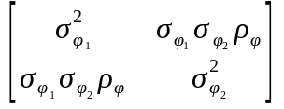
where Σ_{φ}² is the variance-covariance matrix for the correlated additive genetic random effects on the mean and dispersion part, and ρ_{φ} is the correlation between φ₁ and φ₂.
The four models were fitted in a Bayesian framework using OpenBUGS 3.2.1 , run from R via the package R2OpenBUGS. We used Normal priors with mean 0 and precision 0.001 for the intercepts β₀ and γ₀ as well as for the fixed effects β_{1,2...5} and γ_{1,2} in the mean and dispersion part, respectively. σ_{ε} had a uniform prior U(0,20), and σ_{δ} and ω_{δd} had uniform priors U(0,10). In model 1 and 2, σ_{α} had a uniform prior U(0,10), while in model 3 and 4 Σ_{α} had an inverse Wishart prior with 3 degrees of freedom and scale matrix 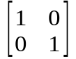. In model 2, σ_{φ} had a uniform prior U(0,15), while for Σ_{φ} we used an inverse Wishart prior with 3 degrees of freedom and scale matrix . The OpenBUGS code for the four models is provided in the Supplementary material. Markov Chain Monte Carlo (MCMC) algorithms were iterated until convergence to the joint posterior distribution. Two chains starting at different initial values were run in parallel. Convergence was first assessed by visually inspecting the trace plots, which were also used to identify an appropriate number of burn-in iterations. We then checked that the Monte Carlo error was less than 1-5% of the posterior standard deviation, and that the Brooks-Gelman-Rubin (BGR) diagnostic converged to 1 ± 0.2 . These convergence checks were carried out using the package coda in R. The mode and 95% Highest Posterior Density Intervals (HPDI) were used to summarise the posterior distributions of the model parameters.
Results
We found that individuals differed not only in their mean docility, but also in their within-individual variance. In addition, we found an additive genetic basis and a positive genetic covariance between the mean and within-individual variation.

Discussion
These analyses are the first to estimate the genetic basis of both mean trait and within-individual variance in a wild population. Our results indicate that equal within-individual variance should not be assumed. In addition, we demonstrate the evolutionary importance of considering variation in within-individual variance in traits, because the positive genetic covariance between the mean trait and within-individual variance can influence the evolutionary trajectory of docility.

Acknowledgments

References

Table 1. Fixed and random effects fitted in each model of docility in yellow-bellied marmots at RMBL. ID represents a permanent environment effects whereas AG represents additive genetic effects.

 | Mean part |  | Variance part
Model | Fixed effects | Random effects | Fixed effects | Random effects
1 | Trial + Date + Time + Age | Year + ID
2 | Trial + Date + Time + Age | Year +ID + AG
3 | Trial + Date + Time + Age | Year + ID | Age | ID
4 | Trial + Date + Time + Age | Year +ID + AG | Age | ID + AG

Table 2. Estimates of variance components and variance ratios of docility for the four different models differing in their random and residual structure (see table 1). Analysis used 11,389 observations from 1,576 individuals over 13 years.
 | Models
 | 1 | 2 | 3 | 4
σ_{P}² | 0.872 (0.903/0.999) | 0.959 (0.918/1.004) | 0.995 (0.892/1.126) | 1.251 (1.075/1.494)
Mean part
σ_{yr}² | 0.003 (0.005/0.059) | 0.012 (0.004/0.038) | 0.012 (0.005/0.038) | 0.01 (0.004/0.031)
σ_{pe}² | 0.215 (0.185/0.243) | 0.099 (0.073/0.129) | 0.18 (0.16/0.205) | 0.105 (0.083/0.128)
σ_{a}² | - | 0.132 (0.09/0.18) | - | 0.097 (0.069/0.132)
year² | 0.016 (0.006/0.061) | 0.013 (0.005/0.039) | 0.012 (0.005/0.037) | 0.008 (0.003/0.024)
pe² | 0.227 (0.196/0.256) | 0.102 (0.075/0.135) | 0.183 (0.156/0.208) | 0.081 (0.059/0.107)
h² |  | 0.14 (0.096/0.183) | - | 0.078 (0.055/0.103)
Variance part
σ_{yr v, exp}² | - | - | 0.03 (0.011/0.092) | 0.026 (0.01/0.086)
σ_{pe v, exp}² | - | - | 0.657 (0.577/0.749) | 0.391 (0.304/0.484)
σ_{a v, exp}² | - | - | - | 0.289 (0.189/0.418)
year_{v}² | - | - | 0.007 (0.003/0.021) | 0.007 (0.002/0.02)
pe_{v}² | - | - | 0.154 (0.139/0.171) | 0.093 (0.073/0.115)
h_{v}² | - | - | - | 0.069 (0.046/0.098)
Covariance
cov_{pe}(mu,V) | - | - | -0.324 (-0.364/-0.293) | -0.183 (-0.225/-0.144)
cov_{A}(mu,V) | - | - | - | -0.149 (-0.208/-0.096)
cor_{pe}(mu,V) | - | - | -0.944 (-0.958/-0.929) | -0.907 (-0.931/-0.871)
cor_{A}(mu,V) | - | - | - | -0.876 (-0.919/-0.811)
σ_{P}² = estimated phenotypic variance (σ_{yr}² + σ_{pe}² + σ_{a}² + σ_{R}²). For model 3 and 4 σ_{R}² following Appendix S2. σ_{a}² and σ_{a v, exp}² = additive genetic variance for mean docility and variance in docility on the exponential scale, respectively. σ_{pe}²= permanent environment variance, σ_{yr}² = year variance. h² and h_{v}² = heritability for mean docility and variance in docility, respectively. pe² = permanent environment (2 and 4) or repeatability (1 and 3) estimates. year² = year effect.

Figures Legends
Figure 1. Posterior mode and 95% credible intervals for four different models of docility of Yellow-bellied marmots at RMBL. Analysis used 11,389 observations from 1,576 individuals over 13 years. Grey shaded area illustrates an invalid region of the parameter space. Residual variance for models 3 and 4 were estimated based on Appendix S2. Juvenile was considered as references in both mean and variance part of the model.

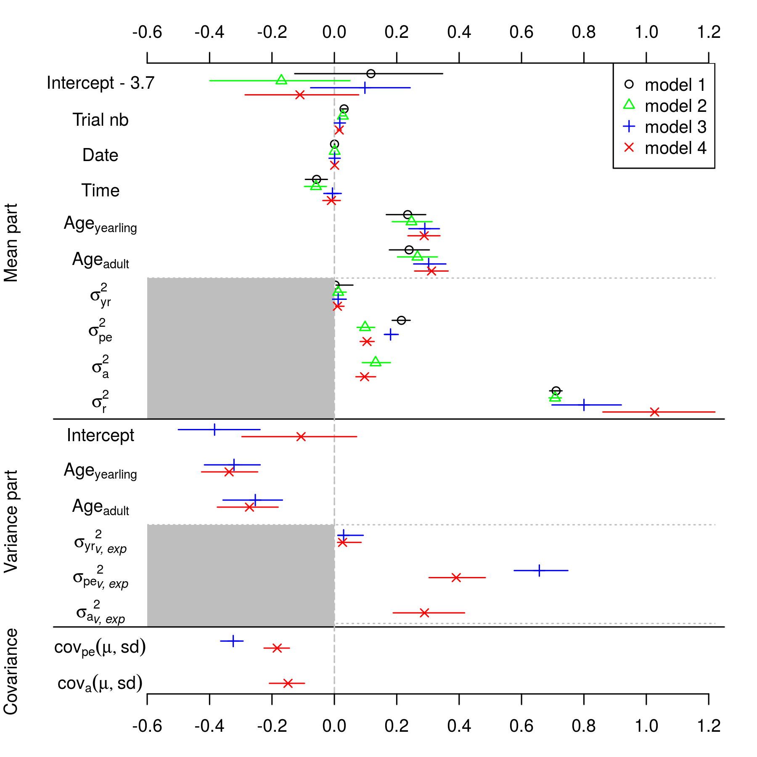

Electronic Supplementary Materials
Martin et al. Genetic basis of between- and within-individual variance of docility

Appendix S1. Supplemeatray information on the methods.
Appendix S2. Annotated code to fit model 4 in OpenBugs (File model4_bugs.r)
Appendix S3. Estimation of variance components and variance ratios for (exponential) double hierarchical models.
Appendix S4. Output of the models when year was not included as a random effect in either the mean or the variance part of the model.

Appendix S1. Supplementary information on the methods.
Table S1.1 Summary statistics for the pruned pedigree used for animal models of docility
Records | 1588
Maternities | 1436
Paternities | 1320
Full sibs | 5335
Maternal sibs | 10960
Maternal half sibs | 5625
Paternal sibs | 31312
Paternal half sibs | 25977
Maternal grandmothers | 1156
Maternal grandfathers | 926
Paternal grandmothers | 660
Paternal grandfathers | 614
Maximum pedigree depth | 10
Founders | 145
Mean maternal sibship size | 8.975
Mean maternal sibship size | 17.600
Non-zero F | 511
F>0.125 | 278
Mean pairwise relatedness | 0.045
Pairwise relatedness >=0.125 | 0.146
Pairwise relatedness >=0.25 | 0.081
Pairwise relatedness >=0.5 | 0.017

Detailled model specification.
Appendix S2. Annotated code to fit model 4 in OpenBugs (File model4_bugs.r)
model{
#priors
## fixed effects: beta, gamma
for(h in 1:6){
beta[h] ~ dnorm(0, 0.001)
}
for(s in 1:3){
gamma[s] ~ dnorm(0, 0.001)
}
##random effects
###year
sd.yearmu ~ dunif(0,10)
tau.yearmu <- 1/sd.yearmu/sd.yearmu
s2.yearmu <- sd.yearmu * sd.yearmu
sd.yearV ~ dunif(0,10)
tauyearV <- 1/sd.yearV/sd.yearV
s2.yearV <- sd.yearV * sd.yearV
for (y in 1:n.years){ # for each year
yearmu[y] ~ dnorm(0, tauyearmu)
yearV[y] ~ dnorm(0, tauyearV)
}
###permanent environment (indivual identity)
tau.pe[1:2,1:2] ~ dwish(R[,],3)
s2.pe[1:2,1:2] <- inverse(tau.pe[,])
for (m in 1:n.id){ # for each individual
pe[m,1:2] ~ dmnorm(zero[], tau.pe[,])
}
###Additive genetic effects
tau.ag[1:2,1:2] ~ dwish(R.ag[,],3)
s2.ag[1:2,1:2] <- inverse(tau.ag[,])
for (k in 1:n.fnd){ #founders (i.e. no parents known)
ag[k,1:2] ~ dmnorm(R.ag[], tau.ag[,])
}
for (u in 1:n.funk){ #only father unknown
ag.funk[u,1:2] ~ dmnorm(R.ag[], tau.ag[,])
par.ag[funk[u],1] <- (ag[mid[funk[u]],1] + ag.funk[u,1])/2
par.ag[funk[u],2] <- (ag[mid[funk[u]],2] + ag.funk[u,2])/2
ag.i[funk[u],1:2] ~ dmnorm(par.ag[funk[u],1:2], tau.ag[,])
ag[funk[u],1] <- ag.i[funk[u],1] * wsq[funk[u]]
ag[funk[u],2] <- ag.i[funk[u],2] * wsq[funk[u]]
}
for (uu in 1:n.munk){ #only mother unknown
ag.munk[uu,1:2] ~ dmnorm(R.ag[], tau.ag[,])
par.ag[munk[uu],1] <- (ag[fid[munk[uu]],1] + ag.munk[uu,1])/2
par.ag[munk[uu],2] <- (ag[fid[munk[uu]],2] + ag.munk[uu,2])/2
ag.i[munk[uu],1:2] ~ dmnorm(par.ag[munk[uu],1:2], tau.ag[,])
ag[munk[uu],1] <- ag.i[munk[uu],1] * wsq[munk[uu]]
ag[munk[uu],2] <- ag.i[munk[uu],2] * wsq[munk[uu]]
}
for (d in 1:n.des){ #known parents
par.ag[des[d],1] <- (ag[fid[des[d]],1] + ag[mid[des[d]],1])/2
par.ag[des[d],2] <- (ag[fid[des[d]],2] + ag[mid[des[d]],2])/2
ag.i[des[d],1:2] ~ dmnorm(par.ag[des[d],1:2],tau.ag[,])
ag[des[d],1] <- ag.i[des[d],1] * wsq[des[d]]
ag[des[d],2] <- ag.i[des[d],2] * wsq[des[d]]
}
#Likelihood
for(i in 1:n){ #for each observation model for docility (y)
docility[i] ~ dnorm(mu.y[i], tau.err[i]) # each y has its own mean and precision
tau.err[i] <- 1/var.y[i] # express the model in terms of the variance
## Model for the mean
mu.y[i] <- beta[1] + beta[2]*trial[i] + beta[3]*day[i] + beta[4]*time[i] + beta[5]*age1[i] + beta[6]*age2[i] + yearmu[year[i]] + pe[id[i],1] + ag[id[i],1]
## Model for the variance
log(var.y[i]) <- gamma[1] + gamma[2]*age1[i] + gamma[3]*age2[i] + yearV[year[i]] + pe[id[i],2] + ag[id[i],2]
}
}

Appendix S3. Estimation of variance components and variance ratios for (exponential) double hierarchical models.

Appendix S4. Output of the models when year was not included as a random effect in either the mean or the variance part of the model.
Table S4.1. Estimates of variance components and variance ratios of docility for the four different models differing in their random and residual structure (see table 1). Analysis used 11,389 observations from 1,576 individuals over 13 years.
 | Models
 | 1 | 2 | 3 | 4
σ_{P}² | 0.951 (0.918/0.985) | 0.966 (0.925/1.006) | 0.984 (0.927/1.057) | 1.248 (1.108/1.455)
Mean part
σ_{pe}² | 0.236 (0.208/0.269) | 0.101 (0.072/0.13) | 0.198 (0.173/0.22) | 0.105 (0.085/0.131)
σ_{a}² | - | 0.15 (0.105/0.199) | - | 0.108 (0.075/0.14)
pe² | 0.251 (0.225/0.276) | 0.106 (0.075/0.136) | 0.198 (0.179/0.219) | 0.083 (0.062/0.108)
h² |  | 0.156 (0.113/0.202) | - | 0.084 (0.061/0.108)
Variance part
σ_{pe v, exp}² | - | - | 0.696 (0.607/0.786) | 0.412 (0.321/0.504)
σ_{a v, exp}² | - | - | - | 0.296 (0.196/0.421)
pe_{v}² | - | - | 0.162 (0.148/0.179) | 0.099 (0.078/0.121)
h_{v}² | - | - | - | 0.071 (0.049/0.1)
Covariance
cov_{pe}(mu,V) | - | - | -0.348 (-0.388/-0.314) | -0.188 (-0.232/-0.15)
cov_{A}(mu,V) | - | - | - | -0.155 (-0.218/-0.104)
cor_{pe}(mu,V) | - | - | -0.949 (-0.96/-0.933) | -0.908 (-0.933/-0.875)
cor_{A}(mu,V) | - | - | - | -0.885 (-0.922/-0.82)
σ_{P}² = estimated phenotypic variance (σ_{yr}² + σ_{pe}² + σ_{a}² + σ_{R}²). For model 3 and 4 σ_{R}² following Appendix S2. σ_{a}² and σ_{a v, exp}² = additive genetic variance for mean docility and variance in docility on the exponential scale, respectively. σ_{pe}²= permanent environment variance, σ_{yr}² = year variance. h² and h_{v}² = heritability for mean docility and variance in docility, respectively. pe² = permanent environment (2 and 4) or repeatability (1 and 3) estimates. year² = year effect.

Figure S4.1. Posterior mode and 95% credible intervals for four different models of docility of Yellow-bellied marmots at RMBL. Analysis used 11,389 observations from 1,576 individuals over 13 years. Grey shaded area illustrates an invalid region of the parameter space. Residual variance for models 3 and 4 were estimated based on Appendix S2. Juvenile was considered as references in both mean and variance part of the model.
