Internet of Things

Pathfinding algorythm

Introduction

This algorithm will try to scan a room thanks to device on wheels, he will try to go accross the greatest surface possible and he will log his path. The device will send his current position and his future direction each time the server ask it.

Step 1 : Initialisation

First we have to choose the start point of the device.
The startpoint must be placed at one of the room's corner.

When you define the startpoint, you put the device face to the opposite wall, this direction will “his” north. He will define his direction according to his north.

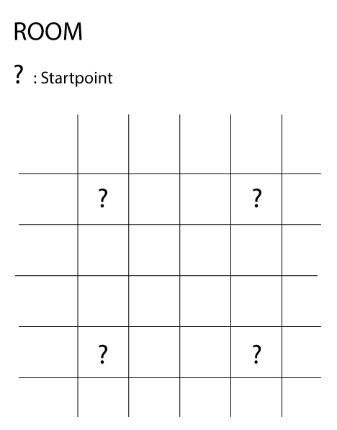
Step 2 : Path

When the device begin to move, he will try to go the furthest right to the direction to his right or left, where his the opposite corner of the room. He go straight until he meet an obstacle (wall) and then he will make a Uturn (or turn back), his direction will be define by his startpoint. He will continue like that until he meets the well at his left or right and unable to turn left or right.

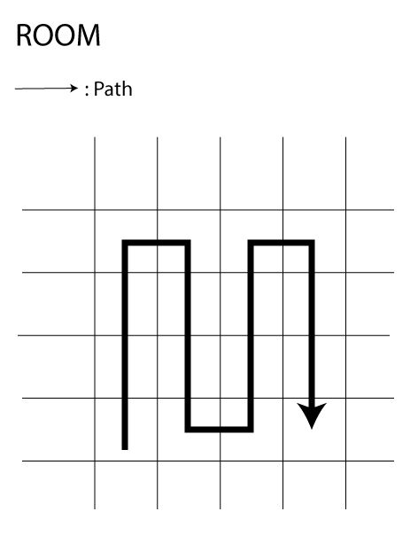
If the starpoint was in the right/south corner of the room, the path would have been the opposite.
Step 3 : Process

When the device is making his way into the room, he will be applying a command whom will be updated for diverse reasons :

  - If the device meet an obstacle will tell him to turn in a direction in order to avoid it and to continue the scanning
  - So the device will send to the server his current position and his future path.

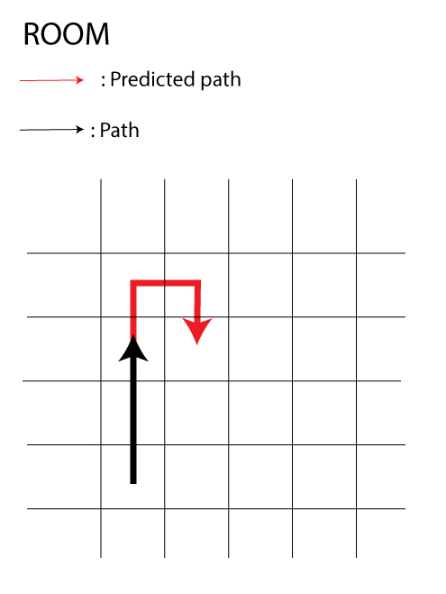
Step 4 : Special case

If the device meet an obstacle who is not right in front, the device will do as always, turn back and then go further to his right or left. The main preoccupation is to ensure that the device is able to go right into the north or south without visiting the already saw path.

