Risk Office v 1.0

Instructions & User guide

Table of contents

Introduction 2

How to start 3

Prerequisites 3

Launching Risk Office 3

Setting up the Portfolios’ tree structure and its contents 4

Adding a new portfolio 4

Adding new assets to a portfolio 5

Setting the exposure 6

Removing an asset or a portfolio 7

Saving your portfolio structure to disk 7

Computing Value-at-Risk 8

Setting up a time window for analysis 9

Setting up a decay factor 10

Setting up the confidence level 10

Results window 11

# Introduction

**Risk Office** **1.0** is a Portfolio Risk management tool that computes a 1-day historical Value-at-Risk ( **VAR** ) for any long NYSE stocks based portfolio ( the further releases will address internationals portfolios also). The VAR is computed through simulations of the future portfolio’s Mark-to-Markets ( Mtm’s ) based on the analysis of the past returns of the portfolio’s different components, following the “classical” approach of historical VAR methodology.

**RiskOffice 1.0** is a C++/ Qt application that was developed with Qt Creator 4.0.3 ( Qt 5.7 ) / Microsoft Visual Studio 12 / Windows 7 SP1 and should be able to run under any recent Windows environment.

*NB : If you have any questions or remarks, be kind to send them directly on my LinkedIn profile. Thank you.*

# How to start

## Prerequisites

If you read this, you should have been able to download the main archive containing all the redistributable packages and dynamic libraries ( .dll ) needed to execute the main program ( **RiskOffice.exe** ). You can unzip the archive on your local hard disk wherever you want to, but don’t alter the files and/or the sub-directory structure, lest RO should crash unexpectedly. Also, be sure to allow outgoing https requests.

## Launching Risk Office

Once everything is installed and set ready, just double-click on the **RiskOffice.exe** icon. The main window should appear :[1]

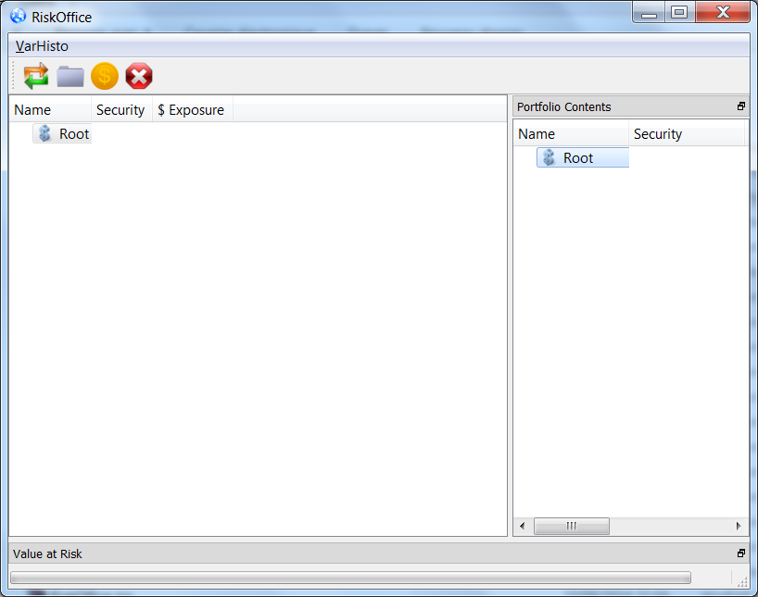

# Setting up the Portfolios’ tree structure and its contents

## Adding a new portfolio

The left pane shows your Portfolio hierarchy : the portfolios are organized under a classical tree-based approach. To add a new portfolio, simply select the Root portfolioand choose the “**add a new sub-portfolio**” icon of the main window’s toolbar (the “blue wallet” icon ) or its equivalent menu item : a dollar icon should then appear under the Root portfolio : double-click on it to define the name of the newly-added portfolio and press enter once finish editing ( Note that you might have to widen the header columns to have the entire name displayed ) :

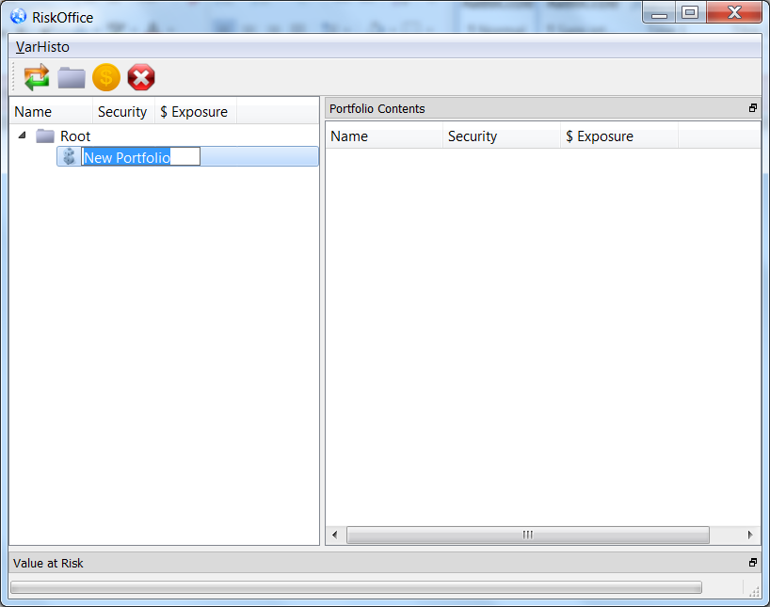

From now on, if you want to add any new portfolio , just follow the same steps : select the parent portfolio first, then select the “**add a new sub-portfolio**” function.

## Adding new assets to a portfolio

Now that your new portfolio is created, just simply select it and click on the golden dollar button to add a new asset : a right arrow will then appear on the left of the portfolio : click on it to unhide its contents : you should see a new dollar icon meaning that a new asset ( or “security” ) is ready to be inserted.

In this first version, you have a limited choice of assets. You can only make a selection among the thirty main stocks listed on the NYSE : just double-click on the “security” area to make the security combo box appear and select the asset you want to include in your portfolio :[2]

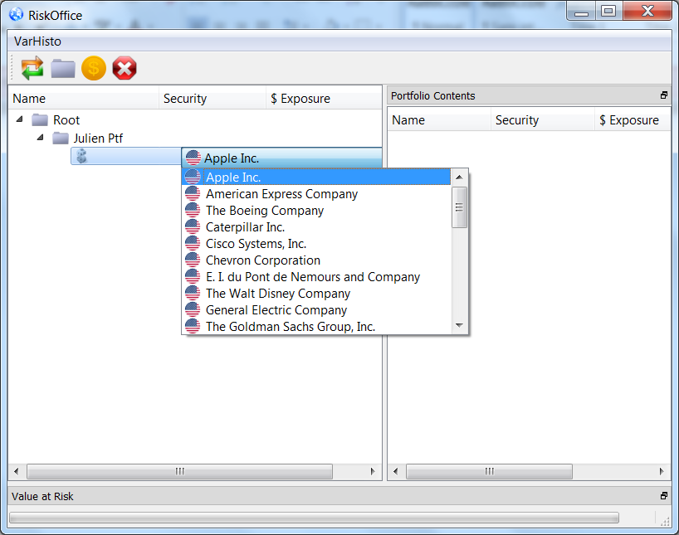

Once you’re done, you still have to determine your exposure. For US markets, the obvious currency unit is the US dollar but one could also accept the assumption that the exposure might be defined in any currency ( although this actually would create a serious methodological bias due to the *quanto* effect on the VAR ).

## Setting the exposure

…is straightforward : double-click on the Exposure area and use the double-spin box to increment/decrement the USD exposure as shown :

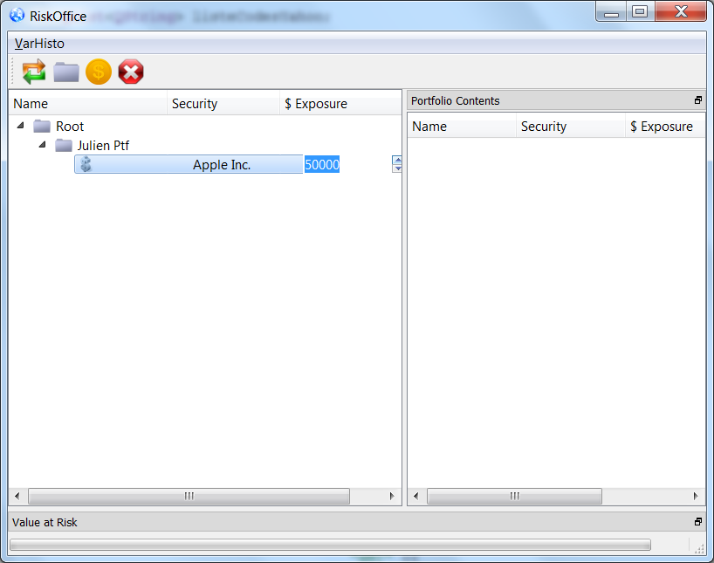

Once you’re done, you can reiterate this process to add new assets to your portfolio or even add new sub-portfolios at any level of your portfolio’s tree : here’s an example of such a structure :

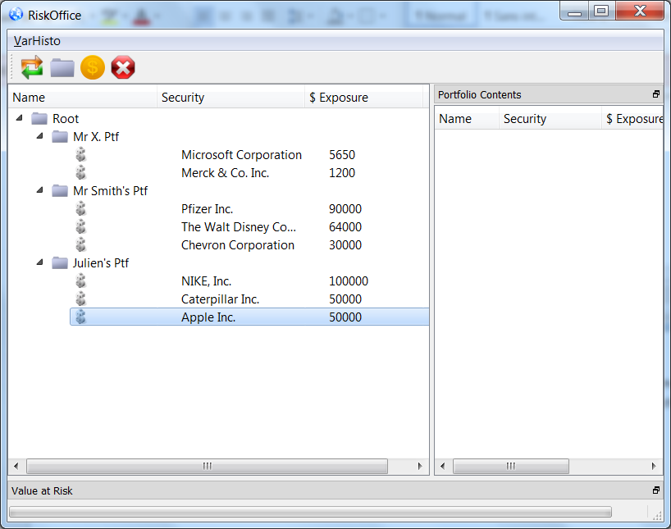

## Removing an asset or a portfolio

To remove an asset from a portfolio, just select it and push the “red stop” button. Any portfolio can be deleted ( recursively ) the same way.

## Saving your portfolio structure to disk

Once you’re finished editing your portfolios’ structure, you can save it to local disk by simply quitting the application ( **Ctrl-Q** or press the red cross upper right button ). This will serialize all the structure to a local file called **srlz_ptfs.ini** on the application directory. Of course, you shouldn’t alter or modify this file.[3]

# Computing Value-at-Risk

Whenever you want to compute the 1-day Historical Value-at-Risk for a portfolio, just select it in the left panel and click on the double arrows button ( or press **Ctrl-W** ) to launch calculations.

→ Note that you ***can’t*** compute a Value-at-Risk for a portfolio that contains other sub-portfolios ( i.e a “container” portfolio ).This functionality will be added in the next version.

At this point, Risk Office will first download through https requests the up-to-date NYSE stocks’ quotes records from Yahoo financial databases that are needed to compute the VAR of your portfolio. These records come as XML files that will take place onto the application directory. Older files are automatically removed by **Risk Office** if needed. This step can take approximately 30 seconds per file but depends primarily on the speed of your Internet connection.

The second step consists in parsing these XML files to extract the correct information **Risk Office** will use to establish the empirical distribution of the portfolio’s futures Mtm’s. As a matter of fact, **Risk Office** is using the adjusted close quotes of each security to avoid famous side effects on stocks quotes due to security transactions that might have previously occur.

The third step comes as a dialog box that gives to the end-user the ability to refine the VAR calculations by picking up between the following options :

## Setting up a time window for analysis

By default, Risk Office will use the last year quotes up to today ( i.e, an approx. 252-sized sample) to simulate the portfolio’s futures Mtm’s distribution, but you can have the time window’s get narrower or wider through the Calendar widgets and their associated spinboxes :

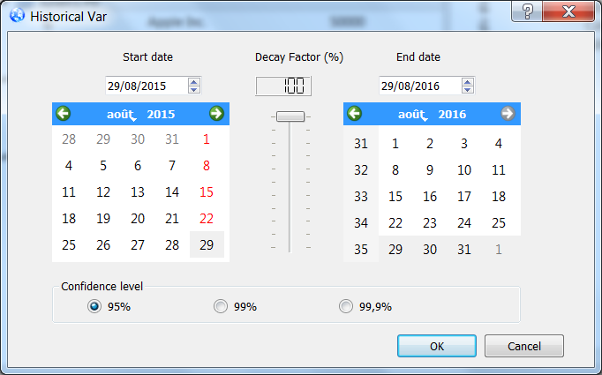

The time window’s limits rules are :

1. The time window shouldn’t count fewer price quotes than the confidence interval will “mathematically” infer ( for example, you can’t evaluate a 99,9% VAR on a 3 years period because this time span encompasses much too fewer quotes ! )[4]
2. Rule #1 is valid UNLESS you set up a decay factor ( an unchanged decay factor at 100% level will therefore enforce this rule ).

:

1. Start date shouldn’t be a Saturday or Sunday.
2. Of course, start date should be earlier than end date.
3. The time window’s start date has a lower boundary that corresponds to the latest date of all the portfolio’s stock records starting dates.
4. The time window’s end date has an upper boundary that corresponds to the earliest date of all the portfolio’s stock records ending dates.

## Setting up a decay factor

In addition, the end-user can select a **decay factor** to account for the resiliency of market conditions ( *volatility clustering*, etc…). This is a more realistic way of forecasting futures Mtm’s and the Risk Manager would ( I hope ) consider this feature as a useful technique to output more relevant VAR estimates ( and to stress it !). The idea is simply to weight the Portfolio’s Mtm’s time series as follows : each time series’ occurrence at time tX days ago is worth 𝞴 times the time series’ occurrence at time tX-1 days ago , where 𝞴 is the decay factor.

Once **Risk Office** has weighted the different Portfolio’s Mtm’s , it sorts them in an increasing order and sum up their respective weights to find the two Mtm’s values of the distribution whose cumulative weights will surround the selected confidence level. The real Value-at-Risk is an interpolated value.

## Setting up the confidence level

The end-user has the choice to set the confidence level between the three commonly accepted standard levels : 95%, 99% or 99,9%. Just click on the proper radio-button.

# Results window

Once Risk Office has performed all the required calculations, it will output the following graph and results in a floatable “results window” ( docked at the main window’s bottom ).

The essential information are displayed on the results window’s top status bar :

-The VAR characteristics : ( confidence level, horizon, absolute value and relative value ).

-A line graph showing the empirical cumulated density function of the Portfolio’s future Mtm’s :

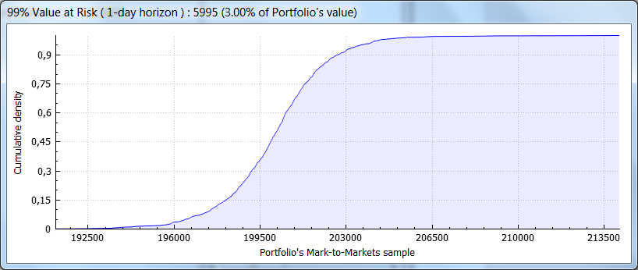

Note that you can use your mouse’s buttons and wheel to zoom in / zoom out the distribution graph ( let’s say you want for instance state for the cumulative distribution’s smoothness around the VAR region )…

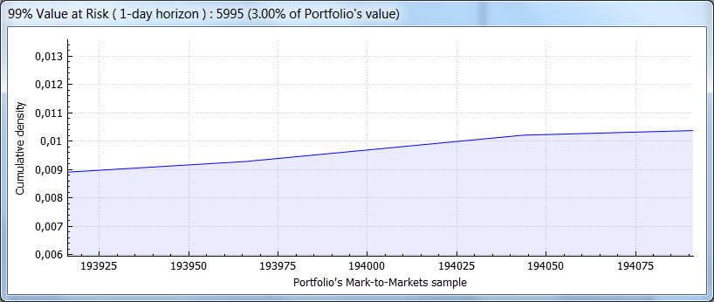

1. Make sure that the redistributable package file vcredist_x64.exe is located in the application directory or in the appropriate system directory ( see <https://www.microsoft.com/en-US/download/details.aspx?id=30679> for more details ).
2. The “*portfolio contents”* window will then reflect the changes made to the selected portfolio…
3. As a matter of fact, I strongly recommend you to copy and save the initial srlz_ptfs.ini file ( containing only the Root portfolio ) in another safe directory to allow future recoveries should this file get corrupted for some reason.
4. Risk Office does not fit the empirical distribution , so 1000 quotes are really needed at 99,9% level !