Cement dataset
13 batches of cement:
Response y: heat evolved in calories during hardening of cement on a per gram basis
Predictor x1: % of tricalcium aluminate
Predictor x2: % of tricalcium silicate
Predictor x3: % of tetracalcium alumino ferrite
Predictor x4: % of dicalcium silicate
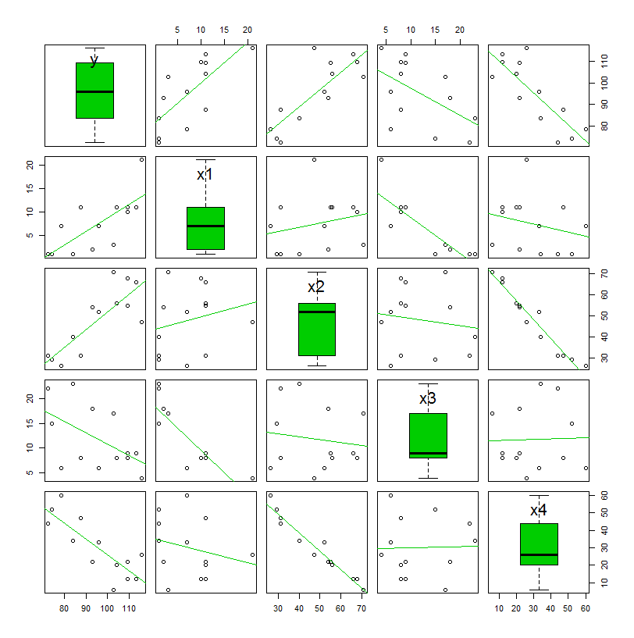
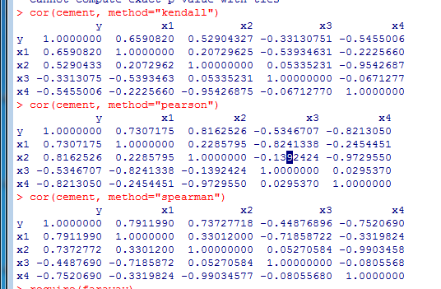
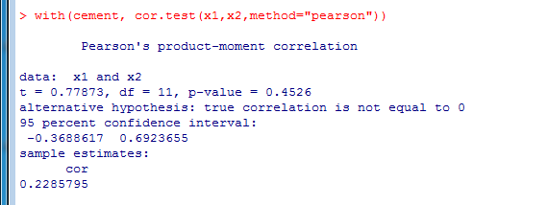
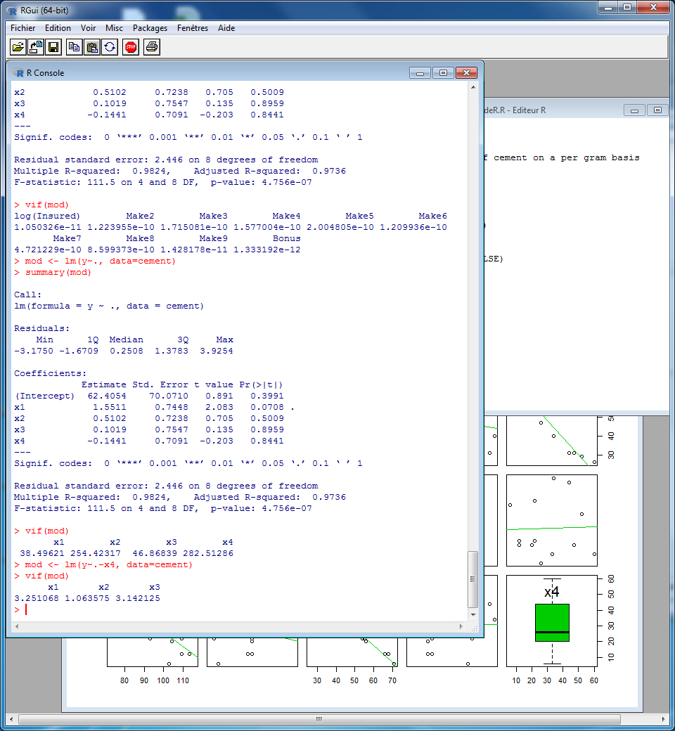

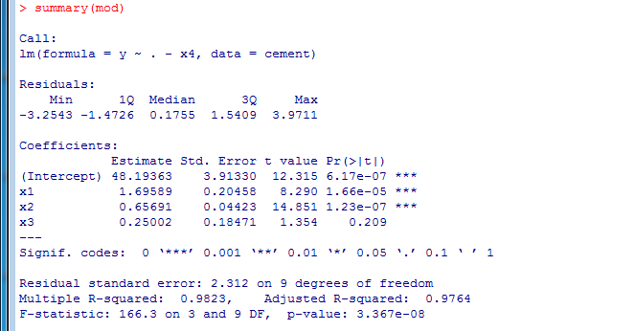
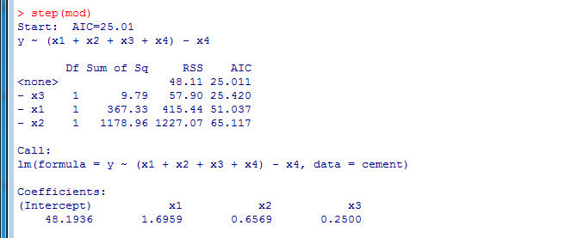
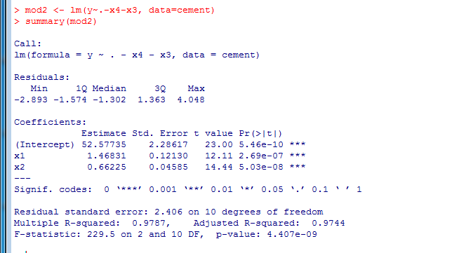
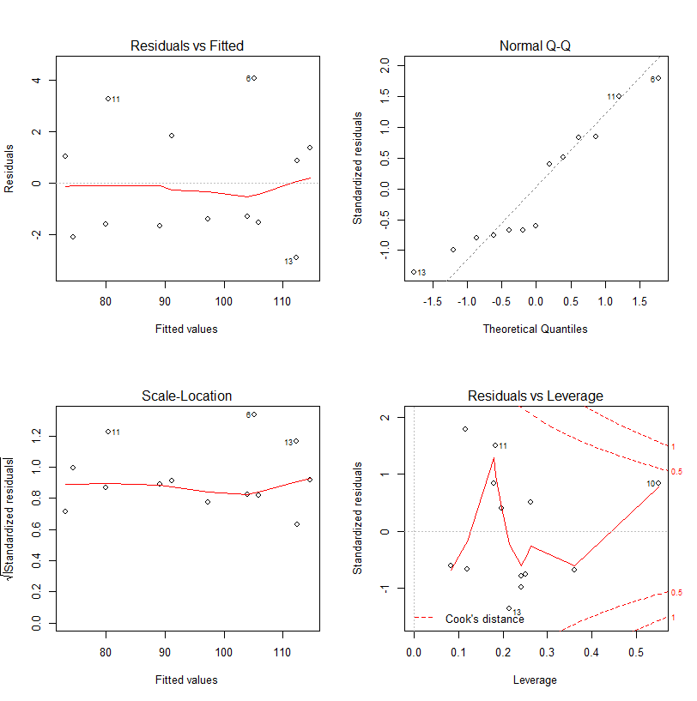
(mod2)

Wake data (A fake example)
We are interested in whether the number of hours since dawn (X2) affect the subjective ratings of wakefulness (Y) 100 graduate students through the consumption of coffee (X1).
N=100 participants
Y: wakefulness index
X1: coffee consumption (suspected mediator)
X2: minutes since dawn
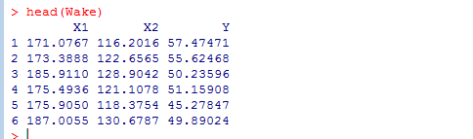
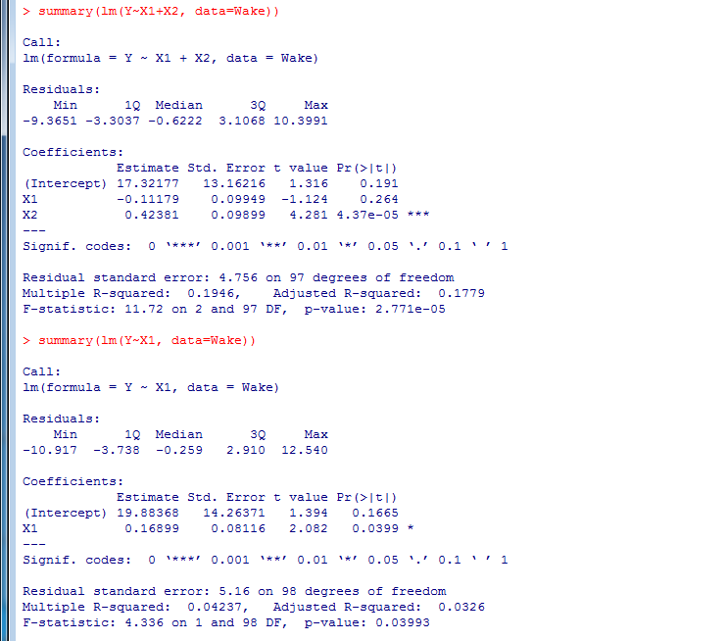
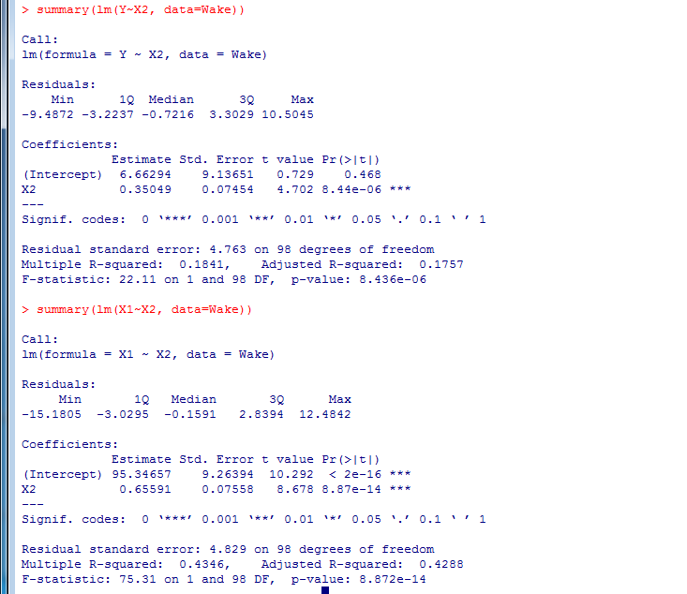
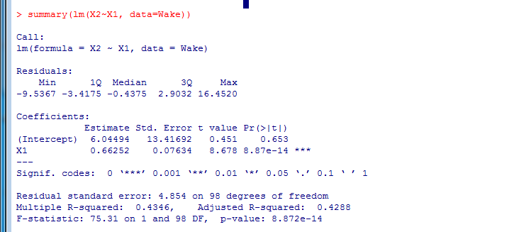
Sleep data (a fake example)
We are interested in whether the relationship between the number of hours of sleep (X) a graduate student receives and the attention that they pay to this tutorial (Y) is influenced by their consumption of coffee (Z).
N=100 participants
Y: Attention Paid
X: Hours of sleep
Z: Ounces of coffee consumed
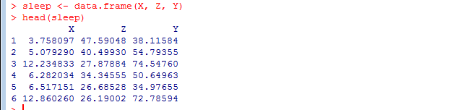
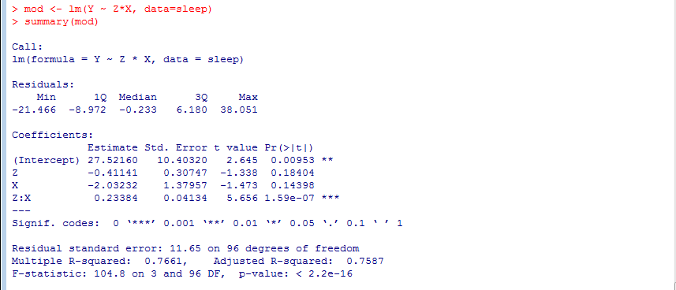

Choccake data
An experiment was conducted to determine the effect of recipe and baking temperature on chocolate cake quality. 15 batches of cake mix for each recipe were prepared. Each batch was sufficient for six cakes. Each of the six cakes was baked at a different temperature, which was randomly assigned. Several measures of cake quality were recorded of which breaking angle was just one.
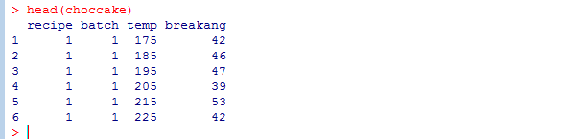
Batches are ignored here.
