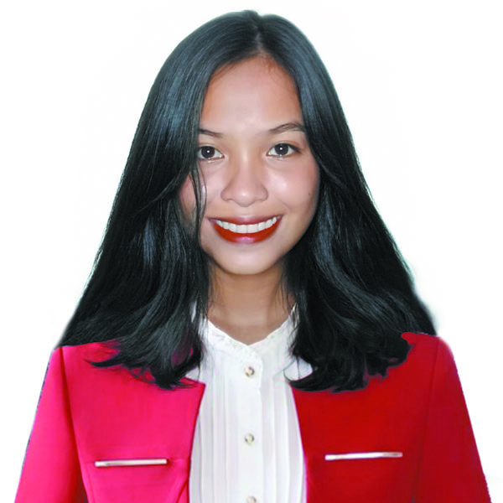**JULIET C. SENCIL**

Home address: Ali Alsree R.T.Lim ZSP

Contact# 09977665995

Email add. **julietsencil7@gmail.com**

**Objective/s:**

To secure a position where I can efficiently contribute my skills and abilities to the growth of the organization and build my professional career. Moreover, I would like to work with other professionals to improve my skills and become a flexible individual

**Educations**

|  |  |  |
| --- | --- | --- |
| Level | Name of School | Year Graduated |
| College | WMSU - IPIL | In progress 2022-2023 |
| Senior High School | Surabay National High School | 2021-2022 |
| Junior High School | Surabay National High School | 2019-2020 |
| Elementary | Kulambugan Elementary School | 2015-2016 |

|  |  |
| --- | --- |
| **Field of Study** | |
| **Relevant Work Experience** | **SPES** |
| **Skills/Qualifications** | Computer Skills:  Well verse in Microsoft Word, Microsoft Excel, and MicrosoftPowerPoint, |
| **Activities and Interests** | *Traveling ( different places)  *Computer  **\***Kitchen Skills (proper hygiene and food handling) |
| **Clubs & Organization** | **N/A** |

**References**:

NAME ADDRESS CONTACT No

Liezel C. Sencil Ali Alsree R.T.L.im ZSP 09269697281

*I hereby certify that the above data are true and correct to the best of my knowledge.*