Ljjgfdfghijokl;

Dyyfdhjhpjmnbvc

Ufyfuj

Lhggihj

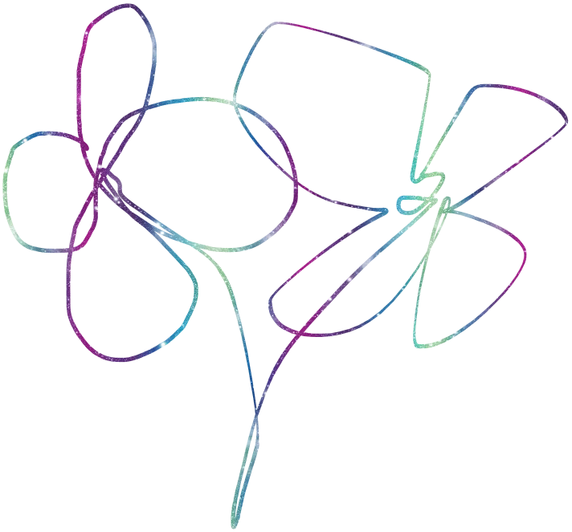J,dhgfojk