Php program sending sales data to Mall interface

1. Unzip the program zip file under the Apache root folder
2. Go to folder HeroKlia2Interface
3. Open the file “setup.txt” and change it accordingly

LocationCode=<Location code assign by Landlord>

ShopCode=<The shop code>

OutletCode=<The outlet code>

PosDatabaseName=<HERO Pos module database name>

OutletDatabaseName=<HERO Outlet module database name>

UserDatabaseName=<HERO User module database name>

DBIPAddress=<Database IP address>

DBLogin=<Database login name>

DBPassword=<Database password>

SalesDataOutputFolder=<Target path of saving output file>

HEROURL=<HERO platform url>

HEROLogin=<HERO platform login name>

HEROPassword=<HERO platform password>

ReportServerIP=<Report server IP address>

ReportServerPort=<Report server port>

NeedFTPConnection=<1/0 1:Need FTP connection, 0:No FTP connection needed **\*\*\*\* If NeedFTPConnection=1, FTPHost, FTPLogin, FTPPassword and FTPSentFolder must be exist. And the output file will be send to target FTP server**>

FTPHost=<FTP Host>

FTPLogin=<FTP login name>

FTPPassword=<FTP password>

FTPTargetPath=<FTP target path(If no need to change path after login, then no need set) ***Optional >

FileSentFolder=<The path to store the files that has been sent to FTP server>

Only the setup “FTPTargetPath” is optional. And the following is an example that I currently use which is for your reference.

LocationCode=L2M123A10

ShopCode=0001

OutletCode=0001

PosDatabaseName=gm4g_pos

OutletDatabaseName=gm4g_outlet

UserDatabaseName=gm4g_user

DBIPAddress=192.168.99.40

DBLogin=abc

DBPassword=abcde

SalesDataOutputFolder=C:\Inetpub\wwwroot\HeroKlia2Interface\salesDatas

HEROURL=http://192.168.99.40/gm4g_demo

HEROLogin=1

HEROPassword=1

ReportServerIP=192.168.99.40

ReportServerPort=8080

NeedFTPConnection=0

FTPHost=192.168.7.203

FTPLogin=abc

FTPPassword=abcde

FTPTargetPath=ftpTesting/mallInterface

FileSentFolder=C:\Inetpub\wwwroot\HeroKlia2Interface\fileSentToFTP

1. Setup the HERO platform

*** When using this interface, both shop and outlet need to setup its code***

1. Setup the shop code

Go to Outlet Management 🡪 Outlet Location 🡪 Shop

Choose the corresponding shop record

Input the shop code

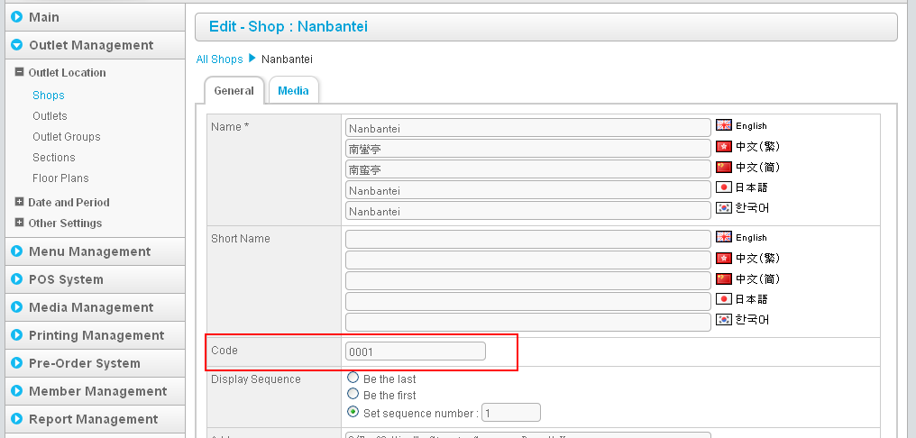

1. Setup the outlet code

Go to Outlet Management 🡪 Outlet Location 🡪 Outlet

Choose the corresponding outlet record

Input the outlet code

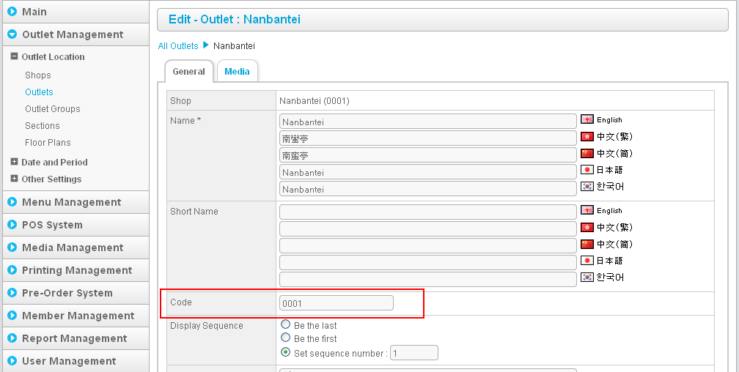

1. Testing in browser

* Open a browser
* Type the url http://<Server IP Address>/HeroKlia2Interface/salesData.php

My example is <http://192.168.7.246/HeroKlia2Interface/salesData.php>

* The following page will be shown

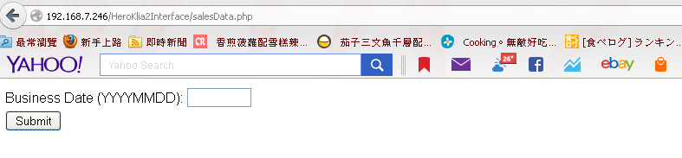

* Input the target business date(e.g. 20131203) and press ‘Sumbit’
* The sales file and revenue report will be generated under the target folder which defined by “SalesDataOutputFolder” in setup.txt
* If “NeedFTPConnection” is turned on, the output files will be send to target FTP server. After that, the files will be moved to target folder which defined by “FileSentFolder” in setup.txt

1. The php program can also run at cmd

* Open cmd
* Go to the path of HeroKlia2Interface
* Type the following command

<php.exe path> generateSalesData.php

E.g.

C:\PHP\php.exe generateSalesData.php

* The following is screen capture

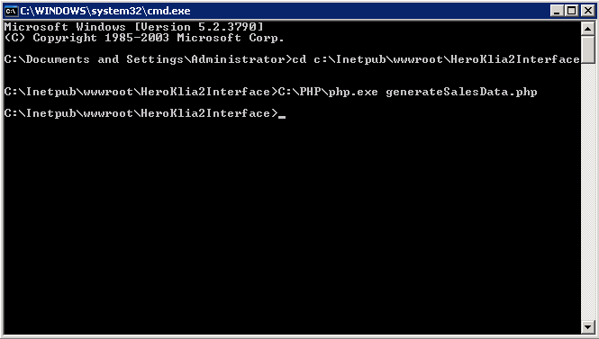

* The sales file and revenue report will be generated under the target folder which defined by “SalesDataOutputFolder” in setup.txt
* If “NeedFTPConnection” is turned on, the output files will be send to target FTP server. After that, the files will be moved to target folder which defined by “FileSentFolder” in setup.txt

1. Set Scheduler Task

* Start 🡪 All Programs 🡪 Accessories 🡪 System Tools 🡪 Task Scheduler
* Click “Create Basic Task…”

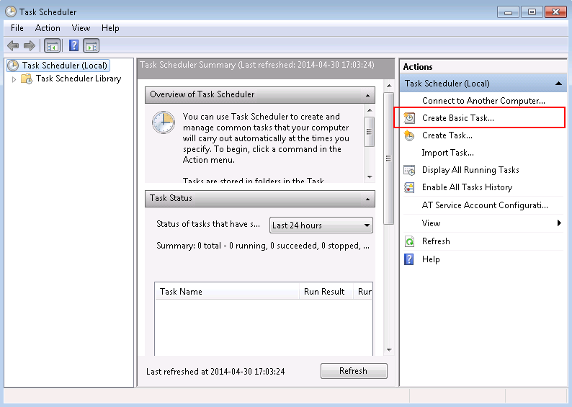

* Type the Name and Description(optional). And then click “Next >”

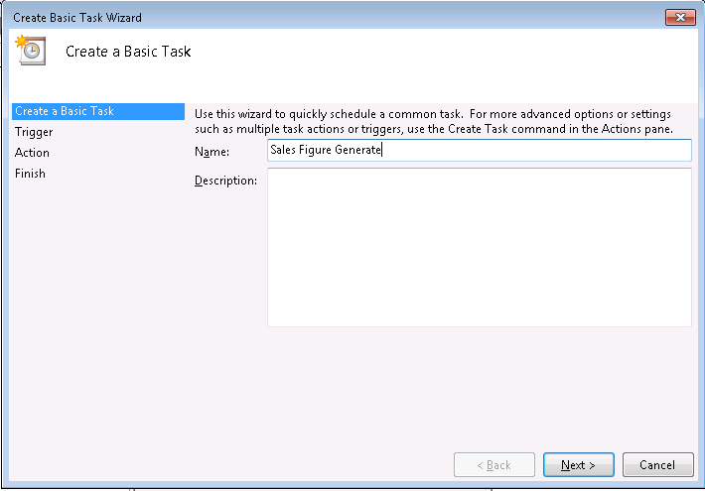

* Chose the trigger for the task. And then click “Next >”

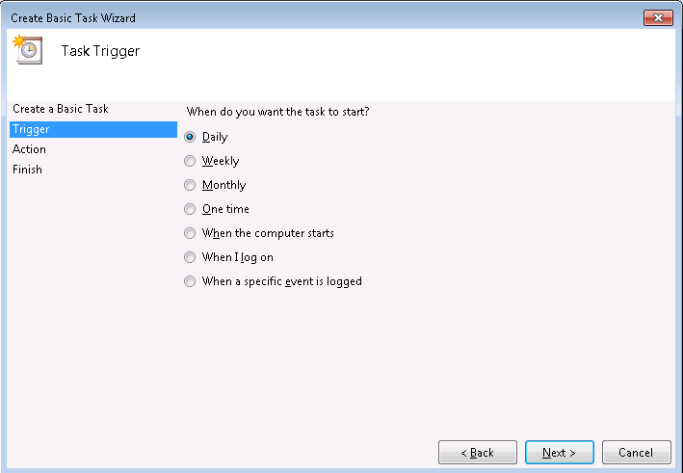

* Set the Start and Recur. And then click “Next >”

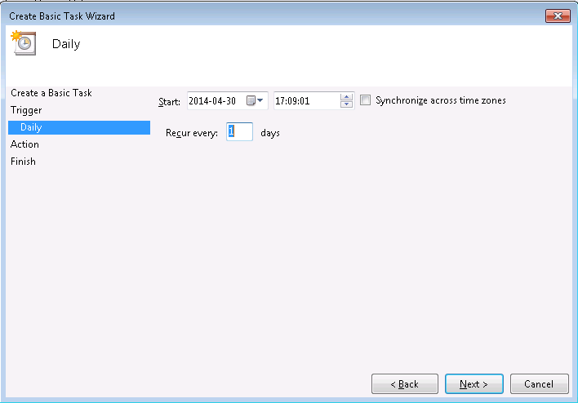

* Set the action, chose “Start a program”. And then click “Next >”

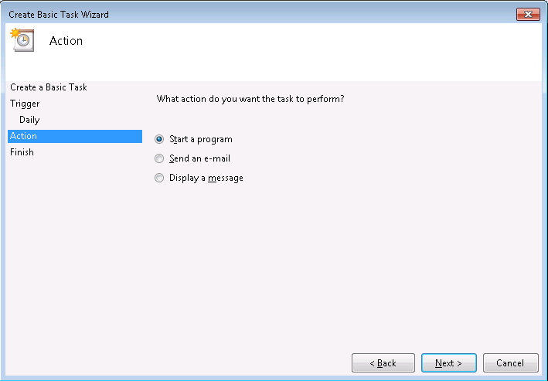

* Set the following and then click “Next >”:

Program/script – C:\PHP\php.exe

Add arguments(optional) – “C:\MyWeb\HeroKlia2Interface\generateSaleData.php”

Start in(optional) – C:\MyWeb\HeroKlia2Interface

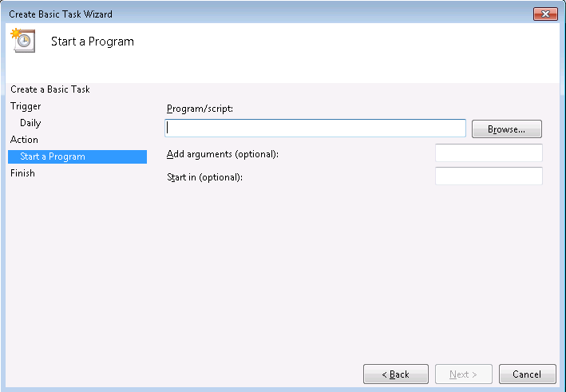

* A summary will be shown and then click ‘Finish’
* Testing the task scheduler job.

In the task list, find the corresponding job and then right click and click ‘Run’