# Interventions to reduce use of unplanned care and emergency treatment from rural areas

Authors:

Julii Brainard1, John Ford1, Andy Jones1, Nick Steel1, Tim Winters2

1Norwich Medical School, University of East Anglia, Norwich.

2 Public Health, Norfolk County Council, Norwich.

****Version 2

27 November 2014

**Executive Summary**

Demand for urgent care has increased steadily in the UK. Set in the context of decreasing funding, there is a greater than ever need for innovative solutions. A proportion of urgent care use is inappropriate in that it could be managed more efficiently in other parts of the healthcare system. Despite much research, little progress has been made in reducing demand for urgent care. There is also a lack of research focusing on rural areas.

Norfolk County Council provided and interpreted local Accident and Emergency (A+E) attendance and admissions data. Using Research Capability Funding (RCF) from North Norfolk Clinical Commissioning Group (NNCCG), a research team at the University of East Anglia undertook a systematic review of interventions, and a narrative review of recommendations to reduce urgent care use in rural areas. The aim was to inform both commissioning decisions at NNCCG and the development of a proposal for funding for further research into reducing unplanned emergency care in rural areas.

Local data show that the total number and rates of walk-in presentations to Norfolk A&E units has remained steady in the period 2010-2014, but arrivals by ambulance have increased sharply between 2010 and 2014 years. Typically, over 80% of all those who attend are discharged rather than admitted. Persons aged 75 years and older continue to have the highest risk (per head of population) of unplanned A&E attendance in all Norfolk CCG areas. Attendance rates vary between CCGs: attendances are highest from West Norfolk and Great Yarmouth & Waveney, and lowest from North Norfolk.

The evidence from the systematic review of interventions to reduce urgent care use in rural areas is limited. Thirty-three studies met the inclusion criteria for the systematic review, of which only 8 were randomised controlled trials, which are considered to be the strongest form of evidence. Most of the 33 studies focused on a specific condition or patient group, such as heart failure or asthmatics. Interventions that were reported can be broadly categorised as addressing chronic illness (using education care planning, case management and self-help programmes) or applying telemedicine in acute presentations (telephone calls, internet video consultations, etc). No one type of intervention was found to consistently reduce urgent care use in rural areas. The strongest evidence was in support of care planning and self-management programmes and telemedicine, which were shown to be effective, especially at averting the use of emergency transport.

There was weaker evidence that preventative education may reduce unplanned care use in rural areas, especially in: self-management; intensive case management for heart failure; rehabilitation for COPD; exercise promotion; and continuity of care. Increased age, deprivation, lower education, chronic disease and multi-morbidity all increased the risk of subsequent urgent care use in rural areas.

The narrative review found a large number of recommendations to better address urgent care needs in rural areas in policy and review documents. Although these ideas have mostly not been tested, opportunities for innovation include one-stop community service centres, improved transport, and more convenient local services.

**The following recommendations are made to reduce unplanned urgent care use in rural areas:**

1. Use multi-factorial risk prediction and stratification tools (such as the Combined Devon Predictive Model1) to target groups which have highest rates of urgent care use, such as older people, those with chronic disease or multi-morbidity and deprived groups: effective interventions in these groups include self-management and case-management programmes.
2. Consider telemedicine (live consultations between professionals via telephone or teleconferencing) to reduce urgent care use and patient transfers from the community or general practice to hospital.
3. Consider telephone triage to reduce inappropriate ambulance use.
4. Consider a community service centre to provide a multi-disciplinary, integrated approach, across the health and social sector.
5. Provide outreach health promotion targeted at hard-to-reach rural groups such as carers, agricultural workers and socially isolated elderly.
6. Promote flexibility in the provision of primary care with respect to appointment times and coordination with public transport.

## Introduction

There are long-term increases in demand for urgent care in Britain2. Emergency hospital admissions in England have increased by 32.5% in the past 14 years (from 4 million per year in 1998/993 to 5.3 million in 2012/134). Among ambulatory care sensitive conditions4, there was a 26% increase in emergency hospital admissions in England between 2001/02 and 2012/13. In addition, ambulance calls have risen; the annual total number of emergency calls in England rose from 5.6 million in 2004/055 to 9.08 million in 2012/136 (62% growth in eight years). Older people make the greatest demands on unplanned care, especially ambulance services7. This age group is increasing as a proportion of the total population8, particularly in rural areas9.

Using National Institute for Health Research Research Capability Funding (RCF), North Norfolk Clinical Commissioning Group (NNCCG) commissioned the development of a research proposal to increase understanding of the use of unplanned care and emergency treatments in rural areas, and this accompanying report. Rural areas have been under-researched with regard to their demand for and usage of urgent health care. This is despite wider recognition that residents of rural areas often have distinct health needs and disadvantages compared to urban communities. NNCCG were particularly interested in exploring innovative solutions from other settings that might be tested in Norfolk but were generalisable across the country; in qualitative approaches to research, and in what drives behaviour of patients and the public in rural areas. The purpose of RCF funding is to allow research teams to undertake some development work to support a formal research bid application. The UEA research team undertook comprehensive reviews of interventions and recommendations to reduce urgent care use in rural areas as part of the research application development process.

## Background: Existing evidence about challenges in rural health care

Rural residents in the UK are often overlooked in health service delivery because they tend to have higher education levels9, fewer health risk factors such as obesity and smoking10, higher incomes, less social deprivation and overall better health11 as well as greater life expectancies than urban populations12, 13 . Per head of population, they also make fewer visits to urgent care facilities14. This situation of overall rural affluence makes it especially hard to target high risk individuals. This situation leads to problems of hidden poverty15, 16 and hidden ill health in the countryside and means that the health needs of this group are especially likely to be neglected17, 18. Rural dwellers in the UK are older on average than their urban counterparts, but limited transport services results in many older rural residents becoming socially isolated. Lack of employment in rural areas can lead to younger family members moving to urban areas which in turn reduces social and welfare support9. All of these factors have knock-on effects for the use of health and social care.

Recent systematic reviews in the UK have considered health service interventions to reduce use of urgent care, although no distinction has been made between rural and urban areas. Purdy et al 19 concluded that a range of interventions may reduce unplanned hospital admissions including use of risk stratification tools, preventative education, especially in self-management, intensive case management for heart failure, telemedicine, exercise promotion, and continuity of care. However there is a lack of evidence for the effectiveness of rehabilitation, case management (except in heart failure as described above), specialist clinics, care pathways and guidelines, medication reviews, vaccine programmes and hospital at home to reduce avoidable admissions.20 Huntley et al 21 suggested that continuity of care was associated with a reduction in unplanned admissions and identified the following patient related risk factors; increased age, deprivation, decreased education, chronic disease and multi-morbidity. Ismail et al 22 concluded that walk-in centres, out-of-hours GP access and telephone triage in primary care had negligible impacts on use of urgent care, but that emergency nurse practitioners in community primary care may reduce usage.

Much research effort has gone into identifying features of individuals or aspects of health care that increase or decrease the risk of unplanned hospital admission. Continuity of care and risk stratification are key themes. Relational continuity of care in general practices, where patients are consistently given health care by the same individual or small team of medical staff, was observed to be a strong and consistent attribute of practices with the lowest unplanned admission rates in the East Midlands23, 24. Identifying people at risk of unplanned hospital admissions, usually through a risk stratification tool, and the promotion of continuity of care have been incorporated into an enhanced service for Primary Care.25 26. Risk stratification tools rely mostly on individual patient attributes but may also consider neighbourhood attributes of patient’s home address. Place of residence may be important, given that O’Cathain et al28 found that areas with highest social deprivation had the highest demand for emergency services. Indeed, they argued that interventions to reduce use of urgent care in the UK should target communities with low socio-economic status. However, socially deprived households tend to be especially difficult to identify in rural areas.15-18

## How this report was produced

The Public Health Directorate within Norfolk County Council provided local data from Hospital Episodes Statistics (HES) covering the period April 2008 to March 2014. Counts and attendance rates were generated, both as raw values and adjusted for the population size of each age cohort. The rurality or relative level of deprivation of the service user’s home area was considered. The contributions to total attendances by mode of arrival (walk-in or by ambulance) were calculated. Data that might suggest the level of non-urgent attendance are discussed.

A systematic review was undertaken to find evidence from implemented and evaluated interventions, using the scientific methodology of searching several large electronic databases (MEDLINE, EMBASE, Cochrane Library). Only studies which reported results for rural areas were included. Because of the diverse nature of the evidence we included both randomised controlled trials (RCTs) and non-randomised studies. Search terms are shown in detail in Appendix 1 and details of included studies are listed in Appendix 2.

A narrative review was undertaken of scientific and grey literature documents to summarise the conclusions and observations from diverse sources about the health care innovations needed in rural areas of developed countries, and particularly the UK. We placed an emphasis on finding innovative recommendations that might impact urgent care usage. These are summarised in Appendix 3.

## What do local data tell us?

Hospital Episode Statistics for Norfolk were used to calculate attendance totals and rates over a six year period (April 2008-March 2014). The information excludes attenders who are neither registered with one of the Norfolk and Waveney practices nor resident in Norfolk or Waveney. Also excluded are those attendances without valid home address information. Rural/Urban classifications are based on ONS 2011 LSOAs classification 29 and total population data are from ONS mid-year sub national population estimates 30 for 2010, 2011 and 2012 (2012 total population data are also used for 2013/14).

Attendances vary between CCGs: total attendances (counts) are highest from West Norfolk and Great Yarmouth & Waveney and lowest from North Norfolk (Figure 1). North Norfolk still has relatively low attendance rates to A&E departments even when rates are adjusted for the age-relevant population base (Figure 2). A more detailed picture of age-adjusted admission rates for 2013/14 is shown in Figure 3.

Raw count attendance is highest among individuals age 10-29 years (Table 1). There may be opportunities to better educate this age cohort about alternative health service provision. Rate of attendance per head of population is highest among individuals age 75+ (Table 2). Previously, this age cohort have been identified as accounting for 40% of total national spend on emergency health care 31.

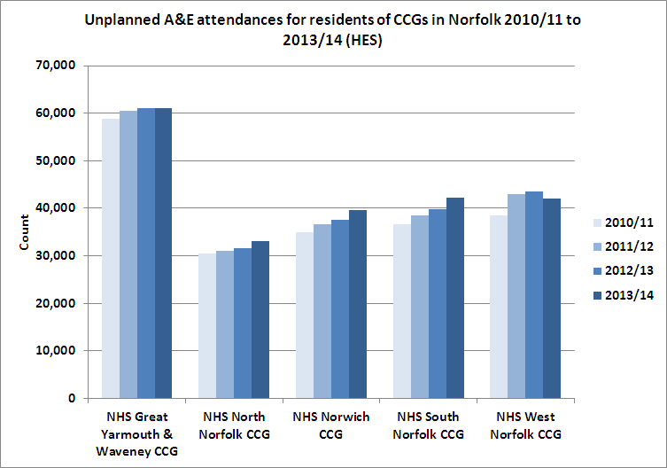

Figure 1. Counts of unplanned A&E attendances for residents of CCGs in Norfolk and Waveney.

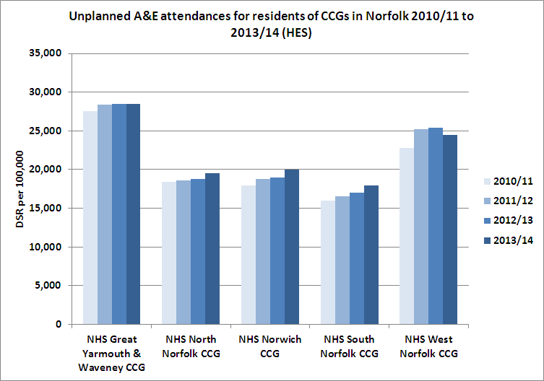

Figure 2. Directly Age Standardised Rate of unplanned A&E attendances for residents of CCGs in Norfolk and Waveney.

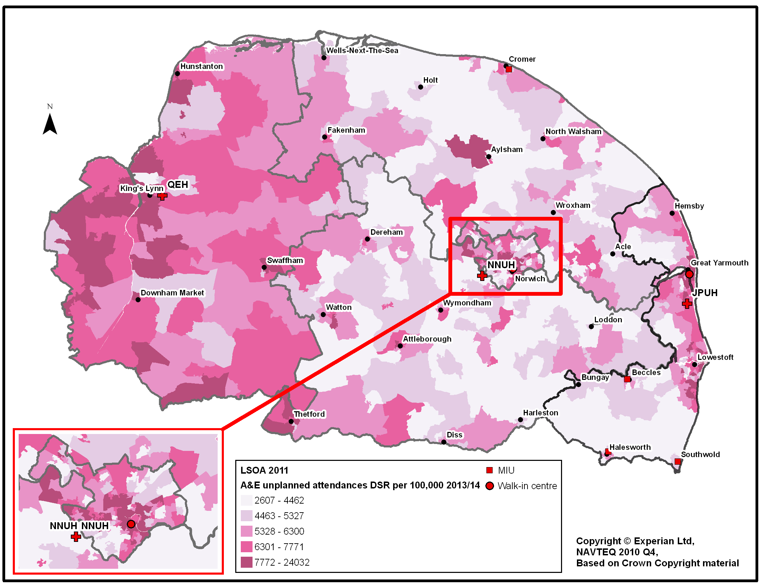

Figure 3. Directly age-standarised rate of A&E unplanned attendances in Norfolk, 2013/14.

|  |  |  |  |  |  |  |  |  |  |  |
| --- | --- | --- | --- | --- | --- | --- | --- | --- | --- | --- |
|  | **NHS Great Yarmouth & Waveney CCG** | | **NHS North Norfolk CCG** | | **NHS Norwich CCG** | | **NHS South Norfolk CCG** | | **NHS West Norfolk CCG** | |
| **Age Band** | Male | Female | Male | Female | Male | Female | Male | Female | Male | Female |
| 0 | 2,177 | 1,708 | 821 | 632 | 1,324 | 1,054 | 1,351 | 1,063 | 1,369 | 1,174 |
| 5-9 | 1,382 | 1,270 | 703 | 615 | 777 | 682 | 878 | 712 | 935 | 863 |
| 10-14 | 1,968 | 1,808 | 1,255 | 899 | 1,038 | 846 | 1,378 | 1,060 | 1,377 | 1,270 |
| 15-19 | 2,168 | 2,326 | 1,230 | 1,026 | 1,384 | 1,464 | 1,564 | 1,399 | 1,623 | 1,573 |
| 20-24 | 2,316 | 2,437 | 1,092 | 911 | 1,965 | 2,001 | 1,588 | 1,409 | 1,617 | 1,566 |
| 25-29 | 1,930 | 1,985 | 815 | 689 | 1,621 | 1,459 | 1,330 | 1,083 | 1,408 | 1,249 |
| 30-34 | 1,599 | 1,655 | 678 | 609 | 1,360 | 1,119 | 1,109 | 956 | 1,099 | 1,006 |
| 35-39 | 1,540 | 1,515 | 723 | 653 | 1,186 | 982 | 1,120 | 932 | 1,159 | 1,004 |
| 40-44 | 1,789 | 1,645 | 882 | 768 | 1,236 | 931 | 1,245 | 1,066 | 1,212 | 1,100 |
| 45-49 | 1,818 | 1,616 | 926 | 800 | 1,101 | 852 | 1,242 | 1,048 | 1,165 | 1,128 |
| 50-54 | 1,524 | 1,472 | 820 | 771 | 815 | 762 | 991 | 952 | 1,018 | 973 |
| 55-59 | 1,297 | 1,294 | 754 | 749 | 717 | 682 | 861 | 788 | 889 | 924 |
| 60-64 | 1,496 | 1,317 | 901 | 864 | 745 | 720 | 913 | 873 | 992 | 951 |
| 65-69 | 1,536 | 1,371 | 898 | 886 | 683 | 675 | 957 | 912 | 1,009 | 1,005 |
| 70-74 | 1,432 | 1,332 | 787 | 817 | 646 | 626 | 873 | 847 | 938 | 950 |
| 75-79 | 1,347 | 1,442 | 882 | 920 | 699 | 845 | 929 | 964 | 980 | 1,083 |
| 80-84 | 1,250 | 1,556 | 851 | 1,048 | 732 | 962 | 892 | 1,077 | 1,048 | 1,142 |
| 85-89 | 949 | 1,373 | 662 | 996 | 570 | 892 | 673 | 1,012 | 841 | 960 |
| 90+ | 556 | 1,150 | 396 | 803 | 301 | 733 | 405 | 840 | 522 | 676 |
| Total | 30,074 | 30,268 | 16,074 | 15,453 | 18,898 | 18,286 | 20,297 | 18,990 | 21,197 | 20,594 |

**Table 1. Average annual total (counts) of unplanned A&E attendances for residents of CCGs in NHS Norfolk between 2010/11 and 2013/14 by age band and sex (Dark blue is highest count and then graded through top 5 from dark to light).**

|  |  |  |  |  |  |  |  |  |  |  |
| --- | --- | --- | --- | --- | --- | --- | --- | --- | --- | --- |
| Resident CCG rates | **NHS Great Yarmouth & Waveney CCG** | | **NHS North Norfolk CCG** | | **NHS Norwich CCG** | | **NHS South Norfolk CCG** | | **NHS West Norfolk CCG** | |
| **Age Band** | Male | Female | Male | Female | Male | Female | Male | Female | Male | Female |
| 0 | 359 | 294 | 210 | 172 | 230 | 192 | 200 | 165 | 295 | 260 |
| 5-9 | 251 | 236 | 177 | 164 | 164 | 150 | 139 | 121 | 212 | 215 |
| 10-14 | 327 | 312 | 282 | 209 | 224 | 196 | 198 | 160 | 302 | 289 |
| 15-19 | 321 | 371 | 260 | 232 | 239 | 246 | 219 | 207 | 335 | 337 |
| 20-24 | 383 | 423 | 298 | 261 | 221 | 215 | 268 | 253 | 340 | 365 |
| 25-29 | 334 | 347 | 231 | 202 | 211 | 188 | 213 | 180 | 297 | 275 |
| 30-34 | 304 | 314 | 196 | 174 | 191 | 165 | 183 | 156 | 259 | 243 |
| 35-39 | 276 | 262 | 178 | 151 | 183 | 163 | 167 | 132 | 259 | 212 |
| 40-44 | 260 | 228 | 165 | 137 | 184 | 149 | 153 | 125 | 221 | 192 |
| 45-49 | 253 | 213 | 158 | 131 | 173 | 140 | 145 | 120 | 196 | 187 |
| 50-54 | 227 | 212 | 146 | 130 | 147 | 136 | 130 | 121 | 186 | 169 |
| 55-59 | 203 | 189 | 133 | 122 | 149 | 130 | 122 | 105 | 173 | 163 |
| 60-64 | 198 | 167 | 133 | 118 | 147 | 134 | 113 | 102 | 164 | 142 |
| 65-69 | 212 | 184 | 137 | 130 | 155 | 144 | 127 | 118 | 171 | 163 |
| 70-74 | 262 | 236 | 160 | 160 | 186 | 162 | 152 | 144 | 205 | 192 |
| 75-79 | 322 | 287 | 219 | 207 | 240 | 235 | 206 | 193 | 262 | 262 |
| 80-84 | 413 | 376 | 307 | 290 | 326 | 308 | 287 | 268 | 410 | 346 |
| 85-89 | 572 | 497 | 455 | 394 | 461 | 413 | 402 | 379 | 614 | 427 |
| 90+ | 805 | 662 | 645 | 506 | 588 | 544 | 600 | 528 | 965 | 532 |
| Total | 289 | 278 | 198 | 179 | 200 | 188 | 177 | 160 | 254 | 236 |

Table 2. Rate of unplanned A&E attendances per 1000 population for residents of CCGs in NHS Norfolk between 2010/11 and 2013/14 by age band and sex (Dark blue is highest rate and then graded through top 5 from dark to light).

Deprivation (Figure 4) and urban residence (Figure 5) are also high risk factors for attendance at Accident and Emergency. The most rural populations use emergency services the least.

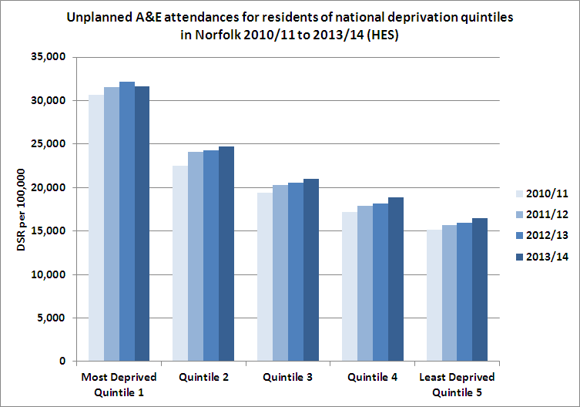

Figure 4. Directly Age Standardised Rate of unplanned A&E attendances for residents of CCGs in Norfolk and Waveney by national deprivation quintile.

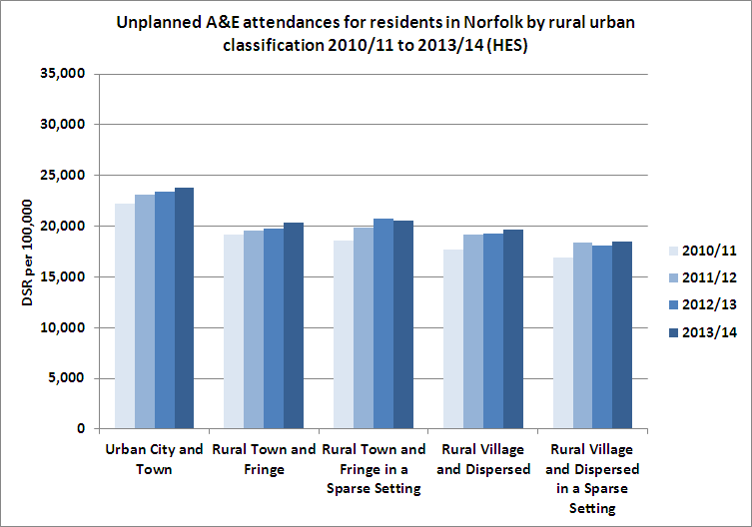

Figure 5. Directly Age Standardised Rate of unplanned A&E attendances for residents of CCGs in Norfolk and Waveney by rural urban classification.

The long term trend for A&E attendances where the arrival mode is via ambulance is increasing (Figure 6), while the long term trend for A&E attendances where the arrival mode is walk-in has remained relatively constant (Figure 7). This indicates that the increase in A&E attendances has been driven by attendances where the arrival mode is via ambulance. Reduction of inappropriate emergency ambulance use 32 therefore has potential to reduce both attendances at hospital and to achieve other significant cost savings.

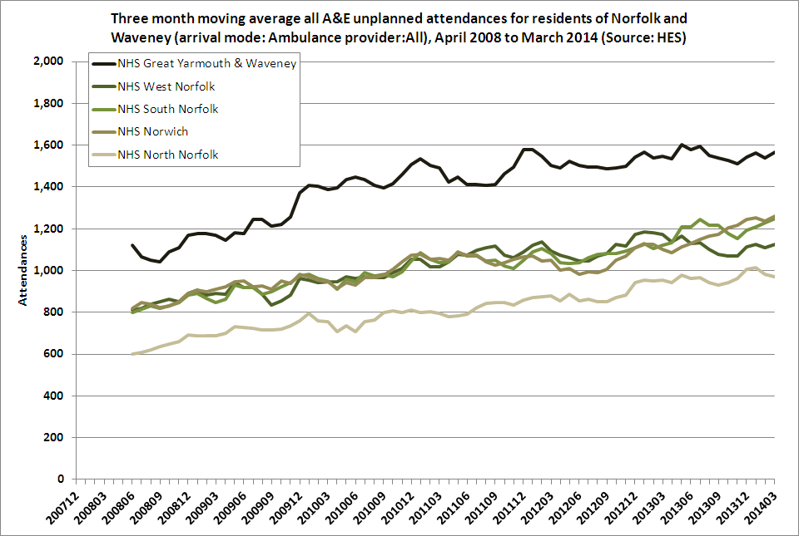

Figure 6. Three month moving average for all A&E unplanned attendances for residents of Norfolk and Waveney where the arrival mode is via Ambulance.

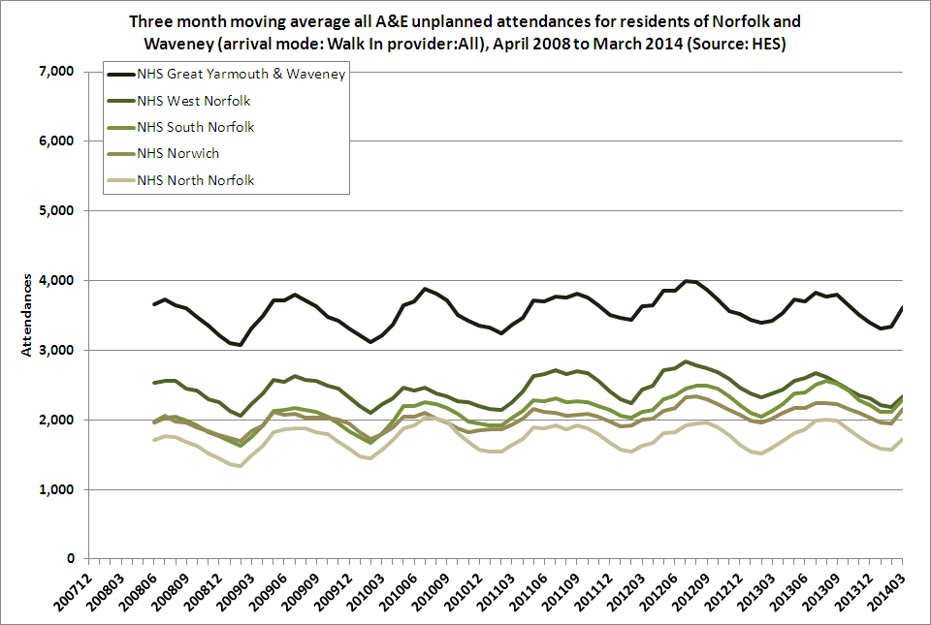

**Figure 7. Three month moving average for all A&E unplanned attendances for residents of Norfolk and Waveney.**

A large proportion of all those who attended Norfolk A&E units were discharged rather than admitted (Figure 8). The extent to which A&E attendance was appropriate for this group is unclear. Further research into risk factors for attendance but not admission might be helpful**.**

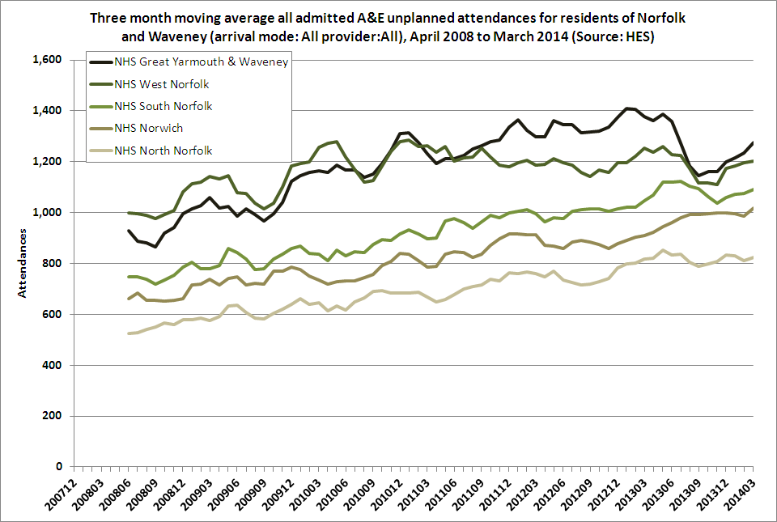

**Figure 8. Conversion of attendances to A&E that become emergency admissions.**

## What did the systematic review find?

Using very broad search terms (see Appendix 1), we found 1418 scientific articles in three databases (MEDline, Embase and Central) and 1290 items in grey literature sources (generally reports not published in academic journals). After screening all the articles for relevance we found 33 suitable articles, which are summarised in Appendix 2.

All 33 articles reported benefits for at least some outcomes relating to urgent care. Most articles measured visits to Accident and Emergency departments or emergency admissions. Eight of the included studies were randomised controlled trials. Thirteen of the remaining 25 studies used a before-and-after design. There were problems with the quality of the evidence. In many studies, several sources of bias were present in study design and implementation, making it hard to conclude whether the intervention or another factor led to reported reductions in use of urgent care.

Most studies looked at a single disease or patient group. Table 3 shows how many studies included participants with each disease or situation.

**Table 3: Condition or patient group studied**

|  |  |
| --- | --- |
| **Condition** | **No. of studies** |
| Unspecified chronic illness | 5 |
| Asthma | 4 |
| Mental Health | 3 |
| Heart Failure | 3 |
| Cancer | 2 |
| Trauma | 2 |
| Patients recently discharged from hospital | 1 |
| COPD | 1 |
| Diabetes | 1 |
| Burns | 1 |
| Children using ventilators | 1 |
| Study not restricted by condition | 9 |

The included studies encompassed diverse populations in six countries, including ethnic minorities specific to only those localities. Just six of the studies were set in the UK. The generalisablity of the results to rural UK populations therefore needs careful consideration.

There were a number of different interventions tested. Table 4 shows their general categories. Some interventions were complex interventions and had more than one component.

**Table 4: Types of interventions tested**

|  |  |
| --- | --- |
| **Type of intervention** | **No. of studies** |
| Telemedicine | 12 |
| Education | 2 |
| Case management and/or virtual ward | 3 |
| Care plan-type intervention | 4 |
| Self-management programme | 5 |
| Drop in clinic or walk in centre | 2 |
| Physician assistant undertaking home visits | 1 |
| Suicide prevention programme | 1 |
| Cardiac implant | 1 |
| Web portal | 1 |
| 24 nurse telephone line | 1 |

Most of the outcomes measured were A+E attendances or unplanned hospital admissions. A few studies had disease-specific outcomes such as asthma-related A+E attendances.

Overall, nine (only 27%) of the 33 selected studies reported statistically significant reductions in use of unscheduled medical care. This group of the most successful interventions are summarised in Table 5. No single intervention was found to consistently reduce urgent care use in rural areas. Outcomes for interventions that focused on chronic illness were the least consistent. Effect sizes in this study group tended to be small and not always successful, which to some extent reflects small studies on diverse populations. However, many interventions demonstrated success at reducing use of urgent care through management of chronic illness and suggest that targeting high risk patients is worthwhile **(Recommendation 1)**. For instance, Postma et al33 found that educational home visits in children with asthma reduced A+E visits and admissions (Hispanic migrant agricultural workers in the USA). Similarly, Larson et al34 found that nurse led education followed by a care plan in patients with asthma (in Australian primary care) led to a reduction in GP attendances and A+E attendances. Rasekaba et al35 held self-management classes for people with COPD leading to fewer hospital admissions (small Australian town). A weekly outpatients group with cognitive behavioural therapy reduced use of mental health services (northern Australia).36 Mitton et al37 found that shared care plans reduced A+E attendances and admissions in people with chronic illness (Canada).

**Table 5. Impacts of systematic review studies that had statistically significant reductions in urgent care use.**

|  |  |
| --- | --- |
| **Intervention summary** | **Study impacts** |
| Home telehealth service for frail elderly living in community 38 | Based on weekly interviews (so self-reported) and compared to 40 control subjects, 44 intervention participants made fewer emergency department visits (5 vs. 17), had fewer visits in all categories of home care utilization (12 vs. 50), and lower use of transportation services (15 vs. 26). |
| Case management of high risk patients with chronic  illness 37 | Patients’ use of acute health care services decreased, showing a 51% reduction in the number of days in hospital, a 32% reduction in emergency department visits and a 25% reduction in hospital admissions. |
| Tele-monitoring of children on home ventilators 39 | In a group of 10 patients over 6 months before and after equipment installation: The net number of hours spent by both patients and physicians in unscheduled medical care was reduced by 95 hours for the patients and 51.2 hours for the physicians. There were 24 unscheduled hospital visits before, and 5 visits after installation of equipment. |
| Community-based and multi-faceted suicide prevention programme 40 | Rate of suicides in the intervention group decreased 7% compared with that of the control group. Subgroup analyses demonstrated suicide rate in the intervention group was significantly lower in males (RR = 0.77, 95% CI 0.59–0.998, p = 0.0485) and the number of suicide attempts was significantly lower in males (RateRatio = 0.39, 95% CI 0.22–0.68, p = 0.001) and the elderly (RR = 0.35, 95% CI 0.17–0.71, p = 0.004). |
| Asthma self-management 33 | Average number of emergency hospital admissions in 12 months before intervention = 0.46 per participant, falling to 0.22 in 12 months after intervention (decline > 50%). |
| COPD self-management 35 | Significant reductions in cumulative acute hospital care utilization indicators (95% emergency department presentations, 95% inpatient admissions, 99% length of stay; effect sizes = 0.62-0.66, P < 0.001) 12 months after the introduction of the program; in contrast, changes in the cumulative indicators were statistically insignificant for the non-intervention cohort (emergency department presentations decreased by 5%, inpatient admissions decreased by 12%, length of stay increased by 30%; effect size = 0.14-0.40, P > 0.05). |
| Community health centres (CHCs) for primary care in poor  communities 41 | Counties without a CHC had 33% higher rates of uninsured all-cause ED visits per 10,000 uninsured population. Compared with non-CHC counties (rate ratio=1.33, 95% CI=1.11-1.59). Higher ED visit rates remained significant (RR=1.21, 95% CI=1.02-1.42) after adjustment for percent of population below poverty level, percent black, and number of hospitals. Uninsured ED visit rates were also higher for various categories of diagnoses, but remained statistically significant on multivariate analysis only for ambulatory care sensitive conditions (adjusted RR=1.22, 95% CI=1.01-1.47). No such relationship was found for ED visit rates of insured patients (RR=1.06, 95% CI=0.92-1.22). |
| Telemedicine acute burns assessment42 | Only 31 patients seen by telemedicine received emergency air transport (44.3%), compared with 100% of patients before programme was implemented. |
| Telemedicine to assess and possibly treat suspected major trauma 43 | For critical care patients, admissions fell significantly (54% to 30%), transfers increased (21% to 39%), and more procedures were performed. For moderate trauma patients, discharges increased significantly (45% to 63%), transfers decreased (48% to 25%) and treatment times were longer. No significant changes were found in outcome indicators. |

Telemedicine, with relative consistency, reduced urgent care use and patient transfers from rural health services to larger urban centres, with few or no negative effects on patient outcomes **(Recommendation 2)**. For instance, acute presentation patients were no more likely to seek treatment again for the same condition within one week whether diagnosed by emergency specialists on site or by GPs on site with remote emergency specialist support44 (teleconferencing in southern England).

Several studies showed that with suitable diagnostic equipment, GPs can diagnose and treat minor injuries as well as emergency specialists (UK and USA)44, 45, which suggests there are opportunities for local urgent care services. Home visits from physician assistants rather than GPs may achieve cost savings with no increase in the risk of subsequent need for urgent care (Germany)46. Assistive technology, especially web portals, enhanced telephone access and text reminders may reduce overall service usage, particularly visits to A&E for frail and isolated people (USA)38. This consistency of desirable impacts across diverse populations in multiple countries suggests that the benefits should be reasonably likely within the UK: live consultations with and between professionals will tend to reduce need for transport from rural areas, particularly emergency travel.

Nurse triage of non-urgent ambulance telephone calls resulted in a 73% reduction in attendance by ambulance life support units47 (Washington State, **Recommendation 3)**.

## Narrative review: What other solutions have been suggested?

The systematic review had strict criteria about which studies could be included. We found evidence in studies which did not meet the systematic review criteria but are relevant as described below, and listed more fully in Appendix 3. Many of their suggestions require an integrated approach across multiple public services.

A recurring suggestion to redress multiple problems is establishment of one-stop community service centres (or “hubs”48-50) in villages to provide multiple simultaneous services, such as: primary health education, pharmacists with information on accessible computer terminals, benefits information, careers advice, local childcare information, etc **(Recommendation 4)**. Projects are recommended to increase social capital and support networks for rural elderly48, 51 and rural young people, particularly for young carers. 48, 49, 52 More home visits and services are desirable, particularly for the elderly. 48, 53-55 It is also advocated that the central government funding formula should mean higher per capita funding for practices to help meet extra rural health care needs. 48, 49, 55, 56

The one-stop service hub is different from the controversial polyclinic model57, 58 in that the hub would not offer consultations, treatment or diagnosis usual to primary or secondary care settings, although some individualised health advice might be available. Patient consultations and treatment could, however, be provided by mobile clinics in rural areas with multi-skilled nurse practitioners or similarly qualified medical staff who can deal with minor urgent problems. 49, 50, 55

Many agencies also endorse targeted outreach of people at high risk of being especially isolated in rural areas (disabled or chronically ill and their carers, **Recommendation 5**)49, 50, 53, 54 or rural occupational groups (particularly agricultural labourers, from settled or migrant communities) who are known to under-use preventative services.48, 49, 53, 55 These groups are particularly rural and unlike urban hard-to-reach groups in the UK who tend to be certain ethnic minorities and/or to live in more easily identified deprived communities.

Some ideas address problems related to worries about confidentiality in small communities, access difficulties and travel distances **(Recommendation 6)**. Expanded flexibility in choice of care provider(s) and flexible appointment times to fit in with bus timetables50, 53 were suggested, as well as expanded rural transport services to be provided by the health sector.49, 53 Getting the balance right between high quality centralised care and convenient local health care services is a key concern.50

## Discussion and Limitations

An important strength of this report are that it combines systematic review of evidence, specifically in rural areas, with a broader narrative review of recommendations for reducing urgent care in general and for better meeting rural health needs. We also looked at local data to put the research evidence into local context.

There are limitations with the current evidence base of interventions. First, there are only a limited number of high quality randomised controlled trials. Other study designs, although sometimes the only pragmatic option, can be subject to a number of different biases. Second, only a small proportion (9 of the 33) reduced use of urgent care that was tested to be statistically significant, and many of these were similar in format to interventions that did not show a statistically significant effect. Third, few of the identified interventions can be “lifted off the shelf” for a rural NHS setting. Some of the research has been undertaken in very specific populations, such as Hispanic children of agricultural workers in the USA, and therefore generalisibilty is limited. However by looking at the evidence together some broad conclusions can be drawn. Targeting of high risk groups, self-management and telemedicine can be particularly effective.

It is important to note that our study applies only to evidence about the impacts of interventions on rural residents; other reviews done in urban and rural areas have a much larger evidence base upon which to make conclusions about the general success rates of any specific intervention approach, as described in the introduction.

Local data show that arrivals by ambulance and emergency health care needs of the elderly are important drivers increasing rates of attendance. Attendances are highest in urban areas and in West Norfolk CCG. Deprivation is also a risk factor.

North Norfolk has relatively low attendance rates to A&E departments, but low use of emergency services in rural areas may not be entirely desirable. Indeed, it has been suggested that *low* usage of all types of health care services in British rural areas is of concern 48-50, 52, 53, 55, leading to poor health outcomes for some groups, especially rural individuals with relatively high social deprivation.

There are many recommendations from public bodies about innovative solutions needed to improve rural health services, but few of these suggestions (Appendix 3) are conventionally delivered by the health service. They may still be worth consideration by commissioners.

**Conclusions**

Local data suggest that A+E attendances from a relatively young age cohort (age 10-30), and from the very oldest age cohort (age 75+) are driving increases in costs and service usage. Arrivals by ambulance are also increasing. Better identification of risk factors for inappropriate service usage in these groups might help formulate effective intervention strategies.

Most interventions in the systematic review focused on a specific disease or patient group, such as heart failure or asthmatics. Interventions broadly addressed either management of chronic illness (through education care planning, case management and self-help programmes) or use of telemedicine in acute presentations (usually via telephone or teleconferencing). Increased age, deprivation, less education, chronic disease and multi-morbidity were identified as important patient factors.

Many innovative ideas have been suggested but not yet tried for improving health care provision in rural areas of the UK. Combined multiple public service provision may be one way to increase access to health care in rural areas while keeping down costs.

Although rural areas are recognised as having unique disadvantages, relatively few studies recognised these specific problems in implementation. No single intervention was consistently found to reduce urgent care use in rural areas. The highest quality evidence supported care planning and self-management programmes. Telemedicine interventions can also be very effective, especially at averting emergency transport. There is also evidence from previous reviews and wider literature (which included urban areas) to recommend: risk stratification tools, preventative education, especially in self-management; interventions that address heart failure including through intensive case management; continuity of care.

Evidence about successful interventions to minimise use of urgent medical care in rural areas is incomplete. However, based on our reviews and local data, the following recommendations are made:

**Recommendations to reduce unplanned urgent care use in rural areas:**

1. Use multi-factorial risk prediction and stratification tools (such as the Combined Devon Predictive Model1) to target groups which have highest rates of urgent care use, such as older people, those with chronic disease or multi-morbidity and deprived groups: effective interventions in these groups include self-management and case-management programmes.
2. Consider telemedicine (live consultations between professionals via telephone or teleconferencing) to reduce urgent care use and patient transfers from the community or general practice to hospital.
3. Consider telephone triage to reduce inappropriate ambulance use.
4. Consider a community service centre to provide a multi-disciplinary, integrated approach, across the health and social sector.
5. Provide outreach health promotion targeted at hard-to-reach rural groups such as carers, agricultural workers and socially isolated elderly.
6. Promote flexibility in the provision of primary care with respect to appointment times and coordination with public transport.

**Acknowledgements:**

Thanks to GP Dr. Alice Shiner who gave information about risk stratification tools currently being used in Norfolk GP surgeries.

## References

1 Sonola L, Thiel V, Goodwin N, Kodner DL. South Devon and Torbay Proactive case management using the community virtual ward and the Devon Predictive Model. The King's Fund; 2013 24 Oct 2013.

2 HSCIC. Accident and Emergency Attendances in England - 2012-13, Experimental statistics. Health and Social Care Information Centre; 2014.

3 Policy Exchange. All Together Now: Competitive integration in the NHS. 2012.

4 Nuffield Trust. Focus on preventable admissions: Trends in emergency admissions for ambulatory care sensitive conditions, 2001 to 2013. . 2013.

5 HSCIC. Ambulance services, England: 2004-05 Health & Social Care Information Centre; 2005. Report No.: Bulletin 2005/01/HSCIC.

6 HSCIC. Ambulance Services, England 2012-13. Health and Social Care Information Centre 2013 19 June 2013. Report No.: 1.0.

7 HSJ. Surge in over-90s needing ambulances Health Service Journal. 2014.

8 The King's Fund. Ageing population. The King's Fund, 2014.

9 Joshi H, Dodgeon B, Hughes G. A Profile of Population Change in Rural England and Wales. 2008.

10 HSCIC. Statistics on Obesity, Physical Activity and Diet: England, 2013 Health and Social Care Information Centre 2013.

11 DEFRA. Statistical Digest of Rural England 2012. Department for the Environment, Food and Rural Affairs; 2012.

12 DEFRA. Living in rural areas: Rural poverty. Department for the Environment, Food and Rural Affairs; 2014 4 Feb 2014.

13 Kyte L, Wells C. Variations in life expectancy between rural and urban areas of England, 2001–07. Health Statistics Quarterly 2010;46:27-52.

14 Cowling TE, Cecil EV, Soljak MA, et al. Access to primary care and visits to emergency departments in England: a cross-sectional, population-based study. PloS one 2013;8:e66699.

15 Smith T, Noble S, Dibben C, Heynat J, Avenall D. DEPRIVATION IN RURAL NORFOLK: Final Report. Brighton, UK: Oxford Consultants for Social Inclusion; 2006 December 2006.

16 Bertin M, Chevrier C, Pelé F, Serrano-Chavez T, Cordier S, Viel J-F. Can a deprivation index be used legitimately over both urban and rural areas? International Journal of Health Geographics 2014;13:22.

17 Haynes R, Gale S. Deprivation and poor health in rural areas: inequalities hidden by averages. Health & place 2000;6:275-285.

18 Riva M, Curtis S, Gauvin L, Fagg J. Unravelling the extent of inequalities in health across urban and rural areas: evidence from a national sample in England. Social science & medicine 2009;68:654-663.

19 Purdy S, Paranjothy S, Huntley A, et al. Interventions to reduce unplanned hospital admission: a series of systematic reviews. Bristol: University of Bristol; 2012 June 2012.

20 Purdey S, Huntley A. Predicting and preventing avoidable hospital admissions: a review. The journal of the Royal College of Physicians of Edinburgh 2013;43:340-344.

21 Huntley A, Lasserson D, Wye L, et al. Which features of primary care affect unscheduled secondary care use? A systematic review. BMJ open 2014;4:e004746.

22 Ismail SA, Gibbons DC, Gnani S. Reducing inappropriate accident and emergency department attendances: a systematic review of primary care service interventions. British Journal of General Practice 2013;63:e813-e820.

23 Bankart M, Baker R, Rashid A, et al. Characteristics of general practices associated with emergency admission rates to hospital: a cross-sectional study. Emergency Medicine Journal 2011;28:558-563.

24 Wiseman CE, Baker R. Exploration of population and practice characteristics explaining differences between practices in the proportion of hospital admissions that are emergencies. BMC Family Practice 2014;15:101.

25 Thomson K, Lewis G. Information Governance and Risk Stratification: Advice and Options for CCGs and GPs. NHS England; 2013.

26 NHS England. Avoiding unplanned admissions: proactive case finding and patient review for vulnerable people. Enhanced service specification.30.

27 Hippisley-Cox J, Coupland C. Predicting risk of emergency admission to hospital using primary care data: derivation and validation of QAdmissions score. BMJ open 2013;3:e003482.

28 O'Cathain A, Knowles E, Maheswaran R, et al. A system-wide approach to explaining variation in potentially avoidable emergency admissions: national ecological study. BMJ quality & safety 2013.

29 Department for Environment FRA: https://[www.gov.uk/government/collections/rural-urban-definition](http://www.gov.uk/government/collections/rural-urban-definition) Accessed 10 September 2014 2014.

30 Office for National Statistics: <http://www.ons.gov.uk/ons/datasets-and-tables/index.html?&newquery=lsoa+mid+year+estimates> Accessed 10 September 2014 2014.

31 The King's Fund. Emergency hospital admissions for ambulatory care-sensitive conditions: identifying the potential for reductions. 2012 April 2012.

32 Vardy J, Mansbridge C, Ireland A. Are emergency department staffs’ perceptions about the inappropriate use of ambulances, alcohol intoxication, verbal abuse and violence accurate? Emergency medicine journal 2009;26:164-168.

33 Postma JM, Smalley K, Ybarra V, Kieckhefer G. The feasibility and acceptability of a home-visitation, asthma education program in a rural, Latino/a population. Journal of Asthma 2011;48:139-146.

34 Larson A, Ward J, Ross L, Whyatt D, Weatherston M, Landau L. Impact of structured education and self management on rural asthma outcomes. Australian family physician 2010;39:141.

35 Rasekaba TM, Williams E, Hsu-Hage B. Can a chronic disease management pulmonary rehabilitation program for COPD reduce acute rural hospital utilization? Chronic respiratory disease. 2009:157-163.

36 Bradley AC, Baker A, Lewin TJ. Group intervention for coexisting psychosis and substance use disorders in rural Australia: outcomes over 3 years. Australian & New Zealand Journal of Psychiatry 2007;41:501-508.

37 Mitton C, O'Neil D, Simpson L, Hoppins Y, Harcus S. Nurse-Physician Collaborative Partnership: a rural model for the chronically ill. Canadian journal of rural medicine : the official journal of the Society of Rural Physicians of Canada = Journal canadien de la médecine rurale : le journal officiel de la Société de médecine rurale du Canada. 2007:208-216.

38 Finkelstein SM, Speedie SM, Zhou X, Potthoff S, Ratner ER. Perception, satisfaction and utilization of the VALUE home telehealth service. Journal of Telemedicine and Telecare. 2011:288-292.

39 Miyasaka K, Suzuki Y, Sakai H, Kondo Y. Interactive communication in high-technology home care: videophones for pediatric ventilatory care. Pediatrics 1997;99:E1.

40 Ono Y, Sakai A, Otsuka K, et al. Effectiveness of a Multimodal Community Intervention Program to Prevent Suicide and Suicide Attempts: A Quasi-Experimental Study. PLoS ONE. 2013.

41 Rust G, Baltrus P, Ye J, et al. Presence of a community health center and uninsured emergency department visit rates in rural counties. The Journal of Rural Health 2009;25:8-16.

42 Saffle JR, Edelman L, Theurer L, Morris SE, Cochran A. Telemedicine evaluation of acute burns is accurate and cost-effective. Journal of Trauma - Injury, Infection and Critical Care 2009;67:358-365.

43 Westbrook JI, Coiera EW, Brear M, et al. Impact of an ultrabroadband emergency department telemedicine system on the care of acutely ill patients and clinicians' work. Medical Journal of Australia 2008;188:704-708.

44 Benger JR, Noble SM, Coast J, Kendall JM. The safety and effectiveness of minor injuries telemedicine. Emergency medicine journal : EMJ. 2004:438-445.

45 Brennan JA, Kealy JA, Gerardi LH, et al. Telemedicine in the emergency department: a randomized controlled trial. Journal of telemedicine and telecare. 1999:18-22.

46 van den Berg N, Meinke C, Matzke M, Heymann R, Flessa S, Hoffmann W. Delegation of GP-home visits to qualified practice assistants: assessment of economic effects in an ambulatory healthcare centre. BMC Health Services Research 2010;10:155.

47 Smith WR, Culley L, Plorde M, et al. Emergency medical services telephone referral program: an alternative approach to nonurgent 911 calls. Prehosp Emerg Care 2001;5:174-180.

48 Community Council of Devon. Draft Rural Health & Wellbeing Strategy for Devon 2010-2013: CCD response. 2010 July 2010.

49 Wood J. Rural Health and Healthcare: a North West perspective. Lancaster, UK: Institute for Health Research, Lancaster University; 2004 January 2004. Report No.: ISBN 1-86220-144-7.

50 Welsh Government. Delivering Rural Health Care Services. 2011. Report No.: ISBN 978 0 7504 6215 0.

51 Farmer J, Munoz S-A, Steinerowski A, Bradley S. Health, wellbeing and community involvement of older people in rural Scotland. In: Le Q, editor editors. Health and wellbeing: a social and cultural perspective. New York: Nova Science, 2010:128-144.

52 NHS Devon. Rural Health and Wellbeing Strategy for Devon 2010-2013. Devon County Council; 2010.

53 Swindlehurst H, Deaville J, Wynn-Jones J, Mitchinson K. Rural proofing for health: a commentary. Rural and remote health 2005;5.

54 Age UK. Later Life in Rural England. London: Age UK; 2013 2013.

55 BMA. Healthcare in a Rural Setting. British Medical Assocation: Board of Science.; 2005 2005.

56 CRC. Tackling rural disadvantage through how public services are reformed. Cheltenham Gloucestershire: Commission for Rural Communities; 2008.

57 Author. The Big Question: What are polyclinics, and why are doctors so angry about them? . The Independent, 2008 13 Jun 2008)

58 Hutt P, Singh S, Modell M, Nazareth I. Polyclinics and polysystems: evolving ambiguity, evidence required. British Journal of General Practice 2010;60:400-401.

59 Valery PC, Masters IB, Taylor B, Laifoo Y, O’Rourke PK, Chang AB. An education intervention for childhood asthma by Aboriginal and Torres Strait Islander health workers: a randomised controlled trial. Medical Journal of Australia 2010;192:574-579.

60 Crane S, Sailer D, Patch SC. Improving asthma care in emergency departments: results of a multihospital collaborative quality initiative in rural western North Carolina. North Carolina medical journal 2011;72:111-117.

61 Stampehl MR, Call CF, Pope SM, Hartwig M, Jennison S. Rural heart failure management by telemedicine: Lessons learned. Journal of Cardiac Failure 2012;1):S98.

62 Dracup K, Moser DK, Pelter MM, et al. A Randomized Controlled Trial to Improve Self-Care in Patients with Heart Failure Living in Rural Areas. Circulation 2014:CIRCULATIONAHA. 113.003542.

63 Varma N, Pavri B, Michalski J. How well does remote monitoring reduce the burden of unnecessary hospital presentation? Results from the TRUST ICD trial. European Heart Journal 2011;32:477.

64 Rettig BA, Shrauger DG, Recker RR, Gallagher TF, Wiltse H. A randomized study of the effects of a home diabetes education program. Diabetes care. 1986:173-178.

65 Thiel V, Sonola L, Goodwin N, Kodner DL. Developing community resource teams in Pembrokeshire, Wales Integration of health and social care in progress. The King's Fund; 2013.

66 Lewis GH, Georghiou T, Steventon A, et al. Impact of ‘Virtual Wards’ on hospital use: a research study using propensity matched controls and a cost analysis. National Institute for Health Research Service Delivery and Organisation Programme; 2013 Nov 2013.

67 Armstrong IJ, Haston WS. Medical decision support for remote general practitioners using telemedicine. Journal of telemedicine and telecare 1997;3:27-34.

68 Hoechsmann A. Decrease in medevacs and overall transportation to a regional emergency department with implementation of territorial picture archiving and communication system. Canadian Journal of Emergency Medicine 2012;14:S13.

69 Thaker DA, Monypenny R, Olver I, Sabesan S. Cost savings from a telemedicine model of care in northern Queensland, Australia. Med J Aust 2013;199:414-417.

70 Sabesan S, Brennan S. Tele Oncology for Cancer Care in Rural Australia. Telemedicine Techniques and Applications, Graschew G, Rakowsky S (Hrsg) InTech 2011:289-306.

71 Kates N, Crustolo AM, Nikolaou L, Craven MA, Farrar S. Providing psychiatric backup to family physicians by telephone. Can J Psychiatry 1997;42:955-959.

72 Saurman E, Perkins D, Roberts R, Roberts A, Patfield M, Lyle D. Responding to mental health emergencies: implementation of an innovative telehealth service in rural and remote new South Wales, Australia. J Emerg Nurs 2011;37:453-459.

73 Gruenewald D, Virtue J, Kopf W, Hartmann T, Nason E, White E. Outcomes for outpatient veterans with cancer receiving care coordination-home telehealth services. Journal of the American Geriatrics Society 2013;61:S56.

74 Dellasega CA, Zerbe TM. A multimethod study of advanced practice nurse postdischarge care. Clinical excellence for nurse practitioners : the international journal of NPACE. 2000:286-293.

75 Mungall I. Trend towards centralisation of hospital services, and its effect on access to care for rural and remote communities in the UK. Rural Remote Health 2005;5:390.

**Appendices**

APPENDIX 1

Terms used to find articles in scientific databases and grey literature.

Items with * were wildcard format; items with (exp) prefix were searched with variants (MESH expansion).

|  |  |  |  |
| --- | --- | --- | --- |
| Urgent adjective | Event | Location | Comparison rather than observation |
| Unplanned  Urgen*  Unscheduled  (exp) emergency | Care, Episode*  Admission  Inciden*  Attendance  Calls, Call-outs  (exp) appointments | Rural  remote | Random*, Trial*, Control*  Randomized-controlled-trial, RCT  (exp) Cohort-studies, (exp) Case-control  (exp) series, (exp) case, time-series,  before, after  Program*, Strateg*, Initiative*, Interven* |

APPENDIX 2

Table of Included Studies in Systematic Review.

Key: * denotes desirable impact with 95% level of statistical confidence.

MANAGEMENT OF CHRONIC ILLNESS

| Study | Target population | | | Outcome measure(s) and time point of followup | Intervention strategy | Strength of evidence and caveats |
| --- | --- | --- | --- | --- | --- | --- |
| Postma et al 201133 | Children with asthma in families of Hispanic agricultural workers | | | Visits to A+E  & Emergency admissions;  4-12 months | Individual and educational home-visits | Reduction in visits and admissions * |
| Valery et al 201059 | Children with asthma in Torres Island Strait families | | | Unscheduled medical visits;  1 year | As above | No significant difference between control and intervention group |
| Crane et al 201160 | Visitors to emergency department in North Carolina due to asthma | | | Rate of return asthma-related visits at 30 or 60 days | A brief education session in the emergency department | No apparent impact |
| Larson et al 201034 | Primary care patients with asthma | | | Unscheduled visits to their GP or presentations to Emergency Departments; 1 year | 20 minute nurse-led, education session resulting in an individualised action plan; reviewed by GP | High but not statistically significant decreases |
| Stampehl et al 201261 | Heart failure patients in the USA | | | Re-admission rates to hospital, compared to US national average;  3 months | Personalised case management, individual patient education and monitoring once or twice a week. | Successful, but patients were more affluent than US average |
| Dracup et al 201462 | As above | | | Unplanned hospitalisations;  2 years | As above | Increases in highest contact group, no difference between usual care and low contact group |
| Varma et al 201163 | As above | | | Unscheduled medical appointments;  15 months | Implantable cardiac electronic devices in the TRUST trial | Increased unscheduled care; other cost savings were achieved |
| Miyasaka et al 199739 | Japanese children residing in the community and dependent on ventilators | | | Hours of unscheduled medical care and unscheduled hospital visits;  6 months | In-home video cameras used to monitor ventilator performance and breathing statistics | Large reductions in both |
| Rasekaba et al 200935 | COPD sufferers in a small Australian rural town | | | Acute hospital care: visits and admissions;  12 months | Self-management classes | Significant reduction compared to non-participants * |
| Rettig et al 198664 | Type II diabetes sufferers | | | Preventable diabetes-related hospitalizations; 12 months | Self-management face-to-face instruction | Not effective |
| Bradley et al 200736 | Mentally ill substance abusers | | | Acute MH services usage;  3 years | Weekly outpatient group intervention, motivational interviewing and CBT | Significant  reductions * |
| Van den Berg et al 201046 | Housebound non-specific chronic illness | | | Use of urgent care;  2 years | Physician assistants instead of GPs were sent for routine appointments | No change |
| Mitton et al 200737 | Chronic illness | | | ED visits and admissions;  6-12 months | Shared care plans reviewed at monthly meetings | Significant reductions in both outcomes; but small pt group (n=37) |
| Finkelstein et al 201138 | Frail elderly people living independently | | | Visits to A&E;  2 months | Usual care supplemented with a web portal (computers and training supplied) | Significant reductions, but seems likely that sicker pts opted out * |
| Thiel et al 201365 | | Chronic illness | | Emergency admissions;  12 months | Enhanced care in the community (closer to home) | Decreases for pts with heart disease; length of hospital stay for other conditions also fell |
|  |  | | |  |  |  |
| Lewis et al 201366  Sonola et al 20131 | Chronic illness | | | Emergency admission rates;  Lewis: 6 months  Sonola: 1-3 years, | Intense case management of high risk patients (Virtual Wards) | Sonola et al observed reductions; in a more rigorous assessment of same programme, Lewis et al found no difference with matched controls |
| TELEMEDICINE FOR ACUTE PRESENTATIONS | | | | | | |
| Armstrong and Haston 199767 | | | Rural Scotland | Emergency transfer to larger centre; 1 year | Telemedicine link between casualty department of remote hospital and A&E of urban hospital | The transfer of 70 patients was avoided |
| Hoechsmann 201268 | | | Acute presentations in rural Canada | Emergency air evacuations;  2 years | Videolink comms. system | 15% decline |
| Saffle et al 200942 | | | Burns victims in Rural western USA | Emergency air transport; 2 years | Audio-video consultations | Averted for 70 patients * |
| Thaker et al 201369  & Sabesan and Brennan 201170 | | | Cancer patients in rural Australia | Emergency transport;  4.5 years | Audio-video links with specialist centre | Averted for ten patients big cost savings |
| Westbrook et al 200843 | | | Patients with moderate or major trauma | Emergency transport; admissions;  18 months | Video links between local doctors and EMS specialists | Decreases for moderate trauma, increases for major trauma |
| Kates et al 199771 | | | Mental illness | Visits to A+E;  1 year | On-call (via the telephone) psychiatrist for family doctors | Up to 50 visits prevented |
| Saurman et al 201172 | | | Mental illness | Emergency transfer to regional treatment centre;  18 months | Videolink for assessment of psychiatric problems | Statistically significant decrease * |
| Benger et al 200444 | | | Minor or major trauma | Followup for urgent subsequent care; 7 days | Diagnosis by remote EMS specialists on videolinks vs. on-site GPs | No difference; possible flaws in comparison due to implementation |
| Brennan et al 199945 | | | Minor conditions | 72 hour return visit for same condition | Comparing on-site physicians with remote nurses or physicians trained in telemedicine working with video-links for diagnosis | No significant difference in return rates |
| Smith et al 200147 | | | Callers to ambulance service in Pacific Northwest USA | Attendance by life support units;  2 days | Transfer of non-urgent calls to a 24-hour consulting nurse | 73% reduction in attendance |
| Rust et al 200941 | | | Poor mostly racial minority Communities in Georgia, USA | Visits to emergency Departments;  3 years | Affordable community Drop-in health clinics | For uninsured pts, less use Compared to counties without such walk-in centres * |
| O’Cathain et al 200740 | | | Respondents to national patient surveys (UK) | Emergency hospital admissions;  5 years | Walk-in centres, NHS-direct and similar NHS services providing unscheduled care | No reduction achieved |
| OTHER/MIXED | | |  |  |  |  |
| Gruenewald et al 201373 | | | American veterans with cancer | Emergency department visits;  1, 2 or 5 months | A multi-professional coordinated care-home telehealth service | Increase, but Other benefits noted |
| Ono et al 201340 | | | Japanese residents, urban and rural | Suicide attempts;  3.5 years | Suicide prevention programme | Lower among elderly and male intervention subjects, especially in rural areas * |
| Dellasegra and Zerbe 200074 | | | Elderly and vulnerable patients being discharged from hospital | Emergency room visits and hospital readmissions;  6 weeks post-discharge | Nurse-led plan to prevent hospital readmissions | Both Fewer, but not statistically significant reduction |

Key: * denotes desirable impact with 95% level of statistical confidence.

APPENDIX 3

Recommendations made by various groups and agencies for health service delivery in rural Britain and the problems that they may address.

|  |  |
| --- | --- |
| Problem | Strategies recommended by experts or focus groups to tackle this problem |
| Large travel distances to providers | “accessible and flexible services including the option to be seen at home” 54  Higher central govt. funding outcome formula for rural services 56;  Getting right balance between high quality centralised care & local health care centres 50, 75 “a rural community’s travel time to services should be an integral factor in the planning of services in the care sector.” 50  Patients able to directly self-refer for some treatment 50  Better equipped pharmacies with better trained staff & more computers to find information 50  “working in partnership to improve public transport,”  and “Community transport schemes, such as voluntary community minibuses, dial-a-ride and car share schemes, have been developed where public bus provision is limited and not cost effective” (specific examples given, and) “complex rural transport networks including public, third sector and ambulance transport coordinated” 49, 53  “Patients should, where required, be offered appointment times which fit in with existing public transport timetables,” 49 and ”‘rural’ hospital outpatient department appointments to provide reasonable travel time for people to get to and from the hospital i.e. no early or very late appointments. 53  “A minibus with wheelchair access was provided from the outset of the project to help residents get to doctors surgeries, dentists, and…” 49  Help from PCT to recruit doctors & keep surgery staffed enough to stay open 55  Village hub idea: community transport schemes and community buildings with broadband and outreach programmes 48 |
| Problem | Strategies recommended by experts or focus groups to tackle this problem |
| Low participation in health promotion programmes  due to rurality or occupational pressure | “Community based falls prevention service based in age-well centres and local community centres.” (education in the community) 50  As well as one-stop community resource centres 50 & “The development of healthy living centres, or as in the Peak District rural ‘healthy living networks’, has offered a holistic approach to address issues that affect health. Such centres have offered activities and services such as outreach work, health education with young people, welfare advice, citizens advice bureaus, crèche facilities, parenting skills courses, local food co-ops, credit schemes, home safety equipment schemes and free exercise schemes.  Rural ‘one stop’ shops could more effectively bring together numerous agencies.” 49  Targeted outreach to occupational groups (eg., agricultural workers) known to under-use preventative services 53  “Consider commissioning innovative approaches to increase self-care, improve health and wellbeing and help overcome geographic restrictions in rural areas e.g. assistive technologies - targeted telephone and email advice, telephone coaching and counselling, text messaging with prompts and reminders.” 53  “complex rural transport networks including public, third sector and ambulance transport coordinated” 53  Branch nurse-P led surgery & mobile services 55 or nurse-practitioner led urgent care clinics 48  Village hubs to provide all sorts of services including health advice 52, community outreach buildings including multi-purpose community facilities 48  Appropriate education in schools 48 |
| Problem | Strategies recommended by experts or focus groups to tackle this problem |
| Delayed diagnosis due to access issues | Health promotion events & drop-in clinics targeting agricultural workers, perhaps using nurse practitioners”. I.e., turning up at places where agricultural workers congregate 48, 49, 53, 55  Telemedicine in form of: phone & website advice, telephone coaching, text messaging prompts & reminders 49, 53  “defined geographical standards such as the maximum time patients can reasonably be expected to spend travelling to access health services?” 53  “‘rural’ hospital outpatient department appointments to provide reasonable travel time for people to get to and from the hospital i.e. no early or very late appointments?” 53  Telemedicine to make more expertise local, including local consultations 55  “Emphasis should be on screening and early detection of disease in rural areas, to reduce the need for emergency care.” BMA 05 |
| Confusion about how to access urgent care | A single point of contact, including village health centres 50;  Community First (Rapid) Responders 50  “In Kentmere, Cumbria, the Women’s Institute are in the process of giving every household in the valley a laminated card which includes their full home grid reference, house name, postcode and important telephone numbers, and which can be used when the emergency services need to be called” 49 |
| Shortage or reduced choice of providers | Telehealth and locating training centres in rural areas so doctors want to continue their careers there 50  Multiskilling of community nurse practitioners 49  And “integrated emergency and minor injuries services with the local out-of-hours [GP co-op] scheme”: 49  “it needs to be recognised that the cost of running equivalent services can be higher in rural areas than in urban ones.” 49  Measures to increase privacy & confidentiality 53  Help from PCT to recruit rural doctors to keep rural surgeries open 55; making sure enough rural staff 48 |
| Reduced choice of treatment options | Community First (Rapid) Responders with telemedicine links to experts 49, 50  Meaningfully involving rural communities (consulting them) in the commissioning of services 53  “integrated delivery of health services to provide healthcare closer to home e.g. outreach from district general hospitals and the repatriation services into primary and community care settings**…** Could you get the consultant advice to the patient rather than the patient to the consultant?” 53  ”‘rural’ hospital outpatient department appointments to provide reasonable travel time for people to get to and from the hospital i.e. no early or very late appointments? 53  “all ambulance trusts in the UK should be trained and equipped to provide appropriate pre-hospital care, including thrombolysis” 55 |
| Problem | Strategies recommended by experts or focus groups to tackle this problem |
| Inadequate support for chronic illness & carers | Integrated case management, especially for chronic respiratory illness 50, 54  Transport services to get people to self-man and other helpful workshops & the doctor 49  Self-monitoring equipment and “a ‘virtual’ Cornwall Carers Service based on a centralised phone line and web space and delivered locally by 21 Carer Support Workers working mainly from home in the communities that they serve.” 52  “‘rural’ hospital outpatient department appointments to provide reasonable travel time for people to get to and from the hospital i.e. no early or very late appointments?” 53  Mobile services including things like wheelchair repair 55  Village hubs & special support for households affected by dementia especially training in community venues  A system of pastoral visiting perhaps delivered by charities 48  Projects to increase social capital and support networks for rural elderly 51 |
| Hidden ill health | “Pilot ‘mini Sure Start’ programmes are being established in rural areas, where there are pockets of deprivation, yet, the number of disadvantaged children living locally is considerably less than required by conventional Sure Start” 49  Projects to increase social capital and support networks for rural elderly 51 , Programmes targeted at young carers 48  “Develop services which focus on marginalised and isolated young people in rural communities to address issues of “double” or “multiple discrimination”. 52 |