The air–surface shared fraction: a closer look
Hospital microbiome manuscript (v2) — note for co-authors, 29 October 2026. For discussion; not yet in the manuscript.
Why this note
The manuscript reports that 590 of 2,255 species (26.2%) were detected in both air and surface samples (Figure 1C). This shared fraction is larger than the "ecologically distinct" framing suggests, so we broke it down by how often each species occurs in each compartment, what it is, and where in the hospital it was found. The same species counts and filters as the manuscript are used (23 air and 35 surface samples; species with more than 10 reads; 696 air-only / 590 shared / 969 surface-only).
Main observations
- Most of the shared fraction is sporadic. 496 of the 590 shared species occur in only one sample of at least one compartment, and no species is found in half or more of both air and surface samples. About half of these sporadic species are Actinomycetota (Microbacterium, Gordonia, Mycolicibacterium, Rhodococcus, Nocardia), typical dust and built-environment genera (Figure 1C).
- Its large share of reads reflects dominant species detected at trace levels in the other compartment. Shared species account for 83% of air reads and 55% of surface reads, but mostly because, for example, R. bonaserana (28.6% of air, 0.01% of surface reads) and A. lwoffii (8.9% of surface, 0.02% of air) were each detected once or a few times in the other compartment (Figure 1A–B).
- A small widespread shared fraction stands out. Thirteen species occur in at least five air and five surface samples (Figure 1B, D; Table 1). Twelve are Gram-negative bacteria, mostly opportunistic or hospital-associated: Pseudomonas aeruginosa, P. putida, P. fluorescens, Stutzerimonas stutzeri, Stenotrophomonas maltophilia, Acinetobacter baumannii, Escherichia coli, Serratia marcescens, S. proteamaculans, S. quinivorans, Pantoea agglomerans and Rahnella aceris; the thirteenth is the alga Chlamydomonas reinhardtii. Together they make up 6.4% of air and 18.2% of surface reads.
- Two patterns within it. The Pseudomonas group (P. aeruginosa, P. putida, P. fluorescens, S. stutzeri) is surface-led (57–66% of surface samples, 22–39% of air) and carries most of the virulence genes (S. stutzeri: 42 VF genes). The Enterobacterales (R. aceris, S. marcescens, P. agglomerans, E. coli) are air-led (57–65% of air samples, 14–29% of surfaces).
- Hospital linkage (Figure 2). These species link air from most wards to almost every ward E room: 82 of the 110 possible air-ward / surface-room pairs share at least one of them. The strongest links (up to 12 species) connect air from wards D, G, H and I with the ward E patient rooms (SR 16, SR 26), the kitchen and the beverage bay. Air from ward F carried none of them, and ward E air (one sample) only one.
- Sample-level view (Figure 3). The Pseudomonas group is spread across almost all ward E rooms and appears in air mainly from wards D, G, H and I, whereas the Enterobacterales (Serratia, Pantoea, Rahnella) occur in air from nearly every ward but on surfaces at only a handful of sites: the three Serratia species in the same five samples (the SR 16 and beverage-bay fridges, an SR 26 room vent and a corridor vent) and P. agglomerans mainly on kitchen vents. A. lwoffii and Paracoccus marcusii, although shared, are clearly anchored in one compartment (surfaces and air, respectively).
Figures
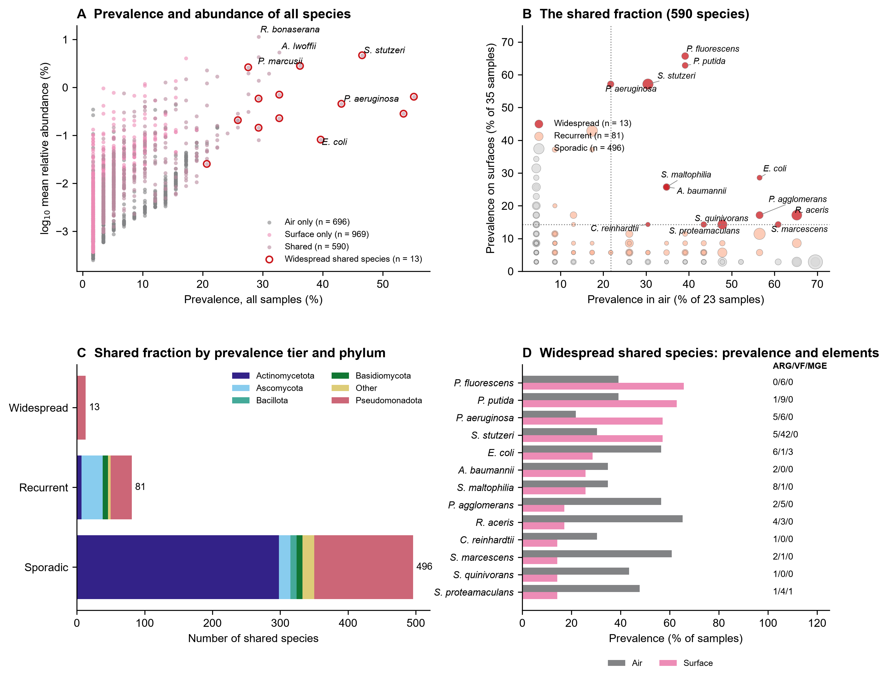
Figure 1. The air–surface shared fraction. (A) Prevalence across all 58 samples against mean relative abundance for every species, coloured by Venn category (air only, surface only, shared); the 13 widespread shared species are circled. (B) Prevalence in air against prevalence on surfaces for the 590 shared species; point size reflects mean relative abundance; dotted lines mark five samples in each compartment. Tiers: widespread (≥5 samples in both), recurrent (2–4 samples in both), sporadic (one sample in at least one compartment). (C) Number of shared species per tier, by phylum. (D) Prevalence of the 13 widespread shared species in air and on surfaces, with the number of distinct ARGs, VFs and MGEs detected on their reads.
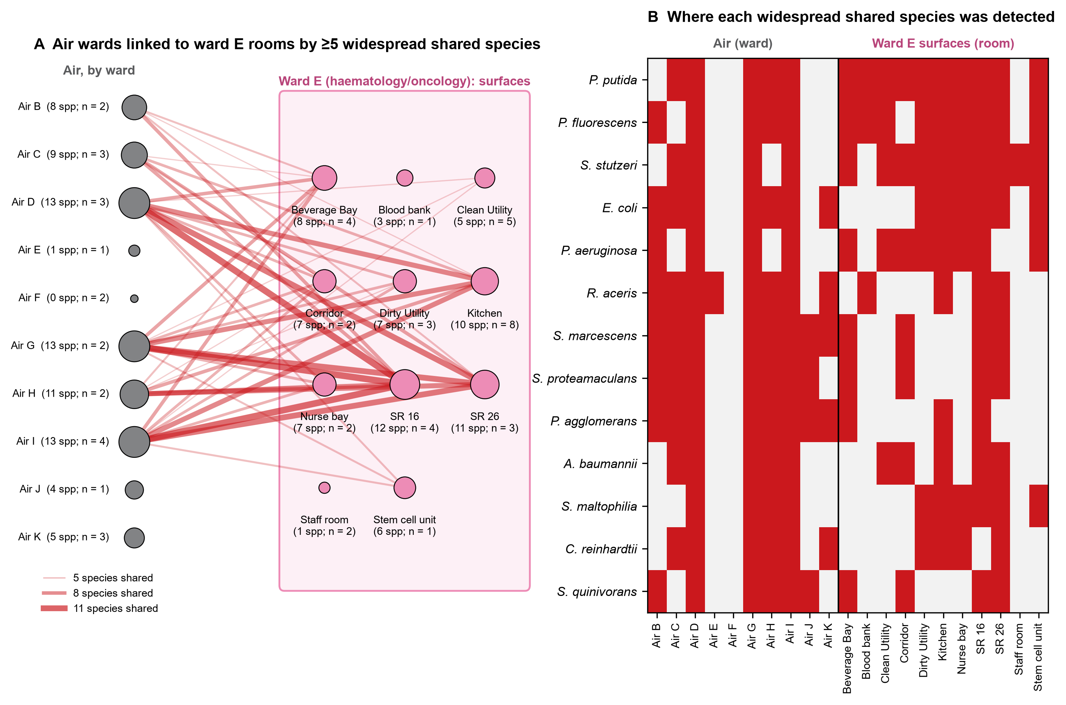
Figure 2. Where the widespread shared species occur in the hospital (schematic; positions are not to scale). (A) Air samples grouped by ward (left) and ward E surface samples grouped by room (right); node size is the number of widespread shared species detected; lines join an air ward and a ward E room that share at least five of them, with line width proportional to the number shared; n is the number of samples. (B) Presence of each widespread shared species per air ward and per ward E room.
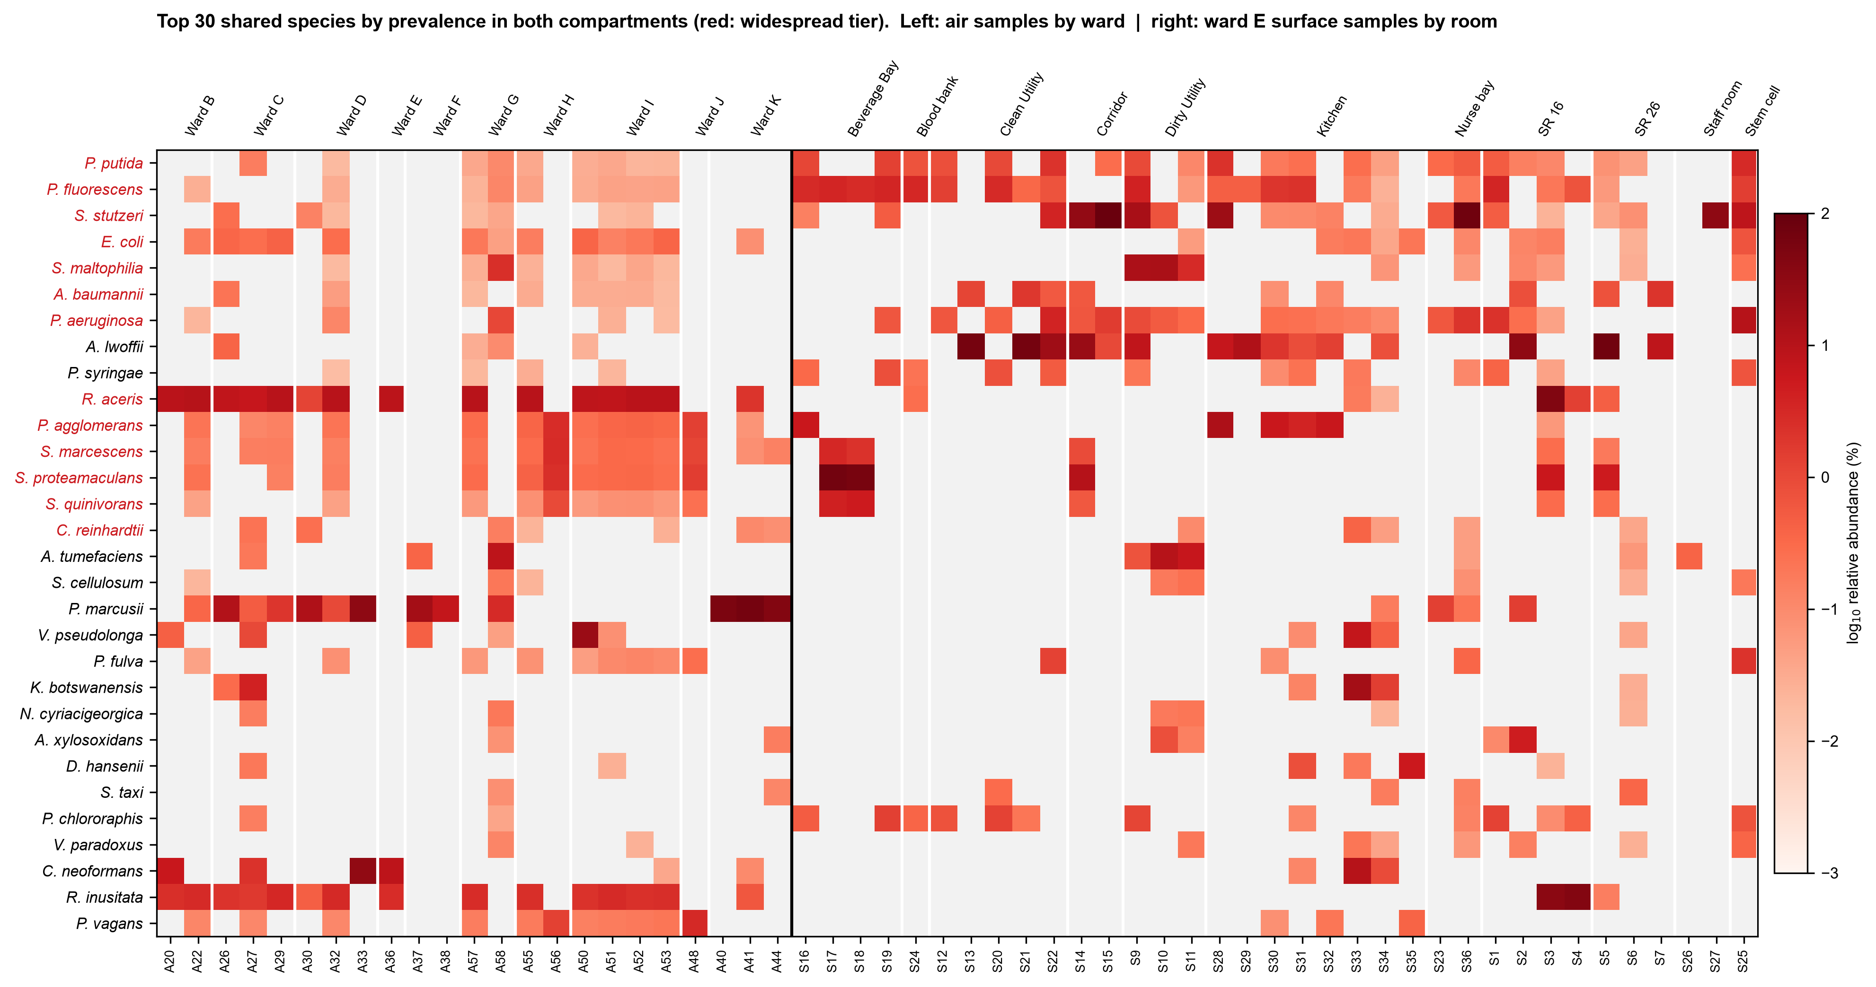
Figure 3. Relative abundance of the 30 shared species with the highest prevalence in both compartments, per sample. Air samples are grouped by ward (left) and ward E surface samples by room (right); grey cells mark no detection (≤10 reads). Species names in red are the 13 widespread shared species; the other 17 belong to the recurrent tier.
Table 1. The 13 widespread shared species
Species | Air samples (of 23) | Surface samples (of 35) | Mean abundance air / surface (%) | ARG / VF / MGE | Example genes
Pseudomonas fluorescens | 9 | 23 | 0.02 / 1.05 | 0 / 6 / 0 | PA1464, fleQ, flgC, flgG, fliI, fliM
Pseudomonas putida | 9 | 22 | 0.02 / 0.46 | 1 / 9 / 0 | algR, flgG, flgI, fliG, fliI, fliM …
Stutzerimonas stutzeri | 7 | 20 | 0.02 / 7.75 | 5 / 42 / 0 | MEXE, MexF, MexK, MexW, PA1459, PA1464 …
Pseudomonas aeruginosa | 5 | 20 | 0.05 / 0.72 | 5 / 6 / 0 | ANT(2'')-Ia, ANT2-DPRIME, MexB, OXA-677, SMR, SULI …
Escherichia coli | 13 | 10 | 0.13 / 0.05 | 6 / 1 / 3 | ANT(2'')-Ia, ANT2-DPRIME, CRP, CTX, Col(Ye4449)_1, Col(pHAD28)_1 …
Acinetobacter baumannii | 8 | 9 | 0.02 / 0.23 | 2 / 0 / 0 | mphE, msrE
Stenotrophomonas maltophilia | 8 | 9 | 0.11 / 0.89 | 8 / 1 / 0 | APH(3')-IIc, APH(9)-Ic, APH3-DPRIME, EMRASM, EMRBSM, EMRCSM …
Rahnella aceris | 15 | 6 | 5.05 / 1.34 | 4 / 3 / 0 | CRP, CTX, H-NS, RAHN-1, RAHN-2, blaRAHN-3 …
Pantoea agglomerans | 13 | 6 | 0.30 / 0.98 | 2 / 5 / 0 | CRP, CTX, RAHN-1, flgH, flgI, fur …
Chlamydomonas reinhardtii | 7 | 5 | 0.04 / 0.02 | 1 / 0 / 0 | CRP
Serratia marcescens | 14 | 5 | 0.28 / 0.19 | 2 / 1 / 0 | H-NS, RAHN-1, motA
Serratia quinivorans | 10 | 5 | 0.07 / 0.30 | 1 / 0 / 0 | H-NS
Serratia proteamaculans | 11 | 5 | 0.27 / 4.18 | 1 / 4 / 1 | BLAC, CRP, Col(Ye4449)_1, SDEB, SDEX, cheY …
Caveats
- Gene–taxon links come from Kraken2 classification of element-carrying reads. Some assignments are implausible and probably reflect misclassification between related taxa or of short element-carrying reads: for example, the Rahnella RAHN-1 β-lactamase on Pantoea and Serratia reads, and the bacterial regulator CRP on a Chlamydomonas read. The element counts in Table 1 should be read with this in mind.
- Presence is based on more than 10 reads per sample; the sporadic tier is sensitive to this floor and to sequencing depth.
- Air and surfaces were not sampled symmetrically (surfaces only on ward E; one ward E air sample), so Figure 2 shows co-occurrence, not transfer.
Questions for co-authors
- Is this worth adding to the manuscript? A minimal option is one Results sentence and one Discussion sentence on the widespread shared fraction, with Figure 1 (or panels B and D) as a new supplementary figure.
- Should Figure 2 (ward linkage) and Figure 3 (heatmap) go in as well, or are they better kept for a follow-up on transmission routes?
- Is the five-sample threshold for "widespread" reasonable, or would you prefer a prevalence-based cut-off (e.g. ≥20% of samples in both)?

