MERIDIAN: a config-driven R workflow for long-read shotgun metagenomics analysis
Authors / Affiliations
Julio C. Ortega Cambara1, Piotr Cuber2, Pedro Humberto Lebre1, Hermine V Mkrtchyan1*
1Centre for Innovation in Genomics and Microbiome Sciences, School of Medicine and Bioscience, University of West London, London, United Kingdom 2Natural History Museum, London, United Kingdom
*Correspondence: Hermine Mkrtchyan — Hermine.Mkrtchyan@uwl.ac.uk
{{TODO: ORCIDs for all authors}}

Abstract
Background: Long-read shotgun metagenomics studies are often analysed using project-specific collections of manually edited R scripts, requiring repeated modifications of sample identifiers, taxonomic annotations and analysis parameters, or else rely on resource-heavy pipelines that require access to high-performance computing (HPC) infrastructure. Existing R workflows predominantly focus on short-read amplicon data or isolated analytical tasks, such as resistome profiling, leaving a gap in integrated, reproducible and sustainable solutions for long-read shotgun metagenomics. Consequently, researchers frequently rely on ad hoc scripting approaches that limit scalability, standardisation and reproducibility for efficient cross-study comparison.
Results: We present MERIDIAN (Metagenomic Evaluation of Resistance, Identity & Diversity through Integrated Analysis of Nanopore sequencing), a modular R workflow designed to standardise and automate downstream analysis of long-read metagenomic sequencing datasets. By consolidating outputs from multiple bioinformatics tools, MERIDIAN delivers a comprehensive Quarto HTML dashboard, publication-ready figures and supplementary result tables. The workflow supports end-to-end metagenomic characterisation, encompassing decontamination, TPM normalisation, taxonomic profiling, alpha and beta diversity analysis with PERMANOVA, two-level ALDEx2 differential abundance testing, and functional profiling of antimicrobial resistance (AMR), virulence and mobile genetic element repertoires. In addition, MERIDIAN infers a tripartite sample × taxon × gene network, enabling integrated interrogation of taxonomic composition and functional gene distributions. Workflow execution is controlled through a single YAML configuration file, ensuring reproducible execution without modification of source code. Each analysis automatically generates a manifest.json artefact catalogue, thereby supporting reproducibility and downstream computational integration.
Availability and Implementation. MERIDIAN is implemented in R and distributed under the MIT licence. Source code and documentation are available at https://github.com/Julio92-C/Metagenomics_pipeline_automation. This note describes release v0.1.0 (https://github.com/Julio92-C/Metagenomics_pipeline_automation/releases/tag/v0.1.0). Reproducible execution is supported through the R environment package renv; after restoring dependencies with renv::restore(), the pipeline is launched with Rscript run_pipeline.R config.yaml.
Corresponding author: Hermine.Mkrtchyan@uwl.ac.uk

1 Introduction
Long-read shotgun metagenomics, enabled by Oxford Nanopore and PacBio sequencing technologies, is central to One Health surveillance, where the emergence and dissemination of biological threats occur at the interface of human, animal and environmental systems [1]. Unlike targeted approaches, shotgun metagenomics enables simultaneous characterisation of microbial community composition and functional genetic content, thereby linking taxonomic identity to antimicrobial resistance genes (ARGs), virulence factors (VFs) and mobile genetic elements (MGEs) within a single experiment. This capability is particularly valuable for tracking the ecology and transmission of high-risk microorganisms and their associated genetic determinants across clinical, agricultural and environmental reservoirs. The downstream analysis supporting long-read metagenomics is now well established. Widely adopted tools include Kraken2 [2] and Bracken [3] for taxonomic classification and abundance estimation, ABRicate [4] for screening ARGs, VFs and MGEs against databases such as CARD [5], VFDB [6] and PlasmidFinder [7], Re-centrifuge [8] for contamination assessment, and R packages including vegan [9] and ALDEx2 [10] for ecological and differential abundance analyses. However, while these tools are individually well established, their integration into reproducible and reusable workflows remains limited.
In practice, downstream analyses continue to rely on a set of bespoke R scripts that have evolved incrementally over successive projects. These scripts frequently contain hard-coded input paths, sample-identifier filters embedded as literal strings, per-study negative-control renames, and taxonomy fixes patched by row index. As a result, individual script copies diverge over time, reducing reproducibility and limiting portability, and the absence of a shared interface prevents automated output logging. Comparing different studies requires manual reconciliation of both code and data. The reference cohort for the present work (Chicken Batch 1; ~46 hand-edited scripts) exemplifies this pattern. The L-ARRAP pipeline [11] provides a framework for long-read resistome risk assessment, while the rANOMALY workflow [12] demonstrates the advantages of a configuration-driven R workflow with auto-generated reports for amplicon data. To our knowledge, no integrated end-to-end R workflow covers long-read shotgun metagenomic data spanning taxonomic composition, microbial diversity, differential abundance, and comprehensive resistome–virulome–mobilome profiling in a single configurable run.
To address this gap, we have developed an alpha-stage R workflow. Here, we describe the workflow's design, current scope, and the real-data validation strategy enabling the assessment of its performance.

2 Implementation
The workflow is implemented as a stand-alone R project, rather than an installable software package. Execution is initiated through a single entry script (run_pipeline.R) that reads one YAML configuration file for each study and dispatches the workflow across fifteen modules (R/00_setup.R through R/13_panels.R; plus the manifest stage R/14, which runs last). A Quarto dashboard template (templates/report.qmd) renders all outputs into a single multi-page HTML deliverable. A subsequent publication-panels stage assembles publication-ready composite figures for the main and supplementary datasets and compiles the accompanying supplementary tables into a workbook. The pipeline concludes with the generation of a final manifest.json file, providing a complete record of all artefacts produced (Figure 1).
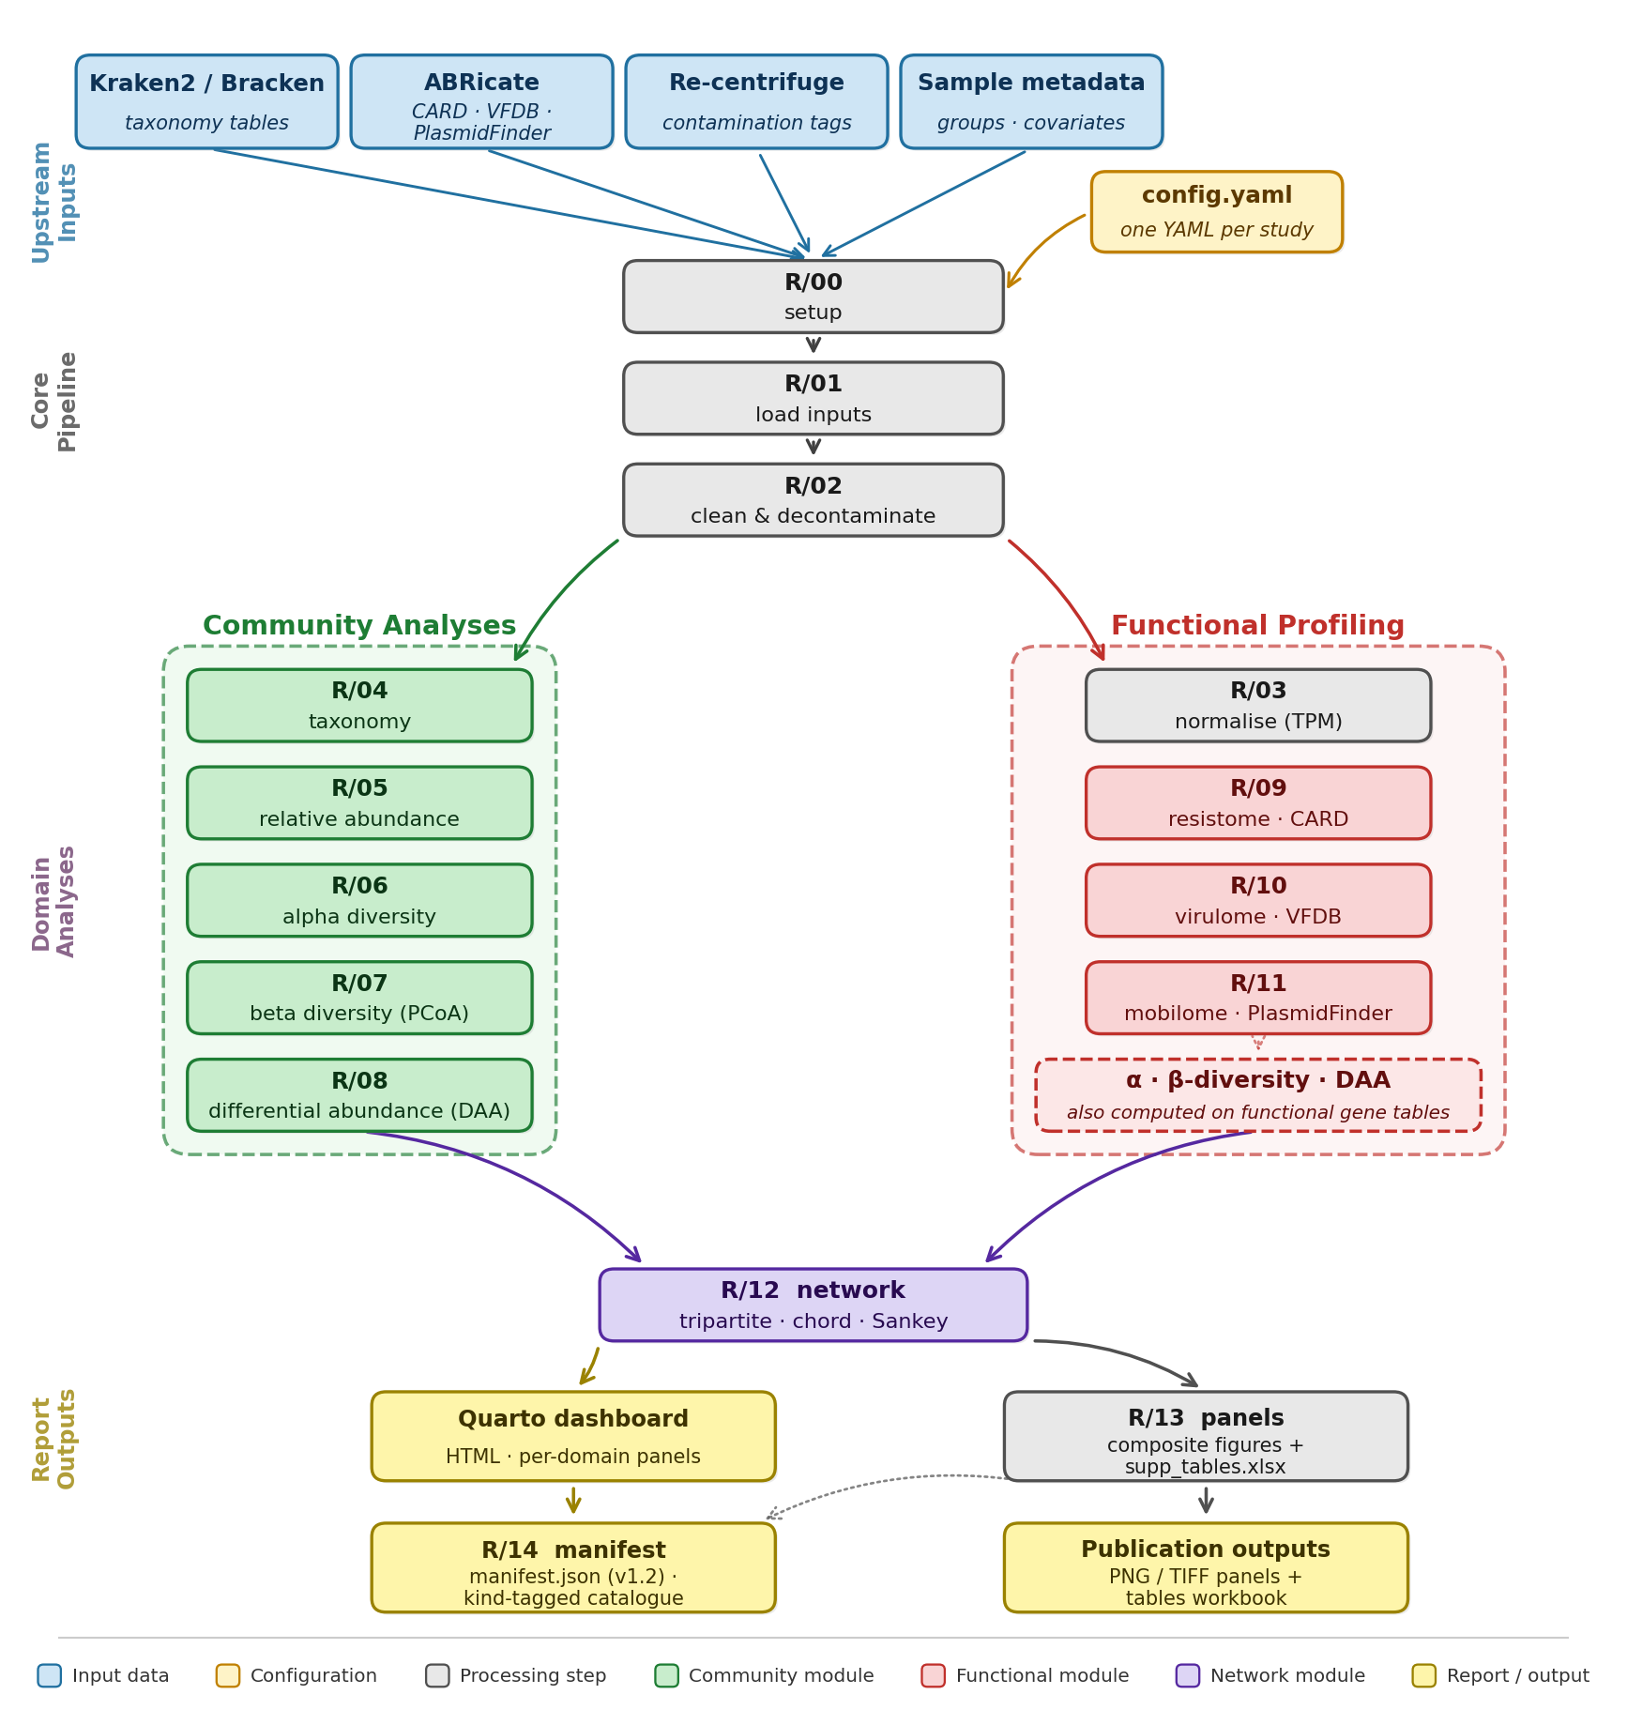
Configuration-driven. All study-specific parameters — metadata file locations, sample grouping variables, negative-control identifiers, abundance filtering thresholds, and sample selection criteria — are defined in config.yaml. Consequently, module code remains invariant across projects, with dataset-specific customisation implemented exclusively through config.yaml settings or the structured fix tables it references. R/00 (setup) and R/01 (input loading) are executed by default, whereas all downstream modules can be selectively enabled or disabled via cfg$stages$* flags; for example, users can re-run only the resistome modules after revising thresholds. TPM normalisation (R/03) and all gene-element stages (R/09–R/11) are contingent upon ABRicate outputs and are automatically omitted when such inputs are absent. Study-specific corrections to NCBI taxonomy assignments, where required, are encoded in a structured taxid_fixes.csv table rather than implemented as row-index edits. Multiple-testing correction is controlled through the cfg$stats$padjust_method parameter, ensuring consistent application of the selected adjustment throughout the pipeline. The Benjamini-Hochberg false discovery rate is used by default, although alternative correction methods are supported and documented in docs/STATISTICS.md.
Stages. The pipeline is organised into five conceptual stages.
(1) Data input and decontamination (R/00–R/02). The pipeline imports upstream outputs — Kraken2/Bracken, ABRicate, Re-centrifuge contamination tags and study metadata tables — accommodating per-project input shapes rather than assuming a fixed column layout, applies optional negative-control subtraction, merges Bracken counts with the metadata covariates declared in cfg$metadata$fixed_effects / random_effect, and links ABRicate calls to taxonomic assignments. Per-study taxonomy patches are applied from taxid_fixes.csv when supplied.
(2) Gene-element normalisation (R/03) computes per-(sample, GENE) TPM based on ABRicate hit counts and annotated gene lengths.
(3) Community analyses (R/04–R/08) cover the standard taxonomic toolkit. Following standardisation and cleaning of shared taxon names, R/04–R/05 generate Venn diagrams, annotated heatmaps, and top-N stacked-bar relative-abundance plots (static PNG and interactive plotly HTML) with paired total-count and sample-prevalence panels. Alpha diversity (R/06) reports Shannon, Simpson, richness, Pielou, and Fisher metrics with Kruskal-Wallis tests and violin/bar plots, preferring a pre-computed indices CSV (e.g., Oxford Nanopore wf-metagenomics output) and falling back to the vegan R package. Beta diversity (R/07) assesses between-sample community differences using PCoA on Hellinger-transformed Bray-Curtis distances with PERMANOVA (adonis2, 9999 permutations) and PERMDISP (betadisper) overlaid on the ordination. Differential abundance analysis (R/08) is performed at both the taxonomic and functional level using ALDEx2: taxonomic analysis uses Bracken counts, whereas gene-level analysis uses ABRicate contig hits per (sample, GENE). The workflow combines an omnibus Kruskal-Wallis test with pairwise Welch's t-tests, with an optional aldex.glm design path for covariate-adjusted models. This compositional approach is deliberate: ALDEx2 models counts through a centred log-ratio (CLR) transformation, which accounts for the compositional nature of sequencing data and avoids the spurious correlations that arise when raw or total counts are compared directly [10]; gene-level features are additionally length-normalised as TPM (R/03) so that genes of differing length remain comparable.
(4) Functional profiling (R/09–R/11) runs a shared analysis engine three times against domain-specific databases: (i) resistome profiling using ABRicate/CARD annotations, including drug-class classification; (ii) virulome profiling using VFDB, with functional categories extracted from the ABRicate PRODUCT field; (iii) mobilome profiling using PlasmidFinder, incorporating configurable replicon-family classification (Col-like, IncF, IncX, other Inc). For each domain, the pipeline generates alpha diversity metrics, Venn diagrams, gene- and category-level heatmaps, relative-abundance and total-count panels, and a PCoA + PERMANOVA + PERMDISP suite.
(5) Integration, reporting and manifest (R/12–R/14). The final stage integrates results across all domains and produces the reporting outputs. R/12 reports igraph topology metrics (degree, betweenness, Louvain modularity) alongside its network, chord and Sankey outputs, and exports Gephi-compatible node/edge tables. R/13 assembles main and supplementary composite figures (PNG and TIFF independently toggleable) driven by a slot-YAML layout, plus supplementary_tables.xlsx. R/14 writes manifest.json (contract v1.2), a kind-tagged catalogue of every figure, table and intermediate artefact the pipeline produced, providing a stable contract for downstream integration.
Reporting. Results are rendered through a Quarto template as a multi-page HTML dashboard containing dedicated panels for taxonomy, diversity, differential abundance, resistome, virulome, mobilome and network, plus embedded download links. Dependencies are pinned via renv, and the project requires R ≥ 4.5; external command-line tools (Kraken2, Bracken, ABRicate, Re-centrifuge) are assumed to have been run upstream. Because MERIDIAN consumes these pre-computed outputs rather than the raw reads, its own footprint is modest and single-threaded (peaking at ~1.5 GB; Section 3), and is therefore decoupled from the substantial memory required by upstream taxonomic classification (for example, a full Kraken2 database), which can be run separately on high-memory or cloud infrastructure.

3 Application and Validation
We validated the pipeline against two long-read chicken caecum metagenomic studies. The primary dataset (Chicken batch 1, PC_JC_2024-11-29; 18 samples; 3 dietary groups — Dulse, Reference diet, Soyabean meal) is publicly available under NCBI BioProject PRJNA1406192 and has approximately 46 hand-edited R scripts with corresponding validated figures and tables, so each stage can be compared output-for-output against the corresponding ground-truth artefact. The second dataset (Chicken batch 2, JC_FL_2025-05-20; 32 samples), for which public release is pending publication of the associated study, was used for scalability and feature coverage: samples were organised into a 4-level composite Treatment_Bird grouping (Control_W4, Control_W5, Dulse_W4, Dulse_W5) with a random effect (block, pens 1–8), two declared negative controls (CTRL1, CTRL2), and a larger per-stage feature load. Two purpose-built validation scripts (scripts/diff_normdata.R and scripts/probe_taxid_parse.R) provide numerical-diff and regression checks on the most error-prone intermediates, and run_pipeline.R auto-instruments per-stage wall time and peak R-process memory (via a gc()-bracketed wrapper equivalent to the peakRAM methodology) and prints a slowest-first breakdown to the run log.
Table 1. Per-stage primary output on the two validation cohorts (B1 = Chicken batch 1, n=18; B2 = Chicken batch 2, n=32). Same statistical settings (PERMANOVA 9999 permutations, ALDEx2 mc.samples = 128); 2026-06-23 sequential run.
Stage | B1 primary output | B2 primary output
load_inputs | 5 upstream tables parsed | 5 upstream tables parsed
clean_data | taxid_fixes.csv applied; no controls declared | no taxid_fixes.csv; 2 controls (CTRL1, CTRL2) subtracted
normalisation | gene-element TPM table written | gene-element TPM table written
taxonomy | 2,971 / 11,196 (taxon, sample) rows kept (count ≥ 5) | 5,570 / 6,549 (taxon, sample) rows kept
relative_abundance | 1,700 / 72,152 rows kept (count > 17); top-50 + Others | 7,557 / 18,073 rows kept; top-50 + Others
alpha_diversity | 9 metrics × 18 samples; KW per metric | 9 metrics × 32 samples; KW per metric
beta_diversity | PERMANOVA R² = 0.145, p = 0.22; PERMDISP p = 0.027 | PERMANOVA R² = 0.121, p = 0.15; PERMDISP p = 0.053
differential_abundance | 31 taxa + 157 gene features; 3 pairwise contrasts | 53 taxa + 221 gene features; 6 pairwise contrasts
resistome (CARD) | 348 rows / 85 genes / 18 drug classes | 648 rows / 99 genes / 20 drug classes
virulome (VFDB) | 320 rows / 140 genes / 6 VF functions (17 / 18 samples) | 492 rows / 156 genes / 8 VF functions (26 / 32 samples)
mobilome (PlasmidFinder) | 65 rows / 10 replicons / 3 families | 137 rows / 25 replicons / 5 families
network | 247 edges, 100 nodes (18 + 42 + 40); modularity = 0.31 | 576 edges, 210 nodes (32 + 77 + 101); modularity = 0.40
panels | main + supplementary composite figures (PNG / TIFF) + supplementary_tables.xlsx | main + supplementary composite figures (PNG / TIFF) + supplementary_tables.xlsx
manifest | manifest.json (contract v1.2; 85 kB) | manifest.json (contract v1.2; 80 kB)
report | Quarto dashboard HTML (~14 MB) | Quarto dashboard HTML (~18 MB)
Across both datasets (Table 1), every enabled stage produced its expected primary artefact under identical settings. Feature counts scale with cohort size and grouping complexity: B2 (n=32, 4-level Treatment_Bird) yields ~1.5–2× the resistome (648 vs 348 rows), virulome (492 vs 320) and mobilome (137 vs 65) rows of B1, with 53 vs 31 differentially abundant taxa across 6 vs 3 pairwise contrasts and a denser integrated network (576 edges/210 nodes/modularity 0.40 vs 247/100/0.31). The pipeline closes cleanly on both runs, producing a contract-v1.2 manifest.json (~80–85 kB) and a Quarto HTML dashboard (~14–18 MB). The performance profile (Figure 2) illustrated that the end-to-end runtime grew from 6m 41s on B1 to 8m 19s on B2 (+24 %, sublinear in both sample count and pairwise-contrast count), dominated on both cohorts by ALDEx2 differential abundance (32 % of B1 total, 40 % of B2). Peak R-process memory tracks the same monotone profile, climbing through the gene-element domains as the joint long-form (sample × gene) tables grow (~1 GB plateau) and tops out during R/13 panel assembly (1.33 GB on B1, 1.51 GB on B2), where every domain's PNGs and tables are loaded simultaneously to lay out; the report stage's modest peak (~0.6 GB) reflects work delegated to the external Quarto process.
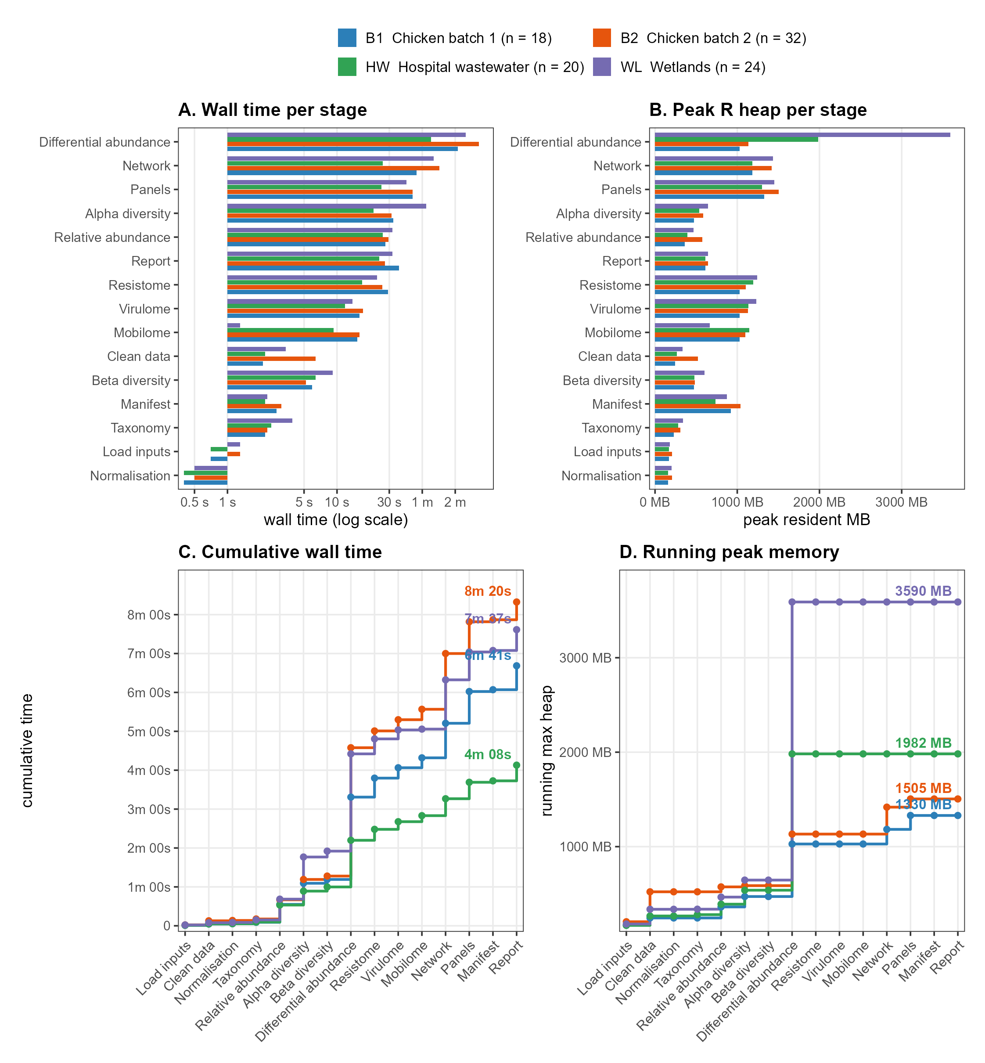

One anticipated and deliberate discrepancy arises at the resistome stage: the ground-truth cleanData.R misparses taxids carrying variant suffixes, dropping the corresponding ABRicate rows. R/02 corrects this parsing issue, so the pipeline retains 110 additional (sample, GENE) rows relative to the hand-edited output (scripts/diff_normdata.R on the 2026-06-23 B1 run: pipeline = 733 rows, ground truth = 623; 121 rows recovered by the parsing correction, and 11 rows present in the ground truth that the pipeline currently drops, concentrated in a handful of plasmid replicon and accessory resistance calls, queued for inspection rather than treated as a regression). Jaccard agreement on the (sample, GENE) key set is 0.82. For other stages with directly comparable ground-truth artefacts, sample-set agreement is exact for alpha diversity (18/18), and Jaccard for the network Gephi exports against the most recent hand-edited snapshot is 0.85 (nodes) and 0.87 (edges). Per-stage comparisons against the remaining hand-edited artefacts — taxonomy, beta diversity, and differential abundance — are deferred to a separate validation effort. The Re-centrifuge column-slicing heuristic in R/02 is acknowledged as still coarse and is queued for rework.
To assess portability beyond the development cohorts, we applied MERIDIAN unmodified — changing only config.yaml — to two independent, publicly available long-read (ONT) metagenomic studies spanning the One Health continuum: hospital wastewater versus tap water from five Egyptian hospitals (NCBI BioProject PRJNA1266479; 20 samples) and anthropogenically impacted versus natural wetland sites along the East Atlantic Flyway (ENA BioProject PRJEB96272; 24 samples). Both cohorts completed all fifteen stages in a single run (4m 08s and 7m 37s; peak 2.0 and 3.6 GB), each emitting a Quarto dashboard, publication panels and a contract-v1.2 manifest.json. The pipeline recovered biologically coherent structure: hospital wastewater was significantly richer and compositionally distinct from tap water (PERMANOVA R² = 0.18, p = 3 × 10⁻⁴), and wetland virulence-factor load was higher at anthropogenically impacted than natural sites across the flyway (PERMANOVA R² = 0.088, p_adj = 0.037; functional profiles available for 23 of 24 samples). Both datasets also exercised edge cases absent from the chicken cohorts — a single-group resistome/mobilome in the hospital cohort (tap water carried essentially no ARGs) and an absence of plasmid replicons in the wetland water (PlasmidFinder), consistent with the source study — which the pipeline handled by skipping the affected sub-analyses with logged notices rather than failing. As these datasets lack hand-curated ground-truth artefacts, they demonstrate portability and robustness across sample types rather than output-for-output correctness.
Table S1. MERIDIAN applied across four long-read metagenomic cohorts spanning the One Health continuum. B1/B2 are the poultry development cohorts; the Egyptian hospital-wastewater and East Atlantic Flyway wetland cohorts are independent public datasets analysed with configuration changes only.
Cohort | One Health axis | n | Primary contrast | Runtime | Peak RAM | Headline result
Chicken batch 1 | Livestock (poultry caecum) | 18 | Diet (3 groups) | 6m 41s | 1.33 GB | Ground-truth reference; R/02 parsing fix recovers 110 (sample, GENE) rows
Chicken batch 2 | Livestock (poultry caecum) | 32 | Treatment × week (4-level) | 8m 19s | 1.51 GB | Sublinear scaling; denser integrated network
Hospital wastewater (EG) | Human-clinical + built environment | 20 | Wastewater vs tap water | 4m 08s | 1.98 GB | Wastewater richer and compositionally distinct (PERMANOVA R² = 0.18, p = 3 × 10⁻⁴)
Wetlands (E. Atlantic Flyway) | Wildlife + environment | 24 | Impacted vs natural | 7m 37s | 3.59 GB | Higher virulome load at impacted sites (PERMANOVA R² = 0.088, p_adj = 0.037)

4 Conclusion
MERIDIAN integrates community analyses, functional profiling, and an integrated network reconstruction into a single configuration-driven R workflow for long-read shotgun metagenomics. Single-thread end-to-end execution completes in minutes with a low memory footprint, scaling sublinearly with cohort size and grouping complexity. Beyond the development cohorts, it has been applied without modification to two independent public cohorts spanning the One Health continuum (hospital wastewater and wetland surveillance). It is currently under active development, and we are releasing this alpha version (v0.1.0) to solicit feedback from researchers conducting comparable long-read metagenomic studies and to guide future development of the workflow.

Acknowledgements. The authors thank the Centre for Innovation in Genomics and Microbiome Sciences (CIGMiS), which generated the chicken caecum metagenomics datasets used to develop and validate the pipeline. We are grateful to colleagues for feedback on the configuration interface and Quarto report layout, and to the School of Medicine and Bioscience at the University of West London for hosting the project. [Optional: compute providers — e.g. UWL / UCL HPC, cloud credits.]
Funding. This study was funded by a Vice-Chancellor scholarship provided by the University of West London.
Conflict of Interest. The authors declare that they have no competing interests.
Data Availability. Sequence data for the primary validation cohort (Chicken batch 1) are available from NCBI under BioProject PRJNA1406192. Data for the second cohort (Chicken batch 2) will be released upon publication of the associated study. The MERIDIAN source code, documentation and configuration examples are available at https://github.com/Julio92-C/Metagenomics_pipeline_automation (release v0.1.0).

References
- Al-Khalaifah H, Rahman MH, Al-Surrayai T, Al-Dhumair A, Al-Hasan M. A One-Health Perspective of Antimicrobial Resistance (AMR): Human, Animals and Environmental Health. Life (Basel) 2025;15(10):1598. doi:10.3390/life15101598.
- Wood DE, Lu J, Langmead B. Improved metagenomic analysis with Kraken 2. Genome Biol 2019;20:257. doi:10.1186/s13059-019-1891-0.
- Lu J, Breitwieser FP, Thielen P, Salzberg SL. Bracken: estimating species abundance in metagenomics data. PeerJ Comput Sci 2017;3:e104. doi:10.7717/peerj-cs.104.
- Seemann T. ABRicate: mass screening of contigs for antimicrobial and virulence genes. https://github.com/tseemann/abricate (accessed 2026-06-23).
- Alcock BP, Huynh W, Chalil R, Smith KW, Raphenya AR, Wlodarski MA, et al. CARD 2023: expanded curation, support for machine learning, and resistome prediction at the Comprehensive Antibiotic Resistance Database. Nucleic Acids Res 2023;51:D690–D699. doi:10.1093/nar/gkac920.
- Liu B, Zheng D, Zhou S, Chen L, Yang J. VFDB 2022: a general classification scheme for bacterial virulence factors. Nucleic Acids Res 2022;50:D912–D917. doi:10.1093/nar/gkab1107.
- Carattoli A, Zankari E, García-Fernández A, Voldby Larsen M, Lund O, Villa L, et al. In silico detection and typing of plasmids using PlasmidFinder and plasmid multilocus sequence typing. Antimicrob Agents Chemother 2014;58:3895–3903. doi:10.1128/AAC.02412-14.
- Martí JM. Recentrifuge: robust comparative analysis and contamination removal for metagenomics. PLoS Comput Biol 2019;15:e1006967. doi:10.1371/journal.pcbi.1006967.
- Oksanen J, Simpson G, Blanchet F, Kindt R, Legendre P, Minchin P, et al. vegan: Community Ecology Package. R package version 2.7-3, 2026. doi:10.32614/CRAN.package.vegan.
- Fernandes AD, Reid JN, Macklaim JM, McMurrough TA, Edgell DR, Gloor GB. Unifying the analysis of high-throughput sequencing datasets: characterizing RNA-seq, 16S rRNA gene sequencing and selective growth experiments by compositional data analysis. Microbiome 2014;2:15. doi:10.1186/2049-2618-2-15.
- Li Y, Gao Y, Liu X, Mao Y, Wang M, Qin Y, et al. Quantifying antibiotic resistome risks across environmental niches: the L-ARRAP for long-read metagenomic profiling. Brief Bioinform 2025;26(5):bbaf535. doi:10.1093/bib/bbaf535.
- Theil S, Rifa E. rANOMALY: AmplicoN wOrkflow for Microbial community AnaLYsis. F1000Res 2021;10:7. doi:10.12688/f1000research.27268.1.
- Allaire JJ, et al. Quarto. https://quarto.org (accessed 2026-06-23).
- R Core Team. R: A Language and Environment for Statistical Computing (version 4.5.0). R Foundation for Statistical Computing, Vienna, 2025. https://www.R-project.org/.
- Pedersen TL. ggraph: An Implementation of Grammar of Graphics for Graphs and Networks. R package version 2.2.2, 2025. doi:10.32614/CRAN.package.ggraph.
- Csárdi G, Nepusz T. The igraph software package for complex network research. InterJournal 2006;Complex Systems:1695. R package version 2.3.1; doi:10.5281/zenodo.7682609. https://igraph.org.
- Allaire JJ, Gandrud C, Russell K, Yetman C. networkD3: D3 JavaScript Network Graphs from R. R package version 0.4.1, 2025. doi:10.32614/CRAN.package.networkD3.

