MERIDIAN: a config-driven R workflow for long-read shotgun metagenomics analysis
Authors / Affiliations
Julio C. Ortega Cambara¹, Piotr Cuber⁴ , Pedro Humberto Lebre¹, Raju Misra², Timothy D. McHugh³, Sylvia Rofael³, David Lowe³, Hermine Mkrtchyan^{1*}
¹School of Biomedical Science, University of West London, London, United Kingdom, ²UK Health Security Agency, London, United Kingdom, ³Centre for Clinical Microbiology, University College London, London, United Kingdom, ⁴Natural History Museum, London, United Kingdom
*Correspondence: Hermine Mkrtchyan — Hermine.Mkrtchyan@uwl.ac.uk
{{TODO: ORCIDs for all authors}}

Abstract
Motivation. Long-read shotgun metagenomics studies typically use several manually-built R scripts that are not easily integrated together into a cohesive workflow, or rely on resource-heavy pipelines that require access to an HPC. Additionally. existing R workflows largely target short-read amplicon data or a single analysis (e.g. resistome risk scoring), leaving long-read shotgun studies with a dearth of integrated, configuration-driven, and sustainable alternatives.
Results. We present MERIDIAN (Metagenomic Evaluation of Resistance, Identity & Diversity through Integrated Analysis of Nanopore sequencing), a modular R workflow that consumes bioinformatics tools outputs and produces a single Quarto HTML dashboard, publication-ready composite figures and a supplementary tables workbook. The workflow covers decontamination, TPM normalisation, taxonomy, alpha/beta diversity with PERMANOVA, two-level ALDEx2 differential abundance, resistome, virulome, and mobilome profiling, and a tripartite sample × taxon × gene network reconstruction. A study is parameterised by a single YAML file; module code is not edited per project, and every run emits a manifest.json artefact catalogue for downstream integration.
Availability and Implementation. Source at https://github.com/Julio92-C/Metagenomics_pipeline_automation (MIT). This note describes release v0.1.0 (https://github.com/Julio92-C/Metagenomics_pipeline_automation/releases/tag/v0.1.0). Run with `git clone --branch v0.1.0 && Rscript run_pipeline.R config.yaml after renv::restore().
Contact. Hermine.Mkrtchyan@uwl.ac.uk

1 Introduction
Long-read shotgun metagenomics (Oxford Nanopore, PacBio) is increasingly central to One Health surveillance, where threats intersect humans, animals and ecosystems [1]. By profiling microbial communities and their functional genetic elements in a single experiment, it links taxonomic identity to determinants of resistance, virulence, and mobility across environmental, clinical, and livestock matrices. The downstream analysis stack is well established — Kraken2 [2] and Bracken [3] for taxonomic assignment and abundance estimation, ABRicate [4] for screening antimicrobial resistance genes (ARGs), virulence factors (VFs) and mobile genetic elements (MGEs) against CARD [5], VFDB [6] and PlasmidFinder [7], Re-centrifuge [8] for contamination assessment, and R packages such as vegan [9] and ALDEx2 [10] for ecological and differential analyses — but the integration between them is not.
In practice, each new study is analysed by adapting a set of bespoke R scripts: hard-coded input paths, sample-identifier filters embedded as literal strings, per-study negative-control renames, and taxonomy fixes patched by row index. Consequently, individual script copies diverge, and the lack of a shared interface prevents automated output logging. Comparing different studies requires manual reconciliation of both code and data. The reference cohort for the present work (Chicken Batch 1; ~46 hand-edited scripts) typifies this pattern. The L-ARRAP pipeline [11] addresses one slice of this problem for long-read resistome risk assessment, and the rANOMALY workflow [12] demonstrates the value of a config-driven R workflow with auto-generated reports for amplicon data. To our knowledge, no comparable workflow exists for end-to-end long-read shotgun metagenomics that covers taxonomy, diversity, differential abundance, and full resistome–virulome–mobilome profiling in a single configurable run.
We present an alpha-stage R workflow that fills this gap. The tool is in active development; this note describes its design, current scope, and the real-data validation strategy we are using to harden each stage.

2 Implementation
The workflow is a stand-alone R project, not an installable package. A single entry point (run_pipeline.R) consumes one YAML configuration file per study and dispatches to fifteen modules (R/00_setup.R through R/13_panels.R; plus the manifest stage R/14 which runs last); a Quarto dashboard template (templates/report.qmd) renders all outputs into a single multi-page HTML deliverable, a publication-panels stage assembles main and supplementary composite figures plus a supplementary tables workbook, and a final manifest stage emits manifest.json describing every artefact produced (Figure 1).
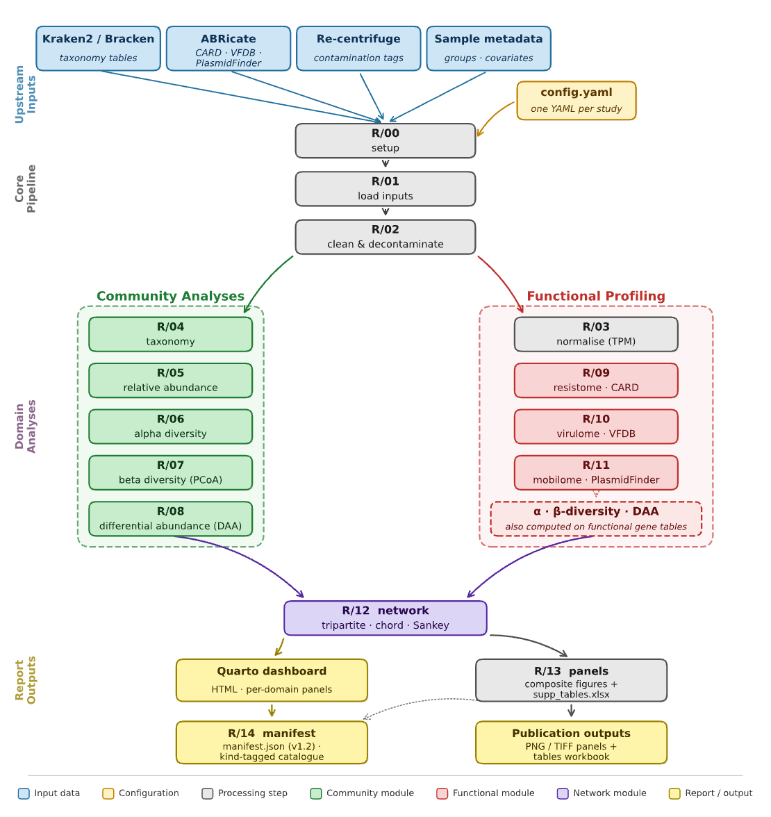
Figure 1. MERIDIAN workflow. A single config.yaml drives fifteen R modules (R/00–R/14) that consume Kraken2/Bracken, ABRicate, Re-centrifuge, and sample metadata. After setup and decontamination (R/00–R/02), community analyses (R/04–R/08) and functional profiling against CARD, VFDB and PlasmidFinder (TPM in R/03, per-domain analyses in R/09–R/11) converge in a tripartite sample × taxon × gene network (R/12). R/12 fans out to a Quarto dashboard and a publication-panels stage (R/13); R/14 finally writes manifest.json (contract v1.2), a kind-tagged catalogue of every artefact produced.
Configuration-driven. Everything that varies between studies — metadata file path, grouping columns, negative-control identifiers, abundance thresholds, sample selection — is declared in config.yaml. Module code is not edited per-project; dataset-specific adjustments live in config.yaml or in the structured fix tables it references. R/00 (setup) and R/01 (input loading) run by default; every subsequent stage can be toggled via cfg$stages$* flags, e.g, users can re-run only the resistome modules after revising thresholds. TPM normalisation (R/03) and all gene-element stages (R/09–R/11) require ABRicate outputs and are skipped otherwise. Per-study NCBI taxonomy fixes, when needed, are declared in a structured taxid_fixes.csv rather than as row-index edits. A single cfg$stats$padjust_method knob (Benjamini-Hochberg is used by default; full list in docs/STATISTICS.md) routes every multiple-testing correction across the pipeline.
Stages. The pipeline organises its work into five conceptual blocks.
(1) Ingest and cleaning (R/00–R/02) load upstream tables — Kraken2/Bracken, ABRicate, Re-centrifuge contamination tags, study metadata — accommodating per-project input shapes rather than assuming a fixed column layout, apply optional negative-control subtraction, merge Bracken counts with the metadata covariates declared in cfg$metadata$fixed_effects / random_effect, and link ABRicate calls to taxonomic assignments. Per-study taxonomy patches are applied from taxid_fixes.csv when supplied.
(2) Gene-element normalisation (R/03) computes per-(sample, GENE) TPM from ABRicate hits and gene lengths.
(3) Community analyses (R/04–R/08) cover the standard taxonomic toolkit. R/04–R/05 produce Venn diagrams and annotated heatmaps after a shared taxa-name cleanup, plus top-N stacked-bar relative-abundance plots (static PNG and interactive plotly HTML) with paired total-count and sample-prevalence panels. Alpha diversity (R/06) reports Shannon, Simpson, richness, Pielou, and Fisher metrics with Kruskal-Wallis tests and violin/bar plots, preferring a pre-computed indices CSV (e.g., Oxford Nanopore wf-metagenomics output) and falling back to the vegan R package. Beta diversity (R/07) computes PCoA on Hellinger-transformed Bray-Curtis distances with PERMANOVA (adonis2, 9999 permutations) and PERMDISP (betadisper) overlaid on the ordination. ALDEx2 differential abundance (R/08) runs at two levels — taxa (Bracken counts) and genes (ABRicate contig hits per (sample, GENE)), combining an omnibus Kruskal-Wallis with pairwise Welch's t tests, with an optional aldex.glm design path for covariate-adjusted models.
(4) Functional profiling (R/09–R/11) runs a shared analysis engine three times against domain-specific databases: the resistome (ABRicate/CARD, with drug-class classification), the virulome (VFDB, with functional categories extracted from the ABRicate PRODUCT field) and the mobilome (PlasmidFinder, with configurable replicon-family classification — Col-like, IncF, IncX, other Inc). Each domain emits its own alpha diversity, Venn diagram, gene- and category-level heatmaps, relative-abundance and total-count panels, and a PCoA + PERMANOVA + PERMDISP suite.
(5) Integration, reporting and manifest (R/12–R/14). R/12 reports igraph topology metrics (degree, betweenness, Louvain modularity) alongside its network, chord and Sankey outputs, and exports Gephi-compatible node/edge tables. R/13 assembles main and supplementary composite figures (PNG and TIFF independently toggleable) driven by a slot-YAML layout, plus supplementary_tables.xlsx. R/14 writes manifest.json (contract v1.2), a kind-tagged catalogue of every figure, table and intermediate artefact the pipeline produced, providing a stable contract for downstream integration.
Reporting. The Quarto template renders all outputs as a multi-page HTML dashboard with per-domain panels (taxonomy, diversity, differential abundance, resistome, virulome, mobilome, network) and embedded download links. Dependencies are pinned via renv, and the project requires R ≥ 4.5; external command-line tools (Kraken2, Bracken, ABRicate, Re-centrifuge) are assumed to have been run upstream.

3 Application and Validation
We are validating the pipeline against two real long-read chicken caecum metagenomics studies. The reference cohort (Chicken batch 1, PC_JC_2024-11-29; 18 samples; 3 dietary groups — Dulse, Reference diet, Soyabean meal) has approximately 46 hand-edited R scripts and known-good figures and tables already in place, so each stage can be compared output-for-output against the corresponding ground-truth artefact. The scaling and feature-coverage cohort (Chicken batch 2, JC_FL_2025-05-20; 32 samples; 4-level composite Treatment_Bird grouping — Control_W4, Control_W5, Dulse_W4, Dulse_W5) exercises a random effect (block, pens 1–8), two declared negative controls (CTRL1, CTRL2), and a larger per-stage feature load. Two purpose-built validation scripts (scripts/diff_normdata.R and scripts/probe_taxid_parse.R) provide numerical-diff and regression checks on the most error-prone intermediates, and run_pipeline.R auto-instruments per-stage wall time and peak R-process memory (via a gc()-bracketed wrapper equivalent to the peakRAM methodology) and prints a slowest-first breakdown to the run log.
Table 1. Per-stage primary output on the two validation cohorts (B1 = Chicken batch 1, n=18; B2 = Chicken batch 2, n=32). Same statistical settings (PERMANOVA 9999 permutations, ALDEx2 mc.samples = 128); 2026-06-23 sequential run.
Stage | B1 primary output | B2 primary output
load_inputs | 5 upstream tables parsed | 5 upstream tables parsed
clean_data | taxid_fixes.csv applied; no controls declared | no taxid_fixes.csv; 2 controls (CTRL1, CTRL2) subtracted
normalisation | gene-element TPM table written | gene-element TPM table written
taxonomy | 2,971 / 11,196 (taxon, sample) rows kept (count ≥ 5) | 5,570 / 6,549 (taxon, sample) rows kept
relative_abundance | 1,700 / 72,152 rows kept (count > 17); top-50 + Others | 7,557 / 18,073 rows kept; top-50 + Others
alpha_diversity | 9 metrics × 18 samples; KW per metric | 9 metrics × 32 samples; KW per metric
beta_diversity | PERMANOVA R² = 0.145, p = 0.22; PERMDISP p = 0.027 | PERMANOVA R² = 0.121, p = 0.15; PERMDISP p = 0.053
differential_abundance | 31 taxa + 157 gene features; 3 pairwise contrasts | 53 taxa + 221 gene features; 6 pairwise contrasts
resistome (CARD) | 348 rows / 85 genes / 18 drug classes | 648 rows / 99 genes / 20 drug classes
virulome (VFDB) | 320 rows / 140 genes / 6 VF functions (17 / 18 samples) | 492 rows / 156 genes / 8 VF functions (26 / 32 samples)
mobilome (PlasmidFinder) | 65 rows / 10 replicons / 3 families | 137 rows / 25 replicons / 5 families
network | 247 edges, 100 nodes (18 + 42 + 40); modularity = 0.31 | 576 edges, 210 nodes (32 + 77 + 101); modularity = 0.40
panels | main + supplementary composite figures (PNG / TIFF) + supplementary_tables.xlsx | main + supplementary composite figures (PNG / TIFF) + supplementary_tables.xlsx
manifest | manifest.json (contract v1.2; 85 kB) | manifest.json (contract v1.2; 80 kB)
report | Quarto dashboard HTML (~14 MB) | Quarto dashboard HTML (~18 MB)
Across both cohorts (Table 1), every enabled stage produced its expected primary artefact under identical settings. Feature counts scale with cohort size and grouping complexity: B2 (n=32, 4-level `Treatment_Bird`) yields ~1.5–2× the resistome (648 vs 348 rows), virulome (492 vs 320) and mobilome (137 vs 65) rows of B1, with 53 vs 31 differentially abundant taxa across 6 vs 3 pairwise contrasts and a denser integrated network (576 edges/210 nodes/modularity 0.40 vs 247/100/0.31). The pipeline closes cleanly on both runs, producing a contract-v1.2 `manifest.json` (~80–85 kB) and a Quarto HTML dashboard (~14–18 MB). The performance profile (Figure 2) illustrated that the end-to-end runtime grew from 6m 41s on B1 to 8m 19s on B2 (+24 %, sublinear in both sample count and pairwise-contrast count), dominated on both cohorts by ALDEx2 differential abundance (32 % of B1 total, 40 % of B2). Peak R-process memory tracks the same monotone profile — climbing through the gene-element domains as the joint long-form (sample × gene) tables grow (~1 GB plateau) and tops out during R/13 panel assembly (1.33 GB on B1, 1.51 GB on B2), where every domain's PNGs and tables are loaded simultaneously to lay out); the report stage's modest peak (~0.6 GB) reflects work delegated to the external Quarto process.
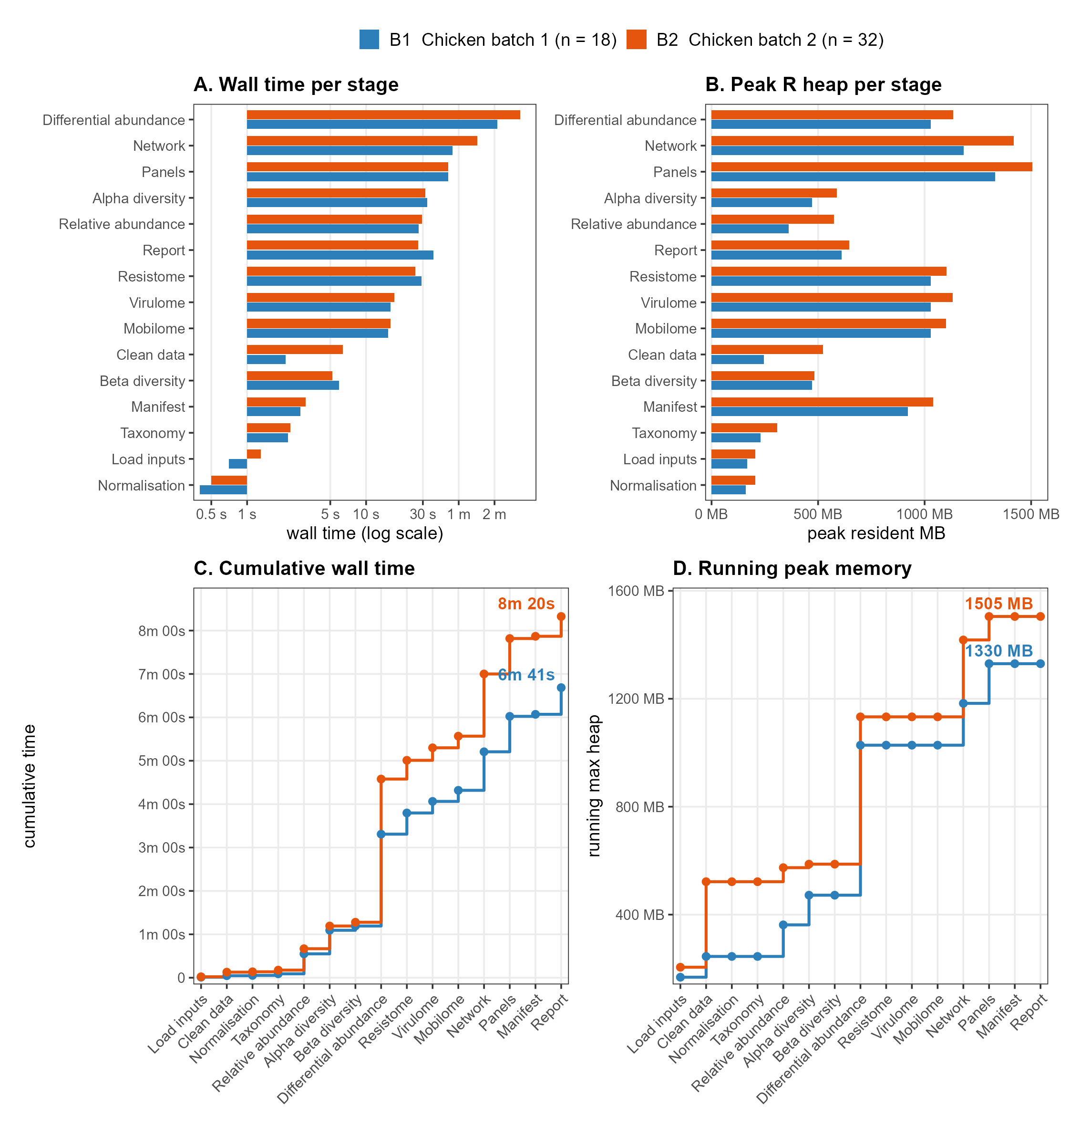
Figure 2. Pipeline performance on the two validation cohorts. (A) Per-stage wall time (log scale) and (B) peak R-process heap, sorted by B2 runtime. (C) Cumulative wall time and (D) running peak memory in pipeline order. R 4.5.0 single-thread analysis, including PERMANOVA 9999 permutations, ALDEx2 `mc.samples` = 128. B1 = Chicken batch 1 (n=18, 3 dietary groups); B2 = Chicken batch 2 (n=32, 4-level `Treatment_Bird`, `block` random effect, two negative controls)
One expected and deliberate divergence concerns the resistome stage: the ground-truth cleanData.R misparses taxids carrying variant suffixes, dropping the corresponding ABRicate rows. R/02 fixes this parsing bug, so the pipeline retains 110 additional (sample, GENE) rows relative to the hand-edited output (scripts/diff_normdata.R on the 2026-06-23 B1 run: pipeline = 733 rows, ground truth = 623; 121 rows gained by the parsing fix, 11 rows present in the ground truth that the pipeline currently drops — concentrated in a handful of plasmid replicon and accessory resistance calls, queued for inspection rather than treated as a regression). Jaccard agreement on the (sample, GENE) key set is 0.82. Across the other stages with directly comparable ground-truth artefacts, sample-set agreement is exact for alpha diversity (18/18), and Jaccard for the network Gephi exports against the most recent hand-edited snapshot is 0.85 (nodes) and 0.87 (edges). Per-stage comparisons against the remaining hand-edited artefacts — taxonomy, beta diversity, and differential abundance — are deferred to a separate validation effort. The Re-centrifuge column-slicing heuristic in R/02 is acknowledged as still coarse and is queued for rework.

4 Conclusion
MERIDIAN consolidates community analyses, functional profiling, and integrated network reconstruction into a single configuration-driven R project for long-read shotgun metagenomics. Single-thread end-to-end execution completes in minutes with a low memory footprint, scaling sublinearly with cohort size and grouping complexity. It is in active development; we are releasing this alpha-stage workflow (v0.1.0) now to invite feedback from groups running comparable analyses.

Acknowledgements. The authors thank the Centre for Innovation in Genomics and Microbiome Sciences (CIGMiS), which generated the chicken caecum metagenomics datasets used to develop and validate the pipeline. We are grateful to colleagues for feedback on the configuration interface and Quarto report layout, and to the School of Biomedical Science at the University of West London for hosting the project. [Optional: compute providers — e.g. UWL / UCL HPC, cloud credits.]
Funding. This study was funded by a Vice-Chancellor scholarship provided by the University of West London.
Conflict of Interest. The authors declare that they have no competing interests.

References
- Al-Khalaifah H, Rahman MH, Al-Surrayai T, Al-Dhumair A, Al-Hasan M. A One-Health Perspective of Antimicrobial Resistance (AMR): Human, Animals and Environmental Health. Life (Basel) 2025;15(10):1598. doi:10.3390/life15101598.
- Wood DE, Lu J, Langmead B. Improved metagenomic analysis with Kraken 2. Genome Biol 2019;20:257. doi:10.1186/s13059-019-1891-0.
- Lu J, Breitwieser FP, Thielen P, Salzberg SL. Bracken: estimating species abundance in metagenomics data. PeerJ Comput Sci 2017;3:e104. doi:10.7717/peerj-cs.104.
- Seemann T. ABRicate: mass screening of contigs for antimicrobial and virulence genes. https://github.com/tseemann/abricate (accessed 2026-06-23).
- Alcock BP, Huynh W, Chalil R, Smith KW, Raphenya AR, Wlodarski MA, et al. CARD 2023: expanded curation, support for machine learning, and resistome prediction at the Comprehensive Antibiotic Resistance Database. Nucleic Acids Res 2023;51:D690–D699. doi:10.1093/nar/gkac920.
- Liu B, Zheng D, Zhou S, Chen L, Yang J. VFDB 2022: a general classification scheme for bacterial virulence factors. Nucleic Acids Res 2022;50:D912–D917. doi:10.1093/nar/gkab1107.
- Carattoli A, Zankari E, García-Fernández A, Voldby Larsen M, Lund O, Villa L, et al. In silico detection and typing of plasmids using PlasmidFinder and plasmid multilocus sequence typing. Antimicrob Agents Chemother 2014;58:3895–3903. doi:10.1128/AAC.02412-14.
- Martí JM. Recentrifuge: robust comparative analysis and contamination removal for metagenomics. PLoS Comput Biol 2019;15:e1006967. doi:10.1371/journal.pcbi.1006967.
- Oksanen J, Simpson G, Blanchet F, Kindt R, Legendre P, Minchin P, et al. vegan: Community Ecology Package. R package version 2.7-3, 2026. doi:10.32614/CRAN.package.vegan.
- Fernandes AD, Reid JN, Macklaim JM, McMurrough TA, Edgell DR, Gloor GB. Unifying the analysis of high-throughput sequencing datasets: characterizing RNA-seq, 16S rRNA gene sequencing and selective growth experiments by compositional data analysis. Microbiome 2014;2:15. doi:10.1186/2049-2618-2-15.
- Li Y, Gao Y, Liu X, Mao Y, Wang M, Qin Y, et al. Quantifying antibiotic resistome risks across environmental niches: the L-ARRAP for long-read metagenomic profiling. Brief Bioinform 2025;26(5):bbaf535. doi:10.1093/bib/bbaf535.
- Theil S, Rifa E. rANOMALY: AmplicoN wOrkflow for Microbial community AnaLYsis. F1000Res 2021;10:7. doi:10.12688/f1000research.27268.1.
- Allaire JJ, et al. Quarto. https://quarto.org (accessed 2026-06-23).
- R Core Team. R: A Language and Environment for Statistical Computing (version 4.5.0). R Foundation for Statistical Computing, Vienna, 2025. https://www.R-project.org/.
- Pedersen TL. ggraph: An Implementation of Grammar of Graphics for Graphs and Networks. R package version 2.2.2, 2025. doi:10.32614/CRAN.package.ggraph.
- Csárdi G, Nepusz T. The igraph software package for complex network research. InterJournal 2006;Complex Systems:1695. R package version 2.3.1; doi:10.5281/zenodo.7682609. https://igraph.org.
- Allaire JJ, Gandrud C, Russell K, Yetman C. networkD3: D3 JavaScript Network Graphs from R. R package version 0.4.1, 2025. doi:10.32614/CRAN.package.networkD3.

