MPN Rounds to a number down or up
The MPN values need to be rounded to a number down or up to the nearest integer.
Example:
TM= DQMTM_Rounding_MPN
PL= DQMPL_RoundingNEREA_MPN
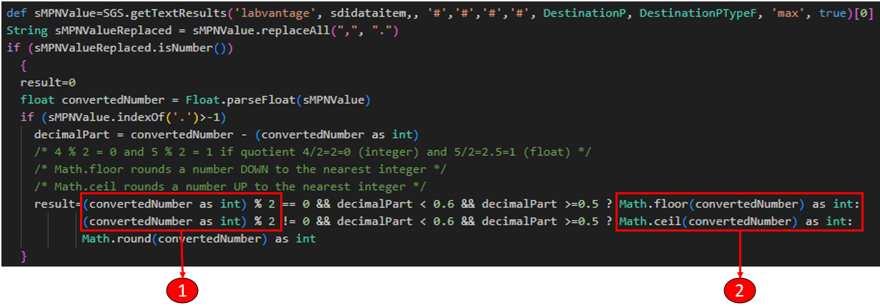
- Identifying if the MPNValue as integer divided by 2 has an integer or float
Case 1: MPNValue = 4.51 converted to integer = 4
Case 2: MPNValue = 5.51 converted to integer = 5
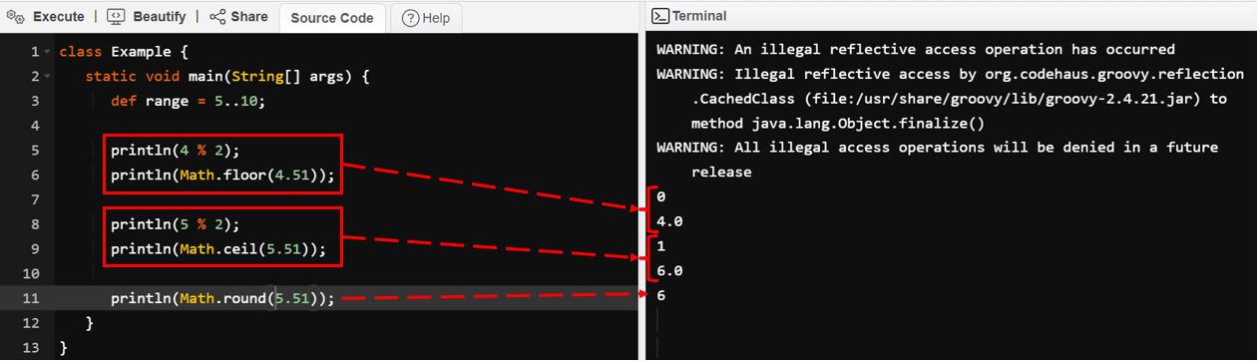
4 % 2 = 0 and 5 % 2 = 1 if quotient 4/2=2 then 0 (integer) and 5/2=2.5 then 1 (float)
When:
Case 1: 4 / 2 = 2 then Groovy operator % == 0
Case 2: 5 / 2 = 2.5 then Groovy operator % == 1}
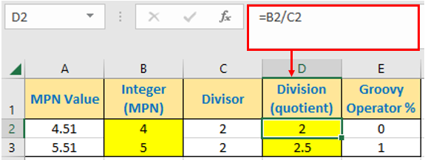

- DataEntry
Case 1:
float convertedNumber = Float.parseFloat(sMPNValue)
convertedNumber = 4.51
decimalPart = convertedNumber - (convertedNumber as int)
decimalPart = 51 = 4.51 - 4
4 % 2 == 0

Math.floor rounds a number DOWN to the nearest integer
Result = Math.floor(convertedNumber) as int
Result = Math.floor(4.51) as int = 4
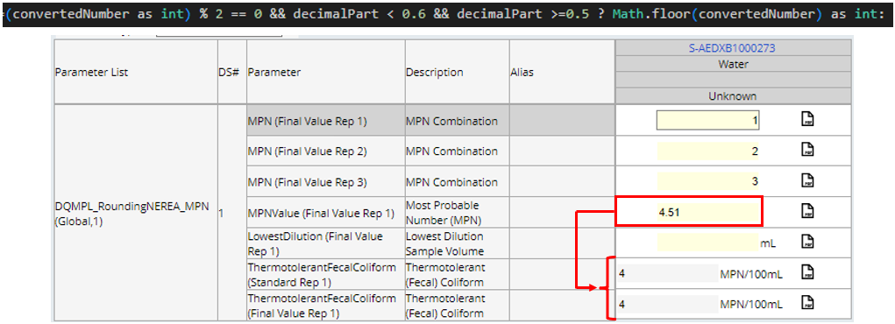

Case 2:
float convertedNumber = Float.parseFloat(sMPNValue)
convertedNumber = 5.51
decimalPart = convertedNumber - (convertedNumber as int)
decimalPart = 51 = 5.51 - 5
5 % 2 == 1

Math.ceil rounds a number UP to the nearest integer
Result = Math. ceil (convertedNumber) as int
Result = Math. ceil (5.51) as int = 6
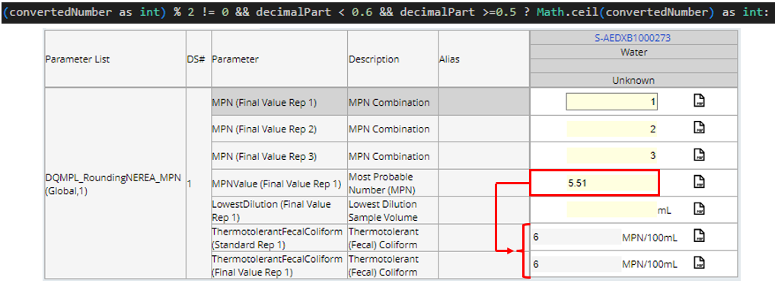

Source:
https://www.tutorialspoint.com/groovy/groovy_operators.htm
https://www.tutorialspoint.com/groovy/groovy_floor.htm
https://www.tutorialspoint.com/groovy/groovy_ceil.htm

