w:compatSetting

2010 adds:
settings.xml
ie <w:compatSetting w:name="compatibilityMode" w:uri="http://schemas.microsoft.com/office/word" w:val="12"/>
changed to val 14.
<w:savePreviewPicture/>
thumbnail.emf
styleWithEffects part: what effect on compat?
<AppVersion>
14.0000

2013
<AppVersion>
15.0000
doesn’t add thumbnail.emf
or styleWithEffects part
settings.xml
adds
theme part: panose...
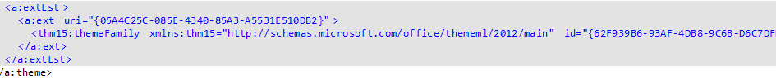

2016
<AppVersion>
16.0000
doesn’t add thumbnail.emf
or styleWithEffects part
settings.xml
<w:compatSetting w:name="compatibilityMode" w:uri="http://schemas.microsoft.com/office/word" w:val="12"/>
changed to val 15 (not 16!!)
theme is same as 2013, more or less

