Field name | Field code | Content control | Part details
Abstract |  | This document is about document properties | CoverPageProperties[1]/ns0:Abstract
Author | jharrop | jharrop | coreProperties[1]/ns0:creator
Bytes | 11501
Category |  | [Category] | coreProperties[1]/ns1:category
Characters | 257 |  | extended
CharactersWithSpaces | 260
Comments |  | [Comments] | coreProperties[1]/ns0:description
COmpany |  | [Company] | extended-properties' " w:xpath="/ns0:Properties[1]/ns0:Company
 |  | [Company Address] | CoverPageProperties[1]/ns0:CompanyAddress
 |  | [Company E-mail] | CoverPageProperties[1]/ns0:CompanyEmail
 |  | [Company Fax] | CoverPageProperties[1]/ns0:CompanyFax
 |  | [Company Phone] | CoverPageProperties[1]/ns0:CompanyPhone
CreateTime | 6/04/2013 10:20 AM |  | coreProperties
HyerlinkBase
Keywrrds |  | [Keywords] | coreProperties[1]/ns1:keywords
LastPrinted |  |  | coreProperties
LastSavedBy |  |  | coreProperties
LastSavedTime |  |  | coreProperties
Lines | 80 |  | extended
Manager |  | [Manager] | xtended-properties' " w:xpath="/ns0:Properties[1]/ns0:Manager[1
NameOfApplication | Microsoft Office Word |  | extended
ODMADocId
Pages | 1 |  | extended
Paragraphs | 35 |  | extended
 |  | [Publish Date] | CoverPageProperties[1]/ns0:PublishDate
RevisionNumber | 1 |  | coreProperties
Security | 0 |  | extended
 |  | [Status] | coreProperties[1]/ns1:contentStatus
Subject |  | [Subject] | oreProperties[1]/ns0:subject
Template | Normal.dotm |  | extended
Title |  | [Title] | coreProperties[1]/ns0:title
TotalEditingTime | 13 |  | extended
Words | 52 |  | extended

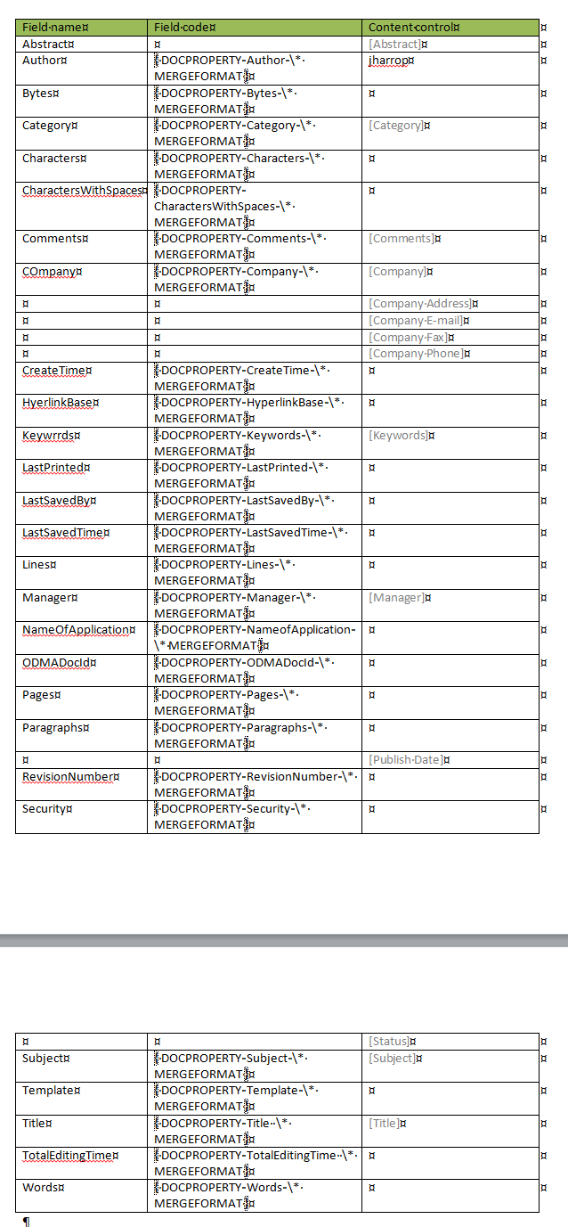

<Properties xmlns="http://schemas.openxmlformats.org/officeDocument/2006/extended-properties" xmlns:vt="http://schemas.openxmlformats.org/officeDocument/2006/docPropsVTypes">
<Template>Normal.dotm</Template>
<TotalTime>21</TotalTime>
<Pages>2</Pages>
<Words>272</Words>
<Characters>1551</Characters>
<Application>Microsoft Office Word</Application>
<DocSecurity>0</DocSecurity>
<Lines>12</Lines>
<Paragraphs>3</Paragraphs>
<ScaleCrop>false</ScaleCrop>
<HeadingPairs>
<vt:vector size="2" baseType="variant">
<vt:variant>
<vt:lpstr>Title</vt:lpstr>
</vt:variant>
<vt:variant>
<vt:i4>1</vt:i4>
</vt:variant>
</vt:vector>
</HeadingPairs>
<TitlesOfParts>
<vt:vector size="1" baseType="lpstr">
<vt:lpstr></vt:lpstr>
</vt:vector>
</TitlesOfParts>
<Company></Company>
<LinksUpToDate>false</LinksUpToDate>
<CharactersWithSpaces>1820</CharactersWithSpaces>
<SharedDoc>false</SharedDoc>
<HyperlinksChanged>false</HyperlinksChanged>
<AppVersion>14.0000</AppVersion>
</Properties>

<cp:coreProperties xmlns:cp="http://schemas.openxmlformats.org/package/2006/metadata/core-properties" xmlns:dc="http://purl.org/dc/elements/1.1/" xmlns:dcterms="http://purl.org/dc/terms/" xmlns:dcmitype="http://purl.org/dc/dcmitype/" xmlns:xsi="http://www.w3.org/2001/XMLSchema-instance">
<dc:creator>jharrop</dc:creator>
<cp:lastModifiedBy>jharrop</cp:lastModifiedBy>
<cp:revision>4</cp:revision>
<dcterms:created xsi:type="dcterms:W3CDTF">2013-04-05T23:20:00Z</dcterms:created>
<dcterms:modified xsi:type="dcterms:W3CDTF">2013-04-05T23:51:00Z</dcterms:modified>
</cp:coreProperties>

<CoverPageProperties xmlns="http://schemas.microsoft.com/office/2006/coverPageProps">
<PublishDate/>
<Abstract>This document is about document properties</Abstract>
<CompanyAddress/>
<CompanyPhone/>
<CompanyFax/>
<CompanyEmail/>
</CoverPageProperties>

