Scanning & Enumeration

Vulnerable Machine(Vulnhub) used: Jangow 1.0.1 by Jangow.
URL: https://www.vulnhub.com/entry/jangow-101,754/

Discover Hosts
- Use netdiscover to find the IP address of the target device.
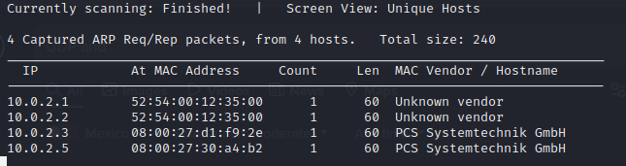
- Use arp-scan to find the IP address of the target device.
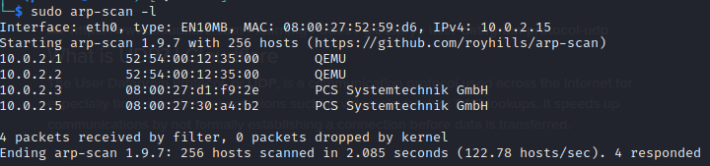
Target IP Address: 10.0.2.5

Scanning with nmap (Network Mapper)
- Nmap concept: A network tool used to scan/map networks and ports.
- On an overview, explain how nmap works.
It works like an incomplete TCP Connection (Three Way Handshake), standard packets (SYN, SYN-ACK), but at the end, instead of an ACK packet to establish the connection, an RST packet for end the connection is send. It’s like ghosting someone.
- Do Host Scan/Discovery (of anytipe) with nmap, and find the IP address of the target host.
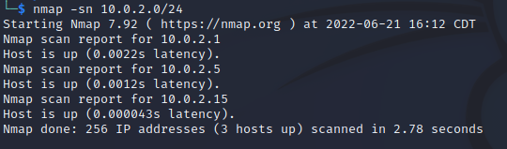
Target Host IP address: 10.0.2.5

- Do a Cybermentor recommend TCP port scan, and take note of the more relevant information that will start your enumeration.
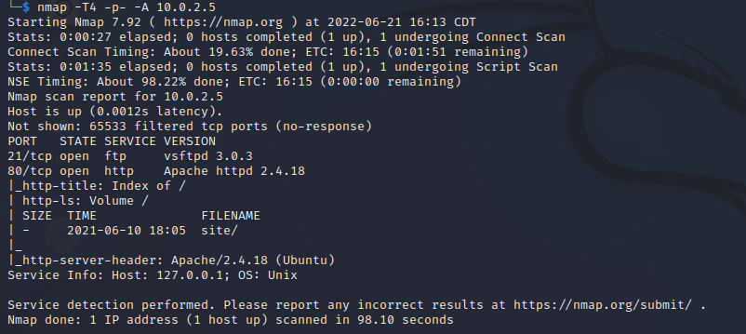
Operating System(Probably): Ubuntu.
Open ports and services:
Port | Service | Version
21 | File Transfer Protocol (ftp) | Vsftpd 3.0.3
80 | Hypertext Transfer Protocol (http) | Apache httpd 2.4.18

- Do an UDP scan (1000 ports), and take note of the more relevant information that could help you to start your enumeration.
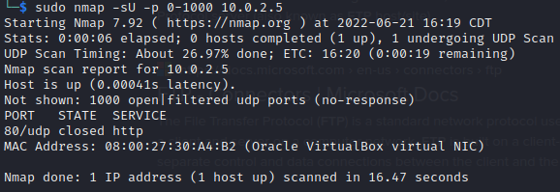
Only one port is showed: 80/udp-http service, but the is closed, so it’s not relevant.

