**So far, what is the severity of your symptoms?**

|  |  |  |  |  |  |  |
| --- | --- | --- | --- | --- | --- | --- |
| **Gait** | None | O | O | O | O | High |
|  | | | | | | | |
| **Stiffness** | None | O | O | O | O | High |
|  |  |  | |  | |  | |
| **Slowness** | None | O | O | O | O | High |

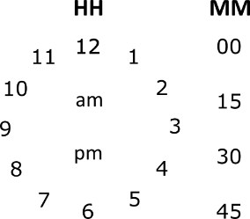

**Optional**

|  |  |  |  |  |  |  |
| --- | --- | --- | --- | --- | --- | --- |
| **Gait** | None | O | O | O | O | High |
|  | | | | | | | |
| **Stiffness** | None | O | O | O | O | High |
|  |  |  | |  | |  | |
| **Slowness** | None | O | O | O | O | High |



|  |  |  |  |  |  |  |
| --- | --- | --- | --- | --- | --- | --- |
| **Gait** | None | O | O | O | O | High |
|  | | | | | | | |
| **Stiffness** | None | O | O | O | O | High |
|  |  |  | |  | |  | |
| **Slowness** | None | O | O | O | O | High |

