**DATE_FORMAT() Function:**

* **Explanation**: The DATE_FORMAT() function is used to format dates as specified by the format string parameter. It allows you to customize the display of dates in various formats such as "YYYY-MM-DD", "MM/DD/YYYY", "DD-Mon-YYYY", etc.
* **Use Case**: This function is useful when you need to present dates in a specific format for reporting or display purposes, catering to different regional or user preferences.

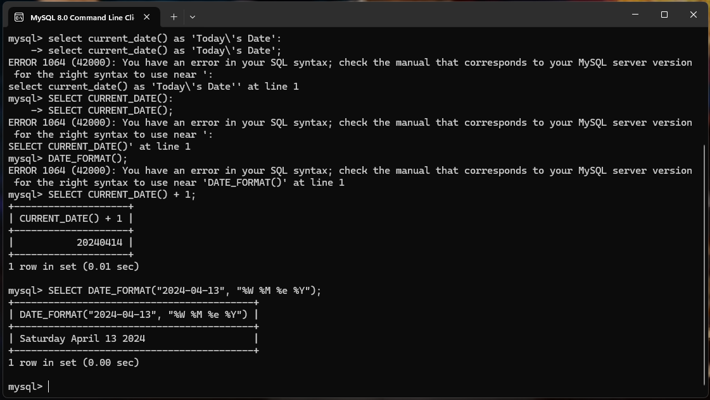

**ROUND() Function:**

* **Explanation: The ROUND() function is used to round a numeric value to a specified number of decimal places.**
* **Use Case: This function is useful for presenting numeric data in a more concise or user-friendly format, especially when dealing with financial or statistical data.**

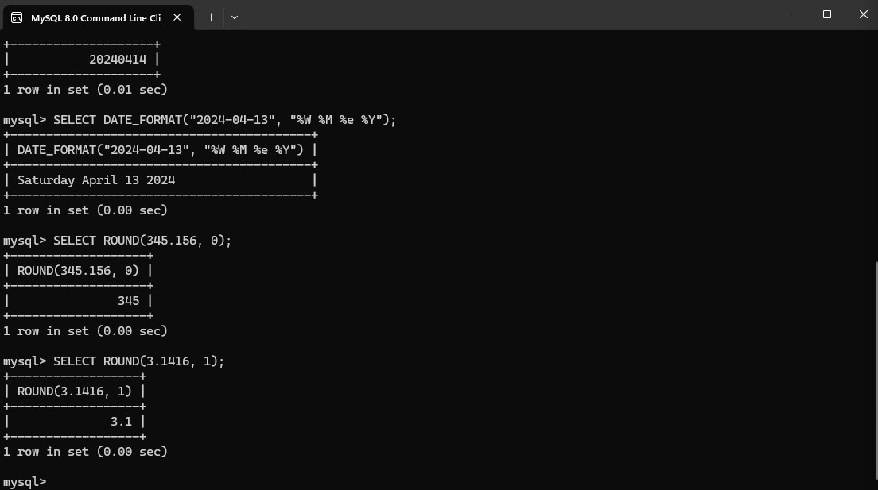

**UPPER() Function:**

* **Explanation**: The UPPER() function is used to convert characters in a string to uppercase.
* **Use Case**: This function can be handy when you want to standardize text data or perform case-insensitive comparisons in SQL queries.

