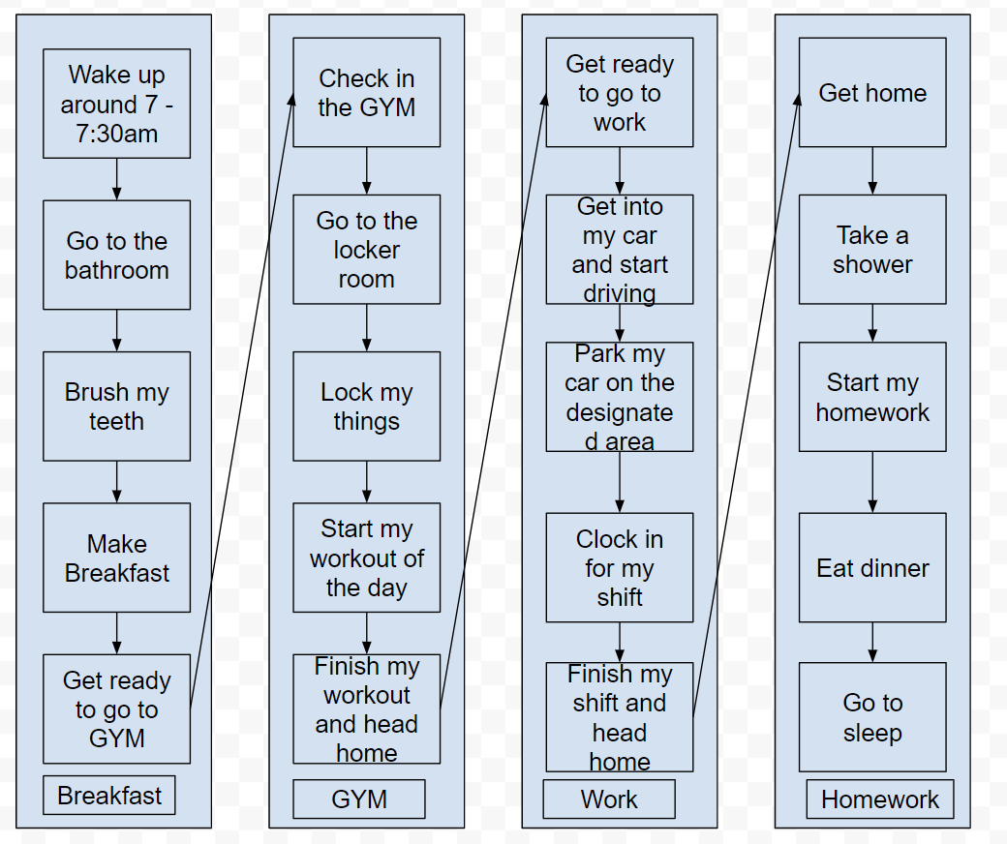

|  |  |
| --- | --- |
| Breakfast | 60 Mins |
| GYM | 120 Mins |
| Work | 600 Mins |
| Homework | 120 Mins |

In my daily routine, I start my day waking up between 7:00 and 7:30 AM, followed by a quick trip to the bathroom and brushing my teeth. I then make breakfast to fuel up before heading to the gym. My gym session begins with storing my belongings in a locker, followed by my workout routine. After the gym, I drive to work, park, and dive into my work tasks. Returning home, I take a shower, eat dinner, tackle my homework, and wrap up the day by going to sleep around 11 PM. This structured routine helps me balance fitness, work, and studies effectively.