**Question**

Retrieve the total number of employees hired in each department

**Team member**

**David Burguete**

**SQL Query**

SELECT departments.dept_name, COUNT(employees.emp_no) AS num_employees

FROM employees

JOIN dept_emp ON employees.emp_no = dept_emp.emp_no --  connects employees with their respective departments based on their employee numbers

JOIN departments ON dept_emp.dept_no = departments.dept_no -- connects departments with their respective names

GROUP BY departments.dept_name;

**Query Results**

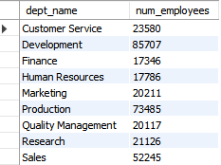

Question:

Retrieve all girls trek brand bikes from the year 2017

Team Member:

Cody Karl

SQL Query:

SELECT product_name

FROM product

WHERE model_year = 2017 AND brand_id = 9 AND product_name LIKE('%Girl%');

Query Results:

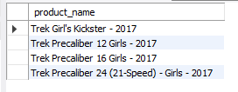

**Question**

-- GET THE MOST EXPENSIVE AND CHEAPEST BIKES

Team Meber

Leo Mosquera

SQL Query

SELECT list_price, product_name

FROM product

WHERE list_price = (SELECT MAX(list_price) FROM product) OR list_price = (SELECT MIN(list_price) FROM product);



**Question**

Find all female employees who were hired before January 1st, 1990

**Team Member**

David Burguete

**SQL Query**

SELECT first_name, last_name, gender, birth_date

FROM employees

WHERE gender = 'F'

  AND hire_date < '1990-01-01'

LIMIT 10;

**Query Results**

