This prompt was stronger because it was less generic 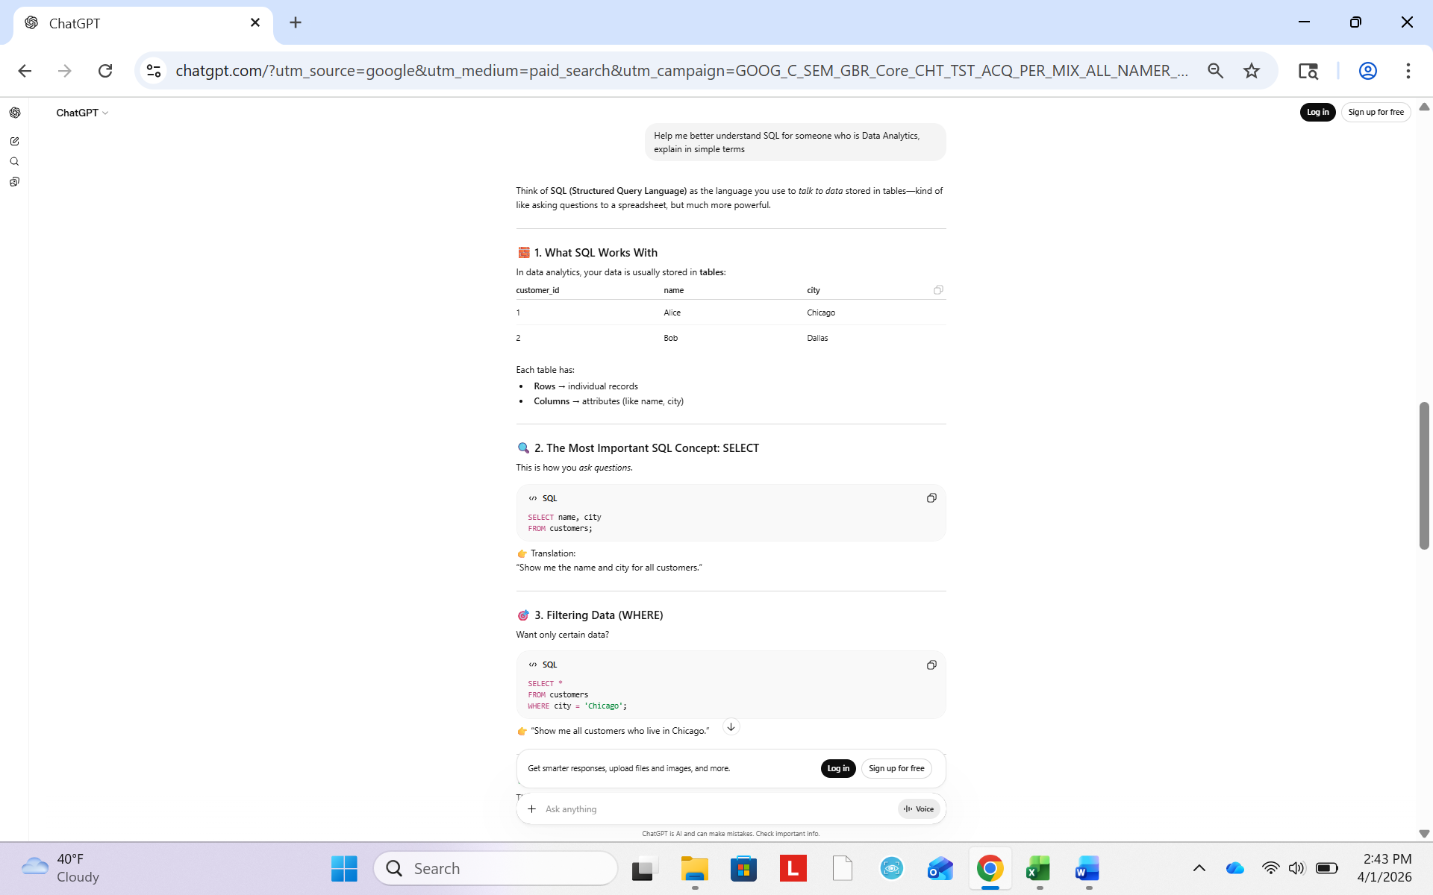This prompt is stronger because I am asking for specificity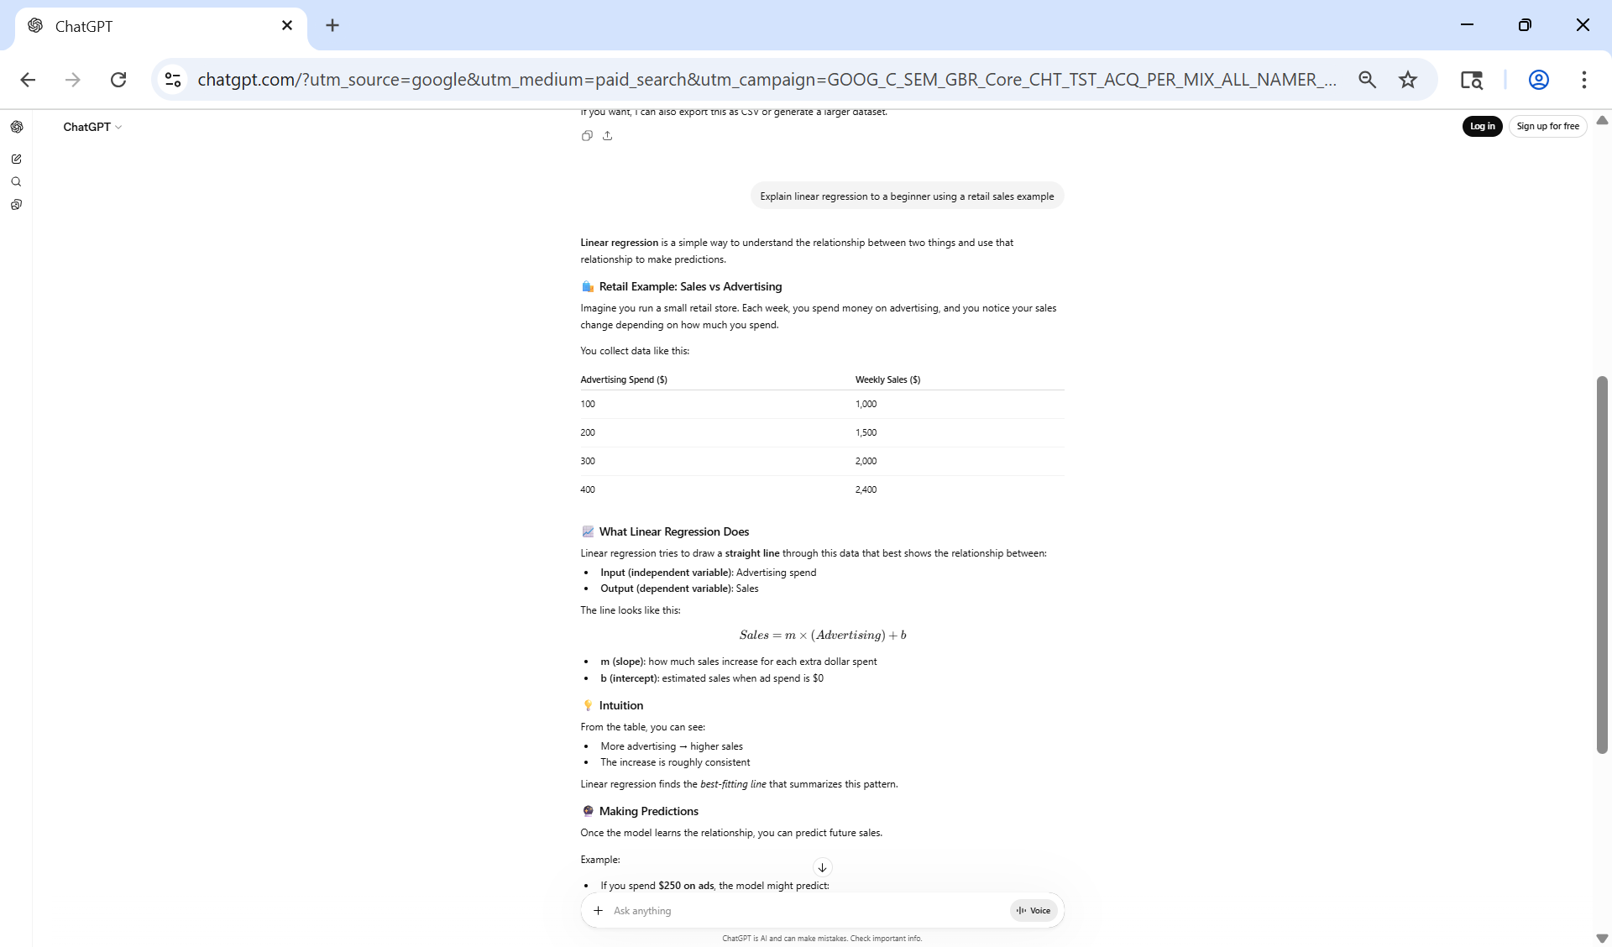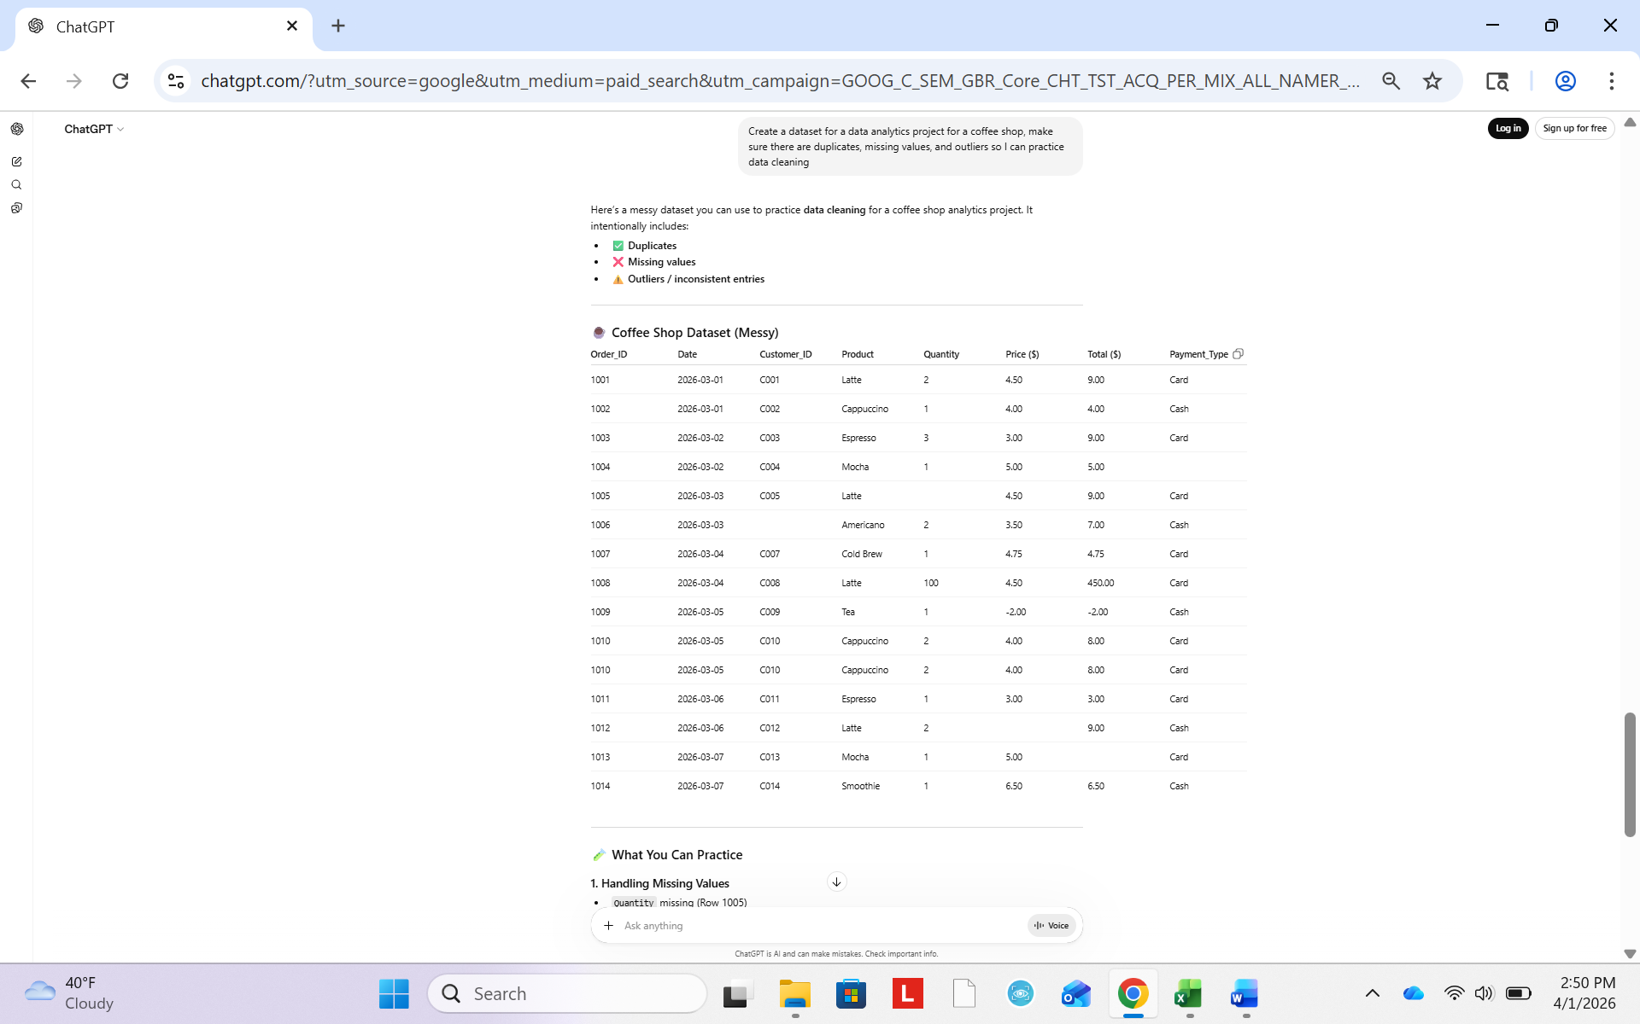This prompt is stronger because I added specificity as well as explained what it was for

