REVISION/PANEL/RESEARCHERS

Add Admin for managing the account of teachers.

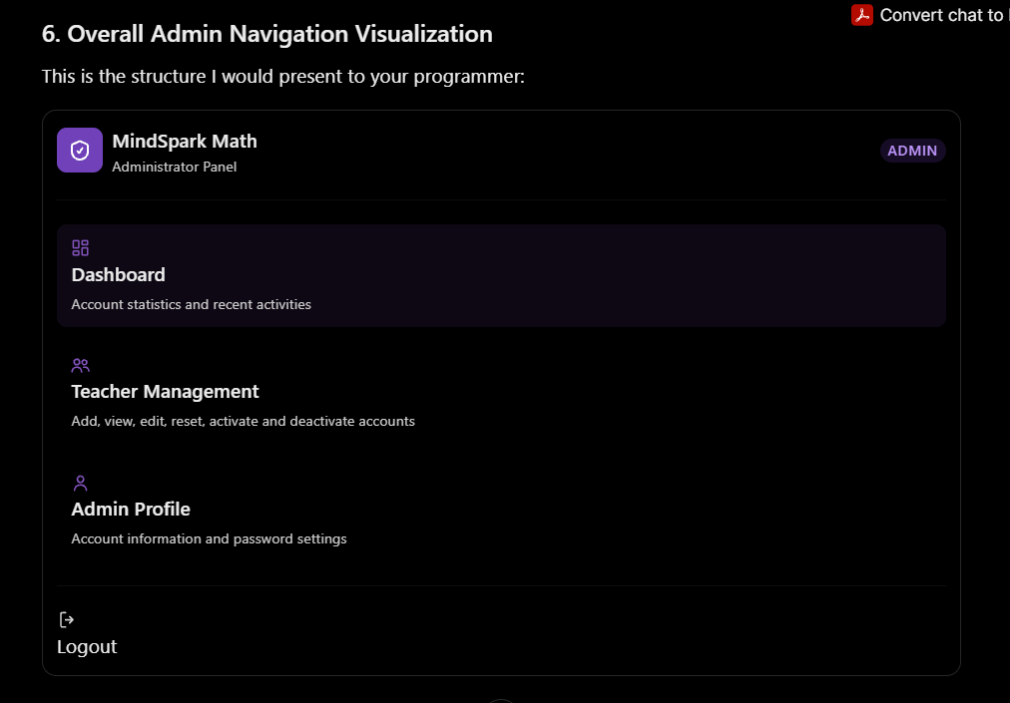

For Teacher Account add this, the teacher can edit there credentials.
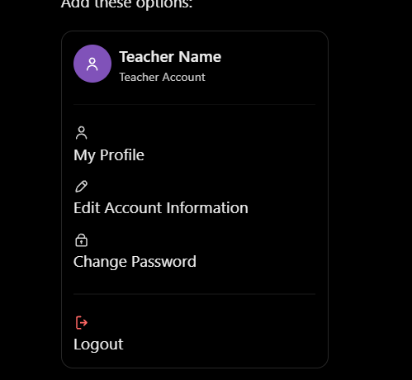

Ang picture sir prmpt by AI based sa current UI.

TEACHERS DASHBOARD
This should be the visualization needed for Dashboard.
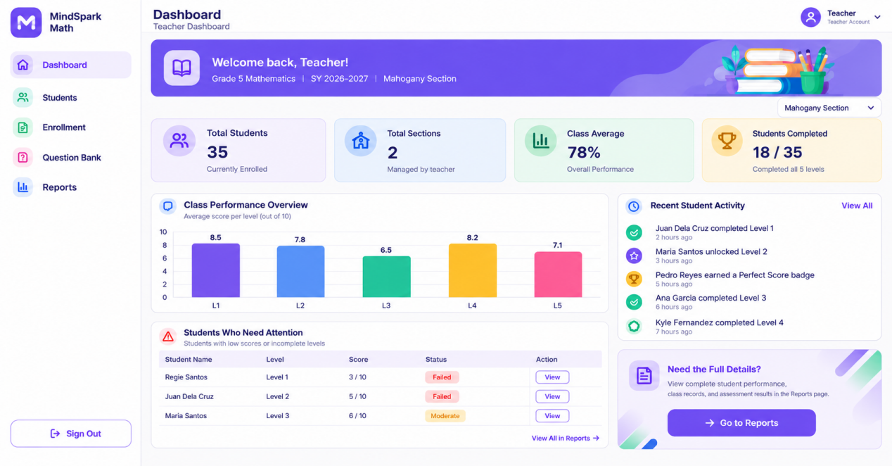

SECTION
Visualization, butangan ug view students sa baba sir then mo direct siya sa students ana na section if e click.
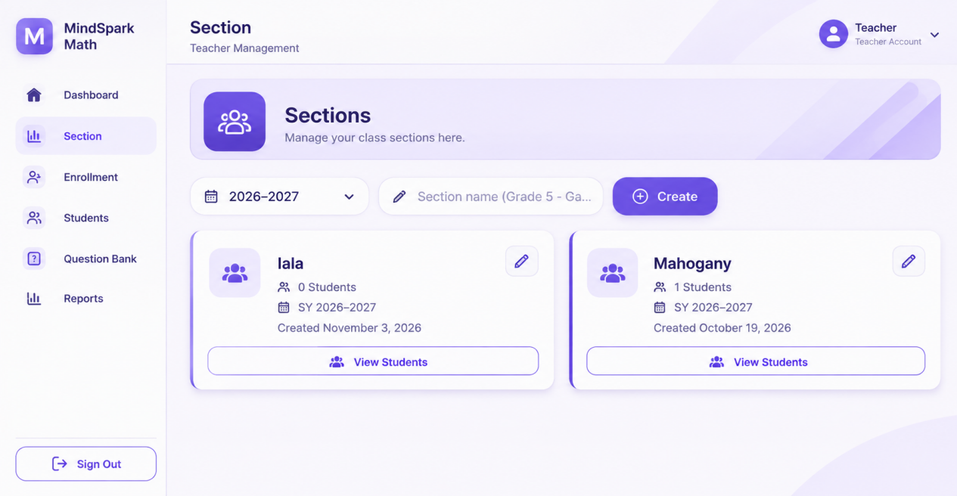

ENROLLMENT
OKAY na siya sir, e consistent lang ang design sa all sub pages.

STUDENT
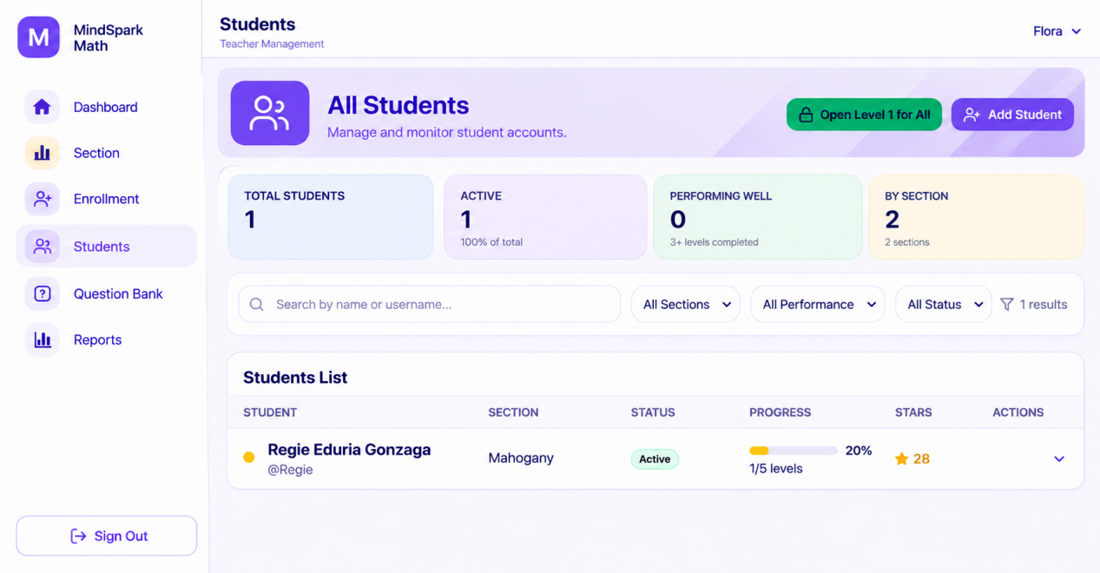

Dire sa quiz score sir ba, wala mi ka gets if mao bani imong pasabot ani direa sir hehe
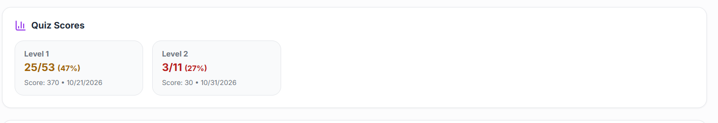
Sir, regarding sa Quiz Scores section, kanang 25/53, does it mean nga accumulated correct answers and total questions answered na siya, including re-attempts? Or lahi iyang meaning? We just want to clarify lang po para sakto among understanding sa score calculation and student performance report.
So If mao na ang meaning, Sir, pwede ba namo siya ing-anaon? Butangan lang namo ug explanation sa kilid or below sa score para mas clear kung unsay meaning sa 25/53. Okay ra ba sir, then maintain the design ra japun sir pabutangan lng anang correct/total answered ug total points earned.

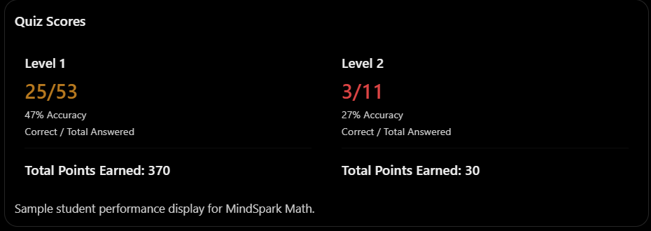

For account detailes sir ba sa TEACHERS DASHBOARD, ipa remove nlng dw ang current password sir kay ang student dapat maka change password.

(STUDENT APP)

- The student has authority nga maka change sd sa ilang password sir.

Sir, enhance lng dw ang padding especially sa main navigation sir, make it more rounded consistent sa tanan. Then nag overlap ang trphies and badges sir.

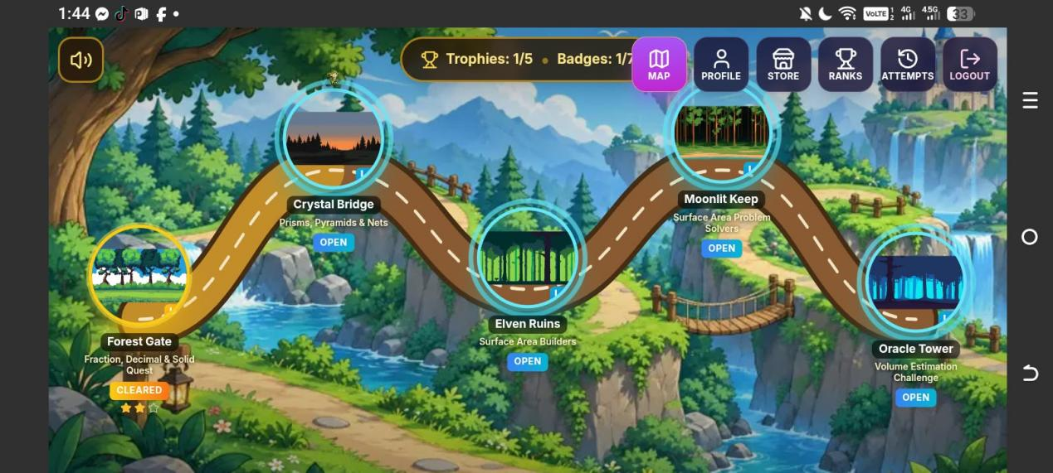

-if mag buy ka ug another character sir is working man siya sir, pero if I click nimo balik tung characters na already purchased kay dile siya ma click sir.

Then sa white circle sir, naay star sa likod dile siya visible, wala siya nakita sir.
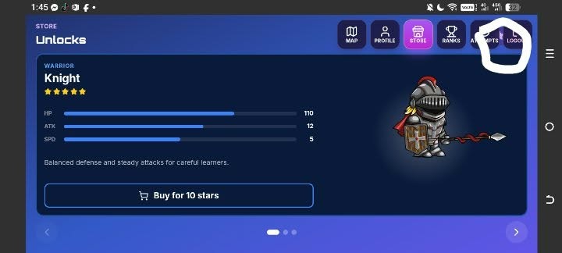

The same ani sir, naay search bar dile visible sir.
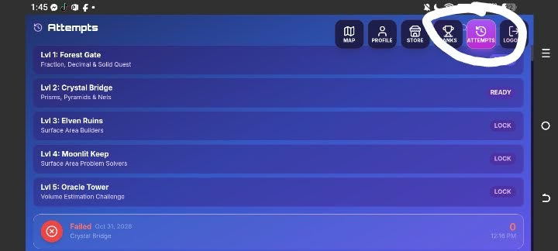

ASK LANG KO BALIK SIR REGARDING SA STAR POINTS SIR

1-5 SCORE 1 STAR
6-9 SCORE 2 STAR
10 SCORE 3 STAR

QUIZ
1 CORRECT 1 STAR 10POINTS

BOSS
1 CORRECT 1STAR 20POINTS

Dire sa ano sir ba correct answer,stars,points earned, hearts left.

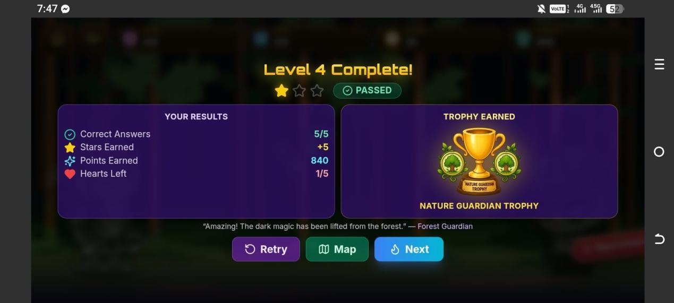

Correct answer - it should be the combination correct answer of both quiz+boss. Ex. 1/10 or 5/10

Stars earned - combination of quiz+boss. Ex. 6

Points Earned - combination of quiz+boss . Ex.120

Hearts Left- Exclusive for Boss battle only representation lang siya sa hearts left. ex. 1/5

IF THE STUDENT GOT 0/5 FOR QUIZ, STILL IT PROCEED TO BOSS BATTLE SIR, THEN HE ANSWER 0/5 FOR BOSS BATTLE SO THE RESULT SHOULD BE. ( sa current man gud sir is if 0/5 iya score sa quiz mag failed siya nya retry ditso dile mo proceed sa boss battle, then if maka score siya ug 1/5 sa quiz sir, then pag proceed sa boss battle kay if 0/5 siya sa boss battle sir kay mag failed sad siya dile mo continue)

(Kulangan lng ni sir, visualization lng pero follow lang japun sa color palette nimo sir hehe)
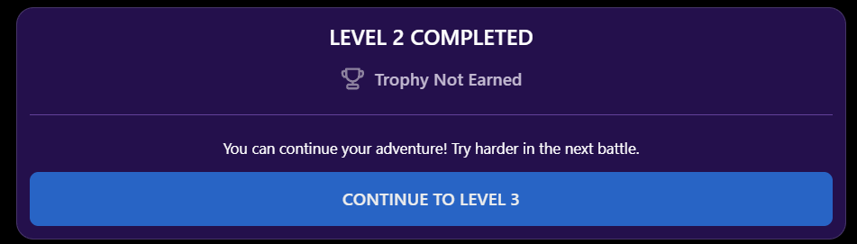

LEVEL 2 COMPLETED
THROPHY(ICON) NOT EARNED BADGE(ICON) NOT EARNED

Correct Answer Stars Earned Points Earned Hearts Left
0/10 0 0 0/5
You can continue your adventure! Try harder in the next battle.
RETRY MAP NEXT
BUT IF HE GOT 1/5 FOR QUIZ AND 0/5 FOR BOSS, still it proceed to result

LEVEL 2 COMPLETED
THROPHY(ICON) NOT EARNED BADGE(ICON) NOT EARNED

Correct Answer Stars Earned Points Earned Hearts Left
1/10 1 10 0/5
"You completed the level, but the boss is still undefeated. Don't give up! You can continue your adventure and improve your skills in the next battle."
RETRY MAP NEXT

But if 0/5 quiz then 1/5 boss, still it gives throphy, trophy dependent on the Boss Battle score only, not the combined quiz score.
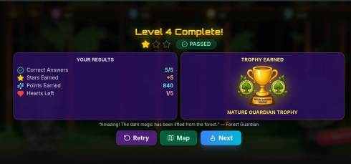
Follow this UI

But the result is
Correct Answer 0/5
Stars Earned +1
pOints earned +20
Hearts Left 1/5

FOR BADGES SAD SIR, BALIK LNG NAKO SEND SIR.
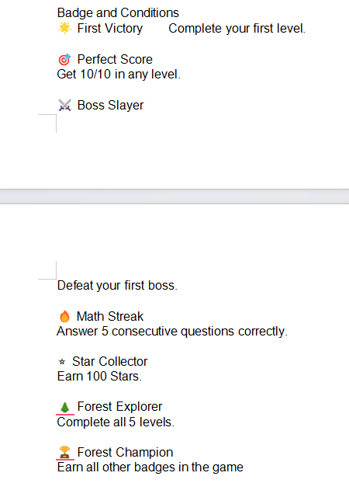
SA BADGES SD SIR IF MA HIT ANG CONDITION MO APPEAR SIYA IN THE MIDDLE OF THE GAME AND END. AND IF PWEDE SIR NA ONCE NA MA ACQUIRE NA NIYA ANG BADGE SIR KAY DILE NA SIYA MO APPEAR UG BALIK.

EX. LEVEL 1, NAG ANSWER KO QUIZ 2/5, THEN NI PROCEED KO SA BOSS BATTLE NAA KOY 3/5 SO ISHOW TUNG RESULT SIR NO NA KANI IMONG POINTS, TROPHY,BADGES NA FIRST VICTORY AND BOSS. THEN IF I RETRY, OR MO PROCEED SIYA SA LEVEL 2, THEN BALIKAN NIYA ANSWER ANG LEVEL 1 , SO DILE NA MO APPEAR UG BALIK TUNG TROPHY UG BADGE NA NAKUHA NA NIYA, UNLESS UG ANOTHER BADGE NAPUD IYANG MA ACQUIRE LIKE MATH STREAK.

FIRST VICTORY AND BOSS BATTLE- IS MO APPEAR SIYA SA RESULT SA END NA. BALI ANG FIRST VICTORY NA BAGDE DEFAULT NASIYA DAAN SIR, SO IF MAG ASNWER SIYA SA QUIZ THEN BOSS BATTLE SO NAA MAN TUNG RESULT SIR NO DDTUA NAA ANG TROPHY, SA KILID ANG FIRST VICTORY UG BOSS NA BADGE.

MATH STREAK - MO APPEAR ON THE MIDDLE OF THE GAME, LIKE QUIZ HE GOT 5 CORRECT ANSWER BADGE APPEAR AFTER ANSWERING 5 CORRECT ANSWER THEN BOSS ANIMATION, OR FOR BOSS HE GOT 5 CORRECT ANSWER, BADGE APPEAR AFTER ANSWERING 5 CORRECT ANSWER, THEN THERE IS RESULT IT APPEAR THROPHY THEN BESIDES IT BADGE.

STAR COLLECTOR - APPEAR LIKE IF HE GOT 99 STAR, THEN IF HE ANSWER THE QUIZ OR THE BOSS BATTLE QUESTION THEN PANG 100 SIYA MO APPEAR SIYA IN THE MDDLE PART THEN SA RESULT SAD.

FOREST EXPLORER- IT APPEAR AFTER ANSWERING THE FIVE LEVEL. ON THE RESULT PART, IT HAS THE THROPHY PROVIDED THEN THE BADGE SIDE

FOREST CHAMPION - APPEAR LIKE FOREST EXPLORER NLNG IYANG KULANG SIR NA BADGE, OR ANY KIND SA BADGE NA MAKUHA NIYA IF MACOMPLETE NIYA TO WHILE ANSWERING THE QUIZZES, LIKE NAG RETRY SIYA ANSWER SA LEVEL 4 NIYA TUNG STAR COLLECTOR NLNG KULANG NIYA NYA PAG ANSWER NIYA SA BOSSBATTLE NAG 100 SIYA SO NI APPEAR ANG STAR COLLECTOR NA BADGE, THEN MO APPEAR SD ANG ANG FOREXT CHAMPION NA BADGE THEN PAG ABOT SA RESULT, NAA DDTUA NAKABUTANG ANG RESULT,THROPHY TUNG BADGE NA NAKUHA NIYA. THEN IF MAKUHA NA NIYA TANAN BADGE AND TROPHY DILE NA SILA MO APPEAR BALIK IF MAG RETRY PA SIYA UG MGA LEVEL, ONCE RA SILA MAKUHA.

Sa level 5 gani sir if mag last na gani siya answer sa Boss battle ing ani ang visual niya sir dile fix, scrollable siya.
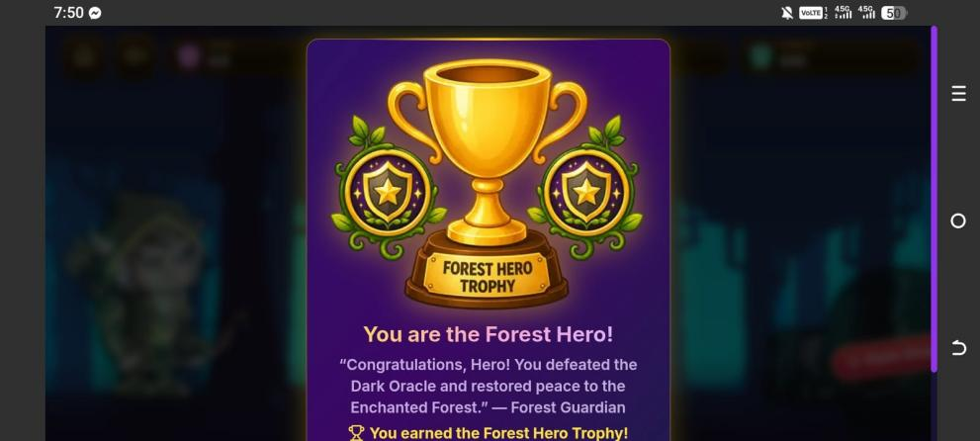
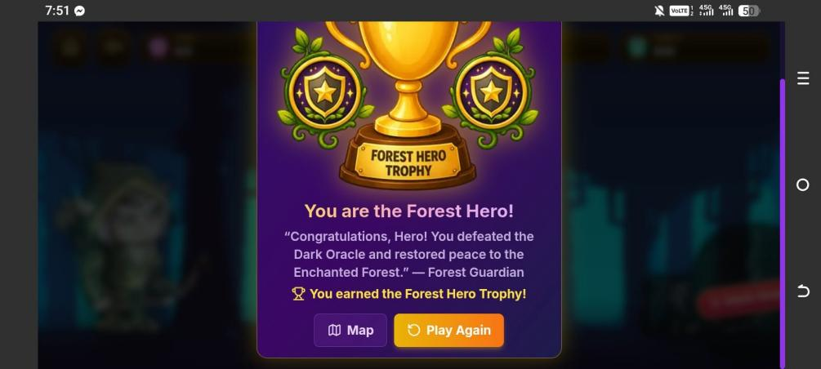
PWEDE BA SIR NA DILE SA SIYA MO DIRETSO DIRAA SIR. AFTER ANSWER SA BOSS KANA SA UPPER PART PICTURE IYA IGAWAS, BALI I SHOW SANI NIYA AFTER ANSWER SA LEVEL 5 SIR IGAWAS SA ANG RESULT

TAPOS IF I CLICK NIYA ANG NEXT SIR, MAG HATAG UG VISUAL LIKE ANIMATION SIMPLE ikaw na bahala sa visual sir.

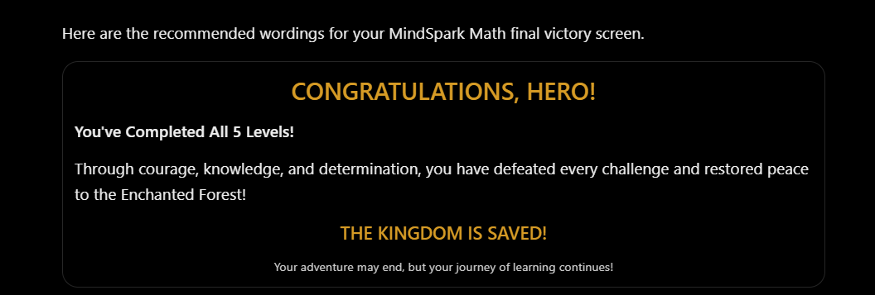
THEN NAAY BUTTON SA BABA SIR
MAP PLAY AGAIN

MAP - IF ICLICK MO BALIK SA DASHBOARD THEN STILL CONTINUOS JAPUN SIYA

PLAY AGAIN - MO BALIK SIYA UG ANSWER SA LEVEL 1 THEN LOCKED ANG UBAN LEVEL.

APP LOGO SIR (MA ROUND MAN CORNER ANI SIR NO PAG APP NA?)



Sa profile icon gani sir if I click or pinduton ang buy ug magpalit kag character kay green ang color mo appear, like kana gung sa upper right side like Unlocked new character bana ang wordings or, purchased kay green color sir wala na change.

SA TEACHER DASHBOARD LNG NA SIYA SIR, PERO ING ANA ANG COLOR GREEN PA SIYA SIR PAG MAG PURCHASE UG NEW CHARACTER

Sa teachers dashboard sad ang color sa log in kay violet
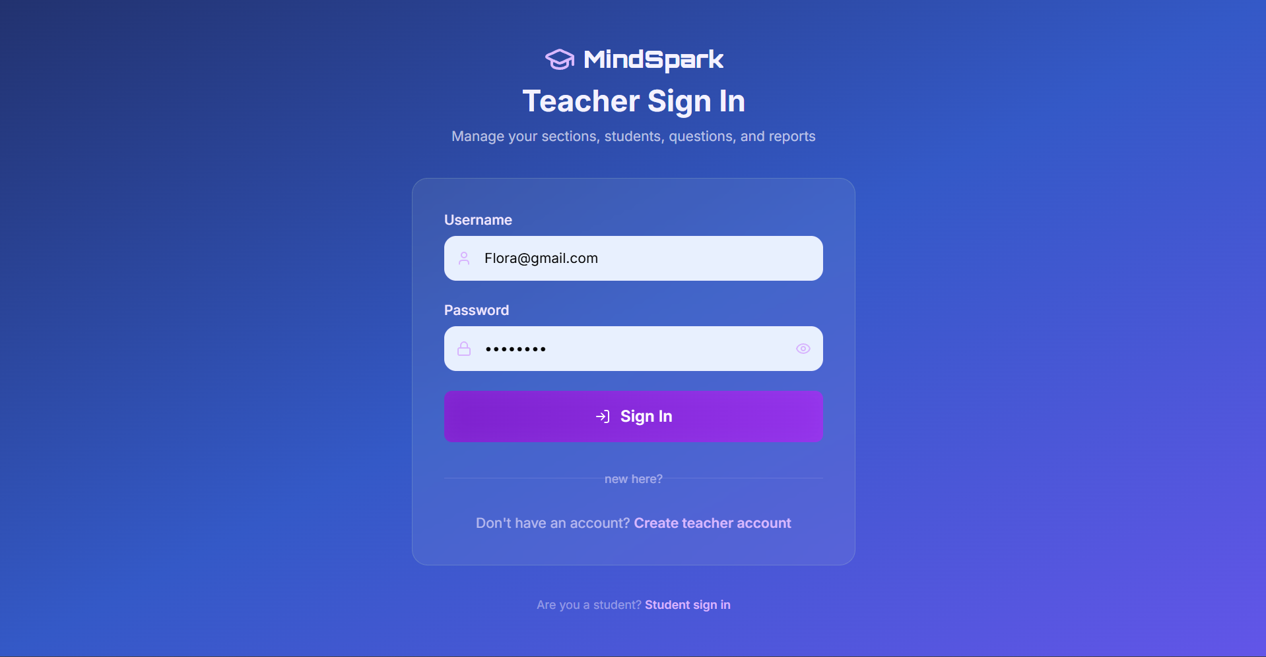
OKAY MAN ANG VIOLET SIR PERO PWEDE NA MA COMPLIMENT SIYA SIR PERO NAA JAPUN PART ANG VIOLET SIR KAY NAA MAN GUD SA SYSTEM ANG COLOR JAPUN. THEN ANG TEACHER IS MO LOG IN NALNG MAN SIYA SIR NO KAY ANG ADMIN NAMAN MAG MANAGE SA IYANG ACCOUNT.

OKAY RAMAN SIR NO NA IISAN NLNG NIMO ANG LOG IN PAGE SA ADMIN AND TEACHER?, OR ROLE NLNG NILA MAG LAHI, PERO STILL LAHI2 ILANG FUNCTIONALITIES.

AFTER LOG IN SD SIR KANI ANG COLOR GREEN

NAAY NAKA BUTANG SA BABA SAD SIR NA ARE YOU A STUDENT? STUDENT SIGN IN. IF I CLICK NIMO SIYA SIR IS MAO NI MO GAWAS

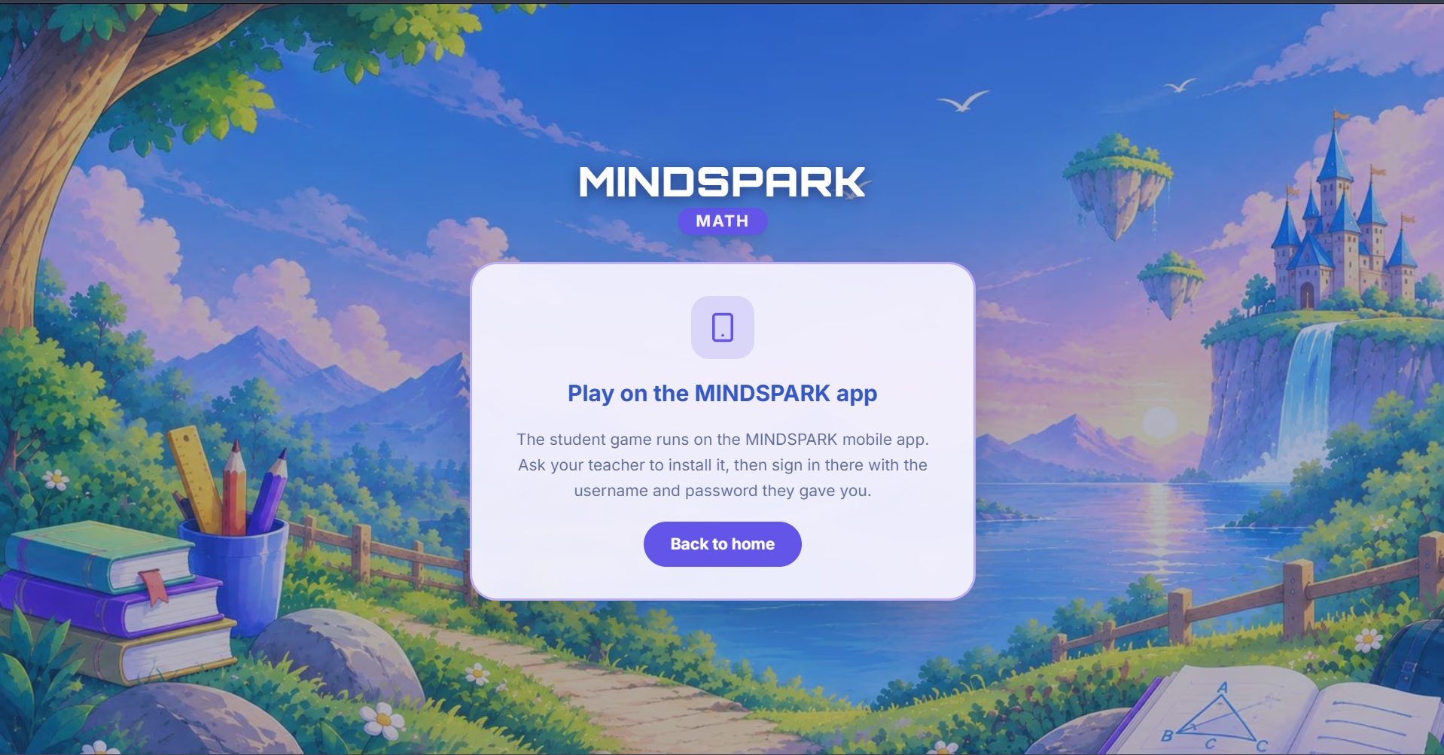
PWEDE BA NA MAHAWA NA SIYA SIR KAY WALA NAMAN ACCESS ANG STUDENT SA WEB PAGES. OR DAPAT NAA NA SIYA SIR KAY BALI MAO NA ANG CONNECTION SA STUDENTS DATA PADUNG SA WEB? IF WALA SIR PWEDE HAWAON NLNG SIYA SIR.

Then sa teacher web favicon ata na sir, kana gung title name sa website kay color green pasd siya sir.



DILE SAD WORKING ANG MAKA SET UG DEADLINE SA STUDENT SIR. IF I CLICK SA TEACHER NA MAO NI DEADLINE NI REGIE, IF E OPEN NIMO ANG STUDENT APP KAY WALAY MURAG NOTICE SIR OR ANY SIGN NA DEADLINE NI NA QUIZ KARON OR NEED NIMO ANSWERAN LIKE ANA GUD SIR, OR MAS BETTER SIR DURING PAG LOG IN NIYA TAPOS AFTER PINDUT SA LOG IN NAAY NOTICE.

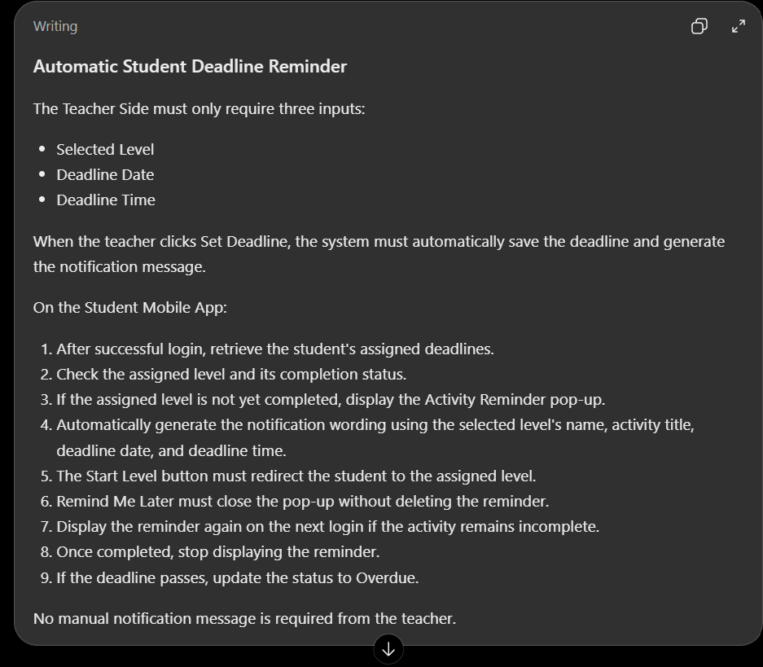
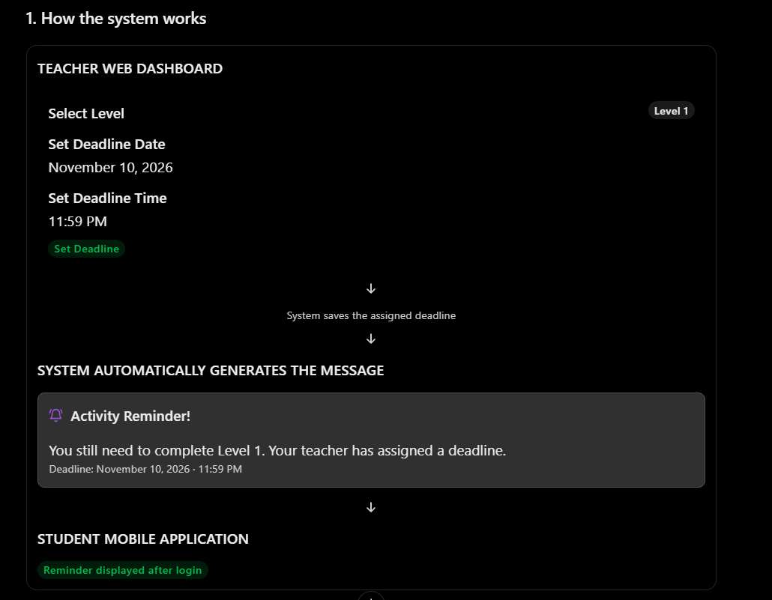
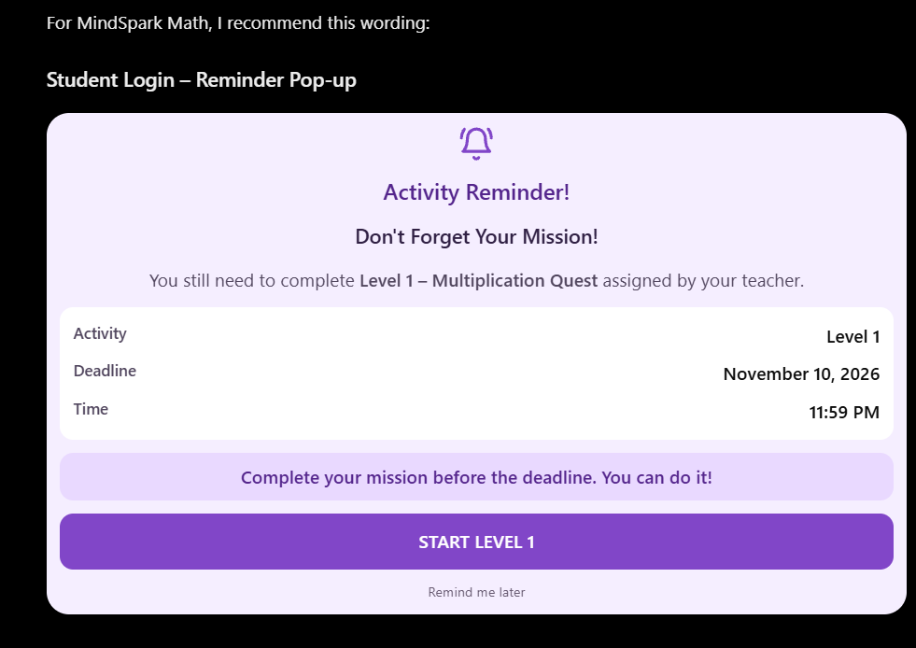

ANG CSV FILE SA ENROLLEMENT
(GINA TRY PA NAMO NA MAKUHA ANG EXISTING NILA NA CSV OR EXCEL FILE SA REGISTRAR NILA SIR SAMPLE, BASIN NAA SILA TEMPLATE GINA USED PARA MAO NLNG I ATTACH AND MASUNDAN. GI TRY NAKO CREATE UG CSV NA AKOA2 LNG SIR PAG UPLOAD NAKO DILE SIYA MAG WORK MAN GUD SIR)

SA REPORTS NI SIR TUNG DOWLOADABLE DIRE
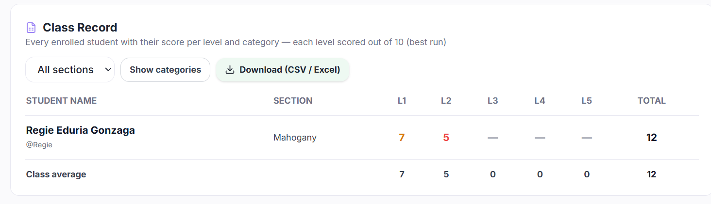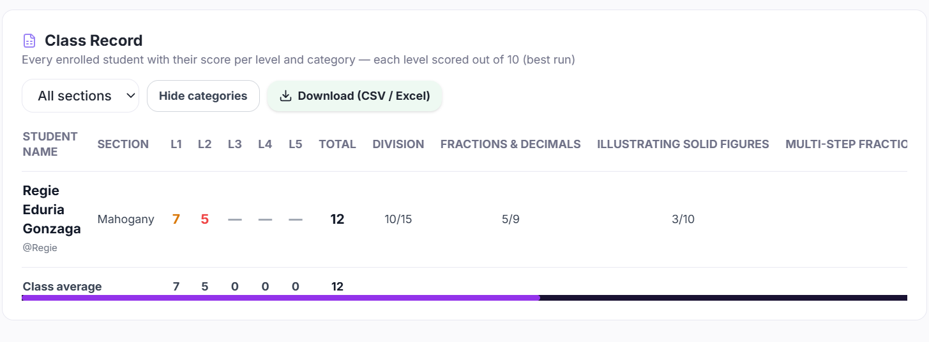
NAG LIBUG KO SABOT SA MGA NUMBERS NA NAA SIR BA HEHE, NAG PA AI RAKO SIR PARA MAS MA GETS NAKO ANG NABUTANG NIMO SIR
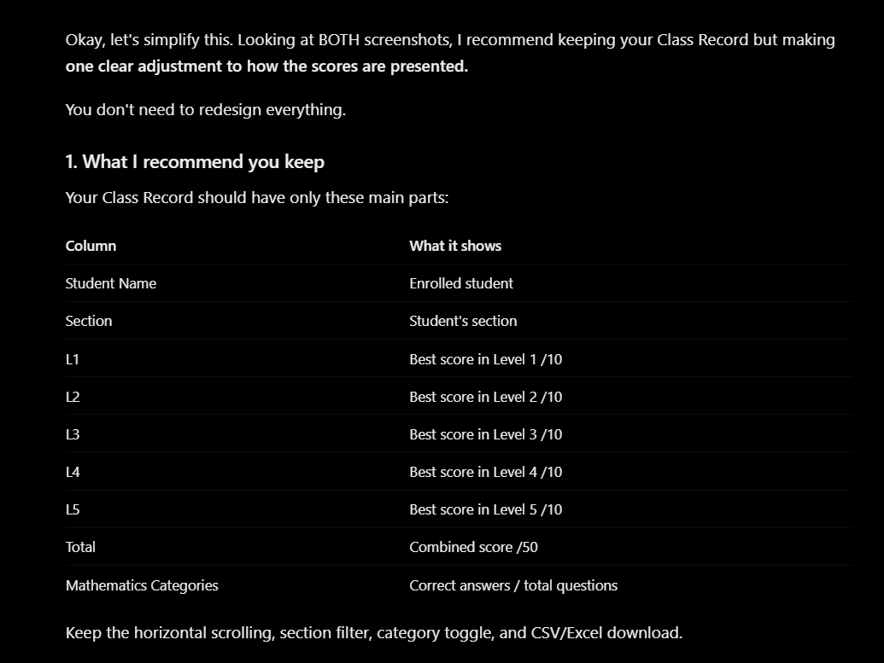
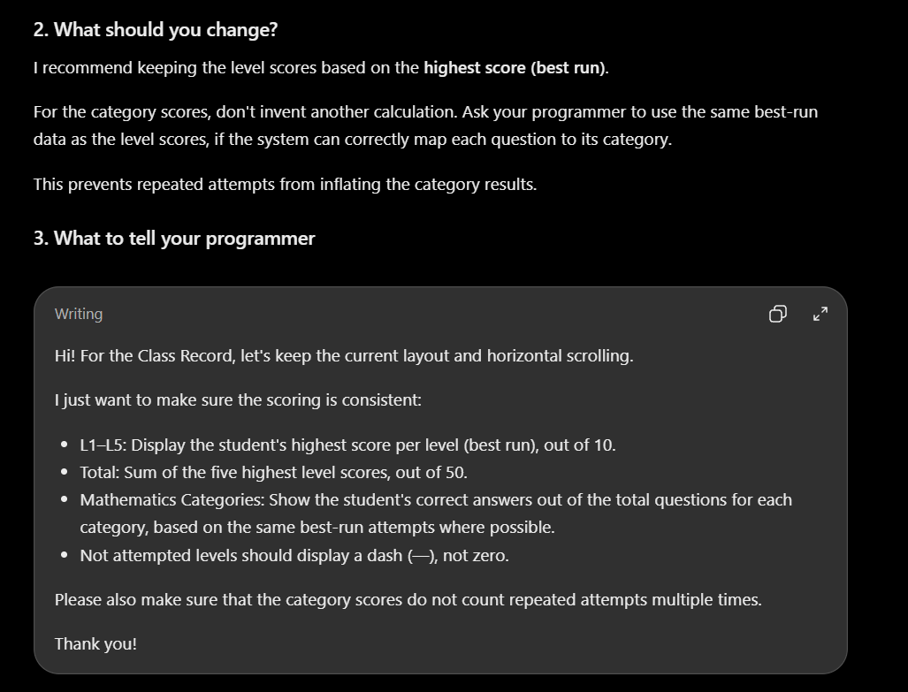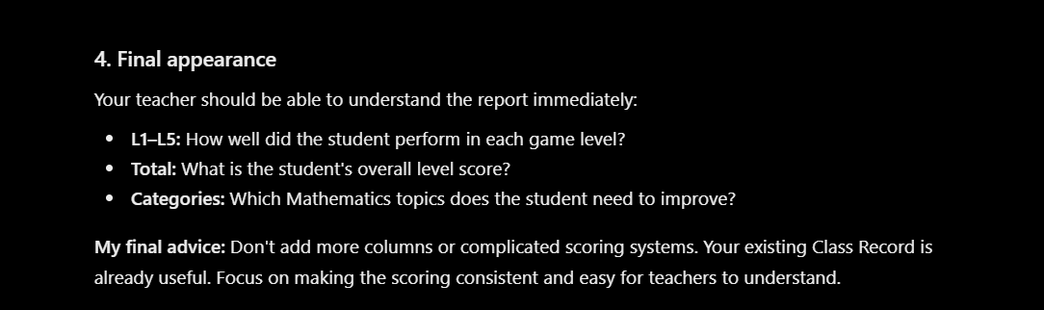
PASENSYA NA SIR IF KANI MA SEND NAKO NAG LIBUG MAN SD GUD KO DIRE DAPITA SIR.

