MindSpark Math

SYSTEM REVISIONS AND ADDITIONAL FEATURES
Hi! These are the additional features and revisions suggested by the evaluators during our system evaluation. Please review the following changes needed for our current system.

1. Admin Account Management (New Feature)
Add an Admin role that will manage the teacher accounts.
Required functions:
Admin login.
View teacher accounts.
Add new teacher accounts.
Edit teacher information.
Deactivate teacher accounts.
The Admin and Teacher should have separate access.

2. Enrollment (Revision)
Remove the existing Enrollment section from the main Dashboard and create a separate navigation menu called Enrollment.
Suggested Teacher Dashboard navigation:
Dashboard
Section
Enrollment
Students
Question Bank
Reports
When the teacher clicks Enrollment, it should display the existing enrollment section with the same design and functionality.
Basically, we will only move the current Enrollment section into its own page to make the dashboard more organized.
Keep it connected to the existing enrollment records in the database, including the CSV enrollment feature.

3. Question Management (Revision)
Add a search bar and filtering options to the existing Question Management page.
Required changes:
Search bar for finding specific questions.
Filter questions by Category.
Filter questions by Level.
Allow both filters to work together.
Example:
Category: Number & Algebra
Level: Level 1 – Multiplication
If the teacher selects these filters, only questions under that category and level should appear.
This will help teachers find specific questions without scrolling through the entire question list.

4. Reports / Class Records (Major Revision)
Aside from the existing dashboard statistics, add a detailed report that looks like a simple electronic class record, similar to the IAIMS class records at DNSC.
The report should display all enrolled students and their corresponding scores per level and category.
Suggested Table Design:
Student Name | L1 | L2 | L3 | L4 | L5 | Total
Student 1 | 8 | 9 | 10 | 7 | 9 | 43
Student 2 | 10 | 8 | 9 | 10 | 10 | 47
Student 3 | 7 | 8 | 6 | 9 | 8 | 38
Note: Sample scores only.
Required functions:
Display all enrolled students.
Show their scores per level (L1–L5).
Include the corresponding categories.
Display each student's total score.
Add a Download/Export button.
Allow teachers to download the class records as CSV or Excel (.xlsx) files.
The downloaded file should contain the student names, levels, categories, and scores.
Please keep the existing dashboard statistics. This class record will serve as an additional detailed report.

5. Game Timer (Additional Feature)
Add a timer during gameplay, particularly during quizzes and boss battles.
Suggested behavior:
Display a visible timer.
If the timer runs out, the game should not automatically close.
Instead, display a confirmation message such as "Are you still there?"
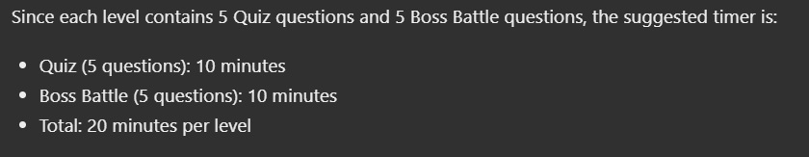
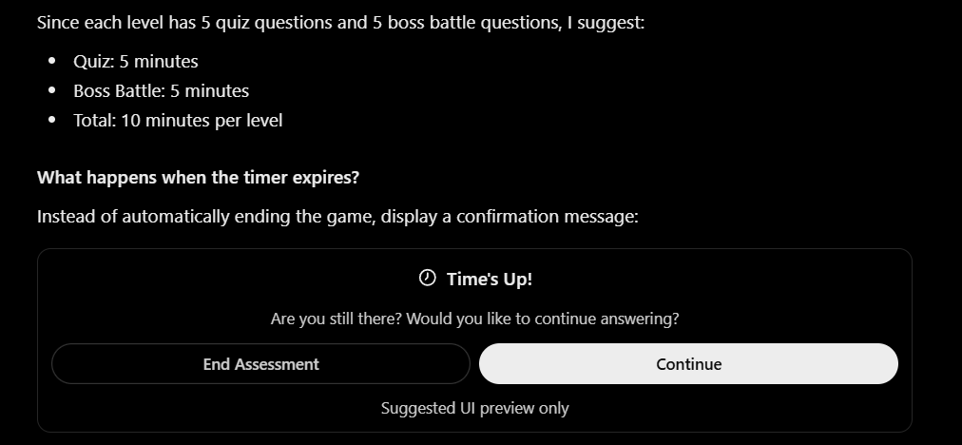

6. Game Background and Animation (For Consideration)
Add simple background movements or transitions while the student progresses through the game, especially when approaching the Boss Battle.
Suggested improvements:
Add Background transition between Quiz and Boss Battle.
Simple character movement.
Visual effects when approaching the boss.

7. Student Leaderboard (New Feature)
Add a Leaderboard where students can see their rankings based on their game performance.
Suggested Table Design:
Rank | Username | Section | Total Points
1 | Student01 | Section A | 950
2 | Student02 | Section B | 890
3 | Student03 | Section A | 850
Note: Sample data only.
Required functions:
Automatically rank students based on their accumulated points.
Display Rank, Username, Section, and Total Points.
Highlight the currently logged-in student's ranking.
Automatically update rankings based on recorded game performance.

SUMMARY OF SYSTEM REVISIONS
Main Revisions:
Admin Account Management
Separate Enrollment Navigation
Question Search and Filtering
Downloadable Class Records / Reports
Student Leaderboard

