PROJECT REPORT

Neural Network-Based
Market Direction Classification
Can historical price patterns help classify the next trading session?

MODELS Majority baseline • Logistic Regression • FNN • LSTM
DATA Historical NIFTY 50 index data
EVALUATION Chronological holdout • Walk-forward validation • Simplified backtest

Prepared from the executed Jupyter notebook

Executive summary
This study tests whether engineered features from historical NIFTY 50 prices can classify the next session's direction. The notebook compares a majority-class baseline and Logistic Regression with a feedforward neural network (FNN) and an LSTM, then evaluates the predictions on a held-out chronological test period.
50.65%  LSTM test accuracy | 0.6717  LSTM positive-class F1 | 1.06%  LSTM backtest total return | 0.0999  LSTM Sharpe ratio
Interpretation in one sentence: the LSTM narrowly leads on test accuracy, but its predictions are heavily one-sided and its backtest advantage over buy-and-hold is small, so the current evidence does not establish a robust trading edge.

At a glance
Data & target | 4,092 usable observations; predict whether the next close is above the current close.
Feature set | 12 price-derived features: lagged returns, rolling volatility, moving-average ratios, and momentum.
Split | 70% train / 15% validation / 15% test, ordered in time.
Key caution | Both neural networks select epoch 1 by validation loss in the saved run; class balance and signal quality require scrutiny.

1. Research objective
The objective is to compare conventional and neural-network classifiers for next-session NIFTY 50 direction, and to determine whether classification outputs produce promising results under a simple long-or-cash trading rule.

Research question
Do engineered features from historical index prices improve next-session direction classification over simple baselines, and does any observed advantage persist in a basic trading simulation?

2. Data and target
The notebook retrieves historical NIFTY 50 index data through yfinance. The model dataset contains 4,092 observations after feature construction and removal of rows with missing values. The final model/test dates shown in the notebook extend through 29 September 2026.
The target is binary: 1 if the next session's closing price is higher than the current session's close, and 0 otherwise. The final observation with no known next close is excluded from supervised learning.

3. Feature engineering
Feature family | Features used
Lagged returns | 1, 2, 3, 4, and 5 sessions
Rolling volatility | 5, 10, and 20 sessions
Moving-average ratios | Close relative to 5- and 20-session moving averages
Momentum | 5- and 10-session percentage changes
These features are all derived from historical prices. The experiment does not include fundamentals, macroeconomic variables, news, or order-book data.

4. Experimental setup
A chronological split was used to preserve time order: 70% training (2,864 observations), 15% validation (614 observations), and 15% test (614 observations). The training period spans 2 February 2010 to 8 October 2021; validation spans 11 October 2021 to 4 April 2024; and testing spans 5 April 2024 to 29 September 2026.
StandardScaler was fitted only on the training features. The FNN used hidden layers of 64 and 32 units with ReLU activations. The LSTM used a 20-session input sequence and hidden size 64. Both neural models used Adam, binary cross-entropy with logits, and validation-loss early stopping. In the saved run, both selected epoch 1.

5. Held-out classification results
All values below are transcribed from the notebook's final test evaluation.
Model | Accuracy | Precision | Recall | F1-score
Majority baseline | 0.5049 | 0.5049 | 1.0000 | 0.6710
Logistic Regression | 0.4658 | 0.4817 | 0.7645 | 0.5910
FNN | 0.4984 | 0.5017 | 0.9581 | 0.6585
LSTM | 0.5065 | 0.5057 | 1.0000 | 0.6717

What the scores mean
The LSTM leads test accuracy by only 0.16 percentage points over the majority baseline. Its positive-class recall is 1.00, and its confusion matrix indicates that it predicts nearly every test observation as upward. The FNN also strongly favors upward predictions. Therefore, the high positive-class F1 scores do not imply balanced prediction of upward and downward sessions.

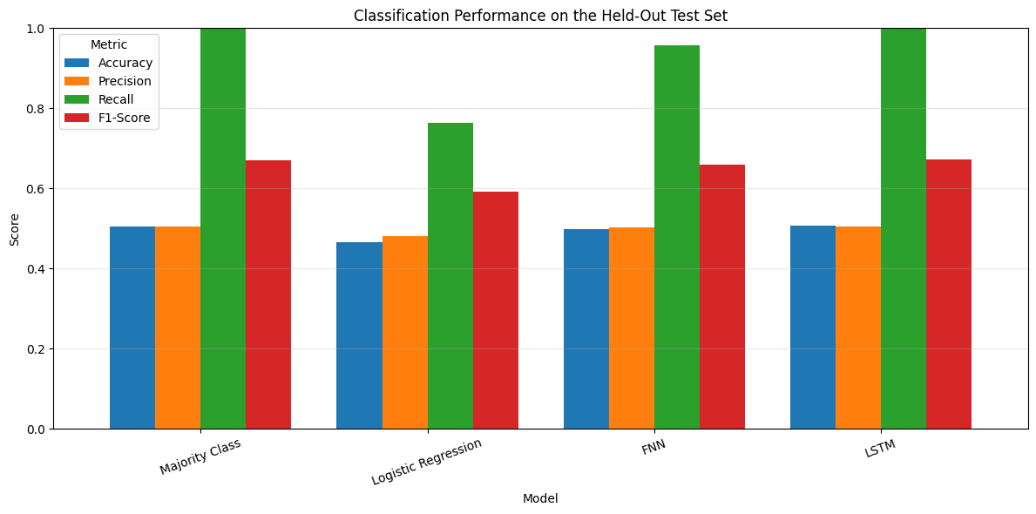
Figure 1. Test-set classification metric comparison generated by the notebook.
Logistic Regression reaches 46.58% accuracy and an F1-score of 0.5910, below the majority baseline on both metrics. Balanced accuracy, macro-F1, Matthews correlation coefficient, and class-specific metrics would provide a more complete view than positive-class F1 alone.

6. Walk-forward validation
Expanding-window TimeSeriesSplit validation was performed for Logistic Regression over the development period. Across five folds, mean accuracy was 0.5340 (standard deviation 0.0179) and mean F1-score was 0.6144 (standard deviation 0.0571). The fold-specific majority baseline achieved mean accuracy 0.5413 and mean F1-score 0.7022. Logistic Regression did not exceed the majority baseline in F1-score in any fold.

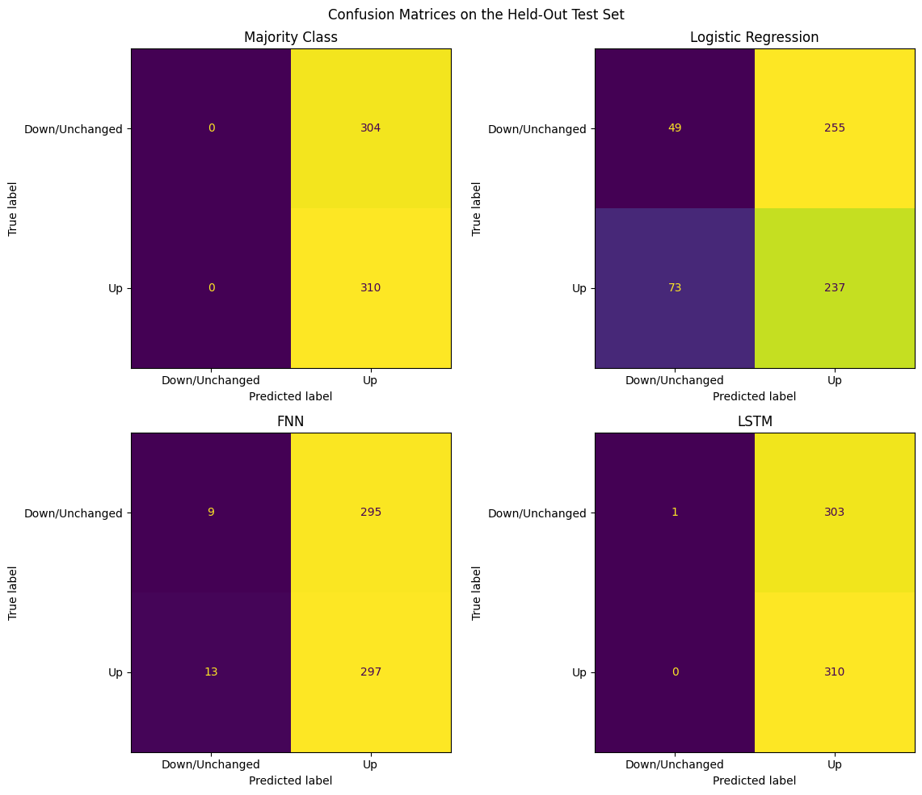
Figure 2. Walk-forward validation results from the notebook.
Walk-forward retraining was not conducted for the FNN and LSTM, so these results do not establish relative robustness across all four approaches.

7. Trading simulation
Predicted probabilities were converted into long-or-cash positions using a 0.50 threshold. A one-way transaction cost of 0.1% was charged on turnover. The simulation covers the held-out test period, 5 April 2024 to 29 September 2026.
Strategy | Total return | Annualized return | Volatility | Sharpe | Max drawdown
FNN | -0.1042 | -0.0442 | 0.1299 | -0.2825 | -0.1885
LSTM | 0.0106 | 0.0043 | 0.1363 | 0.0999 | -0.1519
Logistic Regression | -0.3151 | -0.1439 | 0.1194 | -1.2410 | -0.3708
Buy and Hold | 0.0047 | 0.0019 | 0.1365 | 0.0825 | -0.1577
At the assumed cost, the LSTM strategy returned 1.06%, versus 0.47% for buy-and-hold. Its Sharpe ratio was 0.0999 versus 0.0825 for buy-and-hold, and its maximum drawdown was 15.19% versus 15.77%. This is a small difference and does not establish a reliable edge. The FNN and Logistic Regression strategies returned -10.42% and -31.51%, respectively.

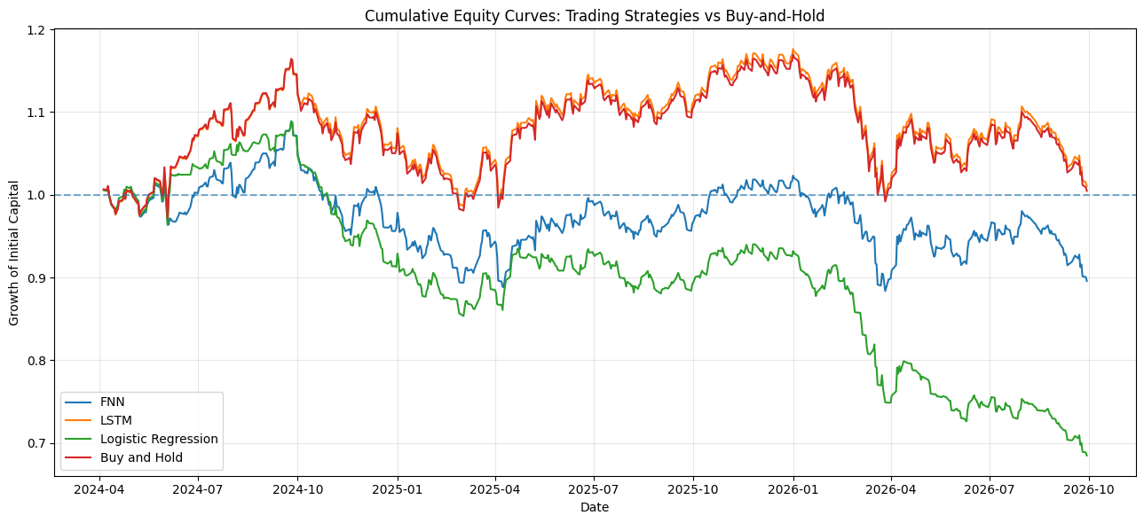
Figure 3. Equity curves for the backtested strategies.

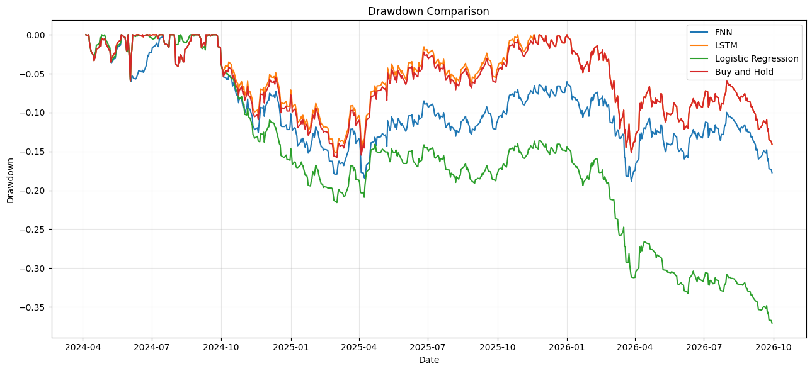
Figure 4. Drawdown comparison across strategies.
The cost-sensitivity output reports an LSTM total return falling from 1.36% at zero assumed cost to 0.76% at 0.2% one-way cost. The notebook's buy-and-hold benchmark does not pay turnover costs, so the cost comparison is not fully symmetric.

8. Limitations and methodological cautions
- The test accuracy is close to 50%, and the neural classifiers make strongly one-sided upward predictions.
- The simulated return convention uses close-to-close returns after a signal based on the current close. Execution at that same close may not be feasible after observing the close.
- Slippage, taxes, liquidity, cash interest, and other frictions are not modeled.
- Both neural models selected epoch 1 by validation loss in the saved run, which may indicate weak learning, underfitting, or limited useful signal.
- Walk-forward evaluation is reported for Logistic Regression only.
- The study uses one index and price-derived features, so its findings may not generalize to other assets or regimes.
- Positive-class F1 alone can be misleading when almost every observation is predicted as upward.

9. Recommended next experiments
- Report balanced accuracy, macro-F1, Matthews correlation coefficient, ROC-AUC, and predicted class proportions.
- Choose probability thresholds on validation data only, then lock them before test evaluation.
- Use a realistic next-open execution model and apply benchmark transaction-cost assumptions consistently.
- Retrain FNN and LSTM in expanding-window folds and compare all models on the same folds.
- Add simple trading baselines such as buy-and-hold and moving-average rules.
- Evaluate more than one chronological test window and report uncertainty.
- Tune model complexity and regularization using validation data without repeatedly consulting the test set.

10. Conclusion
The notebook implements an end-to-end pipeline for next-session NIFTY 50 direction classification, including data preparation, feature engineering, chronological evaluation, baseline models, FNN and LSTM training, walk-forward validation, and a simplified backtest. The LSTM achieved the highest test accuracy (50.65%) and positive-class F1 (0.6717), but its near-always-up predictions mean the apparent advantage over the majority baseline is negligible. Logistic Regression did not consistently outperform the majority baseline in walk-forward validation.
The LSTM backtest was modestly positive under the chosen assumptions, but the small return and Sharpe ratio do not demonstrate dependable trading value. The most defensible conclusion is that the current feature set and model configurations do not show strong or robust market-direction predictability. The next priority is better diagnostic metrics, realistic execution, and fair walk-forward comparisons across all models.

Reproducibility
Numerical results in this report are transcribed from the saved outputs in the uploaded notebook. Before submission, add author/course details, cite yfinance and the software libraries as required, and confirm that all notebook outputs match the version used for the report.

