1.Google studio snapshots

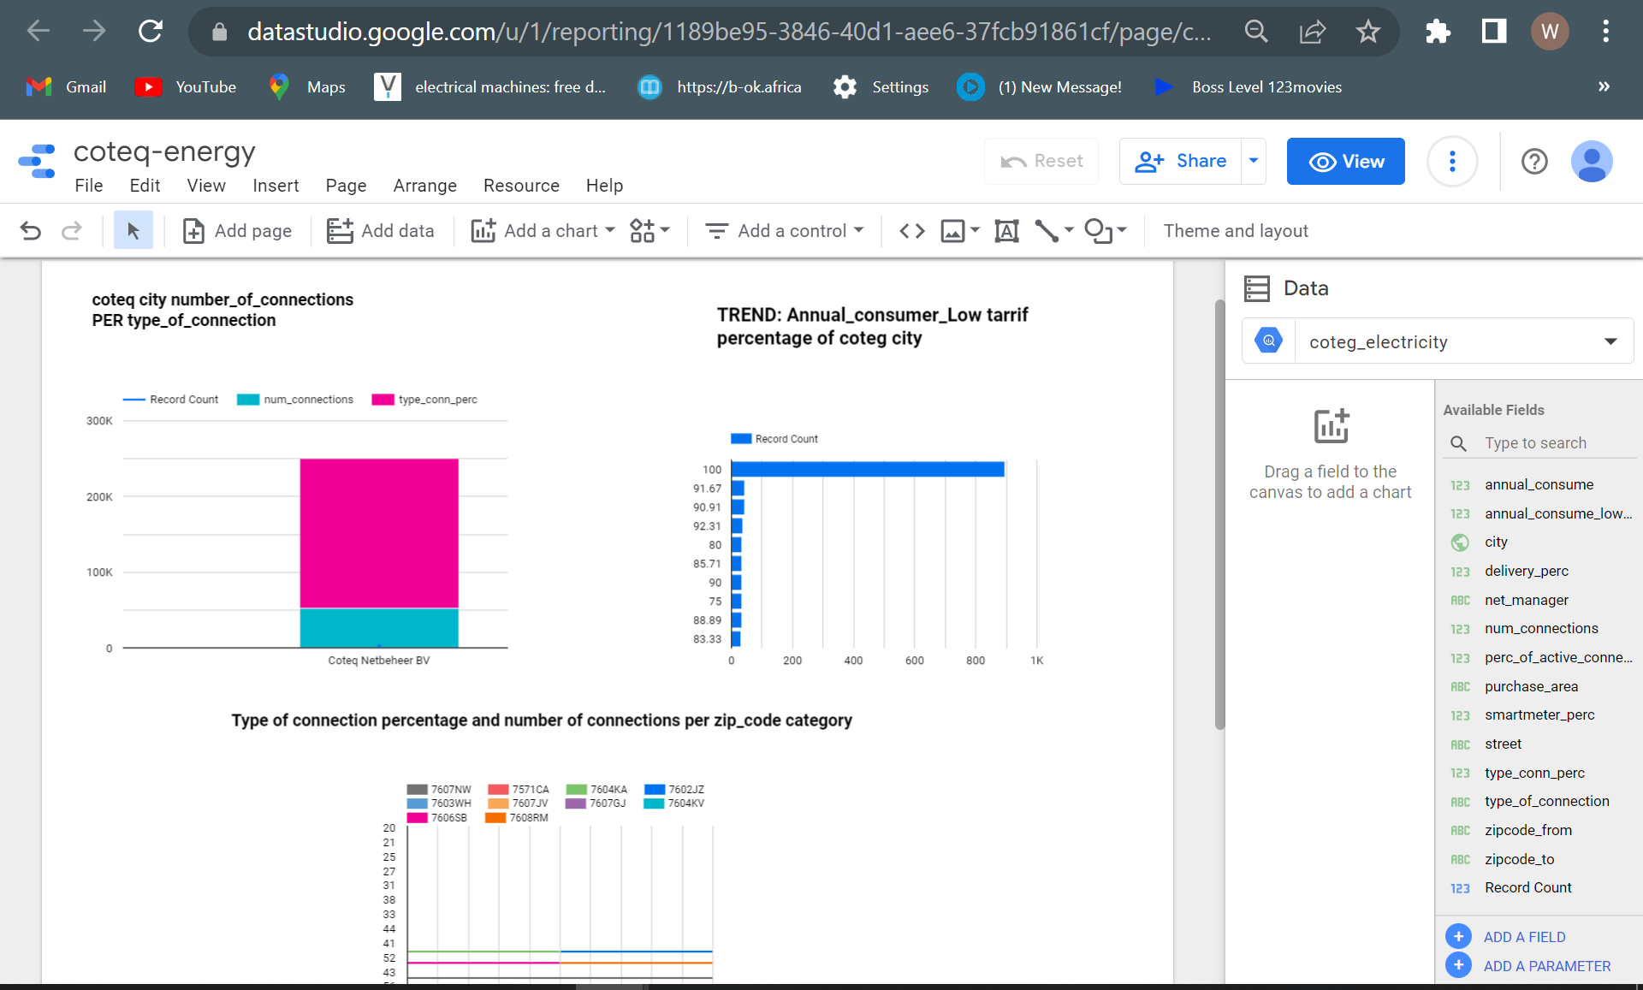

Google data studio

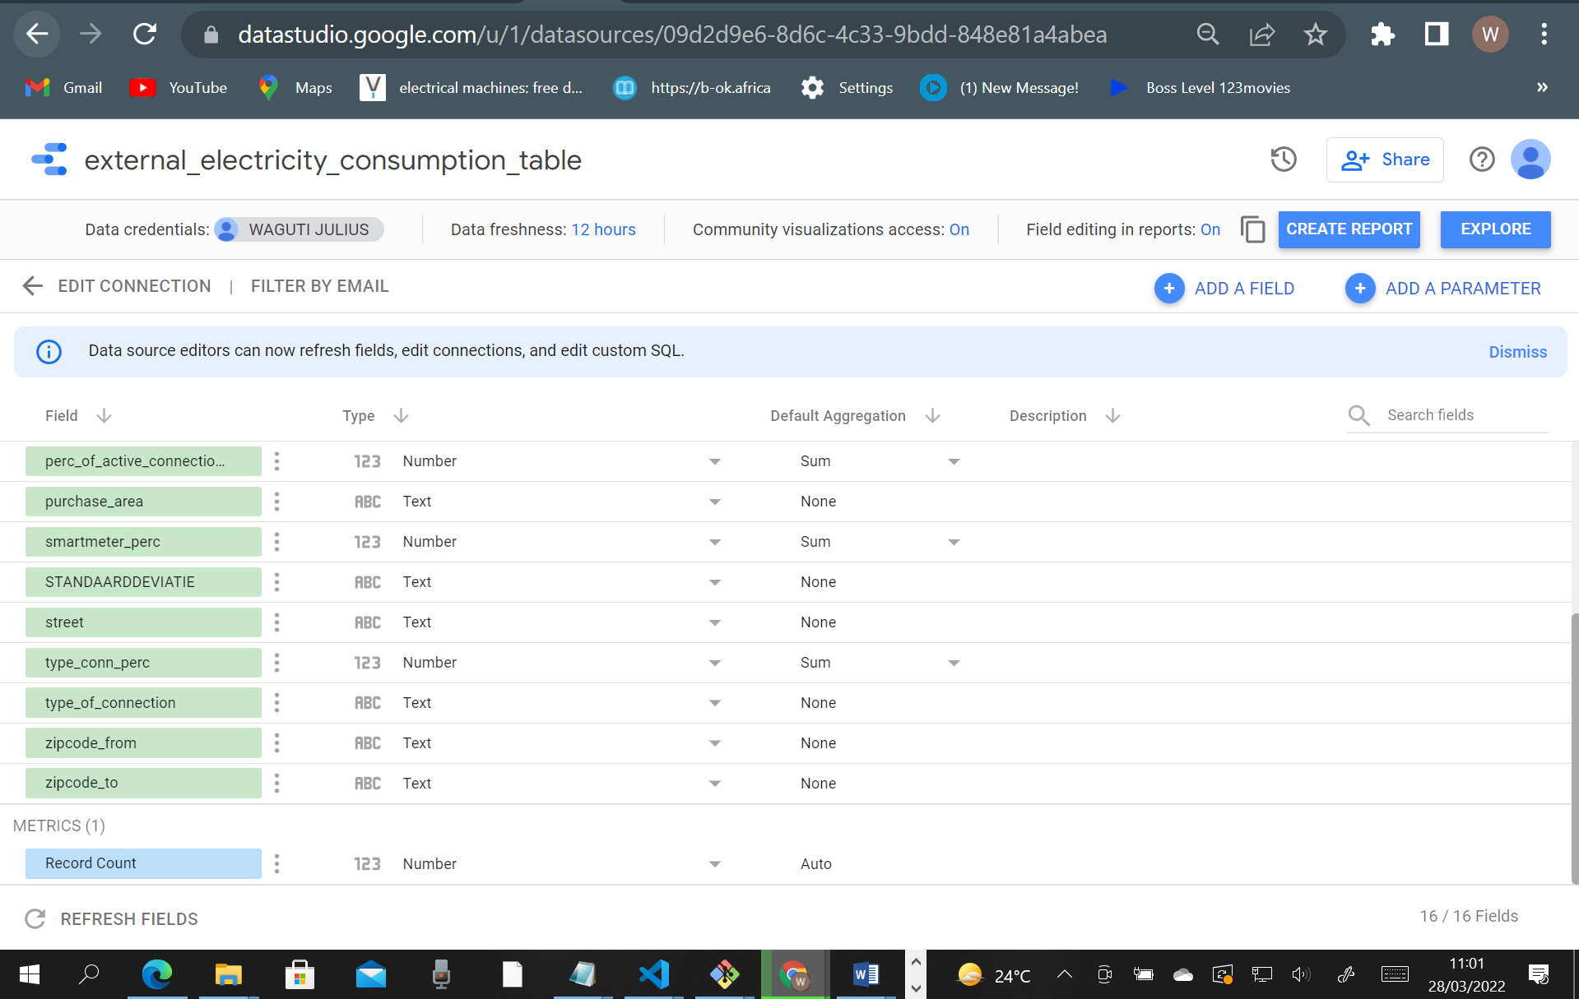

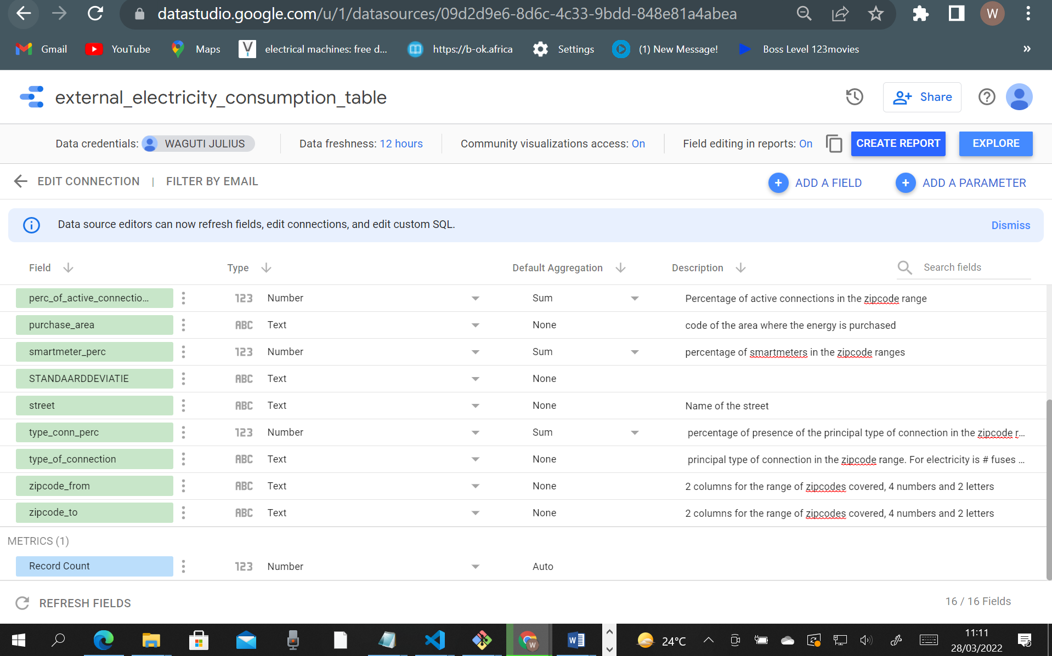

2. Installs of spark-jobs in apache airflow

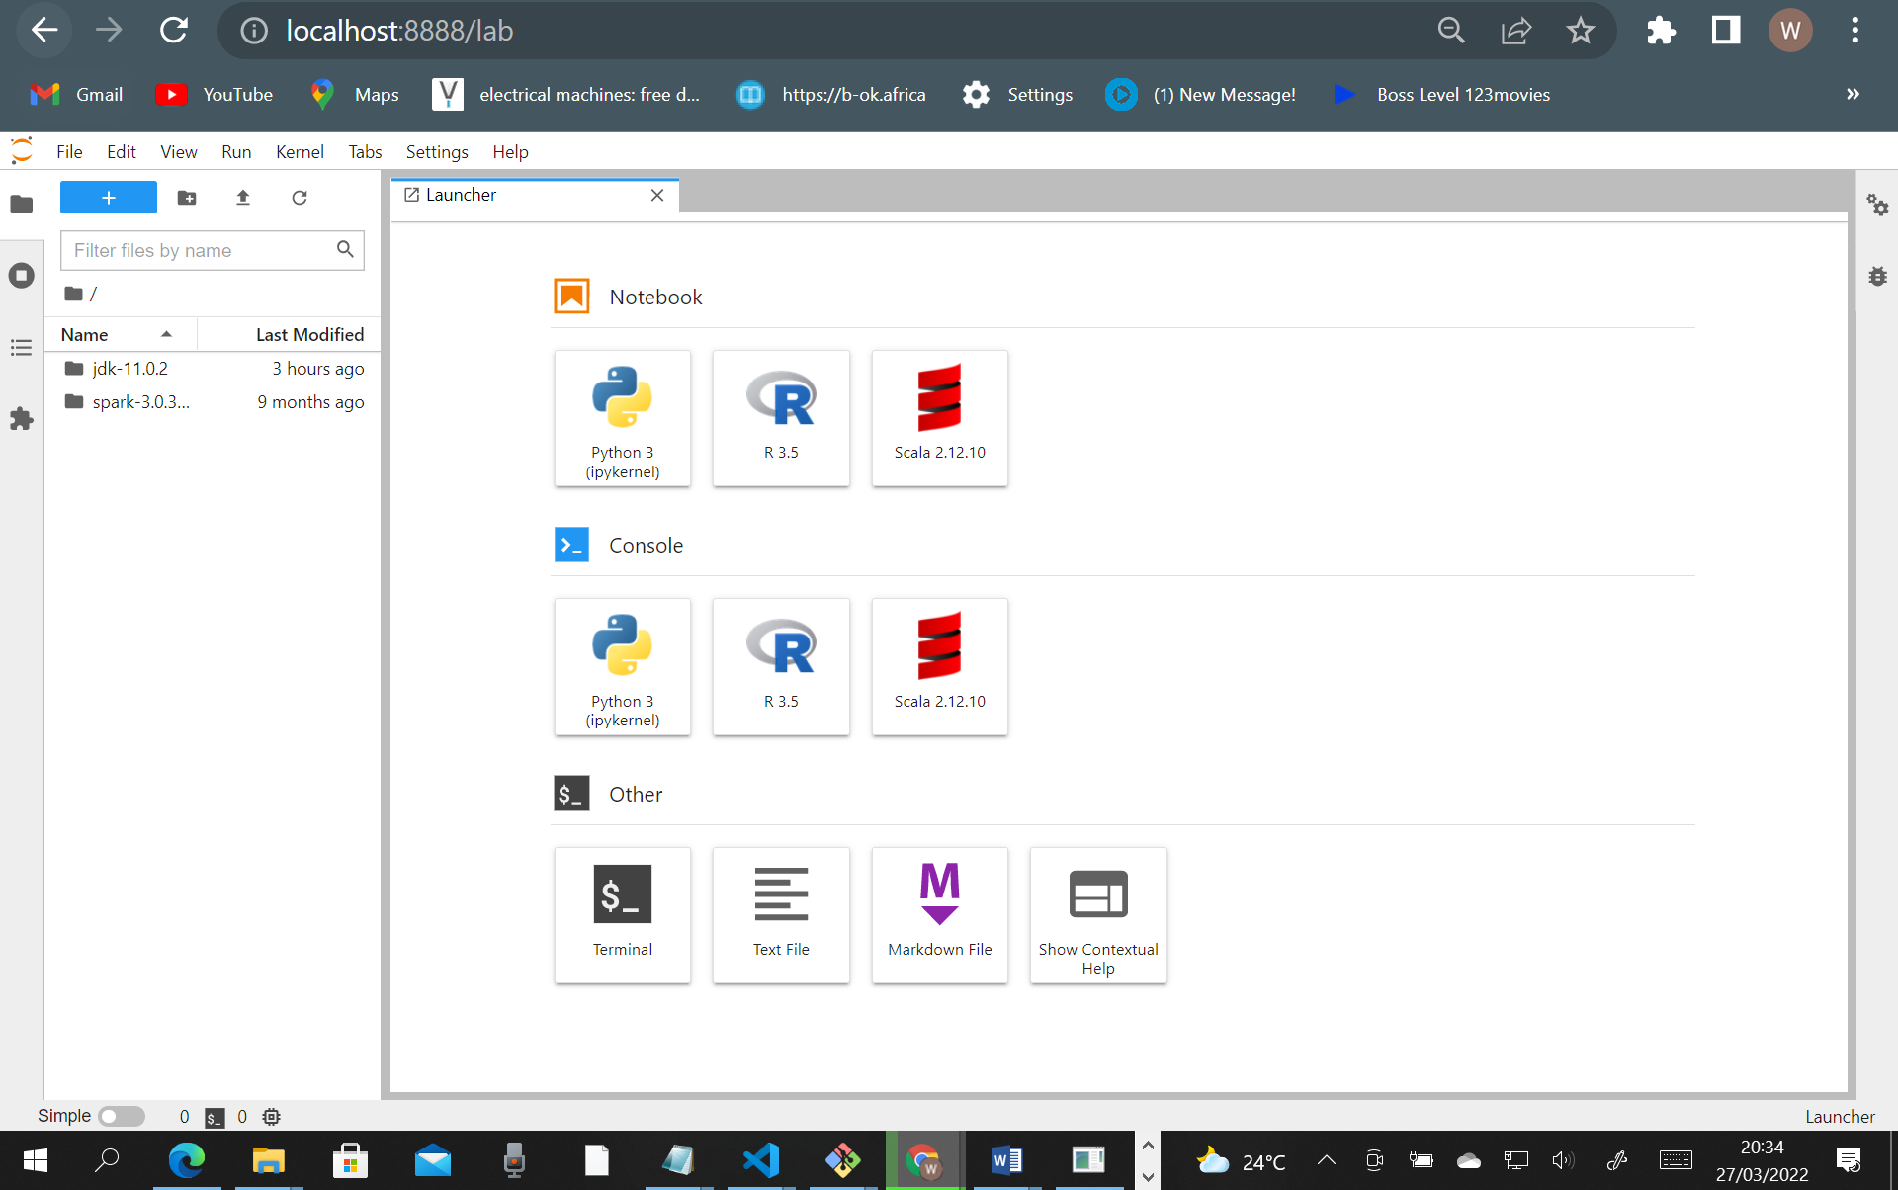

Running spark-jobs in airflow

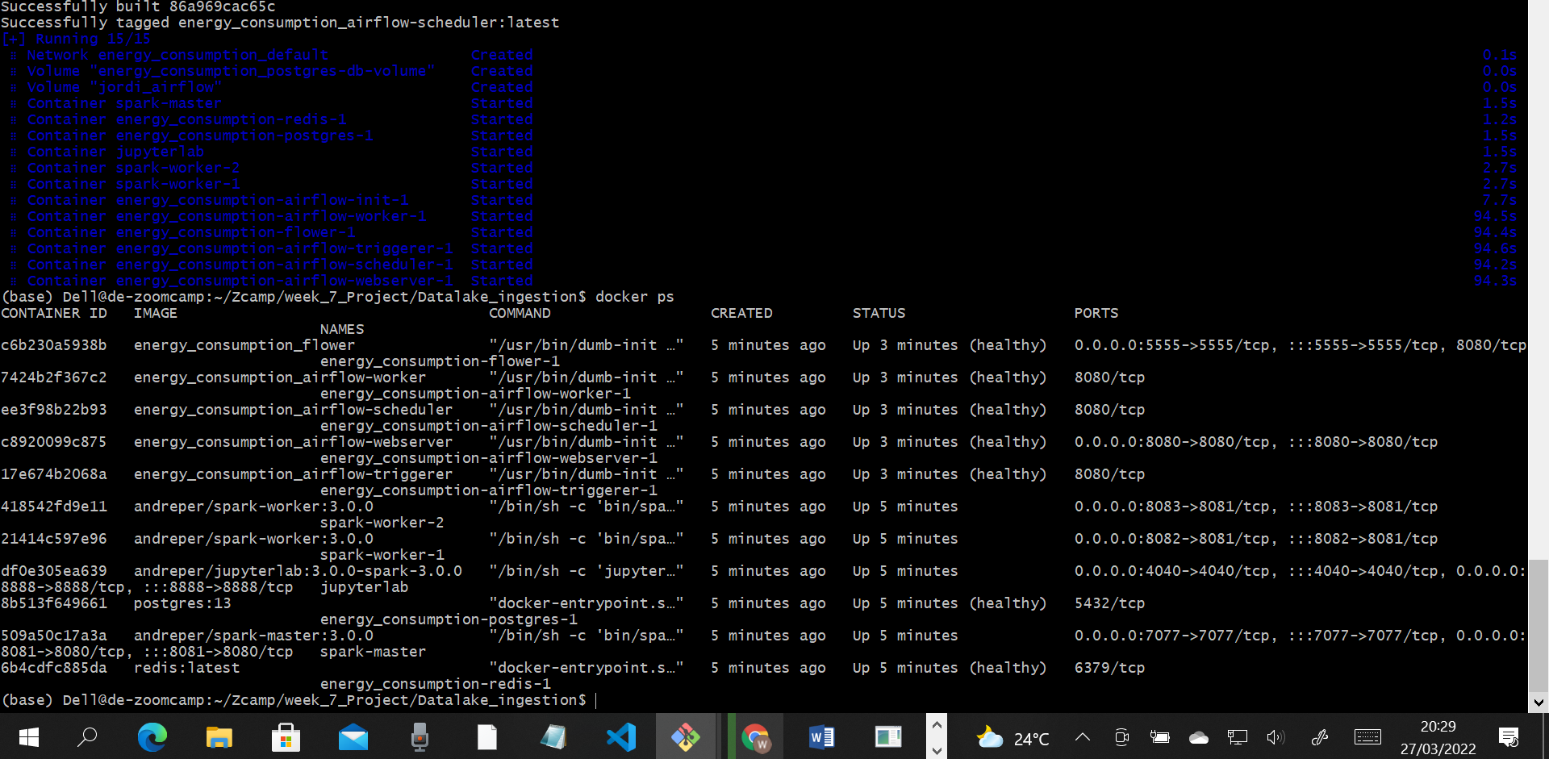

Saving env, variables to path in (nano .bashrc) the (source .bashrc)