The valuation is done via a REST endpoint. It is supplied by the ApplicationREST run configuartion.

The actual valuation is done with the ValuationClientREST.

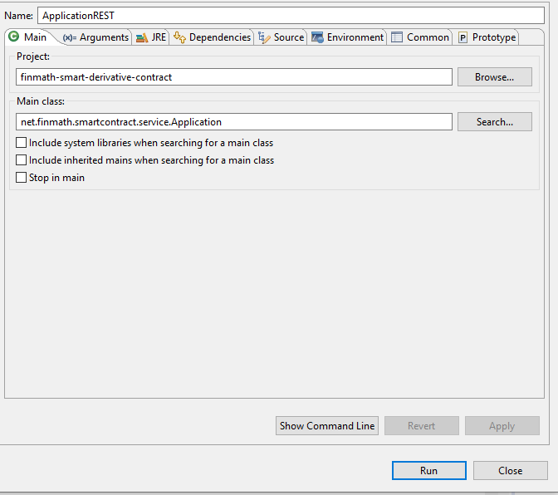

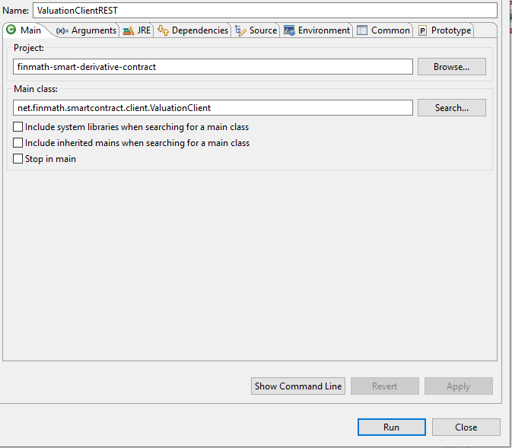

Both run configurations need the following Arguments and Environment variable.

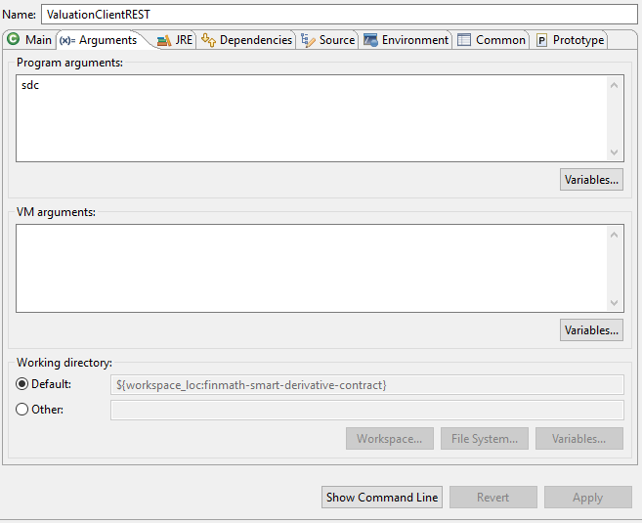

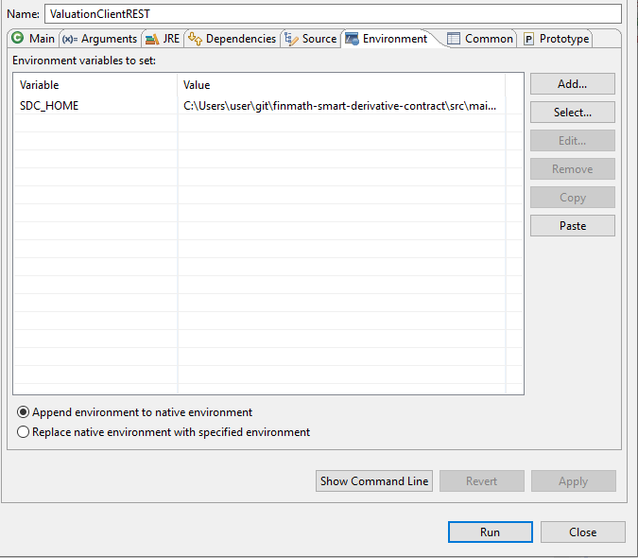

SDC_HOME must point to the main directory containing the data and etc subdirectory.

The file sdc.properties holds the following parameters.

### Demo Files

JSON_FILE_1=20210419.json

JSON_FILE_2=20210420.json

FPML_FILE_1=ird-ex01-vanilla-swap.xml

### Rest Endpoints

URL_ENDPOINT_TWO_CURVES=http://localhost:8080/margincalulationForProductAsFPML

# Application parameters

USE_MARKET_DATA_STRICT=false

USE_CURVES_STRICT_BUS_DAYS=false

USE_TRADE_LAST_MARGIN_DATE=false

The Json files contain the marketdata curves, the fpml file the trade to value.