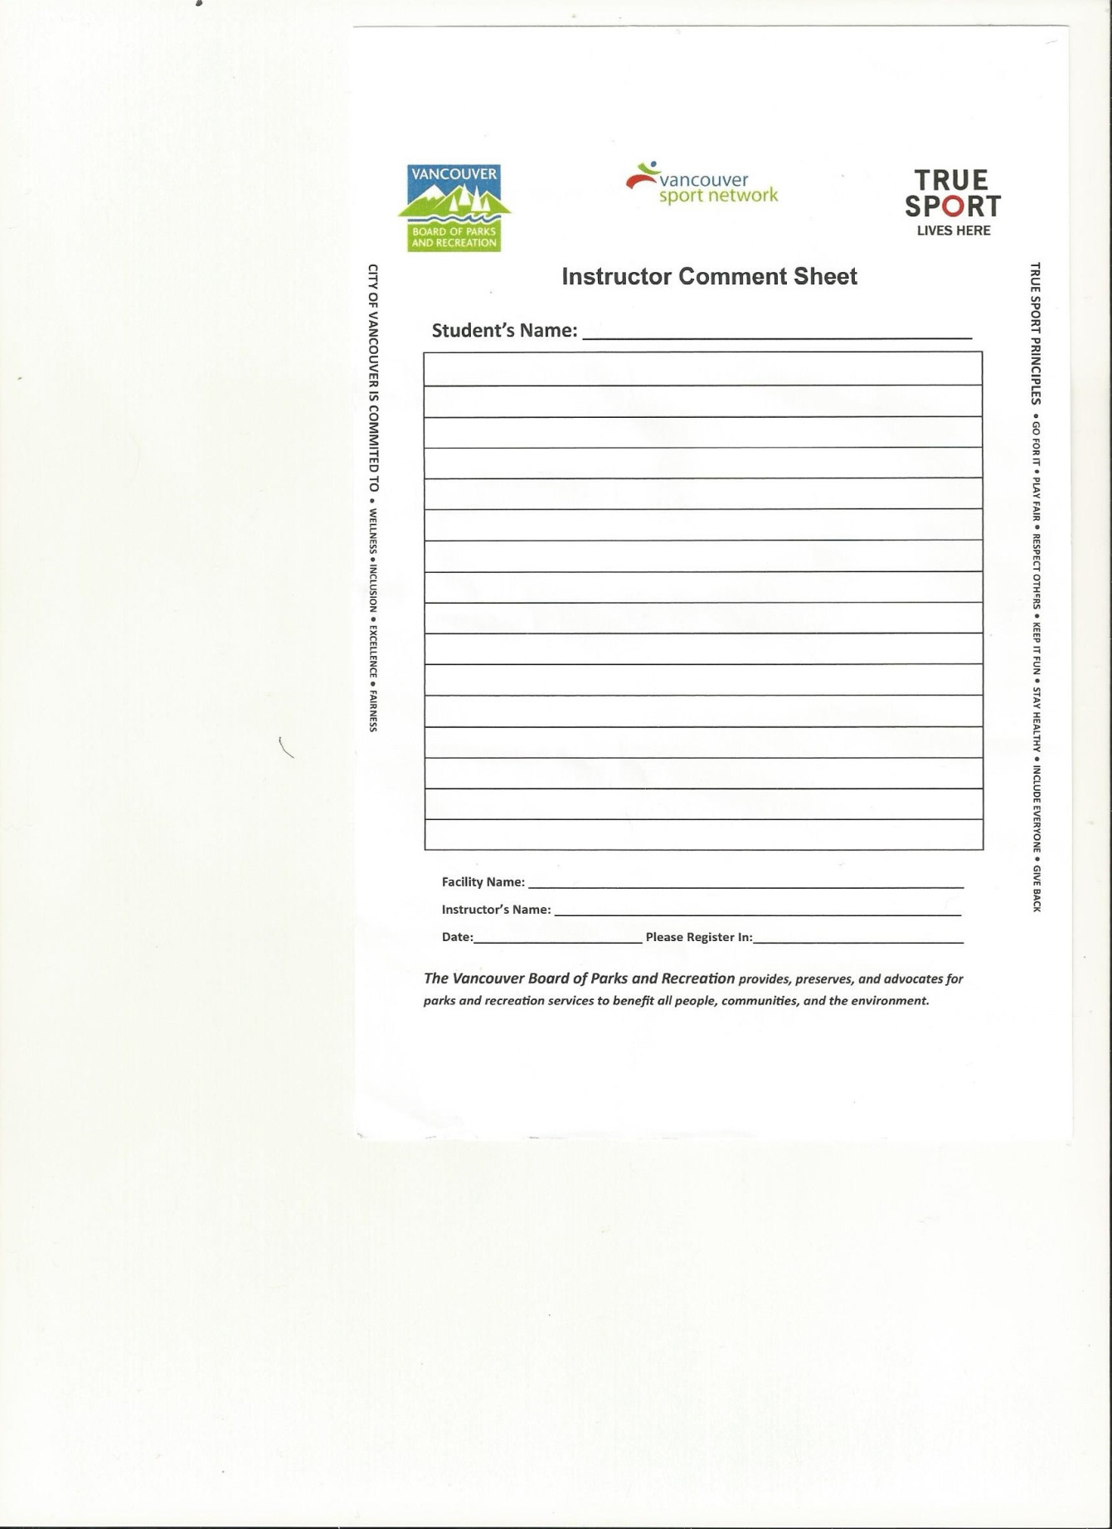

{date}

{level}

{comment1}

{studentName1}

{instructorName}

{facilityName}



{studentName2}

{comment2}

{level}

{date}

{instructorName}

{facilityName}



{date}

{level}

{comment3}

{studentName3}

{instructorName}

{facilityName}



{studentName4}

{comment4}

{level}

{date}

{instructorName}

{facilityName}



{date}

{level}

{comment5}

{studentName5}

{instructorName}

{facilityName}



{studentName6}

{comment6}

{level}

{date}

{instructorName}

{facilityName}