Nama : Julius Christian Simatupang

Class : Data Engineer Batch 8

1. dim_fulfillment

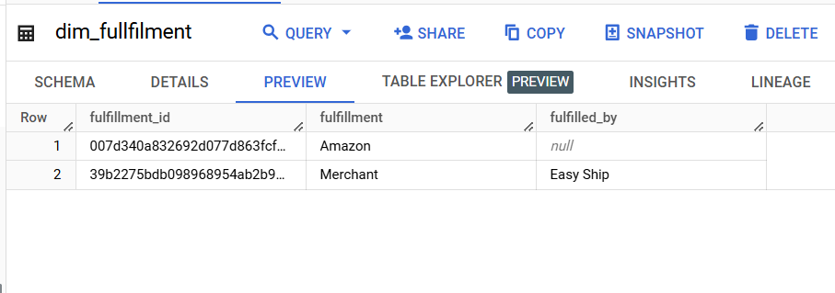

1. dim_product

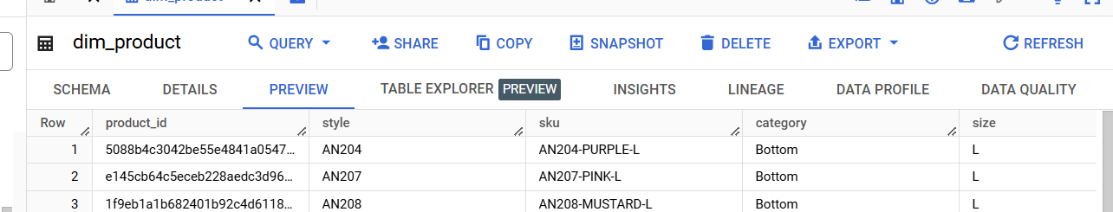

1. dim_promotion

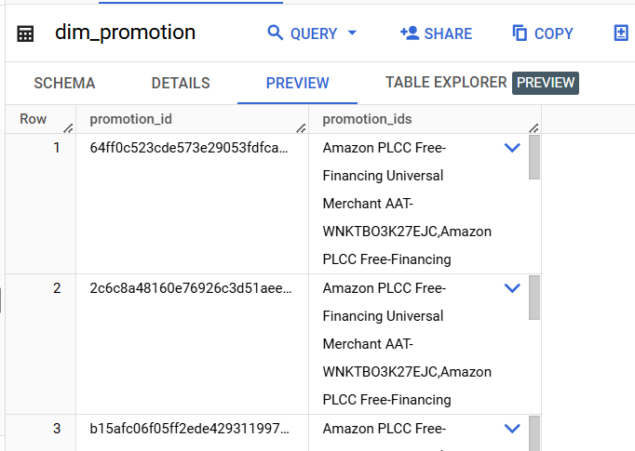

1. dim_sales_channel

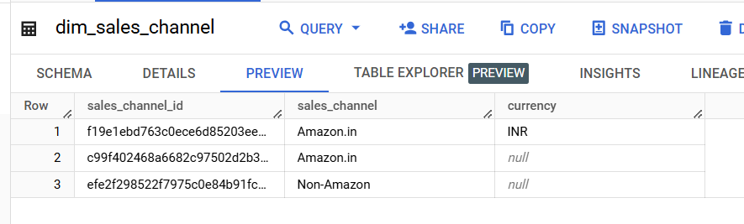

1. dim_sales_shipment

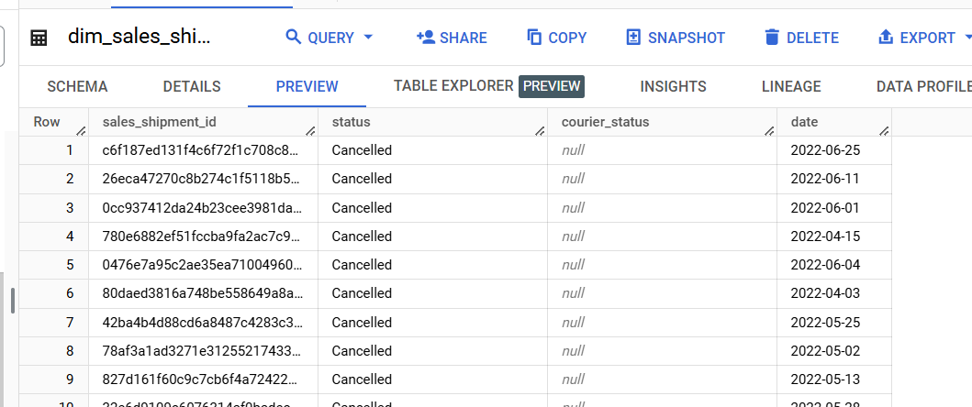

1. fact_sales

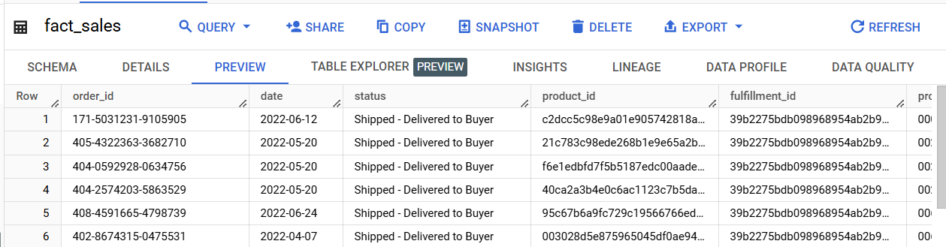

1. ERD

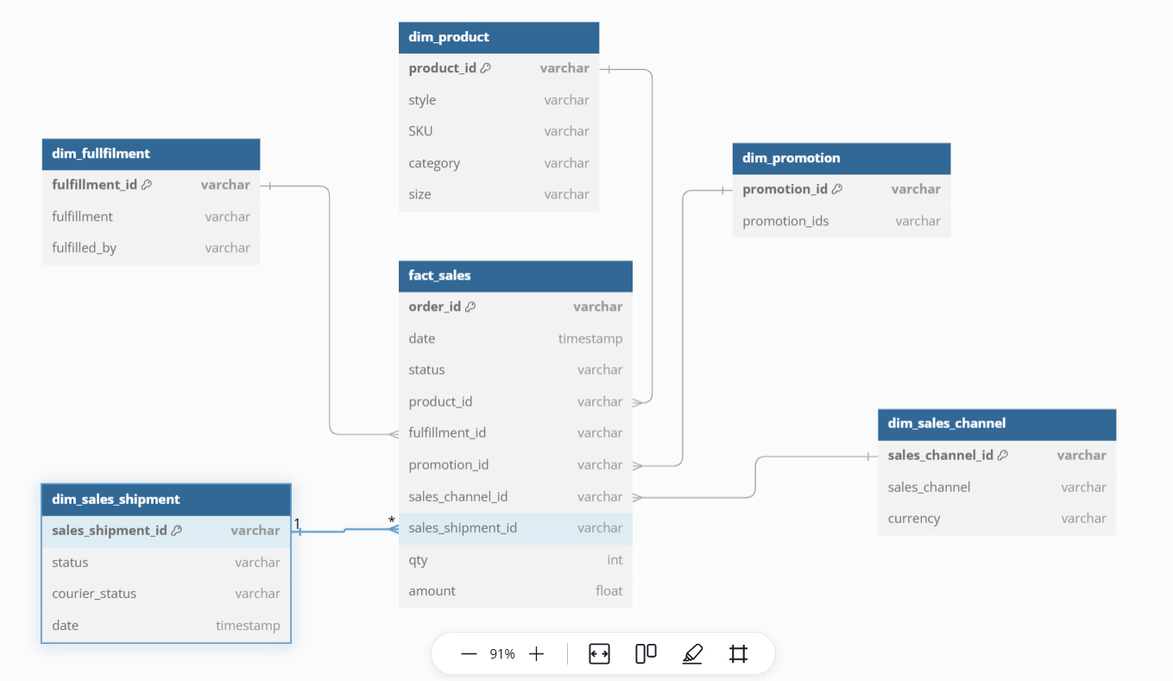

// Use DBML to define your database structure

// Docs: https://dbml.dbdiagram.io/docs

Table dim_fullfilment {

  fulfillment_id varchar [primary key]

  fulfillment varchar

  fulfilled_by varchar

}

Table dim_product {

  product_id varchar [primary key]

  style varchar

  SKU varchar

  category varchar

  size varchar

}

Table dim_promotion {

  promotion_id varchar [primary key]

  promotion_ids varchar

}

Table dim_sales_channel {

  sales_channel_id varchar [primary key]

  sales_channel varchar

  currency varchar

}

Table dim_sales_shipment {

  sales_shipment_id varchar [primary key]

  status varchar

  courier_status varchar

  date timestamp

}

Table fact_sales {

  order_id varchar [primary key]

  date timestamp

  status varchar

  product_id varchar

  fulfillment_id varchar

  promotion_id varchar

  sales_channel_id varchar

  sales_shipment_id varchar

  qty int

  amount float

}

Ref: fact_sales.product_id > dim_product.product_id

Ref: fact_sales.fulfillment_id > dim_fullfilment.fulfillment_id

Ref: fact_sales.promotion_id > dim_promotion.promotion_id

Ref: fact_sales.sales_channel_id > dim_sales_channel.sales_channel_id

Ref: fact_sales.sales_shipment_id > dim_sales_shipment.sales_shipment_id

1. Analisis Query

