**PROJECT REPORT**

**CASHIER SYSTEM USING ANDROID CAMERA AS CODE READER**

**Name : Aji Trinioferi** { 4817050025 }

**Cahya Mulyadi** { 4817050069 }

**Julius Danes Nugroho** { 4817050199 }

**Faculty : Mr. Musawarman S.Kom**

**ENGINEERING CENTRE 3rd FLOOR, FACULTY OF ENGINEERING**

**UNIVERSITY OF INDONESIA**

**PROJECT ON**

**CASHIER SYSTEM USING ANDROID CAM AS CODE READER**

**Developed By**

**Name : Aji Trinioferi** { 4817050025 }

**Cahya Mulyadi** { 4817050069 }

**Julius Danes Nugroho** { 4817050199 }

**NIIT**

**CASHIER SYSTEM USING ANDROID CAM AS CODE READER**

Batch Code : 2NAP1

Start Date : April 2, 2018

End Date : April 20 , 2018

Name Of The Coordinator : Mr. Musawarman, S.Kom

Name Of Developer : Aji Trinioferi { 4817050025 }

Cahya Mulyadi { 4817050069 }

Julius Danes N. { 4817050199 }

Date Of Submission : April 20, 2018

**NIIT**

**NIIT**

**CERTIFICATE**

This is to certify that this report, titled “Cashier System Using Android Camera As Code Reader”, embodies the original work done by Aji Trinioferi, Cahya Mulyadi, and Julius Danes Nugroho. In partial fulfillment of his/her course requirement at NIIT.

Coordinator :

***Mr. Musawarman, S.Kom***

**ACKNOWLEDGEMENT**

Praise and huge thanks to Allah SWT. for giving us blessings, health, ability to be able to finish this Project with the title “Cashier System Using Android Camera As Code Reader”, without any of it we won’t be able to complete it right on time. Despite many hurdles and obstacles that we experienced in the course of the work, but we managed to finish it properly.

We have benefited a lot from the feedback and suggestions given to us by Mr. Musawarman, S.Kom.

**System Analysis**

**System Summary :**

This Project, Our team make Cashier System Using Android Camera As Code Reader application for mini market. Our team using Android Camera as QR Code Reader that used on Product ID. This Application have many menu, which is Product menu, Employee menu, Transaction menu and Report menu, Etc.

**Menu in The Application :**

* Master Main Display (For Login as Admin or User Cashier)
  + Master Admin Display

- Update Employee Data

- Add Employee Data

- Remove Employee Data

- Add Product Data

- Update & Remove Product Data

- Search Product Data

- Report Data

* + Master Menu Cashier Display

- Main

- Payment

- Trans Data

**INTERFACE DESIGN FOR CASHIER**

1. Mini Market Login

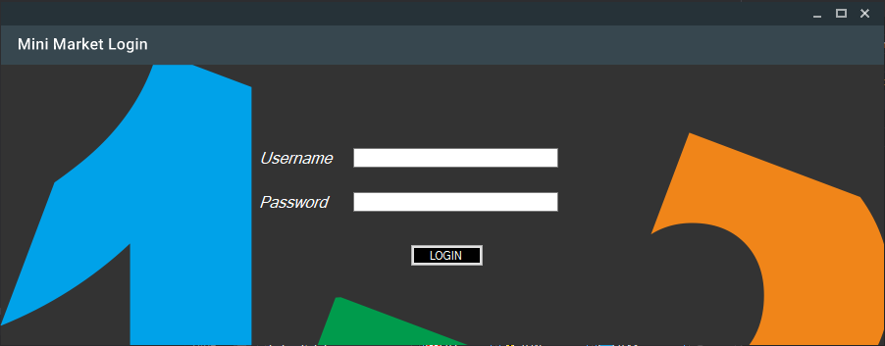

1. Master Admin Menu

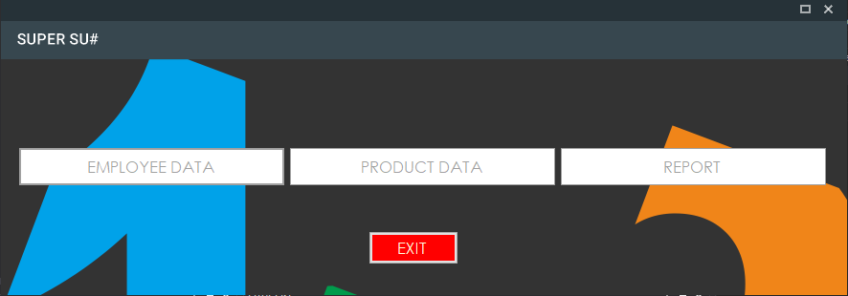

1. Product Data Menu

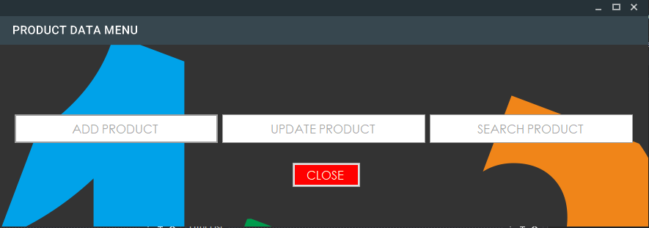

**INTERFACE DESIGN FOR CASHIER**

1. Add Product Menu

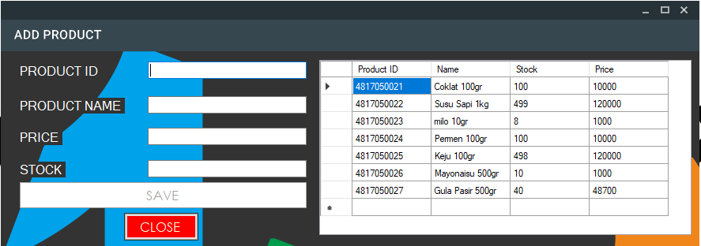

1. Update Product Menu

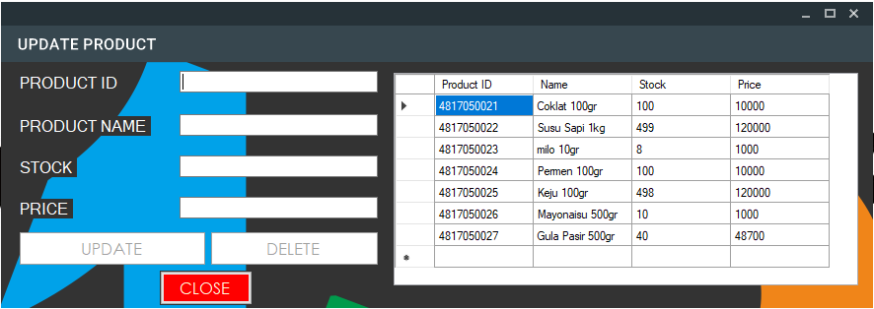

1. Search Product Menu

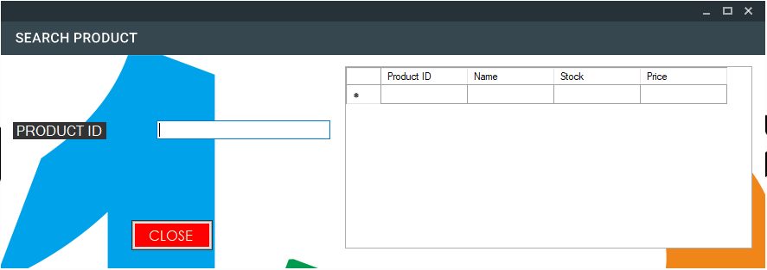

**INTERFACE DESIGN FOR CASHIER**

1. Report Menu

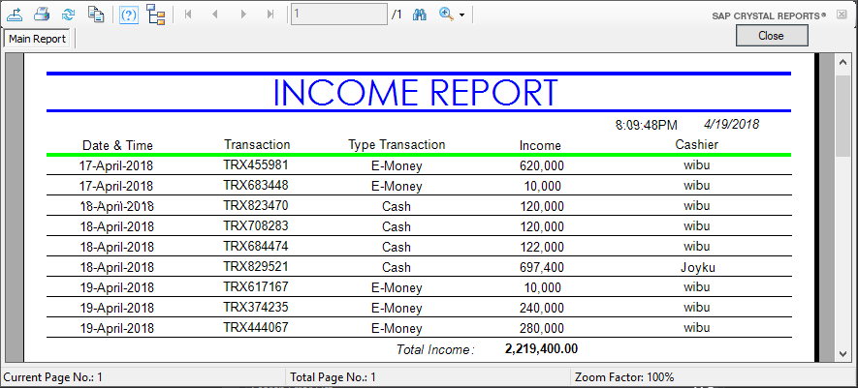

1. Master Employee (Add, Update, Remove, Search)

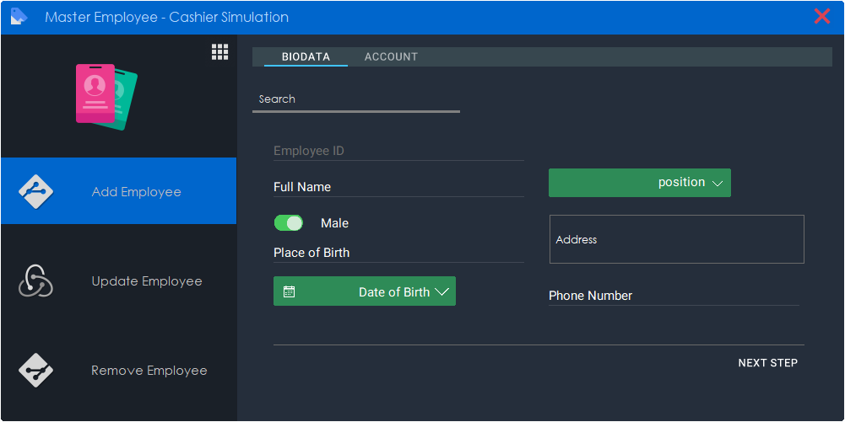

1. Cashier Main Menu

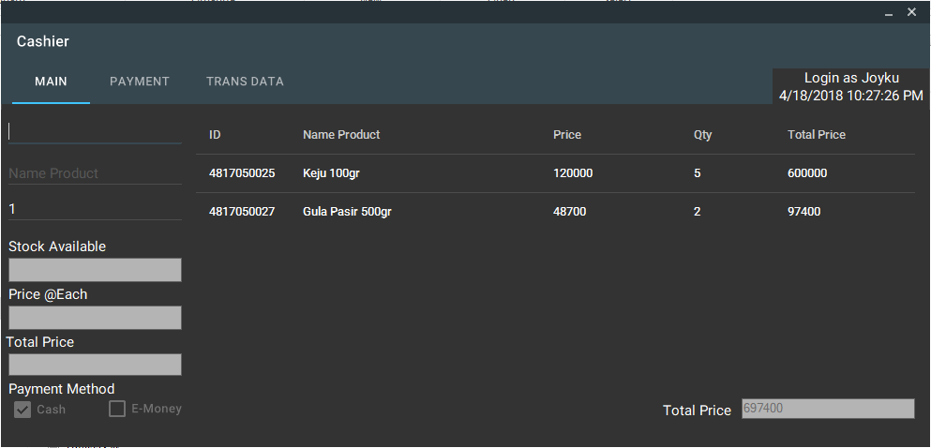

**INTERFACE DESIGN FOR CASHIER**

1. Cashier Payment Menu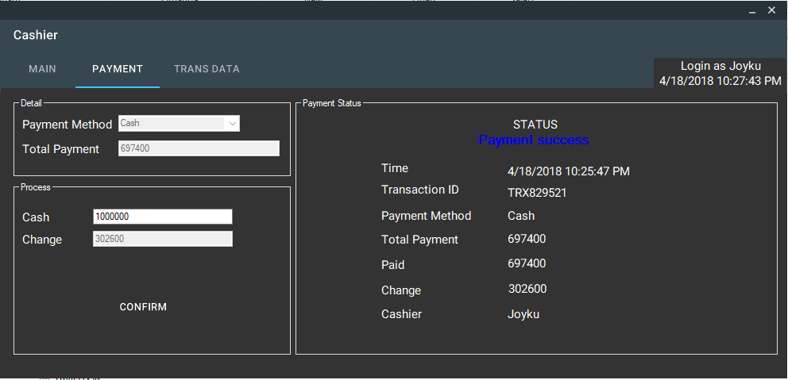
2. Cashier Trans Data (Transaction List) Menu

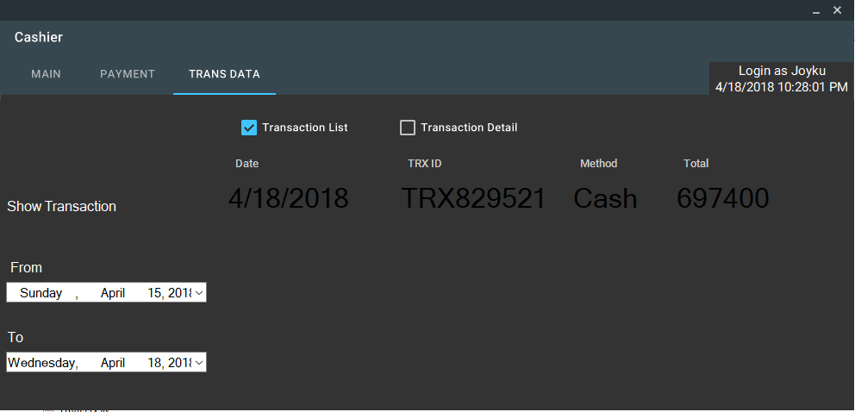

1. Cashier Trans Data (Transaction Detail) Menu

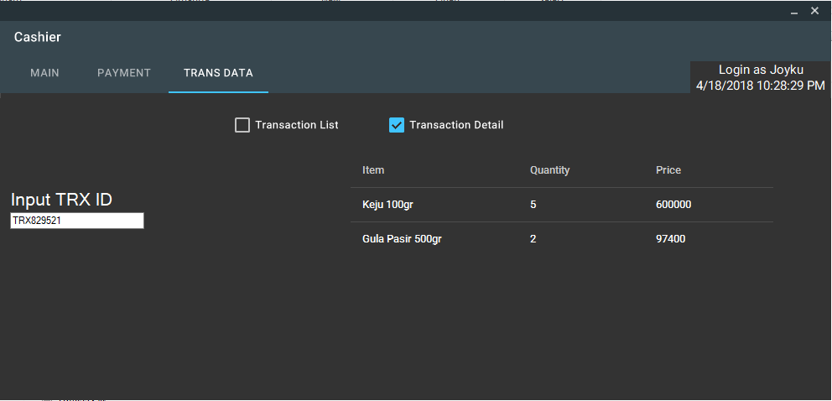

**CONFIGURATION**

**Operating System :**

Windows 10 Pro 64-bit (10.0, Build 16299) (16299.rs3_release.170928-1534) **Language :**

Indonesian (Regional Setting: Indonesian) / English (United State)

**System Manufacturer:**

Acer

**System Model:**

Aspire E14 (E5-475G-70XV)

**BIOS:**

V1.18

**Processor:**

Intel(R) Core(TM) i7-7500U CPU @ 2.70GHz (4 CPUs), ~2.9GHz

**Memory:**

4096MB RAM DDR 4

**Graphic:**

Intel(R) HD Graphics 620

**Software Microsoft :**

Microsoft Visual Studio 2015 Enterprise

**FORM OUTLINE**

|  |  |
| --- | --- |
| ***Form Names*** | ***Description*** |
| Main Form | This form for LogIn as User or Admin |
| Master Admin Display | This Form for Menu as Admin |
| Update Employee Data | This form for Update Employee Data |
| Add Employee Data | This form for Add Employee Data |
| Remove Employee Data | This form for Remove Employee Data |
| Add Product Data | This form for Add Product Data |
| Update & Remove Product Data | This form for Update Product Data |
| Search Product Data | This form for Search Product Data |
| Report Data | This form for Print Report Income |
| Master Menu Cashier Display | This Form for Menu as Cashier |
| Main | This Form for Do Transaction |
| Payment | This Form for Do Final Payment and Show Invoice |
| Trans Data | This Form for show All Transaction / Cashier Employee |