

Figure First Interface

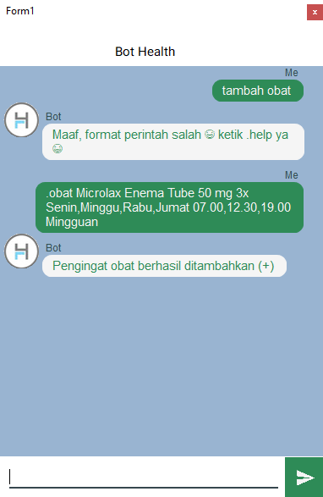

Figure Add Alert of Medicine



Figure Delete Alert of Medicine



Figure Add Alert of Medicine with Another Format Input



Figure Add Alert of Sport



Figure Validation Format Input