**How to install python (installations on windows)**

Visit the link https://www.python.org/downloads/

To download the latest release of Python. In this process, we will install Python 3.8.6 on our Windows operating system. When we click on the above link, it will bring us the following page.

Step 1: **Download the Python Installer:**

* Go to the official Python website python.org or visit the link = *https://www.python.org/downloads/*
* On python.org navigate to the Downloads section and click on the "Download Python" button. This will download the latest version of Python for Windows on your Windows Operating system.
* On the https://www.python.org/downloads/ site download the latest version for windows by clicking “Download python 3.12.4” as shown below

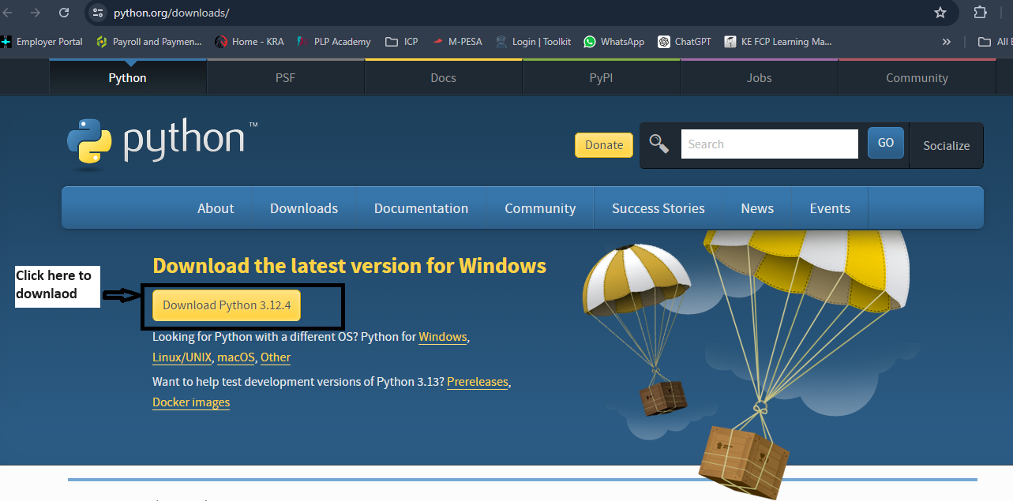

Step 2: **Run the Installer:**

* Once the installer is downloaded, locate it in your downloads folder and double-click it to run.
* When the installer window opens, you’ll see an option at the bottom to "Add Python to PATH." Check this box to ensure you can use Python from the command line.
* Click on "Install Now" for a simple installation. Alternatively, you can click on "Customize installation" for more advanced options (e.g., choosing the installation location, adding Python to the environment variables, etc.).

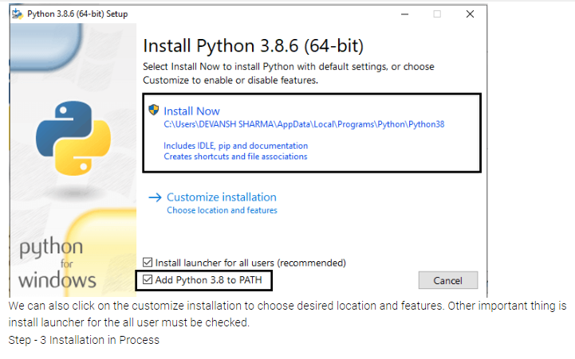

Step 3: **Verify the Installation:**

* Once the installation is complete, open a Command Prompt window (you can do this by searching for cmd in the Start menu).
* Type python --version and press Enter. This should display the version of Python you installed.
* Similarly, you can type pip --version to check that the package installer for Python, pip, is also installed.

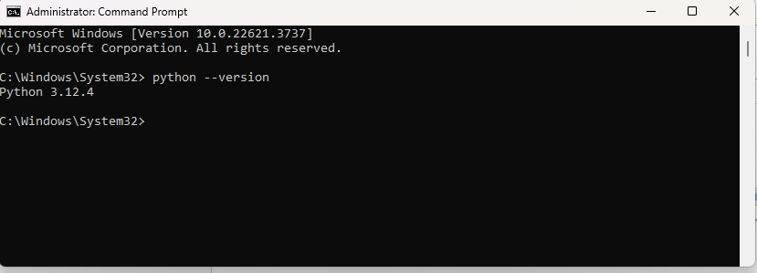

Step 4: **Set Up Your Development Environment (Optional):**

* You may also want to install a code editor or an integrated development environment (IDE) to write your Python code. Popular choices include:
  + **VS Code:** A lightweight but powerful source code editor with support for Python.
  + **PyCharm:** A feature-rich IDE specifically designed for Python development.
* Download and install your chosen editor, then configure it to use Python. For example, in VS Code, you can install the Python extension for enhanced support.

Step 5: **Update pip (Optional but Recommended):**

* Open Command Prompt and run python -m pip install --upgrade pip to ensure that pip is up to date.

**How To Install and Set Up Visual Studio Code.**

**Download Visual Studio:**

1. Visit the [Visual Studio website](https://visualstudio.microsoft.com/) and click on "Download for Windows."

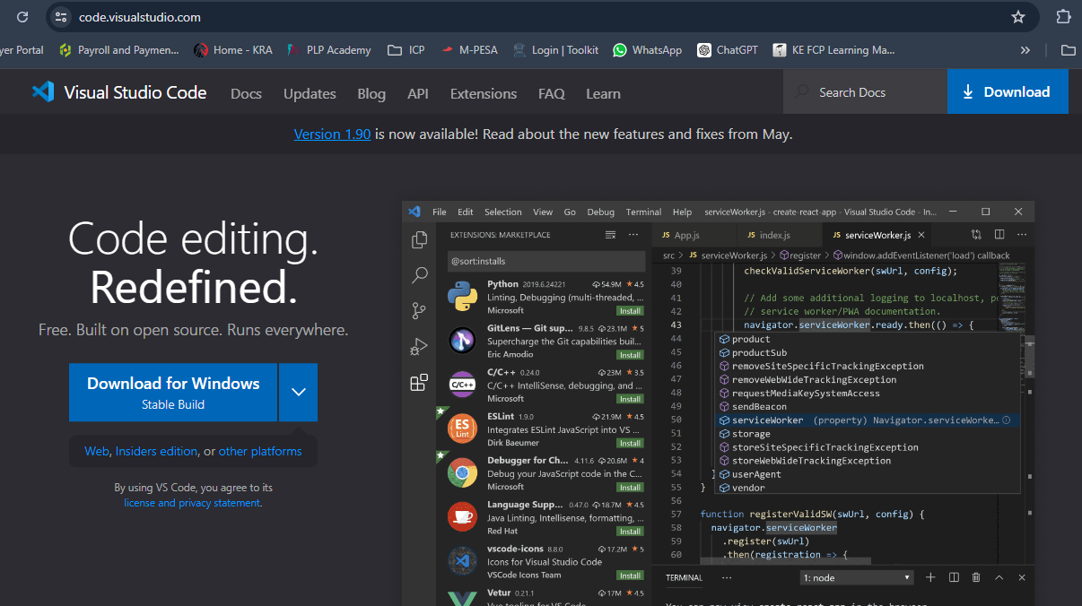

1. Follow the on-screen instructions to download the installer.

**. Run the Installer:**

1. Double click to Run the downloaded installer “VisualStudionSetup”

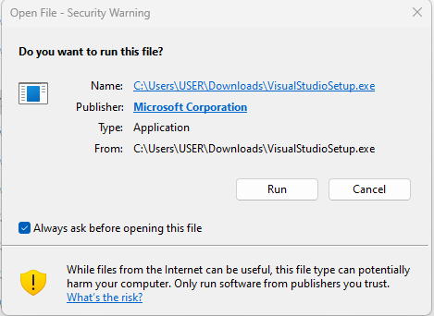

1. Once you click Run, click on the same command “continue” to follow the process.
2. Choose the "Visual Studio" workload during installation, which includes the necessary components for general development.

**. Select Workloads and Components:**

1. In the Visual Studio Installer, select the workloads and components you need based on your development requirements. Common workloads include ".NET Desktop Development" or "Web Development."

**Modify Installation (Optional):**

1. If needed, you can customize the installation by clicking on the "Individual components" tab in the installer and selecting or deselecting specific components.

**Install:**

1. Click the "Install" button to start the installation process.
2. This may take some time, as it involves downloading and installing the selected components.

**Launch Visual Studio:**

1. Once the installation is complete, launch Visual Studio.
2. Sign in with your Microsoft account or create one if prompted.

**Choose Development Environment:**

1. On the welcome screen, select your development environment. For example, you can choose "Development Settings" based on your preferred coding style.

**Start Coding:**

1. You're now ready to start coding! Create a new project or open an existing one to begin your development work.

**How to install git bash**

### 1. Download Git Bash

1. Use this like to download: [*https://gitforwindows.org/*](https://gitforwindows.org/%20)
2. Click the "Download" button. This will download the Git installer for Windows.

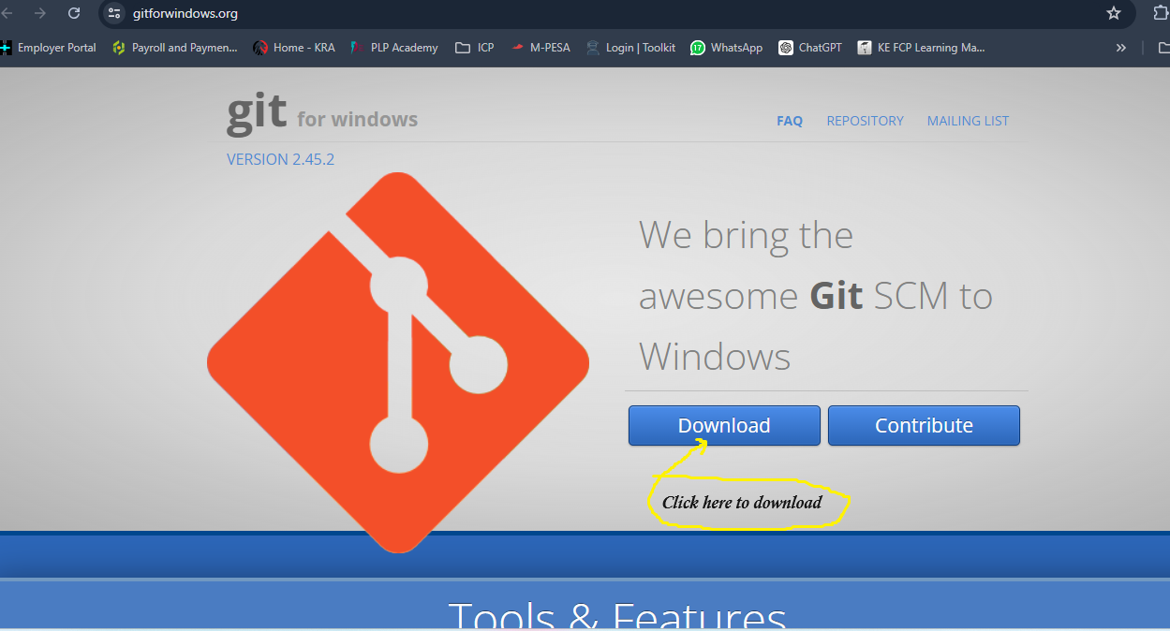

### 2. Install Git Bash

1. 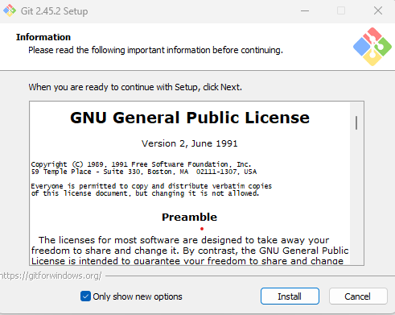Once the download is complete, locate it in your downloads and run the installer (double click the download installer file then click “run”).

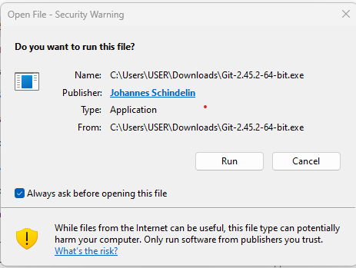

1. Follow the installation instructions:
   * **Select Components**: Leave the default options selected, or choose additional components if you know you need them.
   * **Adjusting your PATH environment**: Choose "Git from the command line and also from 3rd-party software" to ensure Git is available from the command prompt as well.
   * **Choosing the SSH executable**: Use the bundled OpenSSH.
   * **Choosing HTTPS transport backend**: Use the OpenSSL library.
   * **Configuring the line ending conversions**: Choose the option that suits your needs, typically "Checkout Windows-style, commit Unix-style line endings" is recommended.
   * **Configuring the terminal emulator**: Use MinTTY (the default terminal emulator for MSYS2).
   * **Default behavior for git pull**: Choose "Default (fast-forward or merge)".
   * **Enable file system caching**: Leave this enabled.
   * **Enable Git Credential Manager**: This is useful for managing credentials for repositories.
2. Complete the installation process.

### 3. Launch Git Bash

1. After the installation is complete, you can launch Git Bash from the Start menu or by searching for "Git Bash."

### 4. Configure Git

Before you start using Git, it's good to set up your configuration:

1. **Set your username**:

git config --global user.name "Your name”

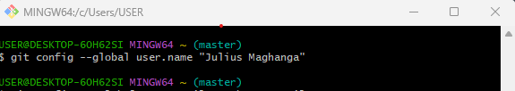

1. **Set your email**:

git config --global user.email [your.email@example.com](mailto:your.email@example.com)

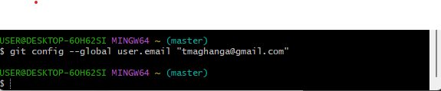

1. **Check your configuration**:

git config –list

1. **Verify the Installation:**

To verify that Git Bash is installed correctly, open Git Bash and run:

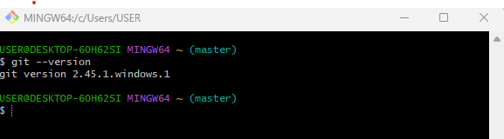

This should display the version of Git you have installed.

**To set an environment variable path**

1. Go to search in the windows search and type “environment variable” then open the file = Edit the system environment variable.
2. Click “Environment Variables” to open the environment variable

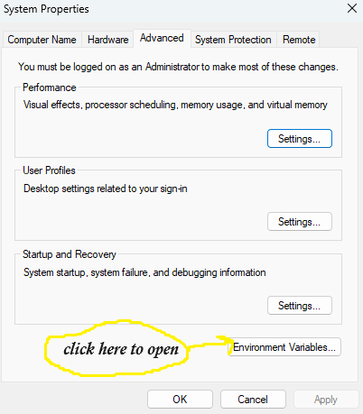

1. Click on the “path” under the section of the system variable (as shown below) then click “edit” to access the path to edit.

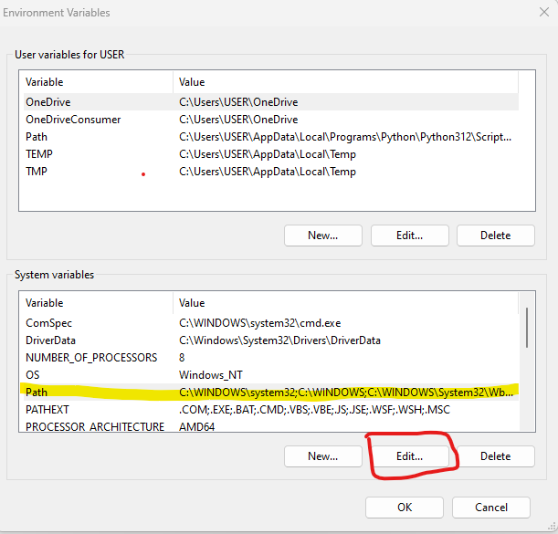

1. Click on “New” to open the dialog box where to insert the parth “C:\Program Files\Git\cmd” then click “OK” to close up the dialog box and seve the file path. Then click “Ok” to close the system Variables dialog box, then click “Ok” again to exit out of the system environment variable dialog box to exit completely.

