**How To Install and Set Up Visual Studio Code.**

**Prerequisites:**

* Ensure you have administrative privileges to install software on your Windows 11 machine.
* Having a stable internet connection to download the installer.

**Download Visual Studio:**

1. Visit the [Visual Studio website](https://visualstudio.microsoft.com/) and click on "Download for Windows."

Click on the "Download" button for Windows. This will download the VS Code installer.

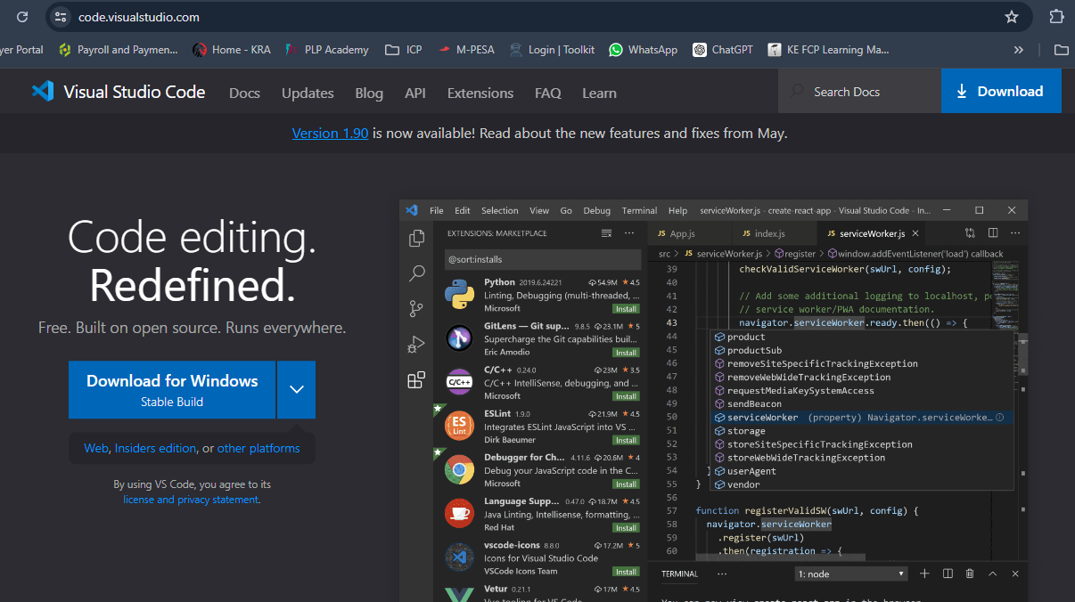

1. Follow the on-screen instructions to download the installer.

**. Run the Installer:**

1. Locate the downloaded installer file (usually in your Downloads folder) and double-click (“VisualStudionSetup”) to run the installer. 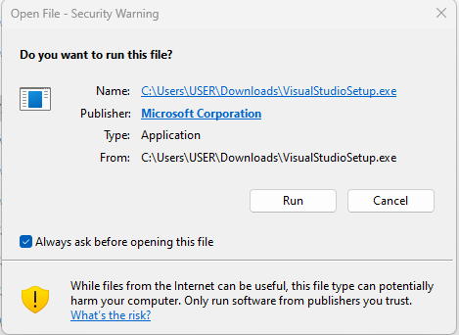
2. Once you click Run, click on the same command “continue” to follow the process.
3. Choose the "Visual Studio" workload during installation, which includes the necessary components for general development.

**. Select Workloads and Components:**

1. In the Visual Studio Installer, select the workloads and components you need based on your development requirements. Common workloads include ".NET Desktop Development" or "Web Development."

**Modify Installation (Optional):**

1. If needed, you can customize the installation by clicking on the "Individual components" tab in the installer and selecting or deselecting specific components.

**Install:**

1. Click the "Install" button to start the installation process.
2. This may take some time, as it involves downloading and installing the selected components.

**Launch Visual Studio:**

1. Once the installation is complete, you can choose to launch VS Code immediately by checking the "Launch Visual Studio Code" option and clicking "Finish.

**First-time Setup:**

**Initial Configurations and Settings:**

1. **Update VS Code:**
   * Check for any updates to ensure you have the latest features and bug fixes.
2. **Theme and Appearance:**
   * Go to File > Preferences > Color Theme and select your preferred theme.
   * Customize the icon theme via File > Preferences > File Icon Theme.
3. **Font Settings:**
   * Adjust the font size and type via File > Preferences > Settings and search for Font Size and Font Family.
4. **Extensions:**
   * Install essential extensions for your development needs (e.g., Python, ESLint, Prettier).
5. **Settings Sync:**
   * Enable settings sync if you use multiple devices. Go to File > Preferences > Settings Sync: Turn On.

**Important Extensions:**

* **Prettier** - Code formatter.
* **ESLint** - Linting JavaScript code.
* **Python** - Support for Python development.
* **Live Server** - Launch a development local server with live reload.
* **GitLens** - Supercharge the built-in Git capabilities.

**User Interface Overview:**

**Main Components of the VS Code User Interface:**

1. **Activity Bar:**
   * Located on the far left side.
   * Provides quick access to different views such as Explorer, Search, Source Control, Run and Debug, and Extensions.
2. **Side Bar:**
   * Adjacent to the Activity Bar.
   * Displays the contents of the selected view from the Activity Bar (e.g., file explorer, search results).
3. **Editor Group:**
   * Central part of the interface where you open and edit files.
   * Supports multiple editors side by side.
4. **Status Bar:**
   * Located at the bottom.
   * Shows information about the current file and workspace, such as encoding, line endings, and language mode.

**Command Palette:**

* **Command Palette -** A powerful feature that allows you to access all of VS Code’s commands and settings.
* **How to Access:** Press Ctrl + Shift + P (or F1) to open the Command Palette.
* **Common Tasks:**
  + Opening files: > Open File.
  + Searching for extensions: > Extensions: Install Extensions.
  + Changing color theme: > Preferences: Color Theme.

**Extensions in VS Code:**

**Role of Extensions:**

* Enhance functionality and support for different programming languages, frameworks, and tools.

**Finding, Installing, and Managing Extensions:**

1. **Finding Extensions:**
   * Click on the Extensions view icon on the Activity Bar or press Ctrl + Shift + X.
2. **Installing Extensions:**
   * Search for the desired extension in the Extensions view and click Install.
3. **Managing Extensions:**
   * Enable, disable, or uninstall extensions from the Extensions view.

**Essential Extensions for Web Development:**

* HTML/CSS Support
* JavaScript (ES6) Code Snippets
* Node.js Extension Pack
* Debugger for Chrome

**Integrated Terminal:**

**How to Open and Use:**

* **Opening the Terminal:**
  + Go to View > Terminal or press Ctrl + .
* **Using the Terminal:**
  + The integrated terminal allows you to run shell commands within VS Code, providing the same functionality as an external terminal.

**Advantages:**

* Convenience of having the terminal within the editor.
* Quick access to run commands and scripts related to your code.
* Supports multiple terminal instances.

**File and Folder Management:**

**Creating, Opening, and Managing Files and Folders:**

1. **Creating Files/Folders:**
   * Right-click in the Explorer view and select New File or New Folder.
2. **Opening Files/Folders:**
   * Use the File > Open File... or Open Folder... menu options.
3. **Managing Files/Folders:**
   * Use the Explorer view to rename, move, and delete files and folders.

**Efficient Navigation:**

* Use Ctrl + P to quickly open files by name.
* Use the breadcrumbs at the top of the editor to navigate between folders and files.

**Settings and Preferences:**

**Customizing Settings:**

1. **Accessing Settings:**
   * Go to File > Preferences > Settings or press Ctrl + ,.
2. **Changing Theme:**
   * Search for Color Theme in settings or use the Command Palette (Ctrl + Shift + P).
3. **Adjusting Font Size:**
   * Search for Font Size in settings and change the value.
4. **Customizing Keybindings:**
   * Go to File > Preferences > Keyboard Shortcuts or press Ctrl + K, Ctrl + S.

**Debugging in VS Code:**

**Setting Up and Starting Debugging:**

1. **Setting Up:**
   * Open the file you want to debug.
   * Add breakpoints by clicking in the gutter next to the line numbers.
2. **Starting Debugging:**
   * Go to Run > Start Debugging or press F5.

**Key Debugging Features:**

* **Breakpoints:** Pause execution at specific lines.
* **Watch:** Monitor variable values.
* **Call Stack:** View the call stack and navigate through the code.
* **Debug Console:** Execute expressions and commands.

**Using Source Control:**

**Integrating Git with VS Code:**

1. **Initializing a Repository:**
   * Open your project folder in VS Code.
   * Go to the Source Control view (Activity Bar) and click Initialize Repository.
2. **Making Commits:**
   * Stage changes by selecting the files and clicking the + icon.
   * Enter a commit message and click the checkmark icon to commit.
3. **Pushing Changes to GitHub:**
   * Use the Command Palette (Ctrl + Shift + P) and search for Push.
   * Authenticate with GitHub if prompted.
   * Follow prompts to create a remote repository if needed and push your changes.