## Statistical analysis

All data were processed using self written scripts (GitHub?) for MATLAB (Version 9.6; MathWorks, Natick, MA, USA).

Plantar loading force for each foot were extracted respectively from the time of stance and averaged for subsequent analysis. Loading forces were normalised to participants bodyweights (Clint?). *The maximum force data collected by the Pedar-X insoles are reported in units of BW. The indicated BW on the AlterG® treadmill is reported as percentage of BW (as in Thomson 2017).* Outliers in the data excluded elements more than 1.5 interquartile ranges above the upper quartile or below the lower quartile. Multiple linear regression was used to reveal the relationship between running speed, percentage body weight and normalized maximal loading force as outcome variable. To understand the effect of different gradients during running on the loading forces, another multiple linear regression was conducted with running speed, percentage body weight and gradient as regressors.

## Results

The results from the regression analysis showed a linear relationship on the loading forces (p < 0.0001, adj. R² = 0.604) by percentage BW and different running speeds (fig. 1). These findings are in line with previous research for lower speeds (Thomson ea., 2017).

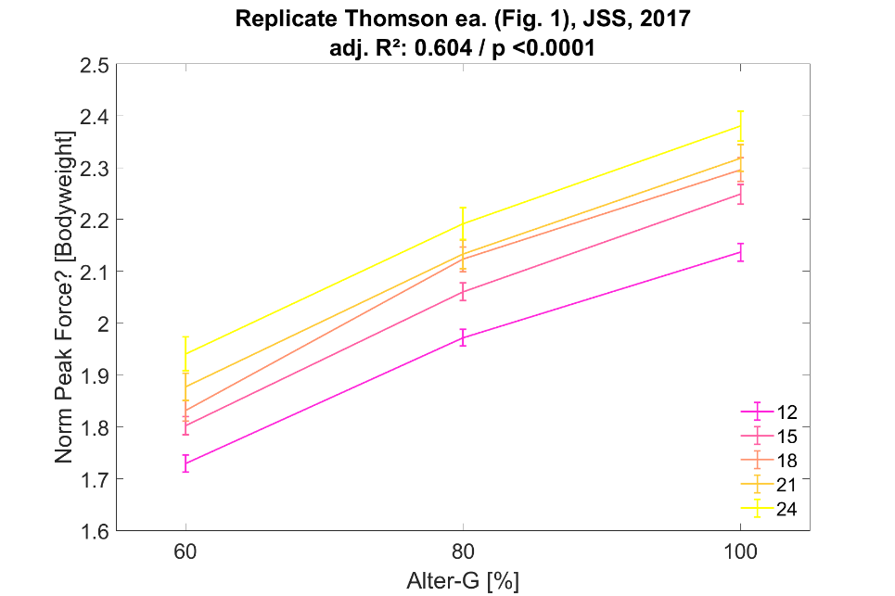

The relationship between loading forces, percentage BW and different running speeds including multiple gradients of running stays linear (p < 0.0001, adj R² = 0.613, fig. 2.1).

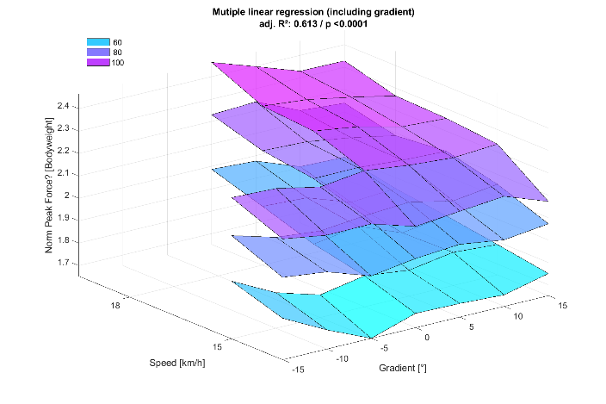 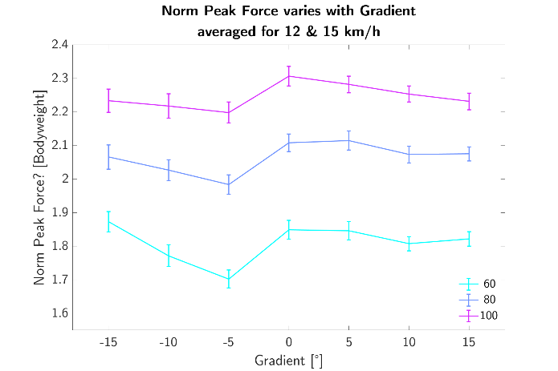

However, the linear relationship does not hold for negative gradients at speed of 12 & 15 km/h (fig 2.2).