

**Multisensory integration as a modulator of action tremor**

Julius Welzela*, Günther Deuschl**a**, Julian Keil**b**, Miriam Güthe**a**, Gesine Hermann**a**, Walter Maetzler**a**, and Jos Becktepe**a**

aUniversity Hospital Schleswig-Holstein, Kiel, Germany

bDepartment of Psychology, University of Kiel, Kiel, Germany

*Correspondence should be addressed to J.W. (j.welzel@neurologie.uni-kiel.de)

**Essential tremor (ET) amplitude is modulated by visual feedback during target driven movements: In a grip force task, tremor amplitude increases during large scale visual feedback compared to a condition with low scale visual feedback. It has not been examined whether visual feedback exclusively modulates action tremor severity or if an increase of other afferent input like auditory sensation has a modulatory effect on tremor amplitude as well. Also, it is unknown whether the sensory feedback itself directly affects the tremor generating network or if the effect is rather indirect: enhanced sensory feedback during targeted driven movements might cause arousal/psychological stress. We hypothesized that (1) amplitude of ET is modulated by variation of auditory feedback in the absence of visual feedback in a force tremor paradigm; (2) increase of tremor amplitude coincides with pupillary dilation as a measure of arousal / psychological stress, independently of the quality of sensory feedback. 14 ET patients and 12 matched controlls conducted a computer-based experiment in which they were asked to match a target force in a force sensor using their thumb and index finger. The quality of the matching the target force was feed back to the participant visually, auditory or a combination of both. For the visual feedback, two bars were displayed on a screen, with the distance between these bars decreasing with approximation of the target force. Results showed a comparable deviation from the target force (RMSE) during the experiment during all three sensory feedback modalities. Additionally, tremor severity did not differ between sensory feedback modalities. The ANOVA revealed an effect of the scaling factor on the tremor severity (Power 4-12Hz) for the visual- and also for the auditory feedback condition. Pupillometry consistently showed a significantly increased pupil diameter during the large scale visual- and auditory feedback conditions compared to the low scale feedback conditions. Our findings suggest that action tremor in ET is firstly modulated not only by visual feedback but also by auditory feedback in a comparable manner and seems to be modality independent. Secondly arousal / cognitive stress, as measured here by the pupil size, could mediate the increase of tremor amplitude. Further work including neurophysiological measures is required to better understand the role of these two possible mechanisms underlying target-related tremor.**

# Introduction

﻿Tremor is the most common movement disorder and is defined as an involuntary, rhythmic, oscillatory movement of a body part. (Bhatia, Bain et al. 2018) Tremor might occur in complete rest or during specific motor activation conditions, for example while actively maintaining a position against gravity (postural tremor) or during voluntary movements (simple kinetic tremor) and especially target-driven movements (intention tremor). Various etiologies can be underlying and, in many cases -including the large group of essential tremors- the etiology remains obscure. However, as a common pathophysiological substrate of action tremor syndromes, an altered oscillating activity within a cerebello-thalamo-motor cortical network was demonstrated by neuroimaging and electrophysiological approaches.(Helmich, Toni et al. 2013)

Despite its´ central origin, Essential tremor amplitude can be affected by modulation of peripheral sensory afference: Either by stimulating muscle end points or peripheral nerves and thereby activating the target muscles at specific phases of the tremor cycle so that the muscle response suppresses the tremor. (Prochazka, Elek et al. 1992, Popović Maneski, Jorgovanović et al. 2011) Or by stimulating peripheral nerves to evoke afferent activity that either modulates the excitability of spinal motor neurons or consecutively interacts with the central oscillations.(Reis, Arruda et al. 2021, Shukla 2022) Recordings of thalamic microelectrodes have shown, that the integration of somatosensory afferent and efferent signals within certain thalamic areas play a decisive role in the generation of tremor amplitude.(Pedrosa, Brown et al. 2018)

Apart from somatosensory afference, the amplitude of action tremor syndromes was shown responsive to visual feedback as well: in the absence of visual feedback the amplitude of target driven action tremor decreases and contrary, by an increase of visual information the tremor amplitude increases. This phenomenon was reported for several different tremor etiologies, encompassing ET, dystonic tremor and intention tremor in multiple sclerosis. (Keogh, Morrison et al. 2004, Feys, Helsen et al. 2006, Gironell, Ribosa-Nogue et al. 2012, DeSimone, Archer et al. 2019) However, it has not been examined yet whether visual feedback exclusively modulates action tremor amplitude or if alterations of other afferent input like auditory sensation has a modulatory effect on tremor amplitude as well. In this view, feedback about the tremor in general would increase the tremor amplitude. This would raise the question for a common underlying mechanism modulating tremor amplitude in dependence of any sensory feedback. Also, a potential role of multisensory integration in tremor amplitude modulation has not been examined yet. Simultaneously incoming sensory feedback could lead to an amplification of the tremor modulating effect compared to the monosensory condition. To test this, we examined the modulation of tremulous activity by visual and auditory feedback exclusively and by the combination of both.

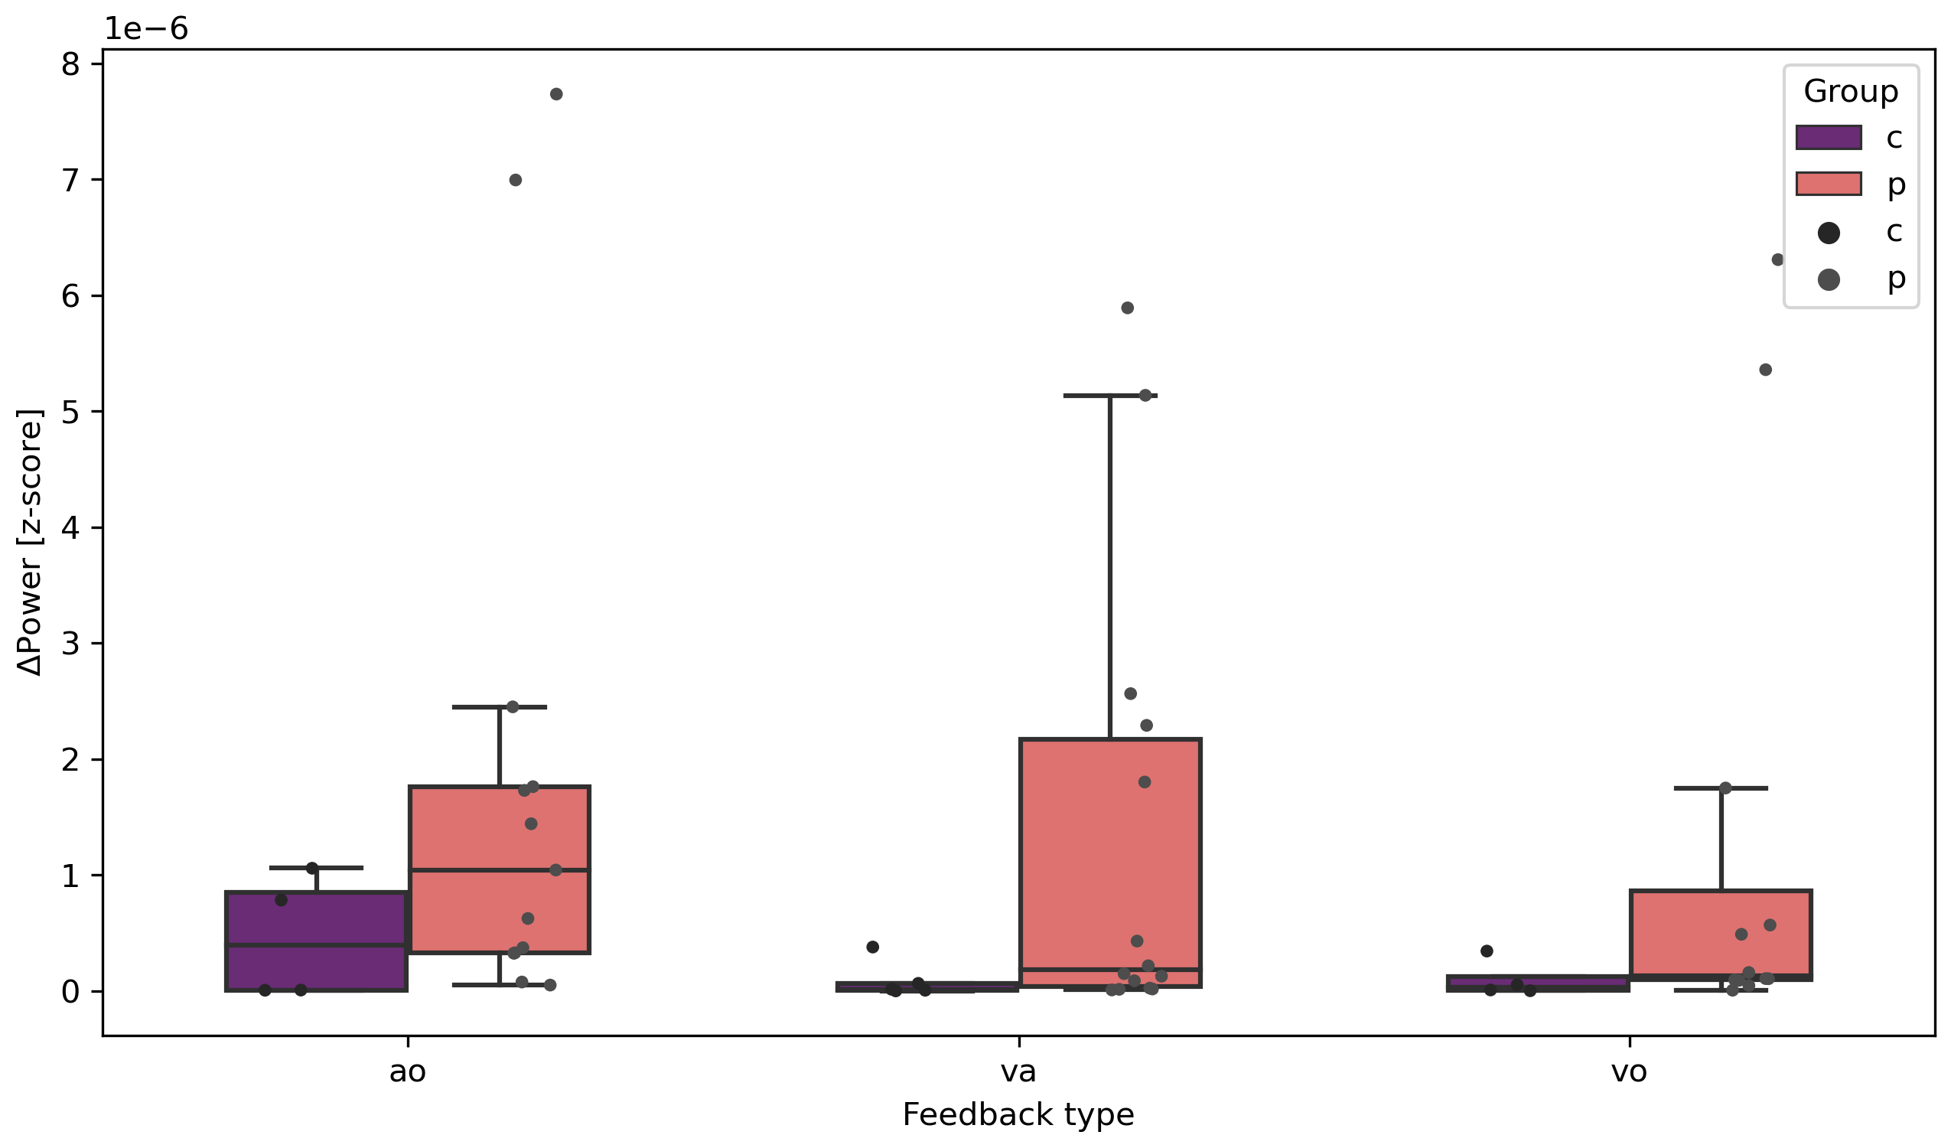

Figure 1: Single trial tremor force averages differences. Split per feedback type (vo, va, ao) and group (ET vs. HC).

Our study aims at testing the following hypotheses:

1: Feedback scaling influences tremor severity in different sensory feedback conditions in ET patients, not HC.

2: Increased pupil dilation during the task as a marker for arousal and noradrenergic activation is expected during more prominent feedback

3: The higher gain with increased scaling in tremor force is reflected in pupil dilation.

# Results

## Clinical data

14 ET patients and 14 age- and gender matched healthy controls were included into the study (Table 1). A total of 52% of participants was female. While there was no significant difference in age (t = 86.50, p = 0.147), the Becks-Depression-Inventory (BDI-II, t = 113.50, p = 0.003) and Schmahmann-Scale (t = 33.50, p = 0.046) revealed a statistically significant difference between the patients and control group. The TETRAS score was significantly correlated with age (r = 0.566, p = 0.035), not however with the BDI-II score (r = -0.145, p = 0.637). The Schahmann scale total score was negatively correlated with age (r = -0.24, p = 0.002) and was sigificantly lower in patients compared to controls (t = 2.226, p = 0.037), even though there was no significant age difference between the groups.

We found a significant correlation between the TETRAS Score and the Schmahmann scale (r = -.21, p = 0.005), this correlation however dropped to r = -.1 (p = 0.197) when including age as a partial factor in the analysis.

|  |  |  |  |  |  |  |  |  |
| --- | --- | --- | --- | --- | --- | --- | --- | --- |
| **Variable** | ET | |  | HC | |  |  | |
| Median | | 25th/75th  percentile | Median | | 25th/75th  percentile | p-value* | |
| n | 14 |  | | 14 |  | | |  |
| Female [n] | 6 |  | | 7 |  | | | n.s. |
| Age [years] | 63.00 | [46.0/66.0] | | 65.50 | [61.0/74.0] | | | n.s |
| BDI Score [n] | 8.00 | [5.0/11.0] | | 0.50 | [0.0/1.8] | | | 0.003 |
| Schmahmann Score [n] | 107.00 | [86.0/101.0] | | 93.00 | [102.0/111.0] | | | 0.046 |
| Tetras Score [n] | 41.00 | [31.6/47.4] | | - | - | | | - |
| Table 1: ET = Essential tremor patients, HC = healthy controls, - = not available, n.s. = not significant, * = Mann-Whitney-U test. | | | | | | | | |

## Tremor force

Mean Force (MF), Unfiltered force error (RMSE) and Force Power 0-3 Hz did not differ between conditions or groups.

The tremor relevant frequency spectrum (4-12 Hz) significantly differed between patients and controls in each of the feedback conditions (visual only (t[53]=39.00, p=0.018), auditiv-visual (t[53]=24.00, p=0.041) and auditiv only (t[53]=42.00, p=0.013).

These stayed significant when including clinical scores such as Schahmann in the analysis.

Patients showed a significant difference between low vs. high feedback per condition (visual: p=0.006; auditiv-visual: p=0.049; auditiv: p=0.008), Controls showed a significant difference between low vs. high feedback per condition (visual: p=0.09; auditiv-visual: p=0.048, auditiv: p=0.065)

## Pupil Size

Pupil dilation also revealed significant differences between each feedback conditions in some of the feedback types, visual only (t[53]=2.00, p=0.028), auditiv-visual (t[53]=2.33, p=0.022) and auditiv only (t[53]=1.33, p=0.047).

Patients showed a significant difference between low vs. high feedback per condition for pupil size (visual: p=0.08; auditiv-visual: p=0.039, auditiv: 0.046), Controls showed a significant difference between low vs. high feedback per condition for pupil size (visual: p=0.328; auditiv-visual: p=0.167, auditiv: p=0.78)

# Discussion

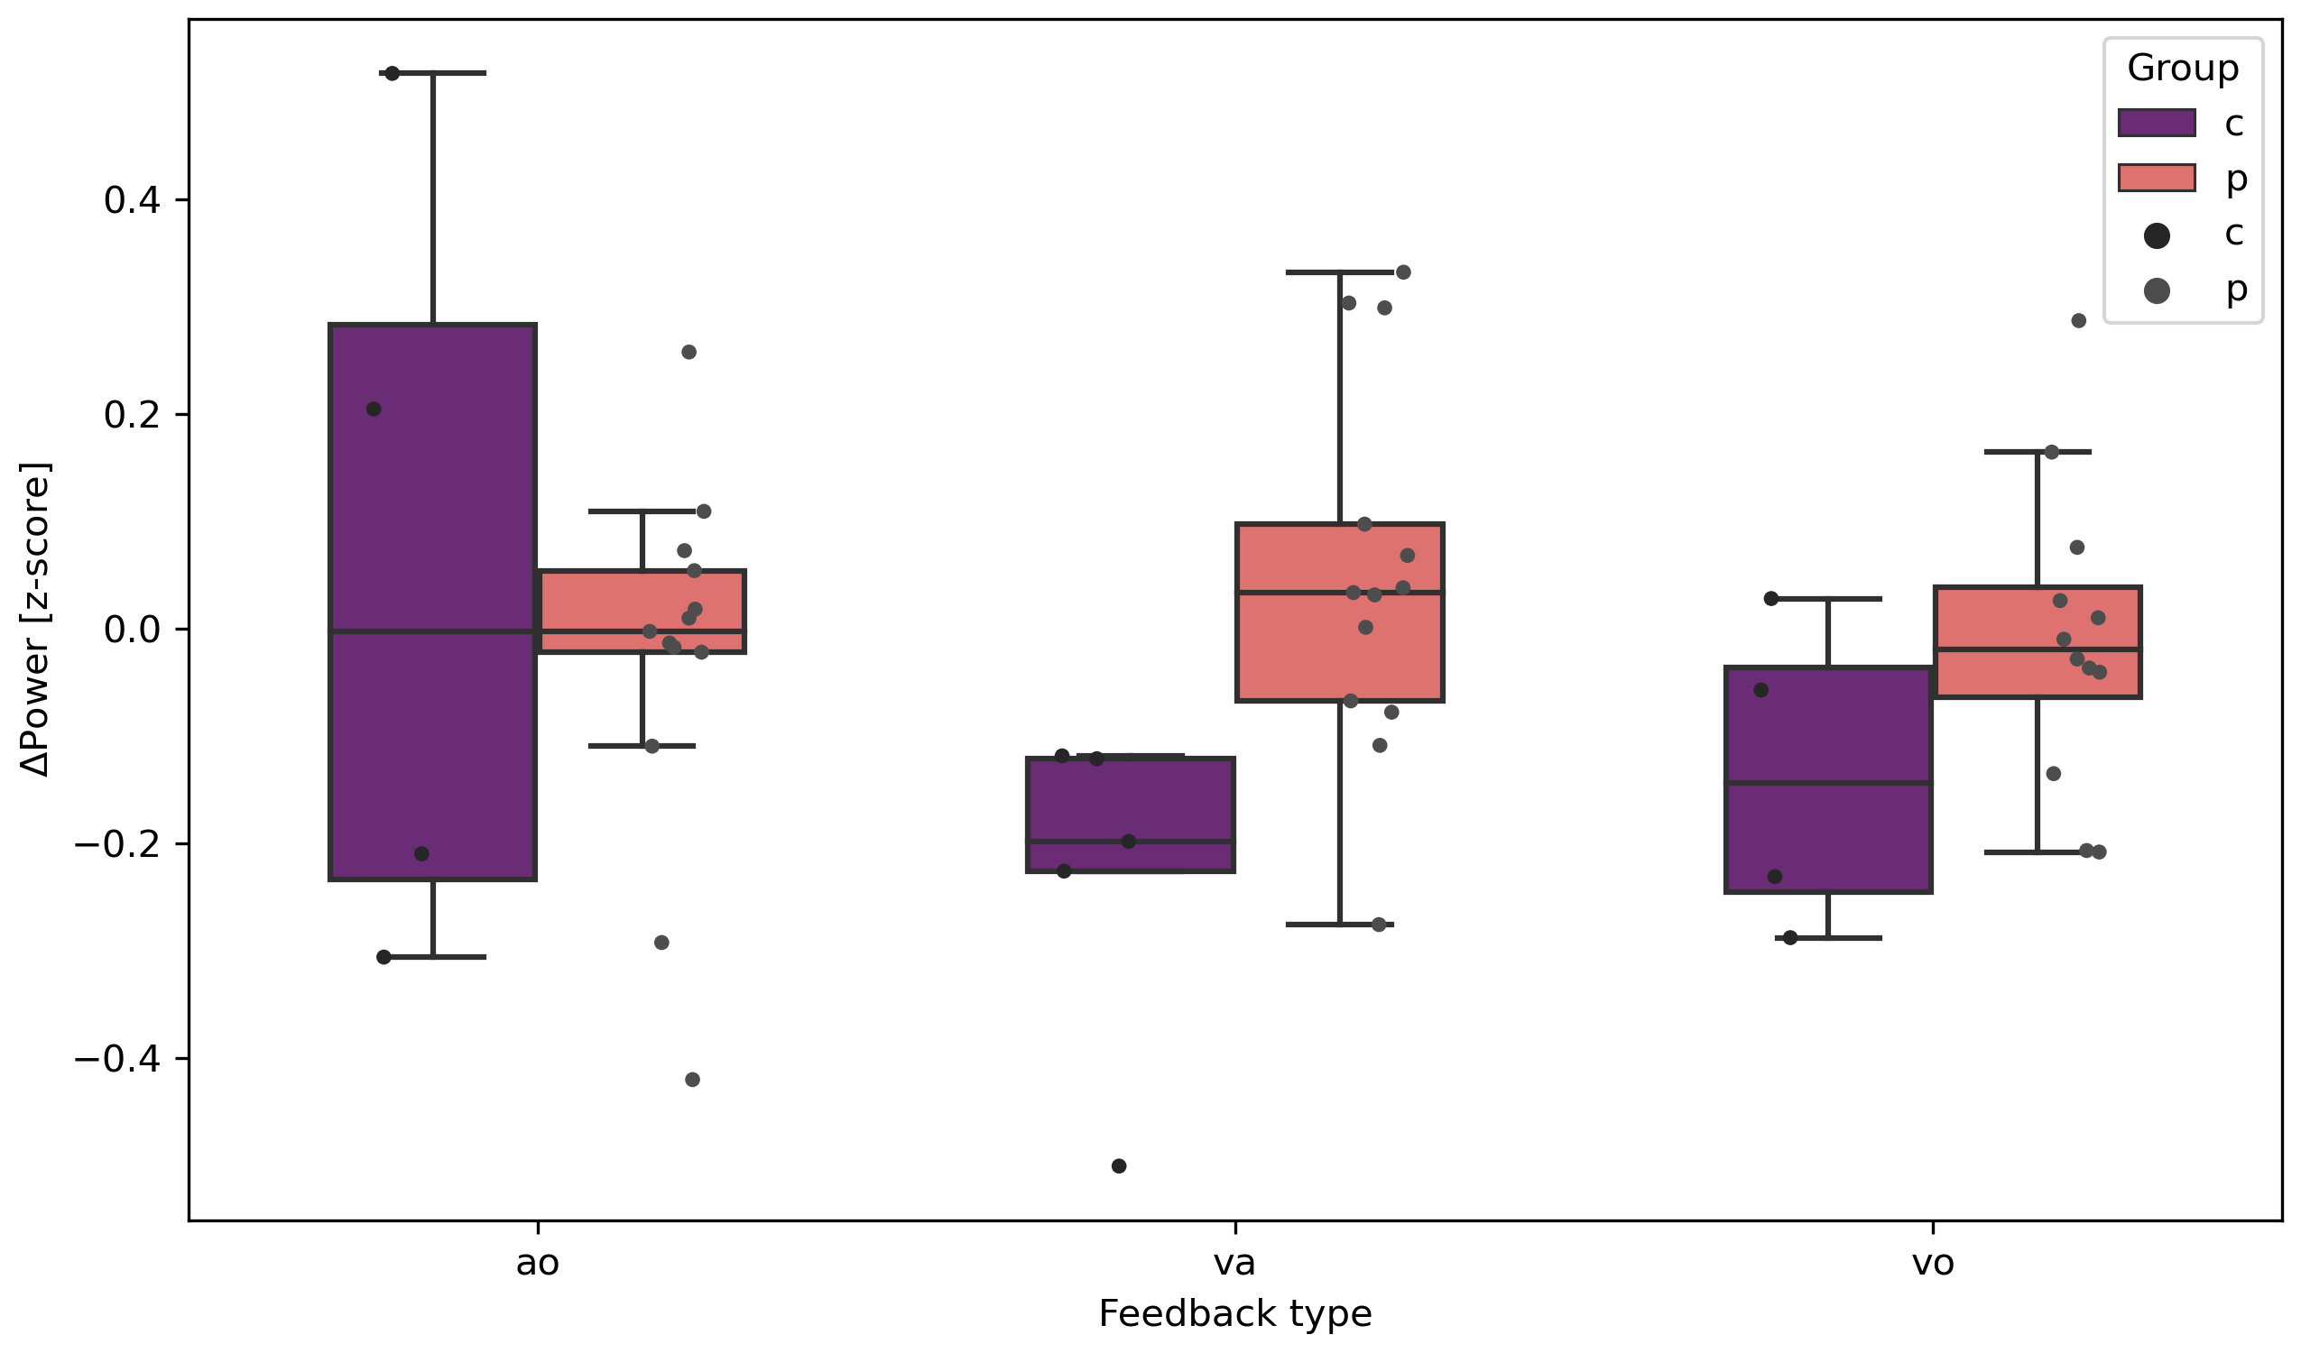

Figure 2: Single trial pupil size differences. Split per feedback type (vo, va, ao) and group (ET vs. HC).

In summary, we found that Essential tremor amplitude is modulated by visual and auditory sensory feedback scaling in a comparable manner. Increased sensory feedback coincided with an increased pupil diameter in patients, but not in controls. Combined auditory and visual feedback evoked the largest increase in tremor amplitude and pupil diameter in patients, although the differences in the tremor amplitude were only significant for the auditive only and auditive-visual condition.

While it is well described, that visual feedback modulates action tremor amplitude in different underlying disease conditions like multiple sclerosis, ET and dystonic tremor.(Sanes, LeWitt et al. 1988, Keogh, Morrison et al. 2004, Feys, Helsen et al. 2006, Gironell, Ribosa-Nogue et al. 2012), to our best knowledge, this is the first study to show that the amplitude of target force tremor in ET is modulated by a different quality of sensory feedback as well and in a comparable manner.

A recent functional MRI study found -apart from the well-known cerebello-thalamo-motor cortical tremor circuit- a widespread visually sensitive network including key regions in the visual cortex and parietal lobule associated with alterations of essential tremor amplitude during visual feedback manipulation in a grip force task.(Archer, Coombes et al. 2017) Interestingly, by the same group visual feedback-induced tremor exacerbation in patients with dystonic tremor was found as well, but in this patient group tremor amplitude modulation was not coupled to an associated dysfunction of visual cortex regions.(DeSimone, Archer et al. 2019) Together with our finding that force tremor amplitude is comparably modulated by auditory feedback, this raises the question if there is a common underlying mechanism for sensory feedback induced tremor modulation in the context of different sensory qualities.

Since the processing of afferent auditory and visual signals encompasses different neuroanatomical regions, it seems questionable that specific sensory networks exert a direct tremor modulating effect. We used pupil diameter as a marker for cognitive arousal and found an increase of pupil dilation during the enhanced feedback trials, independently of the type of sensory feedback. These findings cannot be explained by a direct pupil size modulation due to the visual signal / differences in the lightning since there was no change of the visual input during the auditory feedback trials. It´s rather probable, that the pupil dilation reflects an increased cognitive arousal (or physical effort) during the large-scale feedback trials. Pupil size coincides with cognitive arousal and the task evoked pupillary response is known to reflect the mental effort to perform the task(Beatty 1982), which was also shown in ET patients.(Becktepe, Govert et al. 2019) ﻿Apart from mental effort, pupil diameter also increases during physical effort, thereby reflecting not only the actual intensity of the physical activity but also the individual perception of the effort. (Zenon, Sidibe et al. 2014) In summary, pupil size mirrors the level of effort, which is invested in a task, irrespective of whether it is physical or mental. Therefore, we hypothesize that tremor patients perceived a higher effort during the large-scale feedback tasks, reflected by the larger pupil diameter. We hypothesize, that the subjectively perceived effort itself exerts a modulatory role on target force tremor amplitude.

Recently, a modulatory role of cognitive effort during a serial seven task, as measured by a coincident pupillary dilation, onto the rest tremor network of Parkinson´s disease was shown.(Dirkx, Zach et al. 2020) This effect was most likely exerted by direct bottom-up noradrenergic influences onto the thalamus and indirectly by top-down cognitive influences onto the cerebello-thalamo-cortical circuit. Since the thalamus is a key node not only within the PD resting tremor network but also action tremor networks as well, an amplification of action tremor by ascending noradrenergic systems seems likely. Enhanced feedback of any sensory quality during target driven physical tasks might cause arousal/psychological stress and thereby activate the ascending noradrenergic system, with the locus coeruleus (LC) as main effector. Recent neuroimaging studies have confirmed a close relationship between the LC and bilateral

thalamus and the cerebellum, both key regions within the action tremor network.(Liebe, Kaufmann et al. 2020) Therefore, cognitive arousal/perceived effort during motor tasks, induced by enhanced sensory feedback of any quality, might activate the LC-noradrenergic system and thereby mediate an amplification of action tremor amplitude by thalamic and cerebellar projections of the LC.

# Conclusion

# References

# Acknowledgements

# Author contributions

# Competing interest statement

# Materials and Methods

Participants

The study was approved by the ethical committee of the Medical Faculty of Kiel (AZ 447/21) and was conducted in accordance with the Declaration of Helsinki. Participants gave written informed consent before participation. 14 patients with essential tremor 14 healthy controls were included. All patients were diagnosed with Essential Tremor by a specialist for neurology, healthy controls had no history of neurological or psychological disorders. All participants were right-handed and had no restrictions in vision or hearing.

Patients were asked to pause tremor related medication for at least 24 hours and participants were instructed to avoid caffeine and nicotine consumption on the examination day. Covariates between groups were compared using Mann-Whitney-U tests.

Experimental setup

During the experiment probands were asked to match a target force by using a grip force sensor. Feedback about the target and the movement was given either visually on a computer screen or auditory via headphones or with a combination of both. Force data were collected with an Arduino based force sensor (FRS). The weight cell (Adafruit, ADA4541) was connected to an amplifier (SparkFun, HX711) and digitized at 80Hz via an ArduinoUno. The Arduino was connected via a serial port to the stimulus presentation computer. The experiment presentation was done via PsychoPy (Peirce et al., 2019). Inside the presenting script the data of the serial port was used to feedback information to the participant in real time (delay < 10ms) and send to LSL (Kothe et al., 2020) for recording. Pupil data were recorded using a Pupil Core (Pupil Labs, Berlin, Germany) module with a sampling rate of 240 Hz. Calibration was done prior to the experimental task while data was send to LSL during the experiment via the Pupil LSL relay (Pupil Labs, 2021). All data streams (Experimental Marker, FRS and Pupil data) were recorded using the LabRecorder (Boulay, 2020). For details see Figure 4, left side.

Experimental procedure

The experiment lasted ~20 minutes and took place in a controlled laboratory environment on a computer (distance from the eyes to the screen: approx. 90 cm) in the presence of a test administration. The experiment consisted of a training block and three subsequent experimental blocks, between which the subject could take short breaks. Prior to training the individual maximum force (MF) was determined. Participants were asked to apply maximum pressure to the force sensor with the thumb and index finger three times for 1 second. The maximum of the respective averages of samples was used as MF.

Figure 4: Experimental setup. (Left side) Datastreams (Force sensor, Pupil dialation and experimental triggers) are recorded via the Lab Streaming Layer. (Right side) Example epoch with timing of all elements.

The task for the participants was to match a target force and holding it for a period of 30s (15% of the MF). They got feedback of their performance during every trial in form of sensory feedback. Three different sensory feedback types presented in the following order: 1. Visual only, 2. visual-auditive and 3. auditive only. Visual only (vo) feedback consisted of two vertical bars which were supposed to overlap in position when the target force was matched. Auditory only (ao) feedback was provided by a reference tone (440Hz) and another tone which varied in pitch depending on the distance to the target (between 120 and 880 Hz). Visual-auditiv feedback was a combination of the vo and ao type. Each experimental trial consisted of a written cue what type of feedback is being presented, a 30 s resting period a 1-1.5s fixation cross and a 30 s task period (see Figure 4, right side).

In total every participant conducted 12 experimental trials, four of each feedback type. The subjects were asked to match the target force as quickly as possible using the force sensor in their right hand and hold it for the remainder of the trial. During each trial the feedback was altered using one of two factors applying different gain levels, resulting in different feedback types. The low gain and high gain resulting in an easier or harder task to match the target force (Archer ea., 2017).

.

Here FP is the force produced by the subject, Ft is the target force, and G is the gain level used to manipulate the amplitude of feedback.

Data processing

Preprocessing of force and pupil data:

The force data was first normalized to the participants MF by dividing every sample by the MF * 0.15. Next, data was filtered between 1-12 Hz using a bandpass butterworth filter of order 10, executed by the scipy package (1.8.1) in python (3.8). After filtering, data was cut into trials to estimate power-spectral densities, using the psd_array_welch function from the MNE package. For tremor relevant power, a frequency window 4-12 Hz was defined, for voluntary movement a 0-3 Hz frequency window was defined. Unfiltered force error (RMSE) during a trial was calculated by the root of the squared difference per sample to the target force.

The Pupil data was first cleaned of artifacts. Blinks were detected using outliers in gaze acceleration and PupilLabs confidence values and set to NaN in the time series. NaN values were subsequently interpolated using a fft convolution using a Gaussian kernel ranging 120 samples (~0.5 s). After cleaning the raw time series, data was cut into epochs. A divisive baseline correction (-10—2s) was applied per epoch and changes in pupil size were estimated 5 s after epoch start until 10s before the epoch ended. The mean of the time window of interest was used for statistical analysis.

Preprocessing scripts of the FRS and pupil data can be found at GitHub (<https://github.com/JuliusWelzel/tremor_feedback_jw>).

Statistics

Clinical data were compared between groups using a Mann-Whitney-U test. Correlation analyses were conducted using a Pearson correlation if Levene’s test and Shapiro-Wilk test allowed it, otherwise spearman rank correlation was used. For the FRS data the interindividual difference between the means of the easy and hard feedback condition was calculated per feedback type. T-tests between groups for every feedback condition were calculated. The same was done for the pupil size data. All statistical analyses were performed in Python (3.8) using the scipy package (v1.8.1) or pingouin package (v0.5.2).

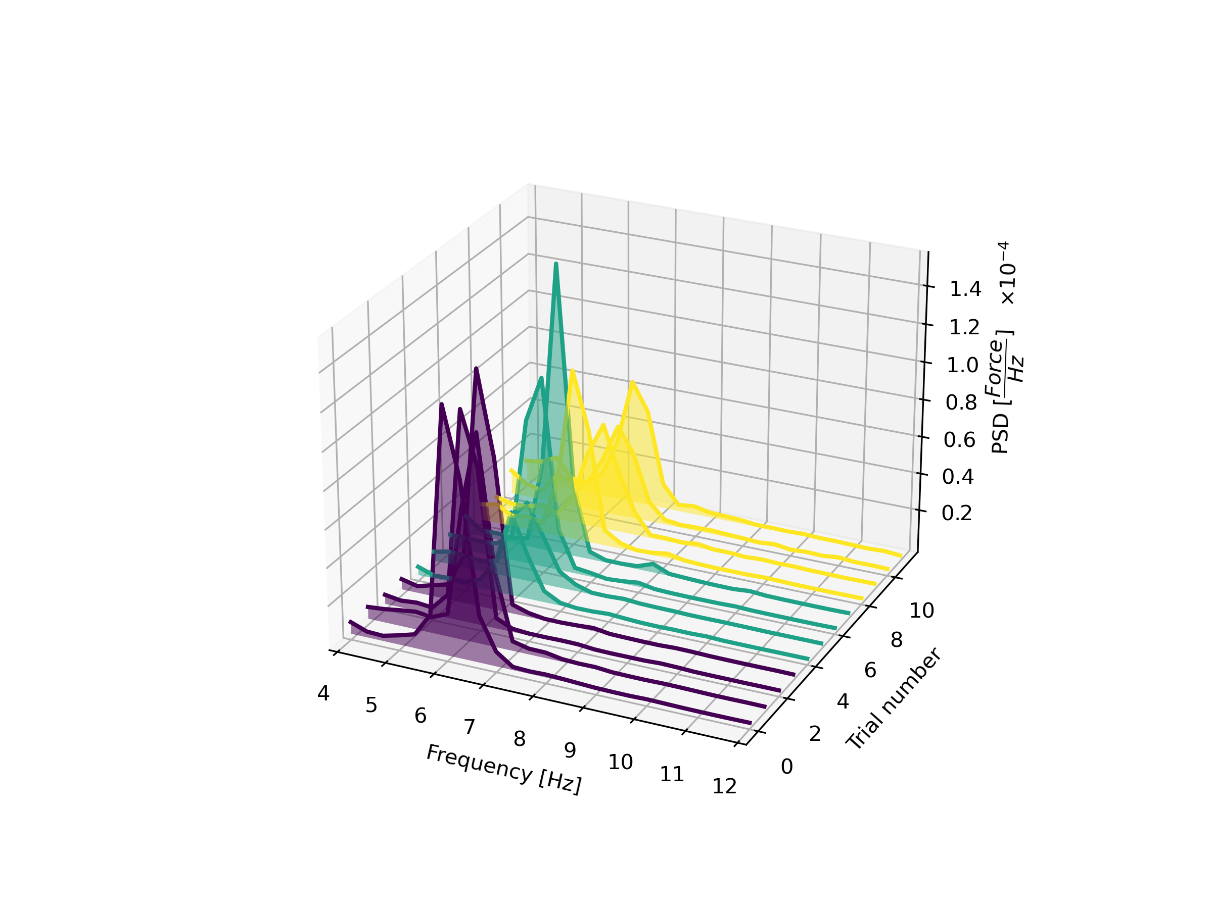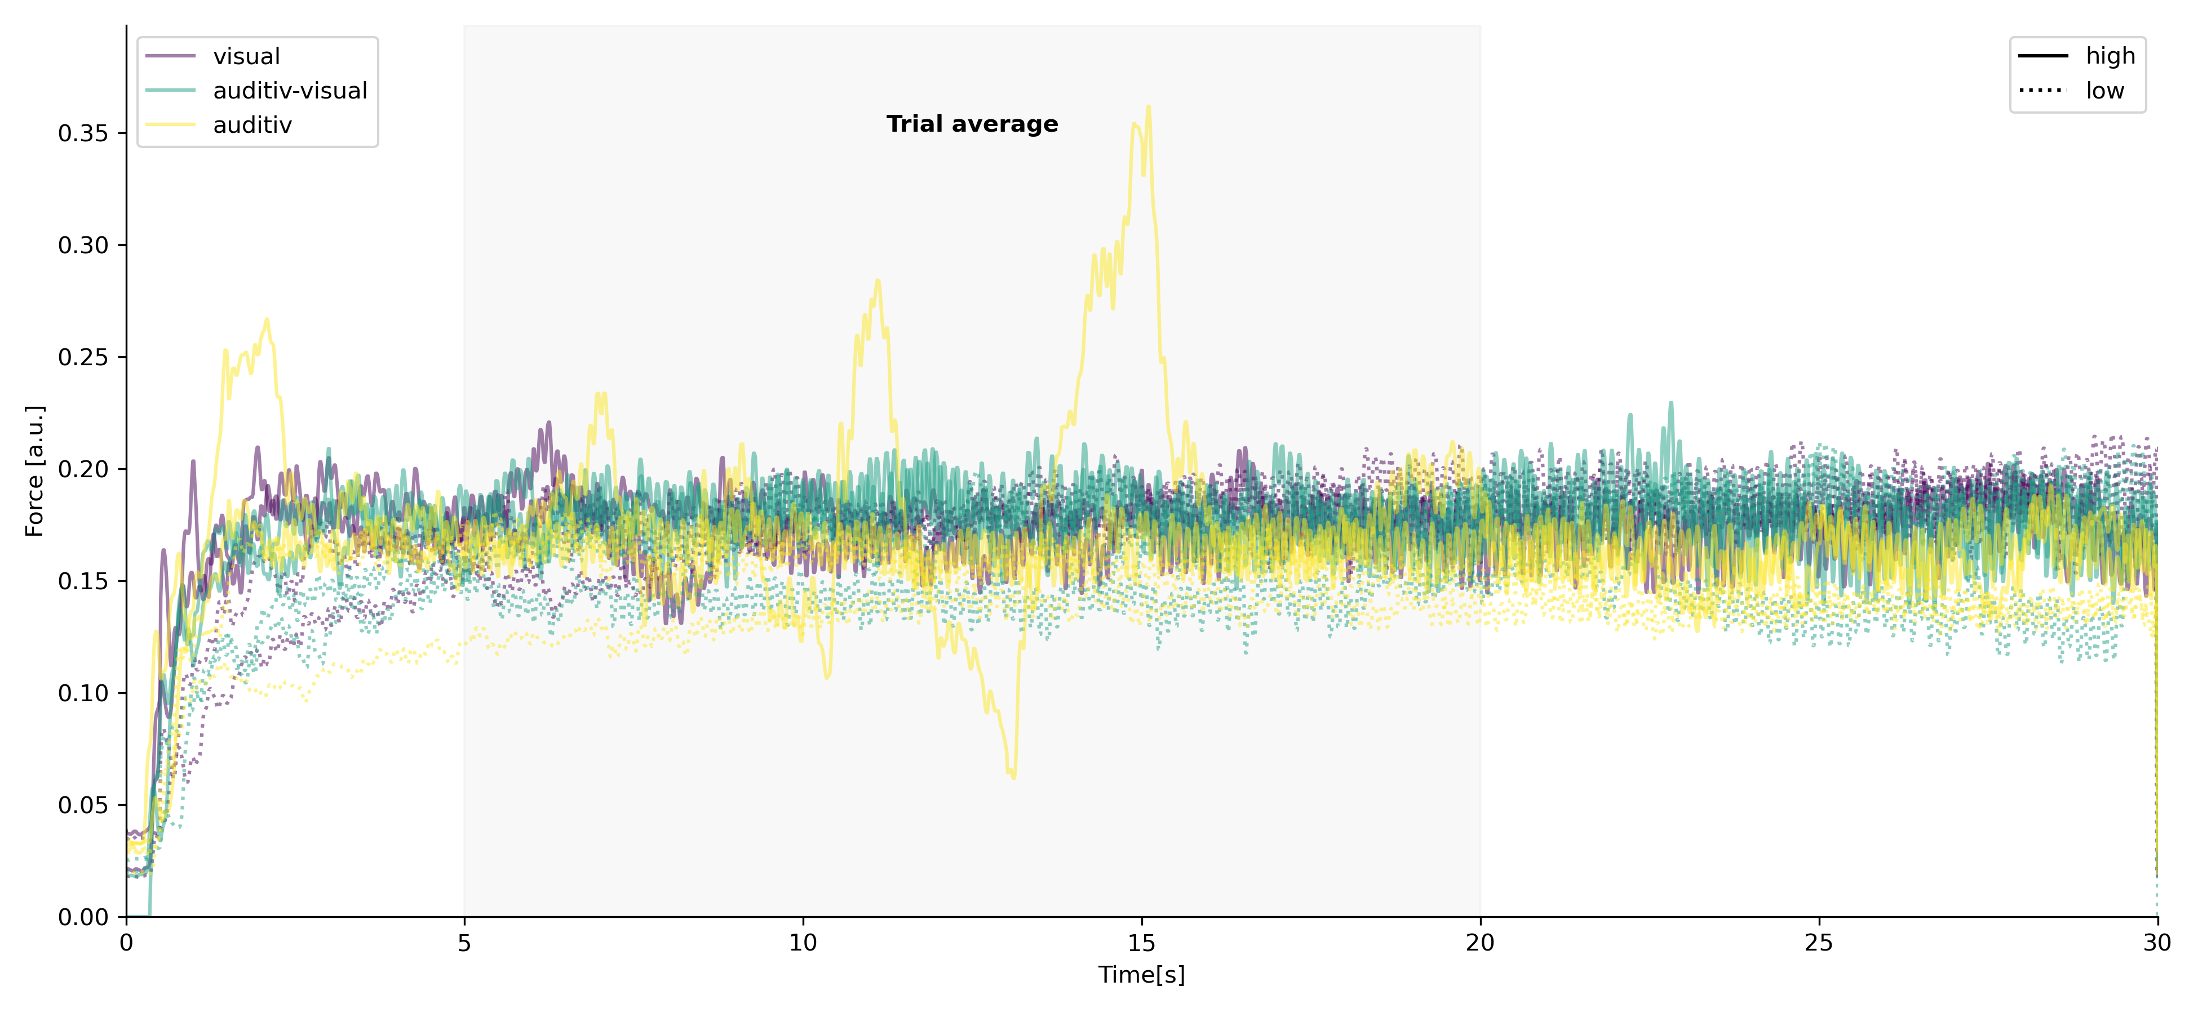

Figure 3: Times series data of a single participant. Above the time course of the pupillometry. Bottom left shows the single trial spectra of the force tremor per epoch. Bottom right displays the single trial raw force data. Both time courses are split per feedback type and feedback condition.

Sample size justification

The paper uses sequential designs with maximal sample sizes to efficiently determine statistical power. In this approach, the study is conducted in stages with the aim of collecting the minimum number of participants required to achieve the desired level of statistical power from the study to replicate (Archer ea., 2018).

The study is designed to have power of 0.80 from the original paper, therefore the data tested after each participant until the desired power level is reached. The desired power is achieved before the planned maximal sample size is reached (max n = 20), hence the study was stopped early, as higher numbers would have impacted the other outcome parameters to a unknown extend.

Overall, sequential designs with maximal sample sizes offer a promising approach to optimizing statistical power in replication studies where new outcome parameters are introduced (Schönebrodt and Wagenmaker, 2018)

Archer, D. B., S. A. Coombes, W. T. Chu, J. W. Chung, R. G. Burciu, M. S. Okun, A. Wagle Shukla and D. E. Vaillancourt (2017). "A widespread visually-sensitive functional network relates to symptoms in essential tremor." Brain.

Beatty, J. (1982). "Task-evoked pupillary responses, processing load, and the structure of processing resources." Psychological bulletin **91**(2): 276.

Becktepe, J. S., F. Govert, L. Kasiske, M. Yalaz, K. Witt and G. Deuschl (2019). "Pupillary response to light and tasks in early and late onset essential tremor patients." Parkinsonism Relat Disord **66**: 62-67.

Bhatia, K. P., P. Bain, N. Bajaj, R. J. Elble, M. Hallett, E. D. Louis, J. Raethjen, M. Stamelou, C. M. Testa and G. Deuschl (2018). "Consensus statement on the classification of tremors, from the task force on tremor of the international Parkinson and movement disorder society." Movement Disorders.

DeSimone, J. C., D. B. Archer, D. E. Vaillancourt and A. Wagle Shukla (2019). "Network-level connectivity is a critical feature distinguishing dystonic tremor and essential tremor." Brain.

Dirkx, M. F., H. Zach, A. J. van Nuland, B. R. Bloem, I. Toni and R. C. Helmich (2020). "Cognitive load amplifies Parkinson’s tremor through excitatory network influences onto the thalamus." Brain.

Feys, P., W. Helsen, M. Buekers, T. Ceux, E. Heremans, B. Nuttin, P. Ketelaer and X. Liu (2006). "The effect of changed visual feedback on intention tremor in multiple sclerosis." Neuroscience letters **394**(1): 17-21.

Gironell, A., R. Ribosa-Nogue and J. Pagonabarraga (2012). "Withdrawal of visual feedback in essential tremor." Parkinsonism Relat Disord **18**(4): 402-403; author reply 404.

Helmich, R. C., I. Toni, G. Deuschl and B. R. Bloem (2013). "The pathophysiology of essential tremor and Parkinson's tremor." Curr Neurol Neurosci Rep **13**(9): 378.

Keogh, J., S. Morrison and R. Barrett (2004). "Augmented visual feedback increases finger tremor during postural pointing." Experimental brain research **159**(4): 467-477.

Liebe, T., J. Kaufmann, M. Li, M. Skalej, G. Wagner and M. Walter (2020). "In vivo anatomical mapping of human locus coeruleus functional connectivity at 3 T MRI." Human brain mapping **41**(8): 2136-2151.

Pedrosa, D. J., P. Brown, H. Cagnan, V. Visser-Vandewalle, J. Wirths, L. Timmermann and J.-S. Brittain (2018). "A functional micro-electrode mapping of ventral thalamus in essential tremor." Brain **141**(9): 2644-2654.

Popović Maneski, L., N. Jorgovanović, V. Ilić, S. Došen, T. Keller, M. B. Popović and D. B. Popović (2011). "Electrical stimulation for the suppression of pathological tremor." Medical & biological engineering & computing **49**(10): 1187-1193.

Prochazka, A., J. Elek and M. Javidan (1992). "Attenuation of pathological tremors by functional electrical stimulation I: Method." Annals of biomedical engineering **20**(2): 205-224.

Reis, C., B. S. Arruda, A. Pogosyan, P. Brown and H. Cagnan (2021). "Essential tremor amplitude modulation by median nerve stimulation." Sci Rep **11**(1): 17720.

Sanes, J. N., P. A. LeWitt and K. H. Mauritz (1988). "Visual and mechanical control of postural and kinetic tremor in cerebellar system disorders." Journal of Neurology, Neurosurgery &amp; Psychiatry **51**(7): 934-943.

Shukla, A. W. (2022). "Rationale and Evidence for Peripheral Nerve Stimulation for Treating Essential Tremor." Tremor and Other Hyperkinetic Movements **12**.

Zenon, A., M. Sidibe and E. Olivier (2014). "Pupil size variations correlate with physical effort perception." Front Behav Neurosci **8**: 286.