

**Sensory feedback and arousal as modulators of action tremor**

Julius Welzela*, Günther Deuschl**a**, Julian Keil**b**, Miriam Güthe**a**, Gesine Hermann**a**, Walter Maetzler**a**, and Jos Becktepe**a**

aUniversity Hospital Schleswig-Holstein, Kiel, Germany

bDepartment of Psychology, University of Kiel, Kiel, Germany

*Correspondence should be addressed to J.W. (j.welzel@neurologie.uni-kiel.de)

**Essential tremor (ET) amplitude is modulated by visual feedback during target driven movements. In a grip force task, tremor amplitude increases during large scale visual feedback compared to a condition with low scale visual feedback. It has not been examined whether visual feedback exclusively modulates action tremor severity or if an increase of other afferent input like auditory sensation has a modulatory effect on tremor amplitude as well. Also, it is unknown whether the sensory feedback itself directly affects the tremor generating network or if the effect is rather indirect: enhanced sensory feedback during targeted driven movements might cause arousal We hypothesized that (1) amplitude of tremor is modulated by variation of auditory feedback in the absence of visual feedback in a force tremor paradigm; (2) increase of tremor amplitude coincides with pupillary dilation as a measure of arousal, independently of the quality of sensory feedback. 14 ET patients and 14 matched controls conducted a computer-based experiment in which they were asked to match a target force on a force sensor using their thumb and index finger. The force-induced movement was fed back to the participant visually, auditory or by a combination of both.**

**Results showed a comparable deviation from the target force (RMSE) during the experiment during all three sensory feedback modalities. The ANOVA revealed an effect of the scaling factor on the tremor severity (Power 4-12Hz) for the visual- and also for the auditory feedback condition. Pupillometry showed a significantly increased pupil diameter during the large scale auditory involved feedback conditions compared to the low scale feedback conditions. Our findings suggest that action tremor in ET is firstly modulated not only by visual feedback but also by auditory feedback in a comparable manner. Therefore, tremor modulation seems to be modality independent. Secondly, arousal as measured here by the pupil size, could mediate the increase of tremor amplitude. Further work including neurophysiological measures is required to better understand the role of these two possible mechanisms underlying target-related tremor.**

# Introduction

﻿Tremor is the most common movement disorder and is defined as an involuntary, rhythmic, oscillatory movement of a body part. (Bhatia, Bain et al. 2018) Tremor might occur in complete rest or during specific motor activation conditions, for example while actively maintaining a position against gravity (postural tremor) or during target-driven movements (intention tremor). Various etiologies can be underlying and, in many cases -including the large group of essential tremors- the etiology remains obscure. However, as a common pathophysiological substrate of action tremor syndromes, an altered oscillating activity within a cerebello-thalamo-motor cortical network was demonstrated by neuroimaging and electrophysiological approaches. (Helmich, Toni et al. 2013, Deuschl, Becktepe et al. 2022)

Despite its´ central origin, Essential tremor amplitude can be affected by modulation of peripheral sensory afference: Either by stimulating muscle end points or peripheral nerves and thereby activating the target muscles at specific phases of the tremor cycle so that the muscle response suppresses the tremor (Prochazka, Elek et al. 1992, Popović Maneski, Jorgovanović et al. 2011) or by stimulating peripheral nerves to evoke afferent activity that either modulates the excitability of spinal motor neurons or consecutively interacts with the central oscillations.(Reis, Arruda et al. 2021, Shukla 2022) Recordings of thalamic microelectrodes have shown, that the integration of somatosensory afferent and efferent signals within certain thalamic areas play a decisive role in the generation of tremor amplitude.(Pedrosa, Brown et al. 2018)

Apart from somatosensory afference, the amplitude of action tremor syndromes was shown responsive to visual feedback as well: in the absence of visual feedback the amplitude of target driven action tremor decreases and contrary, by an increase of visual information the tremor amplitude increases. This phenomenon was reported for several different tremor etiologies, encompassing ET, dystonic tremor and intention tremor in multiple sclerosis. (Keogh, Morrison et al. 2004, Feys, Helsen et al. 2006, Gironell, Ribosa-Nogue et al. 2012, DeSimone, Archer et al. 2019). In a recent fMRI study a “widespread visually-sensitive functional network” was found to contribute to tremor severity in a visual feedback based task. However, it has not been examined yet whether visual feedback exclusively modulates action tremor amplitude or if alterations of other afferent input like auditory sensation has a modulatory effect on tremor amplitude as well. In this view, feedback about the tremor in general would increase the tremor amplitude. This would raise the question for a common underlying mechanism modulating tremor amplitude in dependence of any sensory feedback. Also, a potential role of multisensory integration for tremor amplitude modulation has not been examined yet. Simultaneously incoming sensory feedback could lead to an amplification of the tremor modulating effect compared to the monosensory condition. To test this, we examined the modulation of tremulous activity by visual and auditory feedback exclusively and by the combination of both.

(a)

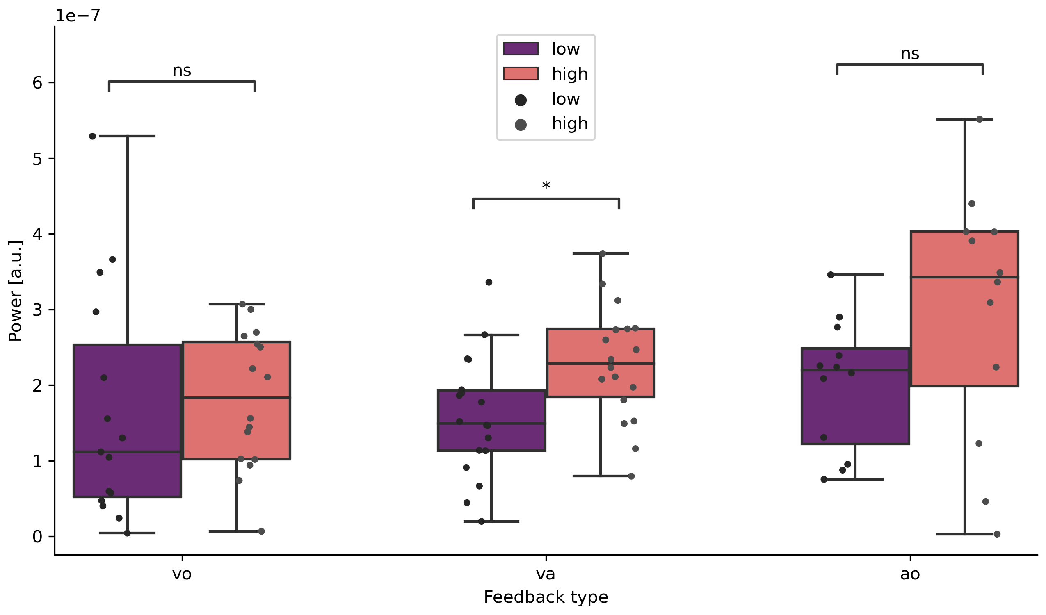

(b)

Figure 1: Single trial tremor force. (a) Patients split per feedback type (visual only (vo), audio-visual (va), auditory (ao)) and feedback angle (low vs. high). (b) Controls split per feedback type (vo, va, ao) and feedback angle (low vs. high).

ao: auditory only; va: audio-visual; vo: visual only

The purpose of our study is to address two specific questions: Firstly, we aim to determine if auditory feedback modulates target force tremor in ET patients in a comparable manner to visual feedback and to a combined multisensory feedback of both conditions. Secondly, we aim to assess whether pupil dilation, as a marker for arousal and noradrenergic activation, is increased during the enhanced feedback conditions. We hypothesize that ET patients experience greater arousal and pupil dilation during the enhanced feedback conditions compared to HC, independently of the type of feedback.

# Results

## Clinical data

14 ET patients and 14 age- and gender matched healthy controls were included into the study (Table 1). While there was no significant group difference in age (t = 86.50, p = 0.147), the Becks-Depression-Inventory (BDI-II, t = 113.50, p = 0.003) and Schmahmann-Scale (t = 33.50, p = 0.046) revealed a statistically significant difference between the patients and control group. The TETRAS score was significantly correlated with age (r = 0.566, p = 0.035), not however with the BDI-II score (r = -0.145, p = 0.637). The Schmahmann scale total score was negatively correlated with age (r = -0.24, p = 0.002). The TETRAS Score was significantly correlated with the Schmahmann score (r = -.21, p = 0.005), this correlation however dropped to r = -.1 (p = 0.197) when including age as a partial factor in the analysis.

|  |  |  |  |  |  |  |  |  |
| --- | --- | --- | --- | --- | --- | --- | --- | --- |
| Variable | ET | |  | HC | |  |  | |
| Median | | 25th/75th  percentile | Median | | 25th/75th  percentile | p-value* | |
| n | 14 |  | | 14 |  | | |  |
| Female [n] | 6 |  | | 7 |  | | | n.s. |
| Age [years] | 63.00 | [46.0/66.0] | | 65.50 | [61.0/74.0] | | | n.s |
| BDI Score [n] | 8.00 | [5.0/11.0] | | 0.50 | [0.0/1.8] | | | 0.003 |
| Schmahmann Score [n] | 107.00 | [86.0/101.0] | | 93.00 | [102.0/111.0] | | | 0.046 |
| Tetras Score [n] | 41.00 | [31.6/47.4] | | - | - | | | - |
| Table 1: ET = Essential tremor patients, HC = healthy controls, - = not available, n.s. = not significant, * = Mann-Whitney-U test. | | | | | | | | |

## Tremor force

The difference in force tremor between the conditions high and low, Power Spectral Density (PSD) in the tremor relevant frequency spectrum (4-12 Hz), significantly differed between patients and controls in each of the feedback conditions (visual only (vo) (t[53]=39.00, p=0.018), audio-visual (va) (t[53]=24.00, p=0.041) and auditory only (ao) (t[53]=42.00, p=0.013, **Figure 1**).

Patients showed a significant increase of force tremor during each high feedback condition (visual: p=0.006; audio-visual: p=0.005; auditory: p=0.028). Controls showed a significant difference between low vs. high feedback per condition only in the audio-visual condition (p=0.048), not in the other two conditions (visual: p=0.09; auditory: p=0.165).

## Pupil Size

Patients showed a significant increase of pupil size during the enhanced feedback in two conditions (audio-visual: p=0.039, auditory: p=0.046), not however in the visual feedback condition (visual: p=0.08, **Figure 2**). Controls showed no significant difference for pupil size between low vs. high feedback per condition (visual: p=0.328; audio-visual: p=0.167, auditory: p=0.78).

Pupil dilation differences between patients and controls showed significant differences in each feedback condition in feedback types, visual only (t[53]=2.00, p=0.028), audio-visual (t[53]=2.33, p=0.022) and auditory only (t[53]=1.33, p=0.047).

# Discussion

In this study we investigated sensory feeback driven modulation of target force tremor amplitude in ET patients.

In summary, we found that target force tremor amplitude is modulated by visual and auditory sensory feedback scaling in a comparable scale. During the enhanced visual, auditory or combined audio-visual feedback tasks the tremor amplitude was significantly increased. Increased sensory feedback coincided with an increased pupil diameter in patients, but not in controls. Combined audio-visual feedback evoked the largest increase of tremor amplitude and pupil diameter in patients.

While it is well described, that visual feedback modulates action tremor amplitude in different underlying disease conditions like multiple sclerosis, ET and dystonic tremor (Sanes, LeWitt et al. 1988, Keogh, Morrison et al. 2004, Feys, Helsen et al. 2006, Gironell, Ribosa-Nogue et al. 2012), our study is the first to show that the amplitude of target force tremor in ET is modulated by a different quality of sensory feedback (i.e. auditory) in a comparable scale.

The increase of the tremor amplitude during the auditory-only condition cannot be explained by an increased error since the MF, RMSE and 0-3 Hz force power as markers for non-tremulous movements did not differ between the conditions or groups.

Our findings raise the question, if there is a common underlying mechanism for sensory feedback induced tremor modulation in the context of different sensory qualities. We hypothesized, that an increased arousal mediates the intensification of the tremor amplitude. Therefore, was measuredsizeauditory and audio-visual feedback was found Only during the enhanced visual-only feedback there was no significant pupil dilation (although a non-significant trend), which is most likely explained by the predominant pupillary light reflex exerting a pupil constriction and hampering the pupil dilation during external illumination.Since external illumination remained constant during the auditory feedback trials, pupil dilation occured independently of external by our group

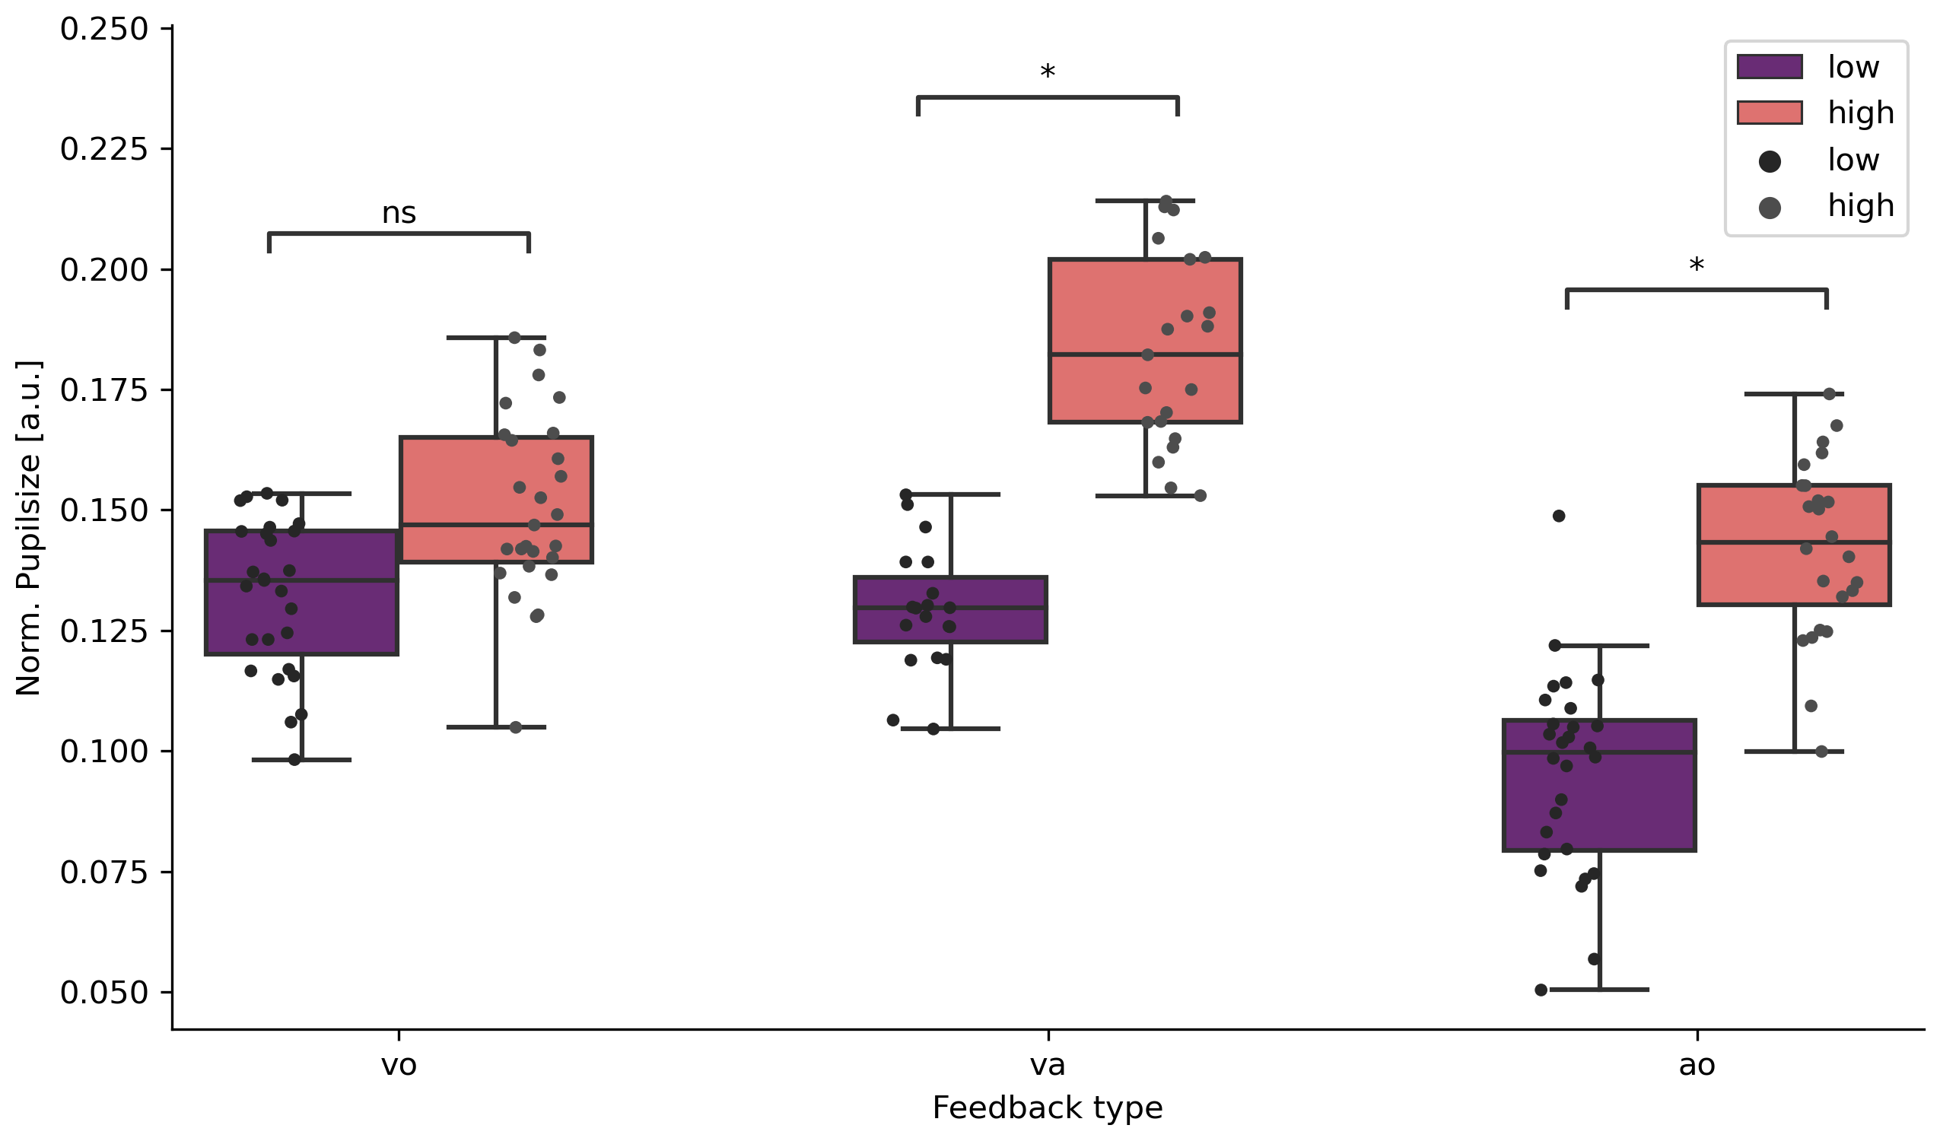

(a)

(b)

Figure 2: Single trial pupil size differences. (a) Patients split per feedback type (visual only (vo), audio-visual (va), auditory (ao)) and feedback angle (low vs. high). (b) Controls split per feedback type (vo, va, ao) and feedback angle (low vs. high).

A recent functional MRI study found -apart from the well-known cerebello-thalamo-motor cortical tremor circuit- a widespread visually sensitive network including key regions in the visual cortex and parietal lobule associated with alterations of essential tremor amplitude during visual feedback manipulation in a grip force task.(Archer, Coombes et al. 2017) Interestingly, by the same group visual feedback-induced tremor exacerbation in patients with dystonic tremor was found as well, but in this patient group tremor amplitude modulation was not coupled to an associated dysfunction of visual cortex regions.(DeSimone, Archer et al. 2019) Taken together with our finding that force tremor amplitude is comparably modulated by auditory feedback as well, this underlines the role of a common underlying mechanism for sensory feedback induced tremor modulation.

Since the processing of afferent auditory and visual signals encompasses different neuroanatomical regions, it seems questionable that specific sensory networks exert a direct tremor modulating effect.

Recently, a modulatory role of cognitive effort during a serial seven task, as measured by a coincident pupillary dilation, onto the rest tremor network of Parkinson´s disease was shown.(Dirkx, Zach et al. 2020) This effect was most likely exerted by direct bottom-up noradrenergic influences onto the thalamus and indirectly by top-down cognitive influences onto the cerebello-thalamo-cortical circuit. Since the thalamus is a key node not only within the PD resting tremor network but also the action tremor network in ET as well, an amplification of action tremor by ascending noradrenergic systems seems likely. Enhanced feedback of any sensory quality during target driven physical tasks might increase the arousal/perceived effort level and thereby activate the ascending noradrenergic system, with the locus coeruleus (LC) as main effector. Recent neuroimaging studies have confirmed a close relationship between the LC and bilateral thalamus and the cerebellum, both key regions within the action tremor network.(Liebe, Kaufmann et al. 2020) Therefore, cognitive arousal/perceived effort during motor tasks, induced by enhanced sensory feedback of any quality, might activate the LC-noradrenergic system and thereby mediate an amplification of action tremor amplitude via thalamic and cerebellar projections of the LC.

# Another explanation for sensory feedback dependent tremor modulation could encompass the interaction between somatosensory cortex (S1) and the primary motor cortex (M1) (Versteeg 2021; Shadmehr & Krakauer, 2008; Todorov & Jordan, 2002). M1 plays a crucial role as a feedback controller for motor control, performing dynamic updates of internal motor commands, which are receive input from the somatosensory cortex (S1). However, when sensory feedback is manipulated, such as in our paradigm where visual feedback is altered and does not match the tactile feedback, it might lead to incorrect updating in M1.

This idea is supported by the fact, that S1 and the cerebellum are closely interconnected and work together during movement control (Diedrichsen et al., 2005). Dysfunction of this interaction seems to contribute to the development of action tremor (Hallett, 2014; Ito, 2008; Raethjen, 2015). Therefore, understanding the complex interactions between M1, S1, and the cerebellum is essential for understanding how action tremor emerges.

Our data of the pupillometry is intended as a primer of the LC activity (Aston-Jones & Cohen, 2005). Studies have shown that the LC projects into the thalamus and basal ganglia and acts as modulator of these regions. Both the basal ganglia and thalamus have an influence on tremor generation. In our task, two mechanisms might contribute to the fact that ET patients show a higher tremor force in harder task conditions, feedback modality independent. First, a bottom-up process triggered by the LC activity in a higher arousal state mute down inhibition on subcortical tremor-generating structures. This is partially supported by our pupil data. Secondly, the cerebellum and sensoricortical structures integrate different sensory information (visual, auditory and somatosensory) which suppose to work as a reference copy for the feedback control of M1.

Limitations

Our study has several limitations. The main limitation is, that, by our experiment setup, we cannot finally prove that the altered arousal (mirrored by pupil dilation) is directly caused by the enhanced feedback. The enhanced arousal could also be just a secondary effect of the increased difficulty to perform the task with increased tremor. However, in this case we would expect a correlation of the pupil dilation with the tremor amplitude independently of the feedback condition or with the individual TETRAS score, but both is not given.

The auditory feedback paradigm consisted of a reference tone (440Hz) as a target and a second tone which varied in pitch depending on the distance to the target force. Hitting the target tone might be easier (and therefore cause less arousal) for participants who are familiar with making music or singing. At least we excluded a manifest hypoacusis in all patients and controls by a hearing test.

With our data, we cannot make assumptions about the relation of processing between muscular and cortical connections, further studies including imaging or high resolution EEG can help to quantify this.

# Conclusion

In this study, it was found that the amplitude of force tremor in Essential Tremor patients is modulated by different sensory feedback, including visual and auditory, in a comparable manner. The perception of higher effort during more difficult tasks, reflected by the larger pupil diameter, could be the reason behind the tremor modulation. The pupil size mirrors the level of effort invested in a task and might activate the LC-noradrenergic system and thereby mediate an amplification of action tremor amplitude by thalamic and cerebellar projections of the LC. It is also suggested that the interaction between somatosensory cortex (S1) and the cerebellum can contribute to the development of action tremor. Overall, the study provides new insights into the underlying mechanism of sensory feedback induced tremor modulation in Essential Tremor patients.

# Acknowledgements

We would like to thank Lena Hamann for her invaluable contribution during data collection and all participants for their time and patients while participating.

# Author contributions

J.W., G.D., J.K., and J.B. designed research; J.W., G.D, M.G., W.M. and J.B. performed research; J.W and G.H. analyzed data; and J.W. and J.B. wrote the paper.

# Competing interest statement

The authors declare no competing financial interests.

# Materials and Methods

Participants

The study was approved by the ethical committee of the Medical Faculty of Kiel (AZ 447/21) and was conducted in accordance with the Declaration of Helsinki. Participants gave written informed consent before participation. 14 patients with essential tremor 14 healthy controls were included. All patients were diagnosed with Essential Tremor by a specialist for neurology, healthy controls had no history of neurological or psychological disorders. All participants were right-handed and had no restrictions in vision or hearing.

Patients were asked to pause tremor related medication for at least 24 hours and participants were instructed to avoid caffeine and nicotine consumption on the examination day. Covariates between groups were compared using Mann-Whitney-U tests.

Figure 4: Experimental setup. (Left side) Datastreams (Force sensor, Pupil dialation and experimental triggers) are recorded via the Lab Streaming Layer. (Right side) Example epoch with timing of all elements.

Experimental setup

In a computer-based task participants were asked to match a target force by using a force sensitive resistor (FSR). Feedback about the target position and the corresponding sensor was given either visually on a computer screen or auditory via headphones or with a combination of both. Force data were collected with a weight cell (Adafruit, ADA4541), which was connected to an amplifier (SparkFun, HX711) and digitized at 80Hz via an ArduinoUno. The Arduino was connected via a serial port to the stimulus presentation computer. The experiment presentation was done via PsychoPy (Peirce et al., 2019). Inside the presenting script the data of the serial port (FSR) was used to feedback information of the applied force to the participant in real time (jitter delay < 10ms) and simultaneously send to LSL (Kothe et al., 2020) for recording. Pupil data were recorded using a Pupil Core module (Pupil Labs, Berlin, Germany) with a sampling rate of 240 Hz. Calibration was done prior to the experimental task while data was send to LSL during the experiment via the Pupil LSL relay (Pupil Labs, 2021). All data streams (Experimental Marker, FSR and Pupil data) were recorded using the LabRecorder (Boulay, 2020). For details see Figure 4, left side.

Experimental procedure

The experiment session lasted ~60 minutes and took place in a controlled laboratory environment. After participants gave consent to participate, clinical data and demographics were recorded. After this, they started the experimental task sitting in front of a computer (distance from the eyes to the screen: approx. 90 cm). The experiment consisted of a training block and three subsequent experimental blocks, between which the subject could take short breaks. Prior to training the individual maximum force (MF) was determined. For this, participants were asked to apply maximum pressure to the force sensor with the thumb and index finger three times for 1 second. The maximum of the respective averages of samples was used as MF.

The task for the participants was to match a target force (15% of the individual MF) as quickly as possible and hold it for a period of 30s. They got feedback on their performance during every trial in form of sensory feedback. Three different sensory feedback types were presented in the following order: 1. Visual only, 2. audio-visual and 3. auditory only. Visual only (vo) feedback consisted of a vertical bar which position varied depending on how close the target force was matched. The target bar and the force sensitive bar overlapped when the target force was matched. Auditory only (ao) feedback was provided by a reference tone (440Hz) as a target and a second tone which varied in pitch depending on the distance to the target force (between 120 and 880 Hz). If the target force was matched, participants heard two 440Hz tones. Audio-visual feedback was a combination of the vo and ao type. Each experimental trial consisted of a written cue what type of feedback is being presented, a 30 s resting period and a 30 s task period (see Figure 4, right side).

In total every participant conducted 12 experimental trials, four of each feedback type. During each trial the feedback was altered using one of two factors applying different gain levels, resulting in different feedback conditions. The low gain and high gain resulting in an easier or harder task to match the target force (Archer ea., 2017).

.

Here FP is the force produced by the subject, Ft is the target force, and G is the gain level used to manipulate the amplitude of feedback.

Data processing

The force data was first normalized to the participants MF by dividing every sample by the MF * 0.15. Next, data was filtered using a bandpass butterworth, executed by the scipy package (1.8.1) in python (3.10). After filtering, data was cut into trials to estimate power-spectral densities, using the psd_array_welch function from the MNE package (1.3.1). For force tremor relevant power, a frequency window of 4-12 Hz was defined, for voluntary movement a 0.1-3 Hz frequency window was defined. Unfiltered force error (RMSE) during a trial was calculated by the root of the squared difference per sample to the target force.

The Pupil data was first cleaned of artifacts. Blinks were detected using outliers in gaze acceleration and PupilLabs confidence values (Pupil v2.5) and set to NaN in the time series. NaN values were subsequently interpolated using a fft convolution using a Gaussian kernel ranging 120 samples (~0.5 s) from the astropy package (5.1). After cleaning the raw time series, data was cut into epochs. A substractive baseline correction (-10 to -2s before trial onset) was applied per epoch and changes in pupil size were estimated 5 s after epoch start until 10s before the epoch ended. The mean of this time window was used for statistical analysis.

Preprocessing scripts of the FSR and pupil data can be found at GitHub (<https://github.com/JuliusWelzel/tremor_feedback_jw>).

Statistics

Clinical data were compared between groups using a Mann-Whitney-U test. Correlation analyses were conducted using a Pearson correlation if Levene’s test and Shapiro-Wilk test allowed it, otherwise spearman rank correlation was used. For the FSR data the interindividual difference between the means of the easy and hard feedback condition was calculated per feedback type. T-tests between groups for every feedback condition were calculated. The same was done for the pupil size data. All statistical analyses were performed in Python (3.10) using the scipy package (1.8.1) or pingouin package (0.5.2).

Sample size justification

The paper uses a sequential design with maximal sample sizes to efficiently determine statistical power. With this approach, the study is conducted in stages with the aim of collecting the minimum number of participants required to achieve the desired level of statistical power from the study to replicate (Archer ea., 2018).

The study is designed to have power of 0.80 from the original paper, therefore the data tested after each participant until the desired power level is reached. The desired power is achieved before the planned maximal sample size is reached (max n = 25), hence the study was stopped early, as higher numbers would have impacted the other outcome parameters to a unknown extend.

Overall, sequential designs with maximal sample sizes offer an approach to optimizing statistical power in replication studies where new outcome parameters are introduced (Schönebrodt and Wagenmaker, 2018).

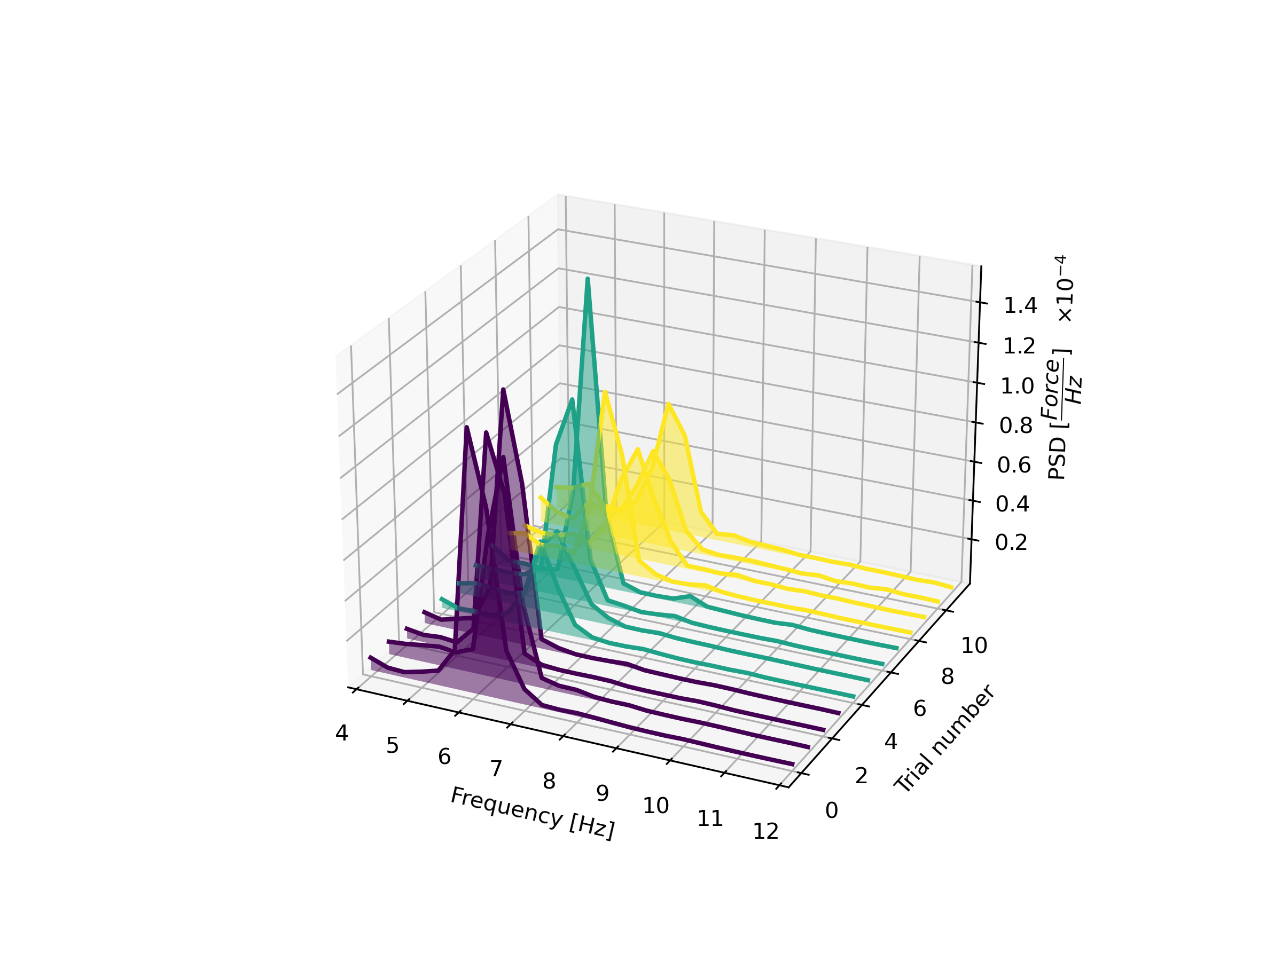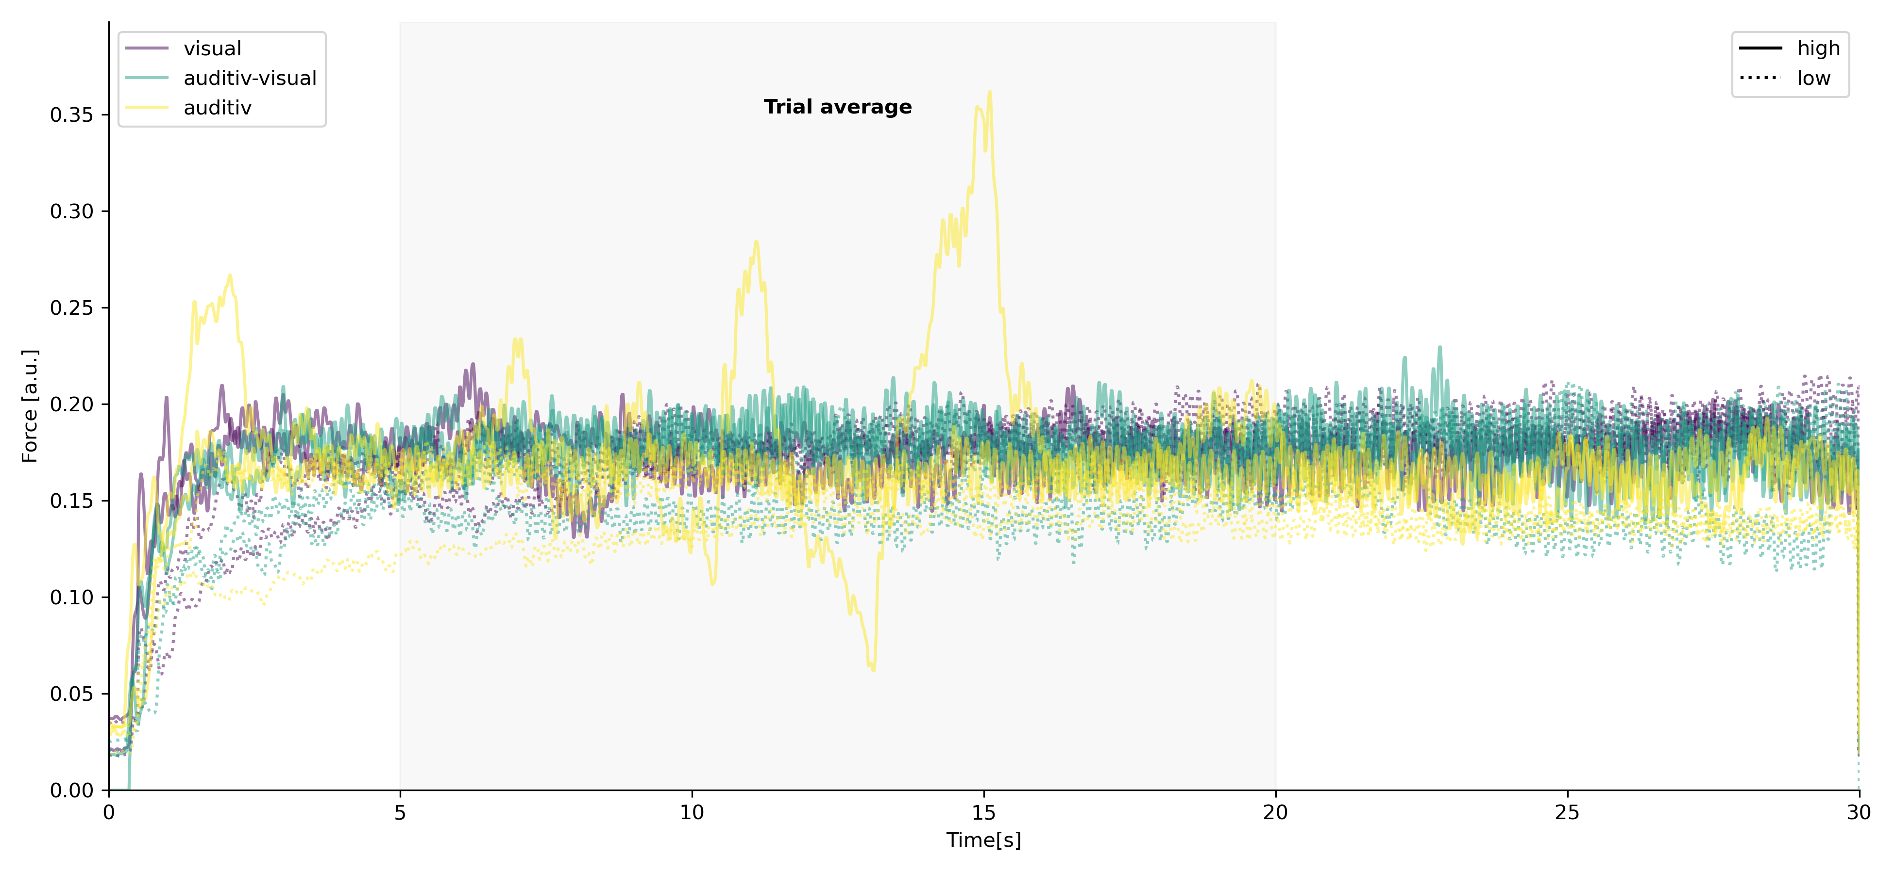

Figure 3: Times series data of a single participant. Above the time course of the pupillometry. Bottom left shows the single trial spectra of the force tremor per epoch. Bottom right displays the single trial raw force data. Both time courses are split per feedback type and feedback condition.

# References

Archer, D. B., S. A. Coombes, W. T. Chu, J. W. Chung, R. G. Burciu, M. S. Okun, A. Wagle Shukla and D. E. Vaillancourt (2017). "A widespread visually-sensitive functional network relates to symptoms in essential tremor." Brain.

Beatty, J. (1982). "Task-evoked pupillary responses, processing load, and the structure of processing resources." Psychological bulletin **91**(2): 276.

Becktepe, J. S., F. Govert, L. Kasiske, M. Yalaz, K. Witt and G. Deuschl (2019). "Pupillary response to light and tasks in early and late onset essential tremor patients." Parkinsonism Relat Disord **66**: 62-67.

Bhatia, K. P., P. Bain, N. Bajaj, R. J. Elble, M. Hallett, E. D. Louis, J. Raethjen, M. Stamelou, C. M. Testa and G. Deuschl (2018). "Consensus statement on the classification of tremors, from the task force on tremor of the international Parkinson and movement disorder society." Movement Disorders.

DeSimone, J. C., D. B. Archer, D. E. Vaillancourt and A. Wagle Shukla (2019). "Network-level connectivity is a critical feature distinguishing dystonic tremor and essential tremor." Brain.

Deuschl, G., J. S. Becktepe, M. Dirkx, D. Haubenberger, A. Hassan, R. C. Helmich, M. Muthuraman, P. Panyakaew, P. Schwingenschuh, K. E. Zeuner and R. J. Elble (2022). "The clinical and electrophysiological investigation of tremor." Clinical Neurophysiology **136**: 93-129.

Dirkx, M. F., H. Zach, A. J. van Nuland, B. R. Bloem, I. Toni and R. C. Helmich (2020). "Cognitive load amplifies Parkinson’s tremor through excitatory network influences onto the thalamus." Brain.

Feys, P., W. Helsen, M. Buekers, T. Ceux, E. Heremans, B. Nuttin, P. Ketelaer and X. Liu (2006). "The effect of changed visual feedback on intention tremor in multiple sclerosis." Neuroscience letters **394**(1): 17-21.

Gironell, A., R. Ribosa-Nogue and J. Pagonabarraga (2012). "Withdrawal of visual feedback in essential tremor." Parkinsonism Relat Disord **18**(4): 402-403; author reply 404.

Helmich, R. C., I. Toni, G. Deuschl and B. R. Bloem (2013). "The pathophysiology of essential tremor and Parkinson's tremor." Curr Neurol Neurosci Rep **13**(9): 378.

Keogh, J., S. Morrison and R. Barrett (2004). "Augmented visual feedback increases finger tremor during postural pointing." Experimental brain research **159**(4): 467-477.

Liebe, T., J. Kaufmann, M. Li, M. Skalej, G. Wagner and M. Walter (2020). "In vivo anatomical mapping of human locus coeruleus functional connectivity at 3 T MRI." Human brain mapping **41**(8): 2136-2151.

Pedrosa, D. J., P. Brown, H. Cagnan, V. Visser-Vandewalle, J. Wirths, L. Timmermann and J.-S. Brittain (2018). "A functional micro-electrode mapping of ventral thalamus in essential tremor." Brain **141**(9): 2644-2654.

Popović Maneski, L., N. Jorgovanović, V. Ilić, S. Došen, T. Keller, M. B. Popović and D. B. Popović (2011). "Electrical stimulation for the suppression of pathological tremor." Medical & biological engineering & computing **49**(10): 1187-1193.

Prochazka, A., J. Elek and M. Javidan (1992). "Attenuation of pathological tremors by functional electrical stimulation I: Method." Annals of biomedical engineering **20**(2): 205-224.

Reis, C., B. S. Arruda, A. Pogosyan, P. Brown and H. Cagnan (2021). "Essential tremor amplitude modulation by median nerve stimulation." Sci Rep **11**(1): 17720.

Sanes, J. N., P. A. LeWitt and K. H. Mauritz (1988). "Visual and mechanical control of postural and kinetic tremor in cerebellar system disorders." Journal of Neurology, Neurosurgery &amp; Psychiatry **51**(7): 934-943.

Shukla, A. W. (2022). "Rationale and Evidence for Peripheral Nerve Stimulation for Treating Essential Tremor." Tremor and Other Hyperkinetic Movements **12**.

Zenon, A., M. Sidibe and E. Olivier (2014). "Pupil size variations correlate with physical effort perception." Front Behav Neurosci **8**: 286.