**The Interplay of Sensory Feedback, Arousal, and Action Tremor Amplitude in Essential Tremor**

Julius Welzela, Miriam Güthe**a**, Julian Keil**b**, Gesine Hermann**a**, Robin Wolke**a**, Walter Maetzler**a**, and Jos S. Becktepe**a\***

aUniversity Hospital Schleswig-Holstein, Kiel, Germany

bDepartment of Psychology, University of Kiel, Kiel, Germany

*Correspondence should be addressed to J.S.B. (j.becktepe@neurologie.uni-kiel.de)

**Essential tremor (ET) amplitude is modulated by visual feedback during target driven movements. In a grip force task, tremor amplitude increased during large scale visual feedback compared to a condition with low scale visual feedback. It has not been examined whether visual feedback exclusively modulates target force tremor amplitude or if other afferent inputs like auditory sensation has a modulatory effect on tremor amplitude as well. Also, it is unknown whether the enhanced sensory feedback causes an increase of arousal in persons with ET (p-ET). We hypothesized that (1) amplitude of tremor is modulated by variation of auditory feedback in the absence of visual feedback in a force tremor paradigm; (2) increase of tremor amplitude coincides with pupillary size as a measure of arousal.**

**14 p-ET and 14 matched healthy controls (HC) conducted a computer-based experiment in which they were asked to match a target force on a force sensor using their thumb and index finger. The force-induced movement was fed back to the participant visually, auditory or by a combination of both.**

**Results showed a comparable deviation from the target force (RMSE) during the experiment during all three sensory feedback modalities. The ANOVA revealed an effect of the scaling factor on the tremor severity (Power 4-12Hz) for the visual- and also for the auditory feedback condition in p-ET. Pupillometry showed a significantly increased pupil diameter during the large scale auditory involved feedback conditions compared to the low scale feedback conditions in p-ET. Our findings suggest that action tremor in ET is firstly modulated not only by visual feedback but also by auditory feedback in a comparable manner. Therefore, tremor modulation seems to be modality independent. Secondly, enhanced feedback causes an increase of arousal as measured here by the pupil size. Further work including neurophysiological measures is required to better understand the interaction between arousal and target-related tremor.**

# Introduction

Tremor is defined as an involuntary, rhythmic, oscillatory movement of a body part 1.

Jean-Martin Charcot was the first who clearly differentiated the rest tremor of parkinsonism from the intention and action tremors of multiple sclerosis 2. Intention tremor is now defined as an action tremor in which “a crescendo increase in tremor occurs as the affected body part approaches its visual target”. It is differentiated from postural tremors (occurring during maintaining a position against gravity) and simple kinetic tremors (which occur during non-goal directed movements) 1,3. ﻿Intention tremor has often been used synonymously with cerebellar tremor, although cerebellar disorders might cause various phenotypes of tremor 4. Also, various etiologies other than cerebellar disorders can underlie and in many cases - including the large group of essential tremors - the etiology remains obscure 5. As a common pathophysiological substrate of action tremor syndromes, an altered oscillating activity within a cerebello-thalamo-motor cortical network was demonstrated by neuroimaging and electrophysiological approaches 6,7. Notably, the amplitude of intention tremor decreases in the absence of visual feedback and on the contrary is amplified by an increase of visual information. This phenomenon was reported in different intention tremor etiologies, encompassing essential tremor (ET), dystonic tremor and intention tremor in multiple sclerosis 8-11.

In a recent fMRI study, a target force paradigm with modulated visual feedback was applied and a “widespread visually-sensitive functional network” was found to contribute to tremor severity in this context 12. This target force tremor paradigm might therefore serve as a simplified model for examining the pathophysiological basis of intention tremor. However, although per definition intention tremor increases by approaching a visual target, it has not been examined yet whether other afferent feedback like auditory sensation has a modulatory effect on tremor amplitude as well. In this view, feedback about the movement in general would increase the tremor amplitude. This would raise the question of a common underlying mechanism modulating tremor amplitude dependent on any sensory feedback. Also, a potential role of multisensory integration for tremor amplitude modulation has not been examined yet. Simultaneously incoming sensory feedback could lead to an amplification of the tremor modulating effect compared to the unisensory condition. This effect has been studied in other settings and seems to alter neural activity13,14. To test this, we examined the modulation of tremor amplitude by visual and auditory feedback exclusively and by the combination of both.

The purpose of our study is to address two specific questions: First, we aim to determine if auditory feedback modulates target force tremor in persons with ET (p-ET) in a comparable manner to visual feedback and to combined multisensory feedback. Second, we aim to assess whether pupil diameter, as a marker for arousal and noradrenergic activation, is increased during high feedback conditions. We hypothesize that persons with ET experience greater arousal and pupil dilation during the enhanced feedback conditions compared to healthy controls (HC), independently of the type of feedback.

# Results

|  |  |  |  |  |  |  |  |  |  |
| --- | --- | --- | --- | --- | --- | --- | --- | --- | --- |
| Variable | p-ET | |  | HC | |  | |  | |
| Median | | 25th/75th  percentile | Median | | 25th/75th  percentile | | p-value* | |
| n | 14 |  | | 14 |  | |  | |
| Female [n] | 6 |  | | 7 |  | | n.s. | |
| Age [years] | 63.00 | [46.0/66.0] | | 65.50 | [61.0/74.0] | | n.s | |
| BDI Score [n] | 8.00 | [5.0/11.0] | | 0.50 | [0.0/1.8] | | 0.003 | |
| Schmahmann Modules [n] | 2.00 | [1/4] | | 4.50 | [0.5/1.5] | | 0.013 | |
| Tetras Score [n] | 41.00 | [31.6/47.4] | | - | - | | - | |
| Table 1: p-ET = persons with essential tremor, HC = healthy controls, - = not available, n.s. = not significant, * = Mann-Whitney-U test. | | | | | | | | | |

14 p-ET and 14 healthy controls (HC), not significantly different concerning age and gender, were included into the study (Table 1). While there was no significant group difference in age (U = 86.50, p = 0.147), the Becks-Depression-Inventory (BDI-II, U = 113.50, p = 0.003) and Schmahmann syndrome scale (U = 137.00, p = 0.013) revealed a statistically significant difference between p-ET and HC. The TETRAS score was significantly correlated with age (r = 0.566, p = 0.035), but not with the BDI-II score (r = -0.145, p = 0.637). The Schmahmann syndrome scale total score was negatively correlated with age (r = 0.32, p ≤ 0.001). The TETRAS Score was significantly correlated with the Schmahmann syndrome scale score (r = .26, p = 0.005), this correlation however showed to be not significant (r = 0.08, p = 0.448) when including age as a partial factor in the analysis.

The differences in force tremor between the conditions of high and low feedback were assessed. High and low feedback refers to the gain of visual and/or auditory feedback-signal, for more details please see “Experimental setup” in the methods section. The difference in force tremor between the conditions high and low feedback, as measured by the power spectral density (PSD) in the tremor relevant frequency spectrum (4-12 Hz), significantly differed between p-ET and HC in each of the feedback conditions (visual only (vo) (t[53]=2.40, p=0.018), audio-visual (va) (t[53]=2.07, p=0.041) and auditory only (ao) (t[53]=2.71, p=0.013, **Figure 1**).

p-ET showed a significant increase of force tremor during each high feedback condition (visual: p=0.006; audio-visual: p=0.005; auditory: p=0.028). HC showed a smaller, but significant difference between low vs. high feedback only in the audio-visual condition (p=0.048), but not in the other two conditions (visual: p=0.09; auditory: p=0.165).

Mean Force (MF), Unfiltered Force Error (RMSE, group: F(1, 294) =2.857, p=0.092 or feedback type: F(2, 297) =1.671, p=0.190.) and Force Power 0-3 Hz did not differ between conditions or groups.

(a) (b)

Figure 1: Single trial tremor force. (a) Trials of p-ET split per feedback type (visual only (vo), audio-visual (va), auditory (ao)) and feedback angle (low vs. high). (b) Trials of HC split per feedback type (vo, va, ao) and feedback angle (low vs. high).

ao: auditory only; va: audio-visual; vo: visual only; p-ET: persons with essential tremor; HC: healthy controls

p-ET showed a significant increase of pupil size during the high feedback compared to low feedback in two conditions (audio-visual: p=0.039, auditory: p=0.046), not however in the visual feedback condition (visual: p=0.08, **Figure 2**). HC showed no significant difference for pupil size between low vs. high feedback per condition (visual: p=0.328; audio-visual: p=0.167, auditory: p=0.78).

Pupil dilation differences between p-ET and HC showed significant differences when comparing the feedback types for each feedback condition, visual only (t[53]=2.00, p=0.028), audio-visual (t[53]=2.33, p=0.022) and auditory only (t[53]=1.33, p=0.047).

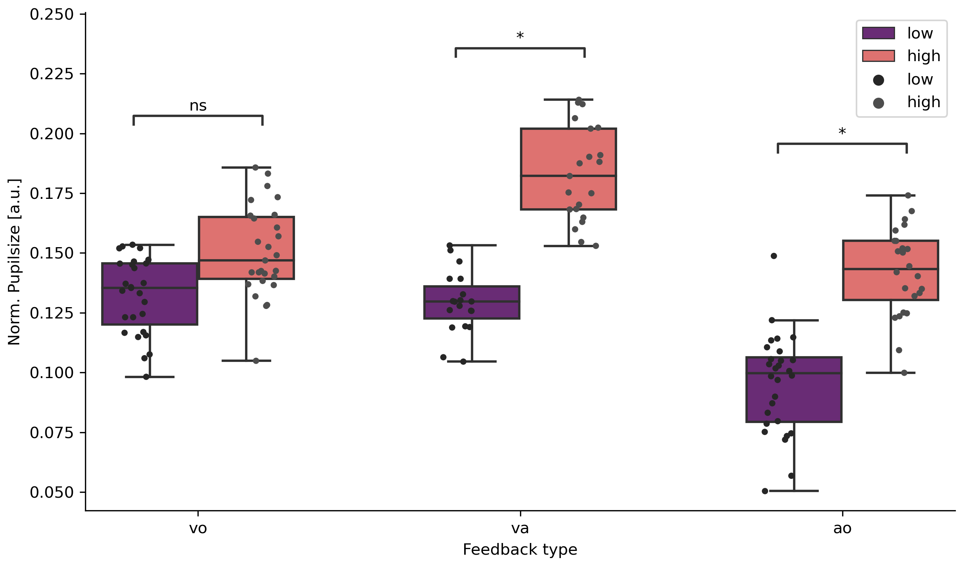

(a) (b)

Figure 2: Single trial pupil size differences. (a) Trials of p-ET split per feedback type (visual only (vo), audio-visual (va), auditory (ao)) and feedback angle (low vs. high). (b) Trials of HC split per feedback type (vo, va, ao) and feedback angle (low vs. high).

# Discussion

In this study we investigated sensory feedback driven modulation of target force tremor amplitude in p-ET and HC.

In summary, we found that target force tremor amplitude is modulated by visual and auditory sensory feedback scaling in a comparable measure in p-ET. During the high visual, auditory or combined audio-visual feedback tasks the tremor amplitude was significantly increased. Augmented sensory feedback coincided with an increased pupil diameter in p-ET, but not in HC. Combined audio-visual feedback evoked the largest increase of tremor amplitude and pupil diameter in p-ET and additionally, a significant increase of tremor force in HC.

While it is well described, that visual feedback modulates action tremor amplitude in different underlying disease conditions like multiple sclerosis, ET and dystonic tremor 8-10,15, our study is the first to show that the amplitude of target force tremor in ET is modulated by a different quality of sensory feedback (i.e. auditory) in a comparable scale.

The increase of the tremor amplitude during the auditory-only condition cannot be explained by an increased error since the MF, RMSE and 0-3 Hz force power as markers for non-tremulous movements did not differ between the conditions or groups.

Our findings raise the question, whether there is a common underlying mechanism for sensory feedback induced tremor modulation in the context of different sensory qualities.

A recent functional MRI study found -apart from the well-known cerebello-thalamo-motor cortical tremor circuit- a widespread visually sensitive network including key regions in the visual cortex and parietal lobule associated with alterations of essential tremor amplitude during visual feedback manipulation in a grip force task 12. Interestingly, by the same group visual feedback-induced tremor exacerbation in patients with dystonic tremor was found as well, but in this patient group tremor amplitude modulation was not coupled to an altered BOLD signal of visual cortex regions 11. Taken together with our finding that force tremor amplitude is comparably modulated by auditory feedback as well, this underlines the role of a common underlying mechanism for sensory feedback induced tremor modulation apart from the visual network.

Our finding that combined audio-visual feedback evoked the largest increase of tremor amplitude in p-ET but also a significant increase of tremor in HC, underlines that the magnitude of sensory feedback per se correlates with a tremorgenic effect.

We hypothesized, that an increased arousal has an effect on the intensification of the tremor amplitude.

Recently, a modulatory role of cognitive effort during a serial seven task, as measured by a coincident pupillary dilation, onto the rest tremor network of Parkinson´s disease (PD) was shown 16. This effect was most likely exerted by direct bottom-up noradrenergic influences onto the thalamus and indirectly by top-down cognitive influences onto the cerebello-thalamo-cortical circuit. Since the thalamus is a key node not only within the PD resting tremor network but also the action tremor network in ET as well 7, an amplification of action tremor by ascending noradrenergic systems seems possible.

Enhanced feedback of any sensory quality during target driven physical tasks might increase the arousal/perceived effort level and thereby activate the ascending noradrenergic system, with the locus coeruleus (LC) as main effector 17. Recent neuroimaging studies have confirmed a close relationship between the LC and bilateral thalamus and the cerebellum, both key regions within the action tremor network 18. Therefore, cognitive arousal/perceived effort during motor tasks, induced by enhanced sensory feedback of any quality, might activate the LC-noradrenergic system and thereby mediate an amplification of action tremor amplitude via thalamic and cerebellar projections of the LC.

Therefore, in our experiment, pupil diameter was measured as a marker for cognitive arousal and an increase of pupil size during the enhanced auditory and audio-visual feedback trials was found. Only during the enhanced visual-only feedback there was no significant pupil dilation (although a non-significant trend), which is most likely explained by the changes in external illumination during the visual-only feedback, triggering a pupil constriction and hampering the pupil dilation. Since external illumination remained constant during the auditory feedback trials, pupil dilation occurred independently of external visual input. It´s rather probable, that the pupil dilation reflects an increased arousal during the large-scale feedback trials. Pupil size coincides with cognitive arousal due to activation of the sympathic system and the task evoked pupillary response is known to reflect the mental effort to perform the task 19, which was also shown in p-ET by our group 20. ﻿Apart from mental effort, pupil diameter also increases during physical effort, thereby reflecting not only the actual intensity of the physical activity but also the individual perception of the effort 21. In summary, pupil size mirrors the level of effort, which is invested in a task, irrespective of whether it is physical or mental. Therefore, we hypothesize that tremor p-ET perceived a higher effort during the large-scale feedback tasks, as reflected by the larger pupil diameter. Thus, the effort itself could exert a modulatory role on target force tremor amplitude.

Another explanation for sensory feedback dependent tremor modulation could encompass the interaction between somatosensory cortex (S1) and the primary motor cortex (M1). M1 plays a crucial role as a feedback controller for motor control, performing dynamic updates of internal motor commands, which receive input from the somatosensory cortex (S1). However, when sensory feedback is manipulated, such as in our paradigm where visual feedback is altered and does not match the tactile feedback, it might lead to incorrect updating in M1 22,23.

This idea is supported by the fact, that S1 and the cerebellum are closely interconnected and work together during movement control (Diedrichsen et al., 2005). Dysfunction of this interaction seems to contribute to the development of action tremor 24-27. Therefore, understanding the complex interactions between M1, S1, and the cerebellum seems essential for understanding how action tremor emerges.

Our data of the pupillometry is intended as a primer of the LC activity (Aston-Jones & Cohen, 2005). Studies have shown that the LC projects into the thalamus and basal ganglia and acts as modulator of these regions. Both, the basal ganglia, and thalamus are involved within tremor generation28,29. In our task, two mechanisms might contribute to the fact that p-ET show a higher tremor force in harder task conditions, feedback modality independent. First, a bottom-up process triggered by the LC activity in a higher arousal state mutes down inhibition on subcortical tremor-generating structures. This is partially supported by our pupil data. Secondly, the cerebellum and sensoricortical structures integrate different sensory information (visual, auditory, and somatosensory) which are supposed to work as an efference copy for the feedback control of M1.

Limitations

Our study has several limitations. The main limitation is that, by our experiment setup, we cannot finally prove that the altered arousal (mirrored by pupil dilation) is directly caused by the enhanced feedback. The enhanced arousal could also be just a secondary effect of the increased difficulty to perform the task with increased tremor. However, in this case we would expect a correlation of the pupil dilation with the PSD in the tremor relevant frequency spectrum (4-12 Hz) independently of the feedback condition or with the individual TETRAS score, but both were not given. Therefore, the increase of arousal seems to be caused by the enhanced sensory feedback itself and is not a secondary effect of the tremor increase.

Another limitation of the auditory feedback paradigm is that hitting the target tone might be easier (and therefore cause less arousal) for participants who are familiar with making music or singing. At least we excluded a manifest hypoacusis in all participants by a hearing test.

# Conclusion

In this study, it was found that the amplitude of force tremor in p-ET is modulated by different sensory feedback, including visual and auditory, in a comparable manner. The perception of higher effort during more difficult tasks, reflected by the larger pupil diameter, could be the reason behind the tremor modulation. The pupil size mirrors the level of effort invested in a task and might activate the LC-noradrenergic system and thereby mediate an amplification of action tremor amplitude by thalamic and cerebellar projections of the LC. Further studies including imaging or high-resolution EEG might help to better understand the relation of feedback dependent tremor modulation in the future.

# Materials and Methods

Participants

The study was approved by the ethical committee of the Medical Faculty of Kiel (AZ 447/21) and was conducted in accordance with the Declaration of Helsinki. Participants gave written informed consent before participation. 14 persons with essential tremor (p-ET) and 14 healthy controls (HC) were included. All p-ET were diagnosed with ET by a movement disorder specialist, HC had no history of neurological or psychological disorders. All participants were right-handed and had no restrictions in vision or hearing.

p-ET were asked to pause tremor related medication and medication possibly affecting the pupillary motion (i.e. cholinesterase inhibitors, betablockers, benzodiazepines, caffeine) for at least 24 h. The clinical examination encompassed a complete neurological examination, a tremor assessment (The Essential Tremor Rating Assessment Scale, TETRAS 30), a cognitive assessment (The Cerebellar cognitive affective/Schmahmann syndrome scale 31) and the Beck´s depression inventory 32.

Figure 3: Experimental setup. (Left side) Datastreams (Force sensor, Pupil dialation and experimental triggers) are recorded via the Lab Streaming Layer. (Right side) Example epoch with timing of all elements.

Covariates between groups were compared using Mann-Whitney-U tests.

Experimental setup

In a computer-based task participants were asked to match a target force by using a force sensitive resistor (FSR). Feedback about the target position and the corresponding sensor was given either visually on a computer screen or auditory via headphones or with a combination of both. Force data were collected with a weight cell (Adafruit, ADA4541), which was connected to an amplifier (SparkFun, HX711) and digitized at 80Hz via an ArduinoUno. The Arduino was connected via a serial port to the stimulus presentation computer. The experiment presentation was done via PsychoPy (Peirce et al., 2019). Inside the presenting script the data of the serial port (FSR) was used to feedback information of the applied force to the participant in real time (jitter delay < 10ms) and simultaneously send to LSL (Kothe et al., 2020) for recording. Pupil data were recorded using a Pupil Core module (Pupil Labs, Berlin, Germany) with a sampling rate of 240 Hz. Calibration was done prior to the experimental task while data was send to LSL during the experiment via the Pupil LSL relay (Pupil Labs, 2021). All data streams (Experimental Marker, FSR and Pupil data) were recorded using the LabRecorder (Boulay, 2020). For details see **Figure 3**, left side.

Experimental procedure

The experiment session lasted ~60 minutes and took place in a controlled laboratory environment. After participants gave consent to participate, clinical data and demographics were recorded. After this, they started the experimental task sitting in front of a computer (distance from the eyes to the screen: 90 cm). The experiment consisted of a training block and three subsequent experimental blocks, between which the subject could take short breaks. Prior to training the individual maximum force (MF) was determined. For this, participants were asked to apply maximum pressure to the force sensor with the thumb and index finger three times for 1 second. The maximum of the respective averages of samples was used as MF.

The task for the participants was to match a target force (15% of the individual MF) as quickly as possible and hold it for a period of 30s. They got feedback on their performance during every trial in form of visual and/or auditory feedback. High and low feedback here refer to a previous study 12 where different levels of feedback were introduced during a task to match a target force. Three different sensory feedback types were presented in the following order: 1. Visual only, 2. Audio-visual and 3. Auditory only. Visual only (vo) feedback consisted of a vertical bar which position varied depending on how close the target force was matched. The target bar and the force sensitive bar overlapped when the target force was matched. Auditory only (ao) feedback was provided by a reference tone (440Hz) as a target and a second tone which varied in pitch depending on the distance to the target force (between 120 and 880 Hz). If the target force was matched, participants heard two 440Hz tones. Audio-visual feedback was a combination of the vo and ao type. The performance between feedback types were assessed using the Root Mean Square Error (RMSE) and the amount of voluntary movement (Power 0-3 Hz). Each experimental trial consisted of a written cue what type of feedback is being presented, a 30 s resting period and a 30 s task period (see **Figure 3**, right side).

In total every participant conducted 12 experimental trials, four of each feedback type. During each trial the feedback was altered using one of two factors applying different gain levels, resulting in different feedback conditions. The low gain (0.04°) and high gain (6.9°) resulting in a low or high feedback task to match the target force 12.

.

Here FP is the force produced by the subject, Ft is the target force, and G is the gain level used to manipulate the amplitude of feedback.

Data processing

The force data was first normalized to the participants MF by dividing every sample by the MF * 0.15. Next, A fifth-order Butterworth band-pass filter was applied to the data with cutoff frequencies at 0.1 Hz and 12 Hz. The filter was implemented using the Second-Order Sections (SOS) format to ensure numerical stability and executed by the scipy package (1.8.1) in python (3.10). After filtering, data was cut into trials to estimate power-spectral densities, using the psd_array_welch function from the MNE package (1.3.1). For force tremor relevant power, a frequency window of 4-12 Hz was defined (the power spectral density (PSD) in the tremor relevant frequency spectrum (4-12 Hz)). For voluntary movement a 0-3 Hz frequency window was defined. Unfiltered force error (RMSE) during a trial was calculated by the root of the squared difference per sample to the target force. **Figure 4** shows an example of time series data for pupil size, raw force data and spectra from the raw force data.

The pupil data was first cleaned of artifacts. Blinks were detected using outliers in gaze acceleration and PupilLabs confidence values (Pupil v2.5) and set to NaN in the time series. NaN values were subsequently interpolated using a fast fourier transform (FFT) convolution using a Gaussian kernel ranging 120 samples (~0.5 s) from the astropy package (5.1). After cleaning the raw time series, data was cut into epochs. A subtractive baseline correction (-10 to -2s before trial onset) was applied per epoch and changes in pupil size were estimated 5 s after epoch start until 10s before the epoch ended. The mean of this time window was used for statistical analysis. Preprocessing scripts of the FSR and pupil data can be found at GitHub (<https://github.com/JuliusWelzel/tremor_feedback_jw>).

Statistics

Clinical data were compared between groups using a Mann-Whitney-U test when not normally distributed based on Shapiro-Wilk tests. Correlation analyses were conducted using a Pearson correlation if Levene’s test and Shapiro-Wilk test allowed it, otherwise Spearman rank correlation was used. For the FSR data interindividual differences between means of the easy and hard feedback condition were calculated per feedback type. T-tests between groups for every feedback condition were calculated. The same was done for pupil size data. All statistical analyses were performed in Python (3.10) using the scipy package (1.8.1) or pingouin package (0.5.2).

Sample size justification

The protocol was designed using a sequential design with maximal sample sizes to efficiently reach statistical power. With this approach, the study is conducted in stages with the aim of collecting the minimum number of participants required to achieve the desired level of statistical power from the study to replicate (Archer ea., 2018).

The study was designed to have power of 0.80 from the original paper, therefore the data tested after each participant until the desired power level is reached. The desired power is achieved before the planned maximal sample size per group is reached (max n = 25), hence the study was stopped early, as higher numbers would have impacted the other outcome parameters to an unknown extend.

(a)

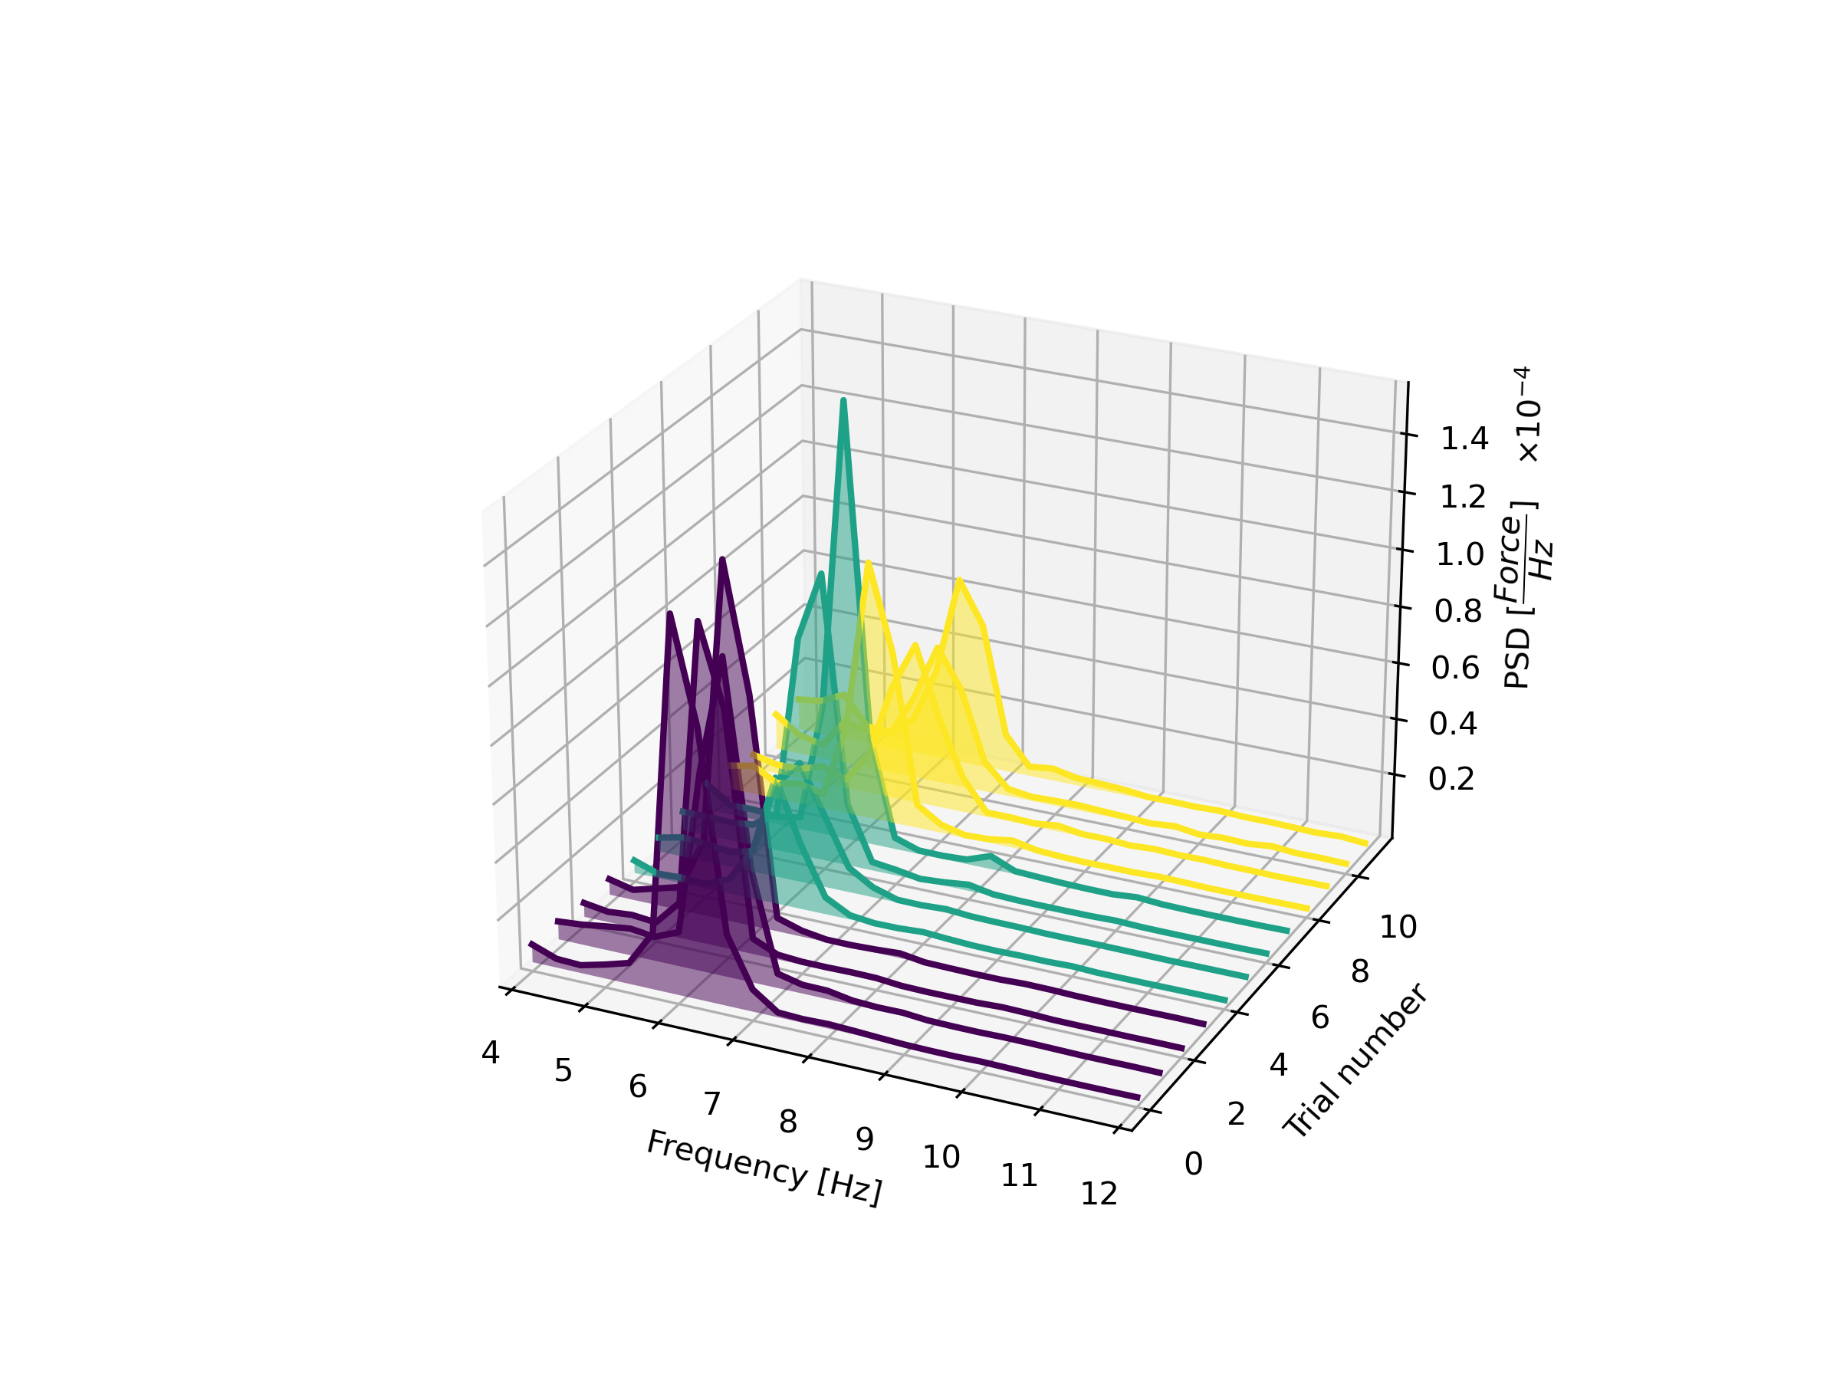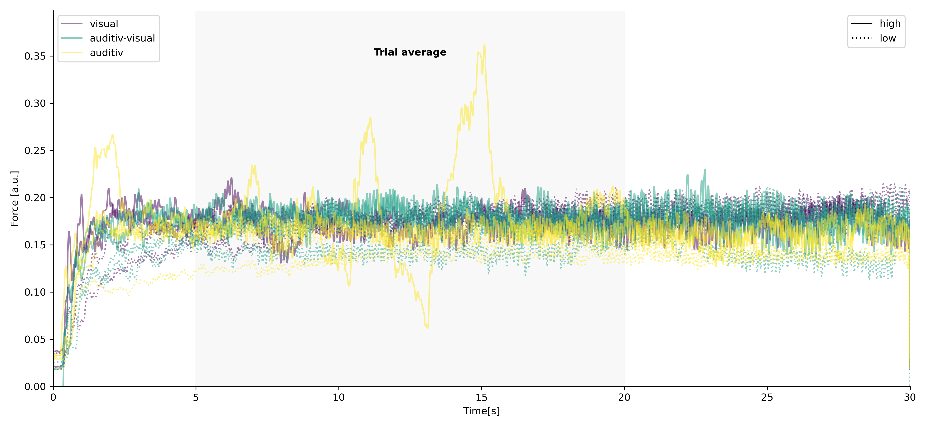 **. (b) (c)**

Figure 4: Times series data of a single participant. (a) The time course of the pupillometry is shown. **(b)** Single trial spectra of the force tremor per epoch. **(c)** Example of a participants single trial raw force data. Time courses are split per feedback type and feedback condition.

Overall, sequential designs with maximal sample sizes offer an approach to optimizing statistical power in replication studies where smaller changes to the protocol are made (Schönebrodt and Wagenmaker, 2018).

# Acknowledgements

We would like to thank Lena Hamann for her invaluable contribution during data collection and all participants for their time and patience while participating.

# Author contributions

# J.W., J.K., and J.S.B. designed research; J.W., M.G., R.W. and J.S.B. performed research; J.W, and G.H. analyzed data; and J.W., W.M. and J.S.B. wrote the paper. All authors reviewed the manuscript.

# Competing interest statement

The authors declare no competing financial interests.

## Data Availability Statement

The datasets generated during and/or analyzed during the current study are available from the corresponding author on reasonable request.

# References

1 Bhatia, K. P. *et al.* Consensus statement on the classification of tremors, from the task force on tremor of the international Parkinson and movement disorder society. *Movement Disorders* (2018).

2 Charcot, J. M. *Lectures on the diseases of the nervous system: delivered at la Salpêtrière*. (HC Lea, 1879).

3 Deuschl, G., Bain, P. & Brin, M. Consensus statement of the Movement Disorder Society on Tremor. Ad Hoc Scientific Committee. *Mov Disord* **13 Suppl 3**, 2-23 (1998).

4 Lenka, A. & Louis, E. D. Revisiting the clinical phenomenology of “cerebellar tremor”: beyond the intention tremor. *The Cerebellum* **18**, 565-574 (2019).

5 Welton, T. *et al.* Essential tremor. *Nature Reviews Disease Primers* **7**, 83, doi:10.1038/s41572-021-00314-w (2021).

6 Helmich, R. C., Toni, I., Deuschl, G. & Bloem, B. R. The pathophysiology of essential tremor and Parkinson's tremor. *Curr Neurol Neurosci Rep* **13**, 378, doi:10.1007/s11910-013-0378-8 (2013).

7 Deuschl, G. *et al.* The clinical and electrophysiological investigation of tremor. *Clinical Neurophysiology* **136**, 93-129, doi:<https://doi.org/10.1016/j.clinph.2022.01.004> (2022).

8 Feys, P. *et al.* The effect of changed visual feedback on intention tremor in multiple sclerosis. *Neuroscience letters* **394**, 17-21 (2006).

9 Gironell, A., Ribosa-Nogue, R. & Pagonabarraga, J. Withdrawal of visual feedback in essential tremor. *Parkinsonism Relat Disord* **18**, 402-403; author reply 404, doi:10.1016/j.parkreldis.2011.11.029 (2012).

10 Keogh, J., Morrison, S. & Barrett, R. Augmented visual feedback increases finger tremor during postural pointing. *Experimental brain research* **159**, 467-477 (2004).

11 DeSimone, J. C., Archer, D. B., Vaillancourt, D. E. & Wagle Shukla, A. Network-level connectivity is a critical feature distinguishing dystonic tremor and essential tremor. *Brain* (2019).

12 Archer, D. B. *et al.* A widespread visually-sensitive functional network relates to symptoms in essential tremor. *Brain* (2018).

13 Senkowski, D., Talsma, D., Grigutsch, M., Herrmann, C. S. & Woldorff, M. G. Good times for multisensory integration: Effects of the precision of temporal synchrony as revealed by gamma-band oscillations. *Neuropsychologia* **45**, 561-571, doi:<https://doi.org/10.1016/j.neuropsychologia.2006.01.013> (2007).

14 Keil, J. & Senkowski, D. Neural oscillations orchestrate multisensory processing. *The Neuroscientist* **24**, 609-626 (2018).

15 Sanes, J. N., LeWitt, P. A. & Mauritz, K. H. Visual and mechanical control of postural and kinetic tremor in cerebellar system disorders. *Journal of Neurology, Neurosurgery &amp; Psychiatry* **51**, 934-943, doi:10.1136/jnnp.51.7.934 (1988).

16 Dirkx, M. F. *et al.* Cognitive load amplifies Parkinson’s tremor through excitatory network influences onto the thalamus. *Brain* (2020).

17 Grimm, C. *et al.* Locus Coeruleus firing patterns selectively modulate brain activity and dynamics. *bioRxiv*, 2022.2008.2029.505672, doi:10.1101/2022.08.29.505672 (2022).

18 Liebe, T. *et al.* In vivo anatomical mapping of human locus coeruleus functional connectivity at 3 T MRI. *Human brain mapping* **41**, 2136-2151 (2020).

19 Beatty, J. Task-evoked pupillary responses, processing load, and the structure of processing resources. *Psychological bulletin* **91**, 276 (1982).

20 Becktepe, J. S. *et al.* Pupillary response to light and tasks in early and late onset essential tremor patients. *Parkinsonism Relat Disord* **66**, 62-67, doi:10.1016/j.parkreldis.2019.07.004 (2019).

21 Zenon, A., Sidibe, M. & Olivier, E. Pupil size variations correlate with physical effort perception. *Front Behav Neurosci* **8**, 286, doi:10.3389/fnbeh.2014.00286 (2014).

22 Shadmehr, R. & Krakauer, J. W. A computational neuroanatomy for motor control. *Experimental brain research* **185**, 359-381 (2008).

23 Todorov, E. & Jordan, M. I. Optimal feedback control as a theory of motor coordination. *Nature neuroscience* **5**, 1226-1235 (2002).

24 Hallett, M. Tremor: pathophysiology. *Parkinsonism & related disorders* **20**, S118-S122 (2014).

25 Raethjen, J. & Muthuraman, M. Cause or compensation? Complex changes in cerebello-thalamo-cortical networks in pathological action tremor. *Brain* **138**, 2808-2810, doi:10.1093/brain/awv238 (2015).

26 Timmermann, L. *et al.* Pathological oscillatory coupling within the human motor system in different tremor syndromes as revealed by magnetoencephalography. *Neurology & clinical neurophysiology: NCN* **2004**, 26-26 (2004).

27 Schnitzler, A., Munks, C., Butz, M., Timmermann, L. & Gross, J. Synchronized brain network associated with essential tremor as revealed by magnetoencephalography. *Mov Disord* **24**, 1629-1635, doi:10.1002/mds.22633 (2009).

28 Bosch-Bouju, C., Hyland, B. & Parr-Brownlie, L. Motor thalamus integration of cortical, cerebellar and basal ganglia information: implications for normal and parkinsonian conditions. *Frontiers in Computational Neuroscience* **7**, doi:10.3389/fncom.2013.00163 (2013).

29 Rivlin-Etzion, M. *et al.* Basal ganglia oscillations and pathophysiology of movement disorders. *Current Opinion in Neurobiology* **16**, 629-637, doi:<https://doi.org/10.1016/j.conb.2006.10.002> (2006).

30 Elble, R. *et al.* Reliability of a new scale for essential tremor. *Movement Disorders* **27**, 1567-1569 (2012).

31 Hoche, F., Guell, X., Vangel, M. G., Sherman, J. C. & Schmahmann, J. D. The cerebellar cognitive affective/Schmahmann syndrome scale. *Brain* **141**, 248-270, doi:10.1093/brain/awx317 (2017).

32 Beck, A. T., Steer, R. A. & Brown, G. K. *Beck depression inventory*. (Harcourt Brace Jovanovich New York:, 1987).