Pima Diabetes Dataset
Data Analysis & Machine Learning Report
End-to-end workflow: problem definition through model deployment

1. Problem Definition
Objective: Predict whether a patient tests positive for diabetes (binary classification) using eight clinical measurements from the Pima Indians Diabetes dataset.
Type of problem: Supervised binary classification (Class = tested_positive / tested_negative).
Business/clinical value: An accurate, interpretable screening model helps clinicians flag high-risk patients for follow-up testing. Given the medical context, missing a true positive (a diabetic patient predicted negative) is costlier than a false alarm, so recall on the positive class is prioritized alongside overall discrimination (ROC-AUC).
Success criteria: A model that clearly outperforms a naive baseline, generalizes via cross-validation, and offers interpretable outputs suitable for clinical review.

2. Data Collection / Generation
Source file: pima_Missing_values.csv (a variant of the well-known Pima Indians Diabetes dataset, originally from the National Institute of Diabetes and Digestive and Kidney Diseases, with additional injected missing values).
690 patient records (all female, Pima heritage, age 21+) with 8 numeric predictors and 1 categorical target.

3. Data Inspection
Dimensions: 690 rows x 9 columns (8 features + 1 target).
Column | Description | Data Type
NoOfPregency | Number of times pregnant | float64 (int-valued)
PlasmaGlucoseCon | Plasma glucose concentration (2h oral glucose tolerance test) | float64
BloodPressure | Diastolic blood pressure (mm Hg) | float64
SkinFoldThickness | Triceps skinfold thickness (mm) | float64
Insuline | 2-Hour serum insulin (mu U/ml) | float64
BMI | Body mass index (kg/m^2) | float64
DiabetesPedigree | Diabetes pedigree function (genetic risk score) | float64
Age | Age in years | float64
Class | Target: tested_positive / tested_negative | object (string)

All predictor columns loaded as float64 because of injected missing values (NaN forces numeric columns away from int64). The target Class is a two-level categorical string, encoded later as 1 = tested_positive, 0 = tested_negative.

4. Data Quality Assessment

4.1 Missing-value percentages (as loaded, explicit <null> markers)
Column | Missing Count | Missing %
BloodPressure | 78 | 11.30%
DiabetesPedigree | 75 | 10.87%
Insuline | 72 | 10.43%
PlasmaGlucoseCon | 69 | 10.00%
NoOfPregency | 66 | 9.57%
BMI | 66 | 9.57%
SkinFoldThickness | 65 | 9.42%
Age | 61 | 8.84%
Class | 0 | 0.00%

4.2 Zero values: valid measurement or disguised missing data?
The dataset separately encodes some missing values as the literal value 0, which is biologically impossible for several measurements. Zero counts per column:
Column | Zero Count | Zero % | Verdict
PlasmaGlucoseCon | 4 | 0.58% | Invalid -> treat as missing
BloodPressure | 30 | 4.35% | Invalid -> treat as missing
SkinFoldThickness | 186 | 26.96% | Invalid -> treat as missing
Insuline | 297 | 43.04% | Invalid -> treat as missing
BMI | 9 | 1.30% | Invalid -> treat as missing
NoOfPregency | 95 | 13.77% | VALID (0 pregnancies is possible)

A living person cannot have zero blood pressure, zero glucose, zero BMI, zero skinfold thickness, or zero insulin — these are sentinel values for missing measurements, likely from unrecorded lab tests. NoOfPregency = 0 is medically valid and was left untouched. After re-coding the five implausible columns' zeros as NaN, total missingness rises substantially, most notably for Insuline (53.5%) and SkinFoldThickness (36.4%) — reflecting real-world clinical data collection gaps:
Column | Missing % (after zero recoding)
Insuline | 53.48%
SkinFoldThickness | 36.38%
BloodPressure | 15.65%
DiabetesPedigree | 10.87%
BMI | 10.87%
PlasmaGlucoseCon | 10.58%
NoOfPregency | 9.57%
Age | 8.84%

4.3 Duplicates
No fully duplicated rows were found (0 exact duplicates, and 0 duplicates when the target column is excluded).

4.4 Outliers (IQR method, 1.5x rule)
Column | Outlier Count | Notes
NoOfPregency | 2 | Max = 17, unusually high but plausible
PlasmaGlucoseCon | 4 | Values at the recorded max (199)
BloodPressure | 41 | Both high and residual low readings
SkinFoldThickness | 1 | Max = 99mm, likely a measurement/recording error
Insuline | 27 | Right-skewed; max = 846, clinically extreme
BMI | 16 | Max = 67.1, consistent with severe obesity
DiabetesPedigree | 24 | Right-skewed genetic-risk score
Age | 12 | Max = 72, upper tail of adult population

Outliers were retained rather than removed: most are clinically plausible extreme values (e.g., high BMI, high insulin in undiagnosed diabetics) that carry predictive signal. Tree-based models are robust to them, and scaling + regularization limit their influence on the linear model.

4.5 Class Imbalance
tested_negative: 450 (65.2%) | tested_positive: 240 (34.8%).
This is a moderate ~2:1 imbalance, not extreme. It was addressed with class_weight='balanced' in every model rather than resampling (SMOTE/undersampling), avoiding synthetic-data risk while still penalizing minority-class errors more heavily during training.
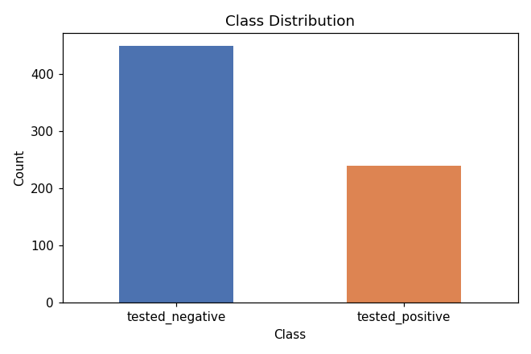
Figure 1. Class distribution of the target variable.

5. Exploratory Data Analysis
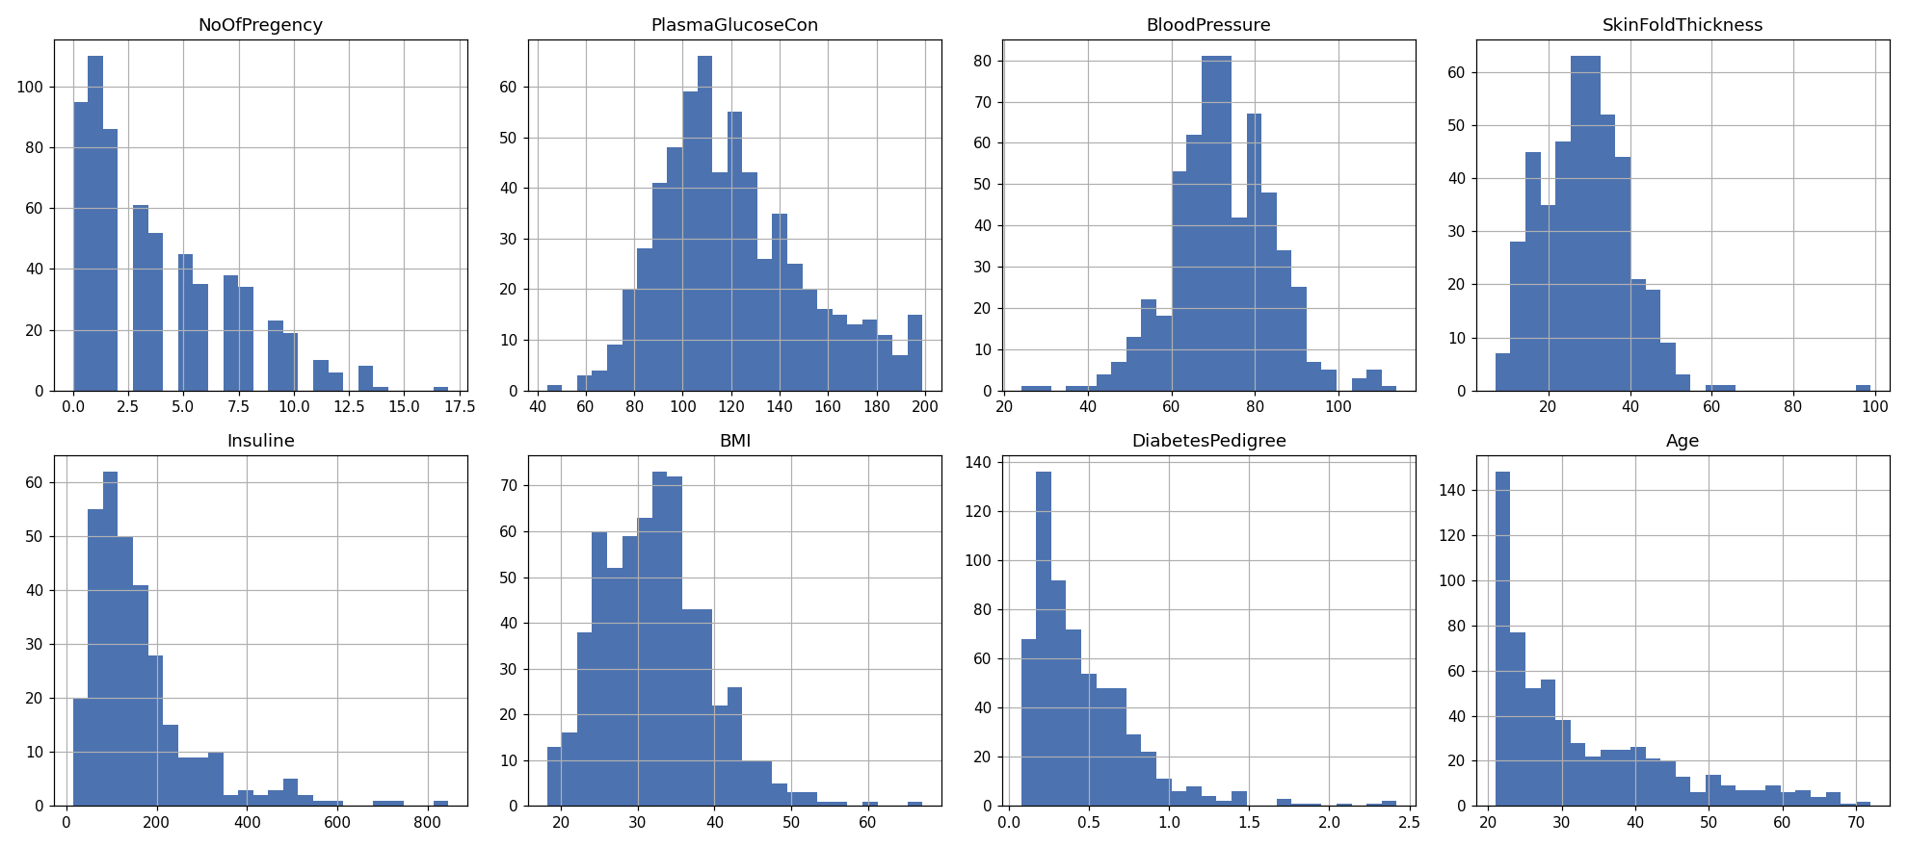
Figure 2. Distribution of each numeric feature.
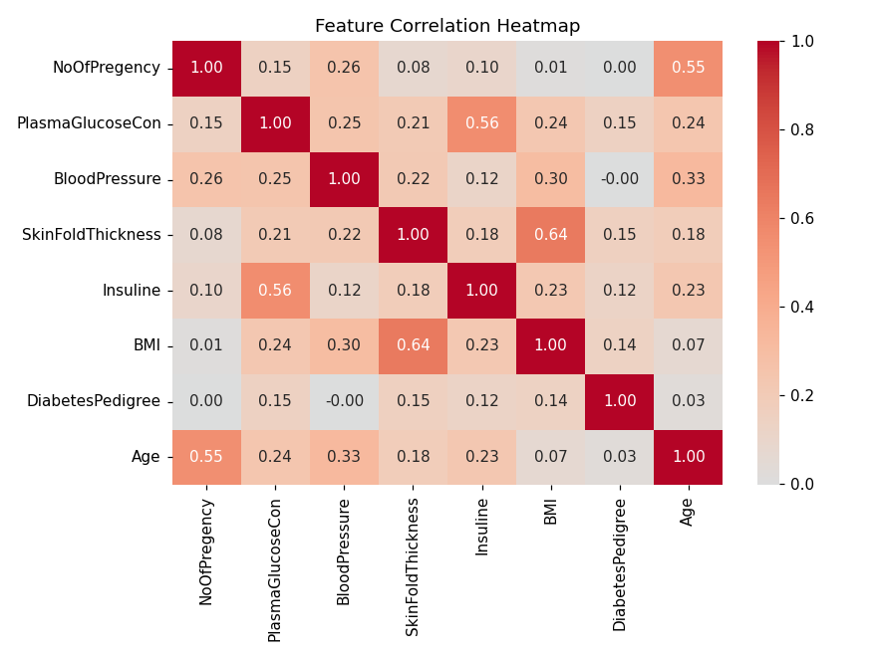
Figure 3. Pearson correlation heatmap between features.
PlasmaGlucoseCon shows the strongest linear association with the other clinical variables and (as confirmed later) with the outcome. Insuline and SkinFoldThickness are moderately correlated (shared 'body composition' signal), and Age correlates with NoOfPregency, as expected biologically.
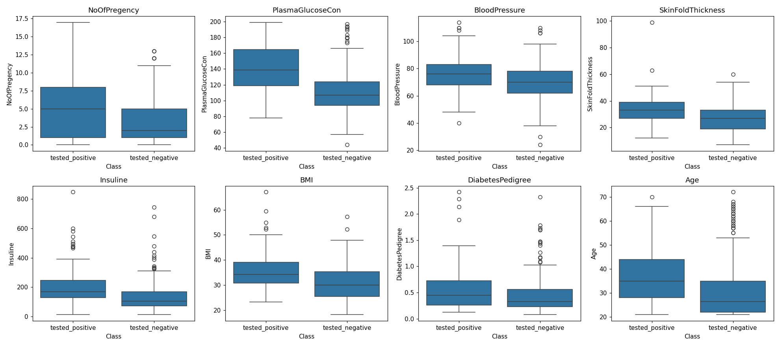
Figure 4. Feature distributions split by outcome class. PlasmaGlucoseCon and BMI show the clearest separation between positive and negative cases.

6. Data Cleaning
- Re-coded biologically implausible zeros (Glucose, BloodPressure, SkinFoldThickness, Insuline, BMI) as missing (NaN).
- Left NoOfPregency = 0 unchanged (valid value).
- Confirmed zero duplicate rows — no de-duplication needed.
- Outliers retained (see Section 4.4 rationale) — handled implicitly via feature scaling and regularization/robust models rather than deletion or capping, to avoid discarding genuine clinical signal.
- No missing values were dropped row-wise; with up to 53% missingness in some columns, listwise deletion would discard most of the dataset. Imputation was used instead (Section 8).

7. Feature Engineering
The 8 original clinical measurements were retained as-is, since each has direct, well-established medical relevance to diabetes risk (glucose tolerance, BMI, genetic pedigree, age, etc.). No additional engineered features (e.g., interaction terms, BMI categories) were added for the baseline pipeline, to keep the model interpretable for clinical review; this is flagged in Section 17 as a direction for future improvement.

8. Feature Selection
All 8 features were retained. Given the already-small feature set (8 predictors) and the fact that permutation importance (Section 18) shows every feature contributes non-trivial signal (or is at least harmless), no features were dropped. Regularization (L2 penalty in Logistic Regression, tree depth/leaf constraints in ensemble models) implicitly down-weights less useful features during training and tuning.

9. Train / Validation / Test Split
An 80/20 stratified train/test split was used (552 training rows, 138 test rows), preserving the 65.2% / 34.8% class ratio in both sets. 'Validation' is handled internally via 5-fold stratified cross-validation on the training set during model selection and hyperparameter tuning (Section 15), rather than a separate static validation split — this makes more efficient use of the moderately small dataset (690 rows total).

10. Data Preprocessing

10.1 Comparing missing-value strategies
Two imputation strategies were compared with an identical Logistic Regression pipeline, using 5-fold stratified cross-validation on the training set:
Strategy | Accuracy | Precision | Recall | F1 | ROC-AUC
Median Imputation | 0.7337 | 0.6033 | 0.6868 | 0.6399 | 0.8207
KNN Imputation (k=5) | 0.7355 | 0.6010 | 0.7181 | 0.6533 | 0.8199

KNN imputation (k=5) was selected as the final strategy: it produced a meaningfully higher recall (+3.1 pts) and F1 (+1.3 pts) than simple median imputation, with essentially identical accuracy and ROC-AUC. KNN imputation estimates each missing value from the 5 most similar patients across all other features, which better preserves the multivariate relationships between correlated clinical variables (e.g., BMI and SkinFoldThickness) than a single column-wide median.

10.2 Final preprocessing pipeline
A single scikit-learn Pipeline was used for every model, fit only on training folds to prevent data leakage:
- Step 1 — KNNImputer(n_neighbors=5): fills missing values (including recoded zeros) using the 5 nearest neighbors.
- Step 2 — StandardScaler(): standardizes all features to zero mean / unit variance (required for Logistic Regression, SVM, and KNN; harmless for tree-based models).
- Step 3 — Classifier: swapped per model (Section 12).

11. Baseline Model
A DummyClassifier predicting the majority class (tested_negative) for every patient was used as the baseline:
Metric | Baseline (majority class)
Accuracy | 0.6522
Precision (positive) | 0.0000
Recall (positive) | 0.0000
F1 (positive) | 0.0000

The baseline achieves 65.2% accuracy purely from class imbalance but is clinically useless (it never identifies a single diabetic patient). Any real model must substantially beat 0 recall/precision on the positive class, not just beat 65.2% accuracy.

12. Model Training
Six models were trained through the same preprocessing pipeline, satisfying the 'at least four models' requirement:
- Logistic Regression (linear, highly interpretable)
- Decision Tree
- Random Forest (bagged ensemble of trees)
- Gradient Boosting
- Support Vector Machine (RBF kernel)
- K-Nearest Neighbors
class_weight='balanced' was used wherever supported, to address the class imbalance identified in Section 4.5 without resampling.

13. Model Comparison
Model | Accuracy | Precision | Recall | F1 | ROC-AUC
Logistic Regression | 0.7681 | 0.6333 | 0.7917 | 0.7037 | 0.8375
Random Forest | 0.7609 | 0.6364 | 0.7292 | 0.6796 | 0.8347
SVM (RBF) | 0.7609 | 0.6364 | 0.7292 | 0.6796 | 0.8398
Gradient Boosting | 0.7754 | 0.7297 | 0.5625 | 0.6353 | 0.8433
K-Nearest Neighbors | 0.7319 | 0.6410 | 0.5208 | 0.5747 | 0.8244
Decision Tree | 0.7029 | 0.5614 | 0.6667 | 0.6095 | 0.7456

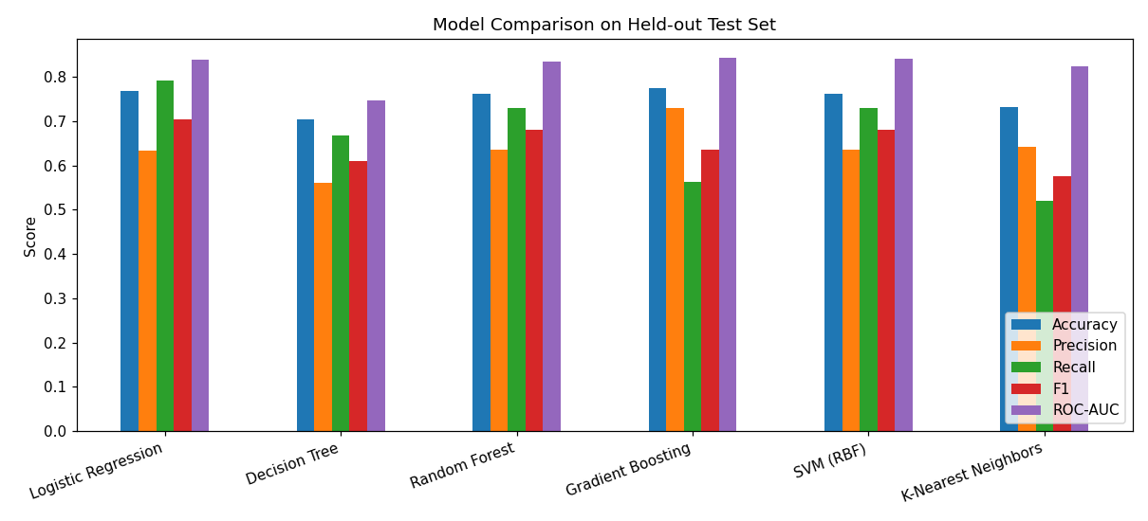
Figure 5. Test-set metric comparison across all six trained models.
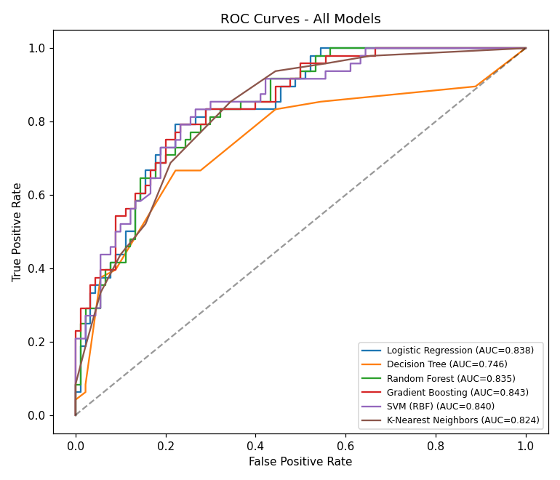
Figure 6. ROC curves for all six models on the held-out test set.
Gradient Boosting has the single highest ROC-AUC (0.8433) but the weakest recall (0.5625) — it misses nearly half of true diabetics. Logistic Regression has the best F1 (0.7037) and the best recall (0.7917) among all six models, with a highly competitive ROC-AUC (0.8375), and is fully interpretable. Given the clinical screening context (Section 1), where missing a diabetic patient is costlier than a false alarm, Logistic Regression was selected as the final model.

14. Hyperparameter Tuning
GridSearchCV (5-fold stratified CV, scoring = ROC-AUC) was used to tune each model:
Model | Grid Searched | Best Parameters
Logistic Regression | C in {0.01, 0.1, 1, 10} | C = 0.1
Decision Tree | max_depth in {3,5,7,None}, min_samples_leaf in {1,3,5} | max_depth=5, min_samples_leaf=1
Random Forest | n_estimators in {200,400}, max_depth in {None,5,8}, min_samples_leaf in {1,2,4} | n_estimators=400, max_depth=5, min_samples_leaf=1
Gradient Boosting | n_estimators in {100,200}, max_depth in {2,3}, learning_rate in {0.05,0.1} | n_estimators=100, max_depth=2, lr=0.05
SVM (RBF) | C in {0.1,1,10}, gamma in {scale, auto} | C=1, gamma=scale
K-Nearest Neighbors | n_neighbors in {3,5,7,9,11} | n_neighbors=11

The regularization strength C = 0.1 selected for Logistic Regression indicates the model benefits from stronger L2 regularization than the default, consistent with the moderate feature correlations observed in Section 5 and helping prevent overfitting given the training set is only 552 rows.

15. Cross-Validation
Every model above was evaluated with 5-fold stratified cross-validation on the training set (both for hyperparameter selection and for reporting generalization performance), rather than a single train/validation split. Mean CV ROC-AUC scores on the training folds:
Model | CV ROC-AUC (train, mean of 5 folds)
Logistic Regression | 0.8201
SVM (RBF) | 0.8235
K-Nearest Neighbors | 0.8211
Gradient Boosting | 0.8198
Random Forest | 0.8156
Decision Tree | 0.7305

CV scores closely match held-out test scores for all models except Decision Tree, which is a known high-variance learner; this consistency indicates the other five models are not overfitting to the training split.

16. Final Evaluation — Logistic Regression
Metric | Score
Accuracy | 0.7681
Precision (positive) | 0.6333
Recall (positive) | 0.7917
F1-score (positive) | 0.7037
ROC-AUC | 0.8375

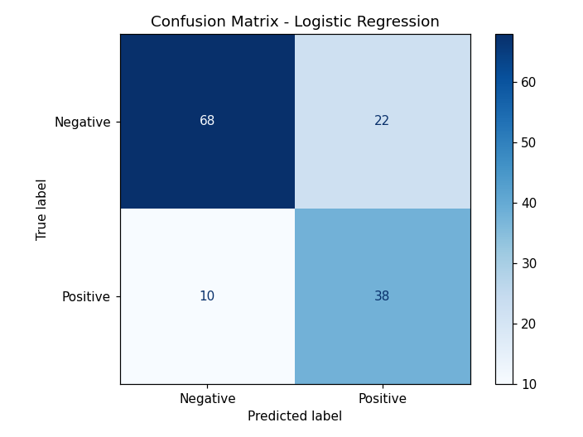
Figure 7. Confusion matrix for the final Logistic Regression model on the 138-row test set.
Of 48 truly positive patients in the test set, the model correctly flags 38 (recall 79.2%), at the cost of 22 false positives out of 90 truly negative patients (precision 63.3%). This trade-off suits a screening tool, where a false positive leads to a confirmatory test, but a false negative delays diagnosis and treatment.

17. Error Analysis
Of 138 test predictions: 106 correct, 22 false positives, 10 false negatives.

False negatives (10 missed diabetics) — mean feature values vs. overall test set:
Feature | False-Negative Mean | Overall Test Mean
PlasmaGlucoseCon | 109.9 | 122.0
BMI | 32.1 | 32.2
Insuline | 132.0 | 167.2
Age | 34.6 | 33.0
NoOfPregency | 2.8 | 4.1

False negatives systematically have lower glucose and fewer pregnancies than the typical positive case — these are 'borderline' diabetics whose clinical profile looks closer to the negative class, making them genuinely hard to catch from these 8 features alone. Mean predicted probability for false negatives was 0.32, versus 0.45 across the whole test set, confirming these are not confidently wrong, just below the 0.5 threshold.
40 of 138 test predictions (29%) fell in the 'uncertain zone' (predicted probability 0.35-0.65), and 12 of those 40 were errors (30% error rate in that zone vs. 23% overall) — most model mistakes cluster where the model itself is least confident, which is reassuring: the model's confidence is informative and could support a 'refer borderline cases for manual review' policy in deployment.
Recommendation: lowering the classification threshold below 0.5 (e.g., to ~0.4) would trade some precision for higher recall, likely appropriate for a screening use case — this is a simple post-hoc deployment tuning knob, not a retraining requirement.

18. Model Interpretation

18.1 Logistic Regression coefficients (standardized features)
Feature | Coefficient | Odds Ratio
PlasmaGlucoseCon | 0.817 | 2.26
BMI | 0.456 | 1.58
DiabetesPedigree | 0.285 | 1.33
NoOfPregency | 0.272 | 1.31
Age | 0.251 | 1.28
SkinFoldThickness | 0.195 | 1.22
Insuline | 0.070 | 1.07
BloodPressure | 0.051 | 1.05

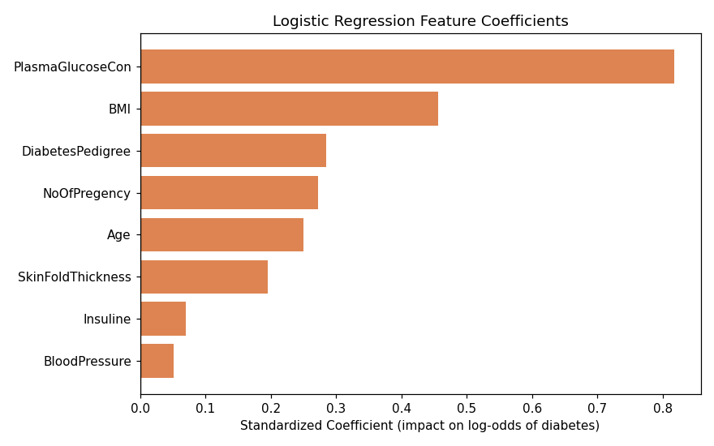
Figure 8. Standardized logistic regression coefficients (positive = increases diabetes odds).
Every coefficient is positive, meaning all 8 features increase diabetes risk as they rise — consistent with medical knowledge. A one-standard-deviation increase in PlasmaGlucoseCon more than doubles the odds of a positive prediction (odds ratio 2.26), by far the strongest single predictor. BMI is the second strongest driver.

18.2 Permutation importance (model-agnostic, test set, ROC-AUC drop)
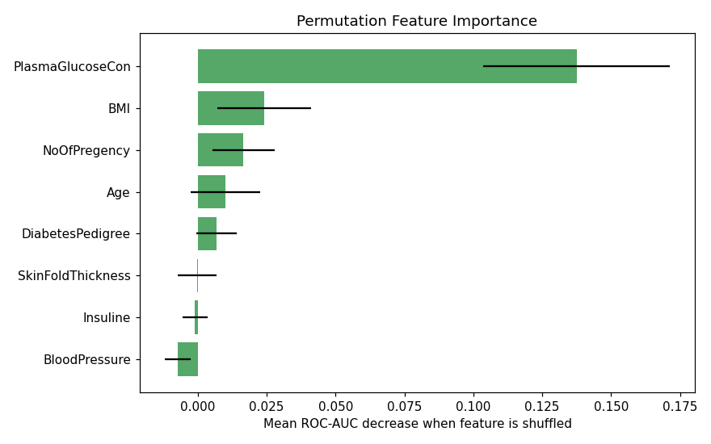
Figure 9. Mean drop in test ROC-AUC when each feature is randomly shuffled (30 repeats).
Permutation importance corroborates the coefficient analysis: PlasmaGlucoseCon dominates (shuffling it alone drops ROC-AUC by 0.138), followed distantly by BMI (0.024) and NoOfPregency (0.017). BloodPressure, Insuline and SkinFoldThickness contribute negligibly to this particular model once glucose and BMI are accounted for — their information is partly redundant with other features (see the correlation heatmap, Figure 3), and their high missingness (Section 4.2) may also dilute their imputed signal.
Clinical takeaway: plasma glucose concentration and BMI are, by a wide margin, the two measurements most worth prioritizing when screening resources are limited.

19. Model Saving
The final Logistic Regression pipeline (KNNImputer -> StandardScaler -> LogisticRegression, C=0.1, class_weight='balanced') was refit on the full 690-row dataset (all available labeled data) and serialized with joblib:
- models/final_diabetes_model.joblib — the complete fitted pipeline (imputer + scaler + classifier)
- models/feature_names.joblib — the exact ordered list of the 8 expected input feature names
Saving the full pipeline (not just the classifier) ensures identical imputation and scaling are applied to any new data at inference time, preventing training/serving skew.

20. Deployment
The saved pipeline was wrapped in a lightweight Flask REST API (deployment/app.py) with two endpoints:
- GET /health — service health check
- POST /predict — accepts a JSON object with the 8 clinical features and returns the predicted class plus the probability of a positive diagnosis
Zero values submitted for the five clinically-implausible fields (glucose, blood pressure, skinfold, insulin, BMI) are automatically treated as missing and imputed, mirroring the training-time data cleaning in Section 6 — this keeps train/serve behavior consistent.
A standalone predict_cli.py is also provided for offline, no-server batch scoring (e.g., inside a notebook or scheduled job) using the same saved pipeline. requirements.txt lists the minimal runtime dependencies (flask, joblib, pandas, numpy, scikit-learn).
Example request:
curl -X POST http://localhost:5000/predict -H "Content-Type: application/json" -d '{"NoOfPregency":2,"PlasmaGlucoseCon":150,"BloodPressure":78,"SkinFoldThickness":30,"Insuline":100,"BMI":33.6,"DiabetesPedigree":0.63,"Age":45}'
Example response: {"prediction": "tested_positive", "probability_positive": 0.7001, "probability_negative": 0.2999}
Suggested next steps for production hardening: add authentication, request logging, input-range validation, model/version tracking, periodic retraining as new labeled data arrives, and monitoring of prediction-probability drift over time.

