## Introduction

The purpose of this assignment created to a 3rd normalized database for a garden construction company. This company record on their data in manually. They give their primary data to create a database with reduce data redundancy on the assignment. The assignment also includes an assessment that provides discussion on how the work has been done to complete the requirements for this Company.

**Task-1**

1. Produce on entity relationship diagram of rouse_gardens in crow’s feet notation. This an 3rd normal from:

rouse_gardens

**ID_And_Class**

Class_ID(PK)

Product_ID(FK)

Product_No(FK)

Component_ID(FK)

Quantity

**Customer_product_order_ID**

Product_ID(PK)(FK)

Customer_ID(FK)

**Customer_Details**

Customer_ID(PK)(FK)

Order_ID(FK)

Customer_Name

Customer_Type

**Service_ID_Details** Customer_ID(PK) Service_NO(FK) Service_ID

Service_Name_ID(FK)

**Staff_and_service**

Service_Name_id_(PK)

Service_Name

**Service_Name_and_Staff**

Name_and_Staff_Id

Service_No_(PK)

Staff_ID(FK)

**Staff_details**

Staff_ID(PK)

Staff_Name

Service No

Staff ID

**Order_Lines_Entity**

Line_No(PK)

Order_Name

**Order_Lines**

Order_ID(PK)

Line_No(FK)

**Component_Details**

Component_ID(PK)

Component_Name

**Product_Type_ID**

Product_NO(PK)

Product_Type

**Product_ID_Details**

Product_ID(PK)

Product_Class

Product_Name

1. Showing the steps in normalizing of data in the scenario. A fully normalized model is shown on a table in 1st to 3rd normal from.

|  |  |  |  |  |
| --- | --- | --- | --- | --- |
| **Product** | **Unit** | **1NF** | **2NF** | **3NF** |
| **Product and Their Component**  Product ID  Product Name  Product Type  Component  **Orders and Services**  Order ID  Service ID  Service Name  Staff  **Details of Orders**  Order ID  Customer Name  Customer Type  Orders Lines | 1  1  2  2  2  1  2  2  1  1  1  2 | **Product**  Product ID  Product Name  Product Type  **Component**  Component  **Orders**  Order ID  Staff  **Services**  Service ID  Service Name  **Customer**  Customer Name  Customer Type  **Order Details**  Orders Lines  Order ID | **Customer product order ID And Class**  Product ID  Customer ID  Product No  Component ID  Quantity  **Product ID Details And Type**  Product ID  Product Class  Product Name  Product Type  **Component and Customer Details**  Component ID  Component Name  Customer ID  Customer Name  Customer Type  **Staff and service**  Customer ID  Service ID  Service Name ID  Service Name  **Order Lines Entity**  Order ID  Line No  Order Name  **Service Name and Staff details**  Name and Staff Id  Service No  Staff ID  Staff Name | **Customer product order ID**  Product ID  Customer ID  **ID And Class**  Class ID  Product ID  Product No  Component ID  Quantity  **Product ID Details**  Product ID  Product Class  Product Name  **Product Type ID**  Product NO  Product Type  **Component Details**  Component ID  Component Name  **Customer Details**  Customer ID  Order ID  Customer Name  Customer Type  **Service ID Details** Customer ID  Service NO  Service ID  Service Name ID  **Staff and service**  Service Name ID  Service Name  **Order Lines**  Order ID  Line No  **Order Lines Entity**  Line No  Order Name  **Service Name and Staff**  Name and Staff Id  Service No  Staff ID  **Staff details**  Staff ID  Staff Name |

1. **Data Dictionary**: Entity relationship model for showing all attributes Data types, Primary key and foreign key**.**

Customer Product ID

|  |  |  |  |
| --- | --- | --- | --- |
| **Attribute** | **Type** | **Primary Key** | **Foreign Key** |
| Product_ID | Integer | Yes | Yes |
| Customer_ID | Integer |  | Yes |

ID and Class

|  |  |  |  |
| --- | --- | --- | --- |
| **Attribute** | **Type** | **Primary Key** | **Foreign Key** |
| Class_ID | Integer | Yes |  |
| Product_ID | Integer |  | Yes |
| Product_No | Integer |  | Yes |
| Component_ID | Integer |  | Yes |
| Quantity | Integer |  |  |

Products ID details

|  |  |  |  |
| --- | --- | --- | --- |
| **Attribute** | **Type** | **Primary Key** | **Foreign Key** |
| Product_ID | Integer | Yes |  |
| Product_Class | Varchar |  |  |
| Product_Name | Varchar |  |  |
|  | | | |

Product Type ID

|  |  |  |  |
| --- | --- | --- | --- |
| **Attribute** | **Type** | **Primary Key** | **Foreign Key** |
| Product_No | Integer | Yes |  |
| Product_Type | Varchar |  |  |

Component details

|  |  |  |  |
| --- | --- | --- | --- |
| **Attribute** | **Type** | **Primary Key** | **Foreign Key** |
| Component_Id | Integer | Yes |  |
| Component_Name | Varchar |  |  |

Customer details

|  |  |  |  |
| --- | --- | --- | --- |
| **Attribute** | **Type** | **Primary Key** | **Foreign Key** |
| Customer_Id | Integer | Yes | Yes |
| Order_ID | Integer |  | Yes |
| Customer_Name | Varchar |  |  |
| Customer_Type | Varchar |  |  |

Service ID details

|  |  |  |  |
| --- | --- | --- | --- |
| **Attribute** | **Type** | **Primary Key** | **Foreign Key** |
| Service_No | Integer | Yes |  |
| Customer_ID | Integer |  | Yes |
| Service_id | Integer |  |  |
| Service_Name_ID | Integer |  | Yes |

Order Lines

|  |  |  |  |
| --- | --- | --- | --- |
| **Attribute** | **Type** | **Primary Key** | **Foreign Key** |
| Order_Id | Integer | Yes |  |
| Lines_no | Integer |  | Yes | |

Service Name and staff

|  |  |  |  |
| --- | --- | --- | --- |
| **Attribute** | **Type** | **Primary Key** | **Foreign Key** |
| Name_and_Staff_ID | Integer | Yes |  |
| Staff_ID | Integer |  |  |
| Service_No | Integer |  | Yes |

Order Lines Entity

|  |  |  |  |  |  |  |
| --- | --- | --- | --- | --- | --- | --- |
| **Attribute** | | **Type** | | **Primary Key** | | **Foreign Key** |
| Lines_NO | Integer | | Yes | |  | |
| Order_Name | Varchar | |  | |  | |

Staff details

|  |  |  |  |
| --- | --- | --- | --- |
| **Attribute** | **Type** | **Primary Key** | **Foreign Key** |
| Staff_ID | Integer | Yes |  |
| Staff_Name | Varchar |  |  |

Staff and service

|  |  |  |  |
| --- | --- | --- | --- |
| **Attribute** | **Type** | **Primary Key** | **Foreign Key** |
| Service_Name_ID | Integer | Yes |  |
| Service_name | Varchar |  |  |

**Task-2**

1. Table Create.

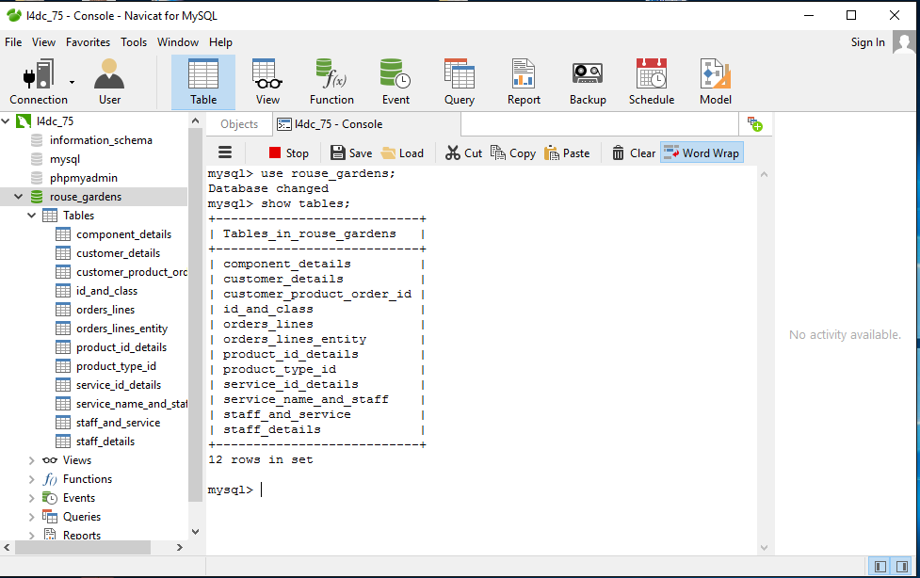

1. Orders and Products.

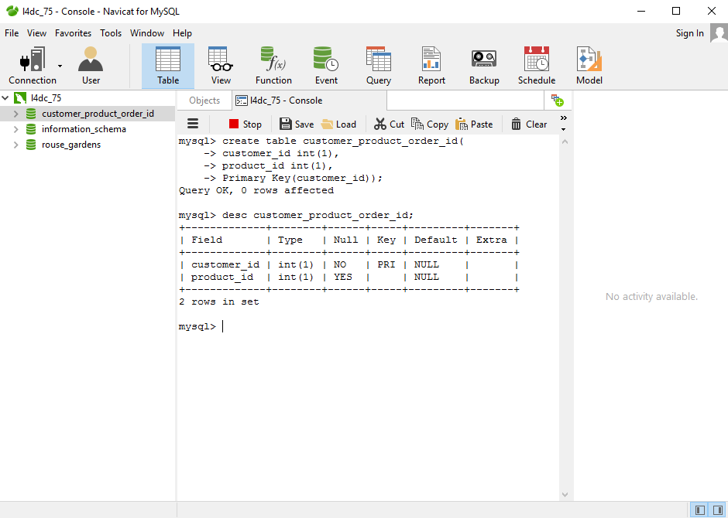

1. Show Component.

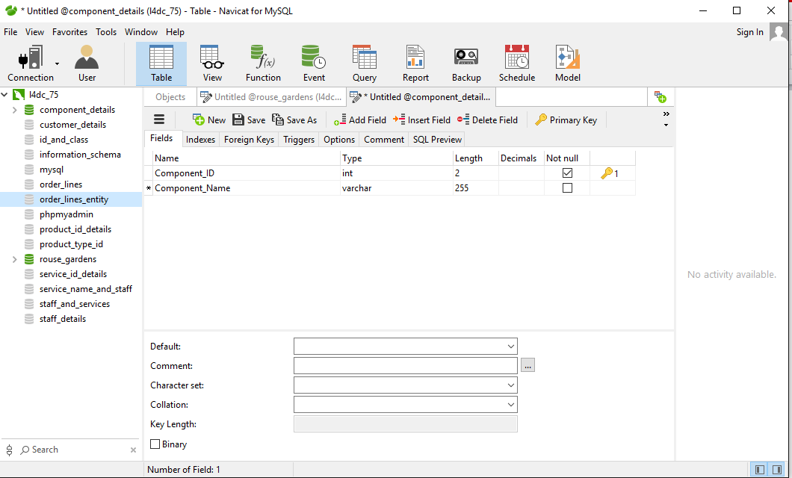

1. Data on staff and services.

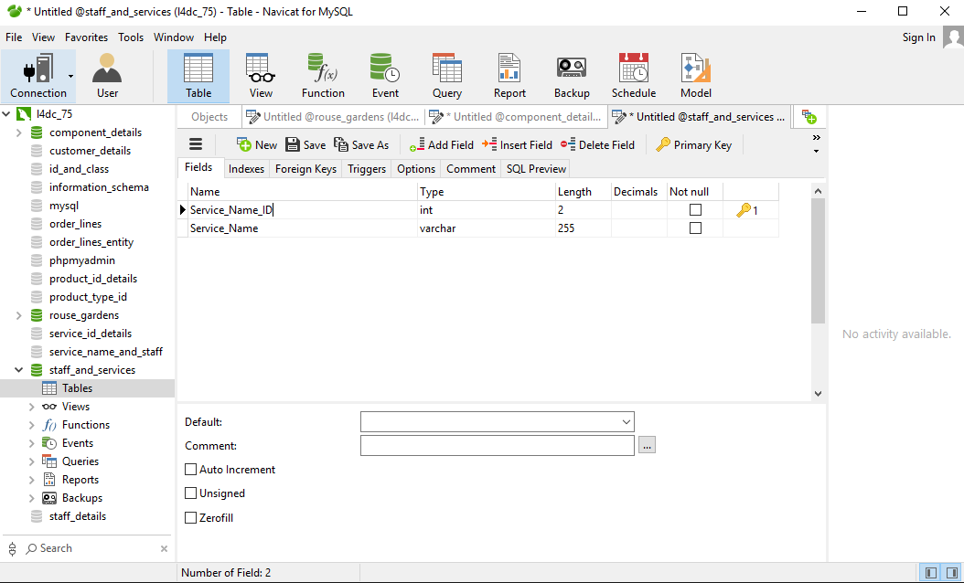

1. All services for particular customer.

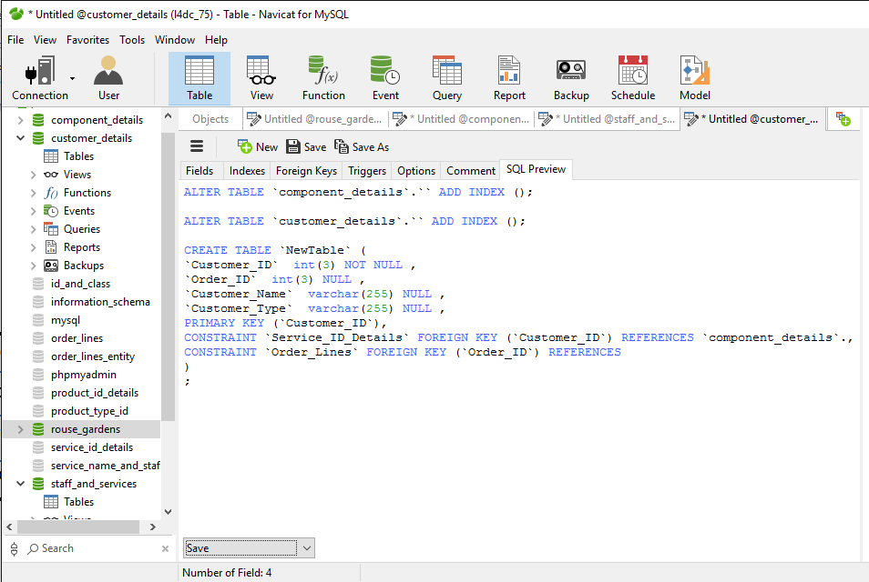

1. Staff Assigned to services.

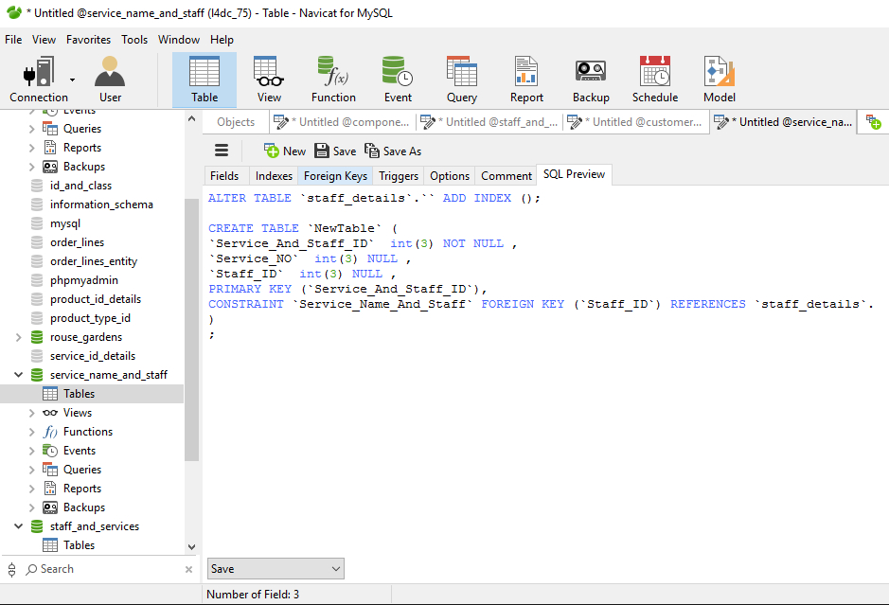

1. Customer details for services.

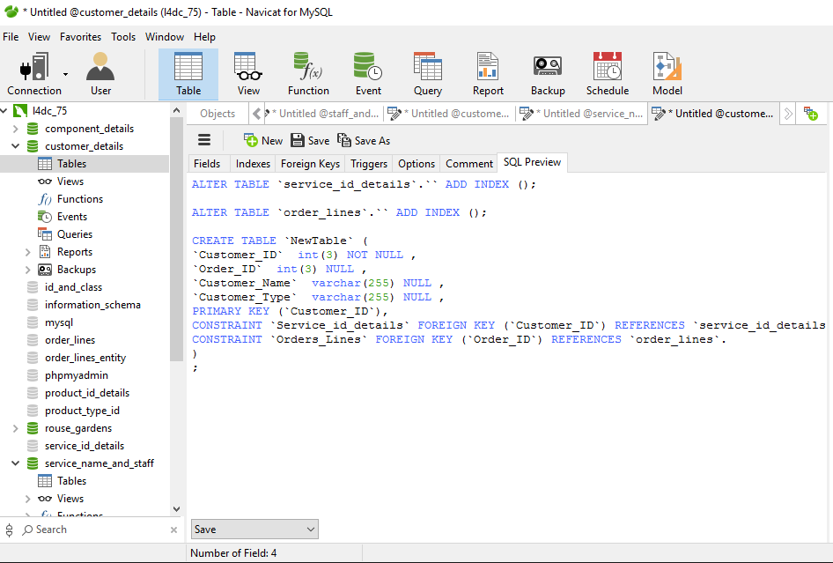

1. All services which involved Gary Crowley.

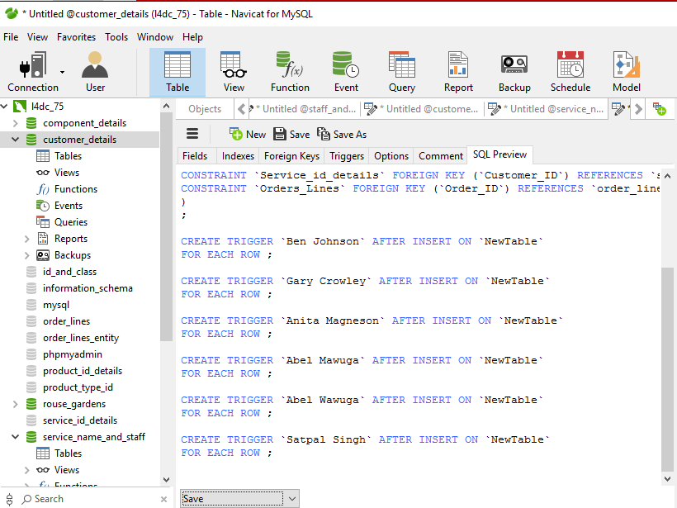

1. Show the Component.

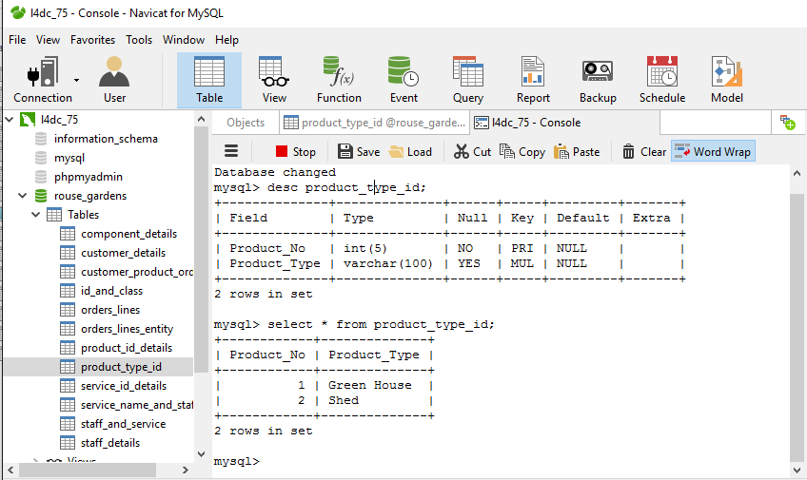

1. Record Updating.

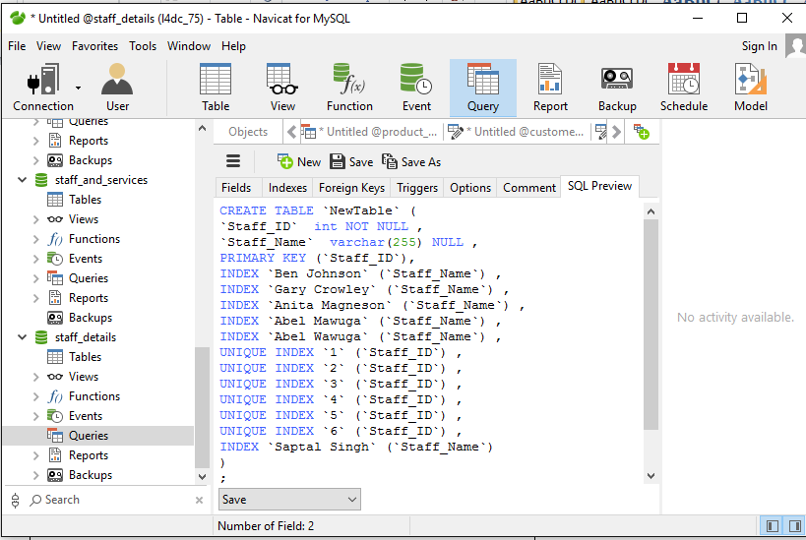

1. Update records for staff.

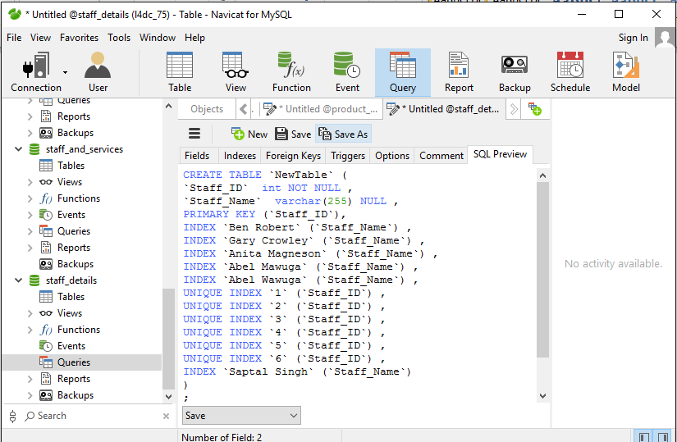

1. Update the order for Walton job center.

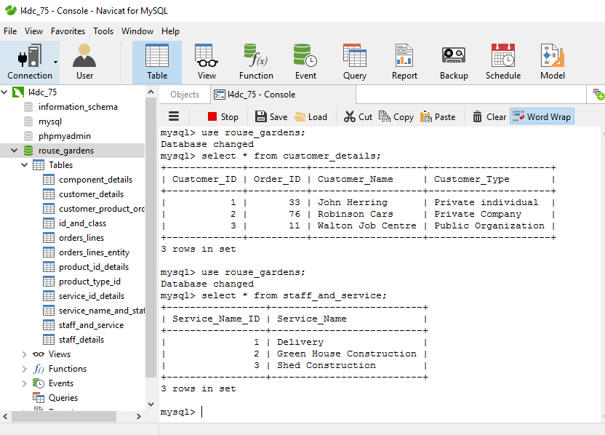

m) Sessions updating

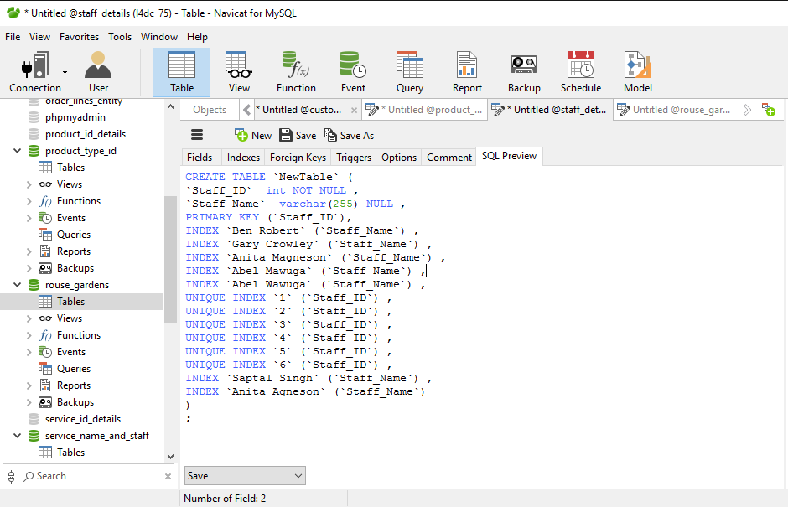

n) Record deleting

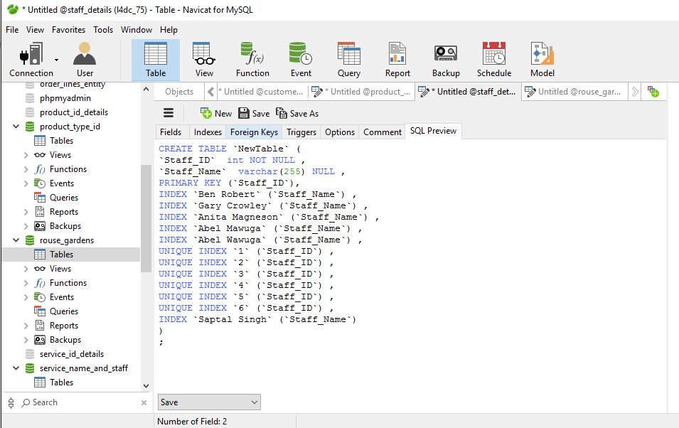

**Task-3**

# Introduction:

The purpose of this assessment is to provide information about how a normalized database has been designed and implemented to meet the requirements for the data provided by a garden construction Company known as Rouse Gardens. The assessment also includes assumptions that were made while completing the task.

# Company requirements:

Rouse Gardens Company is a garden construction company. They asked to design and implement a normalized database that meets their data requirements including Product and their component, customers and staff with order details so that they can be worked with and displayed effectively. They are specializes in constructing sheds, glass houses and other type of garden buildings. This company of the data includes customers where the suppliers include the Company itself and other suppliers and customers items the Company want to save all data database processes system.

# Requirements have been met:

The first task to do a normalized on data in previous records. Then create entities with attributes and create relationships between the entities. An entity relationship diagram was structured and designs to link the entities. A data dictionary was also made for the entity relationship model. In the ERD model is a link that was created between data and information. Crow’s feet notation use on this database databases relationship model; to link product ID and customer ID first create attribute. Crow’s feet notation on entities was created to eliminate many-to-many relationships. Category of products and customer ID required an entity as well to have a relationship with the ID and class with customer details. Product ID details, product type ID and component details are connected on ID and class entities. The following task was to create the entities using SQL. Each entity was given an ID as an attribute to use as primary key and foreign key. The next stage of the task was to enter data that were given in the assignment. This data entry included, associating customers with all events that were shown in the customers and associating them with events and data entry on staff and items given in the assignment.

For the next task a set of queries were written in SQL and manual order to show specific data as asked in the assignment which includes, a query that chooses all events arranged by a particular customer, a query that chooses all the assigned staff and items for an event where an order is required.

## Conclusion:

This assessment has covered discussions on the assignment including what Rouse Garden required me to do, what was done to meet their requirements and assumptions that had to be taken while completing the tasks.

# Conclusion

The assignment first task to create an entity relationship model then creates normalizing steps and data dictionary. Second task showing the created database with screen shot in data entry, queries, update, create and delete.

This assignment helped me learn using SQL effectively to create databases. It also helped me acquire knowledge to about how to database can be designed and implemented in a professional way.