# Introduction

Island Dreams is a travel-based company that wants a centralized database system where data can be accessed and represented in a structured, organized and standardized way. Parts of this assignment include designing a database and an evaluation of the entire system based on the company’s requirement.

# Task 1a, 1b- Normalization

|  |  |  |  |  |  |
| --- | --- | --- | --- | --- | --- |
| Customer and Purchase | | | | | |
| ENTITIES | UNF | 1NF | LEV | 2NF | 3NF |
| Customer  Purchases  ProductType  Product  Location | CustomerId  CustomerName  CustomerAddress  CustomerTelephone  ReturningCustomer  CustomerNotes  PurchasesId  PurchasesDate  PurchasesDuration  ProductTypeId  ProductTypeName  ProductId  ProductName  LocationId  LocationName | CustomerId  CustomerName  CustomerAddress  CustomerTelephone  ReturningCustomer  CustomerNotes  PurchasesId  PurchasesDate  PurchasesDuration  CustomerId*  ProductTypeId  ProductTypeName  ProductId  ProductName  LocationId  LocationName | 1  1  1  1  1  1  2  2  2  2  2  2  2  2  2 | CustomerId  CustomerName  CustomerAddress  CustomerTelephone  ReturningCustomer  CustomerNotes  **Purchases**  PurchasesId  CustomerId*  PurchasesDate  LocationId*  ProductId*  **ProductType**  ProductTypeId  ProductTypeName  **Product**  ProductId  ProductName  ProductTypeId*  **Location**  LocationId  LocationName | **Customer**  CustomerId  CustomerName  CustomerAddress  CustomerTelephone  ReturningCustomer  CustomerNotes  **Purchases**  PurchasesId  CustomerId*  PurchasesDate  LocationId*  ProductId*  **ProductType**  ProductTypeId  ProductTypeName  **Product**  ProductId  ProductName  ProductTypeId*  **Location**  LocationId  LocationName |

|  |  |  |  |  |  |
| --- | --- | --- | --- | --- | --- |
| Compatibility of Products and Outcomes | | | | | |
| ENTITIES | UNF | 1NF | LEV | 2NF | 3NF |
| ProductType  Outcomes | ProductTypeId  ProductTypeName  OutcomesId  OutcomesName | ProductTypeId  ProductTypeName  OutcomesId  OutcomesName | 1  1  2  2 | **ProductType**  ProductTypeId  ProductTypeName  **ProductTypeOutcomes**  ProductTypeOutcomesId  ProductTypeId*  OutcomesId*  **Outcomes**  OutcomesId  OutcomesName | **ProductType**  ProductTypeId  ProductTypeName  **ProductTypeOutcomes**  ProductTypeOutcomesId  ProductTypeId*  OutcomesId*  **Outcomes**  OutcomesId  OutcomesName |

|  |  |  |  |  |  |
| --- | --- | --- | --- | --- | --- |
| A Complaint Record | | | | | |
| ENTITIES | UNF | 1NF | LEV | 2NF | 3NF |
| Complaints  Purchases  Staff  ProductTypeOutcomes | ComplaintsId  ComplaintsDate  ComplaintsDetails  PurchasesId  PurchasesDate  StaffId  StaffName  ProductTypeOutcomesId | ComplaintsId  ComplaintsDate  ComplaintsDetails  StaffId*  PurchasesId  PurchasesDate  ProductTypeOutcomesId  StaffId  StaffName | 1  1  1  1  1  1  2  2 | ComplaintsId  ComplaintsDate  ComplaintsDetails  StaffId*  PurchasesId  PurchasesDate  ProductTypeOutcomesId  ComplaintsStaff  ComplaintsStaffId  StaffId  ComplaintsId  Staff  StaffId  StaffName | Complaints  ComplaintsId  ComplaintsDate  ComplaintsDetails  PurchasesId*  PurchasesDate  ProductTypeOutcomesId*  Purchases  PurchasesId  PurchasesDate  ProductTypeOutcomes  ProductTypeOutcomesId  ComplaintsStaff  ComplaintsStaffId  StaffId*  ComplaintsId*  Staff  StaffId  StaffName |

# Diagram of Entity Relationship Model

Product

ct

1...*

1

1

0...*

Customer

ComplaintsLocation

ation

Complaints

Product

t

omer

1

0...*

1

0...*

0...*

1...*

Location

Complaints

n

ation

Outcomes

ProductTypeOutcomes

ProductType

Purchases

Product

ses

Complaints

ComplaintsStaff

1

1

1...*

Staff

1

0...*

1

1

1...*

# Task 1c- Data Dictionary

|  |  |  |  |  |  |
| --- | --- | --- | --- | --- | --- |
| Customer Table | | | | | |
| Attributes | **Data Type** | **Length** | **Primary Key** | **Foreign Key** | **Reference Table** |
| CustomerId | Varchar | 10 | Yes |  |  |
| CustomerName | Varchar | 100 |  |  |  |
| CustomerAddress | Varchar | 200 |  |  |  |
| CustomerTelephone | Varchar | 20 |  |  |  |
| ReturningCustomer | Char | 3 |  |  |  |
| CustomerNotes | Varchar | 100 |  |  |  |

|  |  |  |  |  |  |
| --- | --- | --- | --- | --- | --- |
| ProductType Table | | | | | |
| Attributes | **Data Type** | **Length** | **Primary Key** | **Foreign Key** | **Reference Table** |
| ProductTypeId | Varchar | 10 | Yes |  |  |
| ProductTypeName | Varchar | 100 |  |  |  |

|  |  |  |  |  |  |
| --- | --- | --- | --- | --- | --- |
| Location Table | | | | | |
| Attributes | **Data Type** | **Length** | **Primary Key** | **Foreign Key** | **Reference Table** |
| LocationId | Varchar | 50 | Yes |  |  |
| LocationName | Varchar | 100 |  |  |  |

|  |  |  |  |  |  |
| --- | --- | --- | --- | --- | --- |
| Staff Table | | | | | |
| Attributes | **Data Type** | **Length** | **Primary Key** | **Foreign Key** | **Reference Table** |
| StaffId | Varchar | 5 | Yes |  |  |
| StaffName | Varchar | 100 |  |  |  |

|  |  |  |  |  |  |
| --- | --- | --- | --- | --- | --- |
| Outcomes Table | | | | | |
| Attributes | **Data Type** | **Length** | **Primary Key** | **Foreign Key** | **Reference Table** |
| OutcomesId | Varchar | 10 | Yes |  |  |
| OutcomesName | Varchar | 100 |  |  |  |

|  |  |  |  |  |  |
| --- | --- | --- | --- | --- | --- |
| Product Table | | | | | |
| Attributes | **Data Type** | **Length** | **Primary Key** | **Foreign Key** | **Reference Table** |
| ProductId | Varchar | 50 | Yes |  |  |
| ProductName | Varchar | 100 |  |  |  |
| ProductTypeId | Varchar | 10 |  | Yes | ProductType |

|  |  |  |  |  |  |
| --- | --- | --- | --- | --- | --- |
| ProductTypeOutcomes Table | | | | | |
| Attributes | **Data Type** | **Length** | **Primary Key** | **Foreign Key** | **Reference Table** |
| ProductTypeOutcomesId | Varchar | 50 | Yes |  |  |
| OutcomesId | Varchar | 10 |  | Yes | Outcomes |
| ProductTypeId | Varchar | 10 |  | Yes | ProductType |

|  |  |  |  |  |  |
| --- | --- | --- | --- | --- | --- |
| Purchases Table | | | | | |
| Attributes | **Data Type** | **Length** | **Primary Key** | **Foreign Key** | **Reference Table** |
| PurchasesId | Varchar | 10 | Yes |  |  |
| PurchasesDate | Date |  |  |  |  |
| PurchasesDuration | Varchar | 100 |  |  |  |
| CustomerId | Varchar | 10 |  | Yes | Customer |
| ProductId | Varchar | 50 |  | Yes | Product |
| LocationId | Varchar | 50 |  | Yes | Location |

|  |  |  |  |  |  |
| --- | --- | --- | --- | --- | --- |
| Complaints Table | | | | | |
| Attributes | **Data Type** | **Length** | **Primary Key** | **Foreign Key** | **Reference Table** |
| ComplaintsId | Varchar | 10 | Yes |  |  |
| ComplaintsDate | Date |  |  |  |  |
| ComplaintsDetails | Varchar | 100 |  |  |  |
| PurchasesId | Varchar | 10 |  | Yes | Purchases |
| ProductTypeOutcomesId | Varchar | 50 |  | Yes | ProductTypeOutcomes |

|  |  |  |  |  |  |
| --- | --- | --- | --- | --- | --- |
| ComplaintsStaff Table | | | | | |
| Attributes | **Data Type** | **Length** | **Primary Key** | **Foreign Key** | **Reference Table** |
| ComplaintsStaffId | Varchar | 10 | Yes |  |  |
| StaffId | Varchar | 5 |  | Yes | Staff |
| ComplaintsId | Varchar | 10 |  | Yes | Complaints |

# Task 2a

## ProductType Table Screenshots

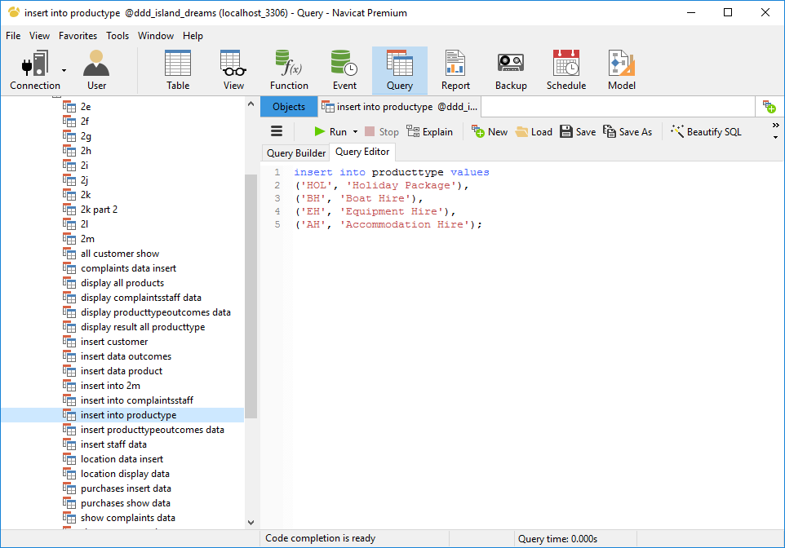

Figure 1: product type data insert

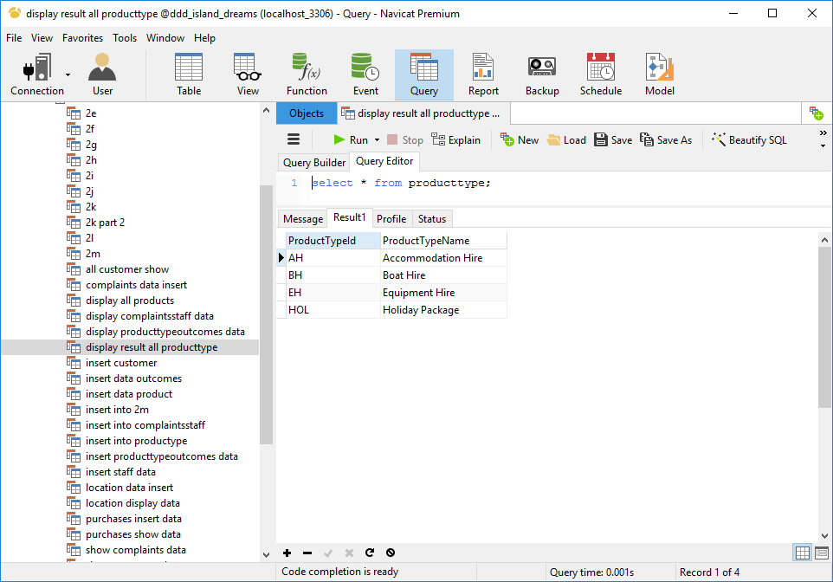

Figure 2: display data of product type

## Product Table Screenshots

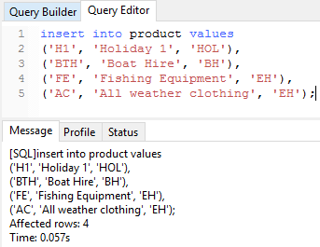

Figure 3: Sample product data insert

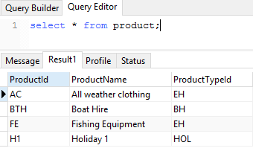

Figure 4: Sample product data display

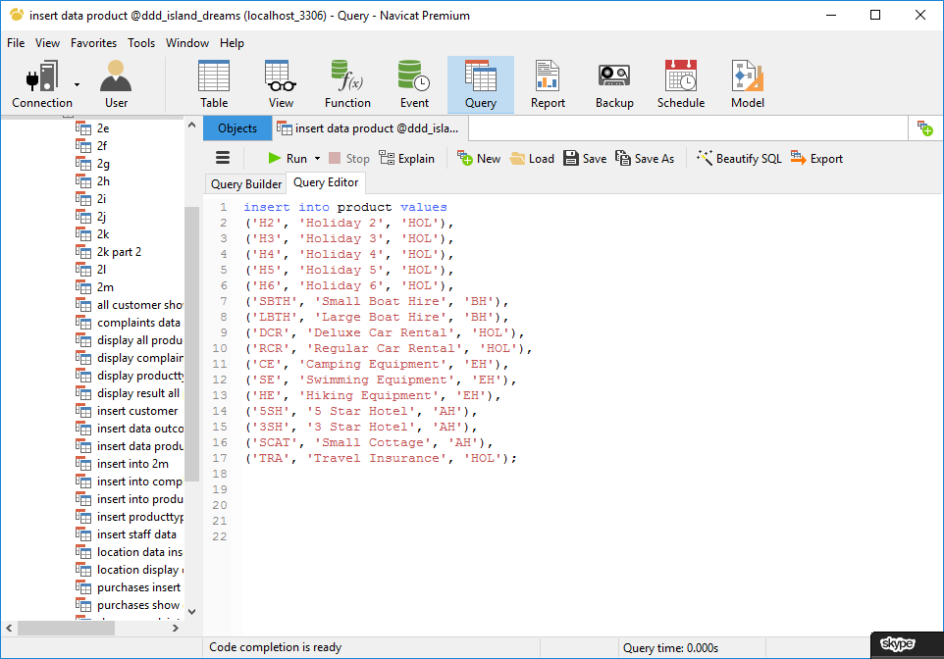

Figure 5: Additional product data insert

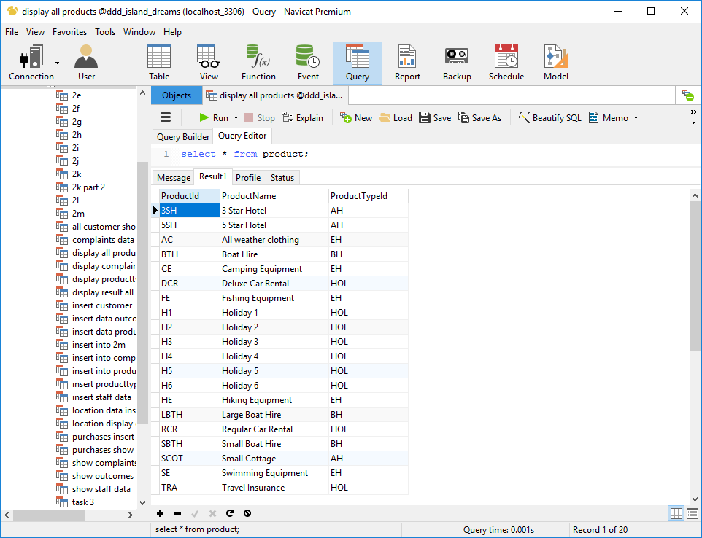

Figure 6: Product data display

# Task 2b

## Customer Table Screenshots

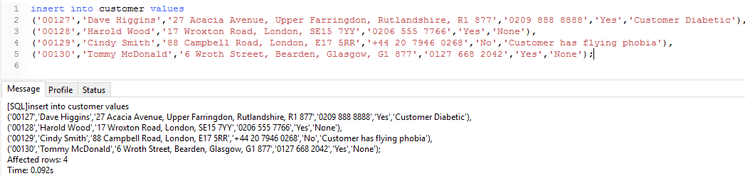

Figure 7: Customer sample data insert

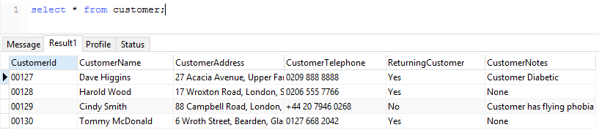

Figure 8: Data display of sample customer

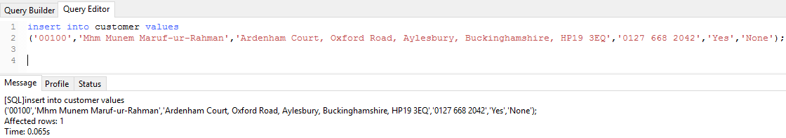

Figure 9: Myself as customer data insert

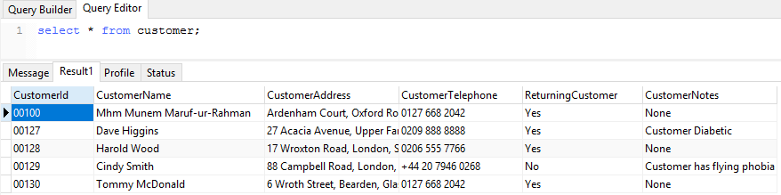

Figure 10: Display data of myself as customer

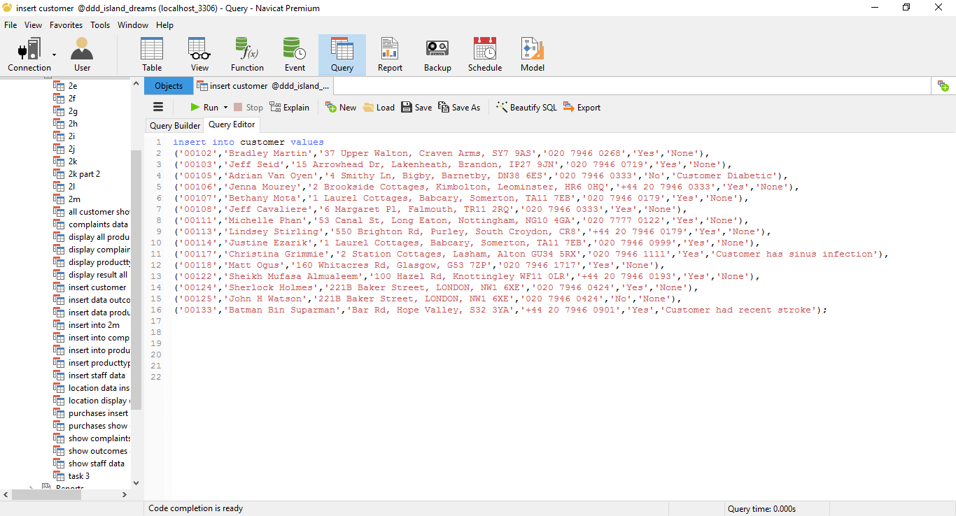

Figure 11: Additional customer data insert

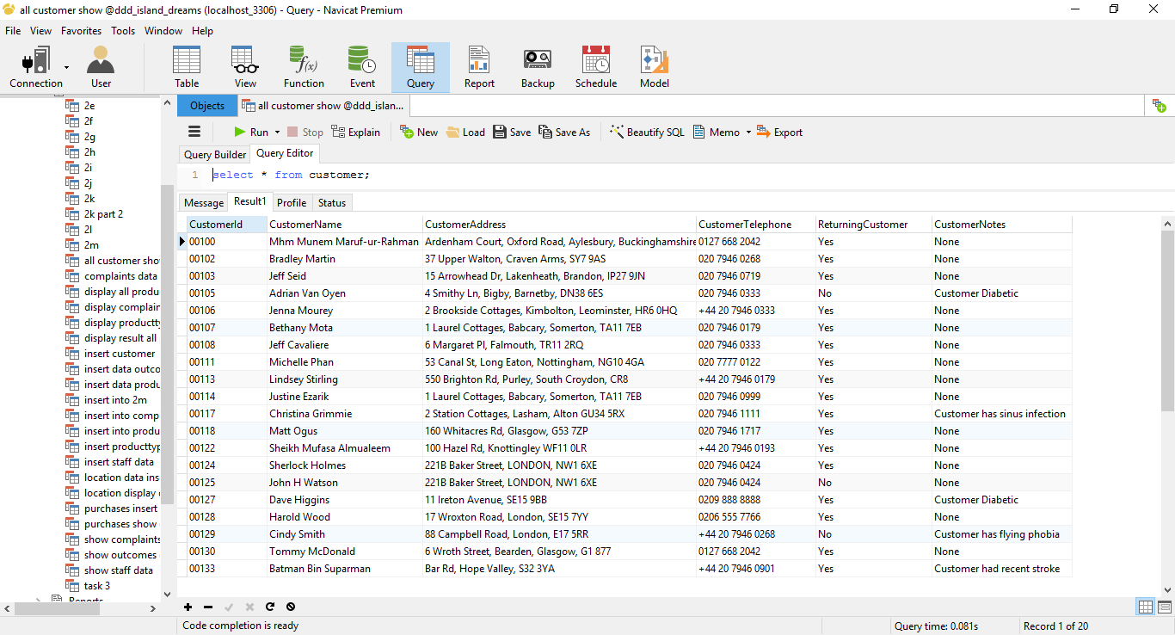

Figure 12: Display data of all 20 customers

# Task 2c

## Location Table Screenshots

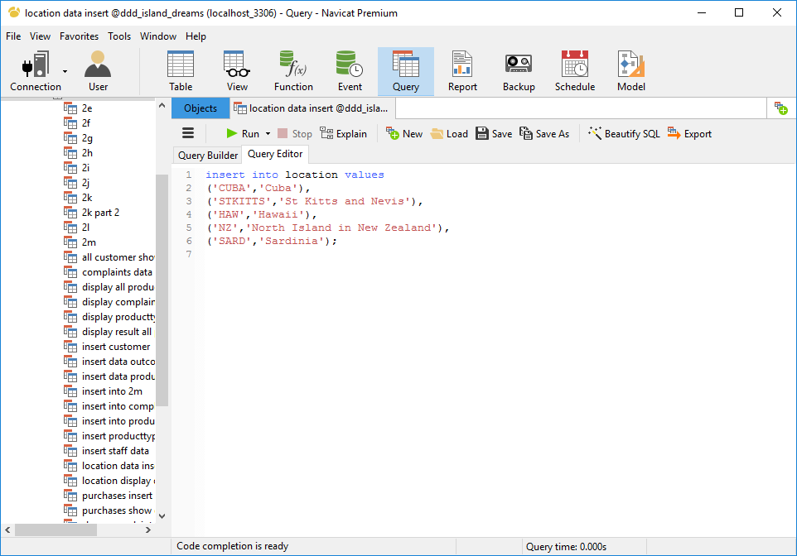

Figure 13: location data insert

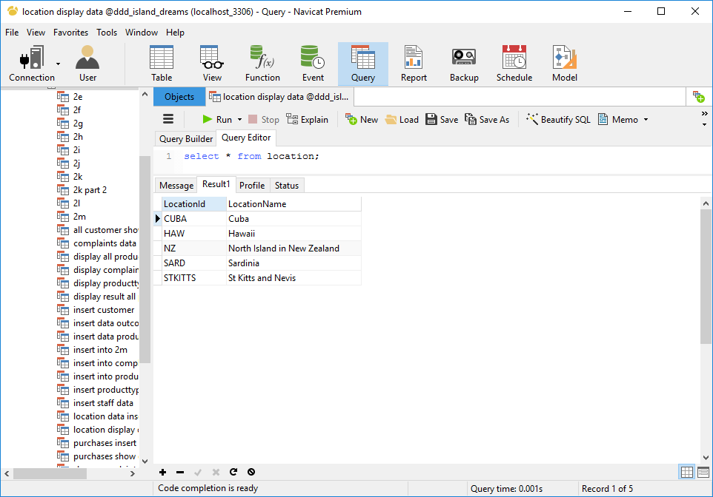

Figure 14: display location data

## Purchases Table Screenshots

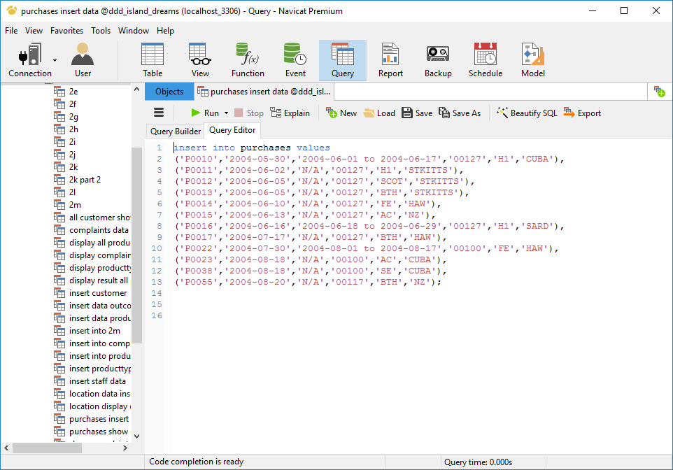

Figure 15: purchases table data insert

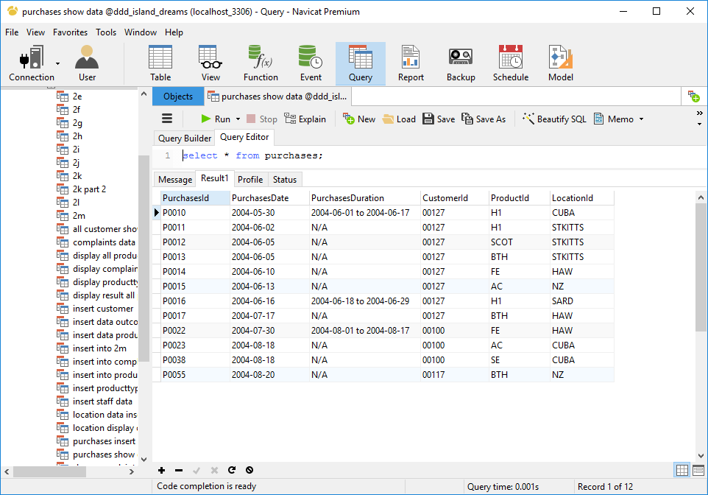

Figure 16: purchases table data display

## Outcomes Table Screenshots

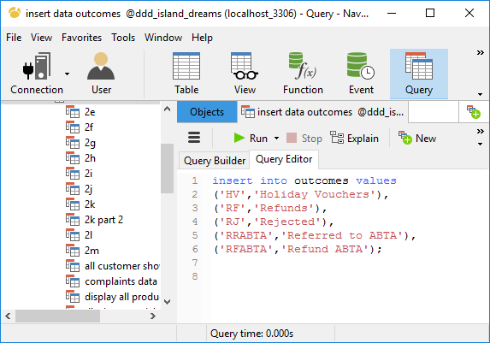

Figure 17: outcomes data insert

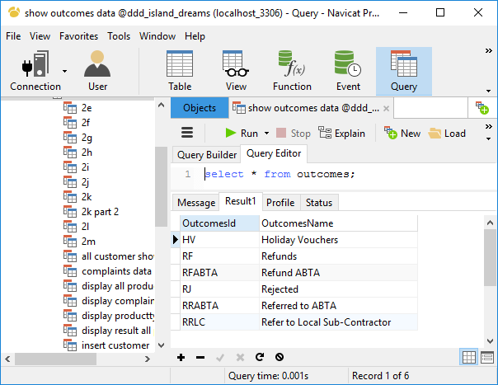

Figure 18: outcomes data display

## ProductTypeOutcomes Table Screenshots

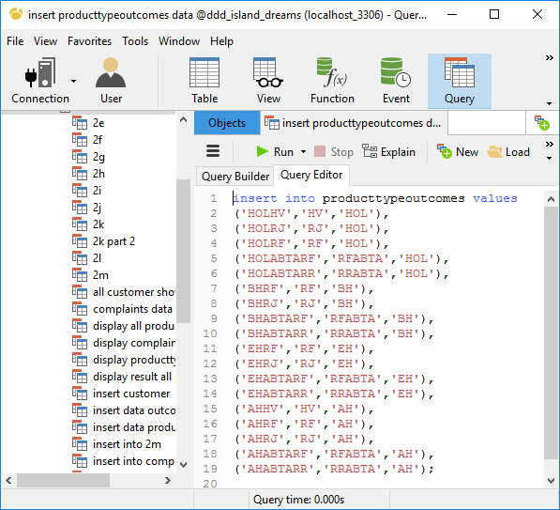

Figure 19: producttypeoutcomes data insert

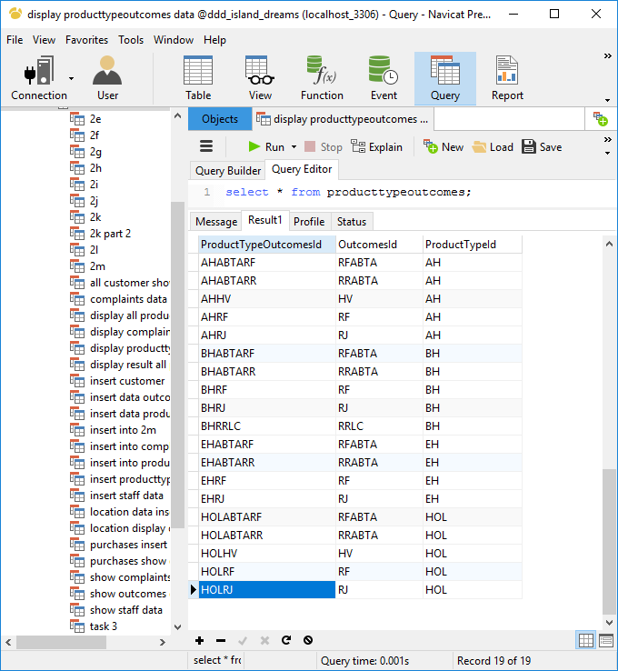

Figure 20: producttypeoutcomes data display

## Complaints Table Screenshots

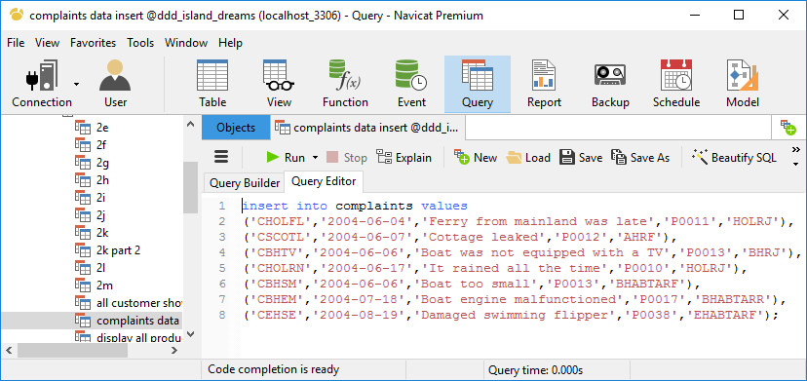

Figure 21: complaints data insert

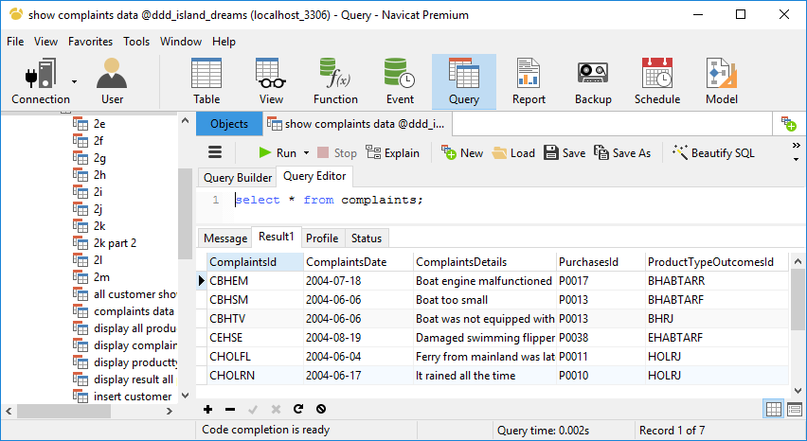

Figure 22: display complaints data

## Staff Table Screenshots

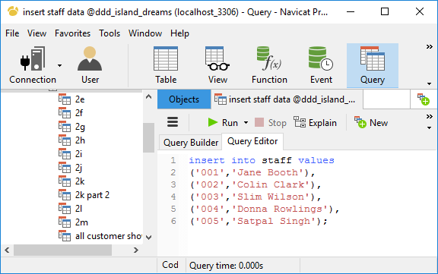

Figure 23: insert staff data

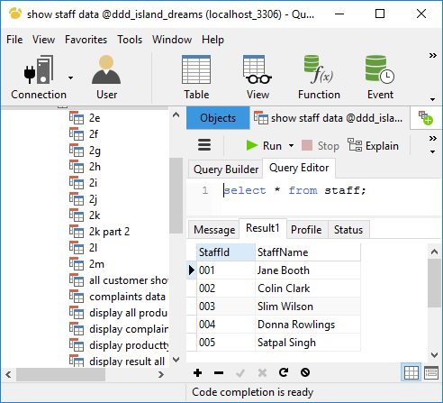

Figure 24: display staff data

## ComplaintsStaff Table Screenshots

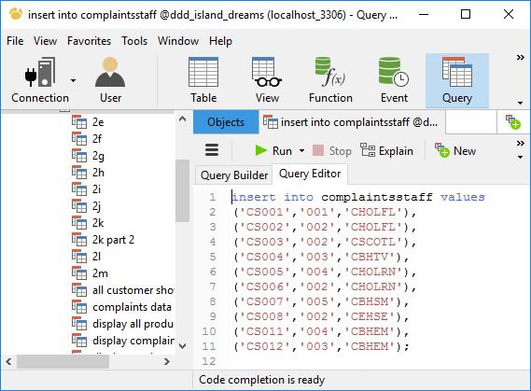

Figure 25: insert complaintsStaff data

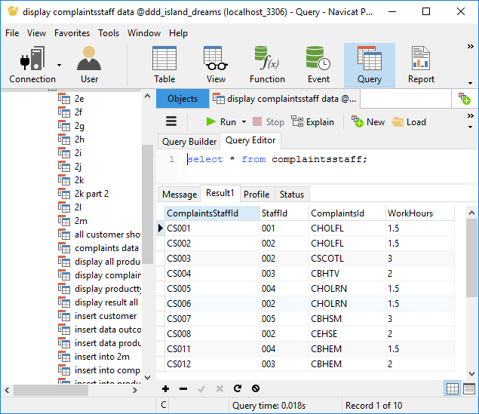

Figure 26: display complaintsStaff data

# Task 2d



Figure 27: All customers selected

# Task 2e

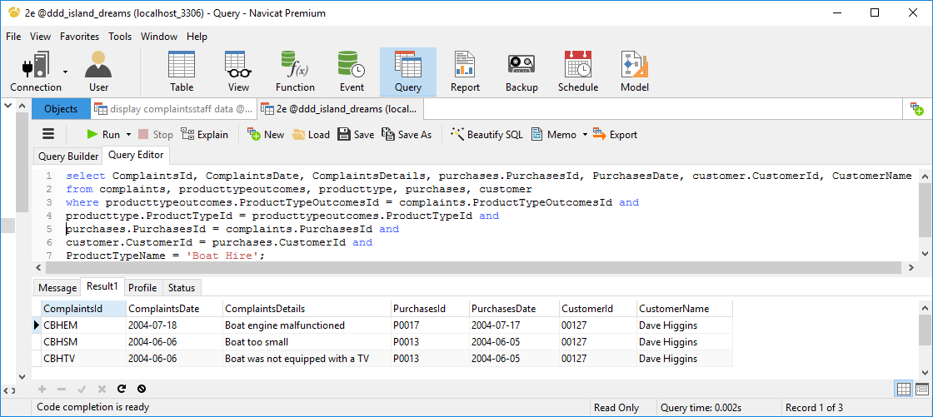

Figure 28: all complaints related to boat hires

# Task 2f

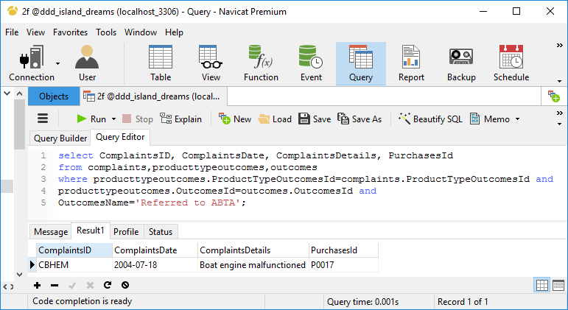

Figure 29: all complaints referred to ABTA

# Task 2g

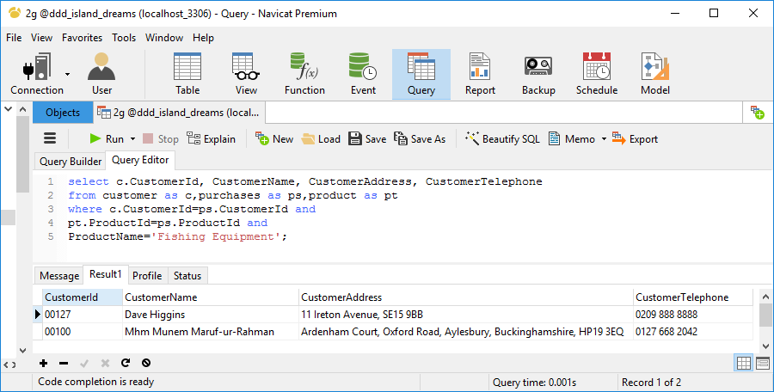

Figure 30: all customers who hired fishing gear

# Task 2h

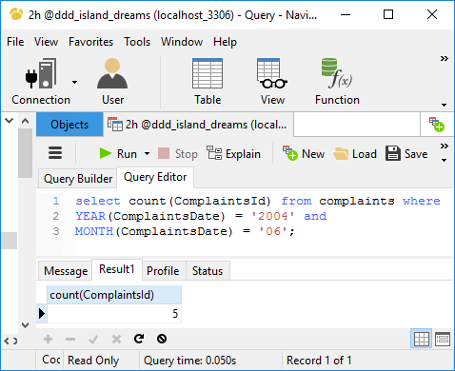

Figure 31: number of complaints in a given month

# Task 2i

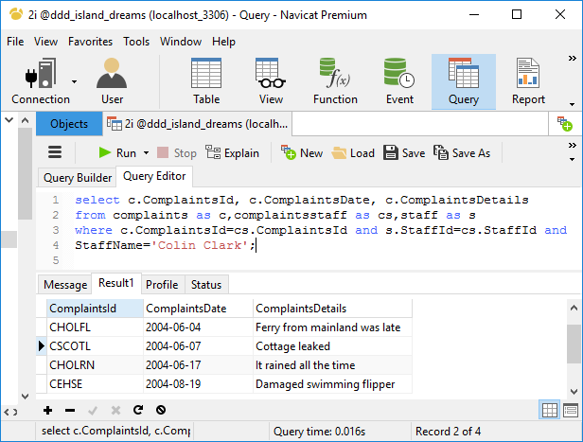

Figure 32: all complaints dealt by Colin Clark

# Task 2j

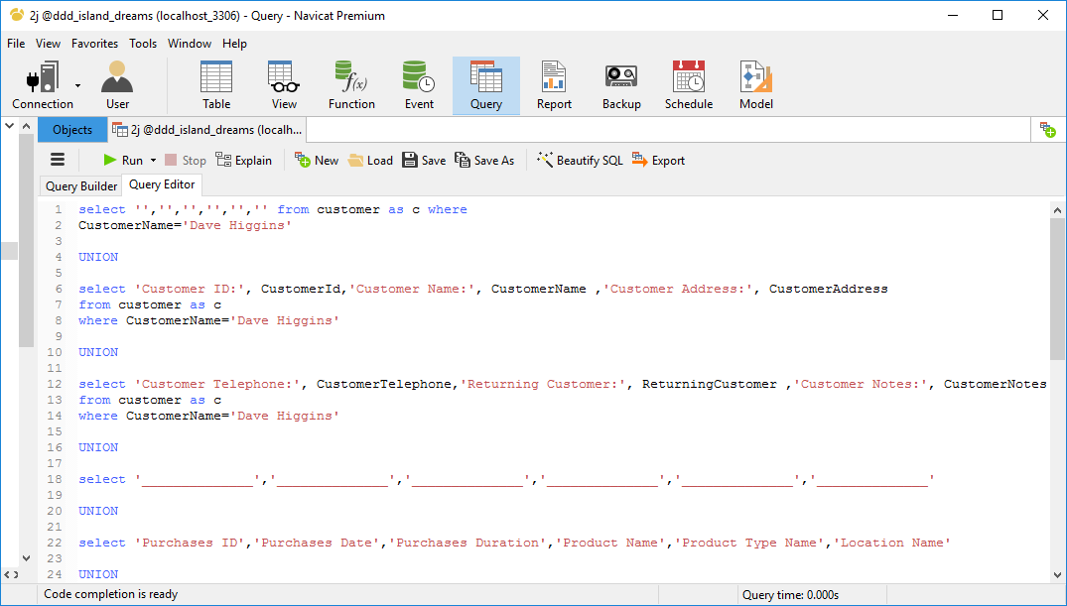

Figure 33: customer, purchase and related complaints

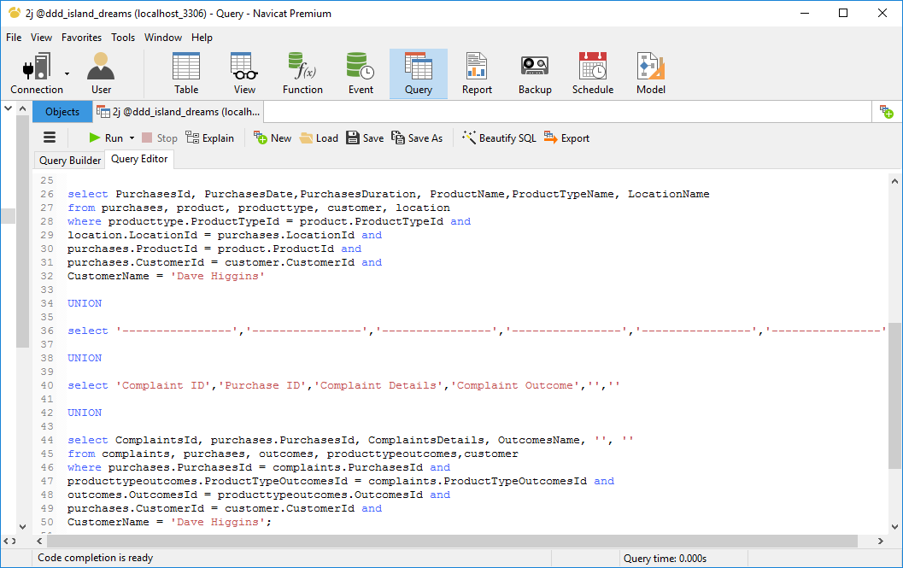

Figure 34: customer, purchase and related complaints continued

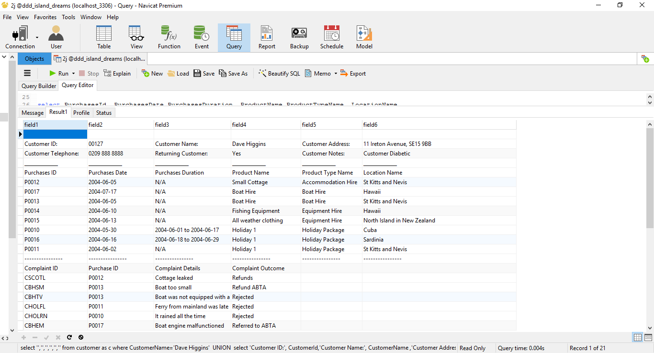

Figure 35: customer, purchase and related complaints output

# Task 2k

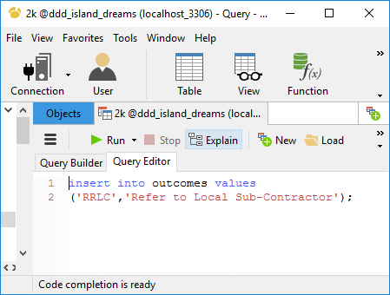

Figure 36: boat hire outcome update

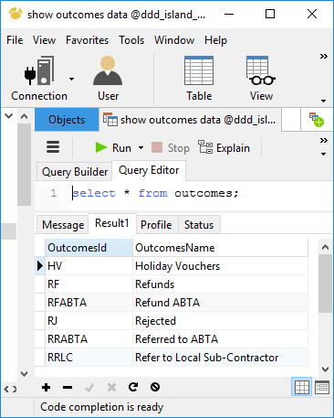

Figure 37: boat hire outcome updated display

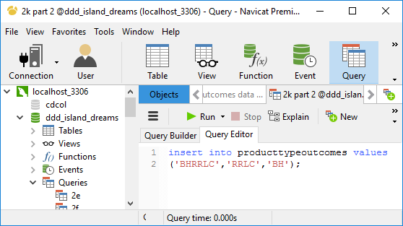

Figure 38: boat hire outcome update in product type outcomes

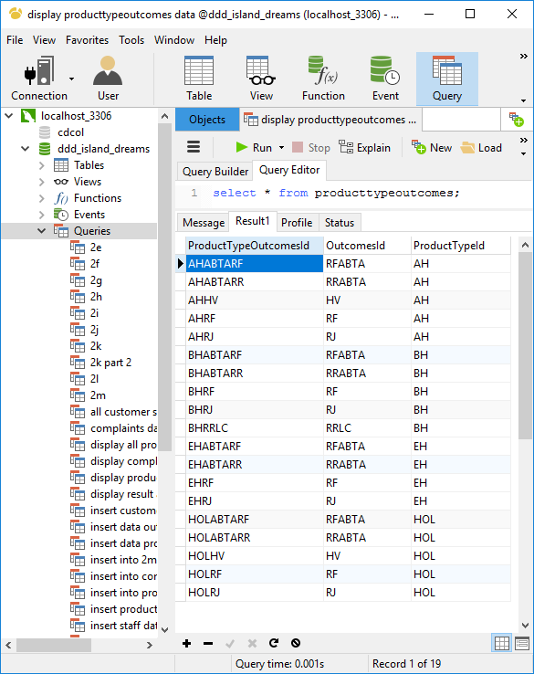

Figure 39: boat hire outcome updated

# Task 2l



Figure 40: previous address of Dave Higgins

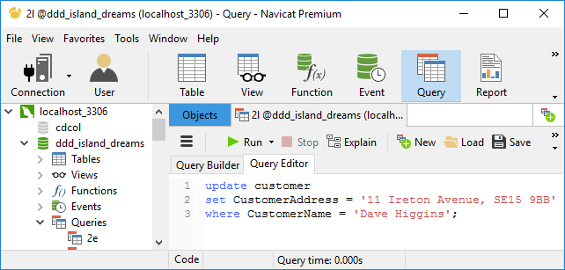

Figure 41: Customer Address update

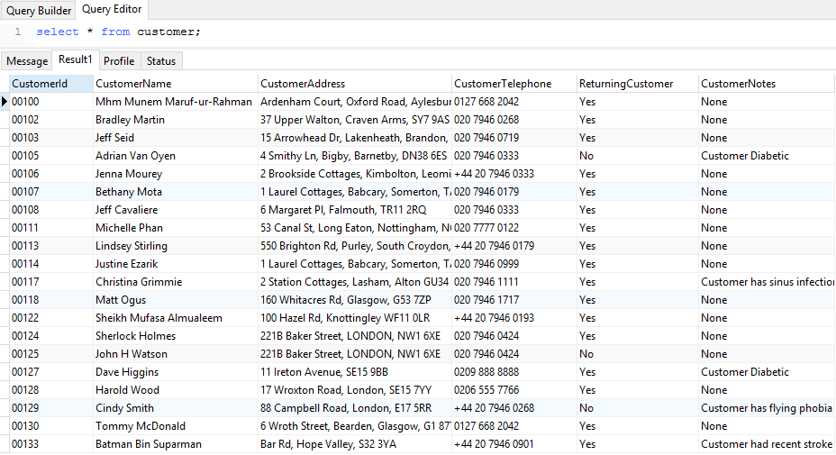

Figure 42: Customer (Dave Higgins) address updated

# Task 2m

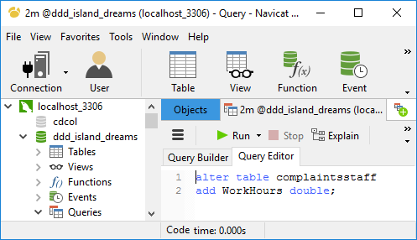

Figure 43: include column for working hours

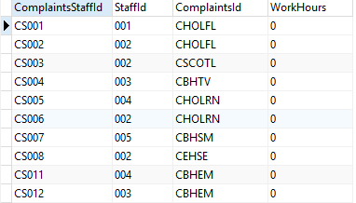

Figure 44: WorkHours column added

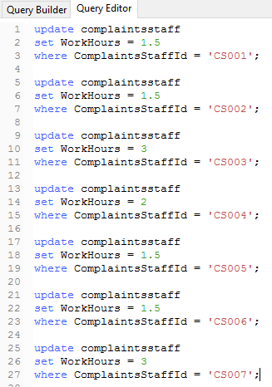

Figure 45: work hours data entry

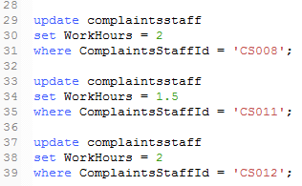

Figure 46: work hours data entry continued

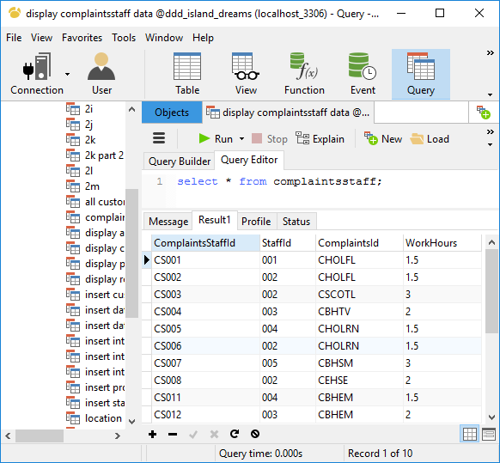

Figure 47: working hour’s data display

# Task 3

# 

Figure 48: staff wages information

|  |  |  |
| --- | --- | --- |
|  | | Reason for use |
| Functions | **COUNT** | To count the number of complaints that were handled by each staff. |
| **BETWEEN** | A range of dates were used with this function to find out the number of complaints made in a given month. |
| **GROUP BY** | This function was used on the COUNT function to find out how many complaints were handled by each staff. |
| Calculation | **COUNT * Pay per complaint + Standard Monthly fee** | To find out the total monthly salary of each staff, number of complaints handled that were previously found by using COUNT function was multiplied with per complaint rate (given) and added to the standard monthly salary (given). |

# Task 4

|  |  |  |
| --- | --- | --- |
| Original Requirement | Initial Requirement | Overall Assessment |
| Island Dreams wanted all data to be stored centrally. | To store all data in one place I have designed a central database. | I was able to meet the requirement using link entity. |
| Island Dreams wanted to avoid duplicity of data. | I have done normalization to break many-to-many relationships in order to avoid data redundancy. | I have performed up to 3rd normalization to successfully remove data redundancy. |
| Island Dreams wanted to have all data organized. | I have designed a normalized entity relationship model so that they get central accessibility to all the data. | I was able to meet this requirement successfully by performing normalization followed by designing an entity relationship model (referred to diagram of entity relationship model). |
| Island Dreams wanted a standardized storage and representation of data where both searching of data and display of search result follows one specific way and not in a random way (for e.g. according to scenario, purchases are searched using product code, complaints searched using customer number). | I have used Primary key and Foreign key to store data in a standardized way. I have used Primary key to uniquely identify data and used Foreign key so data can be shared and accessed. | I was able to meet the requirement by adding attributes to use them as Primary key and Foreign key (referred to Outcomes table). |
| Island Dreams wanted a structured representation of data. | I have designed data dictionary based on the relational model for the structured representation of data. | I have added additional attributes for each table, as needed. |
| Island Dreams wanted to generate reports. | I have performed various queries to generate reports as required. | All queries were performed successfully to generate reports. |
| Island Dreams wanted to generate staff salary report. | I have implemented the concept of derived data so that the database performs the required calculation to represent data for the user (referred to task 3). | Calculation worked as needed and report was generated successfully. |

# Conclusion

In conclusion, the assignment allowed me to learn how to design a more reliable database and perform advanced queries to generate reports and more specifically learn about derived data.