**Task 1**

# Entity Relationship Model:

Figure 1: Entity Relationship Model

# Normalization Process:

|  |  |  |  |  |
| --- | --- | --- | --- | --- |
|  | **UNF** | **1NF** | **2NF** | **3NF** |
| Appointment  Patient  Animal Type  Owner  Vet | AppointmentNO  AppointmentDate  AppointmentTime  AppointmentCost  AppointmentDetails  PatientID  PatientName  AnimalTypeID  AnimalTypeName  OwnerID  OwnerName  OwnerAddress  VetID  VetName | **AppointmentNO (1)**  AppointmentDate (1)  AppointmentTime (1)  AppointmentCost (1)  AppointmentDetails (1)  PatientID (1)  PatientName (1)  AnimalTypeID (1)  AnimalTypeName (1)  OwnerID (1)  OwnerName (1)  OwnerAddress (1)  VetID (1)  VetName (1) | **AppointmentNO (1)**  AppointmentDate (1)  AppointmentTime (1)  AppointmentCost (1)  AppointmentDetails (1)  PatientID (1)  PatientName (1)  AnimalTypeID (1)  AnimalTypeName (1)  OwnerID (1)  OwnerName (1)  OwnerAddress (1)  VetID (1)  VetName (1) | **VetID**  VetName  Vet  **OwnerID**  OwnerName  OwnerAddress  Owner  **AnimalTypeID**  AnimalTypeName  AnimalType  **PatientID**  **OwnerID \***  **AnimalTypeID \***  PatientName  Patient  **AppointmentNO**  **PatientID \***  **VetID \***  AppointmentDate  AppointmentTime  AppointmentCost  AppointmentDetails  Appointment |
| Appointment  Treatment  Hospital | AppointmentNO  AppointmentDate  AppointmentTime  AppointmentCost  AppointmentDetails  TreatmentNO  TreatmentName  Session  HospitalID  HospitalName | **AppointmentNO (1)**  AppointmentDate (1)  AppointmentTime (1)  AppointmentCost (1)  AppointmentDetails (1)  TreatmentNO (2)  TreatmentName (2)  Session (2)  HospitalID (2)  HospitalName (2) | **AppointmentNO (1)**  AppointmentDate (1)  AppointmentTime (1)  AppointmentCost (1)  AppointmentDetails (1)  Treatment  **TreatmentNO**  **HospitalID \***  TreatmentName  AppoinmentTreatment  **AppointmentNO \***  **TreatmentNO \***  Session  **HospitalID**  HospitalName  Hospital | **AppointmentNO \***  **TreatmentNO \***  Session  **HospitalID**  HospitalName  **TreatmentNO**  **HospitalID \***  TreatmentName  Treatment  Hospital  AppoinmentTreatment |
| Appointment  Prescription  Drug | AppointmentNO  AppointmentDate  AppointmentTime  AppointmentCost  AppointmentDetails  PrescriptionNo  prescriptionDate  PrescriptionBy  DrugName  Dosage  Period  LengthOfCourse  DrugCost | **AppointmentNO (1)**  AppointmentDate (1)  AppointmentTime (1)  AppointmentCost (1)  AppointmentDetails (1)  PrescriptionNo (2)  prescriptionDate (2)  PrescriptionBy (2)  DrugName (2)  Dosage (2)  Period (2)  LengthOfCourse (2)  DrugCost (2) | **AppointmentNO (1)**  AppointmentDate (1)  AppointmentTime (1)  AppointmentCost (1)  AppointmentDetails (1)  **PrescriptionNo \***  **DrugName \***  Dosage  Period  LengthOfCourse  Prescription  **PrescriptionNo**  PrescriptionDate  PrescriptionBy  **AppoinmentNo \***  Drug  **DrugName**  DrugCost  PrescriptionDrug | **PrescriptionNo**  **AppointmentNO \***  PrescriptionDate  PrescriptionBy  **AppoinmentNo \***  Drug  **DrugName**  DrugCost  PrescriptionDrug  **PrescriptionNo \***  **DrugName \***  Dosage  Period  LengthOfCourse  Prescription |

# Data Dictionary:

**AnimalType:**

|  |  |  |  |  |  |
| --- | --- | --- | --- | --- | --- |
| Attributes | Data Type | Length | Primary Key | Foreign Key | Reference Table |
| AnimalTypeID | int | 10 | Yes |  |  |
| AnimalTypeName | varchar | 80 |  |  |  |

**Owner:**

|  |  |  |  |  |  |
| --- | --- | --- | --- | --- | --- |
| Attributes | Data Type | Length | Primary Key | Foreign Key | Reference Table |
| OwnerID | int | 12 | Yes |  |  |
| OwnerName | varchar | 90 |  |  |  |
| OwnerAddress | varchar | 110 |  |  |  |

**Patient:**

|  |  |  |  |  |  |
| --- | --- | --- | --- | --- | --- |
| Attributes | Data Type | Length | Primary Key | Foreign Key | Reference Table |
| PatientID | int | 10 | Yes |  |  |
| OwnerID | int | 12 |  | Yes | Owner |
| AnimalTypeID | int | 10 |  | Yes | AnimalType |
| PatientName | varchar | 70 |  |  |  |

**Vet:**

|  |  |  |  |  |  |
| --- | --- | --- | --- | --- | --- |
| Attributes | Data Type | Length | Primary Key | Foreign Key | Reference Table |
| VetID | int | 11 | Yes |  |  |
| VetName | varchar | 100 |  |  |  |

**Appointment:**

|  |  |  |  |  |  |
| --- | --- | --- | --- | --- | --- |
| Attributes | Data Type | Length | Primary Key | Foreign Key | Reference Table |
| AppointmentNO | int | 14 | Yes |  |  |
| PatientID | int | 10 |  | Yes | Patient |
| VetID | int | 11 |  | Yes | Vet |
| AppointmentDate | date |  |  |  |  |
| AppointmentTime | time |  |  |  |  |
| AppointmentCost | float | 5 |  |  |  |
| AppointmentDetails | varchar | 95 |  |  |  |

**Hospital:**

|  |  |  |  |  |  |
| --- | --- | --- | --- | --- | --- |
| Attributes | Data Type | Length | Primary Key | Foreign Key | Reference Table |
| HospitalID | int | 6 | Yes |  |  |
| HospitalName | varchar | 120 |  |  |  |

**Treatment:**

|  |  |  |  |  |  |
| --- | --- | --- | --- | --- | --- |
| Attributes | Data Type | Length | Primary Key | Foreign Key | Reference Table |
| TreatmentNO | int | 9 | Yes |  |  |
| HospitalID | int | 6 |  | Yes | Hospital |
| TreatmentName | varchar | 86 |  |  |  |

**AppoinmentTreatment:**

|  |  |  |  |  |  |
| --- | --- | --- | --- | --- | --- |
| Attributes | Data Type | Length | Primary Key | Foreign Key | Reference Table |
| AppointmentNO | int | 14 | Yes | Yes | Appointment |
| TreatmentNO | int | 9 | Yes | Yes | Treatment |
| Session | int | 15 |  |  |  |

**Prescription:**

|  |  |  |  |  |  |
| --- | --- | --- | --- | --- | --- |
| Attributes | Data Type | Length | Primary Key | Foreign Key | Reference Table |
| PrescriptionNo | varchar | 7 | Yes |  |  |
| AppointmentNO | int | 14 |  | Yes | Appointment |
| PrescriptionDate | date | 8 |  |  |  |
| PrescriptionBy | varchar | 100 |  |  |  |

**Drug:**

|  |  |  |  |  |  |
| --- | --- | --- | --- | --- | --- |
| Attributes | Data Type | Length | Primary Key | Foreign Key | Reference Table |
| DrugName | varchar | 20 | Yes |  |  |
| DrugCost | float | 10 |  |  |  |

**PrescriptionDrug:**

|  |  |  |  |  |  |
| --- | --- | --- | --- | --- | --- |
| Attributes | Data Type | Length | Primary Key | Foreign Key | Reference Table |
| PrescriptionNo | int | 7 | Yes | Yes | Prescription |
| DrugName | varchar | 20 | Yes | Yes | Drug |
| Dosage | varchar | 6 |  |  |  |
| Period | varchar | 11 |  |  |  |

**Task 2**

# Data Insertion:

**AnimalType Table:**

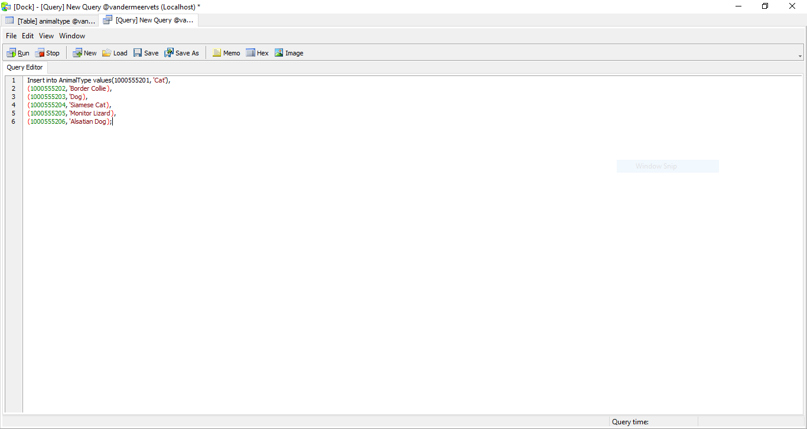

Figure 2: Data Insertion of AnimalType Table

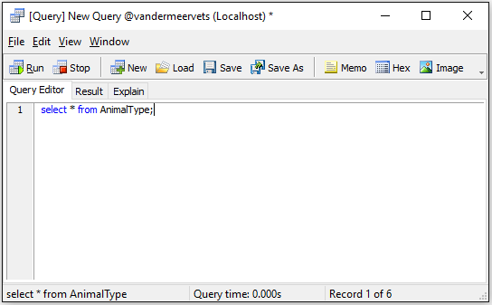

Figure 3: Show all data from AnimalType table

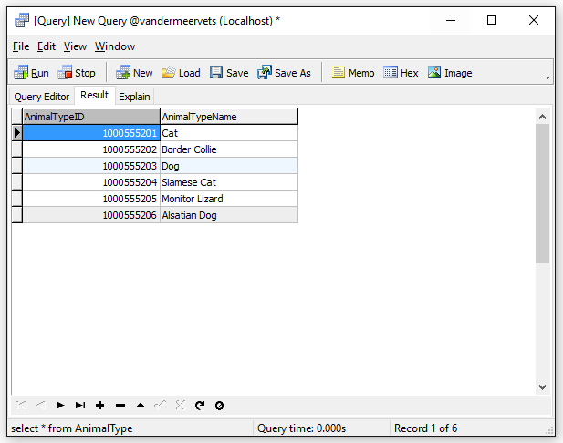

Figure 4: Data Insertion Result of AnimalType Table

**Owner Table:**

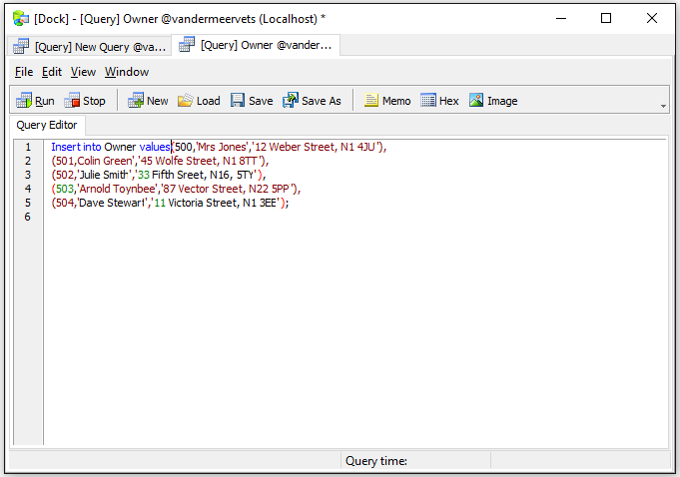

Figure 5: Data Insertion of Owner Table

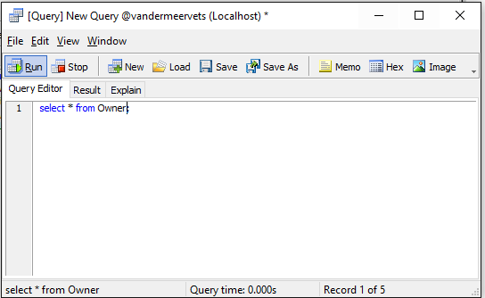

Figure 6: Show all data from Owner table

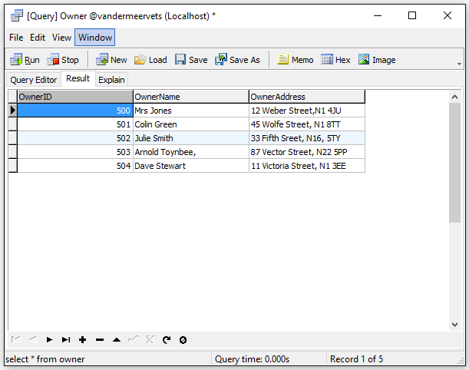

Figure 7: Data Insertion Result of Owner Table

**Patient Table:**

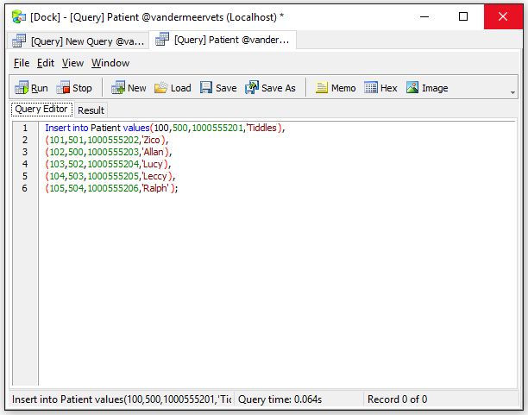

Figure 8: Data Insertion of Patient Table

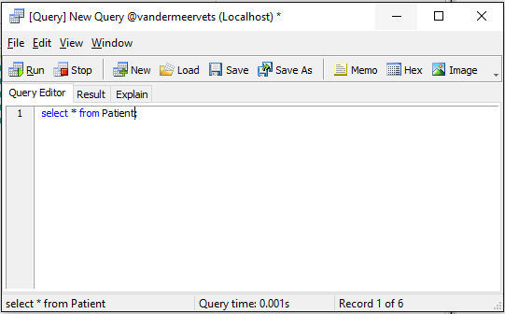

Figure 9: Show all data from Patient table

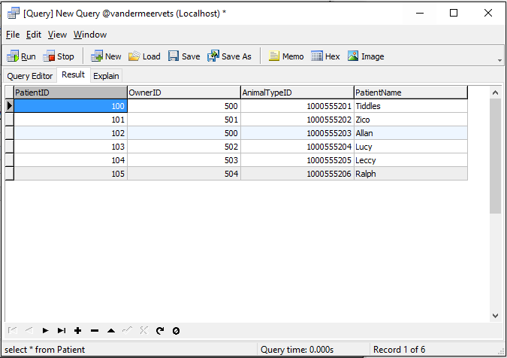

Figure 10: Data Insertion Result of Patient Table

# Data Insertion:

**Vet Table:**

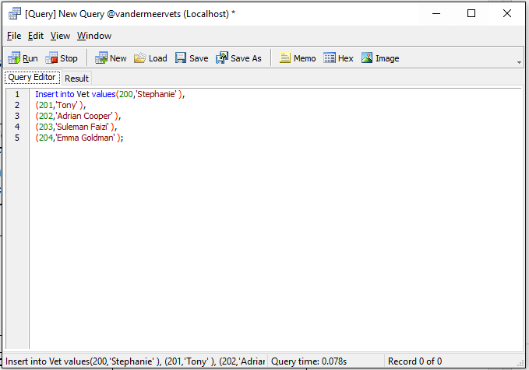

Figure 11: Data Insertion of Vet Table

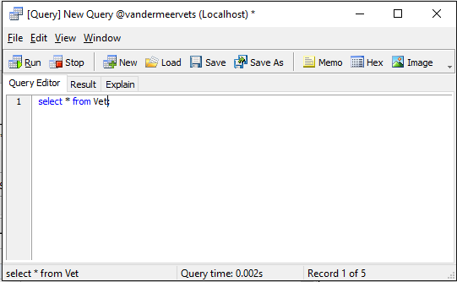

Figure 12: Show all data from Vet table

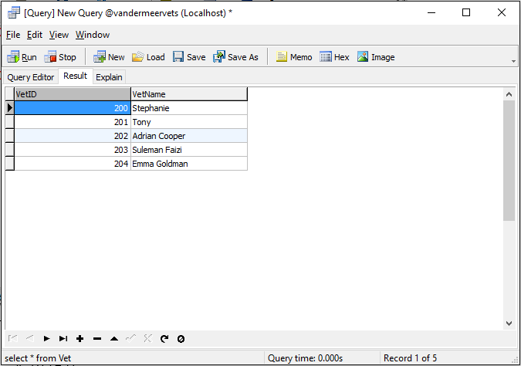

Figure 13: Data Insertion Result of Vet Table

**Appointment Table:**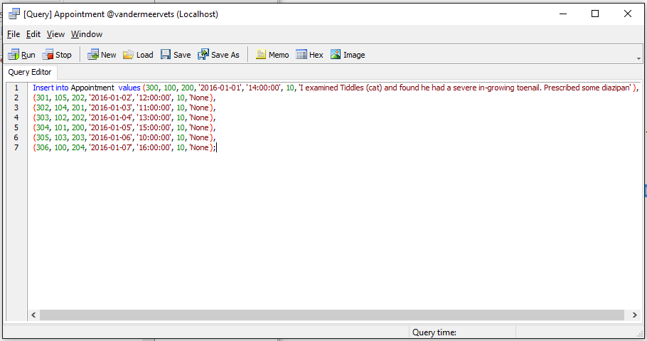

Figure 14: Data Insertion of Appointment Table

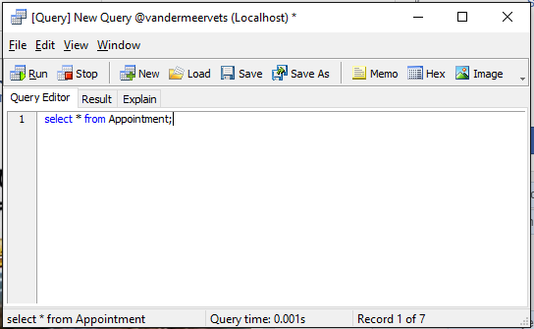

Figure 15: Show all data from Appointment Table

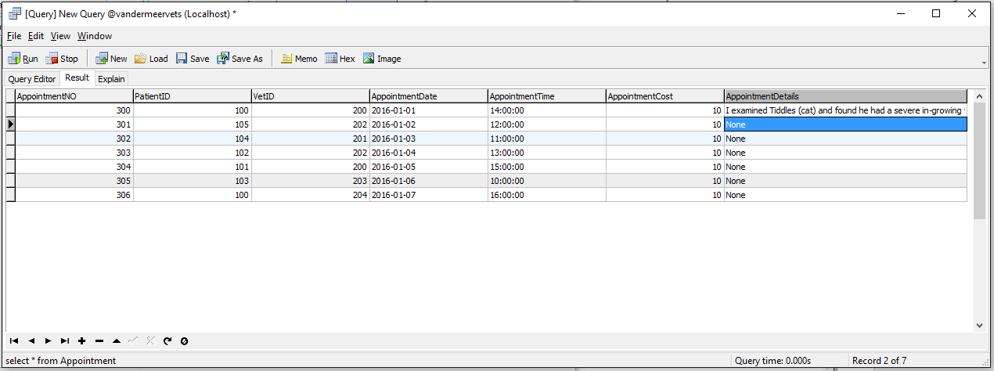

Figure 16: Data Insertion Result of Appointment Table

# Data Insertion

**Hospital Table:**

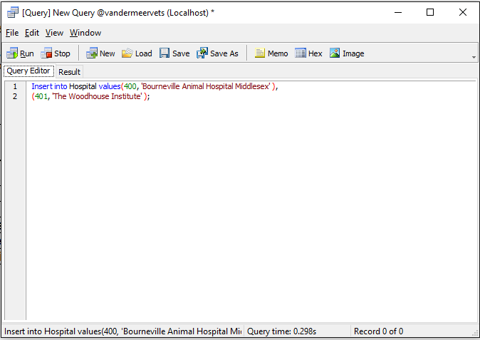

Figure 17: Data Insertion of Hospital table

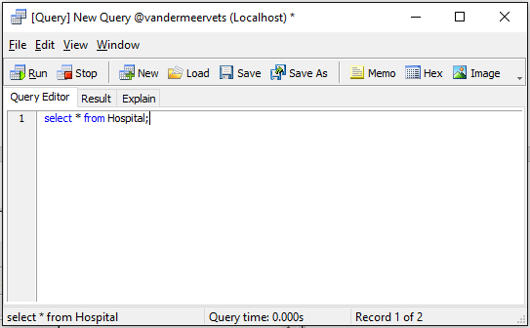

Figure 18: Show all data from Hospital Table

.

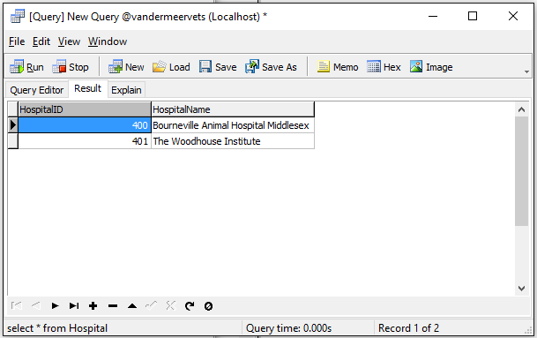

Figure 19: Data Insertion Result of Hospital Table

**Treatment Table:**

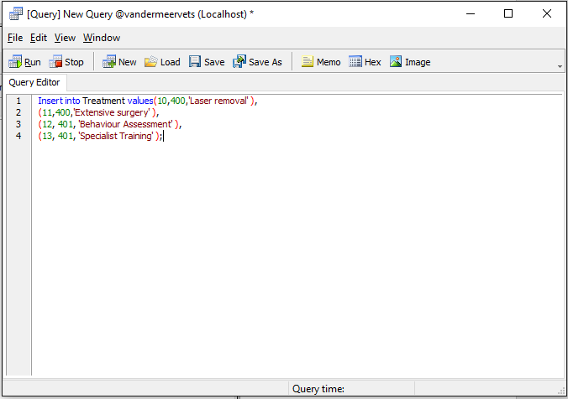

Figure 20: Data Insertion of Treatment Table.

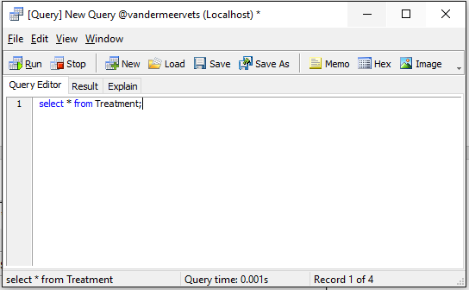

Figure 21: Show all data from Treatment Table

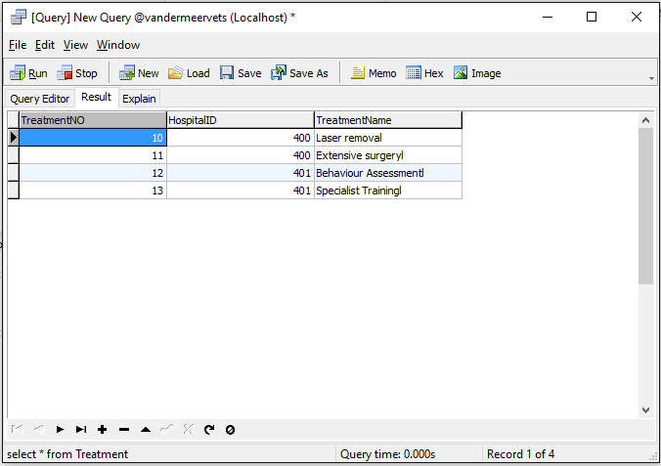

Figure 22: Data Insertion Result of Treatment Table

**AppointmentTreatment Table:**

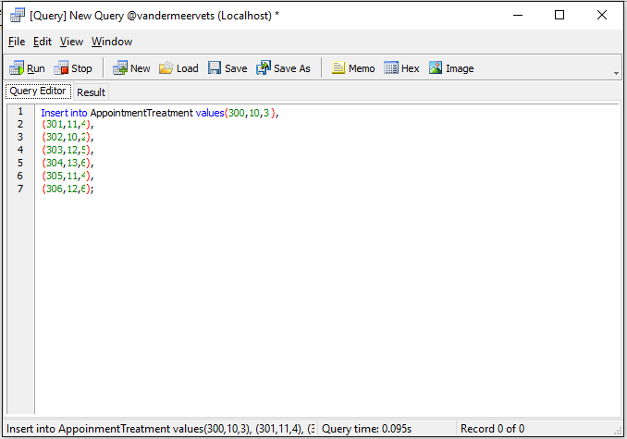

Figure 23.1: : Data Insertion of AppointmentTreatment.

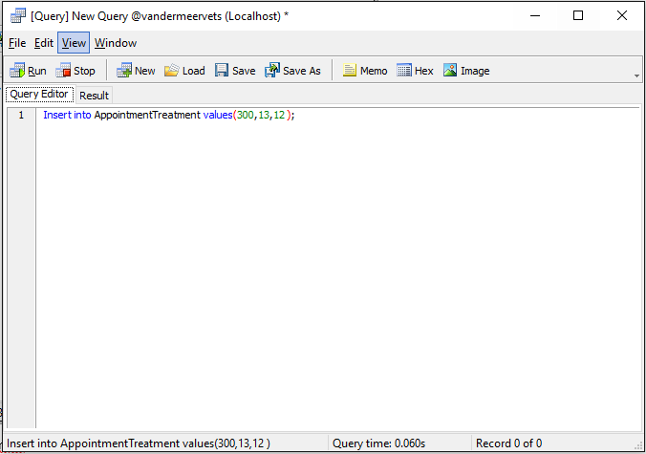

Figure 23.2: Data Insertion of AppointmentTreatment.

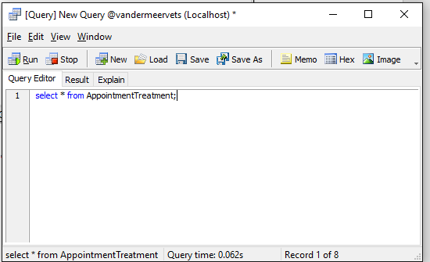

Figure 24: Show all data from AppointmentTreatment Table

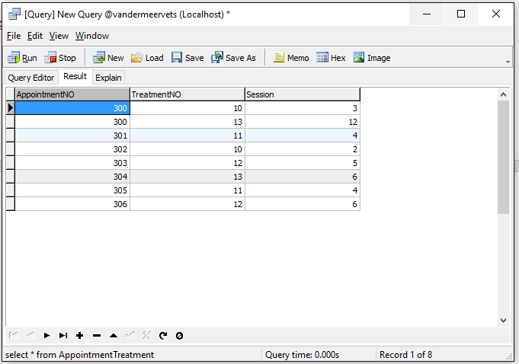

Figure 25: Data Insertion Result of AppointmentTreatment.

# Data Insertion:

**Prescription Table:**

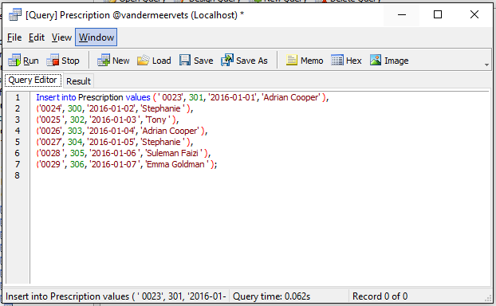

Figure 26: Data Insertion of Prescription

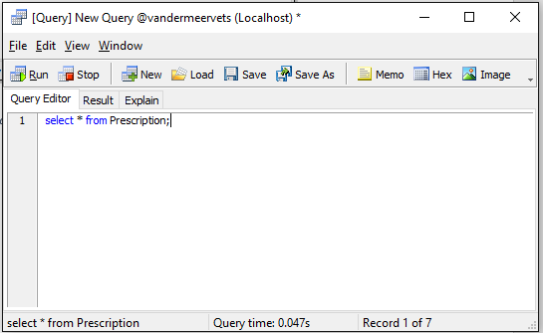

Figure 27: Show all data from Prescription

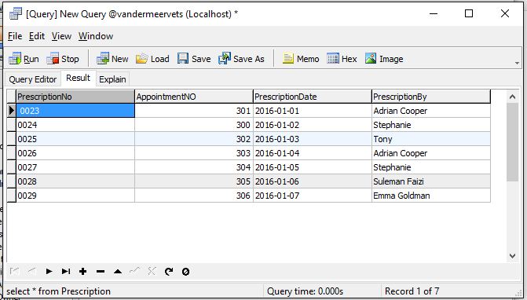

Figure 28: Data Insertion Result of Prescription.

**Drug Table:**

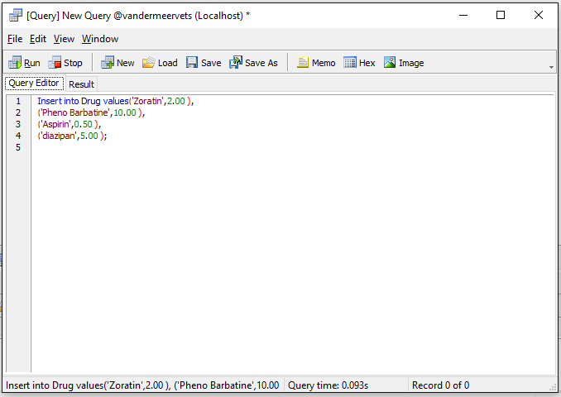

Figure 29: Data Insertion of Drug Table

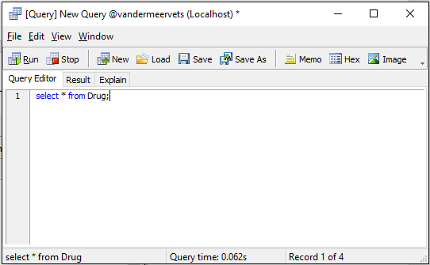

Figure 30: Show all data from Drug

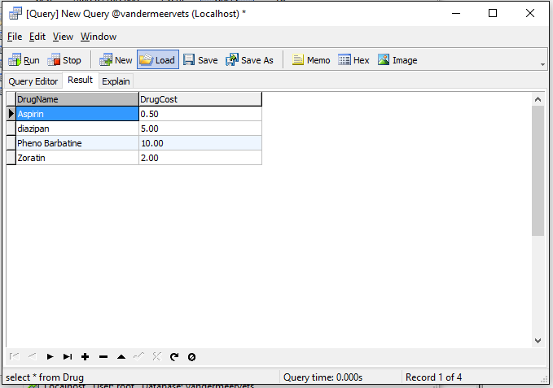

Figure 31: Data Insertion Result of Drug Table

**PrescriptionDrug Table:**

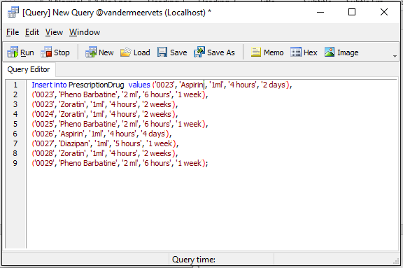

Figure 32: Data Insertion of PrescriptionDrug

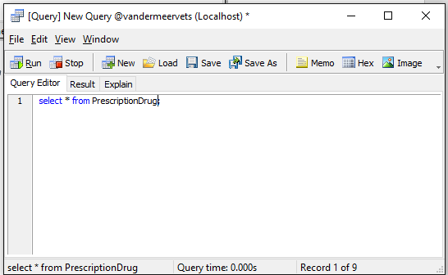

Figure 33: Show all data from PrescriptionDrug table

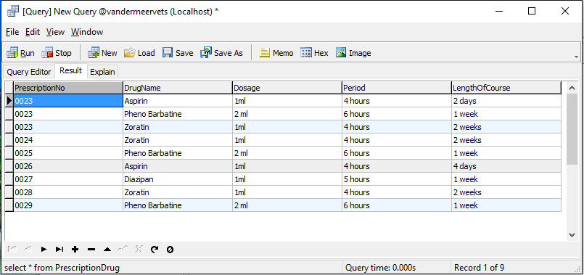

Figure 34: Data Insertion Result of PrescriptionDrug

# Query of Dogs:

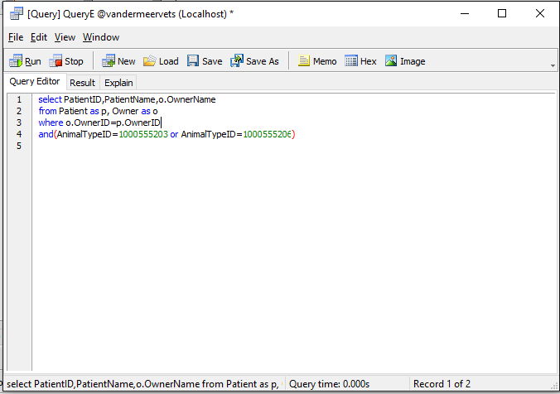

Figure 35: Query that selects all the dogs that are currently patients.

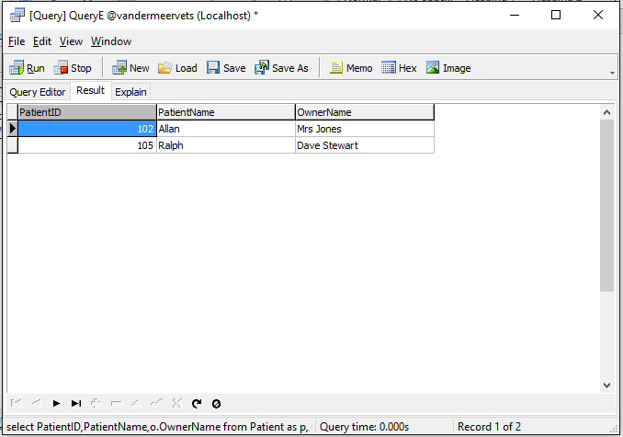

Figure 36: Query result that selects all the dogs that are currently patients.

# Query of Mrs Jones Animals:

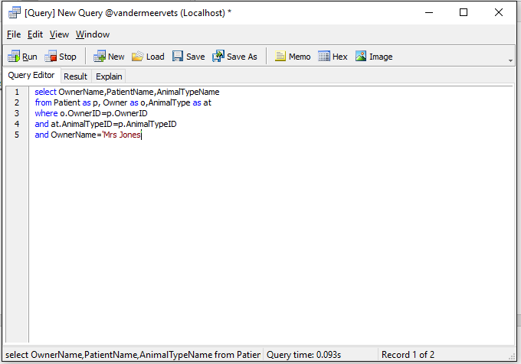

Figure 37: Query that selects the animals that belong to Mrs Jones.

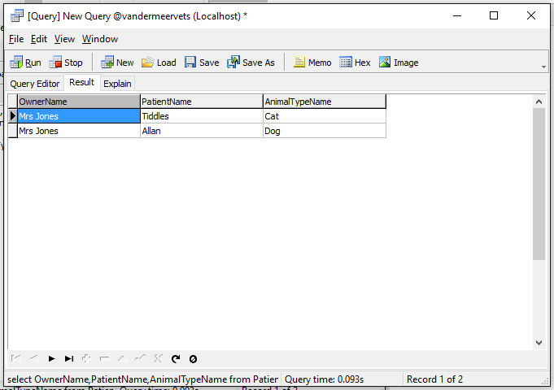

Figure 38: Query result that selects the animals that belong to Mrs Jones.

# Query of Owner details which referred to the Bourneville Animal Hospital:

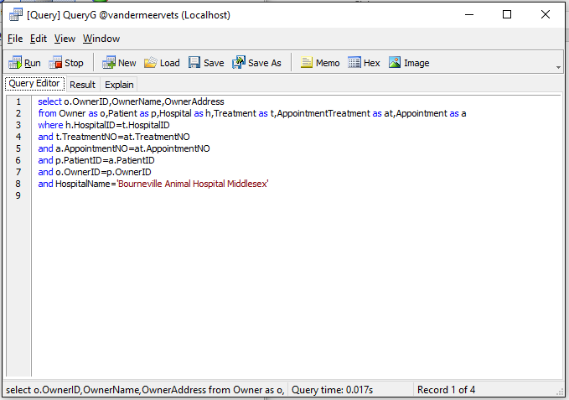

Figure 39: Query that selects the owner details for animals that have been referred to the Bourneville Animal Hospital.

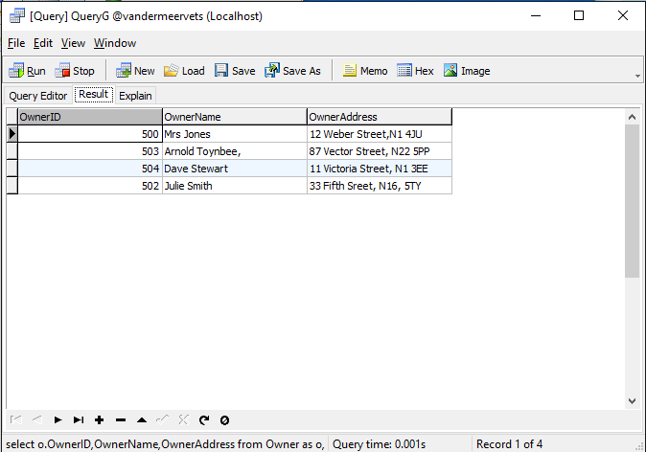

Figure 40: Query result that selects the owner details for animals that have been referred to the Bourneville Animal Hospital.

# h) Query of Prescriptions Drugs of Ralph:

Figure 41: Query that shows all the drugs for the prescription for Ralph

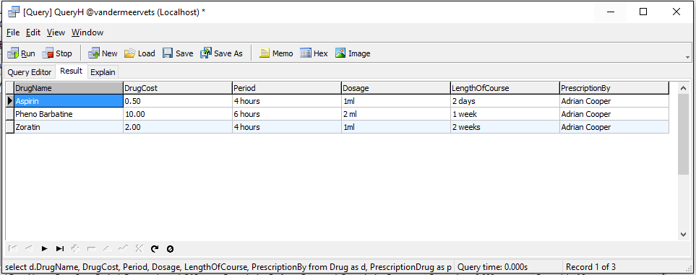

Figure 42: Query result that shows all the drugs for the prescription for Ralph.

# Query of Cats:

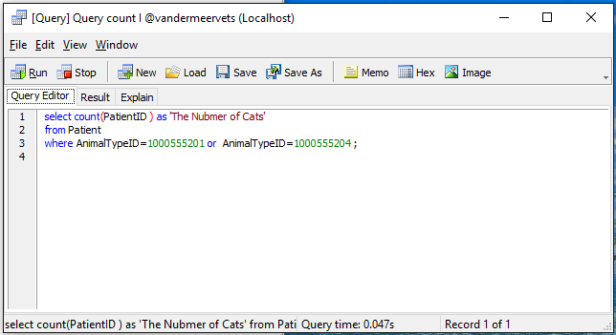

Figure 43: Query that counts the number of cats.

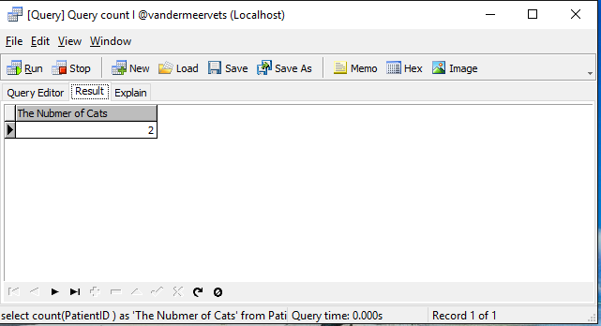

Figure 44: Query result that counts the number of cats.

# Query of Costing Report of an Appointment:

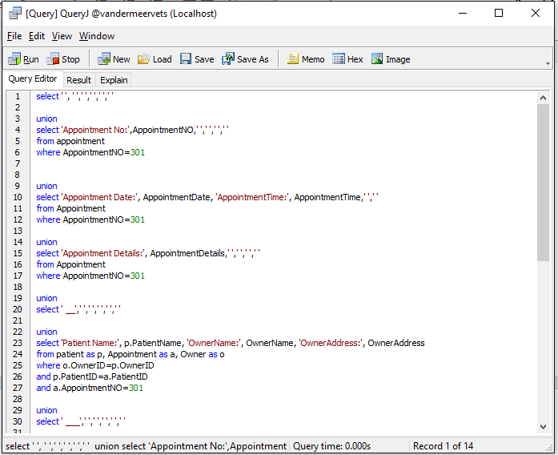

Figure 45.1: Query that produces the output that could be used to a costing report an appointment.

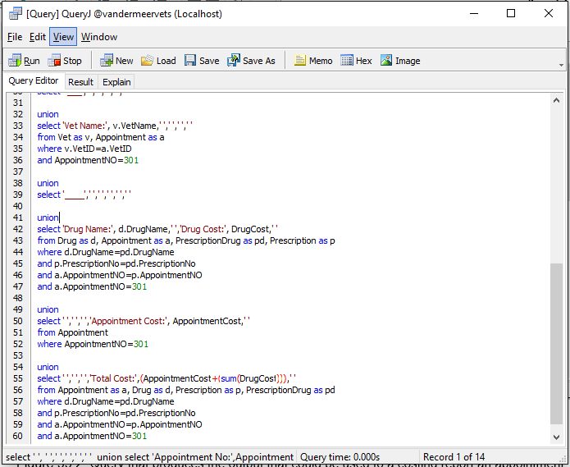

Figure 45.2: Query that produces the output that could be used to a costing report an appointment.

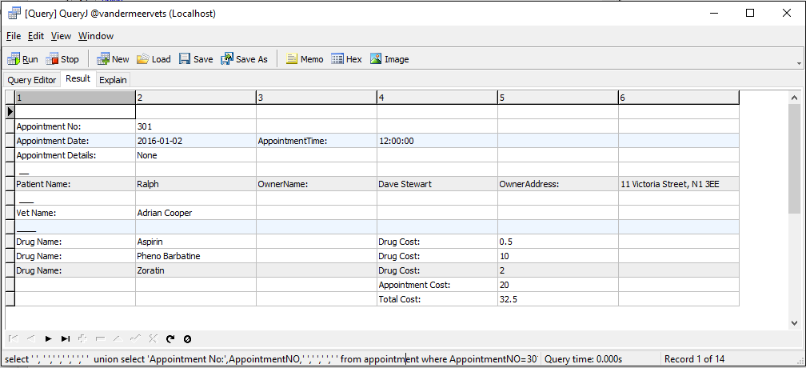

Figure 46: Query result that produces the output that could be used to a costing report an appointment.

# Update of an Appointment Cost:

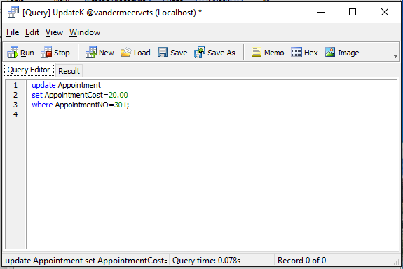

Figure 47: Update the cost of an appointment to £20.00

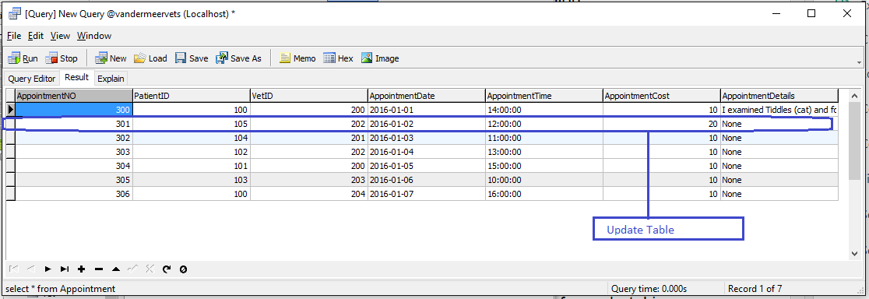

Figure 48: Update the cost of an appointment to £20.00

# Update Julie Smith’s Address:

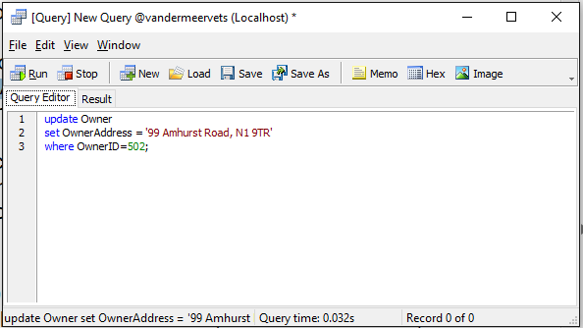

Figure 49: Update Julie Smith’s address to ’99 Amhurst Road, N1 9TR’.

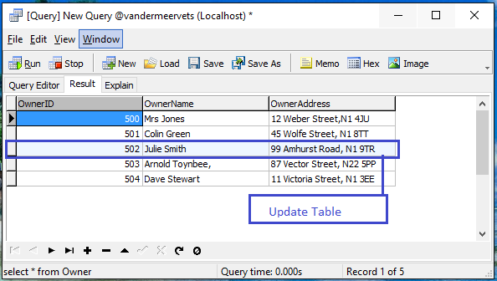

Figure 50: Update result Julie Smith’s address to ’99 Amhurst Road, N1 9TR’.

# Update Treatment:

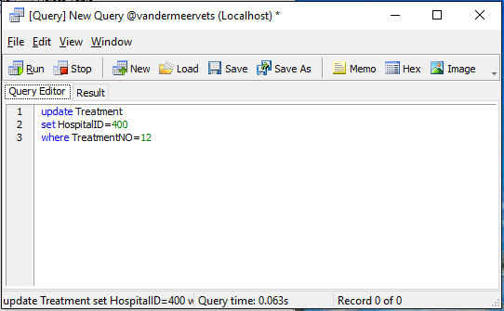

Figure 51: Update the records so that the treatment of Behaviour Assessment is now provided at the Bourneville Animal Hospital

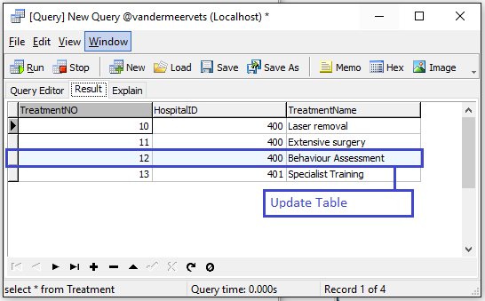

Figure 52: Update result the records so that the treatment of Behaviour Assessment is now provided at the Bourneville Animal Hospital

:

# Alter Database:

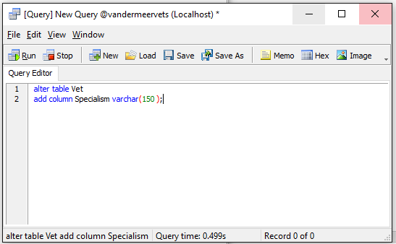

Figure 53: Specialism column added to the Vet table.

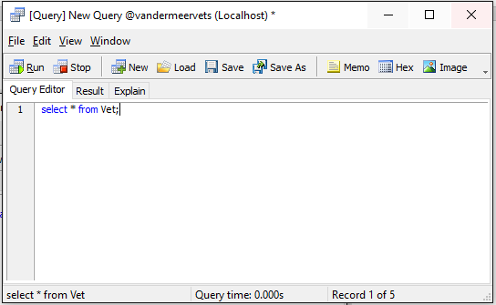

Figure 54: Show all current data of Vet table

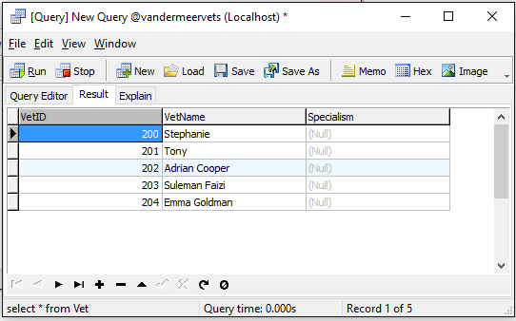

Figure 55: The Result of Specialism column added to the Vet table.

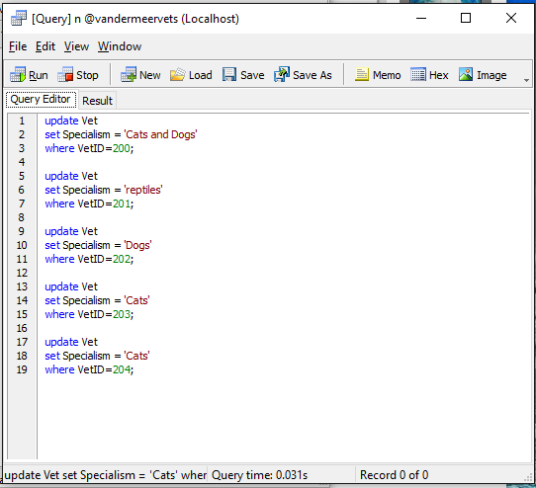

Figure 56: Update Vet and Insert data into Specialism column.

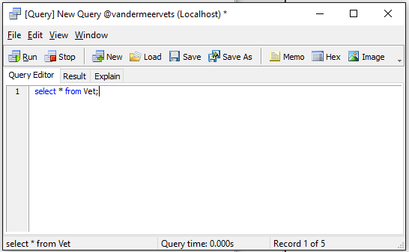

Figure 57: Show all Current data of Vet

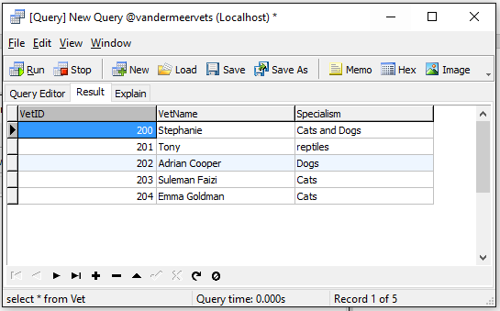

Figure 58: Data insertion result of Specialism column of Vet table

**Task 3**

# Derived Data:

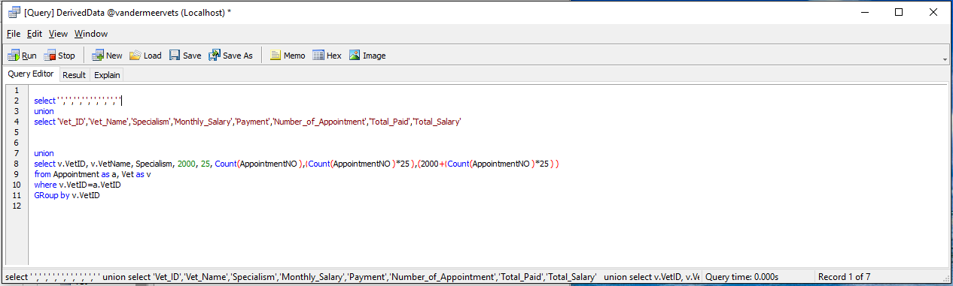

Figure 59: Extended Database of Vandermeer Vets.

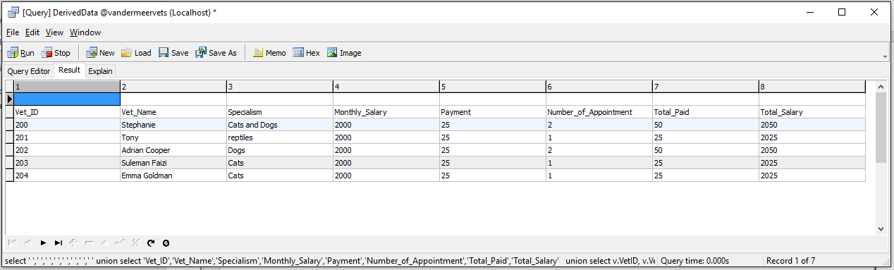

Figure 60: Extended Database result of Vandermeer Vets.

Discussion of Derived Data:

Here I have used some functions for derived data. These functions are discussed below:

**Union:**

Union generally used to combine the result of two or more Select statements. Here I have used a Union function to match the two Select Statements.

**Count:**

The function “Count” returns the number of rows that match specified criteria. Here I have used this function to count all the Appointments taken by vets from Appointment table.

**Group by:**

The Group by function is used in conjunction with the functions in aggregate to group the set of result by one or more columns of the table. Here I have used Group by function with the count function to calculate the list of appointments taken by individual vet.

***Calculation:***

After counting all the appointment, each appointment is multiplied by 25 pounds and after that 2000 standard salary is added individually by using addition. And finally it shows the total payment for each appoint, including their standard salary and payment.

**Task 4**

# Evaluation:

|  |  |  |
| --- | --- | --- |
| **Original Requirements** | **Initial Requirements Met** | **Overall Assessment** |
| 1. All the paper requirements have to store together in a database system. | To store all the paper requirements, I have created an Entity Relationship Model to identify the relationship between entities and break many to many relationships. | And the database system is working properly but some attributes was not given in the scenario that’s why I had to assumed some Attributes. |
| 1. Avoid duplicate data | To avoid duplicate data, I used here the normalization process, which is UNF to 3rd NF. | Through the normalization process, I have identified all the entity attributes and ensured that there is no duplicate data in the system. |
| 1. Data should be organized properly. | Though data dictionary I have organized all the data by declaring data type, length etc. | All the data is organized properly. |
| 1. Uniquely identification of data from each entity. | To identify data uniquely, I have used primary and foreign keys. | Some attributes are required for uniquely identification and that’s why I have selected some Attributes like Patient ID, Appointment Number etc. |
| 1. All data should be secure. | To secure all the data I have created the database system and it’s fully secure. | I have keep the data for individual’s entity so there are no chances to broke the data security of the database system. |
| 1. A monthly salary sheet should be provided. | To create a monthly salary sheet, I have calculated their individual payments in a sheet by using aggregate functions. | The monthly salary sheet is showing all the salary of individuals and total payments properly. |
| 1. Report on Appointment Cost | To generate a report on Appointment cost, I have calculated cost of each appointment. | All the cost of each appointment is showing is properly. |