<https://stackblitz.com/edit/stackblitz-starters-43ub7yls?file=index.js>

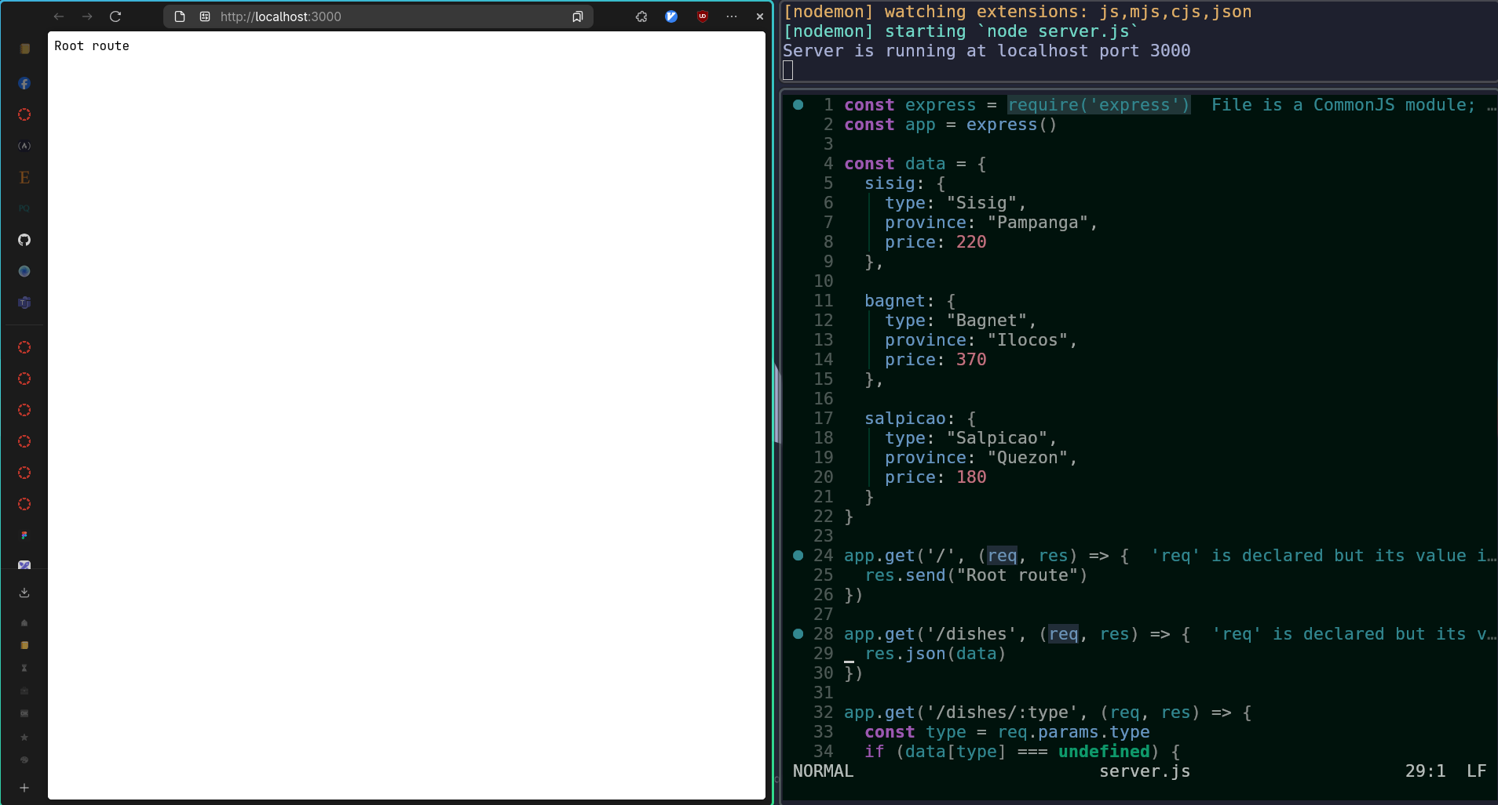

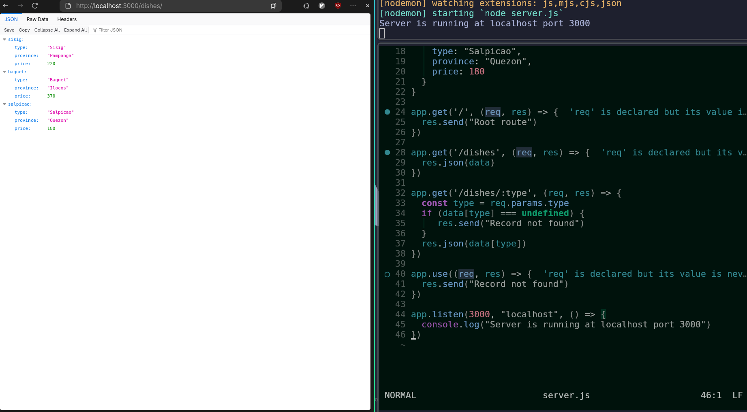



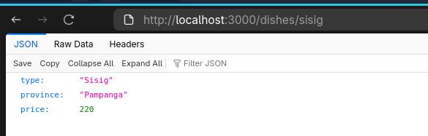

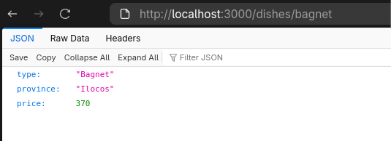

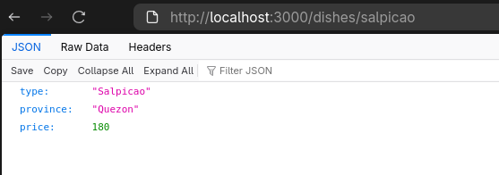

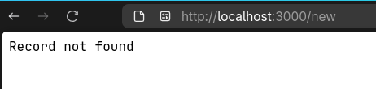

const express = require('express')

const app = express()

const data = {

sisig: {

type: "Sisig",

province: "Pampanga",

price: 220

},

bagnet: {

type: "Bagnet",

province: "Ilocos",

price: 370

},

salpicao: {

type: "Salpicao",

province: "Quezon",

price: 180

}

}

app.get('/', (req, res) => {

res.send("Root route")

})

app.get('/dishes', (req, res) => {

res.json(data)

})

app.get('/dishes/:type', (req, res) => {

const type = req.params.type

if (data[type] === undefined) {

res.send("Record not found")

}

res.json(data[type])

})

app.use((req, res) => {

res.send("Record not found")

})

app.listen(3000, "localhost", () => {

console.log("Server is running at localhost port 3000")

})